🌐 WEBSITE REQUIREMENT DOCUMENT
Centre for Mission on Energy Transition (CMET)


🔷 1. HOMEPAGE
Title:
Centre for Mission on Energy Transition (CMET)
Tagline:
Where Clean Energy Meets Innovation
Subtext:
Driving India’s transition to a reliable, resilient, and low-carbon power system.

🔹 Key Highlights
- Renewable Integration
- Voltage Control
- Pilot Projects
- Grid Analytics

🔹 Focus Areas Preview
- Renewable Integration
- Transmission Planning
- Reactive Power
- Storage
- Digital Grid

🔹 Collaborators Preview
(Logos in scroll format)
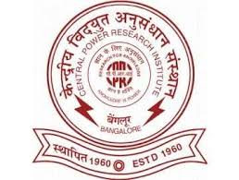

🔹 Call to Action
Collaborate with us for research, pilot projects, and policy development.
2. OUR WORK
🔷 1. FOCUS AREAS
- Renewable energy integration (utility-scale and distributed)
- Transmission planning and network adequacy
- Reactive power management and voltage control
- Resource adequacy and integrated resource planning (IRP)
- Grid flexibility, storage integration, and emerging technologies
- Digitalization and data-driven grid operation
- AC/DC coupling strategies for hybrid energy systems

🔷 2. LABORATORY FACILITIES
🔹 Overview
CMET hosts advanced laboratory facilities to support research, testing, and real-time validation of power system innovations.

🔹 Microgrid Laboratory
Equipment:
- Grid Simulator
- Wind Emulator
- Solar Emulator
- STATCOM
- DC-DC Converter
- PV Grid-Tied Inverter
- Battery Inverter
- Battery Bank (24 kWh)
- Power Plant Controller
- Power Quality Analyzer (Fluke)
- OPAL-RT 5600
- Edge Box Controller
- BTS Relay Module

Capabilities:
- Real-time microgrid simulation
- Renewable integration testing
- Voltage & reactive power control
- HIL simulation
- Power quality analysis
- AC/DC coupling testing

🔹 IoT Laboratory
Equipment:
- IoT Devices
- Sensors
- Controllers
- PCB CNC Cutting Machine

Capabilities:
- Smart monitoring
- Automation
- Demand-side management
- Data acquisition

🔷 3. SOFTWARE & TOOLS
- RT-LAB
- ETAP
- PSS®E
- MATLAB/Simulink

🔷 4. PROJECTS & WORK
🔹
Ongoing Projects
- Sustainable Rural Microgrid (CPRI)
- PM-KUSUM Integration Study (CEEW)
- Solar Inverter Pilot Project (GIZ)
Completed Projects
- KUSUM-A & C Scaling Study (RUMSL)
- Reactive Power Management (RUMSL)
- Technical Loss Estimation (MPMKVVCL)
- Transmission Adequacy Study (WRI)
- IoT-Based Demand Side Management (MPCST)

🔹 Project Display Format
Each project must include:
- Title
- Description
- Key Highlights
- Status (Ongoing / Completed)
- Image
🔷 4. PROJECTS & WORK (DETAILED DISPLAY FORMAT)

🟢 1. Sustainable Rural Microgrid (CPRI)
Description:
Design and development of intelligent control strategies for rural microgrid systems with integrated renewable energy sources.
Key Highlights:
- Planning-based controller for load prioritization
- Co-optimization of distributed energy resources
- Real-time load scheduling and shedding
- Price-based operational strategy
- Market-oriented microgrid design
Status: Ongoing
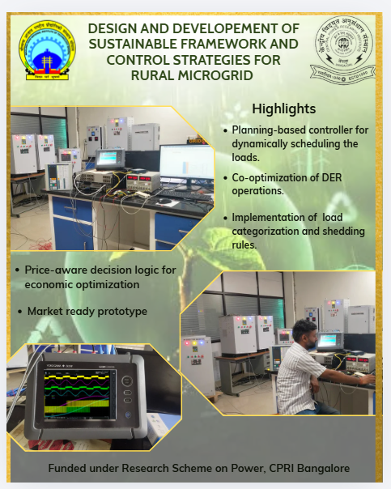
🟢 2. PM-KUSUM Integration Study (CEEW)
Description:
Assessment of cost-effective integration of PM-KUSUM solar plants into distribution networks.
Key Highlights:
- Feeder-level analysis using DISCOM data
- Hosting capacity assessment
- Seasonal load variation modeling
- Solar penetration optimization
- Grid constraint evaluation
Status: Ongoing
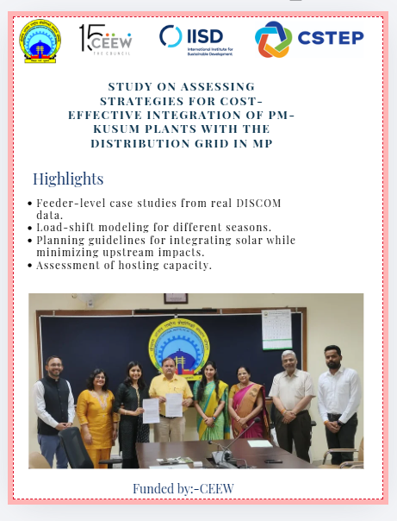
🟢 3. Solar Inverter Pilot Project
Description:
Implementation of inverter-based voltage regulation for improving distribution network performance.
Key Highlights:
- 2 MW solar plant deployment (Ujjain)
- PPC-based real-time control
- Voltage support validation
- Reactive power control using inverters
- Field-tested implementation
Status: Ongoing
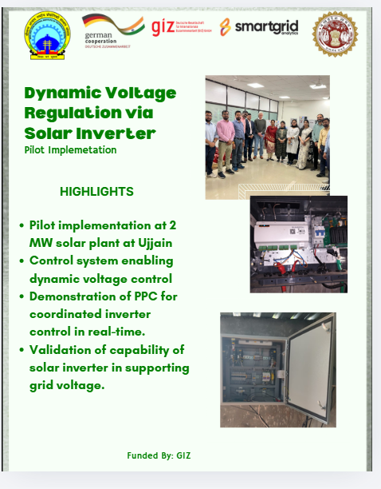
🔵 COMPLETED PROJECTS

🔵 4. Scaling up KUSUM-A & C Projects (RUMSL)
Description:
Technical analysis for optimal deployment of solar projects under KUSUM schemes.
Key Highlights:
- Optimal injection point identification
- Reduction in substation upgrade requirements
- SOP for feeder capacity planning
- Voltage and loss analysis
- CUF-based performance improvement
Status: Completed
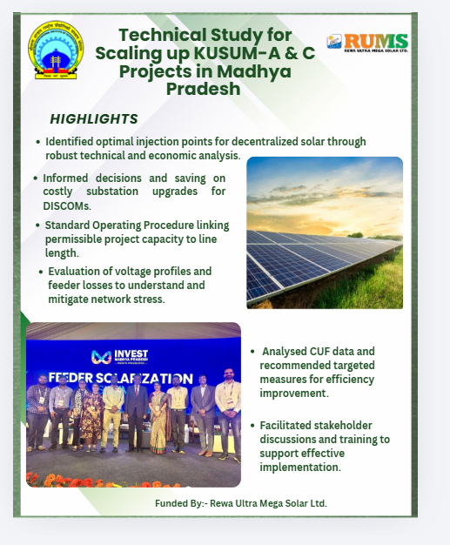

🔵 5. Reactive Power Management in Renewable Grid
Description:
Utilization of solar inverters for reactive power support and grid stability enhancement.
Key Highlights:
- Demonstrated on MANIT 230 kW solar plant
- Inverter-based reactive power injection
- Reduced dependence on capacitor banks
- Improved voltage profile
- Regulatory relevance
Status: Completed
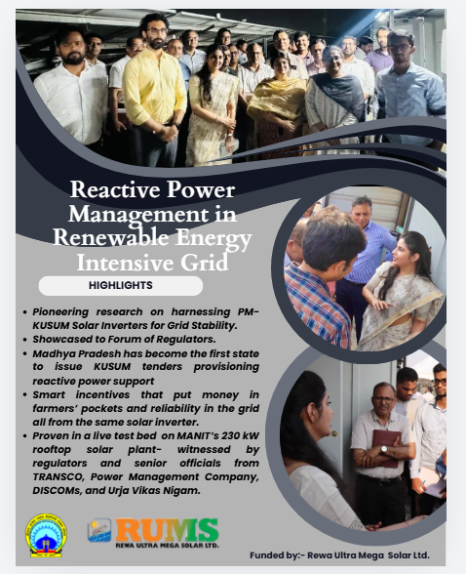

🔵 6. Technical Loss Estimation (MPMKVVCL)
Description:
Evaluation of technical losses in distribution systems to improve efficiency.
Key Highlights:
- Loss analysis for 33 kV and 11 kV feeders
- Identification of high-loss zones
- Simplified calculation methodology
- Network optimization strategies
- Practical utility recommendations
Status: Completed

🔵 7. Transmission Adequacy & Storage Optimization (WRI)
Description:
Assessment of transmission network readiness and optimal energy storage deployment.
Key Highlights:
- N-1 contingency analysis
- Thermal loading and voltage stability study
- Grid reinforcement identification
- Storage placement optimization
- System reliability enhancement
Status: Completed
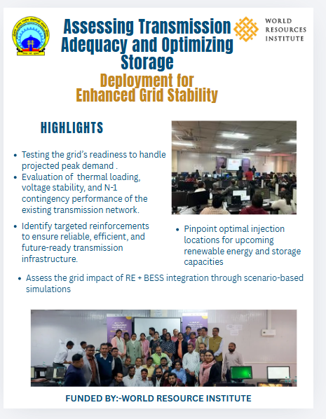
🔵 8. IoT-Based Demand Side Management
Description:
Development of IoT-based system for real-time monitoring and optimization of energy consumption.
Key Highlights:
- Real-time energy monitoring
- Smart load control
- Identification of inefficient loads
- Data-driven optimization
- Energy savings improvement
Status: Completed
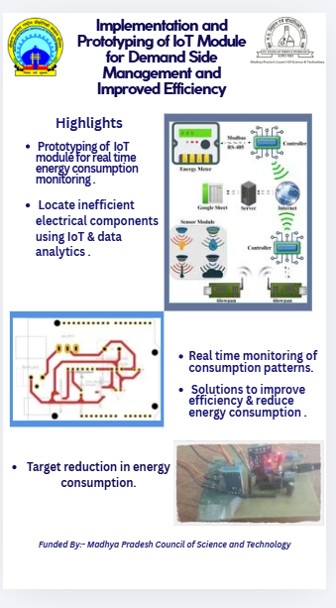
5. Publications
Publications in International Journals
Thakkar, N., Paliwal, P., Prasad Gupta, N. et al. Sensitivity Analysis of Sustainability Dimensions in Technology Ranking in Multi-Criteria Decision-Making Approaches. Process Integr Optim Sustain (2025). https://doi.org/10.1007/s41660-025-00649-x. Springer Nature,
Thakkar, N., Paliwal, P., Arya, A., Gupta, N. P., & Gupta, P. (2026). Probabilistic reliability assessment of hydrogen storage in a solar-wind powered grid-independent microgrid. Energy Sources, Part B: Economics, Planning, and Policy, 21(1). https://doi.org/10.1080/15567249.2025.2595132
Naureen Siddiqui, Priyanka Paliwal, Maximizing solar generator output through reactive power management: A case study from rural India, Energy for Sustainable Development,
Volume 89, 2025, 101829, ISSN 0973-0826, https://doi.org/10.1016/j.esd.2025.101829.
Naureen Siddiqui, Priyanka Paliwal, Incentive mechanism for decentralized reactive power management through solar inverters, Renewable Energy, Volume 255, 2025, 123867, ISSN 0960-1481, https://doi.org/10.1016/j.renene.2025.123867.
(https://www.sciencedirect.com/science/article/pii/S0960148125015319)
Thakkar, N., Paliwal, P., Kaliyaperumal, D. et al. Sensitivity analysis of reliability constrained, eco optimal solar, wind, hydrogen storage based islanded power system. Sci Rep 15, 9743 (2025). https://doi.org/10.1038/s41598-025-92893-x
Gupta, N.P., Gupta, P., Paliwal, P. et al. Real time implementation of scaled droop control in hybrid microgrid with hydrogen storage for regulation of voltage and frequency. Environ Sci Pollut Res (2024). https://doi.org/10.1007/s11356-024-34537-7
Gupta, N. P., Gupta, P., Paliwal, P., Thakkar, N., & Deepa, K. (2024). Design of Universal Control Structure for Regulation of Voltage and Frequency in Hybrid Microgrid. IETE Journal of Research, 1–21. https://doi.org/10.1080/03772063.2024.2380861
Gupta, N.P., Gupta, P., Paliwal, P. et al. A novel scheme for control and management of hybrid microgrid with active filtering capability. Electrical Eng (2024). https://doi.org/10.1007/s00202-024-02434-4
Nishant Thakkar, Priyanka Paliwal, Data driven MCDM models for reliability-economic-environmental analysis of energy storage based autonomous micro-grid, Journal of Energy Storage, Volume 81, 2024, 110408, ISSN 2352-152X, https://doi.org/10.1016/j.est.2023.110408.
Ghole, M.S., Paliwal, P. & Thakur, T. A Nowcasting Central Controller with Continuous RTP for Residential Device Scheduling using Swap-Based BFPSO. Arab J Sci Eng (2023). https://doi.org/10.1007/s13369-023-07696-x
Thakkar, N., Paliwal, P. Quad-Level MCDM Framework to Analyse Technology Combinations for Sustainable Micro-grid Planning in Uncertainty Domain. Arab J Sci Eng 48, 5829–5858 (2023). https://doi.org/10.1007/s13369-022-07019-6
N Thakkar, P Paliwal , “Sensitivity Analysis Based Comparative Assessment of Resource Mix Using MCDM Technique: A Case Study of Thar Desert, India”, Iranian Journal of Electrical and Electronic Engineering, Vol. 18, No. 4, 2022.
https://doi.org/10.22068/IJEEE.18.4.2475
Paliwal, P., Webber, J.L., Mehbodniya, A. et al. Multi-agent-based approach for generation expansion planning in isolated micro-grid with renewable energy sources and battery storage. J Supercomput (2022). https://doi.org/10.1007/s11227-022-04609-x
Sharma J, Soni S, Paliwal P, et al. A novel long term solar photovoltaic power forecasting approach using LSTM with Nadam optimizer: a case study of India. Energy Sci Eng. 2022;1‐21. doi:10.1002/ese3.1178
Nishant Thakkar & Priyanka Paliwal (2022) Hydrogen storage based micro-grid: A comprehensive review on technology, energy management and planning techniques, International Journal of Green Energy, DOI: 10.1080/15435075.2022.2049797
Priyanka Paliwal (2022) Bi-stage planning framework for a solar-battery based micro-grid using techno-socio-economic evaluation, Energy Sources, Part B: Economics, Planning, and Policy, DOI: 10.1080/15567249.2021.2025170
S. K. Wankhede, P. Paliwal and M. K. Kirar, "Bi-Level Multi-Objective Planning Model of Solar PV-Battery Storage-Based DERs in Smart Grid Distribution System," in IEEE Access, vol. 10, pp. 14897-14913, 2022, doi: 10.1109/ACCESS.2022.3148253.
P. Paliwal, “Multi-Stage Framework for Analyzing Penetration of Stochastic Distributed Energy Resources and Storage”, Iranian Journal of Electrical and Electronic Engineering , Vol. 18, No. 4, 2022, pp. 2258, https://doi.org/10.22068/IJEEE.18.2.2258
P. Paliwal, “Securing Reliability Constrained Technology Combination for Isolated Micro-Grid Using Multi-Agent Based Optimization”, IJEEE. 2022; 18 (1) :2180-2180
URL: http://ijeee.iust.ac.ir/article-1-2180-en.html
P. Paliwal, “A Technical Review on Reliability and Economic Assessment Framework of Hybrid Power System with Solar and Wind Based Distributed Generators”, International journal of integrated engineering, vol. 13, no. 6, pp. 233 - 252, Aug. 2021.
Narayan Prasad Gupta and P. Paliwal "Design and operation of smart hybrid microgrid" International Journal of Emerging Electric Power Systems, vol. , no. , 2021, pp. 20210062. https://doi.org/10.1515/ijeeps-2021-0062
P Paliwal, NP Patidar, R Nema, “Probabilistic Indices for Analyzing the Impact of DER Penetration on System Reliability”, IET Renewable Power Generation, Vol. 14, Issue 12, 07 September 2020, pp. 2154 – 2165.doi: 10.1049/iet-rpg.2019.1214.
P Paliwal, “Reliability constrained planning and sensitivity analysis for Solar-Wind-Battery based Isolated Power System”, International journal of sustainable energy planning and management, Vol. 29, 2020. pp. 109-126, http://dx.doi.org/10.5278/ijsepm.4599
P. Paliwal, “Comprehensive Analysis of DER Penetration and Placement using Probabilistic Framework”, IET Renewable Power Generation, Vol. 15, Issue4, 16 March 2021,Pages 794-808, https://doi.org/10.1049/rpg2.12069.
S.K. Wankhede, P. Paliwal, M.K. Kirar, “Increasing Penetration of DERs in Smart Grid Framework: A State-of-the-Art Review on Challenges, Mitigation Techniques and Role of Smart Inverter”, Journal of Circuits, Systems, and Computers (JCSC), Vol 29 No. 16, 31 December 2020.
N.P. Gupta, P. Paliwal, “Regulation of hybrid micro grid under transient operations”, Int. J. Power Electronics, Vol. 13, No. 1, 2021,pp.83 - 111
N.P. Gupta, P. Paliwal, “Novel droop integrated technique for regulation of islanded and grid connected hybrid microgrid”, International Journal of Power and Energy Conversion, Vol. 12, No. 2, 2021 DOI: 10.1504/IJPEC.2020.10033659
R Kamdar, P Paliwal, Y Kumar, “A Hybrid Multi-Agent-Based BFPSO Algorithm for Optimization of Benchmark Functions”, Journal of Circuits, Systems and Computers, 2050112, Vol.29, No.7, 2020.
R Kamdar, P Paliwal, Y Kumar, “A state of art review on various aspects of multi-agent system”, Journal of Circuits, Systems and Computers, Vol. 27 (11), 1830006, 2018. https://doi.org/10.1142/S0218126618300064
R Kamdar, P Paliwal, Y Kumar, “LabVIEW based Multi-Agent Approach towards Restoration in Smart Grid”, Materials Today: Proceedings 5 (2), 4684-4691 January 2018. DOI: 10.1016/j.matpr.2017.12.040
P Paliwal, NP Patidar, R Nema, “Planning of grid integrated distributed generators: A review of technology, objectives and techniques”, Renewable and sustainable energy reviews 40, 557-570, 2014
P Paliwal, NP Patidar, R Nema, “Determination of reliability constrained optimal resource mix for an autonomous hybrid power system using particle swarm optimization”, Renewable energy 63, 194-204, 2014.
P Paliwal, NP Patidar, R Nema, “A novel method for reliability assessment of autonomous PV-wind-storage system using probabilistic storage model”, International Journal of Electrical Power & Energy Systems, 2014, 55, 692-703
PGV Peri, P Paliwal, FC Joseph, “ACMC-based hybrid AC/LVDC micro-grid”, IET Renewable Power Generation, 2016, 11 (4), 521-528
P Paliwal, NP Patidar, “Distributed generator placement for loss reduction and improvement in reliability”, World Academy of Science, Engineering and Technology 69, 809-813
P Paliwal, NP Patidar, R Nema, “Fuzzy Logic Based Determination of Battery Charging Efficiency Applied to Hybrid Power System”, Journal of World Academy of Science, Engineering and Technology, Vol.71, pp. 1164-1168, 2012.
P Paliwal, NP Patidar, “Investigating Storage Options for Renewable Energy based Distributed Generators”, International Journal of Power System Control and Optimization, Vol.2, No.1, pp. 219-224, January 2010.
S.K. Bhargava, S.S. Das, P Paliwal, “Multi-Objective Optimization for Sizing of Solar-Wind Based Hybrid Power System: A Review”, International Journal of Innovative Research in Science, Engineering and Technology, Vol. 3, Special Issue 3, March 2014, pp. 195-201.

Publications in International Conferences
M. Alam, S. K. Sahu, P. Paliwal and M. K. Kirar, "Demand Shifting as a Strategy for Improved Voltage Performance in Distribution Systems with Decentralized Solar Generation," 2026 International Conference on Electric Power and Renewable Energy (EPREC), Durg, India, 2026, pp. 1-6, doi: 10.1109/EPREC66546.2026.11412077.

M. Alam, P. Paliwal and M. K. Kirar, "Seasonal Load and Voltage Profile Assessment of a Mixed-Use 11 kV Feeder with Decentralized Solar under PM-KUSUM Scheme: A Case Study From Madhya Pradesh," 2026 IEEE International Conference on Intelligent Systems, Smart and Green Technologies (ICISSGT), Visakhapatnam, India, 2026, pp. 1-6, doi: 10.1109/ICISSGT67741.2026.11483869.
N. Siddiqui, S. K. Sahu and P. Paliwal, "Management of distribution system voltage using solar inverter-a case study of rural feeder," 2025 IEEE International Students' Conference on Electrical, Electronics and Computer Science (SCEECS), Bhopal, India, 2025, pp. 1-6, doi: 10.1109/SCEECS64059.2025.10940474.
A. K. Agrawal et al., "Analysis of Voltage and Load profiles of a rural distribution Feeder in Madhya Pradesh," 2025 IEEE International Students' Conference on Electrical, Electronics and Computer Science (SCEECS), Bhopal, India, 2025, pp. 1-7, doi: 10.1109/SCEECS64059.2025.10940348.
S. K. Sahu, P. Paliwal et al., "Analysis of Capacity Utilization Factor of Decentralized Solar Generators: A Case Study," 2025 IEEE International Students' Conference on Electrical, Electronics and Computer Science (SCEECS), Bhopal, India, 2025, pp. 1-6, doi: 10.1109/SCEECS64059.2025.10940468.
Anoop Arya, Shweta Mehroliya, Yogendra Kumar, Manoj Arya, and Priyanka Paliwal. 2024. Two-Way Linked List Based Modified Load Flow Method for Radial Distribution System. In Proceedings of the 2024 13th International Conference on Software and Computer Applications (ICSCA '24). Association for Computing Machinery, New York, NY, USA, 326–332. https://doi.org/10.1145/3651781.3651830
Akriti Agrawal, Priyanka Paliwal, Anoop Arya, Tripta Thakur, and Naureen Siddiqui. 2024. Multi-Objective Combined Economic Emission Dispatch using Modified Firefly Algorithm: A Case Study of India. In Proceedings of the 2024 13th International Conference on Software and Computer Applications (ICSCA '24). Association for Computing Machinery, New York, NY, USA, 24–30. https://doi.org/10.1145/3651781.3651786
A. Gautam, P. Paliwal and A. Arya, "A Review Paper On Smart Meter Using Blockchain And Internet Of Things," 2024 IEEE International Students' Conference on Electrical, Electronics and Computer Science (SCEECS), Bhopal, India, 2024, pp. 1-7, doi: 10.1109/SCEECS61402.2024.10482257.
Thakkar, N., Bilare, K., Ghole, M., Paliwal, P. (2024). Optimal Sizing and Location of Distributed Generators in Distribution System for Loss Reduction. In: Pawar, P.M., et al. Techno-societal 2022. ICATSA 2022. Springer, Cham. https://doi.org/10.1007/978-3-031-34644-6_2.
N. Thakkar and P. Paliwal, "Ranking of different generation sources based on Economical/environmental/social value using ENTROPY-MARCOS," 2023 IEEE Renewable Energy and Sustainable E-Mobility Conference (RESEM), Bhopal, India, 2023, pp. 1-5, doi: 10.1109/RESEM57584.2023.10236334.
S. Mehroliya, A. Arya, P. Paliwal, M. Arya and S. Tomar, "Voltage Stability Enhancement with FACTS devices by using Continuation Power Flow," 2023 IEEE Renewable Energy and Sustainable E-Mobility Conference (RESEM), Bhopal, India, 2023, pp. 1-6, doi: 10.1109/RESEM57584.2023.10236058.
L. S. Gajanan, M. Kirar, P. Paliwal and N. Rajak, "A State-of-the-Art Review on Modern Artificial Intelligence based Techniques for Economic Load Dispatch," 2023 IEEE Renewable Energy and Sustainable E-Mobility Conference (RESEM), Bhopal, India, 2023, pp. 1-6, doi: 10.1109/RESEM57584.2023.10236046.
A. Shrivastava and P. Paliwal, "A State-of-Art Review on Applications of Machine Learning Based Approaches on DSM Programs," 2023 IEEE International Students' Conference on Electrical, Electronics and Computer Science (SCEECS), Bhopal, India, 2023, pp. 1-6, doi: 10.1109/SCEECS57921.2023.10063027.
M. S. Ghole, A. Tiwari, N. Thakkar, P. Paliwal, T. Thakur and A. Arya, "Optimal Placement of Distributed Generator using BFPSO," 2022 2nd Odisha International Conference on Electrical Power Engineering, Communication and Computing Technology (ODICON), Bhubaneswar, India, 2022, pp. 1-6, doi: 10.1109/ODICON54453.2022.10010050.
A. Shrivastava and P. Paliwal, "Energy Management in a smart community using deterministic approach at varying load demand," 2022 International Conference on Computer, Power and Communications (ICCPC), Chennai, India, 2022, pp. 123-128, doi: 10.1109/ICCPC55978.2022.10072075.
N. Singh and P. Paliwal, "Planning and monitoring of smart grid Architecture using Internet of Things," 2022 IEEE 6th International Conference on Condition Assessment Techniques in Electrical Systems (CATCON), Durgapur, India, 2022, pp. 12-16, doi: 10.1109/CATCON56237.2022.10077659.
U. Mitra, A. Arya, R. Dwivedi, S. Gupta, P. Paliwal and S. Tomar, "Modelling Proton Exchange Membrane Fuel Cell for Power Generation Using Multi-Stage Power Conversion System," 2023 IEEE International Students' Conference on Electrical, Electronics and Computer Science (SCEECS), Bhopal, India, 2023, pp. 1-6, doi: 10.1109/SCEECS57921.2023.10063048.
A. Banthia, S. Paliwal, V. Patle, M. S. Ghole and P. Paliwal, "Determination of Battery Life Using State of Health Data and Linear Regression," 2023 IEEE International Students' Conference on Electrical, Electronics and Computer Science (SCEECS), Bhopal, India, 2023, pp. 1-5, doi: 10.1109/SCEECS57921.2023.10063037.
N. Singh and P. Paliwal, "Deterministic approach-based energy management of smart microgrids," 2023 International Conference on Power, Instrumentation, Energy and Control (PIECON), Aligarh, India, 2023, pp. 1-6, doi: 10.1109/PIECON56912.2023.10085904.
Gupta, N.P., Paliwal, P. (2023). Implementation of MPPT in Grid Interfaced Solar-PV Generating Unit. In: Namrata, K., Priyadarshi, N., Bansal, R.C., Kumar, J. (eds) Smart Energy and Advancement in Power Technologies. Lecture Notes in Electrical Engineering, vol 926. Springer, Singapore. https://doi.org/10.1007/978-981-19-4971-5_20
Chandrakar, A., Paliwal, P. (2023). An Intelligent Mechanism for Utility and Active Customers in Demand Response Using Single and Double Q Learning Approach. In: Namrata, K., Priyadarshi, N., Bansal, R.C., Kumar, J. (eds) Smart Energy and Advancement in Power Technologies. Lecture Notes in Electrical Engineering, vol 926. Springer, Singapore. https://doi.org/10.1007/978-981-19-4971-5_30
Maitreya, S., Soni, S., Paliwal, P. (2022). Analysis of Electromagnetic Aircraft Launching System for Naval Aircraft. In: Chaurasiya, P.K., Singh, A., Verma, T.N., Rajak, U. (eds) Technology Innovation in Mechanical Engineering. Lecture Notes in Mechanical Engineering. Springer, Singapore. https://doi.org/10.1007/978-981-16-7909-4_71
M. S. Ghole, P. Paliwal, N. Thakkar and T. Thakur, "Application of an Appliance Scheduling Algorithm for Demand Response Program," 2021 IEEE 2nd International Conference On Electrical Power and Energy Systems (ICEPES), 2021, pp. 1-5, doi: 10.1109/ICEPES52894.2021.9699740.
S. Maitreya, H. S. Dangi, N. S. Naruka and P. Paliwal, "Analysis of Solar Powered Electric Vehicles," 2021 IEEE 2nd International Conference On Electrical Power and Energy Systems (ICEPES), 2021, pp. 1-4, doi: 10.1109/ICEPES52894.2021.9699596.
N. Thakkar, P. Paliwal and M. S. Ghole, "Selection of Power Generation Technology Using a Combination of CRITIC and TOPSIS," 2021 IEEE 2nd International Conference On Electrical Power and Energy Systems (ICEPES), 2021, pp. 1-5, doi: 10.1109/ICEPES52894.2021.9699756.
N. Thakkar and P. Paliwal, "Application of Satin Bowerbird Algorithm for Optimal Sizing of a Solar-Biomass based Microgrid," 2021 13th IEEE PES Asia Pacific Power & Energy Engineering Conference (APPEEC), 2021, pp. 1-6, doi: 10.1109/APPEEC50844.2021.9687673.
A. Chandrakar, P. Paliwal and A. Arya, "Employing Demand Response in Energy Management of Microgrid using Q learning," 2021 IEEE 2nd International Conference On Electrical Power and Energy Systems (ICEPES), 2021, pp. 1-5, doi: 10.1109/ICEPES52894.2021.9699659.
N. P. Gupta, P. Gupta and P. Paliwal, "Real Time Implementation of Droop Controlled Wind DFIG System," 2021 IEEE 2nd International Conference On Electrical Power and Energy Systems (ICEPES), 2021, pp. 1-6, doi: 10.1109/ICEPES52894.2021.9699675.
S. Mehroliya, A. Arya, U. Mitra, P. Paliwal and P. Mundra, "Comparative Analysis of Conventional Technologies and Emerging Trends in Wind Turbine Generator," 2021 IEEE 2nd International Conference On Electrical Power and Energy Systems (ICEPES), 2021, pp. 1-6, doi: 10.1109/ICEPES52894.2021.9699538.
Wankhede, S.K., Paliwal, P., Kirar, M.K. (2022). DG Optimal Placement and Sizing Considering Active Power Losses and Voltage Profile Factor. In: Gupta, O.H., Sood, V.K., Malik, O.P. (eds) Recent Advances in Power Systems. Lecture Notes in Electrical Engineering, vol 812. Springer, Singapore. https://doi.org/10.1007/978-981-16-6970-5_48
Thakkar, N., Paliwal, P. (2022). A State-of-the-Art Review on Multi-criteria Decision Making Approaches for Micro-grid Planning. In: Das, K.N., Das, D., Ray, A.K., Suganthan, P.N. (eds) Proceedings of the International Conference on Computational Intelligence and Sustainable Technologies. Algorithms for Intelligent Systems. Springer, Singapore. https://doi.org/10.1007/978-981-16-6893-7_29
Agrawal, A., Paliwal, P., Thakur, T. (2022). Economic Load Dispatch: A Holistic Review on Modern Bio-inspired Optimization Techniques. In: Das, K.N., Das, D., Ray, A.K., Suganthan, P.N. (eds) Proceedings of the International Conference on Computational Intelligence and Sustainable Technologies. Algorithms for Intelligent Systems. Springer, Singapore. https://doi.org/10.1007/978-981-16-6893-7_45
R. Ahirwar, P. Paliwal and T. Thakur, "A Technical Review on Artificial Intelligence Optimization Techniques Used for Micro Grid Planning," 2021 International Conference in Advances in Power, Signal, and Information Technology (APSIT), 2021, pp. 1-6, doi: 10.1109/APSIT52773.2021.9641172.
R. Ahirwar, P. Paliwal and T. Thakur, "Analysis of Differential Evolution Variants for Optimal Sizing of Autonomous Microgrid," 2021 4th International Conference on Recent Developments in Control, Automation & Power Engineering (RDCAPE), 2021, pp. 113-117, doi: 10.1109/RDCAPE52977.2021.9633417.
H. Jain, S. Maitreya and P. Paliwal, "Cooperative Control of Regenerative and Anti-lock Braking Systems in Electric Vehicles Using Fuzzy Logic," 2021 4th International Conference on Recent Developments in Control, Automation & Power Engineering (RDCAPE), 2021, pp. 62-66, doi: 10.1109/RDCAPE52977.2021.9633401.
P. V. P. Gautam and P. Paliwal, "An Economic Feasibility Study of an Automatic Centralised Micro-Grid Controller based hybrid AC/LVDC Microgrid," 2021 International Conference on Sustainable Energy and Future Electric Transportation (SEFET), 2021, pp. 1-5, doi: 10.1109/SeFet48154.2021.9375646, 21-23 Jan. 2021
A. Shrivastava, Rohit, S. Sony, N. Gupta and P. Paliwal, "Control of Solar-battery storage based Micro-grid," 2021 Innovations in Energy Management and Renewable Resources(52042), 2021, pp. 1-6, doi: 10.1109/IEMRE52042.2021.9386769.
P. Paliwal, "Determining optimal component sizes for an isolated solar-battery micro-grid using Butterfly PSO," 2021 1st International Conference on Power Electronics and Energy (ICPEE), 2021, pp. 1-6, doi: 10.1109/ICPEE50452.2021.9358614.
N. Patil, M. K. Kirar, P. Paliwal and S. K. Wankhede, "Protection of Microgrid Using Coordinated Directional Overcurrent and Undervoltage Relay," 2021 International Conference on Sustainable Energy and Future Electric Transportation (SEFET), 2021, pp. 1-5, doi: 10.1109/SeFet48154.2021.9375695.
S. Maitreya, H. Jain and P. Paliwal, "Scalable and De-centralized Battery Management System for Parallel Operation of Multiple Battery Packs," 2021 Innovations in Energy Management and Renewable Resources(52042), 2021, pp. 1-7, doi: 10.1109/IEMRE52042.2021.9386861, 5-7 Feb. 2021, Kolkata, India
P. Paliwal, T. Thakur and S. S. Pandit, "A Novel Approach Towards Time of Day Pricing Scheme using Fuzzy Logic Based Consumer Behavior Model," 2020 IEEE 7th Uttar Pradesh Section International Conference on Electrical, Electronics and Computer Engineering (UPCON), 2020, pp. 1-6, doi: 10.1109/UPCON50219.2020.9376554.
Shreyas Maitreya, Bhushan Raghuwanshi, Priyanka Paliwal “Comparative Study of Linear Induction Motor Guns and Coil-Guns for Naval and Ground-Based Artillery”, Lecture Notes in Electrical Engineering, Advances in Renewable Energy and Electric Vehicles, December 2020, Springer Singapore https://doi.org/10.1007/978-981-16-1642-6_6
Priyanka Paliwal, “Techno-Socio-Economic Sizing of Solar–Diesel Generator-Based Autonomous Power System Using Butterfly-PSO”, Lecture Notes in Electrical Engineering, Advances in Renewable Energy and Electric Vehicles, December 2020, Springer Singapore https://doi.org/10.1007/978-981-16-1642-6_33.
Paliwal P. (2022) Reliability-Based Optimal Sizing for an Isolated Wind–Battery Hybrid Power System Using Butterfly PSO. In: Bansal R.C., Agarwal A., Jadoun V.K. (eds) Advances in Energy Technology. Lecture Notes in Electrical Engineering, vol 766. Springer, Singapore. https://doi.org/10.1007/978-981-16-1476-7_16
Paliwal P. (2022) A State-of-the-Art Review on LVRT Enhancement Techniques for DFIG-Based Wind Turbines. In: Bansal R.C., Agarwal A., Jadoun V.K. (eds) Advances in Energy Technology. Lecture Notes in Electrical Engineering, vol 766. Springer, Singapore. https://doi.org/10.1007/978-981-16-1476-7_13
Wankhede S.K., Paliwal P., Kirar M.K. (2021) Smart Grid Initiatives Towards Sustainable Development: Indian and Worldwide Scenario. In: Baredar P.V., Tangellapalli S., Solanki C.S. (eds) Advances in Clean Energy Technologies. Springer Proceedings in Energy. Springer, Singapore. https://doi.org/10.1007/978-981-16-0235-1_12
Pranita Singh, Priyanka Paliwal and Anoop Arya “A Review on Challenges and Techniques for Secondary Control of Microgrid" IOP Conf. Ser.: Mater. Sci. Eng. 561 012075. doi:10.1088/1757-899X/561/1/012075
Tamil Nadu, India during 12 - 13, April 2019.
Yuvraj Soni, Priyanka Paliwal, Mukesh Kirar, “Control and Coordination of Grid Connected PV Fed Induction Motor” (April 14, 2020). Proceedings of the International Conference on Advances in Electronics, Electrical & Computational Intelligence (ICAEEC) 2019, Available at SSRN: https://ssrn.com/abstract=3575304 or http://dx.doi.org/10.2139/ssrn.3575304
May 31-01 June , 2019IIIT Allahabad
Kalyan B. Ram, Panchaksharayya S. Hiremath, Prajwal MS, Priyanka Paliwal
(2019) Remote Labs for Electrical Power Transmission Lines Simulation Unit. In: Auer M., Langmann R. (eds) Smart Industry & Smart Education. REV 2018. Lecture Notes in Networks and Systems, vol 47. Springer, Cham. https://doi.org/10.1007/978-3-319-95678-7_21
R. Kamdar, R. Khare, Y. Kumar, P. Paliwal, “Multi agent systems : in renewable hybrid power system a critical review”, Proceedings of the India Smart Grid Week, March 2016, pp. 263-267, New Delhi, India.
Shivani Garg , Anoop Arya Priyanka Paliwal, “A Compendious study on Demand Side Management- An Indian Perspective”, Proceedings of the 2015 ACM Sixth International Conference on Future Energy Systems. Pages 283-288, DOI: http://dx.doi.org/10.1145/2768510.2768515.
Rajkamal Kakoti, Priyanka Paliwal , “STATCOM design for voltage control using synchronous vector PI controller”, ICETECH,20th March 2015 Coimbatore
M. Swain, S.K. Pradhan, P. Paliwal and S. Nema, “Ripple Torque Management of BLDC Motor: A Review”, International Conference on Electrical, Electronics and Data Chennai, Tamil Nadu, India Communication(ICEEDC), May 2014.
Priyanka Paliwal and N. P. Patidar, “A Comprehensive Survey of Optimization Techniques used for Distributed Generator Siting and Sizing”, Proceedings of IEEE Southeastcon, pp.1-7, March 2012. Orlando, Florida.
Priyanka Paliwal and Dr. Arvind Mittal, “Distribution loss minimization through feeder reconfiguration”, AEE’2006, 28-29 Nov.’06, MITS Gwalior

Book Chapters Authored
Priyanka Paliwal, “Techno-Socio-Economic Sizing of Solar–Diesel Generator-Based Autonomous Power System Using Butterfly-PSO”, Lecture Notes in Electrical Engineering, Advances in Renewable Energy and Electric Vehicles, December 2020, Springer Singapore https://doi.org/10.1007/978-981-16-1642-6_33.
Paliwal P. (2022) Reliability-Based Optimal Sizing for an Isolated Wind–Battery Hybrid Power System Using Butterfly PSO. In: Bansal R.C., Agarwal A., Jadoun V.K. (eds) Advances in Energy Technology. Lecture Notes in Electrical Engineering, vol 766. Springer, Singapore. https://doi.org/10.1007/978-981-16-1476-7_16
Paliwal P. (2022) A State-of-the-Art Review on LVRT Enhancement Techniques for DFIG-Based Wind Turbines. In: Bansal R.C., Agarwal A., Jadoun V.K. (eds) Advances in Energy Technology. Lecture Notes in Electrical Engineering, vol 766. Springer, Singapore. https://doi.org/10.1007/978-981-16-1476-7_13
Gupta, N.P., Paliwal, P. (2023). Implementation of MPPT in Grid Interfaced Solar-PV Generating Unit. In: Namrata, K., Priyadarshi, N., Bansal, R.C., Kumar, J. (eds) Smart Energy and Advancement in Power Technologies. Lecture Notes in Electrical Engineering, vol 926. Springer, Singapore. https://doi.org/10.1007/978-981-19-4971-5_20
Chandrakar, A., Paliwal, P. (2023). An Intelligent Mechanism for Utility and Active Customers in Demand Response Using Single and Double Q Learning Approach. In: Namrata, K., Priyadarshi, N., Bansal, R.C., Kumar, J. (eds) Smart Energy and Advancement in Power Technologies. Lecture Notes in Electrical Engineering, vol 926. Springer, Singapore. https://doi.org/10.1007/978-981-19-4971-5_30
Maitreya, S., Soni, S., Paliwal, P. (2022). Analysis of Electromagnetic Aircraft Launching System for Naval Aircraft. In: Chaurasiya, P.K., Singh, A., Verma, T.N., Rajak, U. (eds) Technology Innovation in Mechanical Engineering. Lecture Notes in Mechanical Engineering. Springer, Singapore. https://doi.org/10.1007/978-981-16-7909-4_71
Wankhede, S.K., Paliwal, P., Kirar, M.K. (2022). DG Optimal Placement and Sizing Considering Active Power Losses and Voltage Profile Factor. In: Gupta, O.H., Sood, V.K., Malik, O.P. (eds) Recent Advances in Power Systems. Lecture Notes in Electrical Engineering, vol 812. Springer, Singapore. https://doi.org/10.1007/978-981-16-6970-5_48
Agrawal, A., Paliwal, P., Thakur, T. (2022). Economic Load Dispatch: A Holistic Review on Modern Bio-inspired Optimization Techniques. In: Das, K.N., Das, D., Ray, A.K., Suganthan, P.N. (eds) Proceedings of the International Conference on Computational Intelligence and Sustainable Technologies. Algorithms for Intelligent Systems. Springer, Singapore. https://doi.org/10.1007/978-981-16-6893-7_45
Priyanka Paliwal, “Techno-Socio-Economic Sizing of Solar–Diesel Generator-Based Autonomous Power System Using Butterfly-PSO”, Lecture Notes in Electrical Engineering, Advances in Renewable Energy and Electric Vehicles, December 2020, Springer Singapore https://doi.org/10.1007/978-981-16-1642-6_33.

3. TEAM
🔹1. Leadership
Dr. Priyanka Paliwal
Associate Professor, Electrical Engineering Department
Chair, CMET
Maulana Azad National Institute of Technology (MANIT), Bhopal


Dr. Priyanka Paliwal, Associate Professor, Department of Electrical Engineering, Maulana Azad National Institute of Technology, Bhopal, is an accomplished academic and innovator with over 20 years of experience in power systems, renewable-energy integration, and distributed generation. She also serves as an Independent Director with Madhya Pradesh Urja Vikas Nigam Limited. A Senior Member of IEEE, she is widely recognized for pioneering research that bridges technology, regulation, and on-ground implementation in India’s clean-energy transition.
Dr. Paliwal leads the Centre for Mission on Energy Transition (CMET) at MANIT, established in partnership with the New and Renewable Energy Department, Government of Madhya Pradesh. The Centre brings together leading national and international collaborations to conduct flagship research advancing India’s clean-energy transition and net-zero targets.
She spearheaded a World Bank-funded study that, for the first time, demonstrated how PM-KUSUM solar inverters can provide voltage regulation in the distribution grid, improving power quality, reducing feeder losses, and strengthening rural grid reliability. Presented before the Forum of Regulators, this work influenced policy discourse and led Madhya Pradesh to become the first state to include reactive-power provisions in KUSUM tenders.
With over 100 research papers, 12 book chapters, and two patents, Dr. Paliwal is the recipient of the Tejomaya Award, the UN Women WeSTEM Award, and MANIT’s Best faculty Award for her outstanding contributions to science and technology.

Dr. Mukesh Kumar Kirar
Associate Professor, Electrical Engineering Department
Vice-chair, CMET
Maulana Azad National Institute of Technology (MANIT), Bhopal

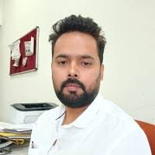
Dr. Mukesh Kumar Kirar is an Associate Professor in the Department of Electrical Engineering at Maulana Azad National Institute of Technology (MANIT), Bhopal. He is an accomplished academic and innovator with over 15 years of experience spanning power systems, renewable energy integration, and distributed generation. He has been associated with MANIT since 2010, contributing extensively to teaching, research, and institutional development.
Dr. Kirar is the lead of the Centre for Mission on Energy Transition (CMET) at MANIT, an initiative established in collaboration with the New and Renewable Energy Department, Government of Madhya Pradesh. The Centre fosters national and international partnerships to undertake advanced research supporting India’s clean energy transition and net-zero goals. He has been actively involved in several sponsored research and consultancy projects, particularly in the areas of renewable energy planning, power system modelling, and smart grid development.
He has over 15 years of combined industry and academic experience and has published several research papers in high-impact journals and reputed international conferences. His research interests include industrial power system design and analysis, load shedding strategies, artificial neural networks, and power system protection.

🔹2. Advisory Board
The Centre for Mission on Energy Transition (CMET) is envisioned as a high-impact institutional platform combining policy, modelling, and implementation expertise. The Advisory Board of CMET brings together leading experts from academia, industry, utilities, and regulatory institutions to ensure that CMET’s work remains technically robust, policy-relevant, and aligned with emerging sectoral needs.
  - Shri Upendra Tripathy
Advisory Member
First and founding Director General of the International Solar Alliance (ISA) and former Secretary, Ministry of New and Renewable Energy (MNRE), Government of India.
  - Shri S. Vijay Iyer
Advisory Member, International Clean Energy Transition
Former Vice President, Multilateral Investment Guarantee Agency (MIGA), World Bank Group.
Former Global Director, Energy Policy and Practice, World Bank
  - Shri Manu Srivastava
Advisory Member (Technical & Strategy)
A nationally recognized renewable energy leader with a proven record of designing and implementing large-scale RE projects, and prior involvement in Madhya Pradesh.
  - Dr. Karunesh Kumar Shukla
Institutional Member
Director, MANIT Bhopal — Ex-officio Member
  - Dr. Amit Kumar Singh Parihar
Advisory Member (Policy and Planning)
Lead, Strategic Insight Units, Energiva Ventures
  - Shri Sushil Kumar Soonee
Advisory Member (System Operations & Market Design)
Former and founding CEO of POSOCO (now Grid-India) with four decades of experience in power system operations, commercial and regulatory affairs, and market development.
  - Dr. Tripta Thakur
Advisory Member (Capacity Building & Institutional Strengthening)
Vice Chancellor, Uttarakhand Technical University
  - Dr. Amol Phadke
Advisory Member (IRP, RE Planning and Procurement strategies)
Adjunct Associate Professor, University of California, Berkeley. Faculty Director India Energy and Climate Center
  - Dr. Nikit Abhyankar
Advisory Member (IRP, RE Planning and Procurement strategies)
Co-Faculty Director,
India Energy & Climate Centre
Associate Adjunct Professor,
Goldman School of Public Policy (GSPP), UC Berkeley
  - Dr. Ranjit Deshmukh
Advisory Member (IRP, Energy Systems, Economics, and Policies)
Associate Professor, Bren School of Environmental Science and Management, University of California, Santa Barbara

  - Prof. Zakir Hussain Rather
Advisory Member (System operation and planning, Demand response, grid storage)
Department of Energy Science and Engineering, IIT Bombay Powai

🔹3. Research Scholars & Team Members
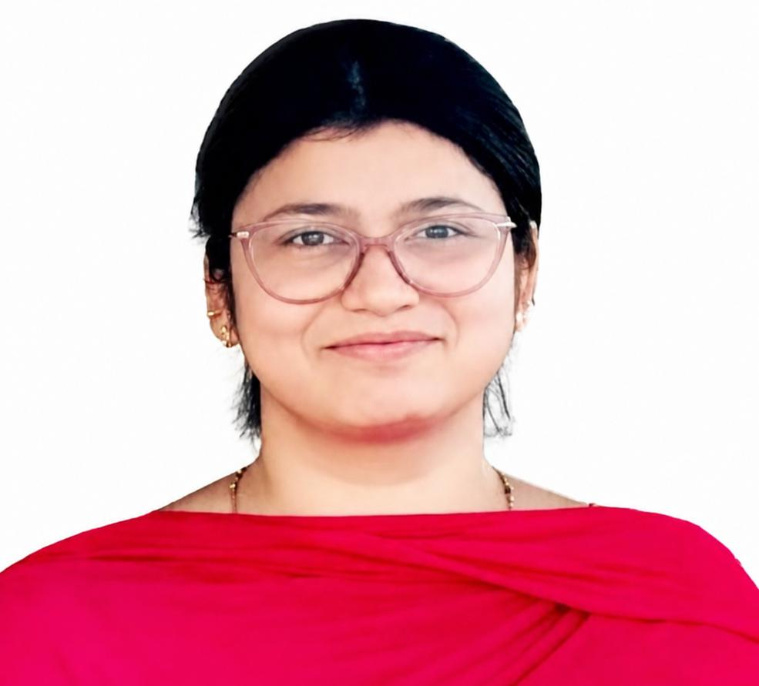

Ms. Naureen Siddiqui
Ph.D. Scholar (Operational planning frameworks for active and reactive power management for grid-connected microgrids)
Research area: Power system management, grid-connected microgrid, operational planning, distributed energy resources integration, BESS and solar
Maulana Azad National Institute of Technology (MANIT), Bhopal
Email: naureen239@gmail.com



Mr Swapnil Kumar Sahu
Ph.D. Scholar (Determination of headroom in transmission network)
Research area: Power system management, grid-connected microgrid, operational planning, distributed energy resources integration, BESS and solar
Maulana Azad National Institute of Technology (MANIT), Bhopal
Email: swapnilkumarsahu11@gmail.com


Mr. Rahul Soni
Senior Research Fellow (SRF)
M.Tech, Maulana Azad National Institute of Technology, Bhopal (2020)
Research area: Power system networking using PSSE, EV converter design, Electric drives, microgrid control algorithm
Email: rahulsoni.vn06@gmail.com


Ms. Reeha Chouhan
Junior Research Fellow (JRF)
M.Tech, RGPV (2024)
Research area: Distribution system planning (loss estimation) and renewable energy integration, power system modelling, data-driven decision-making
Email: reehachouhan17@gmail.com


Ms. Mantasha Alam
Junior Research Fellow (JRF)
B.Tech, RGPV (2023)
M.Tech (Integrated Power Systems), Maulana Azad National Institute of Technology, Bhopal (Ongoing, expected June 2026)
Research area: Microgrid operation, smart-grid analysis, hosting capacity assessment, distribution grid controlling from inverter, demand response and cyber security
Email: mantashaalam2@gmail.com

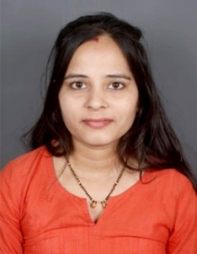
Dr. Shweta Mehroliya
Research Fellow
PhD (Optimal Service Restoration in Radial Distribution Systems employing Renewable Distributed Generators)
Research area: Power System restoration, Renewable Distributed Generators, Microgrid, Planning and optimization of power systems
Maulana Azad National Institute of Technology (MANIT), Bhopal
Email: shwetamehroliya12@gmail.com


Mr. Gautam Kumar Yadav
Research Fellow
Ph.D. (Design and analysis of protection technique for microgrid)
Research area: Power system protection, renewable integration, microgrid planning
Maulana Azad National Institute of Technology (MANIT), Bhopal
Email: gautamyadav542@gmail.com

4. NEWS
5. ABOUT US
Centre for Mission on Energy Transition (CMET) is a policy-driven, implementation-focused research centre anchored at Maulana Azad National Institute of Technology, India, working to enable India’s transition towards a reliable, resilient, and low-carbon power system.
CMET has been established in collaboration with the New and Renewable Energy Department, Government of Madhya Pradesh, to address emerging challenges in renewable energy integration, grid stability, and transmission planning.
CMET operates at the critical interface of government, utilities, industry and academia, translating advanced power system research into actionable solutions and on-ground implementation.
Our work spans the full spectrum—from high-impact technical assessment studies to field-level pilot demonstrations, ensuring that policy recommendations are not only theoretically sound but also practically viable.
Key Contributions
- State-level Renewable Integration & Transmission Planning
Conducted detailed studies to identify optimal locations for solar and storage deployment based on transmission network headroom, land availability, and system constraints, minimizing the need for costly infrastructure upgrades.
- Decentralized Reactive Power & Voltage Control Frameworks
Developed and demonstrated innovative approaches using solar inverters for reactive power support, providing a viable alternative to conventional capacitor banks and enabling dynamic voltage regulation at the distribution level.
- Field Pilots & Demonstration Projects
Successfully implemented live pilot projects (e.g., feeder-level deployments under PM-KUSUM), validating concepts such as volt-VAR control, night-time reactive power support, and decentralized grid services.
- Policy & Regulatory Engagement
Supported state agencies and regulators through evidence-based inputs, contributing to progressive policy directions, including the integration of grid-support functionalities in distributed renewable systems.
- Advanced Grid Analytics & Modeling
Utilizing tools such as ETAP, PSS®E, and real-time data frameworks to perform load flow analysis, hosting capacity assessment, contingency studies, and resource adequacy planning.

🔷 VISION & MISSION
🔹Vision Statement
To be a leading hub of innovation, research, and capacity building that accelerates the transition towards a sustainable, inclusive, and low-carbon energy future for India and the world.

🔹Mission Statement
- Conducting cutting-edge research on renewable energy integration, storage, and efficiency.
- Developing and demonstrating innovative technologies for clean energy production and utilization.
- Facilitating policy dialogue and stakeholder collaboration for equitable and sustainable energy systems.
- Building capacity through education, training, and outreach to empower communities and industries.
- Driving real-world impact through pilot projects, field demonstrations, and technology transfer.

6. V2G FIELD TRIALS
- Sustainable Rural Microgrid (CPRI)
- PM-KUSUM Integration Study (CEEW)
- Solar Inverter Pilot Project (GIZ)
- KUSUM-A & C Scaling Study (RUMSL)
- Reactive Power Management (RUMSL)
- Technical Loss Estimation (MPMKVVCL)
- Transmission Adequacy Study (WRI)
- IoT-Based Demand Side Management (MPCST)

7. OPEN POSITIONS/ Apply here

8. Gallery
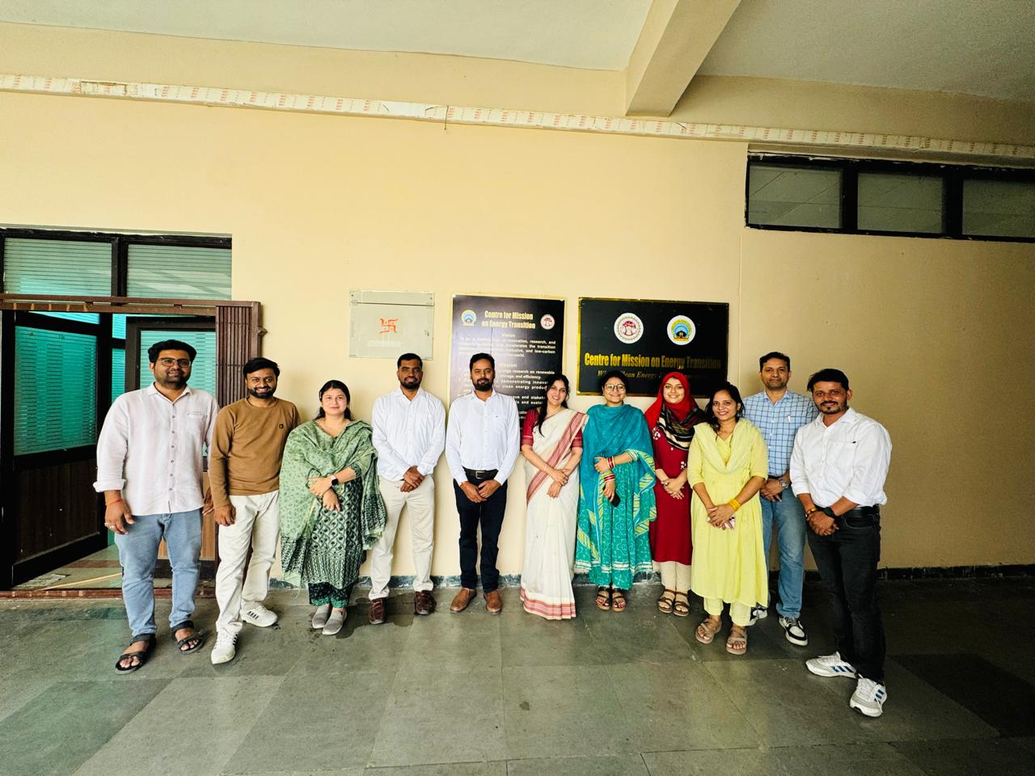
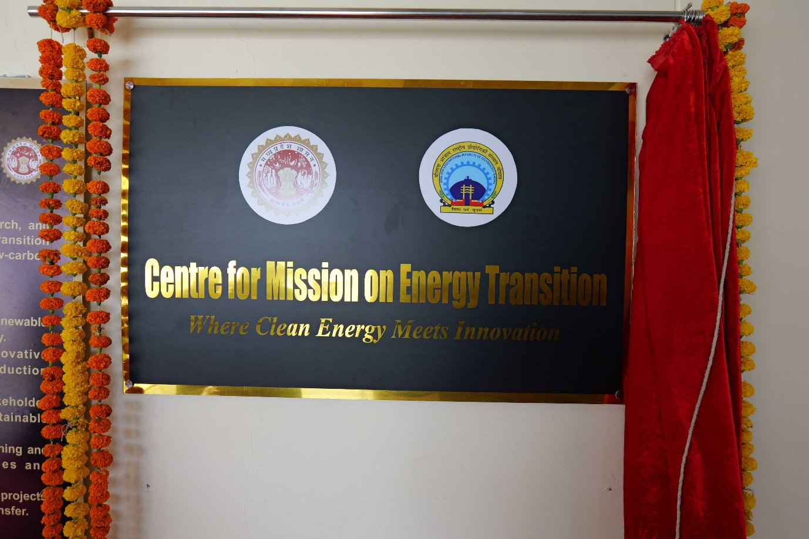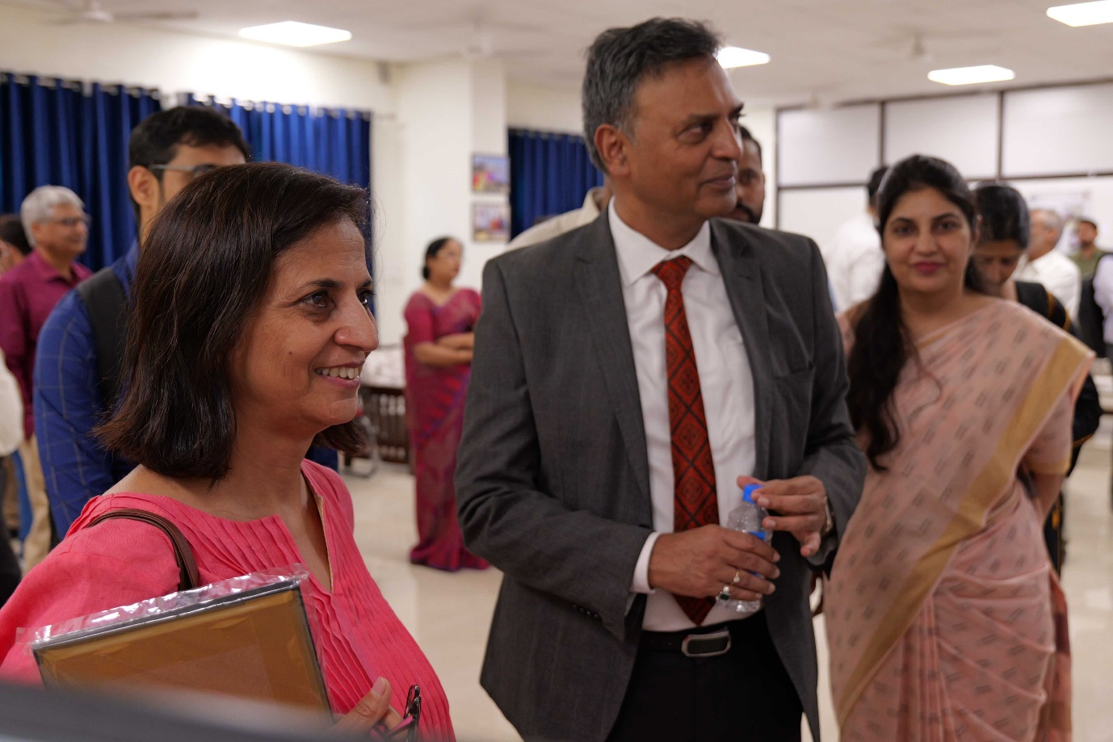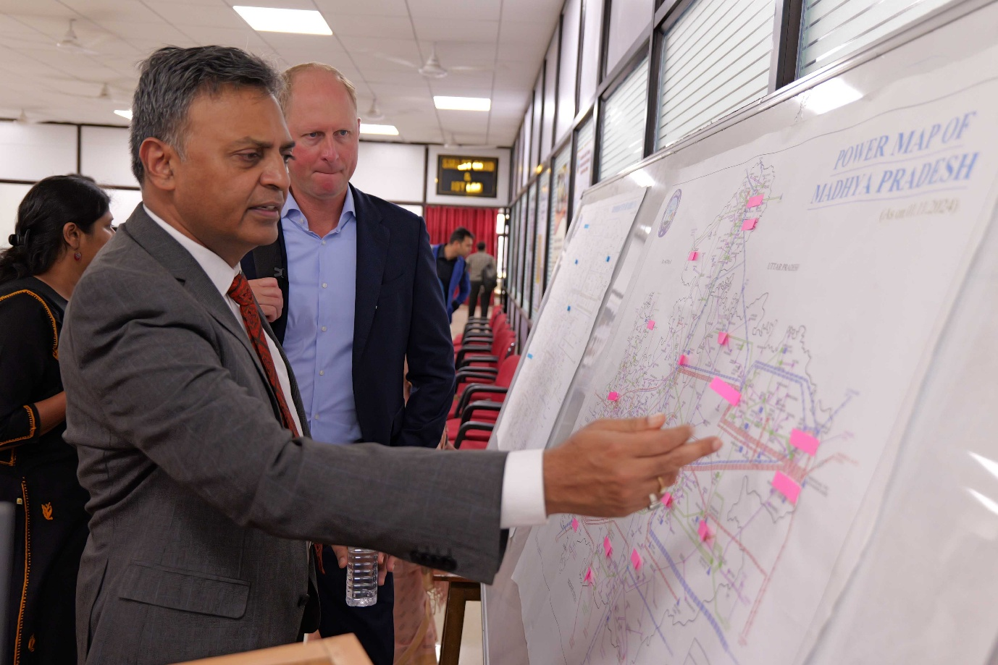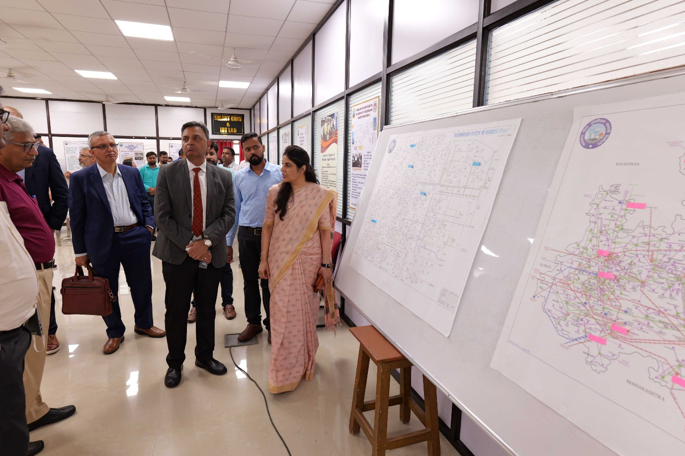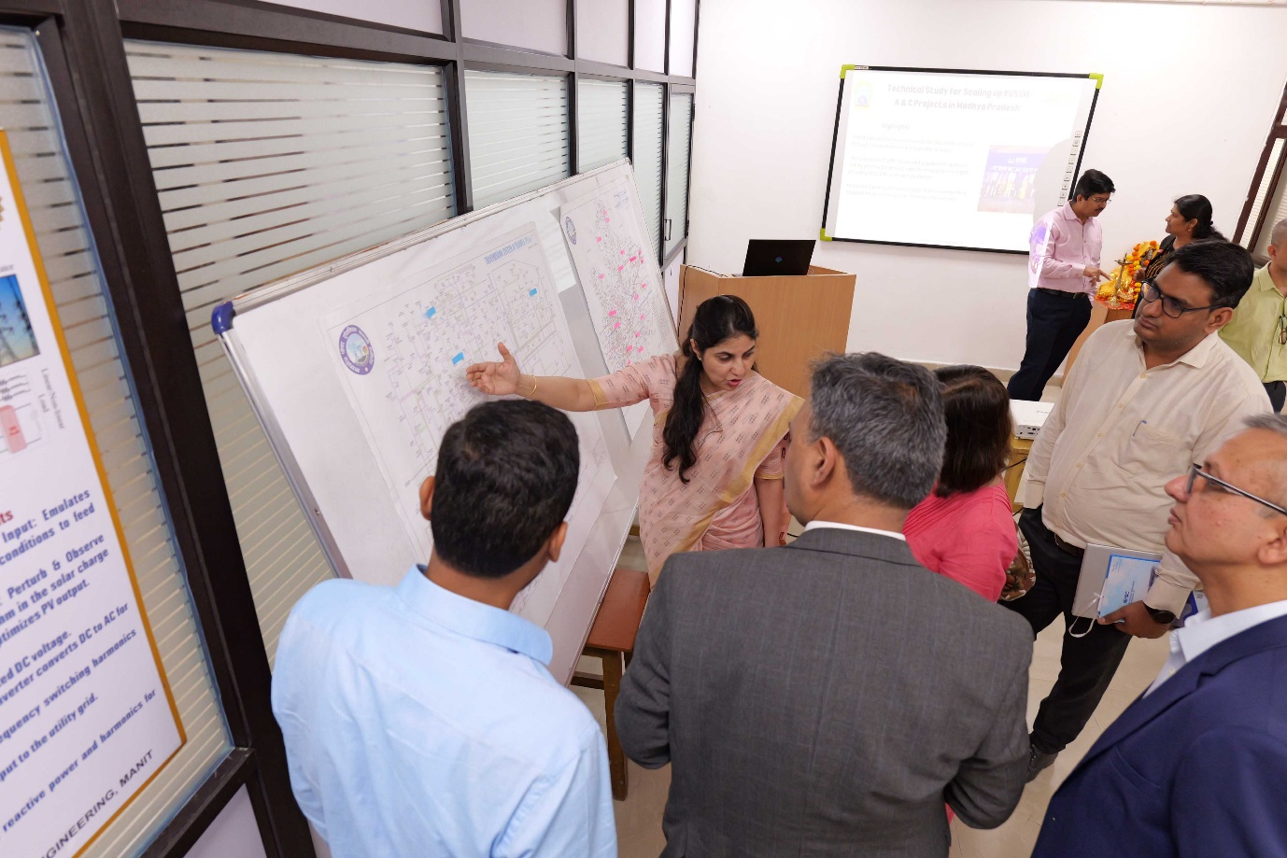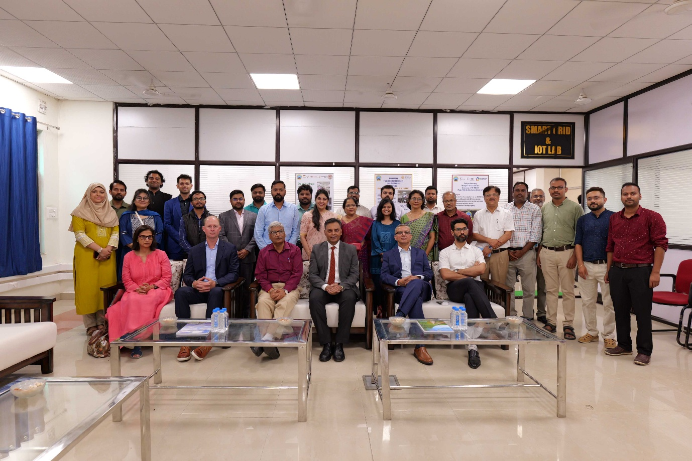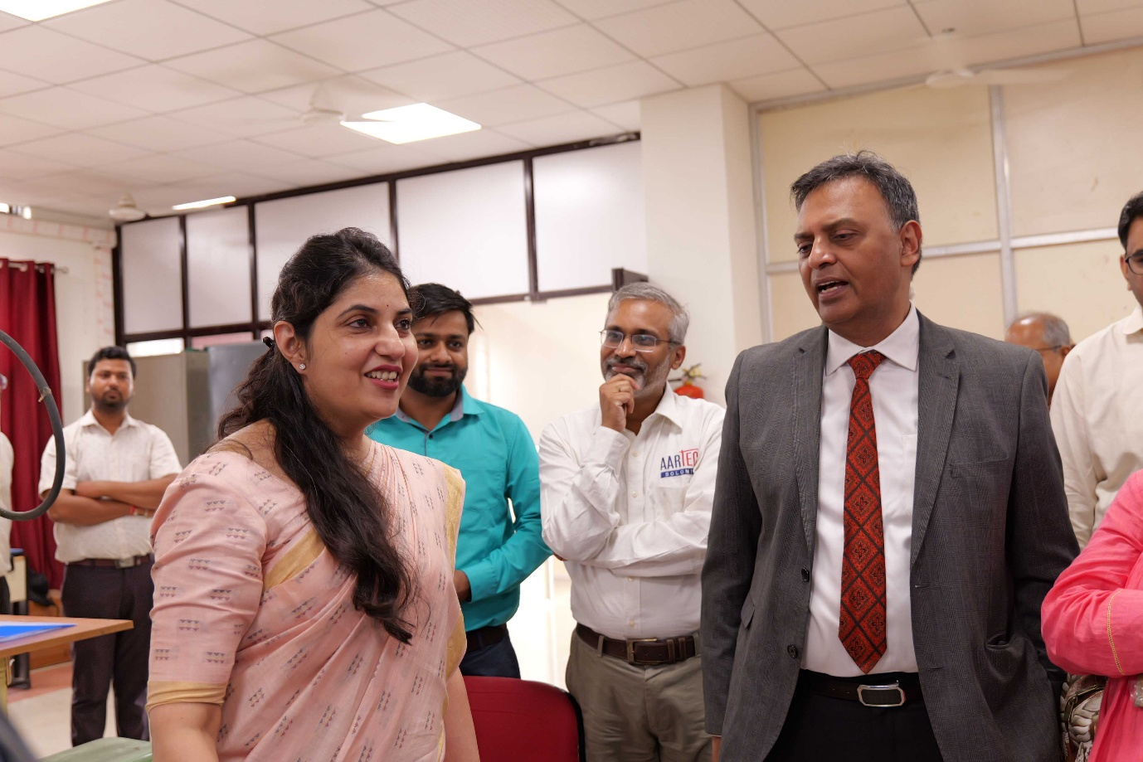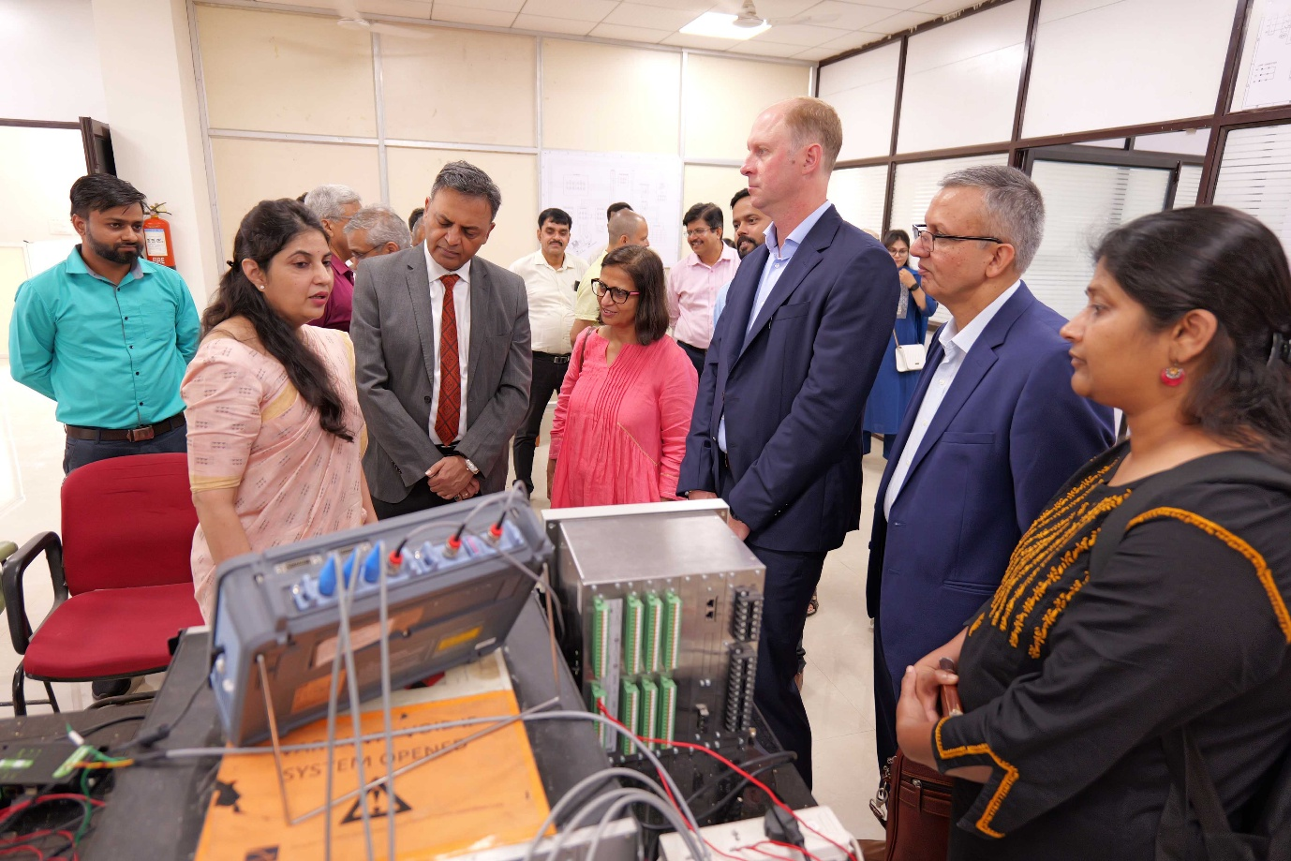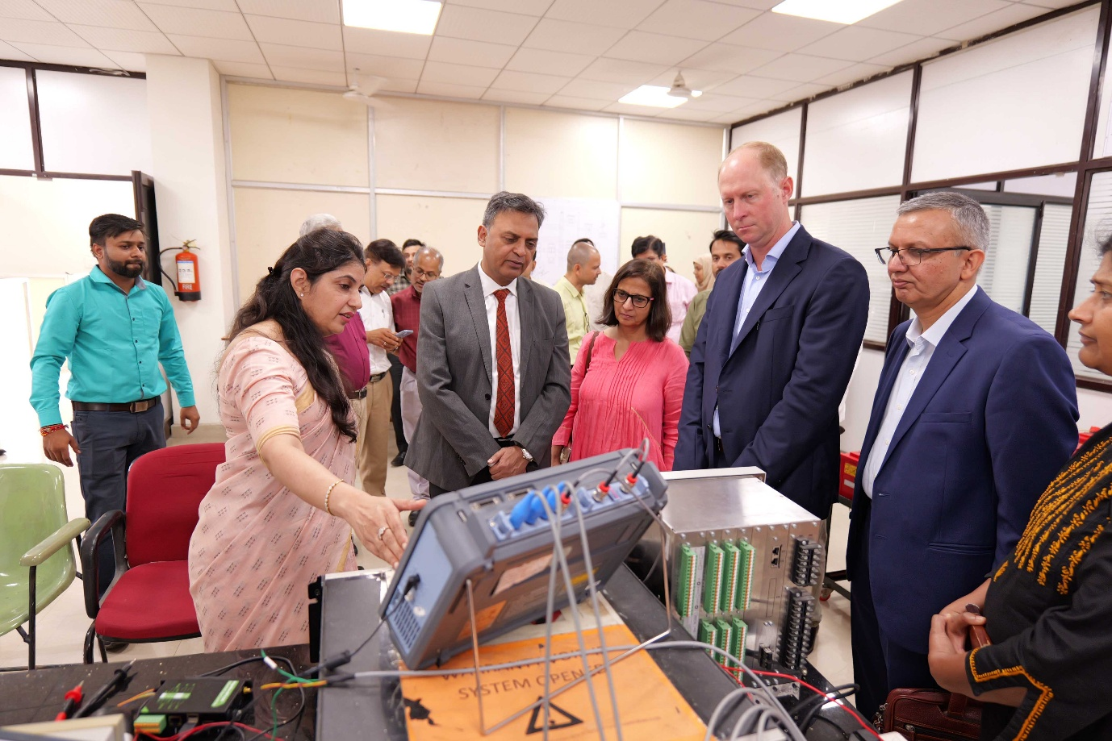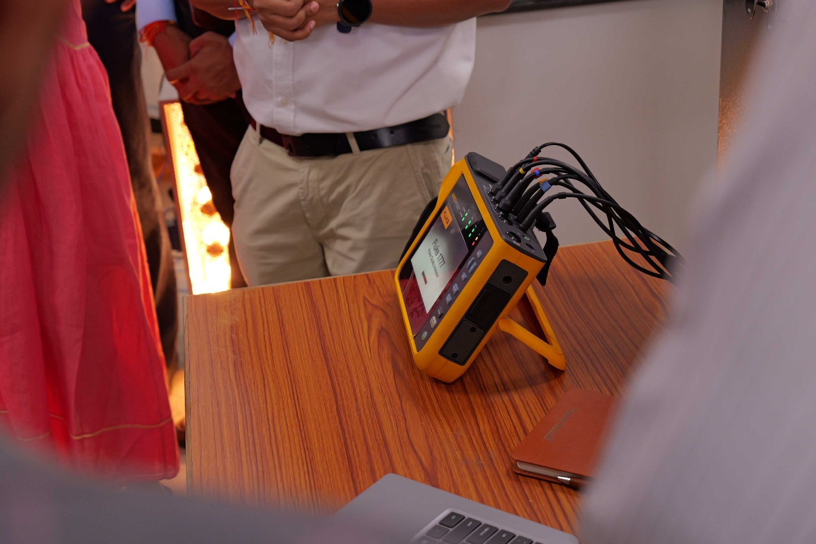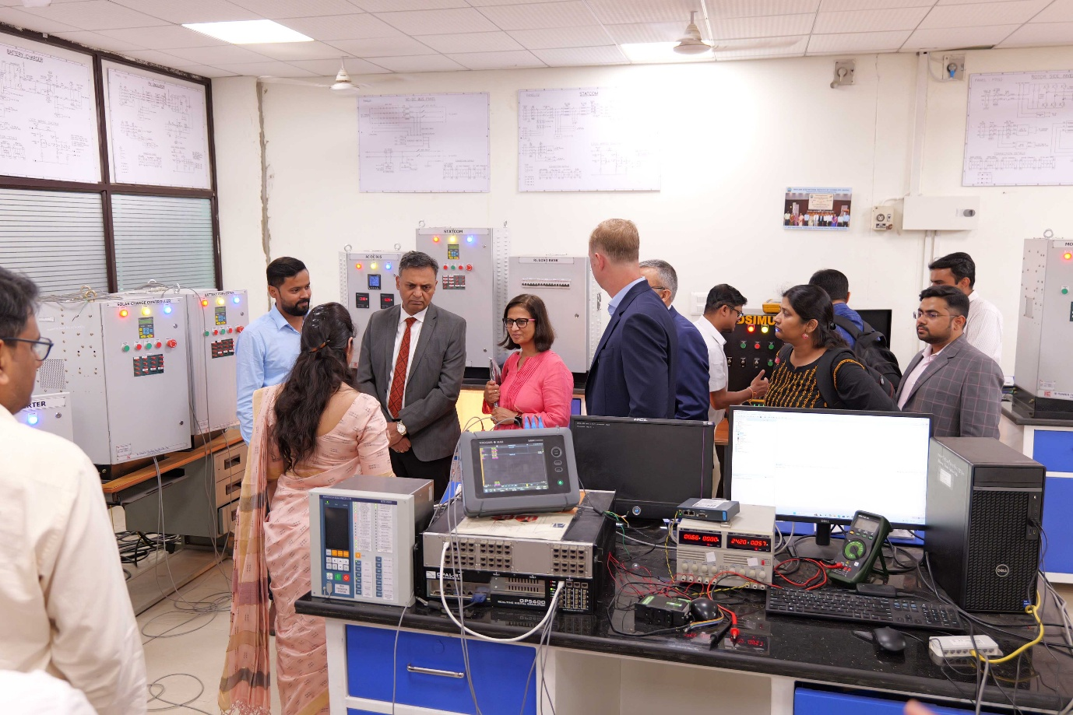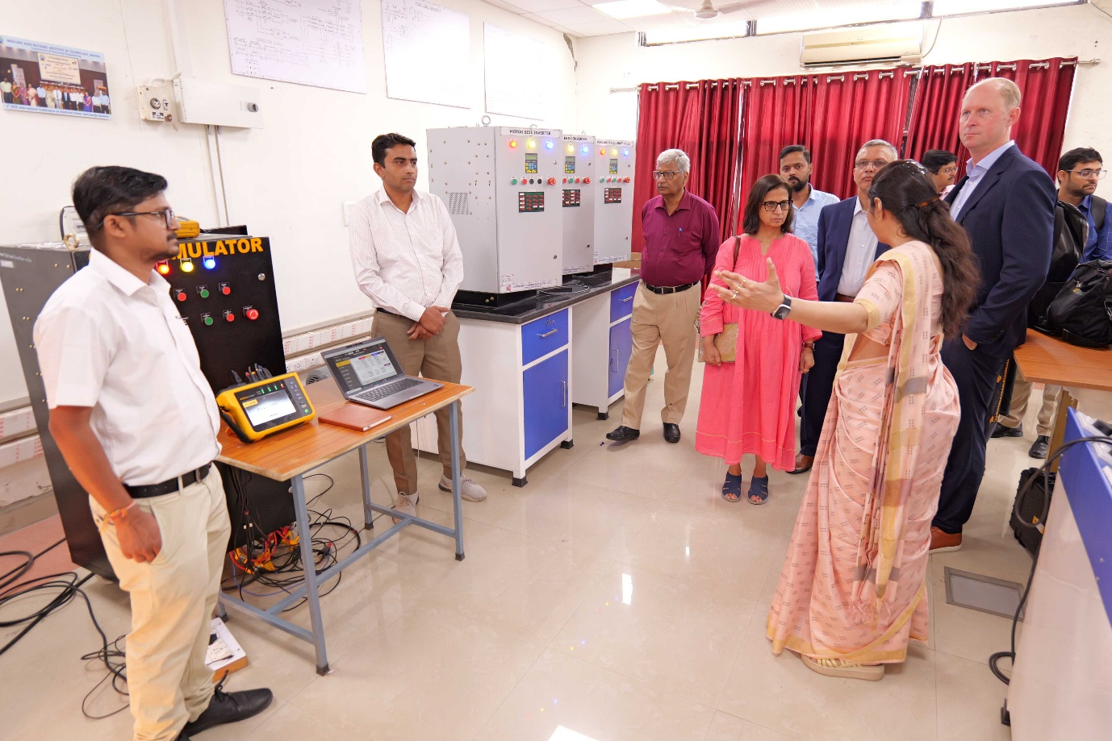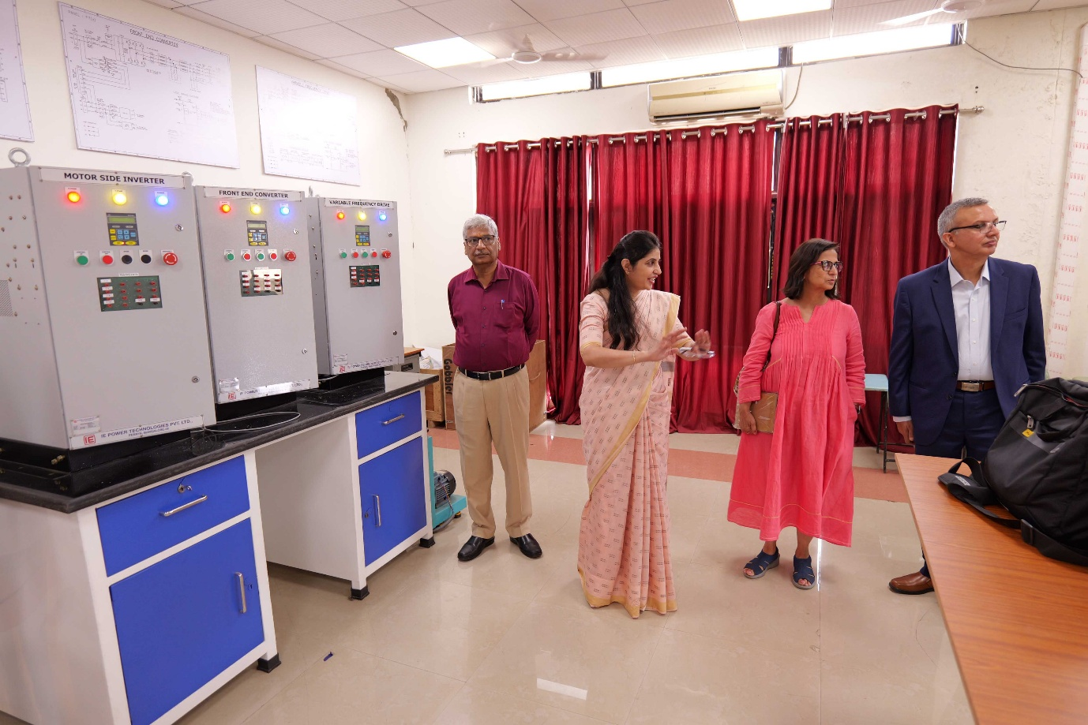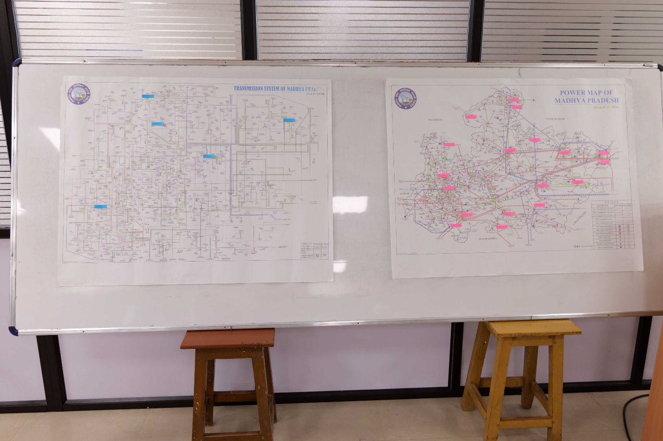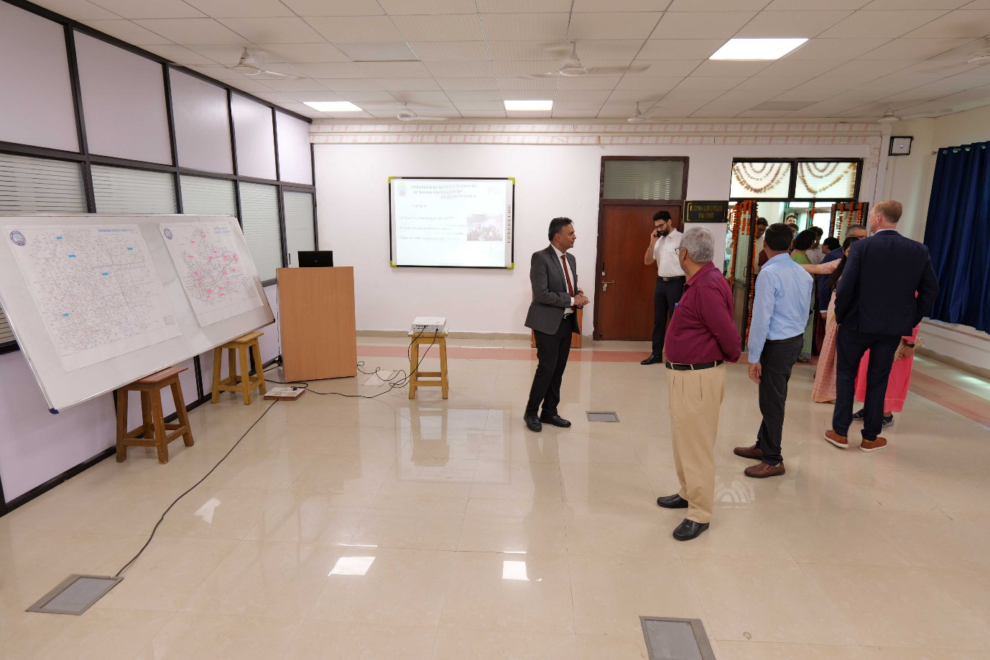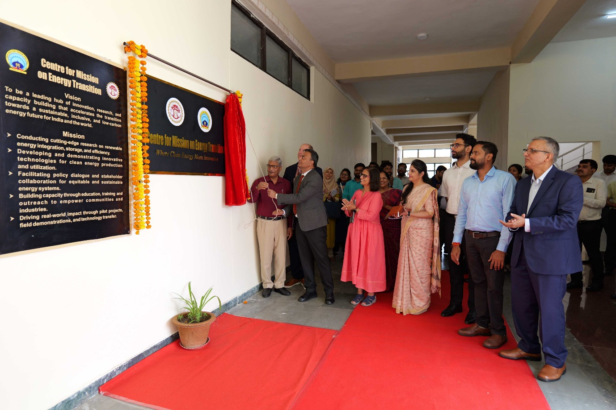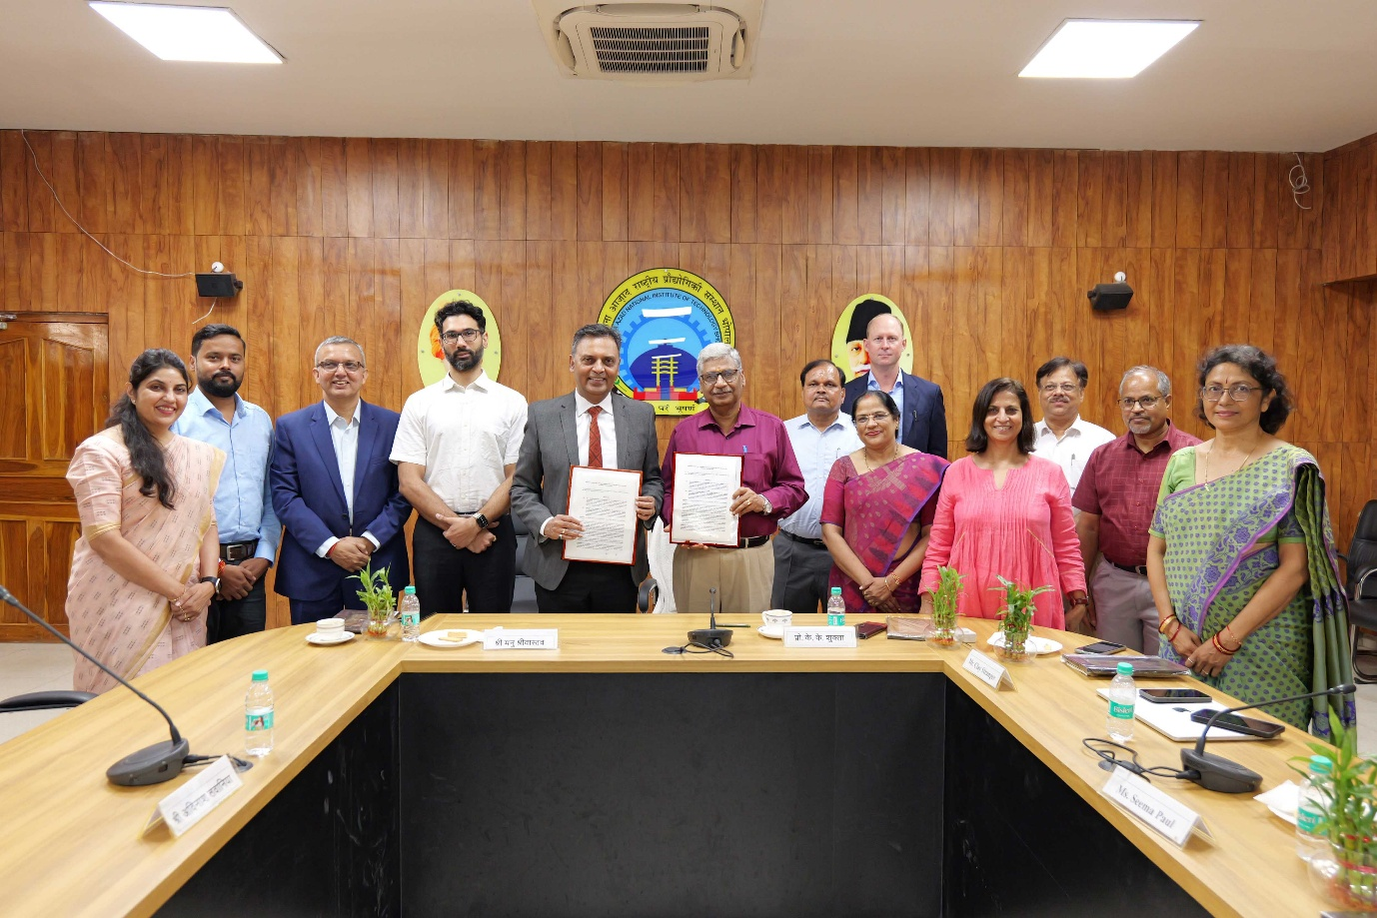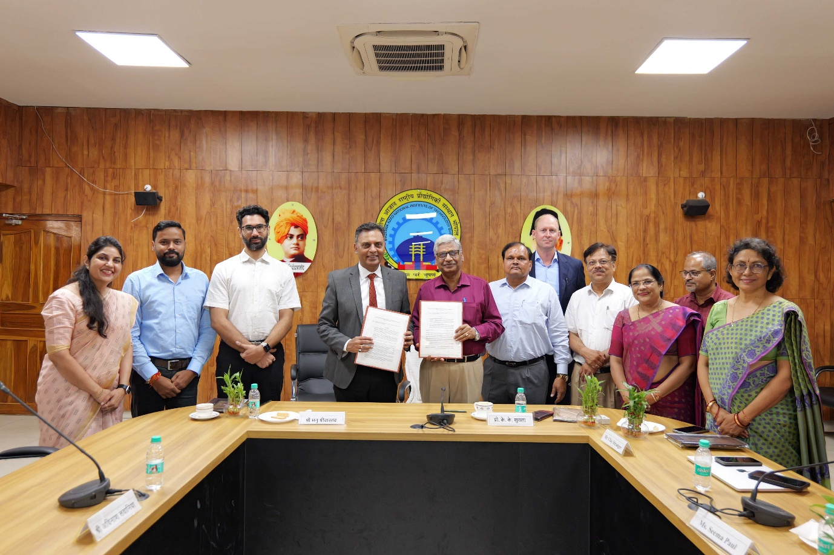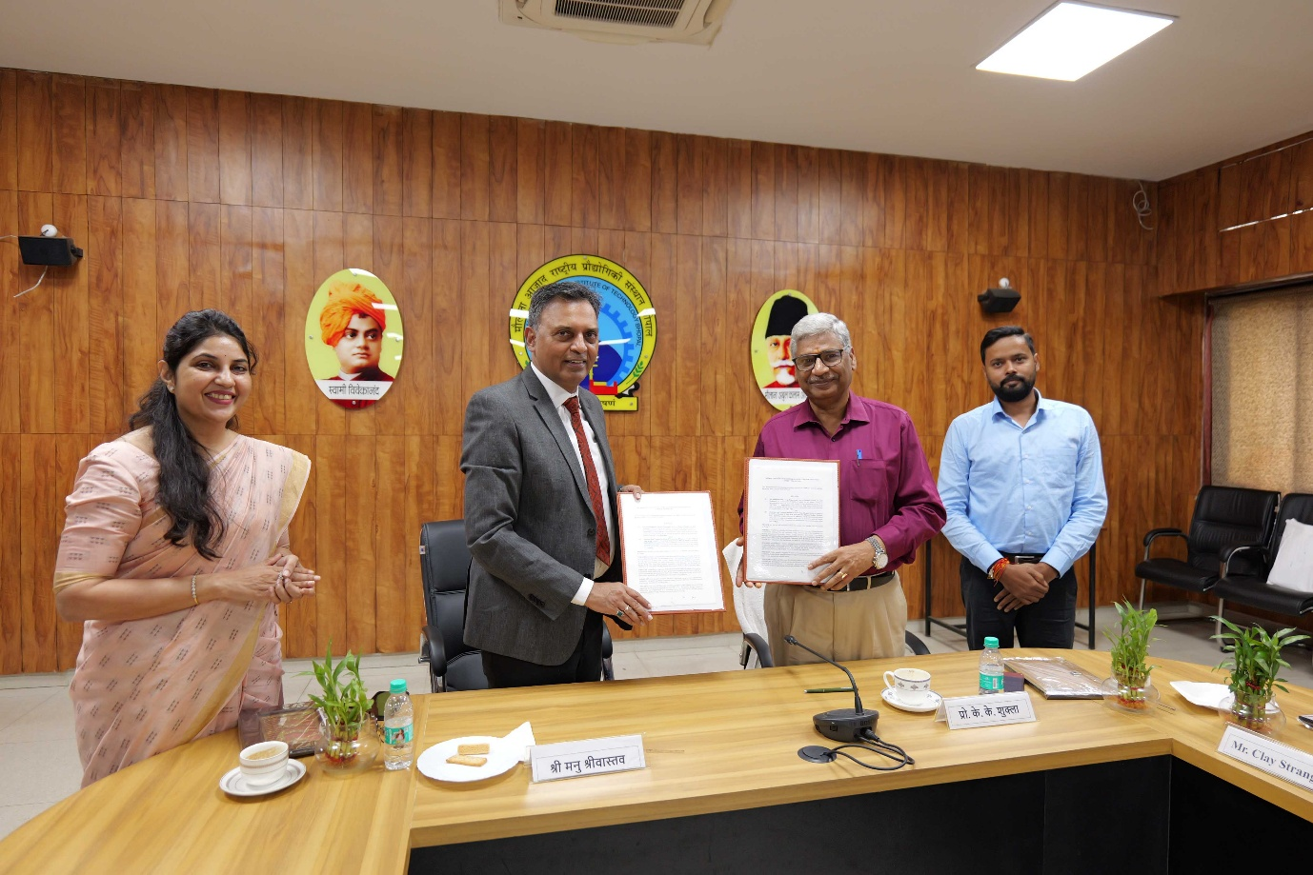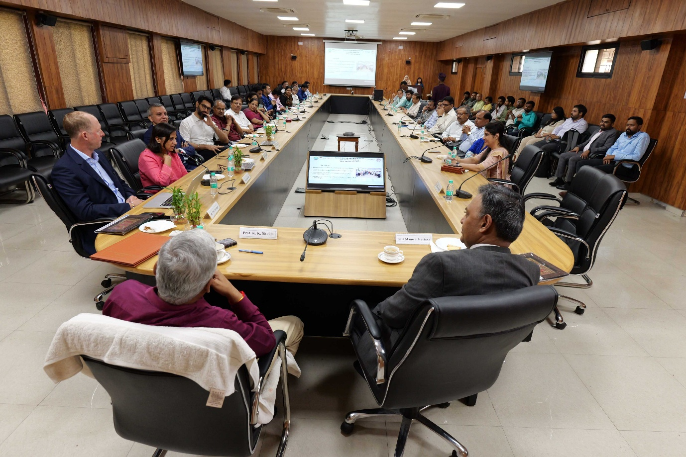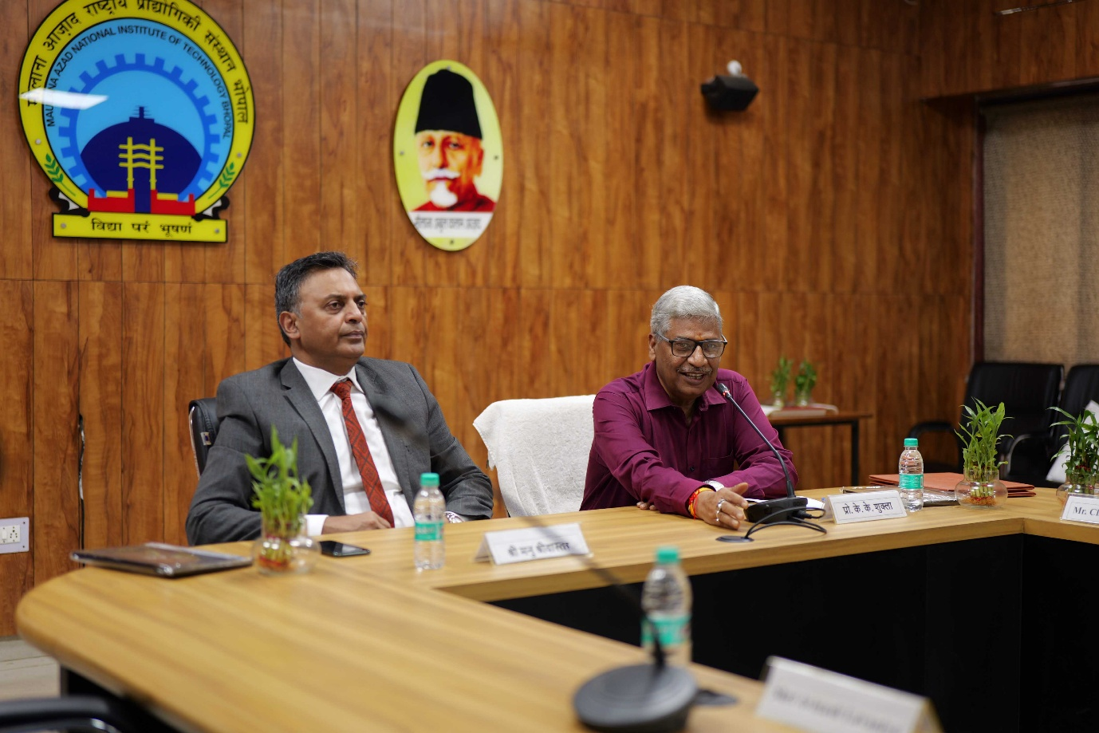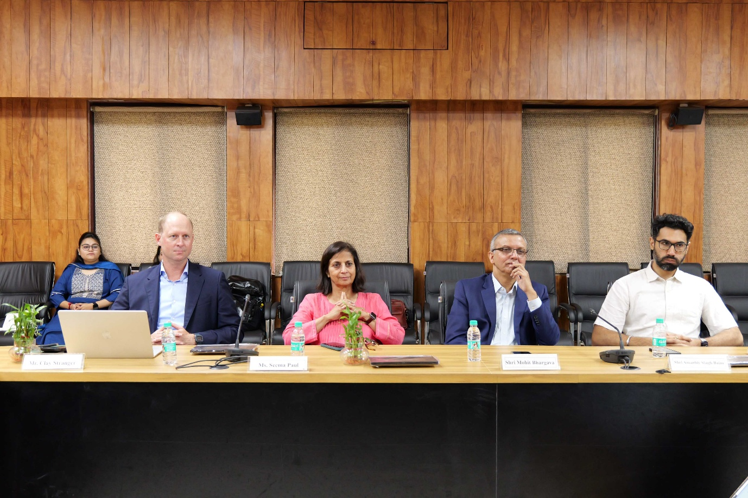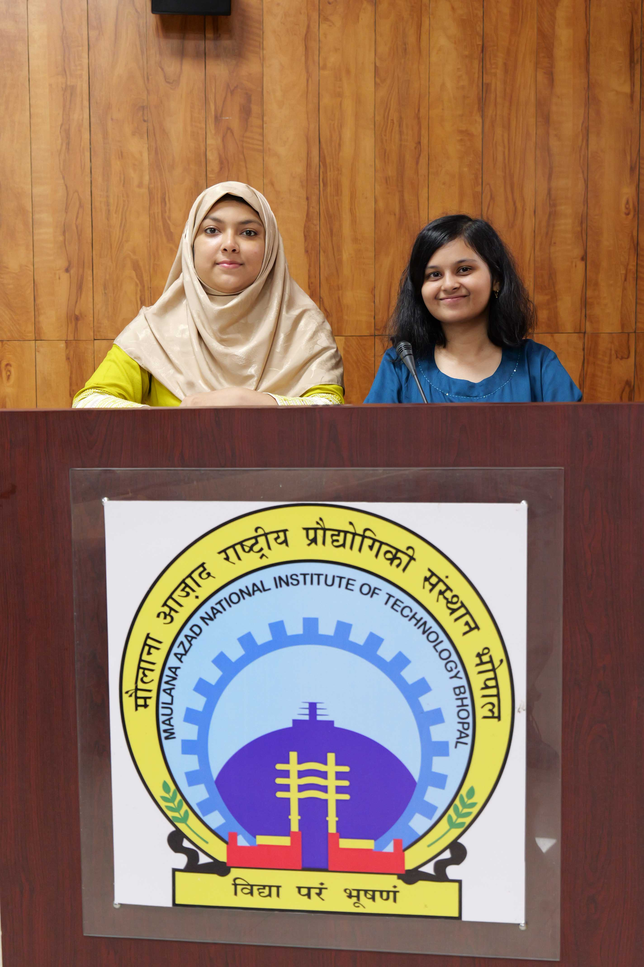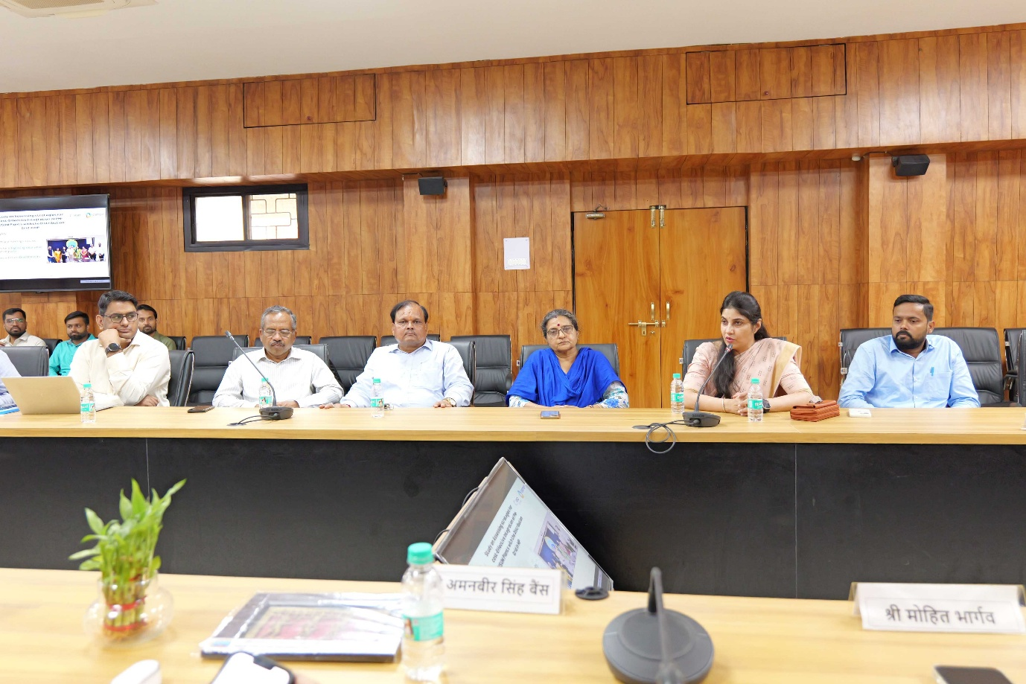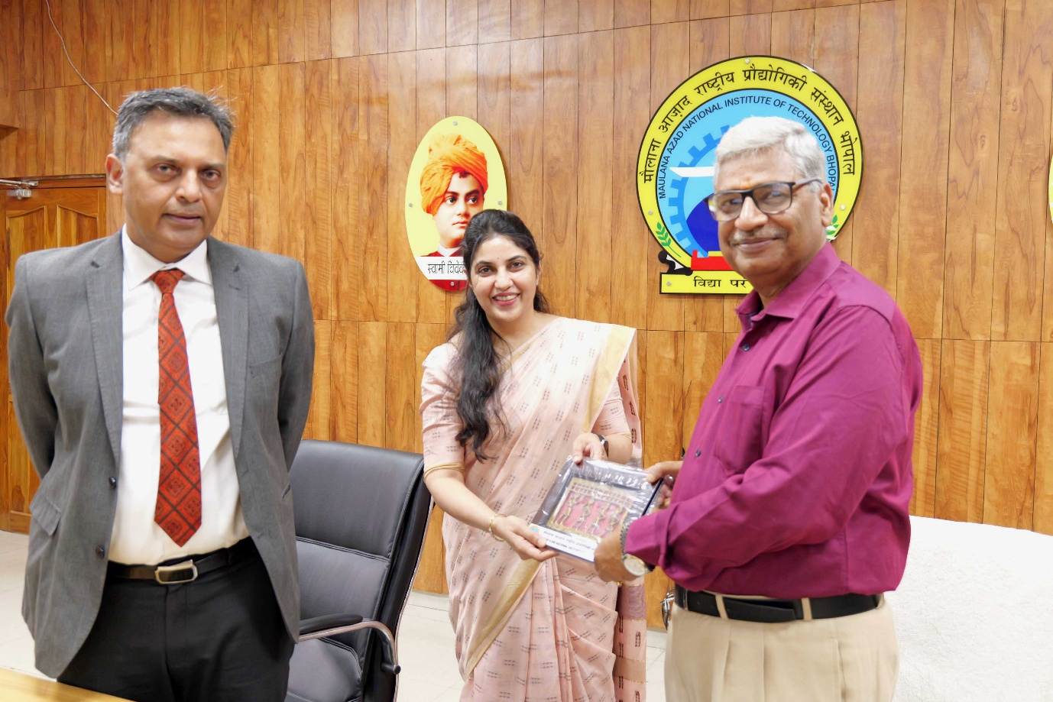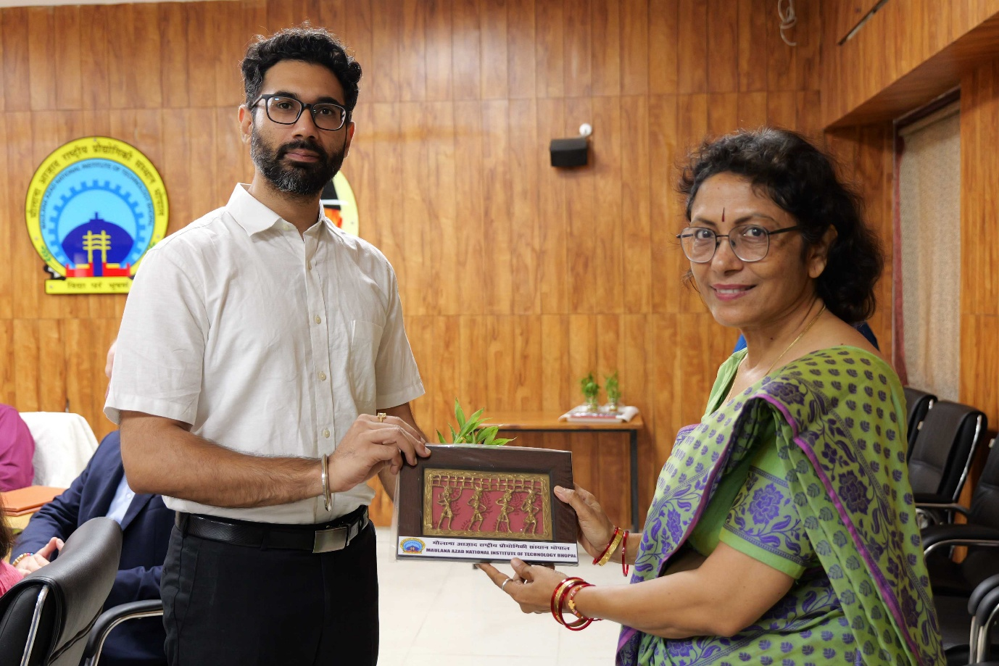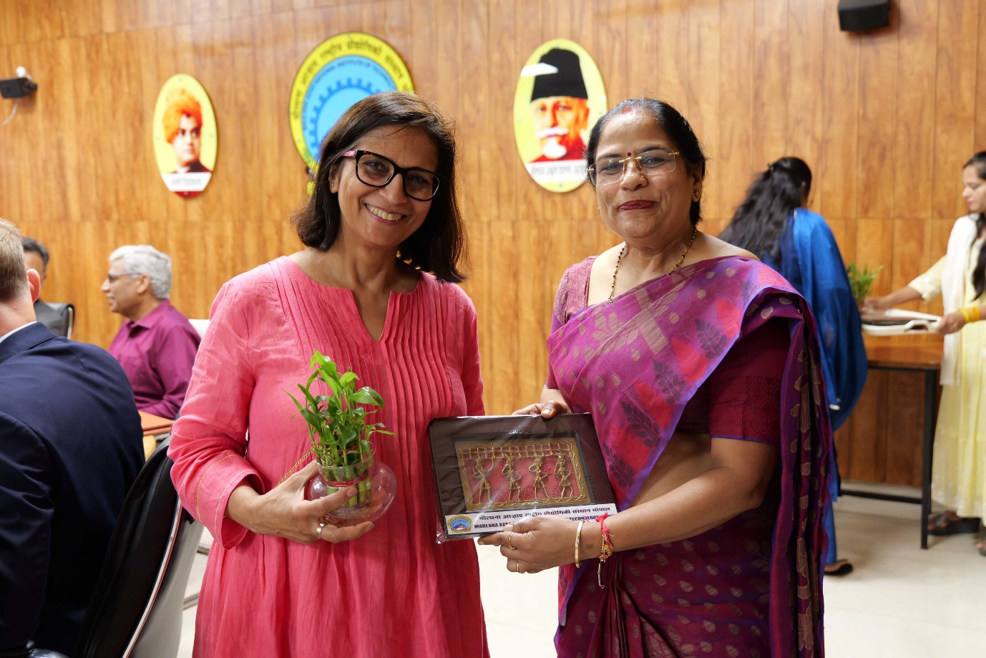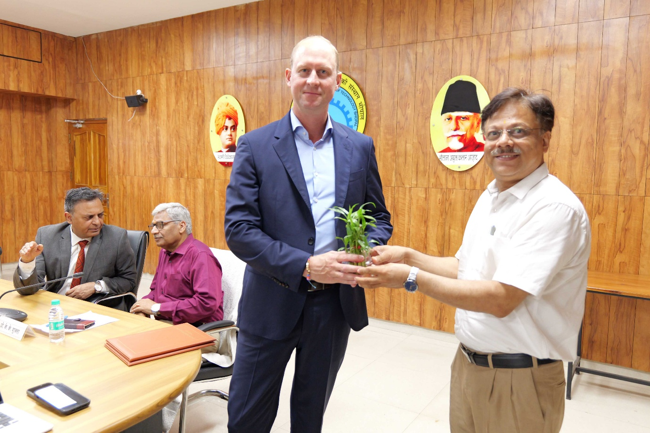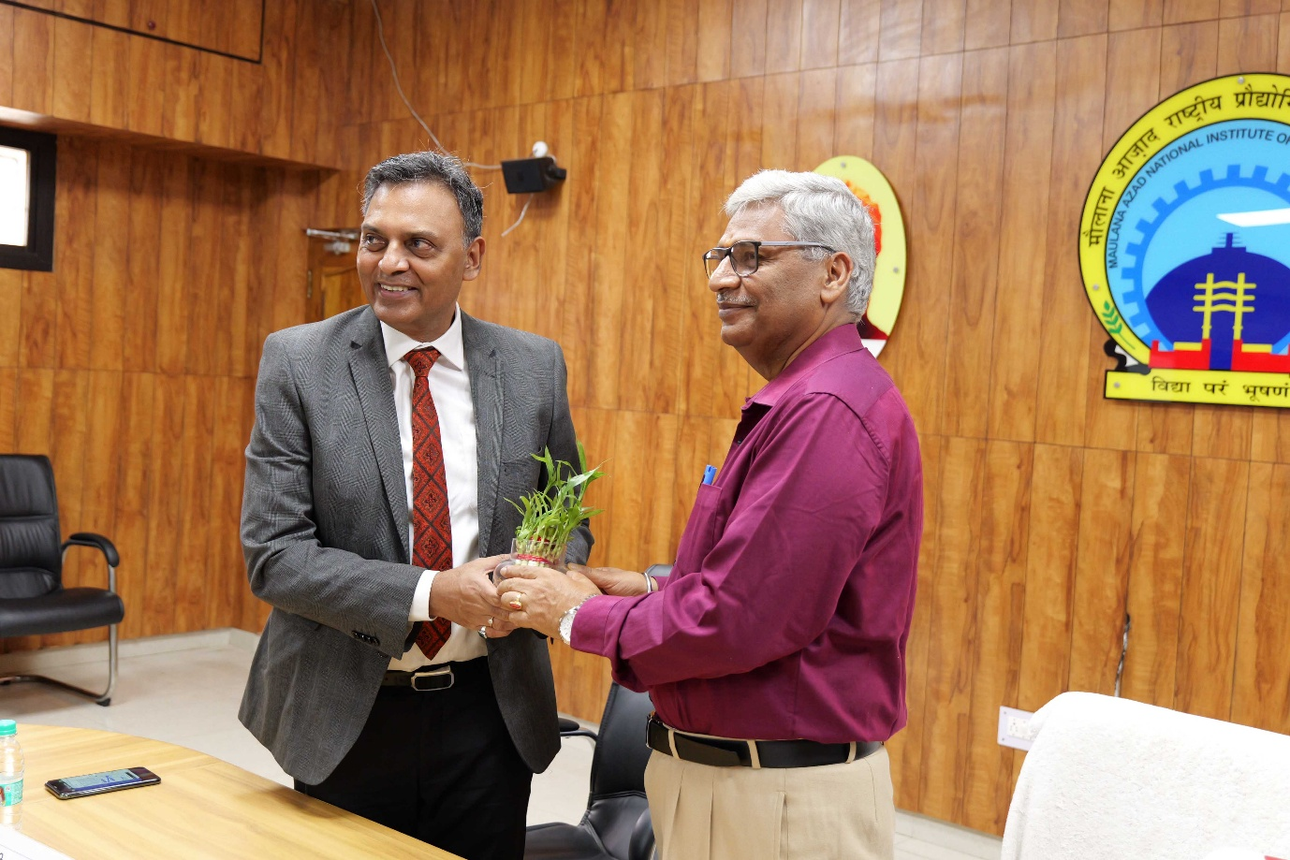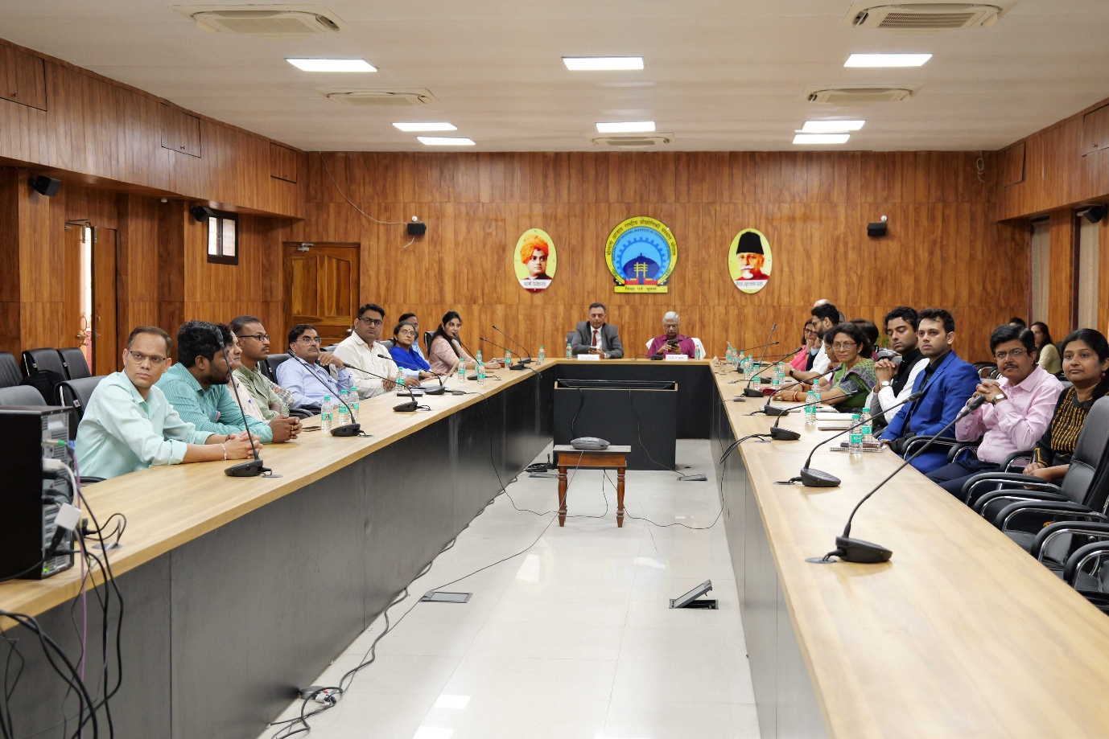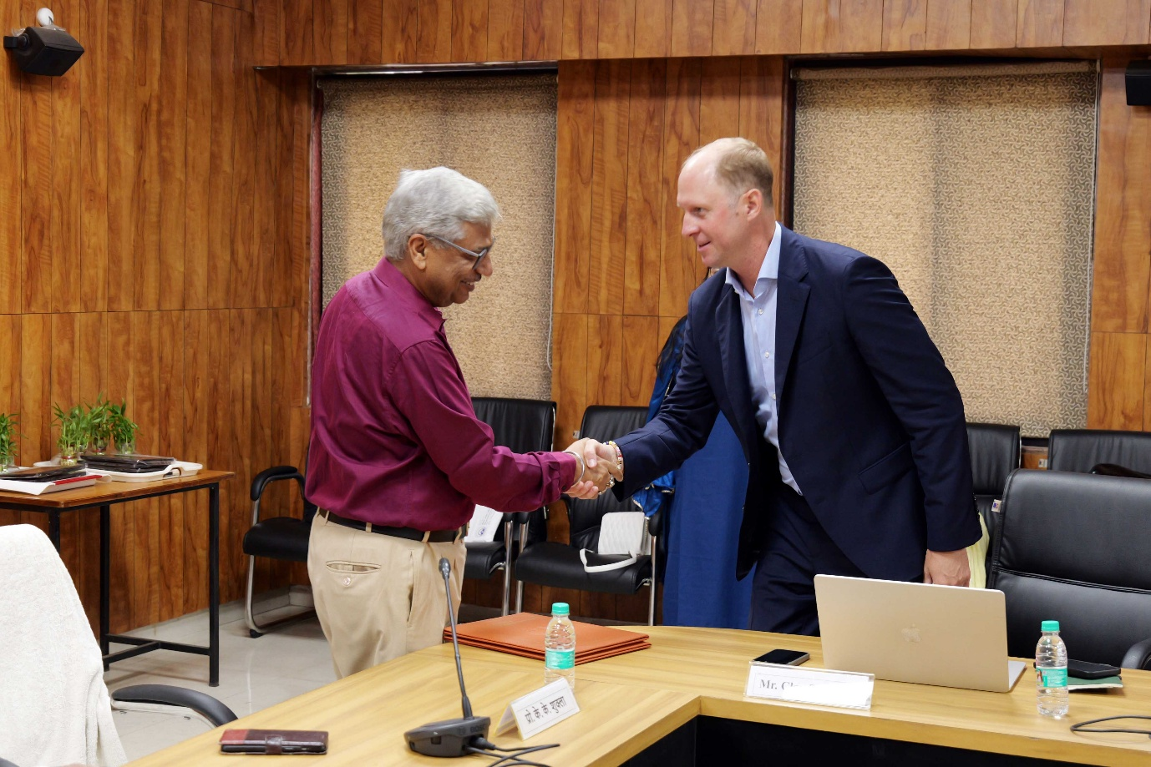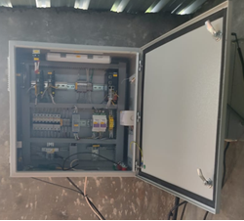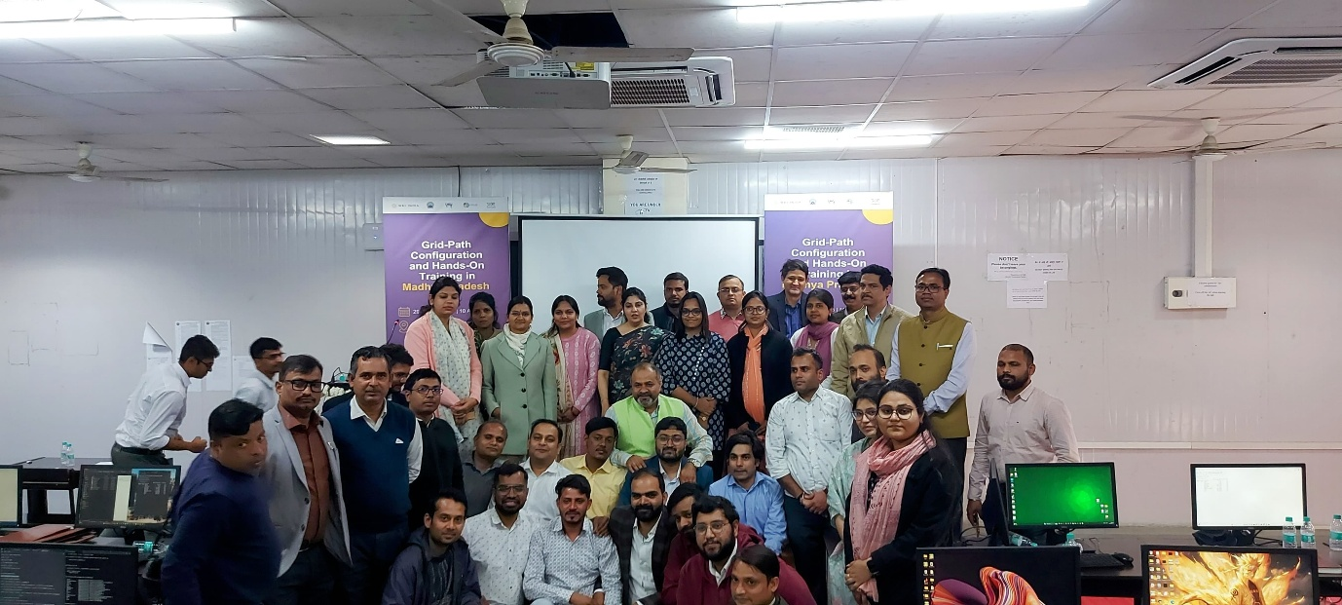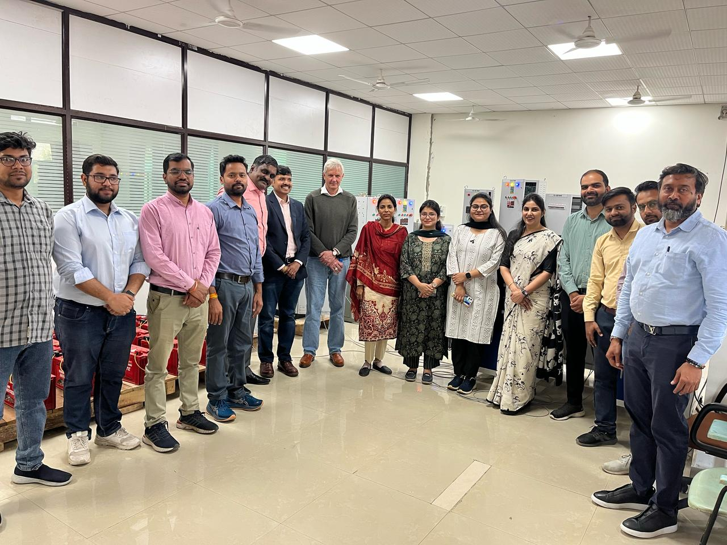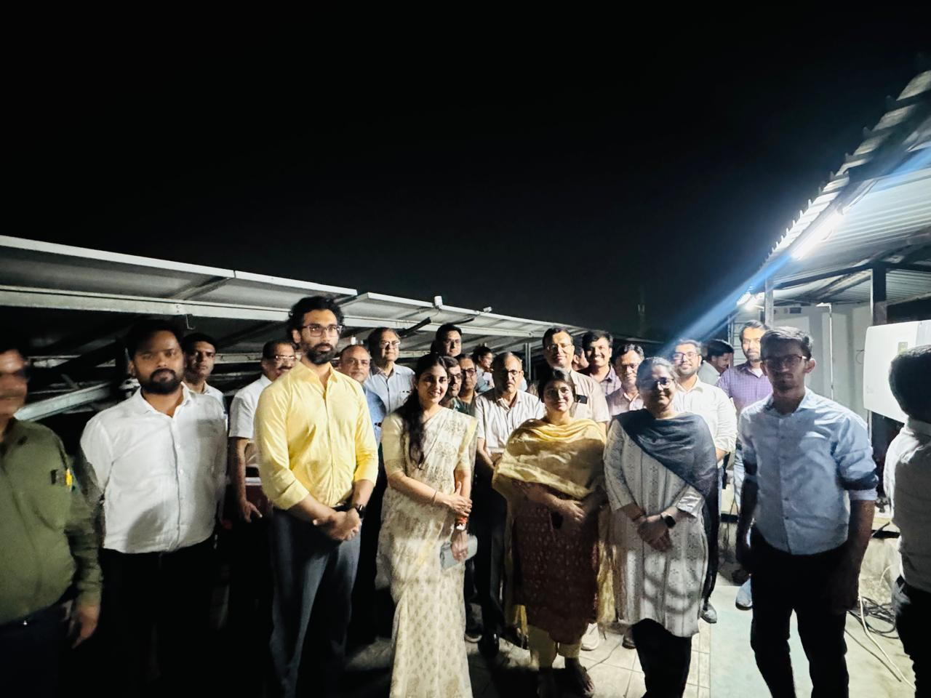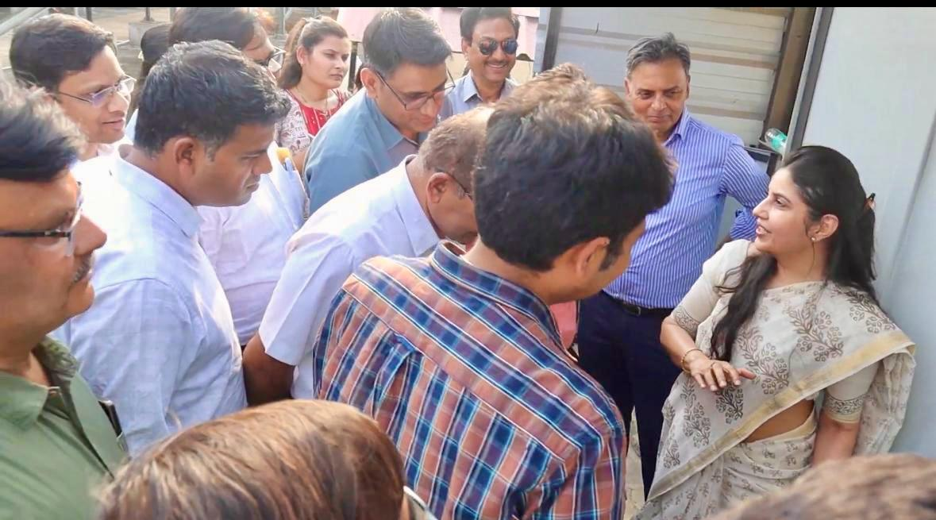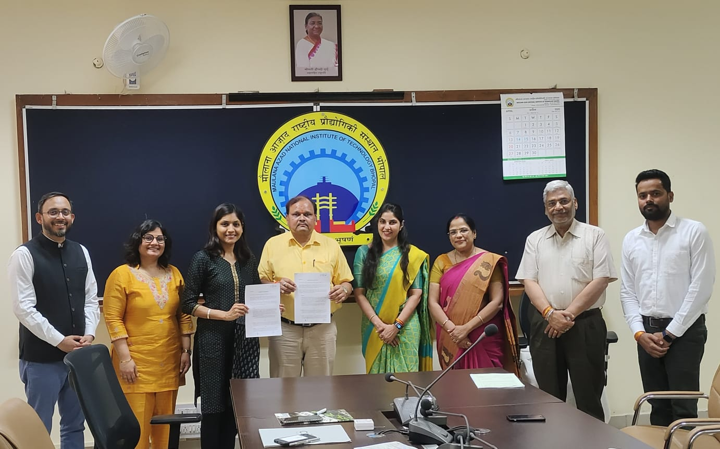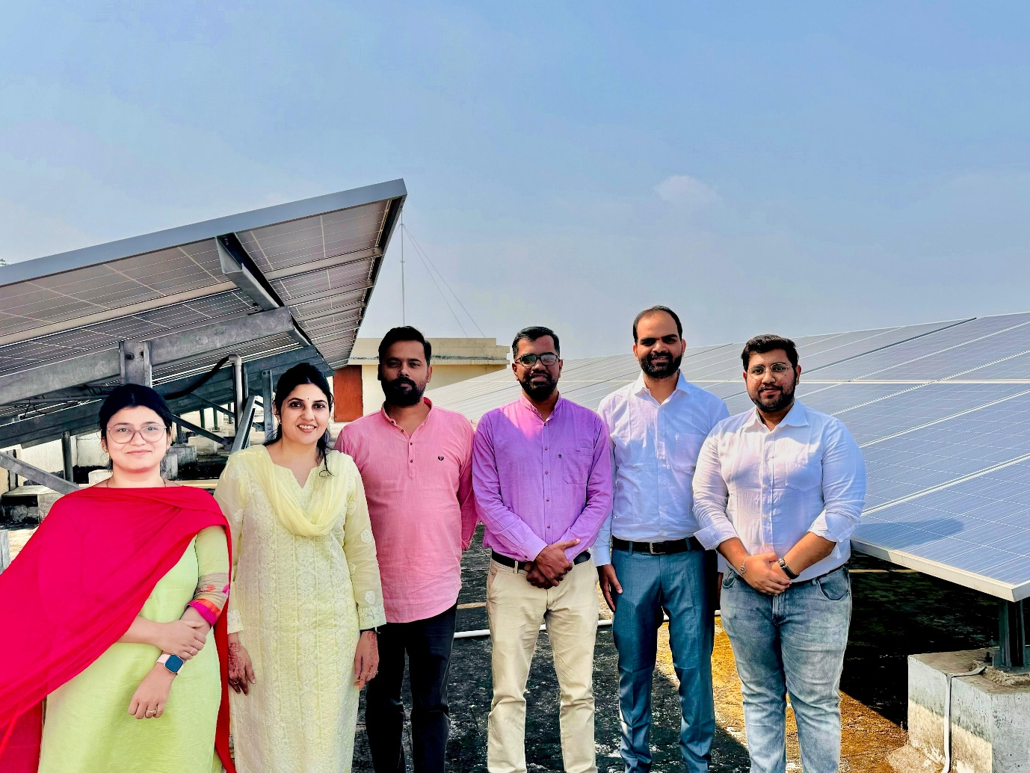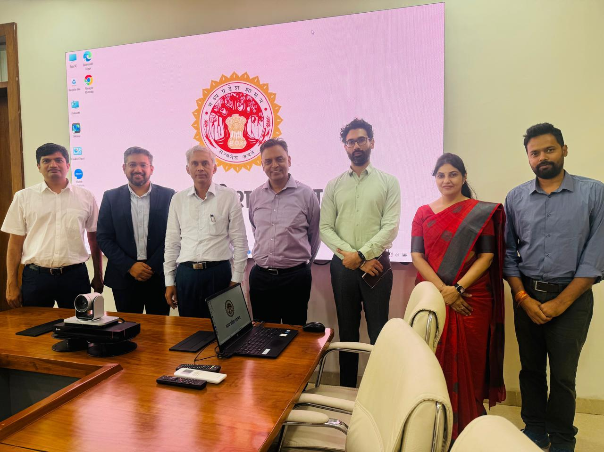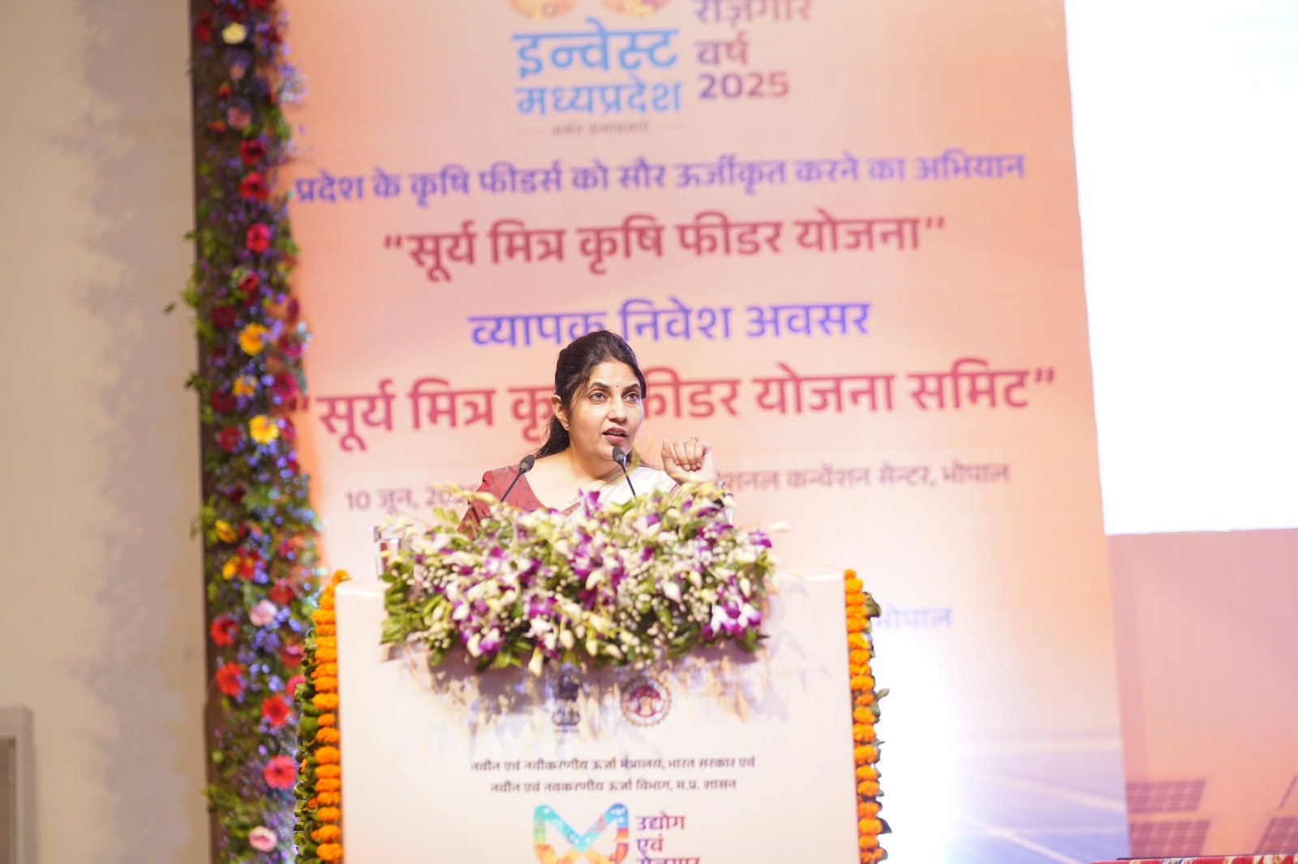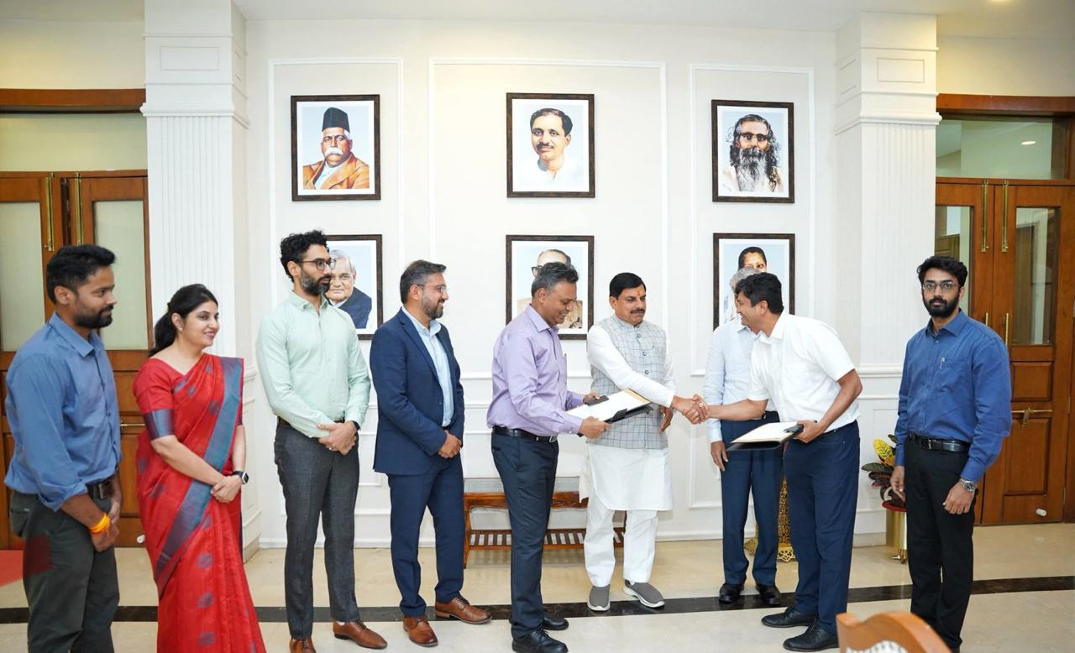
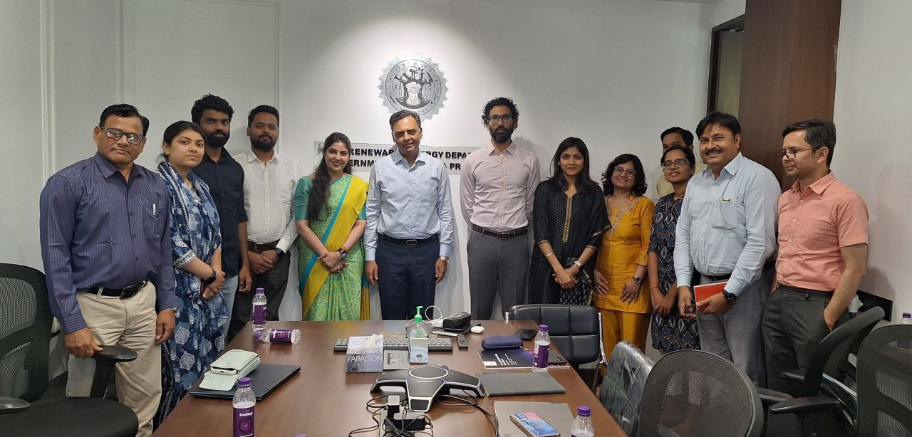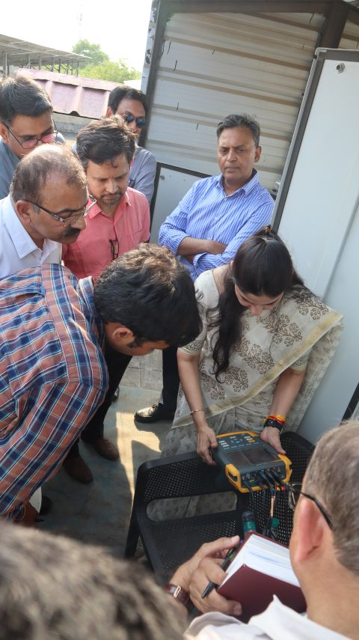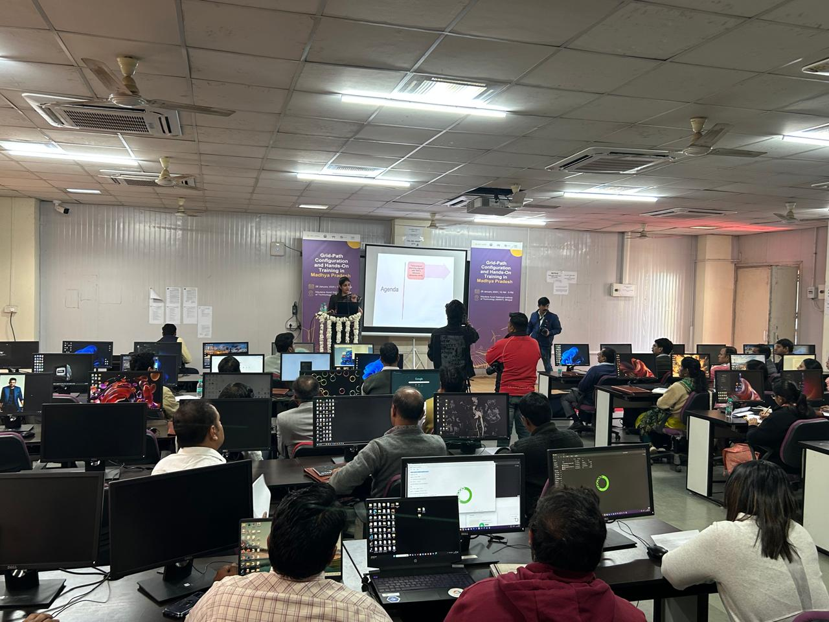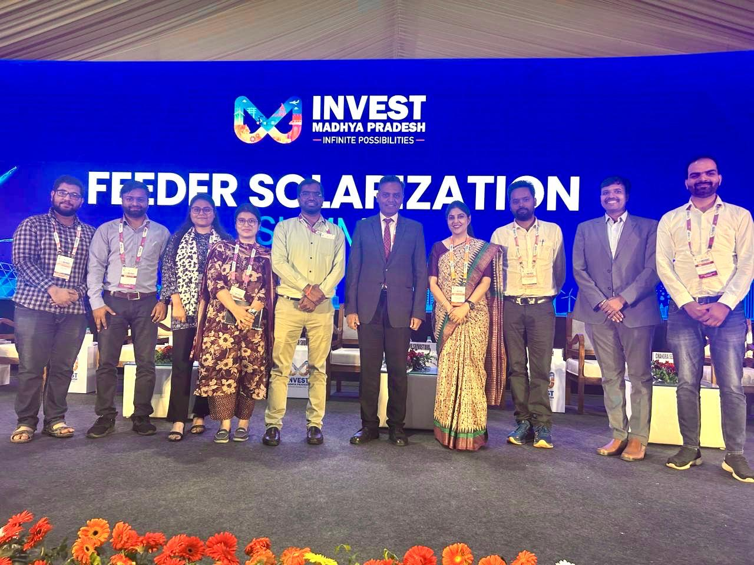
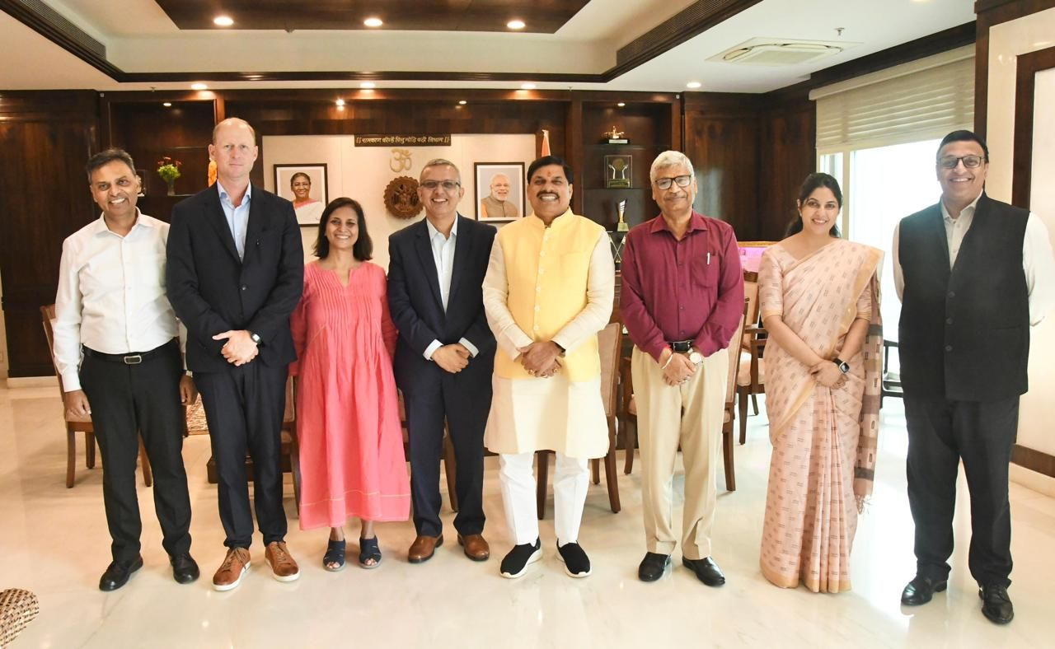

COLLABORATORS
- MPNRED
- UC Berkeley
- CPRI Bengaluru
- CEEW
- CSTEP
- RUMSL
- MPMKVVCL
- Smart Grid Analytics
- GIZ
- IISD
- MPCST
- WRI

9. CONTACT US
Location: Maulana Azad National Institute of Technology (MANIT), Bhopal
Address: Link Road No. 3, Near Kali Mata Mandir, Bhopal, Madhya Pradesh, India, 462003
Email: cmet@manit.ac.in

🔷 11. FOOTER
© CMET
MANIT Bhopal
cmet@manit.ac.in

🔷 13. NAVIGATION MENU
- Home
- About
- Vision & Mission
- Projects
- Focus Areas
- Labs
- Software
- Publications
- Team
- Collaborators
- Gallery
- Contact

🔷 END OF DOCUMENT

