**Final Project Option 2: Data Visualization Tool (with matching map)**

CEE 505 Engineering Computing

Prof. Peter Mackenzie

|  |  |
| --- | --- |
| Name | Student No. |
|  |  |
| Changming Feng | 1568037 |
|  |  |
| Hanzhen Yi | 1566086 |

12/15/2015

# Disclosure of work division

In general, each of us did the half of the whole project, and we expect the same grading for both of us. Detailed disclosure is shown as follows.

Changming Feng: button and event creation, method implementation of reverse direction, reset view, search all, and search shortest path, image plotting of flights and airports, image scaling.

Hanzhen Yi: creation and arrange of the panels, buttons, and sizers, method implementation of search shortest path, add and draw bitmap, image plotting of flights and airports, image scaling.

# Interface layout

* 1. Start interface

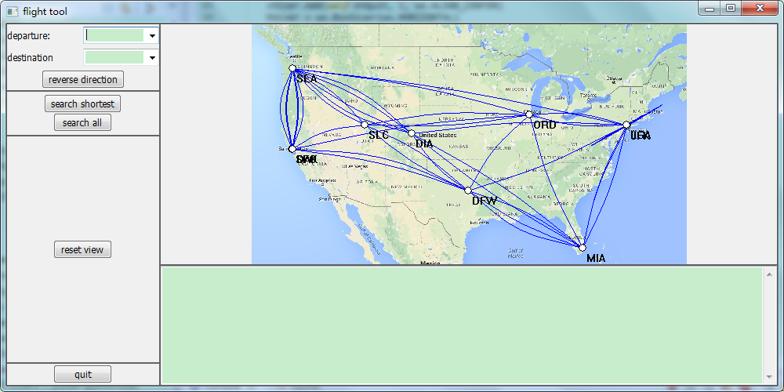

Panel5

btQuit

btSchA

btSchS

btRvs

cbDes

bbtSchA

tSchS

stDes

stDep

Panel4

Panel3

Panel2

l2

Panel1

tc

btRV

cbDep

btRvs

btSchS

Panel6

* 1. search shortest

The paths are listed in the text box and the corresponding paths are drawn in red line in the graph.

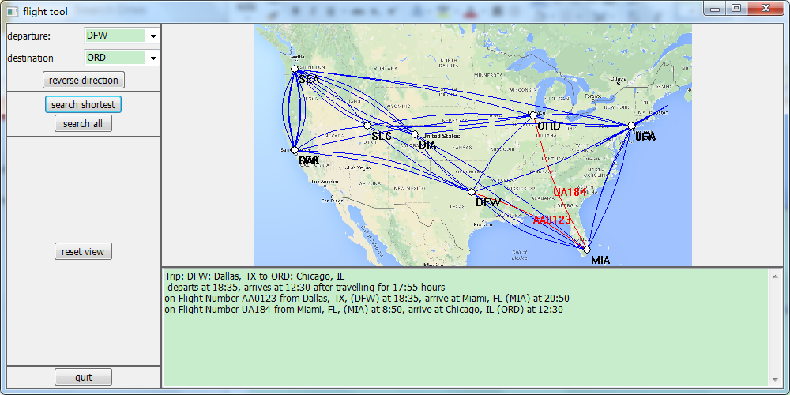

* 1. Any new selection on combobox or reverse direction will clear the text box and the red lines on the picture.

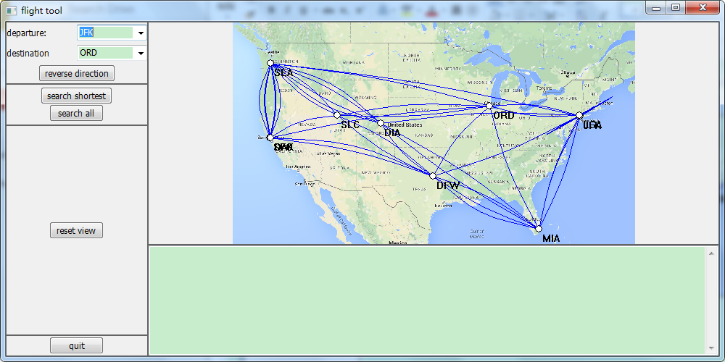

* 1. search all and reset view

Listed all the possible paths from departure to the destination in the text box. Reset view moves the window to the middle of the screen and half size of screen.

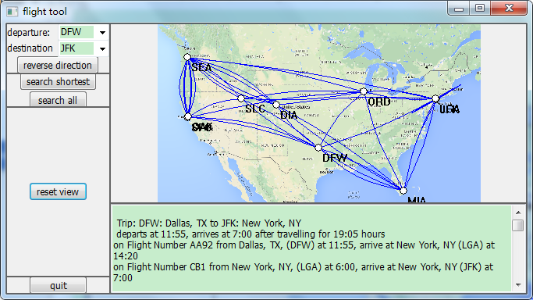

* 1. Scale

Change the size of the window, all the stuff will be redrawn and thus changing size won’t mess the window up.

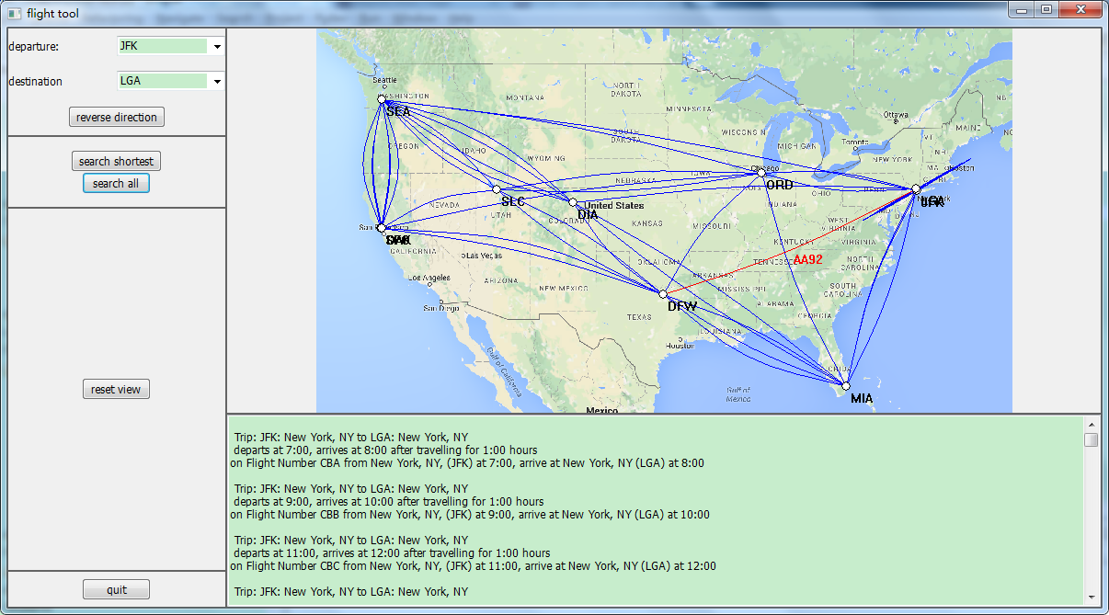

# Discussion on sizer and plot scaling

* 1. How sizers work

The frame consists of 6 panels, all the panels are arranged in two vertical sizer and one horizontal sizer, and each panel has its own sizer.

Panel 1, 2, 3 and 4 are arranged in the same vertical sizer first, with the vertical portion of 3,2,10 and 1, all expanded horizontally. Panel 5 and 6 are arranged in the second vertical sizer with vertical portion of 2 and 1, both expanded horizontally. Then the two vertical sizers are arranged in one horizontal sizer with portion of 1, 4 and both expanded vertically.

For panel 1, stuff are arranges in horizontally first, and then vertically. First line is the first horizontal sizer, arranging the statictext and the combobox one by one both aligning to the vertical center. For the second line, same thing happens to the destination statictext and combobox. The third line consists only a reverse direction button, which is in the third horizontal sizer. Then the three horizontal sizers representing the three lines in panel 1 are arranges in one vertical sizer, with each line the same portion in vertical direction.

For panel 2, the two button are arranged in a vertical sizer with same portion and both aligned to center horizontally. Then the sizer is arranged in a horizontal sizer.

For panel 3, the only reset view button is arranged by a vertical sizer then by a horizontal sizer, both aligned to the center.

For panel 4, the quit button is arranged the same way as the reset view button.

For panel 5, no sizer is used in the constructor since all the stuff in panel 5 is drawn by the onPaint function on the Bitmap.

For panel 6, the textCtrl is arranged by vertical sizer and then horizontal sizer, expanded to both direction.

3.2 plot scaling

When the size of the window changed, the locations of airports and flights need to be recalculated to fit the new scale. Main method to find the correct location related the panel would be discussed in section 5.

# Screenshots for routes SEA-MIA and MIA-SEA

* 1. SEA-MIA

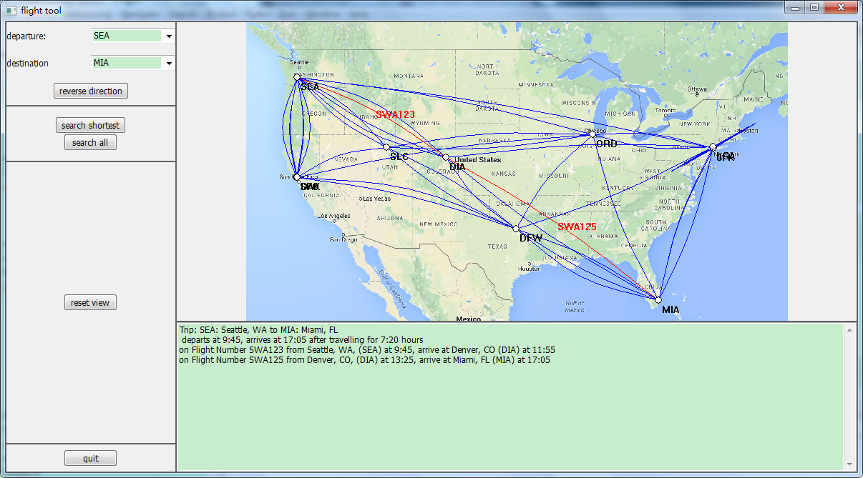

* 1. MIA-SEA

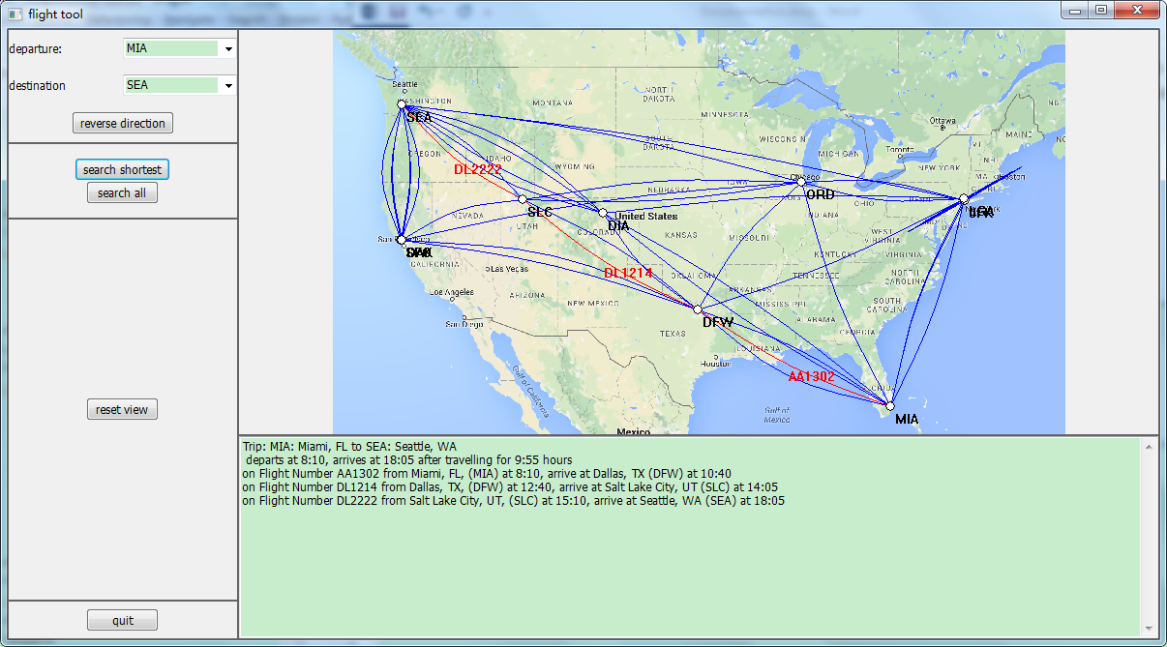

# Image scaling and matching of map and plot

* 1. Image scaling

Import the image first. Since we are drawing the image on panel 5, we need get size of panel 5. Set the left-up position of the image position as (0, 0).

If the length/height ratio of image is larger than that of panel 5, make the new image length same as length of panel 5, and the height changes correspondingly to keep the length/height ration of new image same as the original image. Meanwhile, change the height position to half of the difference between the panel height and new image height.

Else, do exactly the same changes to new image height as done to length above, and new image length same as height above. Change the length position the way height position changed above.

Now that we get the new length and height of the image, scale the image to the new height and length, and convert it to Bitmap to draw. Draw the bitmap at the new positon calculated above.

* 1. matching of map and plot

In this project, the matching of map and plot mainly lies in the matching of the points (airports, starting and ending points of flights and mid points of spines) and the map to the right location on the panel. The locating of maps have been discussed in earlier sections, so once these points are correctly located, the whole plotting would be put corrected on the panel and the matching of the map and the plots would be achieved.

* + 1. Airports, starting and ending point of fights

To locate these points, an auxiliary function that converts the geographic coordinates (longitude and latitude) to the screen coordinates (length and width to the starting point).

Noticing that the distance to the left-most point on the screen and on the earth (which is the radius of the earth times the difference of the longitude of the point the left-most point) has a proportional relation, and so does the distance to the up-most point on the screen and on the earth. So the location of a point on the panel given its longitude and latitude would be:

Convert(long, lat)

longLeft, longRight = the longitude of the left-most and right-most point of the map

latUp, latDown = the latitude of the up-most and down-most point of the map

lenMapScreen = length of the map on screen

widMapScreen = width of the map on screen

mapPosX = x position of map on the screen

mapPosY = y position of map on the screen

length = (long – longLeft)/(longRight-longLeft)*lenMapScreen

width = (lat-latUp)/(latDown-latUp)*widMapScreen

return (mapPosX + length, mapPoxY + width)

* + 1. mid-point of the spine

The mid-point of the spine defines the shape of the spine. To ensure that, the distance of the mid-point should be proportional to the screen size. This can be achieved by:

Mid-point(startX, startY, endX, endY)

panelLen = length of panel

midX = (startX + endX)/2

midY = (startY + endY)/2

// direction

deltaX = -(endY-startY)

deltaY = endX – startX

// scaling

deltaX = deltaX/(deltaX**2+deltaY**2)/panelLen

deltaY = deltaY/(deltaX**2+deltaY**2)/panelLen

return (midX+deltaX, midY+deltaY)

# Acknowledgement

In this course, we have learnt much knowledge in python as well as database. We have encountered with many problems through this quarter, both in classes and in homework. Thanks to Professor Mackenzie, who is so patient in helping us and has helped us figure out every single problem. We really appreciate your kindness and all the favors you have done us.