1. **Problem Statement:**

Simple Graphic User Interface (GUI) searching the shortest path from one chosen airport to another, using the database established in the midterm project.

1. **Algorithm**

I used no panel in the program and I arrange all the objects in the window in several sizers. For each horizontal line, create a horizontal sizer for the objects in the same line. Then arrange all the horizontal sizers in one vertical sizer.

To make sure a new selection of either airport erases the text field, I created two events that correspond to new selections of the two combobox. Then implement the function of onClear to both the events, which clears the textbox.

1. **Screenshots**
   1. The starting view of the program. When executing the program, the window shows up with no selection in both comobox and a clear text field.

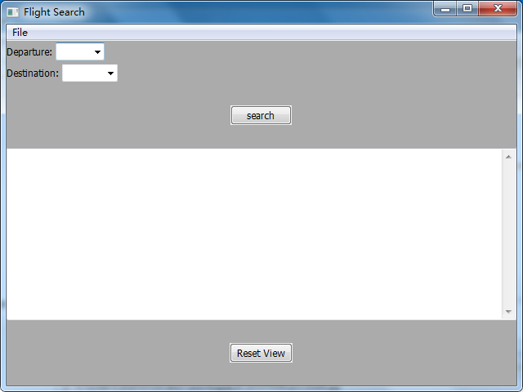

* 1. Selecting the airport. Click the arrow on the combobox and the drop-down list shows where a selection can be made.

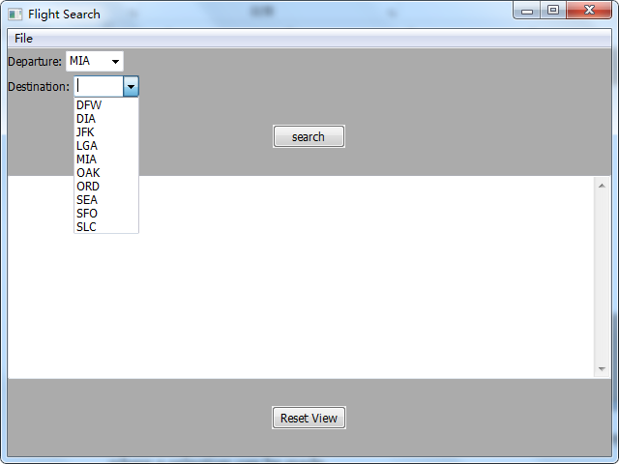

* 1. Search result shown in the text field. The result includes the departure airport, destination, the departure time, arrival time, total travel time, and the flights taken in the path.

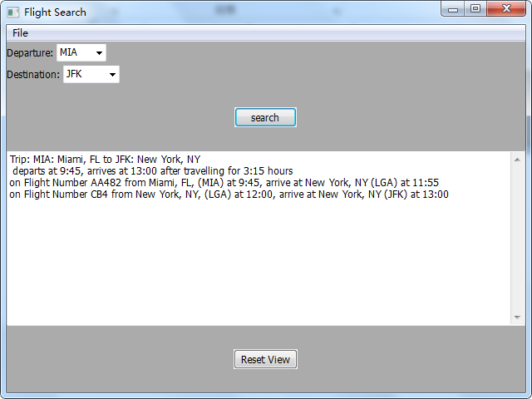

* 1. When the departure matches the destination, an error message shows up in the text field.

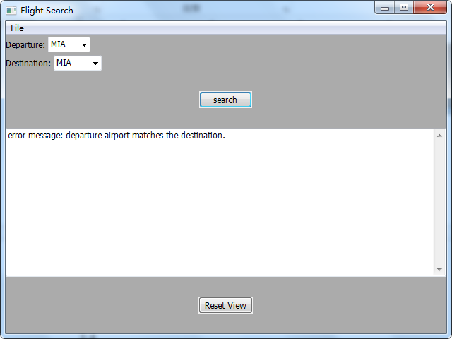

* 1. After a flight search, either a new selection on the departure or destination erases the text field.

