[FILL: Title of the paper]
  - [FILL: Subtitle of the paper]
[FILL: Author One]
[FILL: Author Two]
2026-02-27
Abstract
[FILL: Write your abstract here. Summarize the research question, methods, key findings, and implications.]

Introduction
Regional economic disparities remain a central concern in development economics. Understanding the relationship between GDP per capita and life expectancy across regions is critical for designing effective policy interventions.
This paper uses a novel synthetic dataset to examine these patterns, employing both parametric and non-parametric methods (Keola, Andersson, and Hall 2015).
Our results suggest a strong positive correlation between economic output and health outcomes, with significant heterogeneity across geographic clusters.
This study contributes to the literature in two ways. First, we provide a multi-language reproducible workflow. Second, we demonstrate how modern tools can enhance transparency in empirical research.
The rest of this article is organized as follows. Section 2 provides an overview of the related literature. Section 3 introduces the data and methods. Section 4 presents the results and discussion. Finally, Section 5 offers some concluding remarks.

Related literature
The relationship between income and health has been extensively studied since the seminal work of Keola, Andersson, and Hall (2015). Recent advances in spatial econometrics have enabled more nuanced analyses of regional disparities.

Data and methods
[FILL: Describe the data sources, variables, and sample.]
[FILL: Explain the analytical methods and models used.]

Data
[FILL: Describe the dataset. Include sources, time period, and key variables.]
The following figure, generated in N1: Sample Data Exploration, provides an overview of the data.
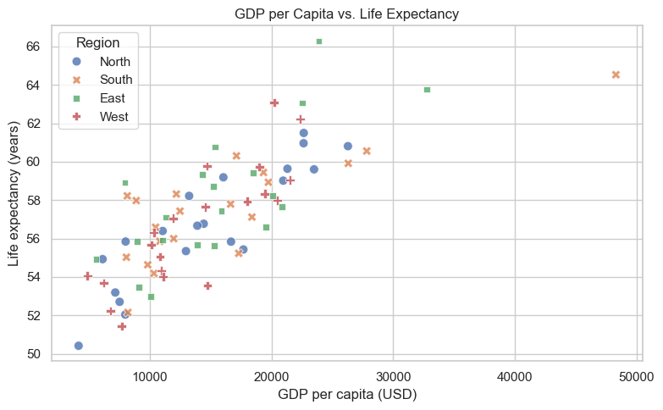
Figure 1: Synthetic regional indicators: GDP per capita vs. life expectancy across 80 simulated regions, colored by geographic cluster.
Source: N1: Sample Data Exploration
Table 1 reports summary statistics by region.
Table 1: Summary statistics by region.
Region | GDP per capita (USD) (mean) | GDP per capita (USD) (std) | GDP per capita (USD) (count) | Life expectancy (years) (mean) | Life expectancy (years) (std) | Life expectancy (years) (count)
East | 15607.9 | 6499.5 | 20 | 58.1 | 3.4 | 20
North | 14709 | 6638.8 | 20 | 56.7 | 3.1 | 20
South | 16113.3 | 9541.1 | 20 | 57.5 | 2.8 | 20
West | 13787 | 5498.2 | 20 | 56.7 | 3.2 | 20

Source: N1: Sample Data Exploration
The same analysis is replicated in R (N2: Sample R Analysis) and Stata (N3: Sample Stata Analysis) to demonstrate multi-language support.
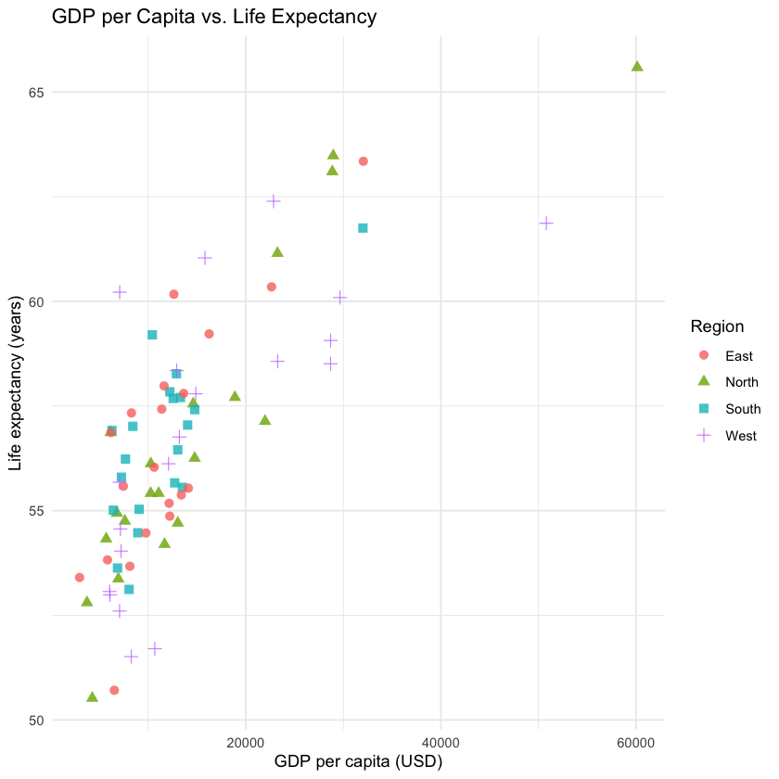
Figure 2: Synthetic regional indicators: GDP per capita vs. life expectancy across 80 simulated regions, colored by geographic cluster (R).
_{Source: N2: Sample R Analysis}
Table 2: Summary statistics by region (R).
|Region | GDP mean| GDP sd| Life exp. mean| Life exp. sd| N|
|:------|--------:|-------:|--------------:|------------:|--:|
|East | 11888.0| 6419.8| 56.5| 2.9| 20|
|North | 15443.4| 13021.0| 56.8| 3.8| 20|
|South | 11517.9| 5595.0| 56.6| 2.0| 20|
|West | 15972.3| 11548.6| 56.8| 3.5| 20|
_{Source: N2: Sample R Analysis}
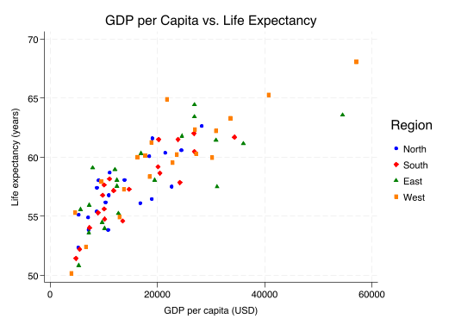
Figure 3: Synthetic regional indicators: GDP per capita vs. life expectancy across 80 simulated regions, colored by geographic cluster (Stata).
Source: N3: Sample Stata Analysis
Summary statistics: Mean, SD, N
Group variable: region
region | gdp_pe~a life_e~y
-------+--------------------
East | 18540.3 58.2
| 12777.3 3.7
| 20.0 20.0
-------+--------------------
North | 13941.3 57.3
| 6845.2 2.8
| 20.0 20.0
-------+--------------------
South | 15757.6 57.4
| 8297.8 3.1
| 20.0 20.0
-------+--------------------
West | 21923.5 59.7
| 12889.5 4.3
| 20.0 20.0
-------+--------------------
Total | 17540.7 58.2
| 10782.0 3.6
| 80.0 80.0
----------------------------
Source: N3: Sample Stata Analysis

Methods
[FILL: Describe the econometric or statistical methods.]

Results and discussion
[FILL: Present and interpret the main findings.]
[FILL: Discuss implications and compare with existing literature.]

Concluding remarks
[FILL: Summarize the main findings and their implications.]
[FILL: Discuss limitations and directions for future research.]

Acknowledgments
[FILL: Acknowledge funding sources, collaborators, and data providers.]

Data and code availability
The data and code used in this study are available at [FILL: repository URL].

References
Keola, Souknilanh, Magnus Andersson, and Ola Hall. 2015. “Monitoring Economic Development from Space: Using Nighttime Light and Land Cover Data to Measure Economic Growth.” World Development 66: 322–34.

See also the World Bank regional development reports.

