Udacity P6: Data Visualization of U.S. Airline Arrival Delays
Christopher Giler
March 30, 2017

Summary
- Introduce data visualization
- Add context

Design
- Explain Design choices you made, including changes to visualization after collecting feedback
Version 1 – Tableau / Mock-up
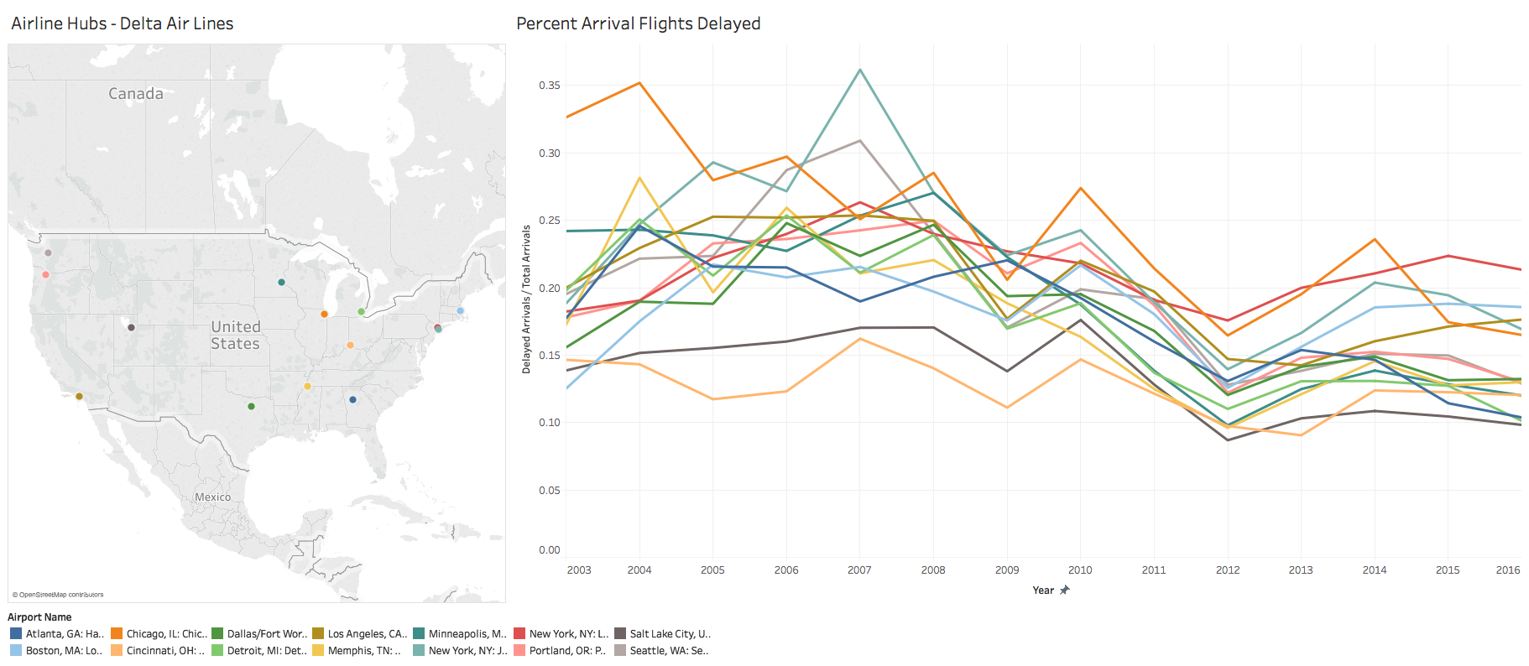
Version 2 – D3.js

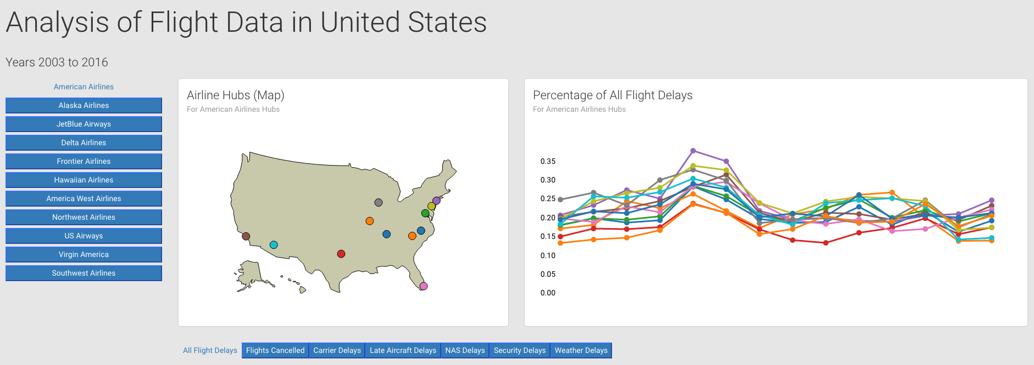

Version 3 – D3.js
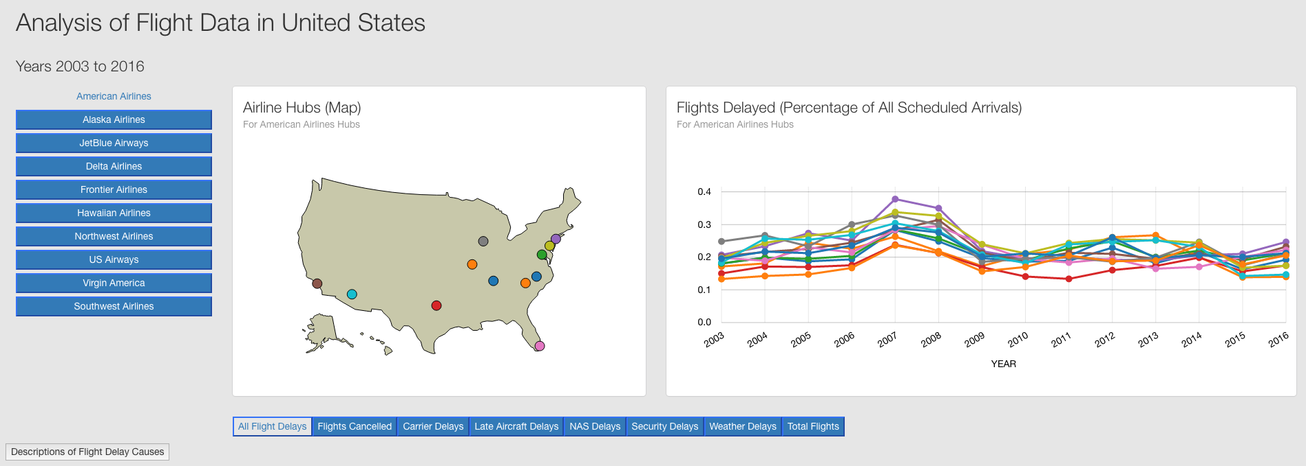
Version 4 – D3.js

Feedback

Feedback for Version 1 (Tableau Mock-up)

I like the layout of showing the map next to the line plots so you can clearly see which line corresponds to which airport visually. I also like that clicking on airport in the legend highlights that point in both the map and the chart. I think it's good that you chose to look at only hubs, because I could imagine viewing all U.S. airports at once would over-saturate the chart, and these are probably the airports which get the most Delta traffic. It looks like there's a trend of Delta flights becoming more reliable over time at all of its hub airports.
It would be useful to see some additional information on the reasons for these flight delays. I see that you can filter by the type of delay through Tableau's filter control, but you could make it more interactive I think. Same goes for airlines – it would be nice to compare this data or the Delta airlines with other airlines as well. As far as interactivity goes, it would also be helpful to the viewer if hovering over a point on the map also highlight the line it corresponds to on the chart. Also, the legend names are cut off – maybe you could have the legend span the entire length of the graphic?
My biggest takeaway from this visualization is that flight delays have decreased over time for Delta at most of their hubs, and large chunk of the airports seem to follow a similar trend from year to year.

Explanation of what was changed

Feedback for Version 2 (index_1.html)

After exploring the visualization, I see a general trend of delays decreasing from 2003 to present. While the values are different, it also appears that the trends aren't dependent on which hub you're looking at. It looks like the total of delays are always around 20-30%, except for Hawaiian airlines which has a much lower delay rate.
The first thing I noticed was a spike for American Airlines delays at JFK in 2007. I did some additional research on it, and noticed that the weird spike occurred the same year that American Airlines announced that they were no longer profitable. Despite their delay rate going down, they filed for Chapter 11 bankruptcy in 2011. I found it interesting that this back-story lines up so well with the data.
The visualization has some room for improvement. I found myself having to count the years from the left or right ends of the chart, depending on the point I was looking at, so it would be nice to have the year shown at the bottom. Some animation on the time axis would also be nice to make it known to the viewer when the scale changes. I'd also suggest slowing down the y axis animation. I'm not clear on what the different types of delays are either (NAS, for example). A description when hovering over the button would help with that. One question I have about the data is whether an airline or airport having less delays can be caused by having less flights per year, so having an option to see total flights would be useful, too. I also see that the delays are in percentages, but what are they percentages of?

Explanation of what was changed

Feedback for Version 3 (index_2.html)

#1) For Delta Airlines, the points on the map for JFK and LGA need to be more distinguished. It would also be nice to be able to select/click on the line graph and have it choose that city (in addition to being able to choose the city from the map). I think it would also be good if when you click on a city, that data will be highlighted permanently until you click anywhere else on the screen. And during this, you could hold your cursor over the data points and get the actual numbers. I think it does a good job visualizing how flight delays change over time for each airline, and I really like the transition animations.

#2) The map view is nice to understand size and presence of each airline, and it's also nice that when hovering over a geo dot that it tells you the airport name. I enjoy the smooth transition of plot change when clicking on other airlines.There's a nice relationship between the plot and map views. I think the main takeaway from this visualization is to provide the customer with data to support the most reliable airline company. At first I didn't understand the types of delays, but that was solved with the description button. As far as adding anything to it, it'd be cool to plot more than one airline so I can more directly compare airlines for a given airport. I'd also prefer that the y axis be in % rather than decimal for easier understanding

Explanation of what was changed

Resources
- www.stackoverflow.com/ – Used for most debugging in code
- www.bl.ocks.org/ - find some examples (tooltips, drawing a map)
- www.gihub.com/ - find source of mapping data

