#include <stdio.h>

int main()

{

printf("hello world");

}

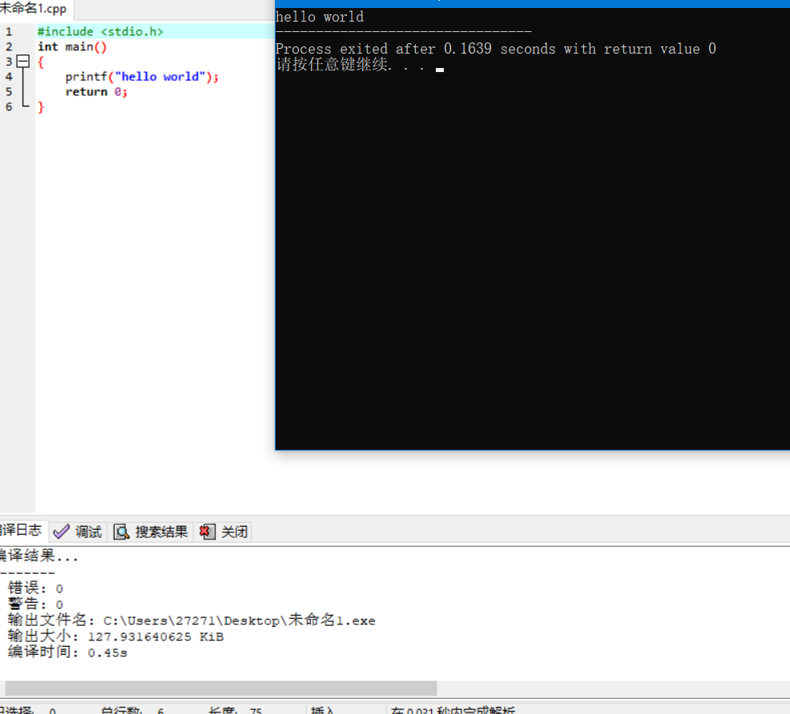

#include <iostream>

using namespace std;

int sum(int x, int y)

{

int z;

z = x + y;

return z;

}

int main(void)

{

int a, b, c;

cin>>a>>b;

c = sum(a, b);

cout << c << '\n';

return 0;

}

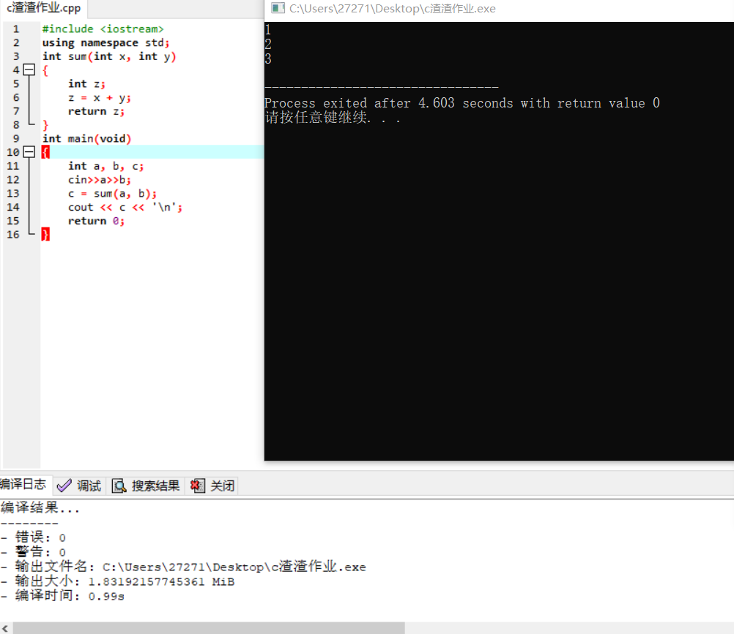

#include<stdio.h>

int main()

{

printf(" \n");

printf("^_^\n");

printf(" \n");

printf(">_<|||\n");

printf(" \n");

printf("　⊙﹏⊙‖∣° \n");

printf(" \n");

printf("o_O???\n");

printf(" \n");

printf("@_@a\n");

return 0;

}

