**WEEK – 2 : PL/SQL PROGRAMMING**

**EXERCISE 1: CONTROL STRUCTURES**

**STEP 1: CREATE REQUIRED TABLES IN ORACLE LIVE SQL**

CREATE TABLE CUSTOMERS (

    CustomerID   NUMBER PRIMARY KEY,

    Name         VARCHAR2(100),

    Age          NUMBER,

    Balance      NUMBER(10, 2),

    IsVIP        VARCHAR2(5) DEFAULT 'FALSE'

);

CREATE TABLE LOANS (

    LoanID       NUMBER PRIMARY KEY,

    CustomerID   NUMBER REFERENCES CUSTOMERS(CustomerID),

    InterestRate NUMBER(5, 2),

    DueDate      DATE

);

**STEP 2: INSERT SAMPLE DATA**

INSERT INTO CUSTOMERS VALUES (1, 'Alice', 65, 12000, 'FALSE');

INSERT INTO CUSTOMERS VALUES (2, 'Bob', 45, 8000, 'FALSE');

INSERT INTO CUSTOMERS VALUES (3, 'Charlie', 70, 9500, 'FALSE');

INSERT INTO CUSTOMERS VALUES (4, 'David', 35, 15000, 'FALSE');

INSERT INTO LOANS VALUES (101, 1, 8.5, SYSDATE + 10);  -- Alice

INSERT INTO LOANS VALUES (102, 2, 7.0, SYSDATE + 40);  -- Bob

INSERT INTO LOANS VALUES (103, 3, 9.0, SYSDATE + 20);  -- Charlie

INSERT INTO LOANS VALUES (104, 4, 6.5, SYSDATE + 5);   -- David

COMMIT;

**SCENARIO 1: DISCOUNT FOR CUSTOMERS OVER 60**

BEGIN

  FOR loan_rec IN (

    SELECT l.LoanID, l.InterestRate, c.Age

    FROM LOANS l

    JOIN CUSTOMERS c ON l.CustomerID = c.CustomerID

    WHERE c.Age > 60

  ) LOOP

    UPDATE LOANS

    SET InterestRate = InterestRate - 1

    WHERE LoanID = loan_rec.LoanID;

  END LOOP;

  DBMS_OUTPUT.PUT_LINE('✅ Discount applied for customers above 60.');

END;

/

**SCENARIO 2: PROMOTE CUSTOMERS TO VIP BASED ON BALANCE**

BEGIN

FOR cust_rec IN (

SELECT CustomerID, Balance

FROM CUSTOMERS

WHERE Balance > 10000

) LOOP

UPDATE CUSTOMERS

SET IsVIP = 'TRUE'

WHERE CustomerID = cust_rec.CustomerID;

END LOOP;

DBMS_OUTPUT.PUT_LINE('VIP status updated based on balance.');

END;/

**SCENARIO 3: LOAN DUE DATE REMINDER (NEXT 30 DAYS)**

BEGIN

FOR loan_rec IN (

SELECT l.LoanID, c.Name, l.DueDate

FROM LOANS l

JOIN CUSTOMERS c ON l.CustomerID = c.CustomerID

WHERE l.DueDate BETWEEN SYSDATE AND SYSDATE + 30

) LOOP

DBMS_OUTPUT.PUT_LINE('Reminder: Loan ' || loan_rec.LoanID ||

' for customer ' || loan_rec.Name ||

' is due on ' || TO_CHAR(loan_rec.DueDate, 'DD-MON-YYYY'));

END LOOP;

END;

/

**OUTPUT**

**QUERY RESULT**

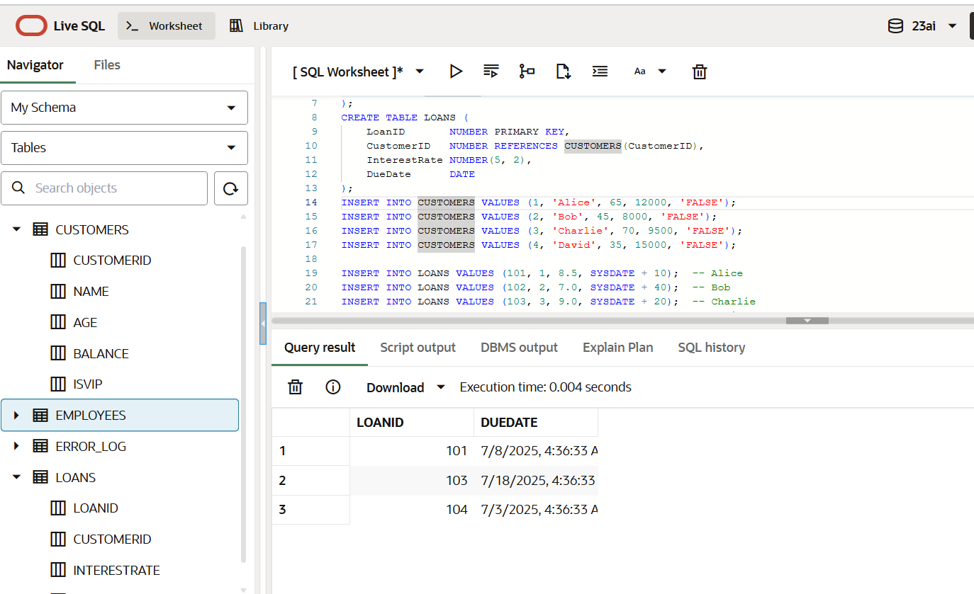

**DBMS OUTPUT**

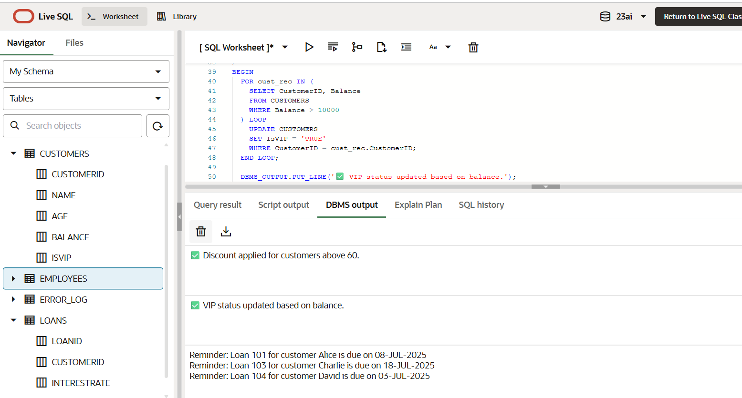

**EXERCISE 3: STORED PROCEDURES**

**STEP 1: CREATE REQUIRED TABLES**

CREATE TABLE SAVINGS_ACCOUNTS (

AccountID NUMBER PRIMARY KEY,

CustomerName VARCHAR2(100),

Balance NUMBER(10, 2)

);

CREATE TABLE EMPLOYEES (

EmployeeID NUMBER PRIMARY KEY,

Name VARCHAR2(100),

Salary NUMBER(10, 2),

DepartmentID NUMBER

);

CREATE TABLE ACCOUNTS (

AccountID NUMBER PRIMARY KEY,

CustomerName VARCHAR2(100),

Balance NUMBER(10, 2)

);

**STEP 2: INSERT SAMPLE DATA**

**-- Savings Accounts**

**INSERT INTO SAVINGS_ACCOUNTS VALUES (1, 'Alice', 10000);**

**INSERT INTO SAVINGS_ACCOUNTS VALUES (2, 'Bob', 5000);**

**INSERT INTO SAVINGS_ACCOUNTS VALUES (3, 'Charlie', 15000);**

**-- Employees**

**INSERT INTO EMPLOYEES VALUES (101, 'John', 60000, 10);**

**INSERT INTO EMPLOYEES VALUES (102, 'Jane', 65000, 10);**

**INSERT INTO EMPLOYEES VALUES (103, 'Mark', 55000, 20);**

**-- Accounts**

**INSERT INTO ACCOUNTS VALUES (1, 'Alice', 10000);**

**INSERT INTO ACCOUNTS VALUES (2, 'Bob', 8000);**

**INSERT INTO ACCOUNTS VALUES (3, 'Charlie', 6000);**

**COMMIT;**

**SCENARIO 1: DISCOUNT FOR CUSTOMERS OVER 60**

**BEGIN**

**FOR loan_rec IN (**

**SELECT l.LoanID, l.InterestRate, c.Age**

**FROM LOANS l**

**JOIN CUSTOMERS c ON l.CustomerID = c.CustomerID**

**WHERE c.Age > 60**

**) LOOP**

**UPDATE LOANS**

**SET InterestRate = loan_rec.InterestRate - 1**

**WHERE LoanID = loan_rec.LoanID;**

**END LOOP;**

**DBMS_OUTPUT.PUT_LINE('✅ Discount applied for customers above 60.');**

**END;**

**/**

**SCENARIO 2: PROMOTE CUSTOMERS TO VIP BASED ON BALANCE**

**BEGIN**

**FOR cust_rec IN (**

**SELECT CustomerID, Balance**

**FROM CUSTOMERS**

**WHERE Balance > 10000**

**) LOOP**

**UPDATE CUSTOMERS**

**SET IsVIP = 'TRUE'**

**WHERE CustomerID = cust_rec.CustomerID;**

**END LOOP;**

**DBMS_OUTPUT.PUT_LINE('✅ VIP status updated based on balance.');**

**END;**

**/**

**SCENARIO 3: LOAN DUE DATE REMINDER (NEXT 30 DAYS)**

**BEGIN**

**FOR loan_rec IN (**

**SELECT l.LoanID, c.Name, l.DueDate**

**FROM LOANS l**

**JOIN CUSTOMERS c ON l.CustomerID = c.CustomerID**

**WHERE l.DueDate BETWEEN SYSDATE AND SYSDATE + 30**

**) LOOP**

**DBMS_OUTPUT.PUT_LINE(**

**'🔔 Reminder: Loan ' || loan_rec.LoanID ||**

**' for customer ' || loan_rec.Name ||**

**' is due on ' || TO_CHAR(loan_rec.DueDate, 'DD-MON-YYYY')**

**);**

**END LOOP;**

**END;**

**/**

**OUTPUT**

**QUERY RESULT**

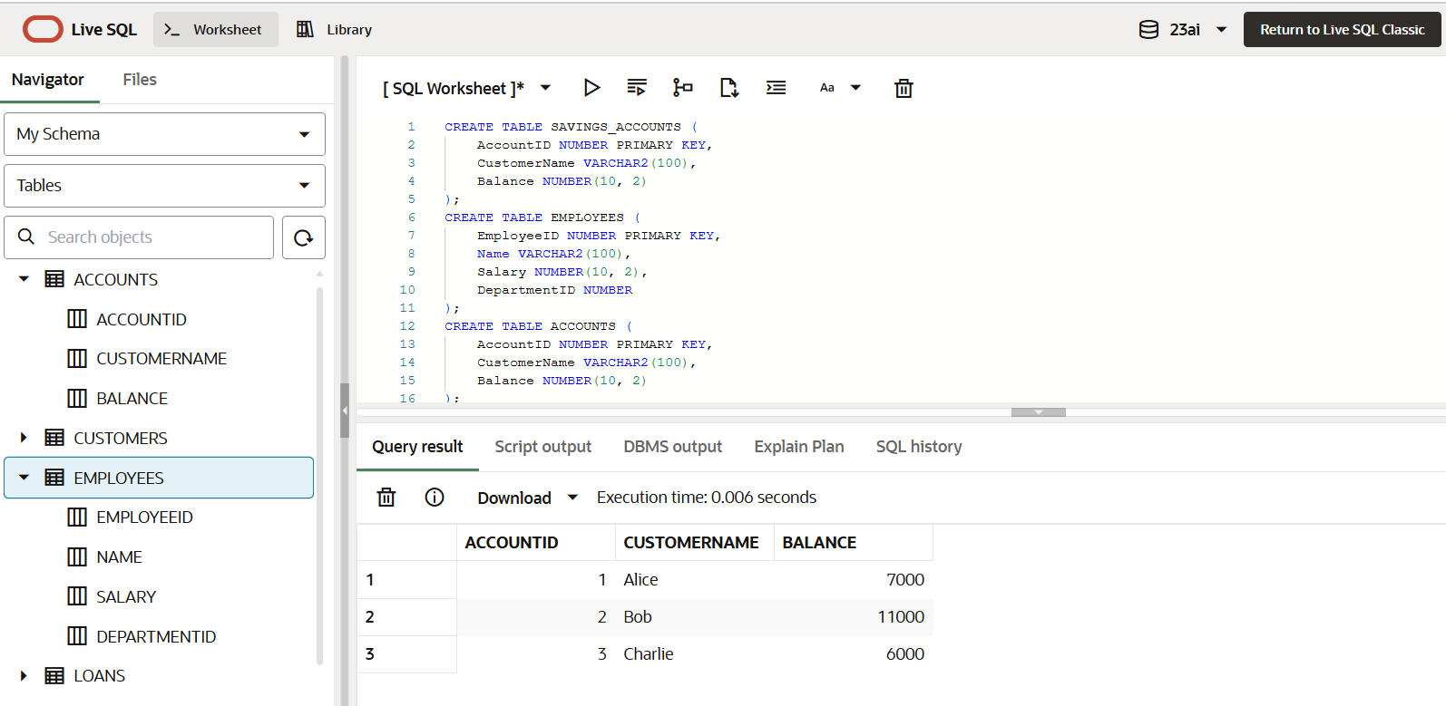

**DBMS OUTPUT**

