Supplementary Information

In a modeled facility, staff are assigned a work schedule that determines when they are in the facility interacting with residents and other staff working at the same time. The function is defined as an indicator function for whether staff member is working at the facility at time step . All staff are also assigned a testing schedule, encoded by function , with different testing schedules discussed further below. The model is simulated for 180 days with three 8-hour time steps per day ( with staff, with each time step corresponding to a work shift as described below.

Staff move through susceptible (S), exposed (E), infected (I), and recovered (R) states, with the infected state corresponding to time when . Recovered staff are assumed to remain in state R and not return to state S due to the relatively short time frame of the simulation. and Staff in state O are restricted from working for 10 days ( for 10 days) and are not required to undergo systematic testing for 90 days following a positive result ( for 90 days).

Assuming constant across all individuals and through the duration of the simulation, the expected number of infections in the facility at time step caused by individual is . Three separate values of (0.5, 1.0, 1.5) were simulated to explore different transmission intensities. Staff may acquire infection from the community according to the community prevalence when they are not working or from fellow staff while working where the force of infection is . The expected number of infections in the facility generated by staff is estimated from each simulation as: .

## Staff schedules

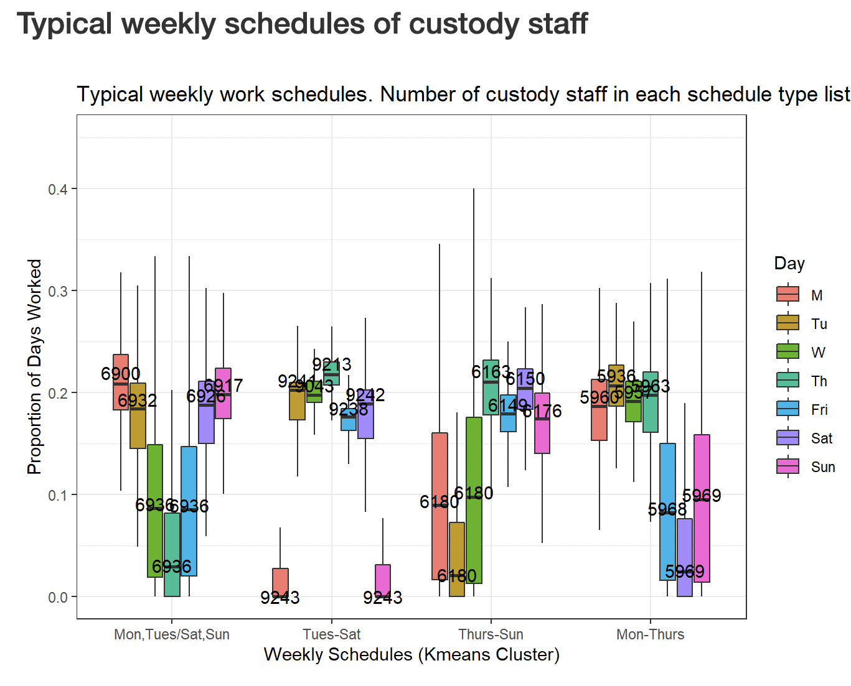

**Figure S1: Staff work schedules identified from CDCR operations records via K-means clustering**. Typical schedules are identified along the x axis and boxplots indicate the proportion of shifts worked on each day of the week for the corresponding work schedule. Overlaid numbers indicate the number of staff in CDCR operations records that worked in the identified work schedule. All work schedules were characterized by four or more consecutive workdays (from left to right: Saturday, Sunday Monday, Tuesday; Tuesday through Saturday; Thursday through Sunday, and Monday through Thursday) with additional shifts commonly occurring prior to or just after these regular work weeks. These structured work schedules were used in model simulations in which systematic tested strategies always occurred on a specified day of the workweek, with testing always on the first day of the workweek leading to the largest reductions in transmission.

Several sensitivity analyses were conducted to evaluate the influence of model assumptions and other factors on key model outcomes. There is some initial evidence that the now widespread B.1.617 “delta” SARS-CoV2 variant has a shorter latent period and higher peak viral load than previously dominant variants. As such, simulations with a “delta” infectiousness profile were conducted to determine if alterations to the infectiousness profile affect the efficacy of the proposed testing regimens [(28), Figure S2)]. Next, simulations incorporating imperfect test sensitivity and variable isolation delays were conducted. These simulations were meant to compare the tradeoffs between prompt isolation and lower diagnostic sensitivity—as may be expected with the use of rapid antigen tests—to higher sensitivity tests that may result in isolation delays—as may be expected if using NAATs. Finally, simulations relaxing the assumption of no self-isolation due to symptoms were conducted. For these simulations, symptoms were assumed to occur in 80% of SARS-CoV-2 infections and the percent of symptomatic individuals who self-isolate upon symptom onset was varied from 0-100% in 10% increments.

## Delta variant sensitivity analysis

Initial evidence suggests that the delta variant of SARS-CoV2 causes higher viral loads and shorter incubation periods than previous variants. Parameter estimates of the incubation period for the “wildtype” variant of SARS-CoV2 from the meta analysis conducted by [McAloon et al](https://doi.org/10.1136/bmjopen-2020-%20039652) assuming a lognormal distribution were used in baseline simulations. Parameter estimates for the delta variant, also assuming the incubation period follows a lognormal distribution, were recently reported from a [Chinese CDC outbreak investigation](https://doi.org/10.46234/ccdcw2021.148). The table below shows the mean and standard deviation of the incubation period derived from sampling 1000 times from lognormal distributions with the reported parameters in each study.

|  |  |  |
| --- | --- | --- |
|  | Alpha | Delta |
| mean | 5.91 | 3.14 |
| SD | 4.08 | 0.73 |

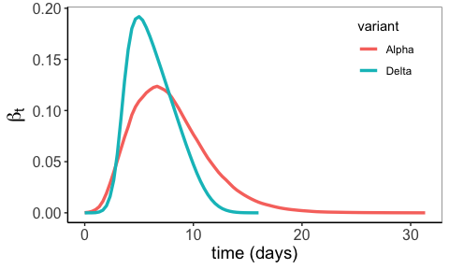

**Figure S2: Compaarison of infectiousness profiles for delta and alpha variants.** Each line shows the mean infectiousness at time t from 1000 simulated infectious profiles in which the latent period was drawn from either the lognormal distribution reported in [Mcaloon et al, mu = ___, sigma = ___] for the alpha variant or from the lognormal distribution reported in [Chinese CDC paper, mu = ___, sigma = ___]. Distributions of the incubation period and total infectious period were as reported in the main text.

The main consequence of the delta variant incubation period appears to be the constriction of the right tail of infectiousness for alpha variant infectiousness profiles. This is driven by the lower mean and variance of the reported incubation period for the delta variant. Whether this is due to a false sense of certainty in the one Chinese study from which incubation period parameters for the delta variant are drawn vs the meta analysis estimates used for the wildtype/alpha variant is up for debate. Regardless, the effect of this constriction is that infectiousness tends to peak sooner and higher in the infectious period for the delta variant. As shown below, this has a minor effect on the simulated number of transmission events when there is no test delay, but when there is a delay between testing and isolation of infections, the delta variant leads to more expected infections regardless of test frequency. This makes sense in the context of the quicker and higher peak infectiousness as the time window in which isolation has an effect on reducing transmission is constrained. All delta variant simulations were run with a community prevalence of % and .

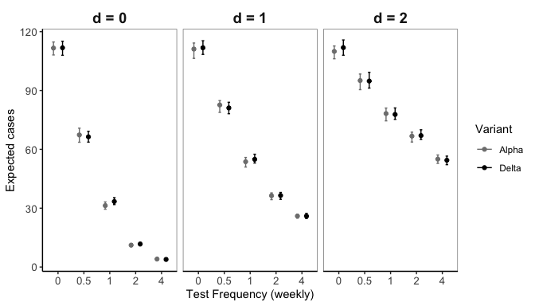

## Sensitivity of tests

Imperfect test sensitivity leading to false negative tests may also negatively influence the efficacy of testing screening programs. Because of the importance of limiting delays between testing and isolation of infectious workers, rapid tests with lower sensitivity but quicker results may be more favorable than NAAT tests such as PCR that have very high sensitivity but may take a day or more to determine results. The figure below shows the expected number of cases for different testing frequencies and delays across test sensitivities ranging from 0.8 to 1 (where 20% of tests conducted on infectious individuals would return a false negative with sensitivity of 0.8). There is no assumption of variable test sensitivity by infectiousness, though there is substantial evidence that the sensitivity of rapid tests is influenced by viral load. All test sensitivity simulations were run with a community prevalence of % and .

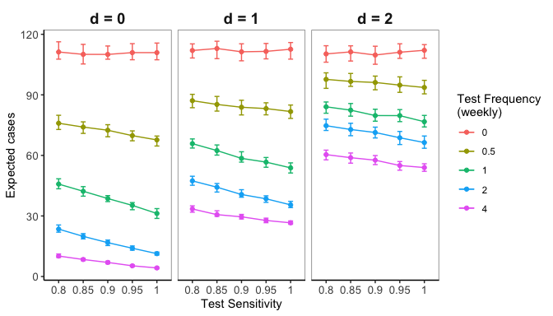

**Figure SX: Test sensitivity has less influence than test frequency and delays to isolation on the number of expected transmission events.**

## Self isolation

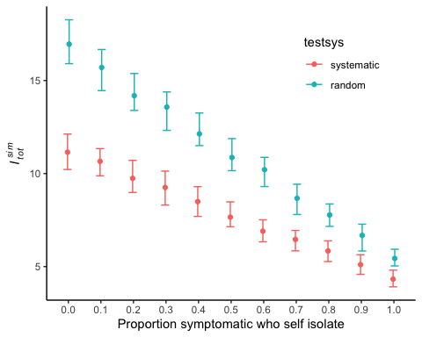

**Figure SX: Expected transmissions across probability of self isolating if infection is symptomatic.** Simulations were conducted with weekly testing either systematically on the first day of staff workweeks (red points) or randomly during staff workweeks (blue points), with no delay between testing and isolation of positive cases, and with community prevalence of 0.5% and (corresponding to the middle points of the middle panels in main text figures 3 and 4). 80% of infections were assumed to produce symptomatic cases, with symptom onset occurring at the end of the incubation period at the time of peak infectiousness. More common self-isolation leads to fewer transmission events, and systematic testing strategies have the most benefit when fewer symptomatic cases self-isolate. However, even under perfect self-isolation, systematic testing leads to fewer expected transmission events than random testing. Points indicate the median and error bars represent the interquartile range of expected transmission events () from 100 simulations under each testing strategy.