Congregate Testing Sensitivity analyses

Chris Hoover et al

10/1/2021

## Delta variant sensitivity analysis

Initial evidence suggests that the delta variant of SARS-CoV2 causes higher viral loads and shorter incubation periods than previous variants. Parameter estimates of the incubation period for the “wildtype” variant of SARS-CoV2 from the meta analysis conducted by [McAloon et al](https://doi.org/10.1136/bmjopen-2020-%20039652) assuming a lognormal distribution were used in baseline simulations. Parameter estimates for the delta variant, also assuming the incubation period follows a lognormal distribution, were recently reported from a [Chinese CDC outbreak investigation](https://doi.org/10.46234/ccdcw2021.148). The table below shows the mean and standard deviation of the incubation period derived from sampling 1000 times from lognormal distributions with the reported parameters in each study.

|  |  |  |
| --- | --- | --- |
|  | Alpha | Delta |
| mean | 5.91 | 3.14 |
| SD | 4.08 | 0.73 |

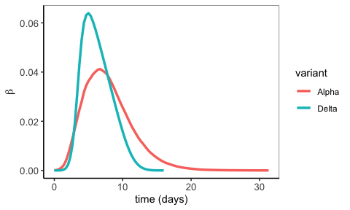

Mean infectiousness through time from 1000 simulated infectiousness profiles for the delta and alpha variants.

The main consequence of the delta variant incubation period appears to be the constriction of the right tail of infectiousness for alpha variant infectiousness profiles. This is driven by the lower mean and variance of the reported incubation period for the delta variant. Whether this is due to a false sense of certainty in the one Chinese study from which incubation period parameters for the delta variant are drawn vs the meta analysis estimates used for the wildtype/alpha variant is up for debate. Regardless, the effect of this constriction is that infectiousness tends to peak sooner and higher in the infectious period for the delta variant. As shown below, this has a minor effect on the simulated number of transmission events when there is no test delay, but when there is a delay between testing and isolation of infections, the delta variant leads to more expected infections regardless of test frequency. This makes sense in the context of the quicker and higher peak infectiousness as the time window in which isolation has an effect on reducing transmission is constrained. All delta variant simulations were run with a community prevalence of $1$% and $R=1.5$.

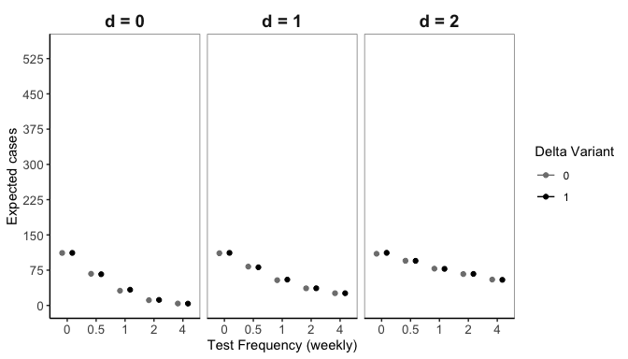

## Sensitivity of tests

Imperfect test sensitivity leading to false negative tests may also negatively influence the efficacy of testing screening programs. Because of the importance of limiting delays between testing and isolation of infectious workers, rapid tests with lower sensitivity but quicker results may be more favorable than NAAT tests such as PCR that have very high sensitivity but may take a day or more to determine results. The figure below shows the expected number of cases for different testing frequencies and delays across test sensitivities ranging from 0.8 to 1 (where 20% of tests conducted on infectious individuals would return a false negative with sensitivity of 0.8). There is no assumption of variable test sensitivity by infectiousness, though there is substantial evidence that the sensitivity of rapid tests is influenced by viral load. All test sensitivity simulations were run with a community prevalence of $1$% and $R=1.5$.

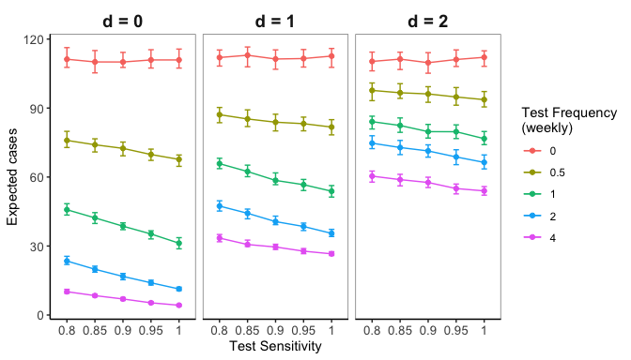

Expected cases across test sensitivity, delay, and frequency

There’s no variability in expected cases in the absence of testing (pink lines) and decreasing cases with increasing sensitivity implying that simulations pass the smell test. What’s most interesting is comparisons across test delays as these give a sense of the tradoffs between test sensitivity and test delay. For instance: weekly testing at 90% test sensitivity with no delay does about as well as biweekly testing with perfect test sensitivity and a one day delay.

## Self isolation

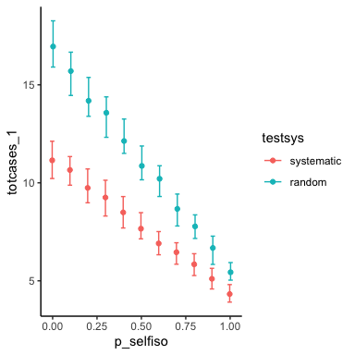

Expected transmissions across probability of self isolating if infection is symptomatic.

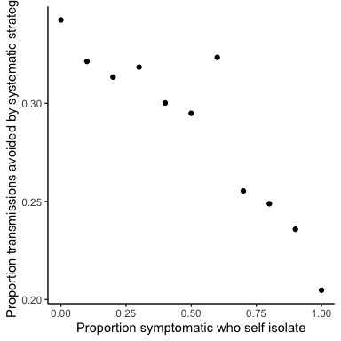

The advantages of systematic testing are diminished when more people self isolate, but are still present even under full compiance with self isolation