Parasite aggregation increases under intense control efforts, complicating helminthiases elimination

Christopher M. Hoover1, Stefanie Knopp2, Joseph A. Lewnard3, Alan E. Hubbard4, Jay Graham1, Giulio A. de Leo5,6, Susanne H. Sokolow5,6, David Rollinson7, Fatma Kabole8, Justin V. Remais1

1 Division of Environmental Health Sciences, University of California, Berkeley School of Public Health, Berkeley, CA 94720 USA

2 Swiss Tropical and Public Health Institute

3 Division of Epidemiology, University of California, Berkeley School of Public Health, Berkeley, CA 94720 USA

4 Division of Biostatistics, University of California, Berkeley School of Public Health, Berkeley, CA 94720 USA

5 Department of Biology, Hopkins Marine Station, Stanford University, Pacific Grove, CA 93950 USA

6 Woods Institute for the Environment and Center for Innovation in Global Health, Stanford University, Stanford, CA 94305 USA

7 London Museum of Natural History

8 Zanzibar Ministry of Health

## Abstract

# Background

Decades of mass drug administration (MDA) have drastically reduced the prevalence and burden of neglected tropical diseases, particularly helminthiases including schistosomiasis, onchocerciasis, lymphatic filariasis (LF), and soil transmitted helminths (STHs). National control programs supported by organizations such as the Gates Foundation and World Health Organization and drug companies which donate necessary drugs for treatment, have made substantial progress reducing the burden of helminthiases. [1] More recently, the global conversation has shifted towards elimination. China, for instance, has made substantial progress towards elimination of schistosomiasis with an integrated control approach that utilizes MDA in addition to environmental and behavioral controls. [2–4] Globally, progress towards elimination is mixed and many areas of sub-Saharan Africa where the vast majority of schistosomiasis and other helminthiases occur have struggled to achieve transmission control and progress towards elimination.

Under sufficient coverage and frequency, elimination using MDA alone is believed to be possible in low and moderate transmission settings. [5] From a practical standpoint, achieving these necessary treatment conditions is challenging due to the programmatic limitations of many control campaigns. School-based interventions, for instance, are often the primary method of drug delivery in communities since they are straightforward to implement and reach school-aged children, widely considered the most vulnerable and most heavily infected segment of the population. However, school-based strategies, and even those that seek to reach all members of the broader community, often miss infected individuals that contribute to transmission. [6,7]

Because of this, control efforts are likely to have profound implications for parasite aggregation: the distribution of parasites among the human host population. While the dynamics of parasite burden following MDA and other interventions have been studied extensively, the corresponding dynamics of aggregation are largely unexplored. Aggregation is measured by the aggregation parameter, (also frequently referred to as “dispersion parameter”) of a negative binomial distribution. While is often considered constant in models and other forward-looking analyses of control efforts, there is reason to believe that it is itself a dynamic variable that is positively correlated with transmission intensity. More transmission leads to less-skewed distributions of infection, while reductions in transmission from interventions such as MDA lead to more skewed distributions in which fewer individuals host larger proportions of the total parasite population. Individuals that remain infected in these scenarios may be those who miss treatment, are heavily exposed, are particularly susceptible to infection, or have parasite strains that are resistant to praziquantel. [8–12]

Aggregation dynamics approaching elimination are important from a number of practical and theoretical vantages. As parasite burden is reduced, so too is the number of individuals contributing to and sustaining transmission—a realization of the “20/80 rule” in which 20% of individuals contribute 80% of the transmission potential. [8] Identifying and treating these individuals through control efforts will therefore be essential to achieving elimination, but is complicated by systematic non-adherence to treatment, treatment failures, and insensitive diagnostics. [8,13–15] A better understanding of aggregation dynamics could aid the planning and implementation of surveillance and control efforts in low transmission and elimination settings. [13]

From a theoretical standpoint, the conditions under which MDA alone can achieve elimination is dependent on reducing the parasite population below its breakpoint. Breakpoints in helminth transmission are expected to arise from mate limitation in low transmission settings whereby the probability of individuals being infected with fecund worms decreases as parasite burden and transmission decrease. Mate limitation in helminth populations is generally quantified in terms of the probability that a given female parasite in a population is successfully mated, , which is estimated as a function of the mean parasite burden, , and aggregation parameter, . [16,17] In endemic settings, parasite distributions among a population of definitive human hosts are well-represented by a negative binomial distribution with below 1. This implies a heavily right-skewed distribution in which most parasites are aggregated in a few human hosts.

For constant dispersion parameter, , in the range as has been widely observed previously, as , giving rise to the hypothesized breakpoint at which worm mating becomes insufficient to sustain transmission. [18] As transmission decreases, the response of the dispersion parameter could have profound implications for the breakpoint. For instance, if as , implying increasingly skewed distributions that can be realistically interpreted as all parasites being harbored by one individual, remains large and the breakpoint is vanishingly small. [17] However, derivations of the mating probability based on the negative binomial distribution of adult parasites are derived from endemic settings, and stochasticity in worm acquisition at low transmission intensities is likely to play an increasingly important role on the distribution of adult parasites as elimination is approached. [16,17]

Here, we examine evidence for dynamic aggregation from the Zanzibar Elimination of Schistosomiasis Transmission (ZEST) study, a randomized control trial with the aim of eliminating schistosomiasis as a public health problem and halting schistosomiasis transmission on the two main islands of the Zanzibar archipelago off the coast of Tanzania. [19,20] We revisit classic assumptions of how adult schistosomes are distributed among human hosts and propose a novel, mechanistic data-generating process for worm acquisition and resulting mating dynamics. We then explore how these assumptions and underlying data-generating process affect estimation of the mating probability and discuss implications for ongoing control and elimination efforts for schistosomiasis and other helminthiases.

# Methods

The ZEST project enrolled 45 administrative regions called shehias on the island of Pemba with the goal of eliminating urogenital schistosomiasis as a public health problem (defined as reducing the prevalence of heavy infections below ) and 45 Shehias on the island of Unguja with the goal of interrupting *S. haematobium* transmission (defined as reducing the number of incident cases to zero). [19,20] On each island, shehias were randomly assigned to receive biannual MDA, biannual MDA plus snail control, or biannual MDA plus a behavioral intervention. [20–22] Cross-sectional parasitological surveys were conducted annually from 2012-2017 in each shehia. Data used here were acquired via a formal data request to the Schistosomiasis Consortium for Operational Research and Evaluation (SCORE) and are comprised of 27,626 observations of parasite burden among adults and 75,039 observations of parasite burden among school-aged children, each measured as *S. haematobium* eggs per 10mL urine.

The likelihood of the inverse negative binomial aggregation parameter, , and mean community egg burden, , can be estimated for each shehia, , and year, , from individual, , egg counts, , as:

While aggregation is most frequently reported and discussed in terms of , its inverse, has more desirable properties for statistical estimation and inference (see e.g. [23]). Therefore results are presented in terms of following trivial transformation from estimates derived using .

The maximum likelihood estimate of is simply the empirical mean of individual egg counts, and maximum likelihood estimates of were estimated using the Brent method within the optim function in R. [24] Uncertainty in estimates of were derived from the Hessian matrix. Both and were estimated among the adult (A), child (C), and total (T) populations in each shehia-year.

Weighted generalized estimating equations (GEE) with unstructured correlation matrices of the form:

were used to estimate the relationship between aggregation and parasite burden. Weights were assigned as the inverse of the standard error of . Models stratifying by population (child, adult, or total), by intervention type (MDA only, behavioral, or snail control), and by island (Pemba or Unguja) were also estimated. Results are reported for each stratum as the change in associated with an interquartile range increase in mean egg burden, . Clustered nonparametric bootstrapping was used to estimate uncertainty in estimates of with bootstrapped samples at the shehia level.

Because egg counts are an indirect estimate of parasite burden, are prone to undercounts at low burdens, and may change non-linearly with parasite burden [25], we next seek to determine if changes in aggregation as measured by egg counts are indicative of changes in aggregation of the adult parasite population. We use approximate Bayesian computation (ABC) to estimate mean community parasite burden and dispersion, denoted and , respectively, under three proposed data-generating mechanisms, (described below). Briefly, ABC proceeds by: 1) sampling parameter sets from a prior distribution, ; 2) simulating datasets, , from the priors under the given data generating mechanism; 3) deriving summary statistics, , from the generated data to compare to the observed data, ; 4) generating distance metrics, , to assess the fit of the generated data to the observed data; and 5) accepting parameter sets that fall within a provided distance tolerance. [25] The accepted parameter sets thus represent an approximation of the posterior distribution of , but the estimation procedure does not require exact calculation of the likelihood of every proposed prior. Here, ABC was preferred to MCMC methods due to the number of estimates needed combined with the complexity of the likelihood function of the parasite population estimated from observed egg counts (see e.g. [26,27]).

The three data-generating mechanisms considered correspond to the “distributed together” and “distributed separately” assumptions (Cases 1 and 2) from Robert May’s seminal work on schistosome mating dynamics [16] and a third mechanism (Case 3) that considers susceptibility and exposure as independent parameters. Prior parameter distributions and data generating processes that connect simulated worm burdens and egg counts to observed egg burdens are delineated in Table 1. Briefly, Case 1 assumes worms are distributed among human hosts according to a single negative binomial distribution with 1:1 sex ratio. Case 2 assumes male, , and female, , worms are distributed according to separate negative binomial distributions, each with mean . Case 3 assumes susceptibility, , interpreted as the probability a given cercarial exposure will result in an adult worm, follows a gamma distribution, and cercarial exposures follow a negative binomial distribution independent of susceptibility. Worm pairing in individual hosts is then determined from a hypergeometric distribution that incorporates individual susceptibility, cercarial exposure, and 1:1 sex ratio among cercarial exposures (Table 1). The susceptibility distribution parameters are fixed, with parameters derived from previous work on *S. japonicum* [11,12], such that Case 3 estimation is based on the same number of parameters (3) as Case 1 and 2, and estimates of the mean worm burden and dispersion parameter can be estimated from the expectation and combined variances of the Case 3 susceptibility and exposure parameters. The number of eggs shed per mated worm pair per day is assumed to follow a negative binomial distribution with mean and dispersion for all three cases (Table 1).

The observed data, , used in the ABC procedure consists of the mean community egg burden, ; standard error of individual egg counts, ; and an adjusted egg-prevalence measure—the number of egg positive individuals squared over the number of individuals—for every shehia-year among separate child and adult populations in which at least one individual had an egg count . The distribution of this adjusted prevalence measure—as opposed to the prevalence (bounded between 0 and 1) or raw number of individuals infected (an integer)—aligns better with the ABC estimation procedure. We used the default standardized distance metric in the R package ABC [28] to compare the observed data to simulated datasets for each Case in each eligible shehia-year, and accepted the parameter sets with the smallest estimated distance for each simulation (e.g. tolerance of ). Posterior parameter sets were then adjusted and weighted based on their distance from the observed data using the ridge regression routine in ABC. Relative fits to the observed data foor each data-generating case were compared using the Bayes factor. Posterior distributions of and were examined as described above for and . In addition, the mating probability was estimated for every simulated dataset as the number of mated worms per worm (). These estimates were then compared to analytic estimates of the mating probability derived from the mean worm burden and worm dispersion parameter as derived previously. [16]

**Table 1**: Priors and data-generating processes for approximate Bayesian computation estimation of community parasite burden and aggregation. Data generation proceeds by first drawing from the multivariate prior, , containing shehia-year level summaries of parasite burden and aggregation (for Cases 1 and 2) or of individual susceptibility and exposure (for Case 3), then generating individual worm burdens, worm pairs, and finally egg burdens. Summaries of individual egg burdens for each shehia-year are then compared to observed summaries from ZEST to derive a posterior estimate of model parameters.

|  |  |  |  |
| --- | --- | --- | --- |
|  | Case 1 (Males and females distributed together) | Case 2 (Males and females distributed separately) | Case 3 (Explicit susceptibility and exposure) |
| Priors |  |  | ; |
| Worms |  | See below |  |
| Pairs |  |  |  |
| Eggs |  | | |
| : multivariate prior for data-generating case,  : mean worm burden in shehia, , and year,  : individual, , worm burden in shehia, , and year,  : aggregation parameter in shehia, , and year,  : mean cercarial exposure in shehia, , and year,  : shape parameter of gamma-distributed susceptibility,  : rate parameter of gamma-distributed susceptibility,  : mean eggs produced per mated worm pair  : aggregation parameter of negative binomially distributed daily egg release | | | |

All analyses were performed in R version 4.0.2 utilizing the geepack [29], tidyverse [30], and ABC [28] packages. All code and derived data files necessary to reproduce the analysis can be found at <https://github.com/cmhoove14/DynamicAggregation>.

# Results

There were 93 shehia-years in which no individuals had positive egg counts and 16 shehia-years in which the maximum individual egg count was 1 and therefore variance estimates for could not be derived. This left 447 observations of and , shown in Figure 1A along with the marginal estimate of from the fitted GEE. We estimate a median 0.011 (Bootstrapped IQR: 0.01-0.013) increase in associated with an IQR increase in , implying a negative relationship between mean egg burden and aggregation. This relationship appears to be driven by dynamics in children, as there was weak evidence for a relationship between and among adults (Fig 1B). Egg burden in adults ( 1.36) was substantially lower than in children ( 4.65), however. Shehias receiving the MDA+snail control and MDA+behavior change interventions appeared to have a stronger burden-aggregation relationship (larger , Fig 1B). An additional GEE model including main effects of intervention arm and island showed that reductions in were significantly larger in shehias receiving the MDA+snail control and MDA+behavioral change interventions ( 0.01 and 0.016, respectively).

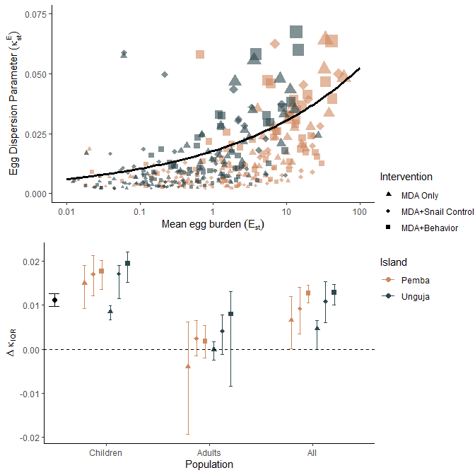

Figure 1: Relationship between community egg burden and dispersion. Panel A shows the scatterplot of all estimates of and where each point is sized according to its weight, derived as the inveerse of the standard error of . Points are also symbolized according to their assigned intervention group—MDA only (▲), MDA+snail control (♦), or MDA+behavioral intervention (■)—and the island of the shehia. The solid black line in panel A represents the marginal estimate of from the fitted GEE. Panel B shows estimates of , the change in aggregation for an interquartile range increase in community egg burden stratified by population, treatment group, and island. The black point and error bars correspond to the unstratified marginal estimate of as in panel A. Error bars correspond to the interquartile range of estimates derived from B=5000 bootstrapped samples.

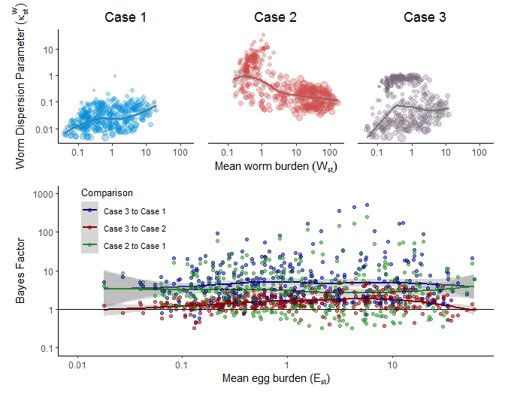

Figure 2: Summary of approximate Bayesian computation estimates of community worm distributions among children. Across the top are posterior estimates of the mean community worm burden () and worm dispersion parameter () from ABC estimation for Case 1 (Together, top left in blue), Case 2 (Separate, top middle in red), and Case 3 (Generalizable, top right in purple). Panel D shows comparisons of model fit for each case across the measured community egg burden () using the Bayes Factor, a ratio of model likelihoods in which higher values imply better fits to the observed data. All axes are log-transformed and smoothed averages are shown for figure clarity. Points in the top panels are sized in proportion to the inverse of the interquartile range of the posterior estimate of .

Results of ABC estimation of the mean worm burden, aggregation parameter and mating probability are shown for children in figures 2 and 3. The same figures for estimation among adult populations can be found in the supplement (Supp Figures 4-6). All three data-generating mechanisms considered produced summary statistics that matched the observed summary statistics from ZEST well (Supp Fig 1). Examination of the Bayes factors comparing the fit of each Case shows that the generalizable Case 3 performs better than both the canonical Case 1 and Case 2, though Case 2 does appear to perform about as well (Bayes Factor ) at lower parasite burdens (Fig 2). Case 1 estimates of and exhibited a similar pattern to and , namely increasing aggregation (indicated by decreasing ) with decreasing measures of burden (Fig 1 and Fig 2). However, Case 2 estimates showed the opposite effect of decreasing aggregation with decreasing worm burden (Fig 2). Finally, Case 3 estimates appear similar to a mixture of Case 1 and Case 2 results, with one cluster of estimates appearing to exhibit Case 1-like dynamics and another exhibiting Case 2-like dynamics (Fig 2). Further examination of each of these clusters reveals that Case 1-like dynamics recovered from Case 3 estimation occur more frequently in Shehia-years with higher egg burdens, prevalences, and standard errors, while Case 2-like dynamics are recovered at lower egg burdens, prevalences, and standard errors (Supp Fig 2). Additionally, comparison of the estimated mean worm burden from each data-generating case to the observed mean egg burden shows that Case 3 estimates are more similar to Case 1 estimates at higher burdens, but closer to Case 2 estimates at lower burdens (Supp Fig 3).

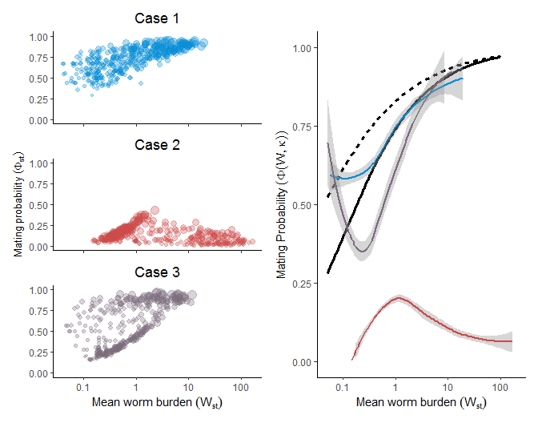

Figure 3: Comparison of predicted and estimated mating probabilities. Along the left side are estimates of the mating probability extracted from the best fit datasets generated in approximate Bayesian computation for every Shehia-year across the three cases. Case 1 (Together, top left in blue) estimates produce a high mating probability at high worm burdens that steadily decreases with decreasing mean worm burden. Case 2 (Separate, middle left in red) estimates produce a low mating probability across all mean worm burdens, with a subtle peak in mating probability at intermediate mean worm burdens. Case 3 (Generalizable, bottom left in purple) again appears to show hybridization with mating probability estimates at high mean worm burdens appearing similar to Case 1 and mating probability estimates at low mean worm burdens appearing similar to Case 2. The right panel compares loess-smoothed estimates of the mating probability from ABC estimation for each case to analytical predictions of the mating probability for static (, solid black line) and dynamic aggregation (, dashed black line). Analytic predictions of the mating probability are accurate at high mean worm burdens, but diverge from the empirical estimates as the mean worm burden decreases, indicating analytic predictions that assume constant Case 1 “distributed together” dynamics may be inaccurate in elimination settings.

Figure 3 shows the mating probability generated by all three data-generating cases from the best fit datasets in ABC estimation for every Shehia-year. These estimates are also compared to analytic predictions of the mating probability for both static aggregation (, Fig 3 black solid line) and dynamic aggregation (, Fig 3 black dashed line). These analytic predictions align well with empirical Case 1 and Case 3 estimates at high mean worm burdens, but underestimate the mating probability at lower mean worm burdens. Hybridization of Case 1 and Case 2 like dynamics recovered from Case 3 estimates are apparent once again, with Case 3 mating probability estimates similar to Case 1 estimates at high mean worm burdens, and resembling Case 2 estimates at lower mean worm burdens. This leads to uncertain mating probability estimates as the main determinant appears to be whether Case 1 or Case 2 like dynamics are dominant, rather than the mean worm burden or aggregation parameter from which analytic estimates are derived.

# Discussion

Here we use data from the ZEST study to explore how parasite aggregation dynamics change as elimination is approached due to intense control efforts. We find that parasite aggregation as measured directly by community egg distributions and through estimation of adult parasite distributions likely increases as elimination is approached. In addition, the classic (Case 1) assumption that male and female parasites are distributed together appears to hold at large mean community worm burdens. However, as proposed previously, this assumption appears to break down at smaller worm burdens as elimination is approached. [16]

The distribution of individual egg counts from ZEST was highly overdispersed, with in the range 0.001-0.067. Community egg dispersion was found to significantly decrease as the community worm burden decreased, and this effect was driven by children. As children frequently have the highest exposure and may be most susceptible to infection due to lack of acquired immunity, [28] this is not surprising. We also found that the relationship between the dispersion parameter and mean community egg burden was significantly greater in shehias from the ZEST study that received snail control or behavioral interventions in addition to biannual MDA. This could be driven by higher starting prevalence and burden among these intervention arms, [20] though could also have theoretical underpinnings that will be the topic of future analyses.

We propose a novel, mechanistic data-generating process (Case 3) that explicitly models the interaction of individual susceptibility and exposure to allow the data to determine the most likely distribution of male and female parasites. Using approximate Bayesian computation to estimate mean parasite burdens and parasite dispersion, we find that this Case 3 data-generating process provides a better fit to the observed ZEST data across all values of parasite intensity. Due to the flexibility and superior fit of the proposed Case 3 mechanism, we believe it represents a superior theoretical basis for analyzing the dynamics of parasite aggregation and mating.

Case 3 estimation supports the hypothesis that male and female parasites are distributed together (Case 1) at high transmission intensities that result in high worm burdens. Case 3 estimates of worm burden and aggregation were more similar to estimates recovered from Case 1 estimation at higher worm burdens. As mean worm burden estimates decreased, Case 3 estimates became more irregular, with some similar to Case 2 estimates and others similar to Case 1. This supports previous hypotheses that the distribution of male and female parasites among a population of definitive human hosts is likely dependent on local transmission intensity and previous

This finding provides evidence supporting the hypothesis of Robert May that the distribution of male and female parasites is not strictly “together” (Case 1) or “separate” (Case 2), but is rather a blend of both that is dependent on the worm burden itself. [16] In particular, male and female parasites appear more likely to be distributed together at high burdens, and separate at low burdens. This reflects the higher likelihood that individuals are exposed to large numbers of cercariae more likely to contain a mix of males and females that will ultimately pair when transmission intensities are greater. At lesser transmission intensities, the probability of exposure events containing only male or female cercariae increases.

Variability in susceptibility as proposed previously [11] and considered as part of Case 3 estimates here plays a similar moderating effect on those cercariae that successfully infect the human host and mature into adult worms. This suggests that identifying individuals who are particularly susceptible to infection could be extremely valuable for control efforts, since these individuals are both most susceptible to pathology associated with infection and are most likely contributing to sustaining transmission. These individuals could be identified through a sufficiently accurate biomarker or simply by taking note of individuals who are most heavily infected. This information could then be used in targeted drug administration campaigns that prioritize treatment of such high-risk individuals, rather than prioritizing broad coverage of the population regardless of individuals’ susceptibility or exposure. Such strategies will be the topic of subsequent modeling analyses that build on the results presented here.

Such strategies should also be pursued with caution if relying on diagnostics such as haematuria or egg-assays that are known to have low sensitivity for light infections. Indeed, reliance on these diagnostics represents a limitation of this analysis as sensitivity in egg counts is not explicitly considered in analysis of the community egg burdens or in the data-generating Cases considered. However, high variability in daily egg counts produced by even heavily infected individuals [26] is a part of the data-generating processes of the ABC estimation, meaning that generated egg distributions would be expected to match observed ones if diagnostic sensitivity in the real world were perfect. Future analyses using more sensitive diagnostics such as circulating cathodic antigen (CCA) could be pursued to confirm these findings.

Heterogeneity in susceptibility and exposure (and their joint distribution) are not the only processes that could explain the dynamics of parasite burden and aggregation identified here, though they most likely play a significant role. Recent analyses have found that mated pairs may survive praziqauntel treatment and resume egg-laying shortly after treatment. [8] This would lead individuals harboring such resistant pairs to maintain their high worm burden following treatment, while others are cleared of adult worms, thus increasing aggregation as is seen in these analyses. Similarly, individuals who miss treatment due to absence, pregnancy, or non-compliance would also maintain their high worm burdens as others are treated and cleared of adult worms, leading to increased aggregation as the mean community burden decreases.

Regardless of the exact mechanism or combination of mechanisms that give rise to increased aggregation, the practical implications are noteworthy. [31] Because some individuals maintain high worm burdens and egg output, they are more likely to maintain transmission among the snail population, which could contribute to infection rebound in the entire community. From a theoretical perspective, this can be expressed in terms of the mating probability. Our results show that increased aggregation coupled with shifts in the distribution of male and female parasites leads to mating probabilities higher than are commonly predicted assuming Case 1 dynamics with constant aggregation. This implies that the hypothesized breakpoint in schistosomiasis transmission could be exceedingly small or non-existent. Widespread resilience to elimination [32–36] and the recent outbreak of schistosomiasis in Corsica that appears to have been introduced by a single egg-shedding individual [37] also provide evidence to this finding. Breaking schistosomiasis transmission to achieve elimination may therefore be more dependent on reducing environmental transmission through snail control, sanitation improvements, and behavioral interventions and on identifying and successfully treating the few individuals who remain infected and maintain transmission as elimination is approached. [38–40]

A renewed focus on snail control as an important component of schistosomiasis elimination is encouraging. Heterogeneities in susceptibility, exposure, and sex differentiation—and resulting aggregation dynamics—are just as complex in intermediate host snail populations as in human hosts. [41] Additional focus on even more integrated strategies that incorporate snail control, MDA, environmental remediation, sanitation, and behavioral changes could prove even more successful, as they were in bringing about widespread elimination of schistosomiasis transmission in China. [2,42] Emerging evidence that zoonotic components of transmission such as hybrid *S. bovis* and *S. haematobium* [43] strains and infected rodents [44] are capable of sustaining transmission even in the presence of widespread MDA make such integrated strategies even more important. Identifying such integrated intervention strategies that result in the highest probability of successful elimination, particularly in the context of resistance to elimination due to dynamic aggregation as described here, is the subject of an ongoing modeling analyses that will be presented separately.

In conclusion, we have identified dynamic aggregation as an important aspect of schistosomiasis transmission in elimination settings. We propose a novel, generalizable quantitative framework for modeling parasite acquisition and subsequent mating dynamics among the human host population that suggests the canonical Case 1 assumption that male and female parasites are distributed together is only accurate at high parasite burdens. This implies that the mating probability of adult worms remains high as elimination is approached, and the feasibility of achieving elimination using MDA alone may be overestimated. We suggest more targeted treatment strategies and a focus on integrated intervention strategies that target other components of the schistosome lifecycle to combat this source of resilience and maintain global progress towards the elimination of schistosomiasis.

# Appendix/Supplement

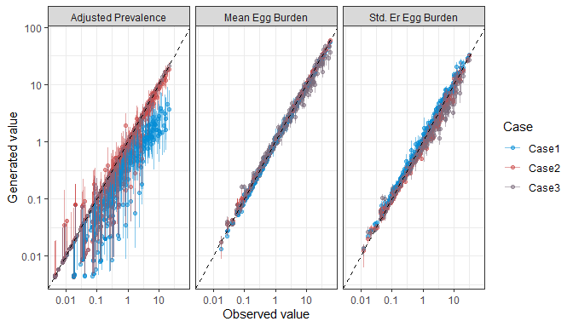

Figure 4: Comparison of generated to observed summary statistics used in approximate Bayesian computation estimation of community parasite burdens. Colors indicate the data generating Case and the 1:1 line implying perfect agreement between observed and generated data is shown. Error bars correspond to interquartile ranges of the generated summary statistics from parameter sets included in the posterior distribution.

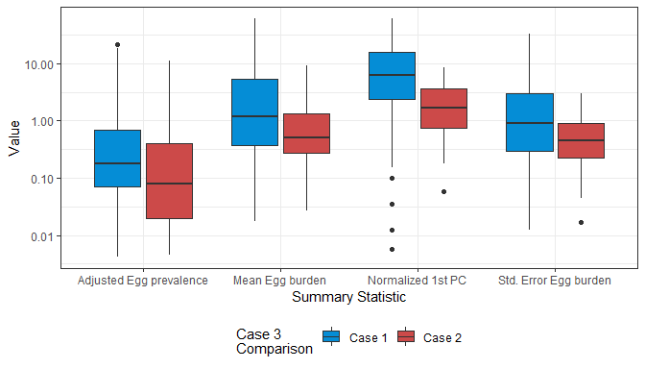

Figure 5: Distribution of summary statistics used in approximate Bayesian computation estimation of worm burdens from egg burdens and their first principle component, stratified by whether the Case 3 worm burden estimates were closer to the Case 1 (blue) or Case 2 (red) estimates. This demonstrates that Case 2 dynamics are more likely to be estimated at lower parasite burdens, prevalences, and standard errors—indicative of lower overall transmission—while Case 1 dynamics are recovered in higher transmission settings

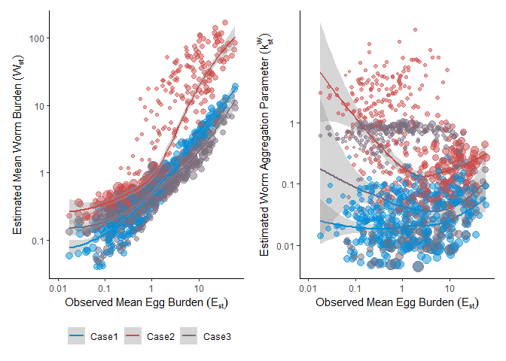

Figure 6: Comparison of mean worm burden and worm aggregation parameter estimates to observed egg burdens in every Shehia_year from ZEST for three data-generating cases. At high observed egg burdens, Case 3 estimates are more similar to Case 1 estimates, while at lower egg burdens, Case 3 estimates appear to stray from Case 1 and towards Case 2 estimates.

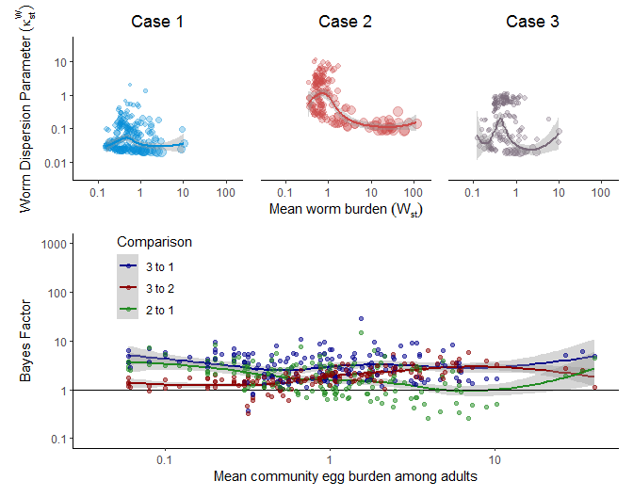

Figure 7: Mean community worm burden by aggregation parameter estimated via approximate Bayesian computation for all three data-generating cases among adults. Bayes factors comparing worm burden and dispersion fits among adult populations.

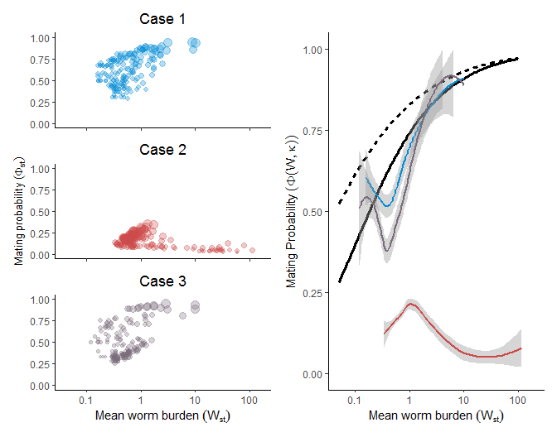

Figure 8: Mating probability observations and comparison to predictions for adult populations.

# References

1. World Health Organization. Ending the neglect to attain the Sustainable Development Goals: A road map for neglected tropical diseases 2021–2030. Geneva; 2020. Available: https://www.who.int/neglected_diseases/Revised-Draft-NTD-Roadmap-23Apr2020.pdf?ua=1

2. Yang Y, Zhou YB, Song XX, Li SZ, Zhong B, Wang TP, et al. Integrated control strategy of schistosomiasis in The People’s Republic of China: Projects Involving agriculture, water conservancy, forestry, sanitation and environmental modification. Adv Parasitol. 2016;92: 237–268. doi:10.1016/bs.apar.2016.02.004

3. Spear R, Zhong B, Liang S. Low Transmission to Elimination: Rural Development as a Key Determinant of the End-Game Dynamics of Schistosoma japonicum in China. Trop Med Infect Dis. 2017;2: 35. doi:10.3390/tropicalmed2030035

4. Liang S, Abe EM, Zhou X-N. Integrating ecological approaches to interrupt schistosomiasis transmission: opportunities and challenges. Infect Dis Poverty. 2018;7: 124. doi:10.1186/s40249-018-0506-4

5. Anderson RM, Turner HC, Farrell SH, Yang J, Truscott JE. What is required in terms of mass drug administration to interrupt the transmission of schistosome parasites in regions of endemic infection? Parasites and Vectors. 2015;8: 553. doi:10.1186/s13071-015-1157-y

6. Faust CL, Osakunor DNM, Downs JA, Kayuni S, Stothard JR, Lamberton PHL, et al. Schistosomiasis Control: Leave No Age Group Behind. Trends in Parasitology. Elsevier Ltd; 2020. pp. 582–591. doi:10.1016/j.pt.2020.04.012

7. Adriko M, Faust CL, Carruthers L V., Moses A, Tukahebwa EM, Lamberton PHL. Low Praziquantel Treatment Coverage for Schistosoma mansoni in Mayuge District, Uganda, Due to the Absence of Treatment Opportunities, Rather Than Systematic Non-Compliance. Trop Med Infect Dis. 2018;3. doi:10.3390/tropicalmed3040111

8. Faust CL, Crotti M, Moses A, Oguttu D, Wamboko A, Adriko M, et al. Two-year longitudinal survey reveals high genetic diversity of Schistosoma mansoni with adult worms surviving praziquantel treatment at the start of mass drug administration in Uganda. Parasites and Vectors. 2019;12: 607. doi:10.1186/s13071-019-3860-6

9. Carlton EJ, Hubbard A, Wang S, Spear RC. Repeated Schistosoma japonicum Infection Following Treatment in Two Cohorts: Evidence for Host Susceptibility to Helminthiasis? Webster JP, editor. PLoS Negl Trop Dis. 2013;7: e2098. doi:10.1371/journal.pntd.0002098

10. Irvine MA, Reimer LJ, Njenga SM, Gunawardena S, Kelly-Hope L, Bockarie M, et al. Modelling strategies to break transmission of lymphatic filariasis - aggregation, adherence and vector competence greatly alter elimination. Parasit Vectors. 2015;8: 547. doi:10.1186/s13071-015-1152-3

11. Wang S, Spear RC. Exploring the Contribution of Host Susceptibility to Epidemiological Patterns of Schistosoma japonicum Infection Using an Individual-Based Model. Am J Trop Med Hyg. 2015;92: 1245–1252. doi:10.4269/ajtmh.14-0691

12. Wang S, Spear RC. Exposure versus Susceptibility as Alternative Bases for New Approaches to Surveillance for Schistosoma japonicum in Low Transmission Environments. Mutapi F, editor. PLoS Negl Trop Dis. 2016;10: e0004425. doi:10.1371/journal.pntd.0004425

13. Toor J, Truscott JE, Werkman M, Turner HC, Phillips AE, King CH, et al. Determining post-treatment surveillance criteria for predicting the elimination of Schistosoma mansoni transmission. Parasit Vectors. 2019;12: 437. doi:10.1186/s13071-019-3611-8

14. Kittur N, Castleman JD, Campbell CH, King CH, Colley DG. Comparison of Schistosoma mansoni Prevalence and Intensity of Infection, as Determined by the Circulating Cathodic Antigen Urine Assay or by the Kato-Katz Fecal Assay: A Systematic Review. Am J Trop Med Hyg. 2016;94: 605–610. doi:10.4269/ajtmh.15-0725

15. Knopp S, Ame SM, Hattendorf J, Ali SM, Khamis IS, Bakar F, et al. Urogenital schistosomiasis elimination in Zanzibar: Accuracy of urine filtration and haematuria reagent strips for diagnosing light intensity Schistosoma haematobium infections. Parasites and Vectors. 2018;11: 552. doi:10.1186/s13071-018-3136-6

16. May RM. Togetherness among Schistosomes: its effects on the dynamics of the infection. Math Biosci. 1977;35: 301–343. doi:10.1016/0025-5564(77)90030-X

17. Bradley DJ, May RM. Consequences of helminth aggregation for the dynamics of schistosomiasis. Trans R Soc Trop Med Hyg. 1978;72: 262–273. doi:10.1016/0035-9203(78)90205-5

18. Anderson RMRM, May RMRM. Infectious Diseases of Humans. New York, NY, NY: Oxford University Press; 1991.

19. Knopp S, Ame SM, Person B, Hattendorf J, Rabone M, Juma S, et al. A 5-Year intervention study on elimination of urogenital schistosomiasis in Zanzibar: Parasitological results of annual cross-sectional surveys. French M, editor. PLoS Negl Trop Dis. 2019;13: e0007268. doi:10.1371/journal.pntd.0007268

20. Knopp S, Person B, Ame SM, Ali SM, Hattendorf J, Juma S, et al. Evaluation of integrated interventions layered on mass drug administration for urogenital schistosomiasis elimination: a cluster-randomised trial. Lancet Glob Heal. 2019;7: e1118–e1129. doi:10.1016/S2214-109X(19)30189-5

21. Person B, Knopp S, Ali SM, A’Kadir FM, Khamis AN, Ali JN, et al. Community co-designed schistosomiasis control interventions for school-aged children in Zanzibar. J Biosoc Sci. 2016;48: S56–S73. doi:10.1017/S0021932016000067

22. Celone M, Person B, Ali SM, Lyimo JH, Mohammed UA, Khamis AN, et al. Increasing the reach: Involving local Muslim religious teachers in a behavioral intervention to eliminate urogenital schistosomiasis in Zanzibar. Acta Trop. 2016;163: 142–148. doi:10.1016/j.actatropica.2016.08.004

23. Lloyd-Smith JO. Maximum Likelihood Estimation of the Negative Binomial Dispersion Parameter for Highly Overdispersed Data, with Applications to Infectious Diseases. Rees M, editor. PLoS One. 2007;2: e180. doi:10.1371/journal.pone.0000180

24. R Core Team. R: A language and environment for statistical computing. Vienna, Austria: R Foundation for Statistical Computing; 2015.

25. Van Lieshout L, Polderman AM, De Vlas SJ, De Caluwé P, Krijger FW, Gryseels B, et al. Analysis of Worm Burden Variation in Human Schistosoma mansoni Infections by Determination of Serum Levels of Circulating Anodic Antigen and Circulating Cathodic Antigen. J Infect Dis. 1995;172: 1336–1342. doi:10.1093/infdis/172.5.1336

26. Hubbard A, Liang S, Maszle D, Qiu D, Gu X, Spear RC. Estimating the distribution of worm burden and egg excretion of Schistosoma japonicum by risk group in Sichuan Province, China. Parasitology. 2002;125: 221–31. Available: http://www.ncbi.nlm.nih.gov/pubmed/12358419

27. De Vlas SJ, Van Oortmarssen GJ, Habbema JD, Gryseels B, Polderman AM. A model for variations in single and repeated egg counts in schistosoma mansoni infections. Parasitology. 1992;104: 451–460. doi:10.1017/S003118200006371X

28. Csilléry K, François O, Blum MGB. Abc: An R package for approximate Bayesian computation (ABC). Methods Ecol Evol. 2012;3: 475–479. doi:10.1111/j.2041-210X.2011.00179.x

29. Halekoh U, Højsgaard S, Yan J. The R package geepack for generalized estimating equations. J Stat Softw. 2006;15: 1–11. doi:10.18637/jss.v015.i02

30. Wickham H, Averick M, Bryan J, Chang W, McGowan L, François R, et al. Welcome to the Tidyverse. J Open Source Softw. 2019;4: 1686. doi:10.21105/joss.01686

31. Klepac P, Metcalf CJE, McLean AR, Hampson K. Towards the endgame and beyond: complexities and challenges for the elimination of infectious diseases. Philos Trans R Soc B Biol Sci. 2013;368: 20120137. doi:10.1098/rstb.2012.0137

32. Landouré A, Dembélé R, Goita S, Kané M, Tuinsma M, Sacko M, et al. Significantly Reduced Intensity of Infection but Persistent Prevalence of Schistosomiasis in a Highly Endemic Region in Mali after Repeated Treatment. Brooker S, editor. PLoS Negl Trop Dis. 2012;6: e1774. doi:10.1371/journal.pntd.0001774

33. Toor J, Alsallaq R, Truscott JE, Turner HC, Werkman M, Gurarie D, et al. Are We on Our Way to Achieving the 2020 Goals for Schistosomiasis Morbidity Control Using Current World Health Organization Guidelines? Clin Infect Dis Achiev WHO Schistosomiasis Goals • CID. 2018: 66. doi:10.1093/cid/ciy001

34. Colley DG, Andros TS, Campbell CH. Schistosomiasis is more prevalent than previously thought: what does it mean for public health goals, policies, strategies, guidelines and intervention programs? Infect Dis Poverty. 2017;6: 63. doi:10.1186/s40249-017-0275-5

35. Spear RC, Seto EYW, Carlton EJ, Liang S, Remais J V, Zhong B, et al. The challenge of effective surveillance in moving from low transmission to elimination of schistosomiasis in China. Int J Parasitol. 2011;41: 1243–7. doi:10.1016/j.ijpara.2011.08.002

36. Arakala A, Hoover CM, Marshall JM, Sokolow SH, De Leo GA, Rohr JR, et al. Estimating the elimination feasibility in the “end game” of control efforts for parasites subjected to regular mass drug administration: Methods and their application to schistosomiasis. Dobson AP, editor. PLoS Negl Trop Dis. 2018;12: e0006794. doi:10.1371/journal.pntd.0006794

37. Boissier J, Grech-Angelini S, Webster BL, Allienne J-F, Huyse T, Mas-Coma S, et al. Outbreak of urogenital schistosomiasis in Corsica (France): an epidemiological case study. Lancet Infect Dis. 2016;16: 971–979. doi:10.1016/S1473-3099(16)00175-4

38. Sokolow SH, Wood CL, Jones IJ, Swartz SJ, Lopez M, Hsieh MH, et al. Global assessment of schistosomiasis control over the past century shows targeting the snail intermediate host works best. Caffrey CR, editor. PLoS Negl Trop Dis. 2016;10: e0004794. doi:10.1371/journal.pntd.0004794

39. Lo NC, Gurarie D, Yoon N, Coulibaly JT, Bendavid E, Andrews JR, et al. Impact and cost-effectiveness of snail control to achieve disease control targets for schistosomiasis. Proc Natl Acad Sci U S A. 2018;115: E584–E591. doi:10.1073/pnas.1708729114

40. Gurarie D, Lo NC, Ndeffo-Mbah ML, Durham DP, King CH. The human-snail transmission environment shapes long term schistosomiasis control outcomes: Implications for improving the accuracy of predictive modeling. Basáñez M-G, editor. PLoS Negl Trop Dis. 2018;12: e0006514. doi:10.1371/journal.pntd.0006514

41. Civitello DJ, Rohr JR. Disentangling the effects of exposure and susceptibility on transmission of the zoonotic parasite *Schistosoma mansoni*. Fenton A, editor. J Anim Ecol. 2014;83: 1379–1386. doi:10.1111/1365-2656.12222

42. Liu Y, Zhong B, Wu Z-S, Liang S, Qiu D-C, Ma X. Interruption of schistosomiasis transmission in mountainous and hilly regions with an integrated strategy: a longitudinal case study in Sichuan, China. Infect Dis Poverty. 2017;6: 79. doi:10.1186/s40249-017-0290-6

43. Webster BL, Diaw OT, Seye MM, Webster JP, Rollinson D. Introgressive Hybridization of Schistosoma haematobium Group Species in Senegal: Species Barrier Break Down between Ruminant and Human Schistosomes. Secor WE, editor. PLoS Negl Trop Dis. 2013;7: e2110. doi:10.1371/journal.pntd.0002110

44. Rudge JW, Webster JP, Lu D-B, Wang T-P, Fang G-R, Basáñez M-G. Identifying host species driving transmission of schistosomiasis japonica, a multihost parasite system, in China. Proc Natl Acad Sci U S A. 2013;110: 11457–62. doi:10.1073/pnas.1221509110