Equity Allocation Outcomes Avoided Results

Chris Hoover et al

2023-06-18

## Process/clean bootstrapped samples and other input data

## used (Mb) gc trigger (Mb) max used (Mb)  
## Ncells 2410737 128.8 44794729 2392.3 55993411 2990.4  
## Vcells 33448427 255.2 2562107236 19547.4 3178157809 24247.5

## Results text

For all three outcomes considered, the candidate model with the best out of sample performance contained an intervention-county interaction term, cumulative case rate, cumulative vaccinated rate, and the percent of the population aged 50 and older (Supplementary Table X). The best model for deaths also included a term for the weekly testing rate, though this model performed only marginally better than one without testing (Supplementary Table X).

From these models, it was estimated that in the eight months following the vaccine equity allocation, 160892 (95%CI: 108878 - 221815) cases, 10248 (95%CI: 6111 - 14853) hospitalizations, and 679 (95%CI: -32 - 1451) deaths were averted in VEM Q1 zip codes. This represents 30.3% of all cases, 27.8% of all hospitalizations, and 11.6% of all deaths that would have occurred in VEM Q1 after the policy. Most of the outcomes averted came after July 1, 2021 during California’s Delta variant wave (Fig 1). However, 22875 (95%CI: 16067 - 30582) cases, 641 (95%CI: 213 - 1108) hospitalizations, and 86 (95%CI: 12 - 168) deaths were averted even in the first two months following the equity allocation.

While 27% of California’s population resides in VEM Q1 areas, residents in VEM Q1 accounted for 37% of cases, 39% of hospitalizations, and 39% of mortalities in the two months before the policy (Fig 2). From the counterfactual analysis in the absence of the policy, this discrepancy is estimated to persist or increase (Fig 2, dashed lines). However, because of the outcomes averted due to the policy, excess COVID-19 cases and–to a lesser extent–hospitalizations in VEM Q1 were reduced (Fig 2, solid lines). Briefly in April and again in July, the number of cases in VEM Q1 reached levels proportionate to the VEM Q1 population ratio, suggesting a lack of excess risk in VEM Q1 (Fig 2). In the absence of the policy, counterfactual estimates suggest that this level would not have been reached.

There was variability in estimated outcomes avoided at the county level. Normalizing by population size, the best performing counties averted 1823.02 (95%CI:30.38 - 5703.11) cases/100,000, 112.14 (95%CI:1.26 - 344.57) hospitalizations/100,000, and 25 (95%CI:-35.97 - 82.51) deaths/100,000, while the worst performing counties averted -133.28 (95%CI:-750.83 - 380.09) cases/100,000, -16.8 (95%CI:-68.62 - 14.06) hospitalizations/100,000, and -73.29 (95%CI:-293.14 - -73.29) deaths/100,000. Negative outcomes averted result from more outcomes estimated in the counterfactual scenarios than were observed, implying the policy had a negative impact in these counties. However, this occurred most commonly in counties with smaller populations. Among counties with a population larger than 100,000 (representing 97.6% of the State’s population), the net rates were 484.69 (95%CI: 327.69 - 666.98) cases/100,000 averted, 30.77 (95%CI: 18.32 - 44.7) hospitalizations/100,000 averted, and 2.28 (95%CI: 0.11 - 4.63) deaths/100,000 averted.

## Figures

### Model predicted vs observed outcomes

#### Cases

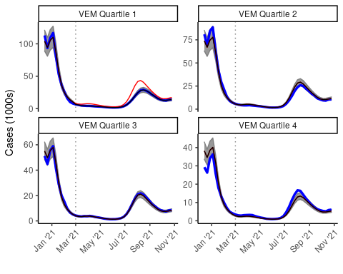

#### Hospitalizations

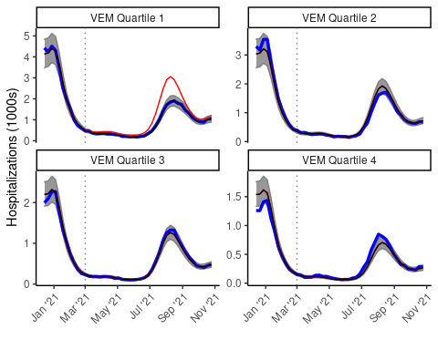

#### Deaths

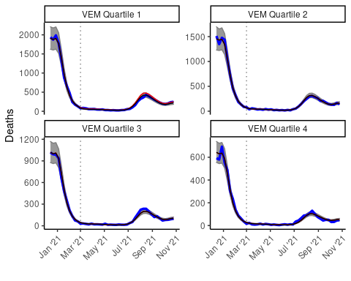

### Cumulative avoided and county results

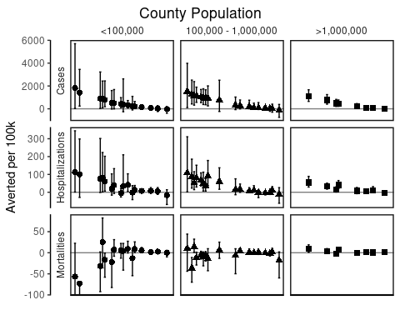

### VEM Quartile Outcomes Averted

### VEM Quartile ratio figures

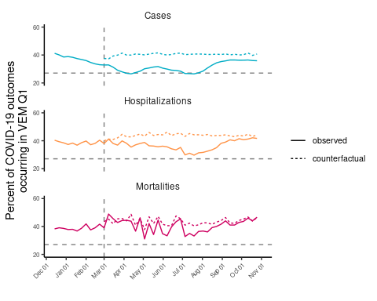

### Counterfactual time series and cumulative avoided base plot

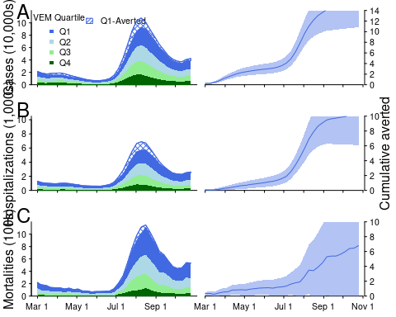

## Model performance table

BASE+int:spline+cumvaxp100k (19) was best performing cases model

BASE+int:spline+cumvaxp100k+testp100k+per50up (31) was best performing hospitalizations model

BASE+int:county+cumvaxp100k+per50up (43) was best performing mortalities model

| Model Terms | Cases MSE (range) | Hospitalizations MSE (range) | Mortalities MSE (range) |
| --- | --- | --- | --- |
| BASE+int:spline+cumvaxp100k | 283 (274 - 288) | 3.03 (3.01 - 3.06) | 0.328 (0.324 - 0.329) |
| BASE+int:county | 285 (274 - 293) | 3.13 (3.07 - 3.39) | 0.321 (0.315 - 0.337) |
| BASE+int:county+cumvaxp100k | 287 (273 - 311) | 7.06 (2.95 - 24.46) | 0.317 (0.312 - 0.332) |
| BASE+cumvaxp100k | 288 (279 - 292) | 3.07 (3.06 - 3.11) | 0.328 (0.325 - 0.33) |
| BASE+int:VEM+cumvaxp100k | 288 (279 - 292) | 3.07 (3.06 - 3.11) | 0.328 (0.325 - 0.33) |
| BASE+int:spline+cumvaxp100k+per50up | 289 (280 - 293) | 2.98 (2.97 - 3.01) | 0.323 (0.32 - 0.325) |
| BASE+int:spline | 290 (279 - 294) | 3.19 (3.18 - 3.22) | 0.336 (0.331 - 0.338) |
| BASE+int:county+per50up | 292 (278 - 312) | 3.11 (3.06 - 3.3) | 0.317 (0.314 - 0.327) |
| BASE+int:spline+per50up | 293 (283 - 298) | 3.18 (3.17 - 3.21) | 0.334 (0.329 - 0.336) |
| BASE+cumvaxp100k+per50up | 293 (284 - 297) | 3.02 (3.01 - 3.06) | 0.324 (0.32 - 0.326) |
| BASE+int:VEM+cumvaxp100k+per50up | 293 (284 - 297) | 3.02 (3.01 - 3.06) | 0.324 (0.32 - 0.326) |
| BASE | 294 (284 - 298) | 3.23 (3.22 - 3.26) | 0.337 (0.332 - 0.339) |
| BASE+int:VEM | 294 (284 - 298) | 3.23 (3.22 - 3.26) | 0.337 (0.332 - 0.339) |
| BASE+int:spline+cumvaxp100k+testp100k | 294 (285 - 300) | 3 (2.99 - 3.03) | 0.33 (0.327 - 0.332) |
| BASE+int:county+cumvaxp100k+testp100k | 294 (276 - 327) | 7.18 (2.95 - 24.03) | 0.32 (0.314 - 0.335) |
| BASE+int:county+cumvaxp100k+per50up | 295 (278 - 332) | 5.83 (2.91 - 18.66) | 0.312 (0.31 - 0.32) |
| BASE+int:VEM+cumvaxp100k+testp100k | 297 (285 - 303) | 3.06 (3.04 - 3.09) | 0.331 (0.328 - 0.333) |
| BASE+cumvaxp100k+testp100k | 297 (285 - 303) | 3.06 (3.04 - 3.09) | 0.331 (0.328 - 0.333) |
| BASE+int:VEM+per50up | 297 (287 - 301) | 3.22 (3.21 - 3.25) | 0.335 (0.33 - 0.337) |
| BASE+per50up | 297 (287 - 301) | 3.22 (3.21 - 3.25) | 0.335 (0.33 - 0.337) |
| BASE+int:spline+cumvaxp100k+testp100k+per50up | 299 (289 - 305) | 2.97 (2.96 - 3) | 0.327 (0.323 - 0.329) |
| BASE+int:county+cumcasep100k+cumvaxp100k | 300 (286 - 306) | 3.78 (3.01 - 6.96) | 0.324 (0.315 - 0.347) |
| BASE+int:county+cumcasep100k+cumvaxp100k+per50up | 300 (287 - 306) | 3.26 (2.98 - 4.47) | 0.318 (0.313 - 0.327) |
| BASE+int:county+cumcasep100k+per50up | 301 (288 - 306) | 3.14 (3.12 - 3.19) | 0.322 (0.317 - 0.335) |
| BASE+int:county+cumcasep100k | 301 (288 - 306) | 3.15 (3.13 - 3.22) | 0.327 (0.318 - 0.352) |
| BASE+cumvaxp100k+testp100k+per50up | 302 (290 - 307) | 3.02 (3 - 3.05) | 0.327 (0.324 - 0.329) |
| BASE+int:VEM+cumvaxp100k+testp100k+per50up | 302 (290 - 307) | 3.02 (3 - 3.05) | 0.327 (0.324 - 0.329) |
| BASE+int:spline+testp100k | 302 (290 - 313) | 3.15 (3.14 - 3.18) | 0.337 (0.332 - 0.34) |
| BASE+int:county+cumvaxp100k+testp100k+per50up | 304 (281 - 354) | 6.01 (2.92 - 18.94) | 0.314 (0.312 - 0.322) |
| BASE+int:spline+testp100k+per50up | 304 (293 - 311) | 3.15 (3.14 - 3.17) | 0.337 (0.331 - 0.339) |
| BASE+int:VEM+testp100k+per50up | 307 (294 - 316) | 3.19 (3.18 - 3.22) | 0.337 (0.332 - 0.34) |
| BASE+testp100k+per50up | 307 (294 - 316) | 3.19 (3.18 - 3.22) | 0.337 (0.332 - 0.34) |
| BASE+testp100k | 308 (291 - 326) | 3.2 (3.19 - 3.23) | 0.338 (0.333 - 0.341) |
| BASE+int:VEM+testp100k | 308 (291 - 326) | 3.2 (3.19 - 3.23) | 0.338 (0.333 - 0.341) |
| BASE+int:county+cumcasep100k+cumvaxp100k+testp100k | 308 (293 - 322) | 3.68 (3.01 - 6.42) | 0.326 (0.316 - 0.349) |
| BASE+int:county+cumcasep100k+cumvaxp100k+testp100k+per50up | 309 (294 - 322) | 3.24 (2.98 - 4.28) | 0.319 (0.315 - 0.329) |
| BASE+int:spline+cumcasep100k+cumvaxp100k | 313 (302 - 321) | 3.12 (3.11 - 3.15) | 0.333 (0.33 - 0.335) |
| BASE+int:spline+cumcasep100k+cumvaxp100k+per50up | 314 (303 - 322) | 3.08 (3.06 - 3.1) | 0.33 (0.327 - 0.332) |
| BASE+int:VEM+cumcasep100k+cumvaxp100k | 317 (306 - 325) | 3.17 (3.15 - 3.2) | 0.334 (0.331 - 0.336) |
| BASE+cumcasep100k+cumvaxp100k | 317 (306 - 325) | 3.17 (3.15 - 3.2) | 0.334 (0.331 - 0.336) |
| BASE+int:spline+cumcasep100k | 317 (305 - 325) | 3.29 (3.28 - 3.31) | 0.342 (0.337 - 0.344) |
| BASE+int:spline+cumcasep100k+per50up | 318 (305 - 325) | 3.29 (3.27 - 3.3) | 0.341 (0.336 - 0.343) |
| BASE+int:VEM+cumcasep100k+cumvaxp100k+per50up | 318 (307 - 326) | 3.13 (3.11 - 3.15) | 0.331 (0.328 - 0.333) |
| BASE+cumcasep100k+cumvaxp100k+per50up | 318 (307 - 326) | 3.13 (3.11 - 3.15) | 0.331 (0.328 - 0.333) |
| BASE+cumcasep100k | 321 (310 - 329) | 3.34 (3.32 - 3.36) | 0.343 (0.338 - 0.345) |
| BASE+int:VEM+cumcasep100k | 321 (310 - 329) | 3.34 (3.32 - 3.36) | 0.343 (0.338 - 0.345) |
| BASE+int:VEM+cumcasep100k+per50up | 321 (310 - 329) | 3.33 (3.32 - 3.35) | 0.342 (0.337 - 0.344) |
| BASE+cumcasep100k+per50up | 321 (310 - 329) | 3.33 (3.32 - 3.35) | 0.342 (0.337 - 0.344) |
| BASE+int:spline+cumcasep100k+cumvaxp100k+testp100k | 322 (312 - 333) | 3.07 (3.05 - 3.09) | 0.334 (0.33 - 0.336) |
| BASE+int:spline+cumcasep100k+cumvaxp100k+testp100k+per50up | 323 (312 - 333) | 3.03 (3.01 - 3.05) | 0.332 (0.328 - 0.334) |
| BASE+cumcasep100k+cumvaxp100k+testp100k | 325 (313 - 336) | 3.12 (3.11 - 3.15) | 0.335 (0.331 - 0.337) |
| BASE+int:VEM+cumcasep100k+cumvaxp100k+testp100k | 325 (313 - 336) | 3.12 (3.11 - 3.15) | 0.335 (0.331 - 0.337) |
| BASE+cumcasep100k+cumvaxp100k+testp100k+per50up | 325 (313 - 336) | 3.09 (3.07 - 3.11) | 0.333 (0.329 - 0.335) |
| BASE+int:VEM+cumcasep100k+cumvaxp100k+testp100k+per50up | 325 (313 - 336) | 3.09 (3.07 - 3.11) | 0.333 (0.329 - 0.335) |
| BASE+int:spline+cumcasep100k+testp100k+per50up | 325 (313 - 337) | 3.21 (3.2 - 3.23) | 0.341 (0.335 - 0.343) |
| BASE+int:spline+cumcasep100k+testp100k | 326 (313 - 338) | 3.21 (3.2 - 3.23) | 0.341 (0.336 - 0.343) |
| BASE+int:VEM+cumcasep100k+testp100k+per50up | 329 (315 - 343) | 3.27 (3.25 - 3.29) | 0.342 (0.337 - 0.344) |
| BASE+cumcasep100k+testp100k+per50up | 329 (315 - 343) | 3.27 (3.25 - 3.29) | 0.342 (0.337 - 0.344) |
| BASE+int:VEM+cumcasep100k+testp100k | 330 (315 - 346) | 3.27 (3.26 - 3.29) | 0.342 (0.337 - 0.344) |
| BASE+cumcasep100k+testp100k | 330 (315 - 346) | 3.27 (3.26 - 3.29) | 0.342 (0.337 - 0.344) |
| BASE+int:county+testp100k+per50up | 336 (284 - 403) | 3.11 (3.06 - 3.3) | 0.319 (0.317 - 0.329) |
| BASE+int:county+cumcasep100k+testp100k+per50up | 409 (294 - 559) | 3.13 (3.11 - 3.18) | 0.324 (0.318 - 0.336) |
| BASE+int:county+cumcasep100k+testp100k | 486 (294 - 724) | 3.14 (3.11 - 3.21) | 0.329 (0.319 - 0.353) |
| BASE+int:county+testp100k | 488 (280 - 826) | 3.13 (3.07 - 3.39) | 0.323 (0.317 - 0.339) |

| Model Terms | Cases MSE (range) | Estimated Cases Avoided* (95%CI) |
| --- | --- | --- |
| BASE+int:spline+cumvaxp100k | 283 (274 - 288) | 160892 (108878 - 221815) |
| BASE+int:county | 285 (274 - 293) | 120180 (84380 - 183261) |
| BASE+int:county+cumvaxp100k | 287 (273 - 311) | 146065 (103028 - 194294) |
| BASE+cumvaxp100k | 288 (279 - 292) | 158814 (97975 - 216603) |
| BASE+int:VEM+cumvaxp100k | 288 (279 - 292) | 157483 (108612 - 212641) |
| BASE+int:spline+cumvaxp100k+per50up | 289 (280 - 293) | 146678 (98634 - 203670) |
| BASE+int:spline | 290 (279 - 294) | 122020 (76147 - 161699) |
| BASE+int:county+per50up | 292 (278 - 312) | 118670 (74653 - 176585) |
| BASE+int:spline+per50up | 293 (283 - 298) | 124645 (86013 - 164348) |
| BASE+cumvaxp100k+per50up | 293 (284 - 297) | 148395 (110207 - 212662) |
| BASE+int:VEM+cumvaxp100k+per50up | 293 (284 - 297) |  |
| BASE | 294 (284 - 298) |  |
| BASE+int:VEM | 294 (284 - 298) |  |
| BASE+int:spline+cumvaxp100k+testp100k | 294 (285 - 300) |  |
| BASE+int:county+cumvaxp100k+testp100k | 294 (276 - 327) |  |
| BASE+int:county+cumvaxp100k+per50up | 295 (278 - 332) |  |
| BASE+int:VEM+cumvaxp100k+testp100k | 297 (285 - 303) |  |
| BASE+cumvaxp100k+testp100k | 297 (285 - 303) |  |
| BASE+int:VEM+per50up | 297 (287 - 301) |  |
| BASE+per50up | 297 (287 - 301) |  |
| BASE+int:spline+cumvaxp100k+testp100k+per50up | 299 (289 - 305) |  |
| BASE+int:county+cumcasep100k+cumvaxp100k | 300 (286 - 306) |  |
| BASE+int:county+cumcasep100k+cumvaxp100k+per50up | 300 (287 - 306) |  |
| BASE+int:county+cumcasep100k+per50up | 301 (288 - 306) |  |
| BASE+int:county+cumcasep100k | 301 (288 - 306) |  |
| BASE+cumvaxp100k+testp100k+per50up | 302 (290 - 307) |  |
| BASE+int:VEM+cumvaxp100k+testp100k+per50up | 302 (290 - 307) |  |
| BASE+int:spline+testp100k | 302 (290 - 313) |  |
| BASE+int:county+cumvaxp100k+testp100k+per50up | 304 (281 - 354) |  |
| BASE+int:spline+testp100k+per50up | 304 (293 - 311) |  |
| BASE+int:VEM+testp100k+per50up | 307 (294 - 316) |  |
| BASE+testp100k+per50up | 307 (294 - 316) |  |
| BASE+testp100k | 308 (291 - 326) |  |
| BASE+int:VEM+testp100k | 308 (291 - 326) |  |
| BASE+int:county+cumcasep100k+cumvaxp100k+testp100k | 308 (293 - 322) |  |
| BASE+int:county+cumcasep100k+cumvaxp100k+testp100k+per50up | 309 (294 - 322) |  |
| BASE+int:spline+cumcasep100k+cumvaxp100k | 313 (302 - 321) |  |
| BASE+int:spline+cumcasep100k+cumvaxp100k+per50up | 314 (303 - 322) |  |
| BASE+int:VEM+cumcasep100k+cumvaxp100k | 317 (306 - 325) |  |
| BASE+cumcasep100k+cumvaxp100k | 317 (306 - 325) |  |
| BASE+int:spline+cumcasep100k | 317 (305 - 325) |  |
| BASE+int:spline+cumcasep100k+per50up | 318 (305 - 325) |  |
| BASE+int:VEM+cumcasep100k+cumvaxp100k+per50up | 318 (307 - 326) |  |
| BASE+cumcasep100k+cumvaxp100k+per50up | 318 (307 - 326) |  |
| BASE+cumcasep100k | 321 (310 - 329) |  |
| BASE+int:VEM+cumcasep100k | 321 (310 - 329) |  |
| BASE+int:VEM+cumcasep100k+per50up | 321 (310 - 329) |  |
| BASE+cumcasep100k+per50up | 321 (310 - 329) |  |
| BASE+int:spline+cumcasep100k+cumvaxp100k+testp100k | 322 (312 - 333) |  |
| BASE+int:spline+cumcasep100k+cumvaxp100k+testp100k+per50up | 323 (312 - 333) |  |
| BASE+cumcasep100k+cumvaxp100k+testp100k | 325 (313 - 336) |  |
| BASE+int:VEM+cumcasep100k+cumvaxp100k+testp100k | 325 (313 - 336) |  |
| BASE+cumcasep100k+cumvaxp100k+testp100k+per50up | 325 (313 - 336) |  |
| BASE+int:VEM+cumcasep100k+cumvaxp100k+testp100k+per50up | 325 (313 - 336) |  |
| BASE+int:spline+cumcasep100k+testp100k+per50up | 325 (313 - 337) |  |
| BASE+int:spline+cumcasep100k+testp100k | 326 (313 - 338) |  |
| BASE+int:VEM+cumcasep100k+testp100k+per50up | 329 (315 - 343) |  |
| BASE+cumcasep100k+testp100k+per50up | 329 (315 - 343) |  |
| BASE+int:VEM+cumcasep100k+testp100k | 330 (315 - 346) |  |
| BASE+cumcasep100k+testp100k | 330 (315 - 346) |  |
| BASE+int:county+testp100k+per50up | 336 (284 - 403) |  |
| BASE+int:county+cumcasep100k+testp100k+per50up | 409 (294 - 559) |  |
| BASE+int:county+cumcasep100k+testp100k | 486 (294 - 724) |  |
| BASE+int:county+testp100k | 488 (280 - 826) |  |

| Model Terms | Hospitalizations MSE (range) | Estimated Hospitalizations Avoided* (95%CI) |
| --- | --- | --- |
| BASE+int:spline+cumvaxp100k+testp100k+per50up | 2.97 (2.96 - 3) | 10248 (6111 - 14853) |
| BASE+int:spline+cumvaxp100k+per50up | 2.98 (2.97 - 3.01) | 10322 (7265 - 15491) |
| BASE+int:spline+cumvaxp100k+testp100k | 3 (2.99 - 3.03) | 10172 (6234 - 14106) |
| BASE+cumvaxp100k+testp100k+per50up | 3.02 (3 - 3.05) | 10003 (5932 - 14985) |
| BASE+int:VEM+cumvaxp100k+testp100k+per50up | 3.02 (3 - 3.05) | 10128 (5680 - 13860) |
| BASE+cumvaxp100k+per50up | 3.02 (3.01 - 3.06) | 9513 (5870 - 14392) |
| BASE+int:VEM+cumvaxp100k+per50up | 3.02 (3.01 - 3.06) | 10088 (6736 - 13516) |
| BASE+int:spline+cumvaxp100k | 3.03 (3.01 - 3.06) | 9328 (5701 - 13920) |
| BASE+int:spline+cumcasep100k+cumvaxp100k+testp100k+per50up | 3.03 (3.01 - 3.05) | 11703 (8208 - 16767) |
| BASE+int:VEM+cumvaxp100k+testp100k | 3.06 (3.04 - 3.09) | 9303 (5447 - 13518) |
| BASE+cumvaxp100k+testp100k | 3.06 (3.04 - 3.09) |  |
| BASE+int:spline+cumcasep100k+cumvaxp100k+testp100k | 3.07 (3.05 - 3.09) |  |
| BASE+cumvaxp100k | 3.07 (3.06 - 3.11) |  |
| BASE+int:VEM+cumvaxp100k | 3.07 (3.06 - 3.11) |  |
| BASE+int:spline+cumcasep100k+cumvaxp100k+per50up | 3.08 (3.06 - 3.1) |  |
| BASE+cumcasep100k+cumvaxp100k+testp100k+per50up | 3.09 (3.07 - 3.11) |  |
| BASE+int:VEM+cumcasep100k+cumvaxp100k+testp100k+per50up | 3.09 (3.07 - 3.11) |  |
| BASE+int:county+per50up | 3.11 (3.06 - 3.3) |  |
| BASE+int:county+testp100k+per50up | 3.11 (3.06 - 3.3) |  |
| BASE+int:spline+cumcasep100k+cumvaxp100k | 3.12 (3.11 - 3.15) |  |
| BASE+int:VEM+cumcasep100k+cumvaxp100k+testp100k | 3.12 (3.11 - 3.15) |  |
| BASE+cumcasep100k+cumvaxp100k+testp100k | 3.12 (3.11 - 3.15) |  |
| BASE+cumcasep100k+cumvaxp100k+per50up | 3.13 (3.11 - 3.15) |  |
| BASE+int:VEM+cumcasep100k+cumvaxp100k+per50up | 3.13 (3.11 - 3.15) |  |
| BASE+int:county+cumcasep100k+testp100k+per50up | 3.13 (3.11 - 3.18) |  |
| BASE+int:county | 3.13 (3.07 - 3.39) |  |
| BASE+int:county+testp100k | 3.13 (3.07 - 3.39) |  |
| BASE+int:county+cumcasep100k+testp100k | 3.14 (3.11 - 3.21) |  |
| BASE+int:county+cumcasep100k+per50up | 3.14 (3.12 - 3.19) |  |
| BASE+int:spline+testp100k+per50up | 3.15 (3.14 - 3.17) |  |
| BASE+int:county+cumcasep100k | 3.15 (3.13 - 3.22) |  |
| BASE+int:spline+testp100k | 3.15 (3.14 - 3.18) |  |
| BASE+cumcasep100k+cumvaxp100k | 3.17 (3.15 - 3.2) |  |
| BASE+int:VEM+cumcasep100k+cumvaxp100k | 3.17 (3.15 - 3.2) |  |
| BASE+int:spline+per50up | 3.18 (3.17 - 3.21) |  |
| BASE+int:VEM+testp100k+per50up | 3.19 (3.18 - 3.22) |  |
| BASE+testp100k+per50up | 3.19 (3.18 - 3.22) |  |
| BASE+int:spline | 3.19 (3.18 - 3.22) |  |
| BASE+int:VEM+testp100k | 3.2 (3.19 - 3.23) |  |
| BASE+testp100k | 3.2 (3.19 - 3.23) |  |
| BASE+int:spline+cumcasep100k+testp100k+per50up | 3.21 (3.2 - 3.23) |  |
| BASE+int:spline+cumcasep100k+testp100k | 3.21 (3.2 - 3.23) |  |
| BASE+per50up | 3.22 (3.21 - 3.25) |  |
| BASE+int:VEM+per50up | 3.22 (3.21 - 3.25) |  |
| BASE | 3.23 (3.22 - 3.26) |  |
| BASE+int:VEM | 3.23 (3.22 - 3.26) |  |
| BASE+int:county+cumcasep100k+cumvaxp100k+testp100k+per50up | 3.24 (2.98 - 4.28) |  |
| BASE+int:county+cumcasep100k+cumvaxp100k+per50up | 3.26 (2.98 - 4.47) |  |
| BASE+cumcasep100k+testp100k+per50up | 3.27 (3.25 - 3.29) |  |
| BASE+int:VEM+cumcasep100k+testp100k+per50up | 3.27 (3.25 - 3.29) |  |
| BASE+cumcasep100k+testp100k | 3.27 (3.26 - 3.29) |  |
| BASE+int:VEM+cumcasep100k+testp100k | 3.27 (3.26 - 3.29) |  |
| BASE+int:spline+cumcasep100k+per50up | 3.29 (3.27 - 3.3) |  |
| BASE+int:spline+cumcasep100k | 3.29 (3.28 - 3.31) |  |
| BASE+cumcasep100k+per50up | 3.33 (3.32 - 3.35) |  |
| BASE+int:VEM+cumcasep100k+per50up | 3.33 (3.32 - 3.35) |  |
| BASE+cumcasep100k | 3.34 (3.32 - 3.36) |  |
| BASE+int:VEM+cumcasep100k | 3.34 (3.32 - 3.36) |  |
| BASE+int:county+cumcasep100k+cumvaxp100k+testp100k | 3.68 (3.01 - 6.42) |  |
| BASE+int:county+cumcasep100k+cumvaxp100k | 3.78 (3.01 - 6.96) |  |
| BASE+int:county+cumvaxp100k+per50up | 5.83 (2.91 - 18.66) |  |
| BASE+int:county+cumvaxp100k+testp100k+per50up | 6.01 (2.92 - 18.94) |  |
| BASE+int:county+cumvaxp100k | 7.06 (2.95 - 24.46) |  |
| BASE+int:county+cumvaxp100k+testp100k | 7.18 (2.95 - 24.03) |  |

| Model Terms | Mortalities MSE (range) | Estimated Deaths Avoided* (95%CI) |
| --- | --- | --- |
| BASE+int:county+cumvaxp100k+per50up | 0.312 (0.31 - 0.32) | 679 (-32 - 1451) |
| BASE+int:county+cumvaxp100k+testp100k+per50up | 0.314 (0.312 - 0.322) | 770 (160 - 1694) |
| BASE+int:county+per50up | 0.317 (0.314 - 0.327) | -354 (-978 - 280) |
| BASE+int:county+cumvaxp100k | 0.317 (0.312 - 0.332) | 492 (-204 - 1354) |
| BASE+int:county+cumcasep100k+cumvaxp100k+per50up | 0.318 (0.313 - 0.327) | 962 (187 - 1718) |
| BASE+int:county+cumcasep100k+cumvaxp100k+testp100k+per50up | 0.319 (0.315 - 0.329) | 969 (212 - 1824) |
| BASE+int:county+testp100k+per50up | 0.319 (0.317 - 0.329) | -298 (-948 - 200) |
| BASE+int:county+cumvaxp100k+testp100k | 0.32 (0.314 - 0.335) | 535 (-201 - 1224) |
| BASE+int:county | 0.321 (0.315 - 0.337) | -329 (-937 - 175) |
| BASE+int:county+cumcasep100k+per50up | 0.322 (0.317 - 0.335) | -134 (-683 - 594) |
| BASE+int:county+testp100k | 0.323 (0.317 - 0.339) |  |
| BASE+int:spline+cumvaxp100k+per50up | 0.323 (0.32 - 0.325) |  |
| BASE+int:county+cumcasep100k+testp100k+per50up | 0.324 (0.318 - 0.336) |  |
| BASE+cumvaxp100k+per50up | 0.324 (0.32 - 0.326) |  |
| BASE+int:VEM+cumvaxp100k+per50up | 0.324 (0.32 - 0.326) |  |
| BASE+int:county+cumcasep100k+cumvaxp100k | 0.324 (0.315 - 0.347) |  |
| BASE+int:county+cumcasep100k+cumvaxp100k+testp100k | 0.326 (0.316 - 0.349) |  |
| BASE+int:spline+cumvaxp100k+testp100k+per50up | 0.327 (0.323 - 0.329) |  |
| BASE+cumvaxp100k+testp100k+per50up | 0.327 (0.324 - 0.329) |  |
| BASE+int:VEM+cumvaxp100k+testp100k+per50up | 0.327 (0.324 - 0.329) |  |
| BASE+int:county+cumcasep100k | 0.327 (0.318 - 0.352) |  |
| BASE+int:spline+cumvaxp100k | 0.328 (0.324 - 0.329) |  |
| BASE+int:VEM+cumvaxp100k | 0.328 (0.325 - 0.33) |  |
| BASE+cumvaxp100k | 0.328 (0.325 - 0.33) |  |
| BASE+int:county+cumcasep100k+testp100k | 0.329 (0.319 - 0.353) |  |
| BASE+int:spline+cumcasep100k+cumvaxp100k+per50up | 0.33 (0.327 - 0.332) |  |
| BASE+int:spline+cumvaxp100k+testp100k | 0.33 (0.327 - 0.332) |  |
| BASE+cumvaxp100k+testp100k | 0.331 (0.328 - 0.333) |  |
| BASE+int:VEM+cumvaxp100k+testp100k | 0.331 (0.328 - 0.333) |  |
| BASE+int:VEM+cumcasep100k+cumvaxp100k+per50up | 0.331 (0.328 - 0.333) |  |
| BASE+cumcasep100k+cumvaxp100k+per50up | 0.331 (0.328 - 0.333) |  |
| BASE+int:spline+cumcasep100k+cumvaxp100k+testp100k+per50up | 0.332 (0.328 - 0.334) |  |
| BASE+int:VEM+cumcasep100k+cumvaxp100k+testp100k+per50up | 0.333 (0.329 - 0.335) |  |
| BASE+cumcasep100k+cumvaxp100k+testp100k+per50up | 0.333 (0.329 - 0.335) |  |
| BASE+int:spline+cumcasep100k+cumvaxp100k | 0.333 (0.33 - 0.335) |  |
| BASE+int:VEM+cumcasep100k+cumvaxp100k | 0.334 (0.331 - 0.336) |  |
| BASE+cumcasep100k+cumvaxp100k | 0.334 (0.331 - 0.336) |  |
| BASE+int:spline+cumcasep100k+cumvaxp100k+testp100k | 0.334 (0.33 - 0.336) |  |
| BASE+int:spline+per50up | 0.334 (0.329 - 0.336) |  |
| BASE+int:VEM+per50up | 0.335 (0.33 - 0.337) |  |
| BASE+per50up | 0.335 (0.33 - 0.337) |  |
| BASE+int:VEM+cumcasep100k+cumvaxp100k+testp100k | 0.335 (0.331 - 0.337) |  |
| BASE+cumcasep100k+cumvaxp100k+testp100k | 0.335 (0.331 - 0.337) |  |
| BASE+int:spline | 0.336 (0.331 - 0.338) |  |
| BASE+int:spline+testp100k+per50up | 0.337 (0.331 - 0.339) |  |
| BASE | 0.337 (0.332 - 0.339) |  |
| BASE+int:VEM | 0.337 (0.332 - 0.339) |  |
| BASE+testp100k+per50up | 0.337 (0.332 - 0.34) |  |
| BASE+int:VEM+testp100k+per50up | 0.337 (0.332 - 0.34) |  |
| BASE+int:spline+testp100k | 0.337 (0.332 - 0.34) |  |
| BASE+testp100k | 0.338 (0.333 - 0.341) |  |
| BASE+int:VEM+testp100k | 0.338 (0.333 - 0.341) |  |
| BASE+int:spline+cumcasep100k+testp100k | 0.341 (0.336 - 0.343) |  |
| BASE+int:spline+cumcasep100k+testp100k+per50up | 0.341 (0.335 - 0.343) |  |
| BASE+int:spline+cumcasep100k+per50up | 0.341 (0.336 - 0.343) |  |
| BASE+int:VEM+cumcasep100k+testp100k | 0.342 (0.337 - 0.344) |  |
| BASE+cumcasep100k+testp100k | 0.342 (0.337 - 0.344) |  |
| BASE+int:VEM+cumcasep100k+per50up | 0.342 (0.337 - 0.344) |  |
| BASE+cumcasep100k+per50up | 0.342 (0.337 - 0.344) |  |
| BASE+cumcasep100k+testp100k+per50up | 0.342 (0.337 - 0.344) |  |
| BASE+int:VEM+cumcasep100k+testp100k+per50up | 0.342 (0.337 - 0.344) |  |
| BASE+int:spline+cumcasep100k | 0.342 (0.337 - 0.344) |  |
| BASE+cumcasep100k | 0.343 (0.338 - 0.345) |  |
| BASE+int:VEM+cumcasep100k | 0.343 (0.338 - 0.345) |  |

## Scratch

### Octiles Sensitivity Analysis

### GGplot Fig 1

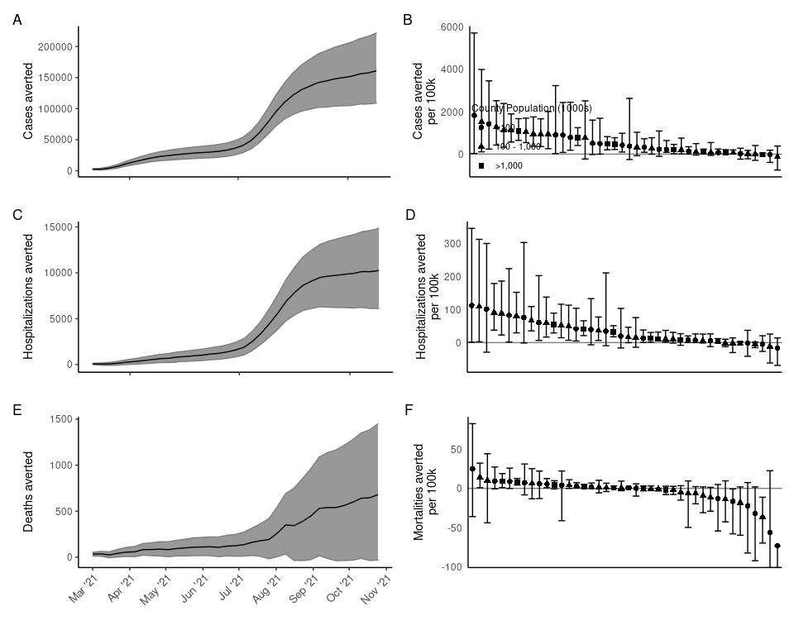

Cumulative cases (A), hospitalizations (C), and deaths (E) averted by week from March 1, 2021 when the vaccine equity allocation was implemented through the end of August 2021. Solid lines indicate the median and shading the 95% credible intervals from 10,000 non-parametric bootstrapping samples of zip codes. Cumulative cases (B), hospitalizations (D) and mortalities (F) per 100,000 by county at the end of the time period. Points are symbolized according to county population and show the median from 10,000 bootstrapped replicates. Error bars represent the 95% credible intervals from bootstrapped replicates.

### Vax avd corr