Equity Allocation Impact Evaluation

Chris Hoover et al

2023-11-24

# Background

As part of the State of California’s focus on health equity, vaccine allocation as of March 2, 2021 was determined by the Vaccine Equity Metric (VEM), derived from the Healthy Places Index. Specifically, zip codes in the lowest HPI quartile received double the allotment of vaccines as other quartiles. [Additional measures](https://www.gov.ca.gov/wp-content/uploads/2021/03/Equitable-Vaccine-Administration-Fact-Sheet.pdf) to ensure that vaccines alloted to these areas were administered to residents rather than more advantaged individuals in neighboring areas were also enacted. This analysis seeks to evaluate the impact of these efforts on vaccination rates as well as key covid-19 outcomes including cases, hospitalizations, and deaths.

# Effect on vaccinations administered

## Approach

A difference in differences analysis using a poisson mixed effects model with a random intercept for county and main effects for binary hpi quartile 1 status, binary intervention period (before/after March 01, 2021), and their interaction of the form:

$$logE\left(y_{ij}|X\right)=log\left(N_{ij}\right)+β_{0}+β_{1}Int_{ij}+β_{2}After_{ij}+β_{3}Int_{ij}×After_{ij}+β_{4}Cnty_{i}$$

Where:

$$logE\left(y_{ij}|X\right)∼Pois\left(λ\right)$$

$$α∼N\left(0,σ^{2}\right)$$

are fitted, where $exp\left(β_{3}\right)$ is the difference in differences (DiD) coefficient–the ratio of rate ratios–indicating the change in vaccination rate in HPI Q1 zip codes compared to non-Q1 zip codes following March 8th.

## Results

### Parallel trends

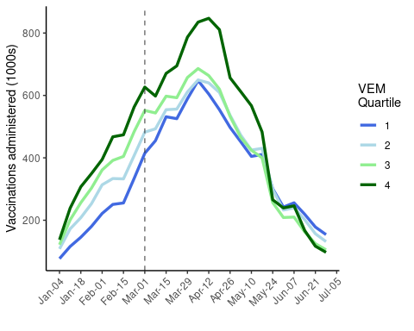

### Raw vaccination rate pre post

Nearly 14.9 million vaccines were administered in California in the four weeks before and after the vaccine equity allocation on March 01, 2021 (February 01, 2021 - March 22, 2021). The vaccination rate per 100,000 in this time period was highest in VEM Q4 and lowest in VEM Q1 (Table 1). However, the vaccination rate increased the most in VEM Q1 following the equity allocation, going from 9998 vaccinations/100,000 in the four weeks before the equity allocation to 18146 vaccinations/100,000 in the four weeks after (Table 1).

| VEM Quartile | Population | Before | After |
| --- | --- | --- | --- |
| 1 | 10617434 | 1061509 (9998) | 1926615 (18146) |
| 2 | 9902750 | 1386711 (14003) | 2085838 (21063) |
| 3 | 9397006 | 1641233 (17465) | 2285986 (24327) |
| 4 | 9298697 | 1898517 (20417) | 2589952 (27853) |

### Diff in diff and sensitivity analyses

From the DiD model, the vaccination rate in VEM Q1 zip codes in the four weeks following the equity allocation was estimated to increase by an additional 28.4% (95%CI: 22.1% - 35.1%) compared to all non-VEM Q1 zip codes. Adjusting for the proportion of the population unvaccinated led to a slight increase in the effect estimate to 26.9 (95%CI: 20.9% - 33.1%). Pairwise comparisons among all VEM quartiles in the negative controls analysis suggest there were also significant relative increases in the vaccination rate among VEM Q2 zip codes compared to VEM Q3 and Q4 zip codes (8% (2.4% - 13.8%) and 10.3% (5% - 15.7%), respectively) in the after-policy period. These increases were smaller than the rate increases in VEM Q1 compared to Q3 and Q4, but may suggest te presence of additional factors that influenced vaccination rates at the time the policy was implemented (Supplementary table X). Finally, restricting the analysis to zip codes in the second or third VEM octiles for better exchangeability between treated and untreated groups led to a reduced estimate of 8.9% (95%CI: 1.1% - 17.2%).

Difference in differences estimates for negative controls sensitivity analysis comparing all combinations of VEM quartiles

| Ref Quartile | VEM Q1 | VEM Q2 | VEM Q3 |
| --- | --- | --- | --- |
| 2 | 20.7% (13.8% - 27.9%) |  |  |
| 3 | 30.3% (23% - 38.1%) | 8% (2.4% - 13.8%) |  |
| 4 | 33% (26.2% - 40.3%) | 10.3% (5% - 15.7%) | 2.1% (-2.7% - 7.1%) |

Difference in differences estimates for negative controls sensitivity analysis comparing all combinations of VEM quartiles and using different pre/post policy periods.

| Ref Quartile | Pre/Post Period | VEM Q1 | VEM Q2 | VEM Q3 |
| --- | --- | --- | --- | --- |
| 2 | 8 weeks | 26.7% (19.4% - 34.4%) |  |  |
| 3 | 8 weeks | 40.5% (32.5% - 48.9%) | 10.9% (5.2% - 16.9%) |  |
| 4 | 8 weeks | 36.6% (29.3% - 44.4%) | 7.9% (2.6% - 13.4%) | -2.8% (-7.3% - 2.1%) |
| 2 | 4 weeks | 20.7% (13.8% - 27.9%) |  |  |
| 3 | 4 weeks | 30.3% (23% - 38.1%) | 8% (2.4% - 13.8%) |  |
| 4 | 4 weeks | 33% (26.2% - 40.3%) | 10.3% (5% - 15.7%) | 2.1% (-2.7% - 7.1%) |
| 2 | 2 weeks | 11.9% (5.4% - 18.8%) |  |  |
| 3 | 2 weeks | 19.7% (12.6% - 27.1%) | 6.9% (1.3% - 12.9%) |  |
| 4 | 2 weeks | 24.9% (18.2% - 32%) | 11.6% (6.2% - 17.4%) | 4.4% (-0.7% - 9.8%) |