### Appendix

Vaccination difference in differences assumptions and sensitivity analyses

We conducted a number of sensitivity analyses to validate the robustness of key results to assumptions of the main analysis. Appendix Figure S1 below shows vaccinations administered by VEM quartile in the first half of 2021, clearly demonstrating the parallel trends assumption in the pre-policy period necessary for difference in differences analysis is met. The first assumption tested in sensitivity analyses was that the population of unvaccinated individuals remained similar across VEM quartiles even as individuals became vaccinated. Vaccination rates may be expected to decline over time due to depletion of the population of unvaccinated individuals, which could bias DiD results, particularly if there were differential vaccination rates across VEM areas. To account for this, an additional model was fitted with a main term for the proportion of the population unvaccinated. Second, non-VEM Q1 ZIP codes may not serve as a valid comparison group for VEM Q1 ZIP codes since they differ by VEM score and the VEM constituent indicators. To assuage concerns with this potential for non-exchangeability, the same DiD model was rerun, but restricted to ZIP codes that fall in the second or third octile of all VEM scores (upper half of VEM Q1 or lower half of VEM Q2, respectively). This analysis sacrifices sample size for a potentially less-biased comparison group, assuming that ZIP codes falling on either side of the 25th percentile cutoff used to define VEM quartiles are more similar. In this analysis, octile 3 ZIP codes that did not receive the equity allocation serve as the control for octile 2 ZIP codes that did receive the equity allocation. Third, a negative controls analysis was conducted by refitting the DiD model for all pairwise combinations of VEM quartiles, with the lower VEM quartile in each instance serving as the intervention group. This analysis sought to test for the presence of unmeasured confounders that could bias DiD results and would be identified by significant DiD estimates among non-VEM Q1 ZIP codes. Finally, the negative controls sensitivity analysis was conducted with symmetric two- and eight-week before/after policy implementation analysis periods (in addition to the symmetric four-week period of the main analysis) to ensure that results were not dependent on the time frame of analysis before and after policy implementation (Appendix Table S1).

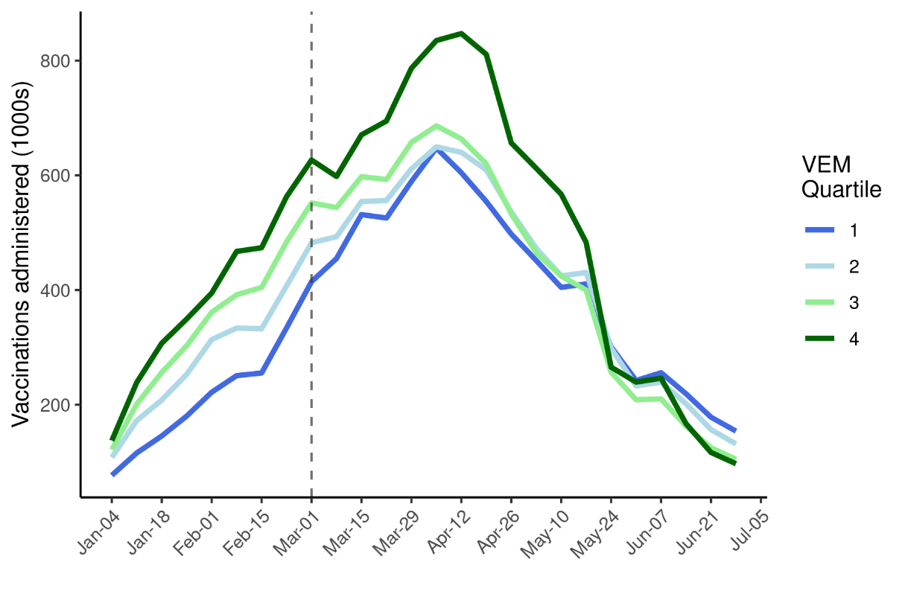

**Supplementary Figure 1: Vaccines administered through time stratified by VEM quartile around the policy period.** The vertical dashed line indicates the date of policy implementation. In the pre-policy period, consistent trends in vaccines administered between VEM quartiles can be observed, validating the parallel trends assumption that is essential to implementation of the difference in differences analysis. In the immediate post-policy period, the effect of the policy is also evident in the slight pause in the trend of increasing vaccinations administered in VEM quartiles 2 (light blue), 3 (light green), and 4 (dark green) along with the greater increase in vaccines administered in VEM quartile 1(dark blue).

**Table S1:** Vaccination rate difference-in-differences estimates from negative controls sensitivity analysis for all pairwise combinations of vaccine equity metric (VEM) quartiles during the after-policy period and when considering different pre/post policy time periods (main results are based on 4 weeks pre/post).

| Ref Quartile | Pre/Post Period | VEM Q1 | VEM Q2 | VEM Q3 |
| --- | --- | --- | --- | --- |
| 2 | 8 weeks | 26.7% (19.4% - 34.4%) |  |  |
| 3 | 8 weeks | 40.5% (32.5% - 48.9%) | 10.9% (5.2% - 16.9%) |  |
| 4 | 8 weeks | 36.6% (29.3% - 44.4%) | 7.9% (2.6% - 13.4%) | -2.8% (-7.3% - 2.1%) |
| 2 | 4 weeks | 20.7% (13.8% - 27.9%) |  |  |
| 3 | 4 weeks | 30.3% (23% - 38.1%) | 8% (2.4% - 13.8%) |  |
| 4 | 4 weeks | 33% (26.2% - 40.3%) | 10.3% (5% - 15.7%) | 2.1% (-2.7% - 7.1%) |
| 2 | 2 weeks | 11.9% (5.4% - 18.8%) |  |  |
| 3 | 2 weeks | 19.7% (12.6% - 27.1%) | 6.9% (1.3% - 12.9%) |  |
| 4 | 2 weeks | 24.9% (18.2% - 32%) | 11.6% (6.2% - 17.4%) | 4.4% (-0.7% - 9.8%) |

#### Model selection for counterfactual estimates of COVID-19 outcomes

To prevent overfitting and avoid reliance on a single parametric model, several candidate Poisson GLMs were fitted with COVID-19 cases, hospitalizations, and deaths as outcomes. We assessed the performance of candidate GLMs on their out-of-sample estimation of COVID-19 cases, hospitalizations, and deaths following the equity allocation. Candidate models shared a base form:

$$\log{E\left(λ_{it} | County_{i},VEM_{i},Int_{it},S_{t}\right)=\log\left(pop_{i}\right)+β_{0}+β_{1}County_{i}+β_{2}VEM_{i}+β_{3}Int_{it}+σS_{t}}$$

$${E(y}_{it})\sim Poisson(λ_{it})$$

where county and VEM quartile main effects are included to, respectively, adjust for county-level differences in transmission and mitigation efforts and inherent differences between VEM Q1 and non-Q1 ZIP codes independent of the intervention. The intervention variable $Int_{it}$ is binary, with ZIP-weeks observations taking place in VEM Q1 ZIP codes after the equity allocation receiving a 1 and all other observations set to 0. The final term represents a cubic spline basis with $σ$ terms estimated to account for non-linear fluctuations in COVID-19 outcomes over the observation period. Additional main effects of cumulative cases per 100,000 at the ZIP-week level (cumcasep100k), cumulative vaccinations per 100,000 at the ZIP-week level (cumvaxp100k), test rates at the ZIP-week level (testp100k), percent of the population over age 50 at the ZIP level (per50up), and interaction terms between the intervention and the spline, county, and VEM terms (int:spline, int:county, and int:VEM) were tested across all 108 possible combinations and assessed using 10 iterations of 10-fold cross validation (Table S2-4). The square root of the MSE gives an interpretable measure of model fit: the average error in outcomes estimated per ZIP-week observation. ZIP codes in counties with less than 100K population—together just 2.4% of California’s population—were excluded in this model evaluation step to avoid errors in the cross-validation procedure caused by counties containing insufficient ZIP codes to allocate to both training and validation sets. In addition to the main results generated from 10,000 non-parametric bootstrapped samples of the best performing model, counterfactual estimates from the next best performing (in terms of low MSE) models were generated and used to estimate VEM Q1 outcomes averted to ensure that results were not unique to the best performing model. For these estimates, only 100 bootstrapped samples per model were performed due to limited computational resources.

#### Policy impact on COVID-19 hospitalizations and deaths

The best performing hospitalizations model was similar to the best cases mode in that it included post-intervention spline term and the cumulative vaccination rate, but it additionally contained terms for the testing rate and the proportion of the population over 50 years old (Appendix Table 3). The best performing deaths model contained an intervention by county interaction as well as the cumulative vaccination rate and proportion of the population over 50 (Appendix Table 4). Out-of-sample error from these models was relatively low, translating to approximately 2 hospitalizations and less than 1 mortality per ZIP-week observation. For all outcomes, the best performing model closely reproduced observed outcomes (Appendix Figures 1-3), providing confidence in counterfactual estimates used to estimate outcomes averted.

From these models, it was estimated that in the eight months following the vaccine equity allocation, 10,248 (95%CI: 6,111 – 14,853) hospitalizations and 679 (95%CI: -32 – 1,451) deaths were averted in VEM Q1 ZIP codes. This represents 27.8% of all expected hospitalizations and 11.6% of all expected deaths that would have occurred in VEM Q1 between March 1 and November 1, 2021 in the absence of the vaccine equity allocation. Most of the outcomes averted in this time period came after July 1, 2021, during the beginning of California’s Delta variant wave (Exhibit 2, Appendix Figures S4-S5). However, 641 (95%CI: 213 – 1,108) hospitalizations and 86 (95%CI: 12 – 168) deaths were averted in the first two months following the equity allocation (Appendix Figures S4-S5).

While 27% of California’s population resides in VEM Q1 areas, residents in VEM Q1 accounted for 39% of hospitalizations and deaths in the two months before the vaccine equity allocation policy was implemented (Appendix Figures S6-S7). Disparities in hospitalizations were notable improved among VEM Q1 communities in the post-policy period, though the observed proportion of hospitalizations occurring among VEM Q1 communities never reached the VEM Q1 population proportion (Appendix Figure S6). Disparities in deaths were less impacted by the policy, with observed and counterfactual estimates of the proportion of deaths occurring among VEMQ1 communities tracking closely in the post policy period (Appendix Figure S7). Together these results suggest that additional factors—such as higher rates of comorbidities—among VEM Q1 residents that were not affected by the vaccine equity allocation policy contributed to the disproportionate share of severe COVID-19 outcomes.

Our approach to evaluate candidate models on their out-of-sample performance optimizes our counterfactual estimates by rigorously identifying the model with the best out-of-sample predictions. The models with the best performance for each outcome in this analysis included terms related to important drivers of COVID-19 outcomes including older age, prior vaccination, and prior infections that reduce population susceptibility. Out-of-sample error from these models was relatively low across all outcomes considered, and bootstrapped resampling at the ZIP code level to generate uncertainty estimates ensures that our results are not reliant on a small number of overly influential observations (such as very high population ZIP codes) and that results accurately reflect uncertainty in the estimation procedure. Finally, we also estimated the main outcomes averted measure for the next nine best performing models to ensure that our results were not entirely reliant on the best performing model and found similar results across cases, hospitalizations, and deaths.

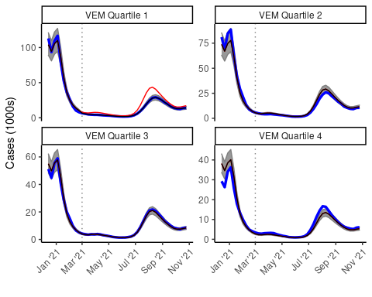

**Supplementary Figure 2: Best performing case model estimates compared to observed cases stratified by VEM quartile.** In each panel, the blue line represents observed total weekly cases in California among all ZIP codes falling into the indicated Vaccine Equity Metric (VEM) quartile. Black lines and shading represent the median and 95% confidence interval from 10,000 bootstrapped estimates of VEM-stratified weekly cases estimated from the best performing cases model. Estimates from the best performing cases model (black) closely align with observed cases (blue) across VEM quartiles and through time. The same model is used to generate counterfactual VEM Q1 case estimates in the absence of the equity allocation, which are shown in red. The difference between these counterfactual case estimates (red) and observed cases (blue) is the reported cases averted result. The vertical dotted line represents the date the equity allocation policy was implemented.

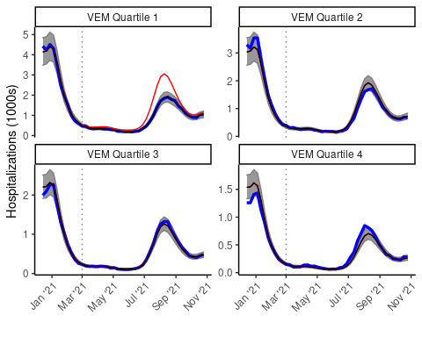

**Supplementary Figure 3: Best performing hospitalizations model estimates compared to observed hospitalizations stratified by VEM quartile.** In each panel, the blue line represents observed total weekly COVID-19 hospitalizations in California among all ZIP codes falling into the indicated Vaccine Equity Metric (VEM) quartile. Black lines and shading represent the median and 95% confidence interval from 10,000 bootstrapped estimates of VEM-stratified weekly cases estimated from the best performing hospitalizations model. Estimates from the best performing hospitalizations model (black) closely align with observed hospitalizations (blue) across VEM quartiles and through time. The same model is used to generate counterfactual VEM Q1 hospitalization estimates in the absence of the equity allocation, which are shown in red. The difference between these counterfactual hospitalization estimates (red) and observed hospitalizations (blue) is the reported hospitalizations averted result. The vertical dotted line represents the date the equity allocation policy was implemented.

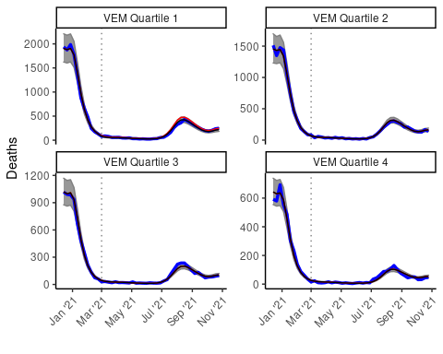

**Supplementary Figure 4: Best performing mortalities model estimates compared to observed mortalities stratified by VEM quartile.** In each panel, the blue line represents observed total weekly COVID-19 deaths in California among all ZIP codes falling into the indicated Vaccine Equity Metric (VEM) quartile. Black lines and shading represent the median and 95% confidence interval from 10,000 bootstrapped estimates of VEM-stratified weekly deaths estimated from the best performing deaths model. Estimates from the best performing deaths model (black) closely align with observed deaths (blue) across VEM quartiles and through time. The same model is used to generate counterfactual VEM Q1 death estimates in the absence of the equity allocation, which are shown in red. The difference between these counterfactual death estimates (red) and observed deaths (blue) is the reported deaths averted result. The vertical dotted line represents the date the equity allocation policy was implemented.

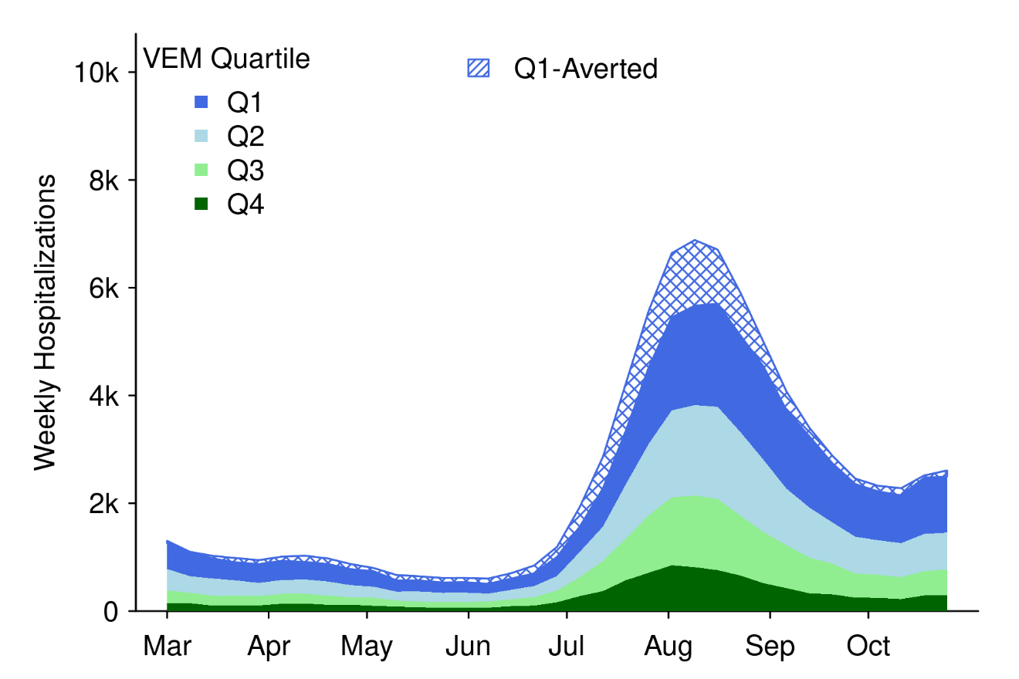

**Supplementary Figure 5:** Time series of weekly COVID-19 hospitalizations stratified by vaccine equity metric (VEM) quartile in California from March 1, 2021 – November 1, 2021. Hatched blue areas indicate outcomes that were averted in VEM Q1 as estimated in counterfactual analyses. COVID-19 activity remained low until the delta variant caused increases beginning in July 2021. Hospitalizations averted were approximately proportional to weekly hospitalization burden, with more hospitalizations averted during the high period caused by the delta variant.

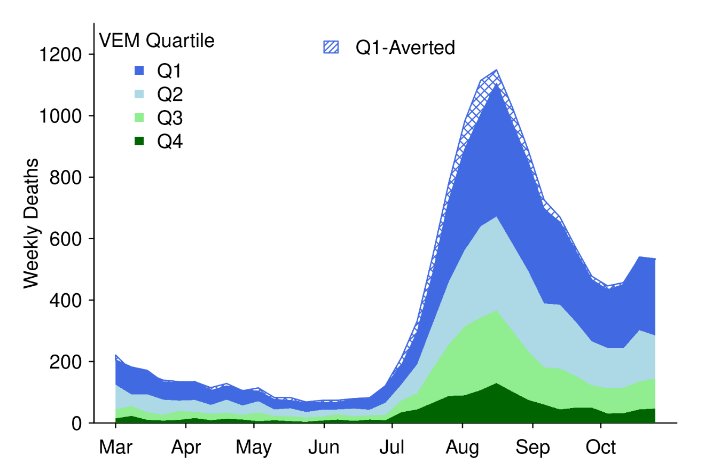

**Supplementary Figure 6:** Time series of weekly COVID-19 deaths stratified by vaccine equity metric (VEM) quartile in California from March 1, 2021 – November 1, 2021. COVID-19 activity remained low until the delta variant caused increases beginning in July 2021. Hatched blue areas indicate deaths that were averted in VEM Q1 as estimated in counterfactual analyses. Relatively fewer deaths were averted due to the policy than may be expected based on the significant number of cases and hospitalizations averted.

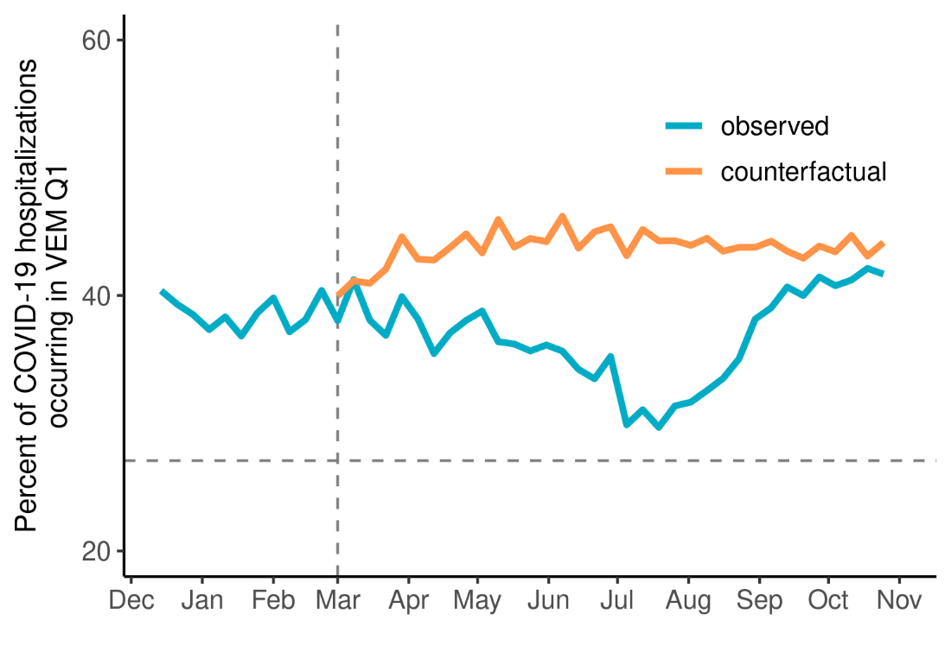

**Supplementary Figure 7:** The percent of all COVID-19 hospitalizations occurring among residents of the least advantaged quartile of the vaccine equity metric (VEM Q1). The blue and orange lines show, respectively, the observed and counterfactual estimates of the percent of hospitalizations occurring among VEM Q1 populations. The vertical dashed line indicates the week the policy was implemented, and the horizontal dashed line indicates the percent of California’s overall population residing in VEM Q1 ZIP codes. This population percent serves as a reference for the percent of hospitalizations that would occur in VEM Q1 if hospitalizations were equally distributed across VEM quartiles. Observations above this line suggest that COVID-19 hospitalizations were occurring disproportionately among VEM Q1 populations. The blue line falling closer to the horizontal reference line in the after-policy period suggests that the policy reduced disparities in COVID-19 hospitalizations among VEM Q1 residents.

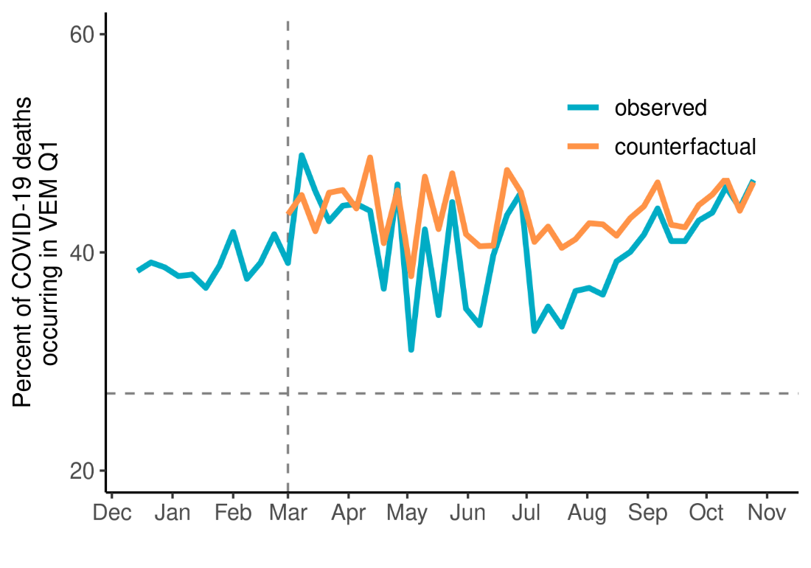

**Supplementary Figure 8:** Same as above, but displaying the proportion of deaths occurring among VEM Q1 residents. Unlike cases and hospitalizations, the policy appears to have had less of an influence reducing disparities in deaths.

**Table S2:** Model formulas, performance across 10 rounds of 10-fold cross validation, and resulting cases averted estimates for the top ten best performing models. The table is ordered by descending performance in terms of the mean mean squared error across all ten rounds, which is shown along the max and min in the second column. The “BASE” term for each model is described in the text above along with additional variables included in all possible combinations. The top model with the lowest mean mean squared error was used to estimate counterfactual cases in the absence of the equity allocation and resulting cases averted reported in the main analysis. The next nine top models were also used to estimate cases averted shown in column three as a sensitivity analysis to ensure cases averted estimates were not unique to the top model. Column three shows the median cases averted and 95% confidence interval from 100 bootstrapped samples as described in the main text.

|  |  |  |
| --- | --- | --- |
| **Model Terms** | **Cases MSE (range)** | **Estimated Cases Avoided (95%CI)** |
| BASE+int:spline+cumvaxp100k | 283 (274 - 288) | 160,892  (108,878 – 221,815) |
| BASE+int:county | 285 (274 - 293) | 120,180  (84,380 – 183,261) |
| BASE+int:county+cumvaxp100k | 287 (273 - 311) | 146,065  (103,028 – 194,294) |
| BASE+cumvaxp100k | 288 (279 - 292) | 158,814  (97,975 – 216,603) |
| BASE+int:VEM+cumvaxp100k | 288 (279 - 292) | 157,483  (108,612 – 212,641) |
| BASE+int:spline+cumvaxp100k+per50up | 289 (280 - 293) | 146,678  (98,634 – 203,670) |
| BASE+int:spline | 290 (279 - 294) | 122,020  (76,147 – 161,699) |
| BASE+int:county+per50up | 292 (278 - 312) | 118,670  (74,653 – 176,585) |
| BASE+int:spline+per50up | 293 (283 - 298) | 124,645  (86,013 – 164,348) |
| BASE+cumvaxp100k+per50up | 293 (284 - 297) | 148,395  (110,207 – 212,662) |
| BASE+int:VEM+cumvaxp100k+per50up | 293 (284 - 297) |  |
| BASE | 294 (284 - 298) |  |
| BASE+int:VEM | 294 (284 - 298) |  |
| BASE+int:spline+cumvaxp100k+testp100k | 294 (285 - 300) |  |
| BASE+int:county+cumvaxp100k+testp100k | 294 (276 - 327) |  |
| BASE+int:county+cumvaxp100k+per50up | 295 (278 - 332) |  |
| BASE+int:VEM+cumvaxp100k+testp100k | 297 (285 - 303) |  |
| BASE+cumvaxp100k+testp100k | 297 (285 - 303) |  |
| BASE+int:VEM+per50up | 297 (287 - 301) |  |
| BASE+per50up | 297 (287 - 301) |  |
| BASE+int:spline+cumvaxp100k+testp100k+per50up | 299 (289 - 305) |  |
| BASE+int:county+cumcasep100k+cumvaxp100k | 300 (286 - 306) |  |
| BASE+int:county+cumcasep100k+cumvaxp100k+per50up | 300 (287 - 306) |  |
| BASE+int:county+cumcasep100k+per50up | 301 (288 - 306) |  |
| BASE+int:county+cumcasep100k | 301 (288 - 306) |  |
| BASE+cumvaxp100k+testp100k+per50up | 302 (290 - 307) |  |
| BASE+int:VEM+cumvaxp100k+testp100k+per50up | 302 (290 - 307) |  |
| BASE+int:spline+testp100k | 302 (290 - 313) |  |
| BASE+int:county+cumvaxp100k+testp100k+per50up | 304 (281 - 354) |  |
| BASE+int:spline+testp100k+per50up | 304 (293 - 311) |  |
| BASE+int:VEM+testp100k+per50up | 307 (294 - 316) |  |
| BASE+testp100k+per50up | 307 (294 - 316) |  |
| BASE+testp100k | 308 (291 - 326) |  |
| BASE+int:VEM+testp100k | 308 (291 - 326) |  |
| BASE+int:county+cumcasep100k+cumvaxp100k+testp100k | 308 (293 - 322) |  |
| BASE+int:county+cumcasep100k+cumvaxp100k+  testp100k+per50up | 309 (294 - 322) |  |
| BASE+int:spline+cumcasep100k+cumvaxp100k | 313 (302 - 321) |  |
| BASE+int:spline+cumcasep100k+cumvaxp100k+per50up | 314 (303 - 322) |  |
| BASE+int:VEM+cumcasep100k+cumvaxp100k | 317 (306 - 325) |  |
| BASE+cumcasep100k+cumvaxp100k | 317 (306 - 325) |  |
| BASE+int:spline+cumcasep100k | 317 (305 - 325) |  |
| BASE+int:spline+cumcasep100k+per50up | 318 (305 - 325) |  |
| BASE+int:VEM+cumcasep100k+cumvaxp100k+per50up | 318 (307 - 326) |  |
| BASE+cumcasep100k+cumvaxp100k+per50up | 318 (307 - 326) |  |
| BASE+cumcasep100k | 321 (310 - 329) |  |
| BASE+int:VEM+cumcasep100k | 321 (310 - 329) |  |
| BASE+int:VEM+cumcasep100k+per50up | 321 (310 - 329) |  |
| BASE+cumcasep100k+per50up | 321 (310 - 329) |  |
| BASE+int:spline+cumcasep100k+cumvaxp100k+testp100k | 322 (312 - 333) |  |
| BASE+int:spline+cumcasep100k+cumvaxp100k+  testp100k+per50up | 323 (312 - 333) |  |
| BASE+cumcasep100k+cumvaxp100k+testp100k | 325 (313 - 336) |  |
| BASE+int:VEM+cumcasep100k+cumvaxp100k+testp100k | 325 (313 - 336) |  |
| BASE+cumcasep100k+cumvaxp100k+testp100k+per50up | 325 (313 - 336) |  |
| BASE+int:VEM+cumcasep100k+cumvaxp100k+  testp100k+per50up | 325 (313 - 336) |  |
| BASE+int:spline+cumcasep100k+testp100k+per50up | 325 (313 - 337) |  |
| BASE+int:spline+cumcasep100k+testp100k | 326 (313 - 338) |  |
| BASE+int:VEM+cumcasep100k+testp100k+per50up | 329 (315 - 343) |  |
| BASE+cumcasep100k+testp100k+per50up | 329 (315 - 343) |  |
| BASE+int:VEM+cumcasep100k+testp100k | 330 (315 - 346) |  |
| BASE+cumcasep100k+testp100k | 330 (315 - 346) |  |
| BASE+int:county+testp100k+per50up | 336 (284 - 403) |  |
| BASE+int:county+cumcasep100k+testp100k+per50up | 409 (294 - 559) |  |
| BASE+int:county+cumcasep100k+testp100k | 486 (294 - 724) |  |
| BASE+int:county+testp100k | 488 (280 - 826) |  |

**Table S3:** Model formulas, performance across 10 rounds of 10-fold cross validation, and resulting hospitalizations averted estimates for the top ten best performing models. The table is ordered by descending performance in terms of the mean mean squared error across all ten rounds, which is shown along the max and min in the second column. The “BASE” term for each model is described in the text above along with additional variables included in all possible combinations. The top model with the lowest mean mean squared error was used to estimate counterfactual hospitalizations in the absence of the equity allocation and resulting hospitalizations averted reported in the main analysis. The next nine top models were also used to estimate hospitalizations averted shown in column three as a sensitivity analysis to ensure hospitalizations averted estimates were not unique to the top model. Column three shows the median hospitalizations averted and 95% confidence interval from 100 bootstrapped samples as described in the main text.

| **Model Terms** | **Hospitalizations MSE (range)** | **Estimated Hospitalizations Avoided (95%CI)** |
| --- | --- | --- |
| BASE+int:spline+cumvaxp100k+testp100k+  per50up | 2.97 (2.96 - 3) | 10,248  (6,111 – 14,853) |
| BASE+int:spline+cumvaxp100k+per50up | 2.98 (2.97 - 3.01) | 10,322  (7,265 – 15,491) |
| BASE+int:spline+cumvaxp100k+testp100k | 3 (2.99 - 3.03) | 10,172  (6,234 – 14,106) |
| BASE+cumvaxp100k+testp100k+per50up | 3.02 (3 - 3.05) | 10,003  (5,932 – 14,985) |
| BASE+int:VEM+cumvaxp100k+testp100k+  per50up | 3.02 (3 - 3.05) | 10,128  (5,680 – 13,860) |
| BASE+cumvaxp100k+per50up | 3.02 (3.01 - 3.06) | 9,513  (5,870 – 14,392) |
| BASE+int:VEM+cumvaxp100k+per50up | 3.02 (3.01 - 3.06) | 10,088  (6,736 – 13,516) |
| BASE+int:spline+cumvaxp100k | 3.03 (3.01 - 3.06) | 9,328  (5,701 – 13,920) |
| BASE+int:spline+cumcasep100k+cumvaxp100k+  testp100k+per50up | 3.03 (3.01 - 3.05) | 11,703  (8,208 – 16,767) |
| BASE+int:VEM+cumvaxp100k+testp100k | 3.06 (3.04 - 3.09) | 9,303  (5,447 – 13,518) |
| BASE+cumvaxp100k+testp100k | 3.06 (3.04 - 3.09) |  |
| BASE+int:spline+cumcasep100k+cumvaxp100k+  testp100k | 3.07 (3.05 - 3.09) |  |
| BASE+cumvaxp100k | 3.07 (3.06 - 3.11) |  |
| BASE+int:VEM+cumvaxp100k | 3.07 (3.06 - 3.11) |  |
| BASE+int:spline+cumcasep100k+cumvaxp100k+  per50up | 3.08 (3.06 - 3.1) |  |
| BASE+cumcasep100k+cumvaxp100k+testp100k+  per50up | 3.09 (3.07 - 3.11) |  |
| BASE+int:VEM+cumcasep100k+cumvaxp100k+  testp100k+per50up | 3.09 (3.07 - 3.11) |  |
| BASE+int:county+per50up | 3.11 (3.06 - 3.3) |  |
| BASE+int:county+testp100k+per50up | 3.11 (3.06 - 3.3) |  |
| BASE+int:spline+cumcasep100k+cumvaxp100k | 3.12 (3.11 - 3.15) |  |
| BASE+int:VEM+cumcasep100k+cumvaxp100k+  testp100k | 3.12 (3.11 - 3.15) |  |
| BASE+cumcasep100k+cumvaxp100k+testp100k | 3.12 (3.11 - 3.15) |  |
| BASE+cumcasep100k+cumvaxp100k+per50up | 3.13 (3.11 - 3.15) |  |
| BASE+int:VEM+cumcasep100k+cumvaxp100k+  per50up | 3.13 (3.11 - 3.15) |  |
| BASE+int:county+cumcasep100k+testp100k+  per50up | 3.13 (3.11 - 3.18) |  |
| BASE+int:county | 3.13 (3.07 - 3.39) |  |
| BASE+int:county+testp100k | 3.13 (3.07 - 3.39) |  |
| BASE+int:county+cumcasep100k+testp100k | 3.14 (3.11 - 3.21) |  |
| BASE+int:county+cumcasep100k+per50up | 3.14 (3.12 - 3.19) |  |
| BASE+int:spline+testp100k+per50up | 3.15 (3.14 - 3.17) |  |
| BASE+int:county+cumcasep100k | 3.15 (3.13 - 3.22) |  |
| BASE+int:spline+testp100k | 3.15 (3.14 - 3.18) |  |
| BASE+cumcasep100k+cumvaxp100k | 3.17 (3.15 - 3.2) |  |
| BASE+int:VEM+cumcasep100k+cumvaxp100k | 3.17 (3.15 - 3.2) |  |
| BASE+int:spline+per50up | 3.18 (3.17 - 3.21) |  |
| BASE+int:VEM+testp100k+per50up | 3.19 (3.18 - 3.22) |  |
| BASE+testp100k+per50up | 3.19 (3.18 - 3.22) |  |
| BASE+int:spline | 3.19 (3.18 - 3.22) |  |
| BASE+int:VEM+testp100k | 3.2 (3.19 - 3.23) |  |
| BASE+testp100k | 3.2 (3.19 - 3.23) |  |
| BASE+int:spline+cumcasep100k+testp100k+  per50up | 3.21 (3.2 - 3.23) |  |
| BASE+int:spline+cumcasep100k+testp100k | 3.21 (3.2 - 3.23) |  |
| BASE+per50up | 3.22 (3.21 - 3.25) |  |
| BASE+int:VEM+per50up | 3.22 (3.21 - 3.25) |  |
| BASE | 3.23 (3.22 - 3.26) |  |
| BASE+int:VEM | 3.23 (3.22 - 3.26) |  |
| BASE+int:county+cumcasep100k+cumvaxp100k+  testp100k+per50up | 3.24 (2.98 - 4.28) |  |
| BASE+int:county+cumcasep100k+cumvaxp100k+  per50up | 3.26 (2.98 - 4.47) |  |
| BASE+cumcasep100k+testp100k+per50up | 3.27 (3.25 - 3.29) |  |
| BASE+int:VEM+cumcasep100k+testp100k+per50up | 3.27 (3.25 - 3.29) |  |
| BASE+cumcasep100k+testp100k | 3.27 (3.26 - 3.29) |  |
| BASE+int:VEM+cumcasep100k+testp100k | 3.27 (3.26 - 3.29) |  |
| BASE+int:spline+cumcasep100k+per50up | 3.29 (3.27 - 3.3) |  |
| BASE+int:spline+cumcasep100k | 3.29 (3.28 - 3.31) |  |
| BASE+cumcasep100k+per50up | 3.33 (3.32 - 3.35) |  |
| BASE+int:VEM+cumcasep100k+per50up | 3.33 (3.32 - 3.35) |  |
| BASE+cumcasep100k | 3.34 (3.32 - 3.36) |  |
| BASE+int:VEM+cumcasep100k | 3.34 (3.32 - 3.36) |  |
| BASE+int:county+cumcasep100k+cumvaxp100k+  testp100k | 3.68 (3.01 - 6.42) |  |
| BASE+int:county+cumcasep100k+cumvaxp100k | 3.78 (3.01 - 6.96) |  |
| BASE+int:county+cumvaxp100k+per50up | 5.83 (2.91 - 18.66) |  |
| BASE+int:county+cumvaxp100k+testp100k+per50up | 6.01 (2.92 - 18.94) |  |
| BASE+int:county+cumvaxp100k | 7.06 (2.95 - 24.46) |  |
| BASE+int:county+cumvaxp100k+testp100k | 7.18 (2.95 - 24.03) |  |

**Table S4:** Model formulas, performance across 10 rounds of 10-fold cross validation, and resulting deaths averted estimates for the top ten best performing models. The table is ordered by descending performance in terms of the mean mean squared error across all ten rounds, which is shown along the max and min in the second column. The “BASE” term for each model is described in the text above along with additional variables included in all possible combinations. The top model with the lowest mean mean squared error was used to estimate counterfactual deaths in the absence of the equity allocation and resulting deaths averted reported in the main analysis. The next nine top models were also used to estimate deaths averted shown in column three as a sensitivity analysis to ensure deaths averted estimates were not unique to the top model. Column three shows the median deaths averted and 95% confidence interval from 100 bootstrapped samples as described in the main text.

| **Model Terms** | **Mortalities MSE (range)** | **Estimated Deaths Avoided* (95%CI)** |
| --- | --- | --- |
| BASE+int:county+cumvaxp100k+per50up | 0.312 (0.31 - 0.32) | 679  (-32 – 1451) |
| BASE+int:county+cumvaxp100k+testp100k+per50up | 0.314 (0.312 - 0.322) | 770  (160 – 1694) |
| BASE+int:county+per50up | 0.317 (0.314 - 0.327) | -354  (-978 – 280) |
| BASE+int:county+cumvaxp100k | 0.317 (0.312 - 0.332) | 492  (-204 – 1354) |
| BASE+int:county+cumcasep100k+cumvaxp100k+per50up | 0.318 (0.313 - 0.327) | 962  (187 – 1718) |
| BASE+int:county+cumcasep100k+cumvaxp100k+  testp100k+per50up | 0.319 (0.315 - 0.329) | 969  (212 – 1824) |
| BASE+int:county+testp100k+per50up | 0.319 (0.317 - 0.329) | -298  (-948 – 200) |
| BASE+int:county+cumvaxp100k+testp100k | 0.32 (0.314 - 0.335) | 535  (-201 – 1224) |
| BASE+int:county | 0.321 (0.315 - 0.337) | -329  (-937 – 175) |
| BASE+int:county+cumcasep100k+per50up | 0.322 (0.317 - 0.335) | -134  (-683 – 594) |
| BASE+int:county+testp100k | 0.323 (0.317 - 0.339) |  |
| BASE+int:spline+cumvaxp100k+per50up | 0.323 (0.32 - 0.325) |  |
| BASE+int:county+cumcasep100k+testp100k+per50up | 0.324 (0.318 - 0.336) |  |
| BASE+cumvaxp100k+per50up | 0.324 (0.32 - 0.326) |  |
| BASE+int:VEM+cumvaxp100k+per50up | 0.324 (0.32 - 0.326) |  |
| BASE+int:county+cumcasep100k+cumvaxp100k | 0.324 (0.315 - 0.347) |  |
| BASE+int:county+cumcasep100k+cumvaxp100k+testp100k | 0.326 (0.316 - 0.349) |  |
| BASE+int:spline+cumvaxp100k+testp100k+per50up | 0.327 (0.323 - 0.329) |  |
| BASE+cumvaxp100k+testp100k+per50up | 0.327 (0.324 - 0.329) |  |
| BASE+int:VEM+cumvaxp100k+testp100k+per50up | 0.327 (0.324 - 0.329) |  |
| BASE+int:county+cumcasep100k | 0.327 (0.318 - 0.352) |  |
| BASE+int:spline+cumvaxp100k | 0.328 (0.324 - 0.329) |  |
| BASE+int:VEM+cumvaxp100k | 0.328 (0.325 - 0.33) |  |
| BASE+cumvaxp100k | 0.328 (0.325 - 0.33) |  |
| BASE+int:county+cumcasep100k+testp100k | 0.329 (0.319 - 0.353) |  |
| BASE+int:spline+cumcasep100k+cumvaxp100k+per50up | 0.33 (0.327 - 0.332) |  |
| BASE+int:spline+cumvaxp100k+testp100k | 0.33 (0.327 - 0.332) |  |
| BASE+cumvaxp100k+testp100k | 0.331 (0.328 - 0.333) |  |
| BASE+int:VEM+cumvaxp100k+testp100k | 0.331 (0.328 - 0.333) |  |
| BASE+int:VEM+cumcasep100k+cumvaxp100k+per50up | 0.331 (0.328 - 0.333) |  |
| BASE+cumcasep100k+cumvaxp100k+per50up | 0.331 (0.328 - 0.333) |  |
| BASE+int:spline+cumcasep100k+cumvaxp100k+  testp100k+per50up | 0.332 (0.328 - 0.334) |  |
| BASE+int:VEM+cumcasep100k+cumvaxp100k+  testp100k+per50up | 0.333 (0.329 - 0.335) |  |
| BASE+cumcasep100k+cumvaxp100k+testp100k+per50up | 0.333 (0.329 - 0.335) |  |
| BASE+int:spline+cumcasep100k+cumvaxp100k | 0.333 (0.33 - 0.335) |  |
| BASE+int:VEM+cumcasep100k+cumvaxp100k | 0.334 (0.331 - 0.336) |  |
| BASE+cumcasep100k+cumvaxp100k | 0.334 (0.331 - 0.336) |  |
| BASE+int:spline+cumcasep100k+cumvaxp100k+testp100k | 0.334 (0.33 - 0.336) |  |
| BASE+int:spline+per50up | 0.334 (0.329 - 0.336) |  |
| BASE+int:VEM+per50up | 0.335 (0.33 - 0.337) |  |
| BASE+per50up | 0.335 (0.33 - 0.337) |  |
| BASE+int:VEM+cumcasep100k+cumvaxp100k+testp100k | 0.335 (0.331 - 0.337) |  |
| BASE+cumcasep100k+cumvaxp100k+testp100k | 0.335 (0.331 - 0.337) |  |
| BASE+int:spline | 0.336 (0.331 - 0.338) |  |
| BASE+int:spline+testp100k+per50up | 0.337 (0.331 - 0.339) |  |
| BASE | 0.337 (0.332 - 0.339) |  |
| BASE+int:VEM | 0.337 (0.332 - 0.339) |  |
| BASE+testp100k+per50up | 0.337 (0.332 - 0.34) |  |
| BASE+int:VEM+testp100k+per50up | 0.337 (0.332 - 0.34) |  |
| BASE+int:spline+testp100k | 0.337 (0.332 - 0.34) |  |
| BASE+testp100k | 0.338 (0.333 - 0.341) |  |
| BASE+int:VEM+testp100k | 0.338 (0.333 - 0.341) |  |
| BASE+int:spline+cumcasep100k+testp100k | 0.341 (0.336 - 0.343) |  |
| BASE+int:spline+cumcasep100k+testp100k+per50up | 0.341 (0.335 - 0.343) |  |
| BASE+int:spline+cumcasep100k+per50up | 0.341 (0.336 - 0.343) |  |
| BASE+int:VEM+cumcasep100k+testp100k | 0.342 (0.337 - 0.344) |  |
| BASE+cumcasep100k+testp100k | 0.342 (0.337 - 0.344) |  |
| BASE+int:VEM+cumcasep100k+per50up | 0.342 (0.337 - 0.344) |  |
| BASE+cumcasep100k+per50up | 0.342 (0.337 - 0.344) |  |
| BASE+cumcasep100k+testp100k+per50up | 0.342 (0.337 - 0.344) |  |
| BASE+int:VEM+cumcasep100k+testp100k+per50up | 0.342 (0.337 - 0.344) |  |
| BASE+int:spline+cumcasep100k | 0.342 (0.337 - 0.344) |  |
| BASE+cumcasep100k | 0.343 (0.338 - 0.345) |  |
| BASE+int:VEM+cumcasep100k | 0.343 (0.338 - 0.345) |  |