**Evaluation of an equity-focused vaccine allocation strategy on vaccination rates and COVID-19 outcomes in California, 2021**

COVID-19, Equity, Vaccination, Evaluation

### Abstract (171 words):

In March 2021, California implemented a vaccine equity policy that prioritized COVID-19 vaccine allocation to communities identified as least advantaged by an area-based socioeconomic measure, the Healthy Places Index (HPI). We conducted quasi-experimental and counterfactual analyses to estimate the effect of this policy on COVID-19 vaccination, case, hospitalization, and death rates. Among prioritized communities, vaccination rates increased 28.4% (95%CI: 22.1% - 35.1%) following policy implementation. Furthermore, an estimated 160,892 (95%CI: 108,878 – 221,815) COVID-19 cases, 10,248 (95%CI: 6,111 – 14,853) hospitalizations, and 679 (95%CI: -32 – 1,451) deaths in the least advantaged communities were averted by the policy. Despite these improvements, the share of COVID-19 cases, hospitalizations, and deaths in prioritized communities remained elevated. These estimates were robust in sensitivity analyses that tested exchangeability between prioritized communities and those not prioritized by the policy, model specifications, and potential temporal confounders including prior infections. Correcting for disparities by strategically allocating limited resources to the least advantaged or most impacted communities can reduce the impacts of COVID-19 and other diseases, but may not eliminate health disparities.

Christopher Hoover1, Emily Estus2, Ada Kwan3, Kristal Raymond2, Tanu Sreedharan2, Tomas Leon1, Seema Jain1, Priya B. Shete3

1 Coronavirus Science Branch, California Department of Public Health

2 Office of Health Equity, California Department of Public Health

3 Division of Pulmonary and Critical Care Medicine, University of California San Francisco, USA.

### Background (473 words)

Since the SARS-CoV-2 virus emerged in 2020, the COVID-19 pandemic has exacerbated and further unveiled longstanding health disparities in California, the United States, and the world (1–4). While these disparities are partially explained by differential rates of comorbidities and other medical risks including age, social and structural determinants also play a key role (5,6). These social and structural factors led to disparities in access to testing, healthcare, the opportunity to work remotely, the ability to isolate or quarantine, and other essential components of pandemic response strategies including vaccine and treatment access (5,7,8). During the initial surges of the COVID-19 pandemic in the United States, Black, Latino, and American Indian or Alaska Native groups were two to five times more likely to be hospitalized or die with COVID-19 than their Asian American and White counterparts (1,9–12). Equity-focused policies that deliberately allocate more resources to communities most impacted by these inequities offer a promising strategy to mitigate health disparities.

Vaccination strategies may be particularly amenable to equity-focused policies due to the high efficacy of COVID-19 vaccines and their ability to induce durable protection against severe outcomes such as hospitalization and death (13). However, equitable vaccination is unlikely to be achieved without explicit effort to account for disparate access and uptake to vaccines (14). Instead, vaccination policies that prioritize the least advantaged or most impacted populations are required to equitably distribute the benefits of vaccination (15).

To reduce inequities in COVID-19 burden and prevent inequities in vaccination among its diverse residents, the State of California implemented an equity-focused policy early during vaccination rollout. This “vaccine equity allocation” policy implemented in March 2021 distributed 40% of available COVID-19 vaccines to the least advantaged quarter of communities in California (16). The vaccine equity allocation utilized the Healthy Places Index (HPI), an area-based socioeconomic measure specific to California that provides an assessment of the ability of community residents to live a healthy life (17). The HPI facilitated identification of COVID-19-related disparities in California and formed the basis of other equity-focused policies in California during the pandemic, including The Blueprint for a Safer Economy which was in effect from August 2020 through June 2021 (18). While making up 27% of the state’s population, individuals residing in ZIP codes classified as least advantaged by falling in the lowest 25% of HPI index scores experienced almost 40% of all COVID-19 cases and deaths, motivating the allocation of 40% of vaccines to these communities (16).

The primary objective of this analysis is to evaluate the impact of California’s vaccine equity allocation on COVID-19 vaccination rates and outcomes. We used a quasi-experimental difference-in-differences approach to estimate the effect of the policy on vaccination rates in communities that received the equity allocation. We then used a counterfactual approach to estimate the number of COVID-19 cases, hospitalizations, and deaths averted due to the policy.

### Methods (1461 words)

#### Data

The HPI is an area-based socioeconomic measure developed by the Public Health Alliance of Southern California (PHASC) that integrates data from the American Community Survey, California Environmental Protection Agency, Bureau of Labor Statistics, and other agencies to generate an index score calibrated to life expectancy at birth. Details of HPI development are available in PHASC’s technical report (19). Since some areas were not assigned scores because of small population or other exclusion criteria, the Vaccine Equity Metric (VEM) was derived by the California Department of Public Health (CDPH) in March 2021 to ensure that all ZIP codes in the state could be counted towards vaccine allocation. The VEM combined scores from HPI version 2.0 with CDPH-derived ZIP code scores (17,20). CDPH assigned a VEM score for every ZIP code in California by creating a predictive regression model trained on existing HPI scores given known data points from the American Community Survey, Surgo Venture’s COVID Community Vulnerability Index (21), and the California “Hard-to-Count” Index (22). These scores were percentile ranked and partitioned into quartiles using quartile thresholds from the HPI to determine VEM Q1 ZIP codes prioritized for the vaccine equity allocation. Thus, the first quartile or VEM Q1 was interpreted as 25% of ZIP codes in the state where residents have the least opportunity to live a healthy life. The vaccine equity allocation then distributed 40% of available vaccines to VEM Q1 communities with the remaining 60% of vaccines divided evenly among VEM Q2, Q3, and Q4 communities. The policy also included equity-oriented technical assistance, contracting support, staffing resources, and mobile vaccination sites for Local Health Jurisdictions (LHJs) to aid their vaccination outreach (16).

COVID-19 vaccination records were collected from statewide immunization databases in California. The date and ZIP code of COVID-19 vaccinations administered, regardless of dose number, were joined with ZIP-level VEM scores to generate a dataset of daily vaccinations administered by VEM quartile.

Person-level records of confirmed SARS-CoV-2 infection in California were used to derive weekly time series of COVID-19 cases, hospitalizations, and deaths. Individual addresses reported in the CDPH Electronic Lab Reporting system were used to assign each individual’s ZIP code of residence. Cases were defined as individuals with a lab-confirmed, positive SARS-CoV-2 Nucleic Acid Amplification Test (NAAT) test reported to CDPH regardless of symptom status. Hospitalizations were determined from the California COVID-19 Reporting System and supplementary hospitalization reports. COVID-19 deaths were defined as individuals with confirmed COVID-19-associated death reported to CDPH by local health departments. COVID-19 confirmed cases and deaths follow CDPH guidance and definitions set by the Council of State and Territorial Epidemiologists (CSTE) (23). Population data used to derive county-specific rates were drawn from 2020 5-year American Community Survey (ACS) estimates.

#### Analytic Approach

***Vaccination Outcomes***

We conducted a difference-in-differences (DiD) analysis to compare the rate of vaccination in prioritized VEM Q1 ZIP codes to non-VEM Q1 ZIP codes before and after the vaccine equity allocation was implemented. A Poisson generalized linear model (GLM) was fitted with the number of vaccines administered by ZIP code as the outcome and ZIP code population as an offset term. Main effects for binary before/after policy implementation, binary VEM Q1/non-Q1 status, and their interaction were included along with a main effect on county to account for variability between LHJs. Symmetric four-week periods before and after the policy was implemented on March 2, 2021 were used to estimate the immediate effect of the policy on vaccination rates before vaccines became more widely available in May 2021. The interaction term—operative in after-policy periods in VEM Q1 ZIP codes—was the target parameter, representing the change in vaccination rate in VEM Q1 ZIP codes compared to non-VEM Q1 ZIP codes, ostensibly due to the vaccine equity allocation. Robust standard errors using the sandwich estimator were used for all regression models to generate 95% confidence intervals around effect estimates.

We conducted additional analyses to probe key assumptions of the DiD model, including the potential effect of secular decline in vaccination rates due to depletion of the eligible population, the suitability of non-VEM Q1 populations to serve as controls for VEM Q1 populations, and the potential for unmeasured confounders (Supplementary Material).

First, vaccination rates may be expected to decline over time due to depletion of the population of unvaccinated individuals. This could bias DiD results, particularly if there were differential vaccination rates across VEM areas. To account for this, an additional model was fitted with a main term for the proportion of the population unvaccinated. Second, non-VEM Q1 ZIP codes may not serve as a valid comparison group for VEM Q1 ZIP codes since they differ by VEM score and the VEM constituent indicators. To assuage concerns with this potential for non-exchangeability, the same DiD model was rerun, but restricted to ZIP codes that fall in the second or third octile of all VEM scores (upper half of VEM Q1 or lower half of VEM Q2, respectively). This analysis sacrifices sample size for a potentially less-biased comparison group, assuming that ZIP codes falling on either side of the 25th percentile cutoff used to define VEM quartiles are more similar. In this analysis, octile 3 ZIP codes that did not receive the equity allocation serve as the control for octile 2 ZIP codes that did receive the equity allocation. Finally, a negative controls analysis was conducted by refitting the DiD model for all pairwise combinations of VEM quartiles, with the lower VEM quartile in each instance serving as the intervention group. This analysis sought to test for the presence of unmeasured confounders that could bias DiD results and would be identified by significant DiD estimates among non-VEM Q1 ZIP codes.

#### *COVID-19 outcomes*

We utilized a counterfactual approach in which the expected number of COVID-19 cases, hospitalizations, and deaths in the absence of the vaccine equity allocation were estimated from fitted generalized linear models (GLMs) and compared to observed outcomes (24). All COVID-19 case, hospitalization, and death data were aggregated at the ZIP code-week level, with weeks defined by the preceding Monday of each record to align with the Monday, March 2, 2021 policy start date. The observation period was defined as December 14, 2020—when Phase 1A of California’s vaccination campaign began (25)—through November 1, 2021—just prior to the emergence of the Omicron variant and widespread booster rollout.

To prevent overfitting and avoid reliance on a single parametric model, several candidate Poisson GLMs were fitted with COVID-19 cases, hospitalizations, and deaths as outcomes. All models included an offset for ZIP code population, county and VEM quartile main effects, cubic spline bases with knots every three weeks, and a binary intervention variable for whether the ZIP-week observation was in a VEM Q1 ZIP code and took place after March 2, 2021 coinciding with the beginning of the intervention. Additional candidate linear predictors included cumulative case rate, cumulative vaccinations administered rate, test rate, population over age 50 years, and interaction terms (Supplementary Tables 2-4). Candidate models were compared via 10 rounds of 10-fold cross validation and performance was assessed via estimation of the mean squared error (MSE) in out-of-sample predictions following the vaccine equity allocation. The square root of the MSE gives a more interpretable measure of model fit: the average error in outcomes estimated per ZIP-week observation. ZIP codes in counties with less than 100K population—together just 2.4% of California’s population—were excluded in this model evaluation step to avoid errors in the cross-validation procedure caused by counties containing insufficient ZIP codes to allocate to both training and validation sets.

For each outcome, the model with the lowest MSE was used to generate counterfactual estimates for VEM Q1 in the absence of the vaccine equity allocation by setting the intervention variable (and any interaction terms with the intervention variable) to 0 and re-estimating the outcome from the fitted model. Averted COVID-19 cases, hospitalizations, and deaths in VEM Q1 were estimated as the difference between these counterfactual model predictions and observed values. Clustered nonparametric bootstrapping at the ZIP code level with 10,000 bootstrapped samples was conducted to generate estimates of uncertainty in outcomes avoided that are robust to model misspecification. To ensure that outcomes averted results were not driven solely by the best performing model, estimates were also generated from the next best performing models, as described in the supplementary material.

#### Code and data availability

Where possible, data used in these analyses is available on the California Open Data Portal ([data.ca.gov](https://data.ca.gov)) and on GitHub (<https://github.com/cmhoove14/VaxEquityEval>). However, ZIP-level weekly time series of COVID-19 outcomes are considered protected public health data. Investigators interested in obtaining these data should email the corresponding author to discuss the process for developing a data-use agreement and obtaining the data. All analyses were conducted using R Statistical Software (4.04, (26)) utilizing the tidyverse (27), splines, lme4 (28), sandwich (29), and fastglm packages and code is also available in the GitHub repository.

### Results (784 words)

#### Policy impact of vaccine equity allocation on vaccinations administered

Nearly 14.9 million COVID-19 vaccines were administered in California in the combined 4-week periods before and after the vaccine equity allocation began on March 1, 2021 (February 1, 2021 - March 29, 2021). The vaccination rate per 100,000 in the 8-week period was highest in VEM Q4 and lowest in VEM Q1 (Table 1). However, the vaccination rate increased the most in VEM Q1 following the equity allocation, from 9,998 vaccinations/100,000 in the four weeks before the equity allocation to 18,146 vaccinations/100,000 in the four weeks after (Table 1).

**Table 1**: Vaccinations administered by Vaccine Equity Metric (VEM) quartile in the four-week periods before and after the vaccine equity allocation was implemented on March 1, 2021. Absolute numbers are shown along with rates per 100,000 residents in parentheses.

|  |  | Vaccines administered (per 100,000) | |
| --- | --- | --- | --- |
| VEM Quartile | Population | Before | After |
| 1 | 10,617,434 | 1,061,509 (9,998) | 1,926,615 (18,146) |
| 2 | 9,902,750 | 1,386,711 (14,003) | 2,085,838 (21,063) |
| 3 | 9,397,006 | 1,641,233 (17,465) | 2,285,986 (24,327) |
| 4 | 9,298,697 | 1,898,517 (20,417) | 2,589,952 (27,853) |

The vaccination rate in VEM Q1 ZIP codes in the four weeks following the vaccine equity allocation increased by an estimated 28.4% (95%CI: 22.1% - 35.1%) compared to non-VEM Q1 ZIP codes. Adjusting for the proportion of the population unvaccinated led to an insignificant change in the effect estimate to 26.9% (95%CI: 20.9% - 33.1%). Pairwise comparisons among all VEM quartiles in the negative controls analysis suggest there were also significant relative increases in the vaccination rate among VEM Q2 ZIP codes compared to VEM Q3 and Q4 ZIP codes (increases of 8.0% (2.4% - 13.8%) and 10.3% (5.0 % - 15.7%), respectively) in the after-policy period (Supplementary table S1). Finally, restricting the analysis to ZIP codes in the second or third VEM octiles for better exchangeability between treated and untreated groups led to an estimated 8.9% (95%CI: 1.1% - 17.2%) increase in vaccination rate in VEM octile 2 communities.

#### Policy impact of vaccine equity allocation on COVID-19 outcomes

The best performing cases model included a post-intervention spline term as well as the cumulative vaccination rate (Supplementary Table 2). The best performing hospitalizations model was similar, but additionally contained terms for the testing rate and the proportion of the population over 50 years old (Supplementary Table 3). The best performing deaths model contained an intervention by county interaction as well as the cumulative vaccination rate and proportion of the population over 50 (Supplementary Table 4). Out-of-sample error from these models was relatively low, translating to approximately 17 cases, 2 hospitalizations, and less than 1 mortality per ZIP-week observation. For all outcomes, the best performing model closely reproduced observed outcomes (Supplementary Figures 1-3), providing confidence in counterfactual estimates used to estimate outcomes averted.

From these models, it was estimated that in the eight months following the vaccine equity allocation, 160,892 (95%CI: 108,878 – 221,815) cases, 10,248 (95%CI: 6,111 – 14,853) hospitalizations, and 679 (95%CI: -32 – 1,451) deaths were averted in VEM Q1 ZIP codes. This represents 30.3% of all expected cases, 27.8% of all expected hospitalizations, and 11.6% of all expected deaths that would have occurred in VEM Q1 between March 2 and November 1, 2021 in the absence of the vaccine equity allocation. Most of the outcomes averted in this time period came after July 1, 2021, during the beginning of California’s Delta variant wave (Fig 1). However, 22,875 (95%CI: 16,067 – 30,582) cases, 641 (95%CI: 213 – 1,108) hospitalizations, and 86 (95%CI: 12 – 168) deaths were averted in the first two months following the equity allocation (Fig 1).

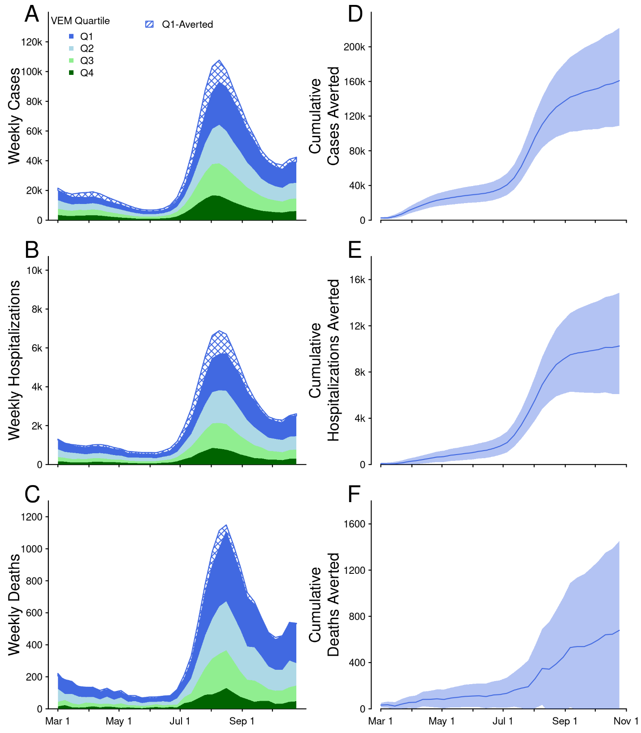

**Figure 1: Counterfactual outcomes averted results.** Time series of weekly observed cases (A), hospitalizations (B), and deaths (C) stratified by vaccine equity metric (VEM) quartile are shown in each lefthand panel. All outcomes were at relatively low levels around the time the vaccine equity allocation policy was implemented on March 2, 2021. COVID-19 activity remained low until the delta variant caused increased cases, hospitalizations, and deaths beginning in July 2021. Cumulative estimates of cases (D), hospitalizations (E), and deaths (F) averted due to the vaccine equity allocation policy are shown in the right panels. Hatched blue areas in the left panels indicate outcomes that were averted in VEM Q1 as estimated in the counterfactual analysis. Solid lines in the right panels indicate the median and shading the 95% credible intervals from 10,000 non-parametric bootstrapping samples of ZIP codes. Significant estimates of cases and hospitalizations averted were reached soon after the policy was implemented, though the majority of outcomes averted came during the delta wave when COVID-19 activity was significantly higher.

While 27% of California’s population resides in VEM Q1 areas, residents in VEM Q1 accounted for 37% of cases, 39% of hospitalizations, and 39% of deaths in the two months before the vaccine equity allocation policy was implemented (Fig 2). In the absence of this policy, disparities experienced by the least advantaged communities would have persisted or increased over time (Fig 2, dotted lines). During the post-policy period, excess COVID-19 cases and–to a lesser extent–hospitalizations in VEM Q1 were reduced (Fig 2, solid lines). In fact, in April and again in July 2021, the proportion of overall cases occurring in VEM Q1 matched the proportion of the state population residing in VEM Q1, suggesting that the burden of disease in these communities was not disproportionate (Fig 2, solid lines overlapping horizontal dashed lines). Counterfactual estimates suggest that disparities would have persisted unabated without the vaccine equity allocation.

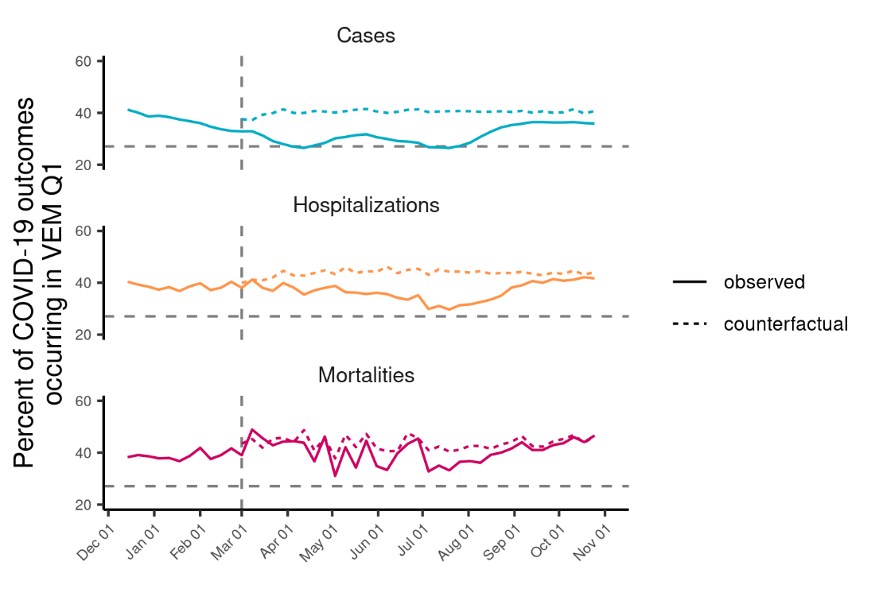

**Figure 2: Burden of COVID-19 cases, hospitalizations, and deaths in VEM Q1.** The percent of all COVID-19 cases (blue, top), hospitalizations (orange, middle), and deaths (pink, bottom) occurring among residents of the least advantaged quartile of the vaccine equity metric (VEM Q1). Solid lines show the observed percentages and dotted lines show counterfactual estimates of the percentage of each outcome occurring among VEM Q1 populations in the absence of the policy. The vertical dashed line indicates the week the policy was implemented, and the horizontal dashed line indicates the percent of California’s overall population residing in VEM Q1 ZIP codes. This population percent serves as a reference for the percent of each outcome that would occur in VEM Q1 if risk were equally distributed across VEM quartiles. Observations above this line suggest that COVID-19 cases, hospitalizations, and deaths were occurring disproportionately among VEM Q1 populations. Solid lines—representing observed data—fall closer to the horizontal reference line than the dotted lines—representing counterfactual estimates—particularly for cases and hospitalizations, indicating that the policy reduced disparities in COVID-19 outcomes among VEM Q1 residents. However, the policy was not sufficient to eliminate disparities, as the percent of outcomes occurring among VEM Q1 residents (solid lines) remains above the population percent (horizontal dashed lines) for the majority of the observation period.

Estimates of COVID-19 cases, hospitalizations, and deaths avoided varied at the county level, with generally more outcomes averted in counties with larger populations. Normalizing by population size, the county with the most impact from the vaccine equity allocation averted 1,823 (95%CI: 30 – 5,703) cases/100,000, 112 (95%CI: 1 – 345) hospitalizations/100,000, and 25 (95%CI: -36 – 83) mortalities/100,000. The county with the least impact from the vaccine equity allocation averted -133 (95%CI: -751 – 380) cases/100,000, -17 (95%CI: -69 – 14) hospitalizations/100,000, and -73 (95%CI: -293 – -73) mortalities/100,000 (Fig S4), where negative outcomes averted implies more outcomes estimated in the counterfactual scenario than were observed. Among counties with a population larger than 100,000 (representing 97.6% of the State’s population), there were 485 (95%CI: 328 – 667) cases/100,000 averted, 31 (95%CI: 18 – 45) hospitalizations/100,000 averted, and 2 (95%CI: 0 – 5) deaths/100,000 averted after the vaccine equity allocation.

### Discussion (1535 words)

Equity-based policies to guide public health programs and resource allocation are critical to addressing health disparities. The effectiveness of these policies, however, often lacks rigorous evaluation. Throughout the COVID-19 pandemic, the CDPH sed area-based socioeconomic measures such as the VEM to aid equity-based policies. In this analysis, we demonstrate that one such policy to distribute more vaccines to less advantaged communities led to increased vaccination rates and subsequent decreases in COVID-19 cases, hospitalizations, and deaths among the prioritized populations. Specifically, we estimate that vaccination rates increased 28.4%, and more than 160,000 cases, 10,000 hospitalizations, and 670 mortalities were averted because of the policy.

Our estimate of a 28.4% increase in the vaccination rate in VEM Q1 areas in the four weeks following the policy compared to all other areas varied in sensitivity analyses that tested key assumptions of the base model. When compared only to VEM Q2 areas, we estimate a 20.7% increase, while comparing only the upper half of VEM Q1 to the lower half of VEM Q2 results in a further attenuated estimate of an 8.9% increase. While our negative controls analysis suggests there were significant increases in vaccination rates in both VEM Q2 and Q3 communities compared to those in Q4, adjustment for the proportion of the population that was vaccinated before and after the policy was implemented had very little effect on these estimates. Together, these results may suggest the presence of additional factors that influenced vaccination rates at the time the policy was implemented. Another potential explanation is that VEM Q1 and Q2 ZIPS often border each other, leading to potential for spillover effects of the policy into VEM Q2 ZIPS. Regardless, the equity allocation appears to have led to at least an 8.9% increase in the vaccination rate among intended VEM Q1 residents.

The increased vaccination rate among VEM Q1 communities also resulted in significant decreases in COVID-19 outcomes. Over the eight months after the vaccine equity allocation, more than 160,000 cases, 10,000 hospitalizations, and 670 deaths were averted among VEM Q1 residents. Most of this effect was concentrated in large, urban counties. COVID-19 outcomes in smaller and more rural counties were estimated to be unaffected or to have marginally increased relative to the counterfactual scenario with no policy, though these effect estimates were more uncertain than in larger counties. This could be because of differences in implementation and epidemiology of the disease in these communities. For instance, the prevalence of prior infections varies by county and could have blunted the effect of vaccination on county-level outcomes in places with high previous burden of disease. Vaccination campaigns have also been more difficult to implement in rural areas where constraints in healthcare capacity at the local level are associated with low vaccination rates (30). Finally, LHJs attempted to ensure that vaccines allotted to VEM Q1 areas were not utilized by more advantaged individuals in neighboring areas. Implementation of such measures is likely to have varied by county, with larger, more resourced jurisdictions potentially more successful ensuring vaccines were administered to intended VEM Q1 residents.

These results corroborate prior theoretical work that found vaccine distribution to disadvantaged communities can reduce inequities in COVID-19 outcomes (15). Our results are also in agreement with previous analyses that quantified the impact of vaccinations on COVID-19 outcomes among all Californians over a similar period. Tan et al. found that approximately 1.5 million cases, 73,000 hospitalizations, and 20,000 deaths were averted due to all vaccinations in California through mid-October of 2021 (32). Our results—evaluated from the beginning of the vaccine equity allocation policy in March 2021 through the end of October 2021—suggest that the policy accounted for 10.5% of these averted cases, 14.1% of averted hospitalizations, and 3.5% of averted mortalities.

Our analysis has the added value of assessing how equitably these averted outcomes were distributed across the population. COVID-19 heavily impacted VEM Q1 communities in the pre-vaccine era of the pandemic, with these communities accounting for 40% of all cases and deaths, despite making up only 27% of California’s population (16). Our counterfactual estimates imply that this disparity would have persisted at similar levels without the vaccine equity allocation. However, the observed proportion of cases and hospitalizations coming from VEM Q1 communities was briefly equivalent to the proportion of the population in these communities following the vaccine equity allocation. This implies that the policy reduced inequities in the distribution of COVID-19 outcomes but did not successfully eliminate these inequities entirely.

The majority of estimated COVID-19 outcomes averted in this analysis were accumulated in the Delta wave in July and August 2021, more than four months after the policy was implemented in early March. Attributing COVID-19 outcomes averted in this period to the vaccine equity allocation may be tenuous since individuals vaccinated earlier because of the policy may feasibly have been vaccinated by August 2021 despite the policy. However, some individuals who were vaccinated because of the policy may otherwise never have been vaccinated due to increased politicization of the vaccine in summer 2021 (33) or other factors such as lack of access. Estimating the size of these and other relevant population subsets that were affected by the policy is infeasible. Despite the large effect estimated in the Delta wave, significant estimates of cases, hospitalizations, and deaths averted were attained quickly after the equity allocation was implemented, well before the Delta wave in California.

The estimate of cumulative deaths averted due to the policy failed to reach significance (i.e. overlapped with 0 mortalities averted) at the end of the estimation period, though estimates were significant in some weeks prior to the Delta period. Temporal trends of deaths averted in the eight months following the policy also do not align as well with cases and hospitalizations, suggesting that different factors may have influenced the progression of COVID-19 cases and hospitalizations to deaths. The Delta variant’s increased severity, particularly among unvaccinated individuals (34), is likely partially responsible for this. In addition, changing clinical treatment aided by the approval of remdesivir (35) and monoclonal antibodies (36) over the course of 2021 could confound the effect of the intervention variable and influence the counterfactual mortality estimates. Similarly, survivorship bias could affect accurate estimation of deaths in the post-policy era as many individuals that were vulnerable to severe COVID-19 outcomes may have succumbed to the disease prior to the widespread availability of vaccines (37).

There are inherent limitations in a complex policy analysis assessing the impact of vaccination policies. Our main challenge was overcoming the lack of a consistently reliable comparison group for VEM Q1 communities that were prioritized in the vaccine equity allocation policy. We attempted to resolve this issue via sensitivity analyses that compared the upper half of VEM Q1 (second VEM octile) with the lower half of VEM Q2 (third VEM octile) on the assumption that these areas are arbitrarily divided by the quartile cutoff, but are quite exchangeable in reality. We still found significant, albeit attenuated, increases in the vaccination rate in the second VEM octile after the policy was implemented.

Analyzing the effect of an upstream vaccination policy on COVID-19 outcomes is more challenging than evaluating the effect of the policy on vaccinations. Multi-dose vaccination schedules along with variability in exposure, testing access, and underlying health conditions may all affect observed rates of COVID-19 outcomes. The counterfactual approach we used to estimate outcomes averted due to the policy has been used previously to estimate the impact of vaccination campaigns in which a control group does not exist (24). This approach to generate counterfactual estimates in the absence of the policy is similar to a synthetic control analysis in which counterfactual estimates are generated for the target area or population using data from related, but non-targeted areas or populations and compared to what was actually observed.

Our approach to evaluate candidate models on their out-of-sample performance optimizes our counterfactual estimates by rigorously identifying the model with the best out-of-sample predictions. The models with the best performance for each outcome in this analysis included terms related to important drivers of COVID-19 outcomes including older age, prior vaccination, and prior infections that reduce population susceptibility. Out-of-sample error from these models was relatively low across all outcomes considered, and bootstrapped resampling at the ZIP code level to generate uncertainty estimates also ensures that our results are not reliant on a small number of overly influential observations (such as very high population ZIP codes) and that results accurately reflect uncertainty in the estimation procedure. Finally, we also estimated the main outcomes averted measure for the next nine best performing models to ensure that our results were not entirely reliant on the best performing model and found similar results across cases, hospitalizations, and deaths.

In conclusion, we found consistent evidence that California’s vaccine equity allocation policy that distributed more vaccines to the least advantaged and most impacted communities resulted in substantial increases in vaccination rates and reductions in COVID-19 outcomes. However, the policy was not sufficient to eliminate disparities in vaccination rates and COVID-19 risk experienced by these communities. Additional public health interventions that address disparities across all social determinants of health, in addition to outcome-specific policies such as the vaccine equity allocation, are needed to achieve health equity (38).

### Acknowledgements

We thank other staff at the California Department of Public Health who have engaged in valuable dialogue around the methods and findings of this manuscript, especially Natalie Linton, Joshua Quint, Lauren White, Mugdha Thakur, Sindhu Ravuri, Sophie Zhu, and Ryan McCorvie. The findings and conclusions in this article are those of the author(s) and do not necessarily represent the views or opinions of the California Department of Public Health or the California Health and Human Services Agency.

### Citations

1. Azar KM, Shen Z, Romanelli RJ, Lockhart SH, Smits K, Robinson S, et al. Disparities in outcomes among COVID-19 patients in a large health care system in California: Study estimates the COVID-19 infection fatality rate at the US county level. Health Affairs. 2020;39(7):1253–62.

2. Karmakar M, Lantz PM, Tipirneni R. Association of social and demographic factors with COVID-19 incidence and death rates in the US. JAMA network open. 2021;4(1):e2036462–e2036462.

3. Abedi V, Olulana O, Avula V, Chaudhary D, Khan A, Shahjouei S, et al. Racial, Economic, and Health Inequality and COVID-19 Infection in the United States. J Racial and Ethnic Health Disparities. 2021 Jun 1;8(3):732–42.

4. Mude W, Oguoma VM, Nyanhanda T, Mwanri L, Njue C. Racial disparities in COVID-19 pandemic cases, hospitalisations, and deaths: A systematic review and meta-analysis. J Glob Health. 11:05015.

5. Reitsma MB, Claypool AL, Vargo J, Shete PB, McCorvie R, Wheeler WH, et al. Racial/Ethnic Disparities In COVID-19 Exposure Risk, Testing, And Cases At The Subcounty Level In California: Study examines racial/ethnic disparities in COVID-19 risk, testing, and cases. Health Affairs. 2021;40(6):870–8.

6. Franz B, Parker B, Milner A, Braddock JH. The Relationship between Systemic Racism, Residential Segregation, and Racial/Ethnic Disparities in COVID-19 Deaths in the United States. Ethn Dis. 2022;32(1):31–8.

7. Assoumou SA, Peterson A, Ginman E, James T, Pierre CM, Hamilton S, et al. Addressing Inequities in SARS-CoV-2 Vaccine Uptake: The Boston Medical Center Health System Experience. Annals of Internal Medicine. 2022;175(6):879–84.

8. Casillas E, Ye M, Vargo J, Nardone A, Shete P, Thakur N. The Color of a Pandemic: The Association Between Historical Residential Redlining and COVID-19 Outcomes in California. In: C14 BURNOUT, DISPARITIES, AND OUTCOMES OF THE COVID-19 PANDEMIC. American Thoracic Society; 2022. p. A3693–A3693.

9. Hooper MW, Nápoles AM, Pérez-Stable EJ. COVID-19 and racial/ethnic disparities. JAMA. 2020;323(24):2466–7.

10. Moore JT, Ricaldi JN, Rose CE, Fuld J, Parise M, Kang GJ, et al. Disparities in incidence of COVID-19 among underrepresented racial/ethnic groups in counties identified as hotspots during June 5–18, 2020—22 states, February–June 2020. Morbidity and Mortality Weekly Report. 2020;69(33):1122.

11. Tai DBG, Shah A, Doubeni CA, Sia IG, Wieland ML. The disproportionate impact of COVID-19 on racial and ethnic minorities in the United States. Clinical Infectious Diseases. 2021;72(4):703–6.

12. Rossen LM, Branum AM, Ahmad FB, Sutton P, Anderson RN. Excess deaths associated with COVID-19, by age and race and ethnicity—United States, January 26–October 3, 2020. Morbidity and Mortality Weekly Report. 2020;69(42):1522.

13. Andrews N, Tessier E, Stowe J, Gower C, Kirsebom F, Simmons R, et al. Duration of Protection against Mild and Severe Disease by Covid-19 Vaccines. New England Journal of Medicine. 2022 Jan 27;386(4):340–50.

14. National Academies of Sciences Engineering, Medicine, others. Framework for equitable allocation of COVID-19 vaccine. National Academies Press; 2020.

15. Chen L, Xu F, Han Z, Tang K, Hui P, Evans J, et al. Strategic COVID-19 vaccine distribution can simultaneously elevate social utility and equity. Nat Hum Behav. 2022 Nov;6(11):1503–14.

16. FACT SHEET: Ending the Pandemic Through Equitable Vaccine Administration [Internet]. Office of the Governor of California; 2021. Available from: https://www.gov.ca.gov/wp-content/uploads/2021/03/Equitable-Vaccine-Administration-Fact-Sheet.pdf?emrc=48b733

17. Maizlish N, Delaney T, Dowling H, Chapman DA, Sabo R, Woolf S, et al. California healthy places index: frames matter. Public Health Reports. 2019;134(4):354–62.

18. California Department of Public Health. Blueprint For a Safer Economy: Equity Focus [Internet]. 2021 [cited 2022 Nov 1]. Available from: https://www.cdph.ca.gov/Programs/CID/DCDC/Pages/COVID-19/CaliforniaHealthEquityMetric.aspx

19. Delaney T, Dominie W, Dowling H, Maizlish N, Chapman D, Hill L, et al. Healthy places index. Public Health Alliance of Southern California, Long Beach, CA. 2018;

20. HPI into Action During the COVID-19 Pandemic: The State of California’s Health Equity and Vaccine Equity Metrics [Internet]. Public Health Alliance of Southern California; 2021 Dec. Available from: https://assets.website-files.com/613a633a3add5db901277f96/62cf1862fc7cc631dfe09812_HPI%20COVID-19%20State%20Uses.pdf

21. COVID-19 Community Vulnerability Index (CCVI) Methodology [Internet]. Surgo Ventures; 2020 Dec. Available from: https://covid-static-assets.s3.amazonaws.com/US-CCVI/COVID-19+Community+Vulnerability+Index+(CCVI)+Methodology.pdf

22. State of California. Identifying California’s Hard-to-Count in Census 2020 [Internet]. [cited 2022 Nov 1]. Available from: https://census.ca.gov/california-htc/

23. Centers for Disease Control and Prevention. Coronavirus Disease 2019 (COVID-19) 2020 Interim Case Definition, Approved August 5, 2020 [Internet]. 2021 [cited 2022 Nov 1]. Available from: https://ndc.services.cdc.gov/case-definitions/coronavirus-disease-2019-2020-08-05/

24. Head JR, Collender PA, Lewnard JA, Skaff NK, Li L, Cheng Q, et al. Early evidence of inactivated enterovirus 71 vaccine impact against hand, foot, and mouth disease in a major center of ongoing transmission in China, 2011–2018: a longitudinal surveillance study. Clinical Infectious Diseases. 2020;71(12):3088–95.

25. Shewry S, Pan E. CDPH Allocation Guidelines for COVID-19 Vaccine During Phase 1A: Recommendations [Internet]. 2020. Available from: https://www.cdph.ca.gov/Programs/CID/DCDC/Pages/COVID-19/CDPH-Allocation-Guidelines-for-COVID-19-Vaccine-During-Phase-1A-Recommendations.aspx

26. R Core Team. R: A Language and Environment for Statistical Computing [Internet]. Vienna, Austria: R Foundation for Statistical Computing; 2021. Available from: https://www.R-project.org/

27. Wickham H, Averick M, Bryan J, Chang W, McGowan LD, François R, et al. Welcome to the tidyverse. Journal of Open Source Software. 2019;4(43):1686.

28. Bates D, Mächler M, Bolker B, Walker S. Fitting Linear Mixed-Effects Models Using lme4. Journal of Statistical Software. 2015 Oct 7;67:1–48.

29. Zeileis A, Köll S, Graham N. Various Versatile Variances: An Object-Oriented Implementation of Clustered Covariances in R. Journal of Statistical Software. 2020 Oct 7;95:1–36.

30. Cuadros DF, Gutierrez JD, Moreno CM, Escobar S, Miller FD, Musuka G, et al. Impact of healthcare capacity disparities on the COVID-19 vaccination coverage in the United States: A cross-sectional study. Lancet Reg Health Am. 2023 Feb;18:100409.

31. Chapman LA, Shukla P, Rodríguez-Barraquer I, Shete PB, León TM, Bibbins-Domingo K, et al. Risk factor targeting for vaccine prioritization during the COVID-19 pandemic. Scientific Reports. 2022;12(1):1–12.

32. Tan ST, Park HJ, Rodríguez-Barraquer I, Rutherford GW, Bibbins-Domingo K, Schechter R, et al. COVID-19 Vaccination and Estimated Public Health Impact in California. JAMA network open. 2022;5(4):e228526–e228526.

33. Sharfstein JM, Callaghan T, Carpiano RM, Sgaier SK, Brewer NT, Galvani AP, et al. Uncoupling vaccination from politics: a call to action. The Lancet. 2021 Oct 2;398(10307):1211–2.

34. Lewnard JA, Hong VX, Patel MM, Kahn R, Lipsitch M, Tartof SY. Clinical outcomes associated with SARS-CoV-2 Omicron (B.1.1.529) variant and BA.1/BA.1.1 or BA.2 subvariant infection in Southern California. Nat Med. 2022 Sep;28(9):1933–43.

35. Beigel JH, Tomashek KM, Dodd LE, Mehta AK, Zingman BS, Kalil AC, et al. Remdesivir for the Treatment of Covid-19 — Final Report. N Engl J Med. 2020 Nov 5;383(19):1813–26.

36. Marovich M, Mascola JR, Cohen MS. Monoclonal Antibodies for Prevention and Treatment of COVID-19. JAMA. 2020 Jul 14;324(2):131–2.

37. Shi X, Li KQ, Mukherjee B. Current Challenges With the Use of Test-Negative Designs for Modeling COVID-19 Vaccination and Outcomes. American Journal of Epidemiology. 2023 Feb 24;192(3):328–33.

38. Lavery JV, Porter RM, Addiss DG. Cascading failures in COVID-19 vaccine equity. Science. 2023 May 5;380(6644):460–2.

### Supplementary Material

**Table S1:** Vaccination rate difference-in-differences estimates from negative controls sensitivity analysis for all pairwise combinations of vaccine equity metric (VEM) quartiles during the after-policy period

| Ref Quartile | VEM Q1 | VEM Q2 | VEM Q3 |
| --- | --- | --- | --- |
| 2 | 20.7% (13.8% - 27.9%) |  |  |
| 3 | 30.3% (23% - 38.1%) | 8% (2.4% - 13.8%) |  |
| 4 | 33% (26.2% - 40.3%) | 10.3% (5% - 15.7%) | 2.1% (-2.7% - 7.1%) |

#### Model selection for COVID-19 outcomes counterfactual estimates

We assessed the performance of a number of candidate Poisson-distributed GLMs on their out-of-sample estimation of COVID-19 cases, hospitalizations, and mortalities following the equity allocation. Candidate models shared a base form:

$$\log{E\left(y_{it} | County_{i},VEM_{i},Int_{it},S_{t}\right)=\log\left(pop_{i}\right)+β_{0}+β_{1}County_{i}+β_{2}VEM_{i}+β_{3}Int_{it}+σS_{t}}$$

$${E(y}_{it})\sim Poisson(λ)$$

where county and VEM quartile main effects are included to, respectively, adjust for county-level differences in transmission and mitigation efforts and inherent differences between VEM Q1 and non-Q1 ZIP codes independent of the intervention. The intervention variable $Int_{it}$ is binary, with ZIP-weeks observations taking place in VEM Q1 ZIP codes after the equity allocation receiving a 1 and all other observations set to 0. The final term represents a cubic spline basis with $σ$ terms estimated to account for non-linear fluctuations in COVID-19 outcomes over the observation period. Additional main effects of cumulative cases per 100,000 at the ZIP-week level (cumcasep100k), cumulative vaccinations per 100,000 at the ZIP-week level (cumvaxp100k), test rates at the ZIP-week level (testp100k), percent of the population over age 50 at the ZIP level (per50up), and interaction terms between the intervention and the spline, county, and VEM terms (int:spline, int:county, and int:VEM) were tested across all 108 possible combinations and assessed using 10 iterations of 10-fold cross validation (Table S2-4). In addition to the main results generated from 10,000 non-parametric bootstrapped samples of the best performing model, counterfactual estimates from the next nine best performing (in terms of low MSE) models were generated and used to estimate VEM Q1 outcomes averted to ensure that results were not unique to the best performing model. For these estimates, only 100 bootstrapped samples per model were performed due to limited computational resources.

#### Variability in outcomes averted at the county level

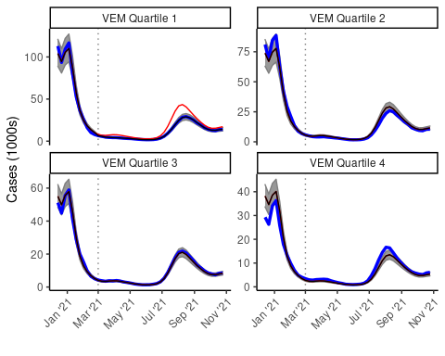

**Supplementary Figure 1: Best performing case model estimates compared to observed cases stratified by VEM quartile.** In each panel, the blue line represents observed total weekly cases in California among all ZIP codes falling into the indicated Vaccine Equity Metric (VEM) quartile. Black lines and shading represent the median and 95% confidence interval from 10,000 bootstrapped estimates of VEM-stratified weekly cases estimated from the best performing cases model. Estimates from the best performing cases model (black) closely align with observed cases (blue) across VEM quartiles and through time. The same model is used to generate counterfactual VEM Q1 case estimates in the absence of the equity allocation, which are shown in red. The difference between these counterfactual case estimates (red) and observed cases (blue) is the reported cases averted result. The vertical dotted line represents the date the equity allocation policy was implemented.

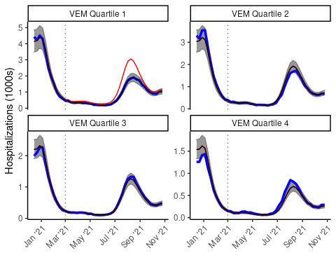

**Supplementary Figure 2: Best performing hospitalizations model estimates compared to observed hospitalizations stratified by VEM quartile.** In each panel, the blue line represents observed total weekly COVID-19 hospitalizations in California among all ZIP codes falling into the indicated Vaccine Equity Metric (VEM) quartile. Black lines and shading represent the median and 95% confidence interval from 10,000 bootstrapped estimates of VEM-stratified weekly cases estimated from the best performing hospitalizations model. Estimates from the best performing hospitalizations model (black) closely align with observed hospitalizations (blue) across VEM quartiles and through time. The same model is used to generate counterfactual VEM Q1 hospitalization estimates in the absence of the equity allocation, which are shown in red. The difference between these counterfactual hospitalization estimates (red) and observed hospitalizations (blue) is the reported hospitalizations averted result. The vertical dotted line represents the date the equity allocation policy was implemented.

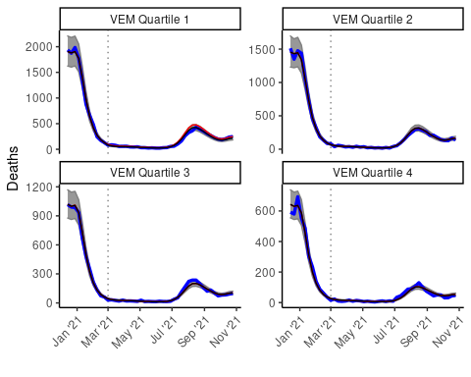

**Supplementary Figure 3: Best performing mortalities model estimates compared to observed mortalities stratified by VEM quartile.** In each panel, the blue line represents observed total weekly COVID-19 deaths in California among all ZIP codes falling into the indicated Vaccine Equity Metric (VEM) quartile. Black lines and shading represent the median and 95% confidence interval from 10,000 bootstrapped estimates of VEM-stratified weekly deaths estimated from the best performing deaths model. Estimates from the best performing deaths model (black) closely align with observed deaths (blue) across VEM quartiles and through time. The same model is used to generate counterfactual VEM Q1 death estimates in the absence of the equity allocation, which are shown in red. The difference between these counterfactual death estimates (red) and observed deaths (blue) is the reported deaths averted result. The vertical dotted line represents the date the equity allocation policy was implemented.

**Table S2:** Model formulas, performance across 10 rounds of 10-fold cross validation, and resulting cases averted estimates for the top ten best performing models. The table is ordered by descending performance in terms of the mean mean squared error across all ten rounds, which is shown along the max and min in the second column. The “BASE” term for each model is described in the text above along with additional variables included in all possible combinations. The top model with the lowest mean mean squared error was used to estimate counterfactual cases in the absence of the equity allocation and resulting cases averted reported in the main analysis. The next nine top models were also used to estimate cases averted shown in column three as a sensitivity analysis to ensure cases averted estimates were not unique to the top model. Column three shows the median cases averted and 95% confidence interval from 100 bootstrapped samples as described in the main text.

|  |  |  |
| --- | --- | --- |
| **Model Terms** | **Cases MSE (range)** | **Estimated Cases Avoided (95%CI)** |
| BASE+int:spline+cumvaxp100k | 283 (274 - 288) | 160,892  (108,878 – 221,815) |
| BASE+int:county | 285 (274 - 293) | 120,180  (84,380 – 183,261) |
| BASE+int:county+cumvaxp100k | 287 (273 - 311) | 146,065  (103,028 – 194,294) |
| BASE+cumvaxp100k | 288 (279 - 292) | 158,814  (97,975 – 216,603) |
| BASE+int:VEM+cumvaxp100k | 288 (279 - 292) | 157,483  (108,612 – 212,641) |
| BASE+int:spline+cumvaxp100k+per50up | 289 (280 - 293) | 146,678  (98,634 – 203,670) |
| BASE+int:spline | 290 (279 - 294) | 122,020  (76,147 – 161,699) |
| BASE+int:county+per50up | 292 (278 - 312) | 118,670  (74,653 – 176,585) |
| BASE+int:spline+per50up | 293 (283 - 298) | 124,645  (86,013 – 164,348) |
| BASE+cumvaxp100k+per50up | 293 (284 - 297) | 148,395  (110,207 – 212,662) |
| BASE+int:VEM+cumvaxp100k+per50up | 293 (284 - 297) |  |
| BASE | 294 (284 - 298) |  |
| BASE+int:VEM | 294 (284 - 298) |  |
| BASE+int:spline+cumvaxp100k+testp100k | 294 (285 - 300) |  |
| BASE+int:county+cumvaxp100k+testp100k | 294 (276 - 327) |  |
| BASE+int:county+cumvaxp100k+per50up | 295 (278 - 332) |  |
| BASE+int:VEM+cumvaxp100k+testp100k | 297 (285 - 303) |  |
| BASE+cumvaxp100k+testp100k | 297 (285 - 303) |  |
| BASE+int:VEM+per50up | 297 (287 - 301) |  |
| BASE+per50up | 297 (287 - 301) |  |
| BASE+int:spline+cumvaxp100k+testp100k+per50up | 299 (289 - 305) |  |
| BASE+int:county+cumcasep100k+cumvaxp100k | 300 (286 - 306) |  |
| BASE+int:county+cumcasep100k+cumvaxp100k+per50up | 300 (287 - 306) |  |
| BASE+int:county+cumcasep100k+per50up | 301 (288 - 306) |  |
| BASE+int:county+cumcasep100k | 301 (288 - 306) |  |
| BASE+cumvaxp100k+testp100k+per50up | 302 (290 - 307) |  |
| BASE+int:VEM+cumvaxp100k+testp100k+per50up | 302 (290 - 307) |  |
| BASE+int:spline+testp100k | 302 (290 - 313) |  |
| BASE+int:county+cumvaxp100k+testp100k+per50up | 304 (281 - 354) |  |
| BASE+int:spline+testp100k+per50up | 304 (293 - 311) |  |
| BASE+int:VEM+testp100k+per50up | 307 (294 - 316) |  |
| BASE+testp100k+per50up | 307 (294 - 316) |  |
| BASE+testp100k | 308 (291 - 326) |  |
| BASE+int:VEM+testp100k | 308 (291 - 326) |  |
| BASE+int:county+cumcasep100k+cumvaxp100k+testp100k | 308 (293 - 322) |  |
| BASE+int:county+cumcasep100k+cumvaxp100k+  testp100k+per50up | 309 (294 - 322) |  |
| BASE+int:spline+cumcasep100k+cumvaxp100k | 313 (302 - 321) |  |
| BASE+int:spline+cumcasep100k+cumvaxp100k+per50up | 314 (303 - 322) |  |
| BASE+int:VEM+cumcasep100k+cumvaxp100k | 317 (306 - 325) |  |
| BASE+cumcasep100k+cumvaxp100k | 317 (306 - 325) |  |
| BASE+int:spline+cumcasep100k | 317 (305 - 325) |  |
| BASE+int:spline+cumcasep100k+per50up | 318 (305 - 325) |  |
| BASE+int:VEM+cumcasep100k+cumvaxp100k+per50up | 318 (307 - 326) |  |
| BASE+cumcasep100k+cumvaxp100k+per50up | 318 (307 - 326) |  |
| BASE+cumcasep100k | 321 (310 - 329) |  |
| BASE+int:VEM+cumcasep100k | 321 (310 - 329) |  |
| BASE+int:VEM+cumcasep100k+per50up | 321 (310 - 329) |  |
| BASE+cumcasep100k+per50up | 321 (310 - 329) |  |
| BASE+int:spline+cumcasep100k+cumvaxp100k+testp100k | 322 (312 - 333) |  |
| BASE+int:spline+cumcasep100k+cumvaxp100k+  testp100k+per50up | 323 (312 - 333) |  |
| BASE+cumcasep100k+cumvaxp100k+testp100k | 325 (313 - 336) |  |
| BASE+int:VEM+cumcasep100k+cumvaxp100k+testp100k | 325 (313 - 336) |  |
| BASE+cumcasep100k+cumvaxp100k+testp100k+per50up | 325 (313 - 336) |  |
| BASE+int:VEM+cumcasep100k+cumvaxp100k+  testp100k+per50up | 325 (313 - 336) |  |
| BASE+int:spline+cumcasep100k+testp100k+per50up | 325 (313 - 337) |  |
| BASE+int:spline+cumcasep100k+testp100k | 326 (313 - 338) |  |
| BASE+int:VEM+cumcasep100k+testp100k+per50up | 329 (315 - 343) |  |
| BASE+cumcasep100k+testp100k+per50up | 329 (315 - 343) |  |
| BASE+int:VEM+cumcasep100k+testp100k | 330 (315 - 346) |  |
| BASE+cumcasep100k+testp100k | 330 (315 - 346) |  |
| BASE+int:county+testp100k+per50up | 336 (284 - 403) |  |
| BASE+int:county+cumcasep100k+testp100k+per50up | 409 (294 - 559) |  |
| BASE+int:county+cumcasep100k+testp100k | 486 (294 - 724) |  |
| BASE+int:county+testp100k | 488 (280 - 826) |  |

**Table S3:** Model formulas, performance across 10 rounds of 10-fold cross validation, and resulting hospitalizations averted estimates for the top ten best performing models. The table is ordered by descending performance in terms of the mean mean squared error across all ten rounds, which is shown along the max and min in the second column. The “BASE” term for each model is described in the text above along with additional variables included in all possible combinations. The top model with the lowest mean mean squared error was used to estimate counterfactual hospitalizations in the absence of the equity allocation and resulting hospitalizations averted reported in the main analysis. The next nine top models were also used to estimate hospitalizations averted shown in column three as a sensitivity analysis to ensure hospitalizations averted estimates were not unique to the top model. Column three shows the median hospitalizations averted and 95% confidence interval from 100 bootstrapped samples as described in the main text.

| **Model Terms** | **Hospitalizations MSE (range)** | **Estimated Hospitalizations Avoided (95%CI)** |
| --- | --- | --- |
| BASE+int:spline+cumvaxp100k+testp100k+  per50up | 2.97 (2.96 - 3) | 10,248  (6,111 – 14,853) |
| BASE+int:spline+cumvaxp100k+per50up | 2.98 (2.97 - 3.01) | 10,322  (7,265 – 15,491) |
| BASE+int:spline+cumvaxp100k+testp100k | 3 (2.99 - 3.03) | 10,172  (6,234 – 14,106) |
| BASE+cumvaxp100k+testp100k+per50up | 3.02 (3 - 3.05) | 10,003  (5,932 – 14,985) |
| BASE+int:VEM+cumvaxp100k+testp100k+  per50up | 3.02 (3 - 3.05) | 10,128  (5,680 – 13,860) |
| BASE+cumvaxp100k+per50up | 3.02 (3.01 - 3.06) | 9,513  (5,870 – 14,392) |
| BASE+int:VEM+cumvaxp100k+per50up | 3.02 (3.01 - 3.06) | 10,088  (6,736 – 13,516) |
| BASE+int:spline+cumvaxp100k | 3.03 (3.01 - 3.06) | 9,328  (5,701 – 13,920) |
| BASE+int:spline+cumcasep100k+cumvaxp100k+  testp100k+per50up | 3.03 (3.01 - 3.05) | 11,703  (8,208 – 16,767) |
| BASE+int:VEM+cumvaxp100k+testp100k | 3.06 (3.04 - 3.09) | 9,303  (5,447 – 13,518) |
| BASE+cumvaxp100k+testp100k | 3.06 (3.04 - 3.09) |  |
| BASE+int:spline+cumcasep100k+cumvaxp100k+  testp100k | 3.07 (3.05 - 3.09) |  |
| BASE+cumvaxp100k | 3.07 (3.06 - 3.11) |  |
| BASE+int:VEM+cumvaxp100k | 3.07 (3.06 - 3.11) |  |
| BASE+int:spline+cumcasep100k+cumvaxp100k+  per50up | 3.08 (3.06 - 3.1) |  |
| BASE+cumcasep100k+cumvaxp100k+testp100k+  per50up | 3.09 (3.07 - 3.11) |  |
| BASE+int:VEM+cumcasep100k+cumvaxp100k+  testp100k+per50up | 3.09 (3.07 - 3.11) |  |
| BASE+int:county+per50up | 3.11 (3.06 - 3.3) |  |
| BASE+int:county+testp100k+per50up | 3.11 (3.06 - 3.3) |  |
| BASE+int:spline+cumcasep100k+cumvaxp100k | 3.12 (3.11 - 3.15) |  |
| BASE+int:VEM+cumcasep100k+cumvaxp100k+  testp100k | 3.12 (3.11 - 3.15) |  |
| BASE+cumcasep100k+cumvaxp100k+testp100k | 3.12 (3.11 - 3.15) |  |
| BASE+cumcasep100k+cumvaxp100k+per50up | 3.13 (3.11 - 3.15) |  |
| BASE+int:VEM+cumcasep100k+cumvaxp100k+  per50up | 3.13 (3.11 - 3.15) |  |
| BASE+int:county+cumcasep100k+testp100k+  per50up | 3.13 (3.11 - 3.18) |  |
| BASE+int:county | 3.13 (3.07 - 3.39) |  |
| BASE+int:county+testp100k | 3.13 (3.07 - 3.39) |  |
| BASE+int:county+cumcasep100k+testp100k | 3.14 (3.11 - 3.21) |  |
| BASE+int:county+cumcasep100k+per50up | 3.14 (3.12 - 3.19) |  |
| BASE+int:spline+testp100k+per50up | 3.15 (3.14 - 3.17) |  |
| BASE+int:county+cumcasep100k | 3.15 (3.13 - 3.22) |  |
| BASE+int:spline+testp100k | 3.15 (3.14 - 3.18) |  |
| BASE+cumcasep100k+cumvaxp100k | 3.17 (3.15 - 3.2) |  |
| BASE+int:VEM+cumcasep100k+cumvaxp100k | 3.17 (3.15 - 3.2) |  |
| BASE+int:spline+per50up | 3.18 (3.17 - 3.21) |  |
| BASE+int:VEM+testp100k+per50up | 3.19 (3.18 - 3.22) |  |
| BASE+testp100k+per50up | 3.19 (3.18 - 3.22) |  |
| BASE+int:spline | 3.19 (3.18 - 3.22) |  |
| BASE+int:VEM+testp100k | 3.2 (3.19 - 3.23) |  |
| BASE+testp100k | 3.2 (3.19 - 3.23) |  |
| BASE+int:spline+cumcasep100k+testp100k+  per50up | 3.21 (3.2 - 3.23) |  |
| BASE+int:spline+cumcasep100k+testp100k | 3.21 (3.2 - 3.23) |  |
| BASE+per50up | 3.22 (3.21 - 3.25) |  |
| BASE+int:VEM+per50up | 3.22 (3.21 - 3.25) |  |
| BASE | 3.23 (3.22 - 3.26) |  |
| BASE+int:VEM | 3.23 (3.22 - 3.26) |  |
| BASE+int:county+cumcasep100k+cumvaxp100k+  testp100k+per50up | 3.24 (2.98 - 4.28) |  |
| BASE+int:county+cumcasep100k+cumvaxp100k+  per50up | 3.26 (2.98 - 4.47) |  |
| BASE+cumcasep100k+testp100k+per50up | 3.27 (3.25 - 3.29) |  |
| BASE+int:VEM+cumcasep100k+testp100k+per50up | 3.27 (3.25 - 3.29) |  |
| BASE+cumcasep100k+testp100k | 3.27 (3.26 - 3.29) |  |
| BASE+int:VEM+cumcasep100k+testp100k | 3.27 (3.26 - 3.29) |  |
| BASE+int:spline+cumcasep100k+per50up | 3.29 (3.27 - 3.3) |  |
| BASE+int:spline+cumcasep100k | 3.29 (3.28 - 3.31) |  |
| BASE+cumcasep100k+per50up | 3.33 (3.32 - 3.35) |  |
| BASE+int:VEM+cumcasep100k+per50up | 3.33 (3.32 - 3.35) |  |
| BASE+cumcasep100k | 3.34 (3.32 - 3.36) |  |
| BASE+int:VEM+cumcasep100k | 3.34 (3.32 - 3.36) |  |
| BASE+int:county+cumcasep100k+cumvaxp100k+  testp100k | 3.68 (3.01 - 6.42) |  |
| BASE+int:county+cumcasep100k+cumvaxp100k | 3.78 (3.01 - 6.96) |  |
| BASE+int:county+cumvaxp100k+per50up | 5.83 (2.91 - 18.66) |  |
| BASE+int:county+cumvaxp100k+testp100k+per50up | 6.01 (2.92 - 18.94) |  |
| BASE+int:county+cumvaxp100k | 7.06 (2.95 - 24.46) |  |
| BASE+int:county+cumvaxp100k+testp100k | 7.18 (2.95 - 24.03) |  |

**Table S4:** Model formulas, performance across 10 rounds of 10-fold cross validation, and resulting deaths averted estimates for the top ten best performing models. The table is ordered by descending performance in terms of the mean mean squared error across all ten rounds, which is shown along the max and min in the second column. The “BASE” term for each model is described in the text above along with additional variables included in all possible combinations. The top model with the lowest mean mean squared error was used to estimate counterfactual deaths in the absence of the equity allocation and resulting deaths averted reported in the main analysis. The next nine top models were also used to estimate deaths averted shown in column three as a sensitivity analysis to ensure deaths averted estimates were not unique to the top model. Column three shows the median deaths averted and 95% confidence interval from 100 bootstrapped samples as described in the main text.

| **Model Terms** | **Mortalities MSE (range)** | **Estimated Deaths Avoided* (95%CI)** |
| --- | --- | --- |
| BASE+int:county+cumvaxp100k+per50up | 0.312 (0.31 - 0.32) | 679  (-32 – 1451) |
| BASE+int:county+cumvaxp100k+testp100k+per50up | 0.314 (0.312 - 0.322) | 770  (160 – 1694) |
| BASE+int:county+per50up | 0.317 (0.314 - 0.327) | -354  (-978 – 280) |
| BASE+int:county+cumvaxp100k | 0.317 (0.312 - 0.332) | 492  (-204 – 1354) |
| BASE+int:county+cumcasep100k+cumvaxp100k+per50up | 0.318 (0.313 - 0.327) | 962  (187 – 1718) |
| BASE+int:county+cumcasep100k+cumvaxp100k+  testp100k+per50up | 0.319 (0.315 - 0.329) | 969  (212 – 1824) |
| BASE+int:county+testp100k+per50up | 0.319 (0.317 - 0.329) | -298  (-948 – 200) |
| BASE+int:county+cumvaxp100k+testp100k | 0.32 (0.314 - 0.335) | 535  (-201 – 1224) |
| BASE+int:county | 0.321 (0.315 - 0.337) | -329  (-937 – 175) |
| BASE+int:county+cumcasep100k+per50up | 0.322 (0.317 - 0.335) | -134  (-683 – 594) |
| BASE+int:county+testp100k | 0.323 (0.317 - 0.339) |  |
| BASE+int:spline+cumvaxp100k+per50up | 0.323 (0.32 - 0.325) |  |
| BASE+int:county+cumcasep100k+testp100k+per50up | 0.324 (0.318 - 0.336) |  |
| BASE+cumvaxp100k+per50up | 0.324 (0.32 - 0.326) |  |
| BASE+int:VEM+cumvaxp100k+per50up | 0.324 (0.32 - 0.326) |  |
| BASE+int:county+cumcasep100k+cumvaxp100k | 0.324 (0.315 - 0.347) |  |
| BASE+int:county+cumcasep100k+cumvaxp100k+testp100k | 0.326 (0.316 - 0.349) |  |
| BASE+int:spline+cumvaxp100k+testp100k+per50up | 0.327 (0.323 - 0.329) |  |
| BASE+cumvaxp100k+testp100k+per50up | 0.327 (0.324 - 0.329) |  |
| BASE+int:VEM+cumvaxp100k+testp100k+per50up | 0.327 (0.324 - 0.329) |  |
| BASE+int:county+cumcasep100k | 0.327 (0.318 - 0.352) |  |
| BASE+int:spline+cumvaxp100k | 0.328 (0.324 - 0.329) |  |
| BASE+int:VEM+cumvaxp100k | 0.328 (0.325 - 0.33) |  |
| BASE+cumvaxp100k | 0.328 (0.325 - 0.33) |  |
| BASE+int:county+cumcasep100k+testp100k | 0.329 (0.319 - 0.353) |  |
| BASE+int:spline+cumcasep100k+cumvaxp100k+per50up | 0.33 (0.327 - 0.332) |  |
| BASE+int:spline+cumvaxp100k+testp100k | 0.33 (0.327 - 0.332) |  |
| BASE+cumvaxp100k+testp100k | 0.331 (0.328 - 0.333) |  |
| BASE+int:VEM+cumvaxp100k+testp100k | 0.331 (0.328 - 0.333) |  |
| BASE+int:VEM+cumcasep100k+cumvaxp100k+per50up | 0.331 (0.328 - 0.333) |  |
| BASE+cumcasep100k+cumvaxp100k+per50up | 0.331 (0.328 - 0.333) |  |
| BASE+int:spline+cumcasep100k+cumvaxp100k+  testp100k+per50up | 0.332 (0.328 - 0.334) |  |
| BASE+int:VEM+cumcasep100k+cumvaxp100k+  testp100k+per50up | 0.333 (0.329 - 0.335) |  |
| BASE+cumcasep100k+cumvaxp100k+testp100k+per50up | 0.333 (0.329 - 0.335) |  |
| BASE+int:spline+cumcasep100k+cumvaxp100k | 0.333 (0.33 - 0.335) |  |
| BASE+int:VEM+cumcasep100k+cumvaxp100k | 0.334 (0.331 - 0.336) |  |
| BASE+cumcasep100k+cumvaxp100k | 0.334 (0.331 - 0.336) |  |
| BASE+int:spline+cumcasep100k+cumvaxp100k+testp100k | 0.334 (0.33 - 0.336) |  |
| BASE+int:spline+per50up | 0.334 (0.329 - 0.336) |  |
| BASE+int:VEM+per50up | 0.335 (0.33 - 0.337) |  |
| BASE+per50up | 0.335 (0.33 - 0.337) |  |
| BASE+int:VEM+cumcasep100k+cumvaxp100k+testp100k | 0.335 (0.331 - 0.337) |  |
| BASE+cumcasep100k+cumvaxp100k+testp100k | 0.335 (0.331 - 0.337) |  |
| BASE+int:spline | 0.336 (0.331 - 0.338) |  |
| BASE+int:spline+testp100k+per50up | 0.337 (0.331 - 0.339) |  |
| BASE | 0.337 (0.332 - 0.339) |  |
| BASE+int:VEM | 0.337 (0.332 - 0.339) |  |
| BASE+testp100k+per50up | 0.337 (0.332 - 0.34) |  |
| BASE+int:VEM+testp100k+per50up | 0.337 (0.332 - 0.34) |  |
| BASE+int:spline+testp100k | 0.337 (0.332 - 0.34) |  |
| BASE+testp100k | 0.338 (0.333 - 0.341) |  |
| BASE+int:VEM+testp100k | 0.338 (0.333 - 0.341) |  |
| BASE+int:spline+cumcasep100k+testp100k | 0.341 (0.336 - 0.343) |  |
| BASE+int:spline+cumcasep100k+testp100k+per50up | 0.341 (0.335 - 0.343) |  |
| BASE+int:spline+cumcasep100k+per50up | 0.341 (0.336 - 0.343) |  |
| BASE+int:VEM+cumcasep100k+testp100k | 0.342 (0.337 - 0.344) |  |
| BASE+cumcasep100k+testp100k | 0.342 (0.337 - 0.344) |  |
| BASE+int:VEM+cumcasep100k+per50up | 0.342 (0.337 - 0.344) |  |
| BASE+cumcasep100k+per50up | 0.342 (0.337 - 0.344) |  |
| BASE+cumcasep100k+testp100k+per50up | 0.342 (0.337 - 0.344) |  |
| BASE+int:VEM+cumcasep100k+testp100k+per50up | 0.342 (0.337 - 0.344) |  |
| BASE+int:spline+cumcasep100k | 0.342 (0.337 - 0.344) |  |
| BASE+cumcasep100k | 0.343 (0.338 - 0.345) |  |
| BASE+int:VEM+cumcasep100k | 0.343 (0.338 - 0.345) |  |

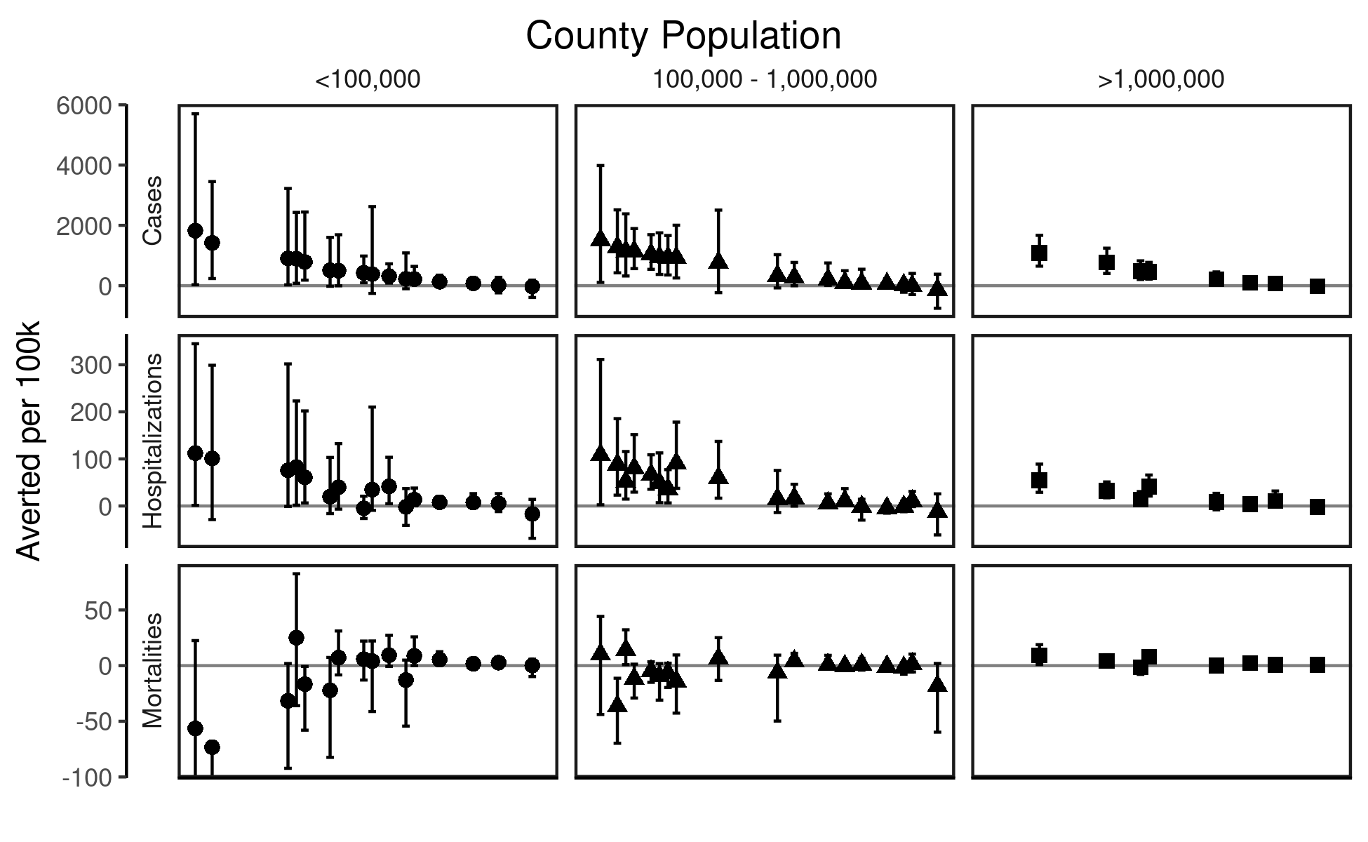

**Supplementary Figure 4: Outcomes averted estimates normalized by county population.** Median and 95% confidence intervals of outcomes averted per 100,000 residents from 10,000 bootstrapped samples are shown for all counties in California included in the analysis. Each individual point represents a county with names redacted. Counties are stratified in column panels and by point shape according to their population size (less than 100,000 residents, between 100,000 and 1,000,000 residents, or greater than 1,000,000 residents). Row panels are divided by COVID-19 outcome considered (cases, hospitalizations, and mortalities). Most counties that experienced negative outcomes averted per 100,000 residents, implying fewer outcomes in the counterfactual scenario without the equity allocation, were smaller in terms of population. Seven out of eight counties with a population greater than 1,000,000 were estimated to have averted cases, hospitalizations, and mortalities due to the policy. Results among medium- and small-sized counties were more mixed. Some lower confidence intervals are cut off to aid data visualization.