Report

Section 0: System Specifications

The IS3 system is an interactive shared whiteboard implemented using HTML5, JavaScript and node .js . The system supports the collaborative activity of preparing documents. It is expected that the system will have the following features: multiple user creation of documents that is simultaneous and distributed, and other usual functionalities of a document creation system.

Section 1: Scenarios of Use

Mark, Caroline and Philip are high school students working on a group project for the annual science fair. They are still in the early stages of the project. They would like to have a whiteboard where they could drop down their ideas in the form of text or illustrations, which would allow them to keep track of their work. Each of them have a very different timetable, so it is rather difficult for them to get together often.

Samantha and her family are very much involved in organizing community events in her neighborhood, whose population mainly consists of families with children. The neighbors have asked the family to take over the task of advertising (e.g. produce some posters) for the next Christmas fair.

Something Inc. is currently using a software that allows their employees to communicate with each other using text and images. Although the problem with the current system is that the response time is rather slow. After collecting the data on the system that they use for daily basis, they have found out that too many time resources have been wasted on waiting for responses. They believe that the performance of the company would drastically boost, it the application was capable of fetching responses in real time instead.

Section 2: Design

– Describe your initial design, your evaluation process, and your final design – justifying all the decision made.

- Describe work-flow of our web application

- Describe an idea that fulfills the need

- Define tasks that users needed to do for the initial design, then talk about the data that you have collected.

- Provide a design rationale – Provide justification for the choices made in the design. The choices can be validated by reference to participant data or prior experience, or theory. - Sometimes describe why one particular point that has been chosen instead of another.

- Based on the design rationale of the previous iterations produce a final design

- Provide a design rationale on the final iteration – provide justification made in the design based on the previous data from the tasks and the design rationale. Describe why the final design is chosen over the initial one.

Initial Design

For our initial design we first created a work flow of the web application using the dialogue notation. This allowed us to illustrate how the different tasks get accomplished, and also how information flows between them. The nodes on the diagram represent the different tasks that the user could execute and the edges represent the information which is being transferred between them.

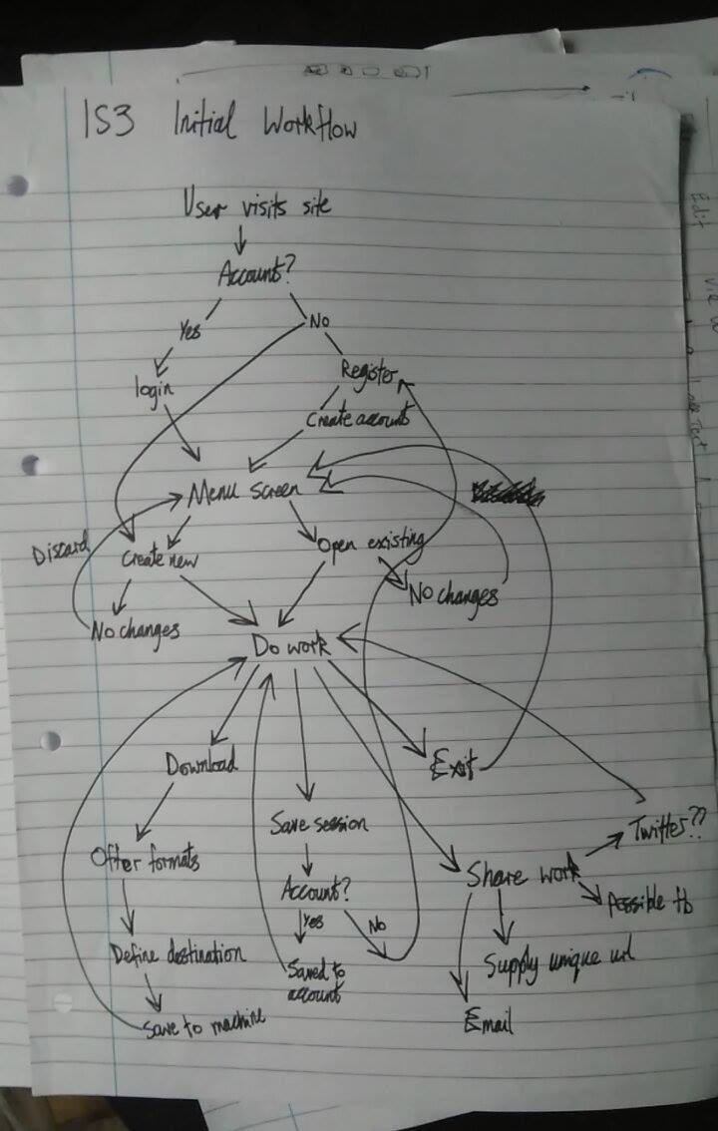

Afterwards we split the workflow diagram into several modules; each representing a design issue that we will address in the wireframes:

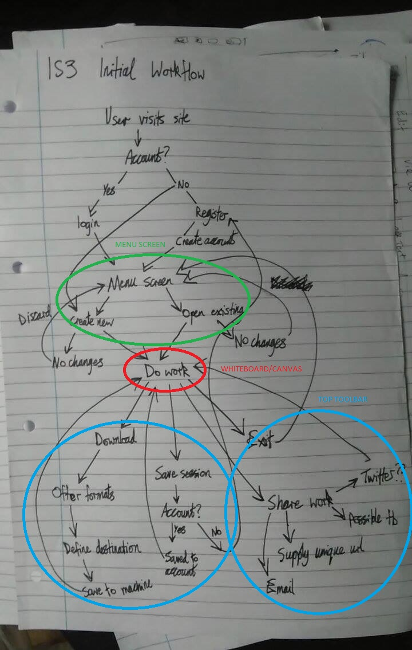

We have identified 4 modules: menu screen (green), canvas (red), top toolbar (blue), and side bar (blue). Using these modules we produced two wireframes:

Wireframe 1:

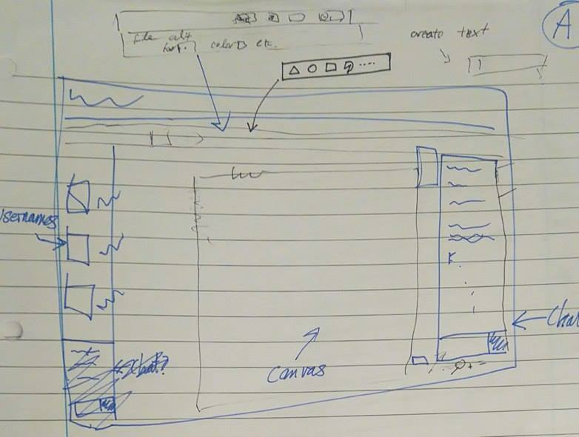

Wireframe 2:

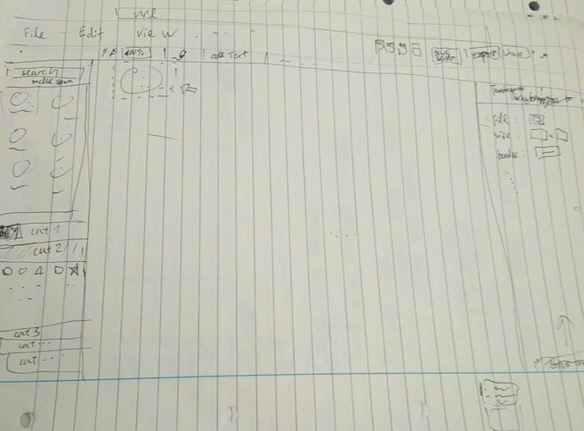

Both wireframes went through a round of discussion in the team, where we looked at how each module was implemented and whether these were user-friendly. Team discussions seemed to favour the less cluttered design of wireframe 2; we produced a more detailed wireframe based around this, which we then used as our initial design for the formative evaluation:

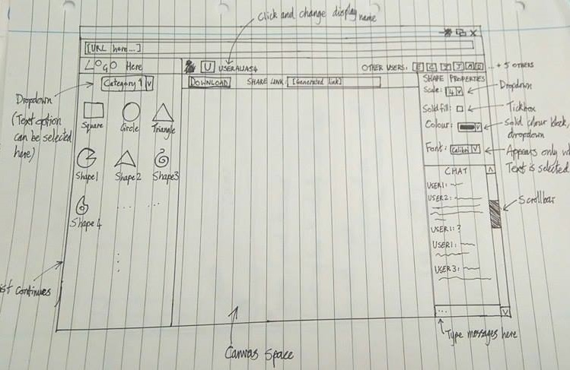

User feedback is a vital ingredient in creating an efficient, user-friendly end product and these ideas are invaluable for helping us see the system from a fresh perspective, identifying blind spots that we had not noticed ourselves. We performed surveys of potential users to gather this data as part of our project's formative evaluation.

We surveyed six people from a range of technical and non-technical backgrounds; a small number, but this can provide valuable insights without being overloaded with qualitative responses. The member of the team performing the survey provided some background information on the key features and the aims of the application, then invited feedback from the potential user.

Some points were only brought up once (for example, one participant didn't see the need for including a chat function) and can be written off as anomalous, but several concerns were brought up multiple times:

* Canvas space might not be consistent across different display sizes and the drawing itself might extend beyond the initial visible area.
* Similar issue with the list of shapes on smaller displays.
* The word 'download' on its own is vague – it's unclear what format the work would be saved in and less technically inclined users might not realize it's equivalent to saving a permanent copy of the canvas.
* Numeric value for 'scale' attribute on shapes is unintuitive.

The fact that these same issues were mentioned by several people independently of each other shows that there are genuine problems with our current design and solutions we needed to consider.

Suggested changes for the above problems:

* Add scrollbars to the list of shapes and the canvas space.
* Change wording on the download button to 'save canvas' or 'download canvas'.
* Use 'small', 'medium', 'large', etc. instead of numbers for the scale attribute. Alternatively, use a slider for changing the size of shapes instead of a dropdown menu.

After analyzing the responses we obtained from the formative survey, we were able to come up with several design space diagrams, which allowed us to understand how a "good" interface looks like from the user's point of view. The diagrams provided us with information on how we should arrange our modules in the interface. The red areas in the diagrams are the limits, I.e.the design constraints of a given object or where we would not want to place a given object.

Final Design

Following a careful consideration of the results from the design space diagrams, we produced a wireframe that we would deem as our final design. Using this design we will implement the system interface. The positions of the modules should be treated as absolute at this point, but if any technical challenges arise from them, then they might be subject to change.

Section 3: Describe your evaluation process, and subsequent changes made – justifying all the decision made. → Focus on the interesting technical challenges of implementing the interactive features of your system. (Talk about System implementation)

- Describe the system implemented (what are the specific features) and the technologies used

- Describe technical challenges encountered when porting the final design over to the system.

- Talk about any other challenges encountered during implementation.

Section 4: Summative comparison – focus on the differences in the interaction and use, rather than differences in implementation. Describe your evaluation method, and write a comparative summary of the two systems (our and the one of the other team).