Pattern Recognition Manuscript Draft
Manuscript Number: PR-D-16-01875R1

Title: Regularized 2-D Complex-Log Spectral Analysis and Subspace Reliability Analysis of Micro-Doppler Signature for UAV Detection
Article Type: Full Length Article Section/Category: Various applications
Keywords: UAV detection; radar; micro-Doppler signature; 2-D regularized complex-log-Fourier transform; subspace reliability analysis
Abstract: Unmanned aerial vehicle (UAV) has become an important radar target recently because of its wide applications and potential security threats. Traditionally, visual features such as spectrogram were often extracted for human operators to identify the micro-Doppler signature (mDS) of UAVs, i.e. sinusoidal modulation. In this paper, the authors aim to design a system for machine automatic classification of UAVs from other targets, particularly from birds as both UAVs and birds are small and slow-moving radar targets. Most existing mDS representations such as spectrogram, cepstrogram and cadence velocity diagram discard the phase spectrum, and only make use of the magnitude spectrum. What's more, people often take the logarithm of the spectrum to enlarge the weak mDS but without sufficient care, as noise may be enlarged at the same time.
The authors thus propose a regularized 2-D complex-log-Fourier transform to address these problems. Furthermore, the authors propose an object-oriented dimension-reduction technique: subspace reliability analysis, which directly removes the unreliable feature dimensions of two class-conditional covariance matrices in two separate subspaces. On the benchmark dataset, the proposed approach demonstrates better performance than the state-of-the-art approaches. More specifically, the proposed approach significantly reduces the equal error rate of the second best approach, cadence velocity diagram, from 6.68% to 3.27%.

*Title Page

Regularized 2-D Complex-Log Spectral Analysis and Subspace Reliability Analysis of Micro-Doppler Signature for UAV Detection
Jianfeng Ren∗, Xudong Jiang
Electrical & Electronic Engineering, Nanyang Technological University, Nanyang Link, Singapore 639798.

Abstract
Unmanned aerial vehicle (UAV) has become an important radar target recently because of its wide applications and potential security threats. Traditionally, visual features such as spectrogram were often extracted for human operators to identify the micro-Doppler signature (mDS) of UAVs, i.e. sinusoidal mod-ulation. In this paper, the authors aim to design a system for machine au-tomatic classification of UAVs from other targets, particularly from birds as both UAVs and birds are small and slow-moving radar targets. Most exist-ing mDS representations such as spectrogram, cepstrogram and cadence veloc-ity diagram discard the phase spectrum, and only make use of the magnitude spectrum. What’s more, people often take the logarithm of the spectrum to enlarge the weak mDS but without sufficient care, as noise may be enlarged at the same time. The authors thus propose a regularized 2-D complex-log-Fourier transform to address these problems. Furthermore, the authors propose an object-oriented dimension-reduction technique: subspace reliability analysis, which directly removes the unreliable feature dimensions of two class-conditional covariance matrices in two separate subspaces. On the benchmark dataset, the proposed approach demonstrates better performance than the state-of-the-art approaches. More specifically, the proposed approach significantly reduces the

∗ Corresponding author. Tel.: +65 6790 5018
Email addresses: jfren@ntu.edu.sg (Jianfeng Ren), exdjiang@ntu.edu.sg
(Xudong Jiang)

Preprint submitted to Pattern Recognition March 15, 2017

*Highlights (for review)

Highlights
- The proposed 2-D regularized complex-log-Fourier transform better represents mDS.
- The proposed subspace reliability analysis better removes unreliable dimensions.
- The proposed approach demonstrates superior performance for UAV detection.

*Response to Reviewers

PR-D-16-01875.R1 Response to Reviewers’ Comments
Dear Editor and Reviewers,
Authors sincerely thank the associate editor and the four anonymous reviewers for the constructive comments. We have carefully studied all comments and tried our best to address all issues in the revised manuscript. The main revisions are marked in blue in the revised manuscript. All comments of reviewers are addressed in this document.

To Associate Editor:

This paper requires a lot of significant revisions as suggested by reviewers. Also since most readers are not so familiar with the signal processing aspect of the work, I suggest at least one figure be shown of the waveform of the micro-Doppler signature, perhaps that corresponds to Fig. 2 where the spectrum is shown.

Authors’ reply:
Thank you for your comments. We have added Fig. 1 in Section 1 of the revised manuscript to show some examples of micro-Doppler signature of UAVs and birds. For your convenience, we copy it here:
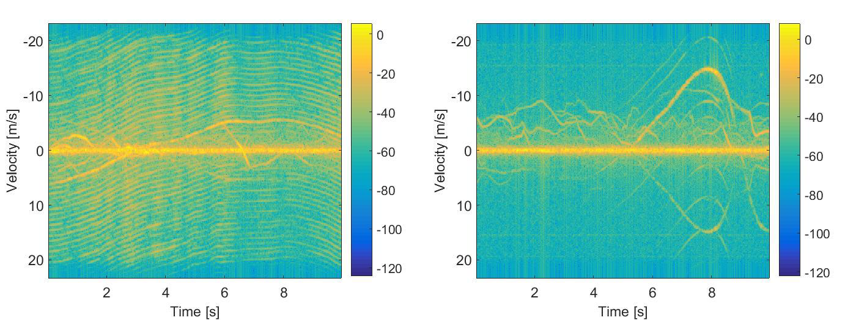
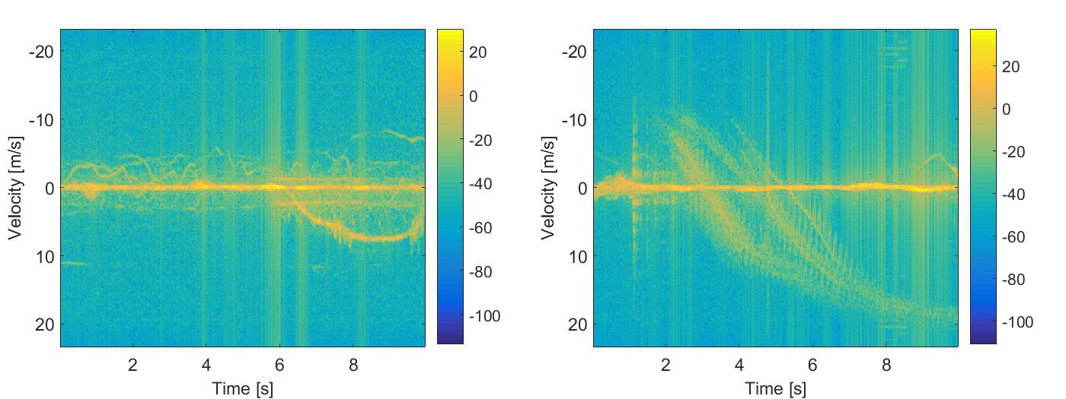
(a) Spectrogram of an UAV close to radar. (b) Spectrogram of an UAV far away from radar.
(c) Spectrogram of a bird. (d) Spectrogram of a group of birds.
Fig. 1 Examples of micro-Doppler signature of UAVs and birds are shown in (a) – (d), respectively. When the UAV is close to radar, we can see the clear micro-Doppler signature of the rotor blades of the UAV, shown as the parallel lines in (a). However, when the UAV is far away from radar, the micro-Doppler signature shown in (b) is weak. It is difficult to visually differentiate the UAV shown in (b) from the bird shown in (c), or the group of birds shown in (d).
We have also added some discussions at the end of the fourth paragraph of Section 1. We copy them here for your convenience:

“Fig. 1 shows the spectrograms of UAVs and birds. When the UAV is close to radar, clear micro-Doppler signature of rotor blades, the parallel lines, can be observed as shown in Fig. 1(a). When the UAV is far away from radar, it is difficult to visually differentiate the UAV shown in Fig. 1(b) from the bird shown in Fig. 1(c), or the group of birds shown in Fig. 1(d).”

Summary of Major Revision.
The major revisions are summarized as follow:
  - We have highlighted our contributions.
    - We have added the summary of contributions at the end of Section 1 per R#4.
    - We have compacted Section 2.1 and 3.1 to remove some basic information of the existing approaches, and focused more on the proposed approaches per R#7.
  - We have revised the paper presentation to make the paper clearer.
    - We have added Fig. 1 in Section 1 to show some visual examples of the micro-Doppler signature of UAVs and birds using spectrograms.
    - Per R#7, we have added more discussions on the differences between the proposed signal representation and the existing approaches in the first paragraph of Section 2.2. We have also highlighted those differences in the caption of Fig. 2.
    - We have added more justifications why the phase spectrum helps the classification in the last paragraph of Section 2.3 per R#7.
    - We have added Section 3.4 as the summary of the proposed UAV-detection system, per R#7.
  - We have revised the experimental section according to reviewers’ comments to better analyse the performance improvement of the proposed approach.
    - We have added Table 1 and the discussions on the comparison between the proposed signal representation and the existing signal representations in the last paragraph of Section 4.2, per R#4.
    - We have added Table 2 and the related discussions to summarize the comparison of the proposed SRA with PCA.
    - We have added more analysis on Fig. 6 in the third paragraph of Section 4.3 per R#7.
    - We have added how to choose the optimal feature dimensions for the proposed SRA at the end of Section 4.3, per R#3.
    - We have set up a new section, Section 4.4, as the comparison to the state-of-the-art approaches, per R#7.
  - We have added more references according to reviewers’ comments.
    - We have added the reference to complex cepstrogram per R#1.
    - We have added six references suggested by R#4.
    - We have added four recent references, per R#7.

In summary, we have revised the manuscript to highlight our contributions, to make the paper clearer and easier to understand and to better show the performance improvement by the proposed approach. We believe that those revisions greatly enhance the paper quality.

To Reviewer #1

This work proposes two main solutions to identify the radar micro-Doppler signature of unmanned aerial vehicle. One is a signal representation with preserving both of magnitude

and phase spectrums; the other is subspace reliability analysis with dimension-reduction technique.

Authors’ reply:
Thank you for the nice summary of the paper.

- For readers in pattern recognition, this is an interesting topic. I have a detailed review of each mathematical formula of the derivation and description, only to find a little bit of a small typing mistake and some questions, as follows:
  - p. 2
However, both vibration of "birds's" wing beating and rotation of UAVs' rotors share the same mDS model:

Authors’ reply:
We have corrected the typo.

p. 5
where each frame xi ... is of length N. What does it mean? Vector? What does this parameter j in Equation (1) mean?

Authors’ reply:
The reviewer is correct. 𝒙𝑖 is indeed a vector. We have modified the sentence as follows to make it clearer:
“… where each frame 𝒙𝑖 = {𝑥𝑖[𝑛], 𝑛 = 0,1, … , 𝑁 − 1} is a column vector of length 𝑁.” “𝑗” in Eqn. (1) is not a parameter, it is the imaginary unit for a complex number, 𝑗 = √−1.

  - p. 8
However, no one in literature has ever taken the “logarithm of a complex spectrum”.
But I found that Randall et al. (2012) had proposed an Equation similar to the expression mentioned above.
“It can be seen that combining the edited log amplitude spectrum (as real part) with the original phase (as imaginary part) gives the complex logarithm of a complex spectrum (as in Eq.(3))...”
R.B. Randall, B. Peeters, J. Antoni, S. Manzato, New cepstral methods of signal pre-processing for operational modal analysis, PROCEEDINGS OF ISMA2012-USD2012, pp755-764.
Could the author tell me in detail what its difference is?

Authors’ reply:
The reviewer is correct that the aforementioned paper does utilize “logarithm of a complex spectrum.” We have added this paper as a reference and added the following statement in the first paragraph of Section 2.4:
“Complex cepstrum [49], which is often used to edit time signals in operational modal analysis, is obtained by taking the inverse Fourier transform of the complex logarithm of the complex spectrum.” We would like to highlight that the proposed 2-D regularized complex-log-Fourier transform is very different from complex cepstrum [49]. First of all, complex cepstrum is a 1-D transform, whereas the porposed transform is a 2-D transform. Secondly, for complex cepstrum, both the Fourier transform and the inverse Fourier transform are taken on the same window. However, for the proposed 2-D regularized complex-log-Fourier transform, the first Fourier transform is taken on the overlapping window, but the second Fourier transform is taken along the other dimension, the time axis. Lastly,

complex cepstrum is a real-valued vector [49], whereas the outcome of the 2-D complex-log-Fourier transform is a complex matrix.

p. 11
How to prove that the most frequency components are noise components and the median value of the spectrum could well approximate the noise floor? Is this a general or special case?

Authors’ reply:
Thank you for your comments. These two statements hold in general. It is difficult to provide a formal proof. Instead, we illustrate the intuitions behind these two statements one by one.
- “Most frequency components are noise components.”
The radar system is designed in such a way that the micro-Doppler signature of a radar target is concentrated in a certain frequency band in order to have a large frequency response, whereas all other bands corresponding to the noise components have a small frequency response. The micro-Doppler frequency is closely related to the velocity of the micro-motion, in which at any particular time instance, one micro motion has one specific velocity. Unless many radar targets with different velocities are captured at the same time, in most cases we have some concentrated frequency responses for micro-Doppler signature and all others are noise components. In this aspect, we state that “most frequency components are noise components.”
- “The median value of the spectrum could well approximate the noise floor.”
When no signal is captured, the noise floor is often estimated by averaging the frequency response of all bands. When there is indeed a captured signal, people may isolate the signal components first, and then average the noise frequency components to estimate the noise floor. However, it is not an easy task to isolate the signal components. In addition, although the signal components only account for a very small portion of the frequency components, their frequency response may be much larger than those of the noise components. Thus, the average of all frequency components may deviate far from the noise floor. The median value, which is robust to outliers (For noise floor estimation, the signal components may be seen as the “outliers”), better approximates the noise floor than the average value.

p. 14
In Equation (15), the transpose symbol T of the latter seems to be a mistake.

Authors’ reply:
We have modified the manuscript according to the comment.

p. 18
The author should explain why if h belongs to w1, g1,m1(h) should be small and g2,m2(h) should be large, intuitively?

Authors’ reply:
Thank you for your comment. 𝑔₁,𝑚1 (𝒉) is in fact the Mahalanobis distance of 𝒉 to the class center of class 1 in the projected subspace and 𝑔₂,𝑚2 (𝒉) is the Mahalanobis distance of 𝒉 to the class center of class 2 in the projected subspace. If 𝒉 ∈ 𝜔₁, we expect that 𝒉 is close to the class center of class 1 and far away from the class center of the other class, which means that 𝑔1,𝑚1 (𝒉) should be small and
𝑔2,𝑚2 (𝒉) should be large. To make it clearer, we have revised the manuscript as follow:
“Intuitively, if 𝒉 ∈ 𝜔₁, the Mahalanobis distance of 𝒉 to the class center of class 1 in the projected subspace, 𝑔₁,𝑚1 (𝒉), should be small and the Mahalanobis distance of 𝒉 to the class center of class 2 in the projected subspace, 𝑔2,𝑚2 (𝒉), should be large. As such, 𝑔(𝒉) should be small.”

To Reviewer #3

The authors claimed two contributions: 1) a regularized 2-D complex-log Fourier transform to capture more discriminant information in mDS feature; 2) subspace reliability analysis to remove unreliable features. However, they lack discussion about the choice of subspace dimensions.

Authors’ reply:
Thank you for your comments. We have added more discussions about the choice of subspace dimensions in the fourth paragraph of Section 4.3. Please refer to the reply to Q(2) for more details.

Is there any particular reason using half-half testing rather than n-fold cross validation to evaluate the classification performance?

Authors’ reply:
Thank you for your comment. Both half-half testing and n-fold cross validation have been widely used to evaluate the classification performance. The only reason that we choose half-half testing is that it shows large performance differences among different approaches. Half-half testing is a more challenging evaluation protocol than n-fold cross validation as the former uses ½ and the latter uses (𝑛 − 1)/𝑛 of the whole data for training. If n-fold cross validation is used, the error rates of all approaches are small and hence it is difficult to see the performance differences among different approaches.

The authors should make it clear about the process of choosing feature dimensions of the UAV class and non-UAV class.

Authors’ reply:
Thank you for your comment. It is indeed difficult to determine the optimal feature dimensionality for subspace approaches. In literature, most subspace approaches do not specifically discuss how to choose the optimal feature dimensions. A common practice is to report the recognition rate (or error rate) vs. the feature dimensionality, as shown in Fig. 5. In order to compare the different approaches using one number, the best performance of each approach at the optimal feature dimensionality is reported. In this paper, we follow the same protocol. The proposed SRA achieves its best performance when the feature dimensionality is 100 for the non-UAV class and 10 for the UAV class.

In the last version of the manuscript, we briefly discuss why the optimal feature dimensionalities of two classes for the proposed SRA are very different in the fourth paragraph of Section 4.3. Basically, from the eigen-spectrum plot shown in Fig. 6(c) of the revised manuscript, we can see that the eigen-spectrum of the training samples and that of the testing samples match well for the non-UAV class. We thus should utilize 100 feature dimensions for the non-UAV class. On the other hand, the eigen-spectrum of the training samples and that of the testing samples do not match well for the UAV class for the first 100 dimensions, as shown in Fig. 6(d). We thus should further reduce the feature dimensions and utilize only the first 10 feature dimensions.
To make it clearer, we have revised the fourth paragraph of Section 4.3 as follow:
“The proposed subspace reliability analysis achieves the optimal performance when the dimensionality is 10 for the UAV class and 100 for the non-UAV class. We now show why the optimal feature dimensionalities of two classes are very different using the eigen-spectrum plots. For the non-UAV class, the eigen-spectrum of the testing samples matches well with that of the training

samples, as shown in Fig. 6(c). We thus should utilize 100 feature dimensions of the non-UAV class. On the other hand, many feature dimensions are unreliable for the first 100 dimensions of the UAV class, as the eigen-spectrum of the testing samples does not match well with that of the testing samples, as shown in Fig. 6(d). To remove these unreliable feature dimensions, we thus should reduce the feature dimensionality of the UAV class to 10.”

- For the performance comparison, it would be better to show and discuss the influence of the proposed two contributions separately. Specifically, for example, what about the performance of the authors' regularized 2-D complex-log Fourier transform + PCA.

Authors’ reply:
Thank you for your comments. We have added Table 1 in Section 4.2 to summarize the comparison of different signal representations, and some discussion in the last paragraph of Section 4.2. For your convenience, we copy them here:
Feature | EER | 𝐅𝐀𝐑𝐅𝐑𝐑=𝟏%
Spectrogram | 7.75% | 27.00%
CVD | 6.68% | 28.41%
Cepstrogram | 10.17% | 48.07%
Proposed representation | 3.98% | 4.50%
Table 1: Comparison of different signal representations in terms of EER and FARFRR=1% at the optimal feature dimensionality.

“The error rates of different approaches at the optimal dimensionality are summarized in Table 1. We choose the feature dimensionality where FARFRR=1% is minimum. Take note that all the compared approaches do not utilize the phase spectrum but the proposed approach does. Among the compared
approaches, the CVD is most similar to the proposed approach in the sense that both approaches conduct a sort of 2-D Fourier transform. Indeed, the CVD performs best among the compared approaches in terms of EER. The proposed signal representation consistently and significantly outperforms all the compared features. In terms of EER, compared with the CVD, the proposed representation reduces the error rate by 2.7%. In terms of FARFRR=1%, the proposed representation
outperforms the second best feature, spectrogram, by 22.50%.”
We have added Table 2 to summarize the performance comparison of the proposed SRA to PCA. We copy it here for your convenience:
Feature | EER | 𝐅𝐀𝐑𝐅𝐑𝐑=𝟏%
Proposed signal representation  + PCA | 3.98% | 4.50%
Proposed signal representation  + SRA | 3.27% | 3.89%
Table 2. Comparison between PCA and the proposed SRA in terms of EER and FARFRR=1%.

We can see that the proposed SRA reduces the EER of PCA from 3.98% to 3.27% and the
FARFRR=1% from 4.50% to 3.89%.
We have set up a new section, Section 4.4, to compare the proposed approach with the state-of-the-art approaches. We have revised the discussions of the two core contributions in the last paragraph of Section 4.4. For your convenience, we copy them here:

“3. By utilizing the proposed robust spectral analysis, the error rates are greatly reduced compared with other signal representations. The proposed feature utilizes not only the amplitude, but also the phase information of the first FFT. What's more, the proposed regularized complex logarithm resolves the noise-amplification problem of the log-spectrogram, and hence significantly improves the performance.
- Lastly, the proposed subspace reliability analysis well resolves the reliability issues of two class-conditional covariance matrices in this two-class classification problem. More specifically, the proposed SRA better removes the unreliable feature dimensions of two covariance matrices separately in two different subspaces, which further improves the classification performance.”

Minor revision: labels of a) and b) are missing in Fig 1.

Authors’ reply:
We have added the labels in Fig. 1.

To Reviewer #4

I appreciate the Editor to give me a chance to review an interesting and valuable paper. I found some merits in the both methodology and results. In my opinion, this paper has a good potential to be published in the journal. However, I have also some concerns on the different parts of the manuscript. If only the author(s) address carefully to all of my comments, I'll recommend publication of the manuscript in the journal.

Authors’ reply:
Thank you for your comments. We have tried our best to address all your comments.

There is no any line number in the manuscript. It is difficult for us to review and to cite in the text.

Authors’ reply:
Thank you for your comment. We have added the line number according to your comment.

Add some of the most important quantitative results to the Abstract.

Authors’ reply:
Thank you for your comment. We have added the quantitative results to the abstract. We copy it here for your convenience.
“More specifically, the proposed approach significantly reduces the equal error rate of the second best approach, cadence velocity diagram, from 6.68% to 3.27%.”

Replace “we” with “the authors” in the whole of the manuscript.

Authors’ reply:
Thank you for your comment. We have modified the manuscript according to your comment. Only a few are not changed, e.g. when “we” does not refer to “the authors”, but “the authors and the readers”.

In the last paragraph of the Introduction, the authors should clearly mention the weakness point of former works (identification of the gaps) and describe the novelties of the current investigation to justify us the paper deserves to be published in this journal.

Authors’ reply:

Thank you for your comments. We have added the summary of contributions at the end of introduction. We copy it here for your convenience.
“The contributions of this paper are summarized as follow: 1) The proposed 2-D regularized complex-log-Fourier transform well addresses the problems of the existing signal representations. The existing approaches are often designed for human operator, whereas the proposed one targets at machine automatic classification. The proposed approach utilizes both magnitude and phase spectrums, whereas the existing approaches often discard the phase spectrum. In addition, the proposed regularization procedure greatly suppresses the noise in the log-spectrum. 2) The existing subspace approaches could not optimally remove the unreliable feature dimensions of both class-conditional covariance matrices in one subspace. The proposed subspace reliability analysis thus removes them separately in two different subspaces. 3) Lastly, the proposed approach is evaluated on a large benchmark dataset, and demonstrates superior performance compared with various feature representations and other state-of-the-art approaches.”

In this study, the authors have used the MATLAB to simulate the results. In this case, it is necessary to cite some of the successful applications of this software in other fields to justify the methodology and to indicate the advantages of the work. For this purpose, cite all of the papers below.

Authors’ reply:
Thank you for your comments. We have added all suggested papers as references.

Explain the advantages of the proposed subspace reliability analysis with respect to the obtained results.

Authors’ reply:
Thank you for your comment.
We analyse the advantages of the proposed subspace reliability analysis in two aspects:
  - From the eigen-spectrum plots, we can see that the proposed subspace reliability analysis better removes the unreliable feature dimensions compared with PCA. PCA aims to remove the unreliable feature dimensions in one linear subspace. However, as the unreliable feature dimensions of two class-conditional covariance matrices are different, it is difficult to remove them effectively in one subspace. From Fig. 6(a), we can see that even we reduce the feature dimensions from 7000+ to 100 only using PCA, the eigen-spectrum of the testing samples still significantly differs from that of the training samples. On the other hand, the proposed SRA better removes the unreliable feature dimensions of the non-UAV class, as shown in Fig. 6(c).
The proposed signal representation + PCA achieves its optimal performance at 90 dimensions, as shown in Fig. 5. However, from Fig. 5(b) we can see that in the first 90 dimensions, the eigen-spectrum of the testing samples differs largely from that of the training samples. As such, PCA could not well remove the unreliable feature dimensions of the UAV class. On the other hand, we have the flexibility of choosing a lower feature dimensionality for the UAV class for the proposed SRA, i.e. we set the feature dimensionality of SRA as low as 10 for the UAV class. Then, many unreliable feature dimensions of the UAV class can be effectively removed.
  - We have added Table 2 to summarize the comparison between PCA and the proposed SRA. The proposed SRA removes the unreliable feature dimensions of two class-conditional covariance matrices separately in two different subspaces. It has the flexibility of better removing the unreliable feature dimensions, which significantly improves the classification performance compare with PCA.

Discuss the performance evaluation of the proposed 2-D regularized complex-log-Fourier transform more thoroughly.

Authors’ reply:
Thank you for your comments. In the last version of the manuscript, we compared the different signal representations, i.e. spectrogram, CVD and cepstrogram, with the proposed signal representation. All the signal representations are evaluated using the same classification framework as the proposed approach, i.e. after PCA, a minimum-Mahalanobis-distance classifier is used. The error rates vs. the feature dimensionality for different approaches are shown in Fig. 5. From Fig. 5, we can see clearly that the proposed signal representation significantly outperforms all the compared signal representations for all feature dimensions.
We have added Table 1 to summarize the performance comparison to other signal representations. We copy it here for your convenience. From Table 1, we can see that the proposed signal representation significantly outperforms the compared approaches.
Feature | EER | 𝐅𝐀𝐑𝐅𝐑𝐑=𝟏%
Spectrogram | 7.75% | 27.00%
CVD | 6.68% | 28.41%
Cepstrogram | 10.17% | 48.07%
Proposed representation | 3.98% | 4.50%
Table 1: Comparison of different signal representations in terms of EER and FARFRR=1% at the optimal feature dimensionality.

What are the strategies/recommendations to reduce uncertainties in this study?

Authors’ reply:
Thank you for your comment. We follow the standard evaluation protocol to ensure that the reported results are trustworthy. More precisely, we randomly select half of the dataset as the training samples and the other half as the testing samples. Then, we repeat the randomly partition 20 times and report the average performance. In many papers, the experiments are repeated for 5 random partitions. In our paper, we increase the number of random partitions to 20. With more sets of experimental results, we could reduce the measurement uncertainties. If required, more random partitions can be used to further reduce the uncertainties.

The quality of the language needs to improve by a native English speaker for grammatically style and word use.

Authors’ reply:
Thank you for your comment. We have carefully proof-read the paper several times and tried our best to improve the paper writing.

To Reviewer #7
- The overall evaluation of this paper is marginal, and the paper should be reviewed again in revised form.
In this paper, the author designed a system for machine automatic classification of UAVs from other targets such as birds. Unlike most existing mDS representations such as spectrogram, cepstrogram and cadence velocity diagram, the proposed representation method considered both phase spectrum and magnitude spectrum to form the spectrogram.

In order to address problems of the logarithm of spectrum and suppress the effects of noises, a regularized 2-D complex-log-Fourier transform was proposed. Furthermore, a kind of dimension-reduction technique, SRA, is proposed to filter out the unreliable feature dimensions.

Authors’ reply:
Thank you for the nice summary of the paper.

Generally speaking, the innovation of this paper is lack and experiments are not complete.

Authors’ reply:
Thank you for your comment. We illustrate the innovation of this paper as follow:
  - UAV has become an important radar target because of its low cost and wide applications. However, traditional techniques of radar target recognition utilizing observed kinematic and cross-section characteristics could not reliably differentiate UAVs from birds, because both of them are small and slow-moving targets. Instead, the proposed approach utilizes radar micro-Doppler signature to differentiate UAVs from birds.
  - The proposed approach is the first complete system for automatic UAV detection using radar micro-Doppler signature. In literature, no complete solution to machine automatic UAV detection is available. Many existing approaches only study the feasibility of using micro-Doppler signature for target recognition, but without complete classification framework.
  - A novel signal representation of micro-Doppler signature, 2-D regularized complex-log-Fourier transform, is proposed in this paper. It addresses the following problems of existing approaches. 1) The existing signal representations are often designed for human operators. The proposed signal representation works better for machine automatic classification. 2) The existing approaches often discard the phase spectrum, which may carry important discriminant information. The proposed approach utilizes both magnitude and phase spectrums. 3) The existing approaches often take the logarithm to enlarge the weak micro-Doppler signature, but the noise is enlarged at the same time. The proposed regularization procedure greatly supresses the noise in the log-spectrum, and at the same time preserves the micro-Doppler signature.
  - We analyse the objectives of dimension-reduction techniques under the Bayes’ classification framework, i.e. to remove the feature dimensions that harmful to reliable classification. We thus propose a subspace reliability analysis that better removes the unreliable feature dimensions of two class-conditional covariance matrices. The unreliable dimensions of two covariance matrices may be different. It is hence difficult to remove them in one common subspace. We thus propose to remove them separately in two different subspaces, and then fuse two discriminant functions using a ratio test. This offers great flexibility of using subspace reliability analysis to remove unreliable feature dimensions in two aspects. 1) For each class-conditional covariance matrix, we could optimally remove its unreliability feature dimensions without the need of considering the other class-conditional covariance matrix. 2) We could choose different feature dimensionalities for two class-conditional covariance matrices, whereas for other approaches such as PCA we can only choose one common subspace for two classes in which the unreliable feature dimensions of two class-conditional covariance matrices are optimally removed.
We hope that these could make the innovations of this paper clearer. To highlight our contributions, we have added the summary of contributions at the end of Section 1.
The revised paper largely strengthens the experimental evaluation, which is summarized as follow:
  - In the last version of the manuscript, we have implemented two approaches, dynamic time warping and robust PCA (designed for other applications), and adapted them for UAV detection.

In the revised manuscript, we have set up a new section, Section 4.4, to summarize the comparison to the state-of-the-art approaches. The results in Table 3 of the revised manuscript show the superior performance of the proposed approach compared with the state-of-the-art approaches. These serve as the comparison to the existing complete radar automatic-target-recognition systems.
  - In the last version of the manuscript, we have implemented spectrogram, CVD and cepstrogram, and utilized the same classification framework as the proposed approach. The experimental results in Fig. 5 show the superior performance of the proposed signal representation compared with the existing signal representations. To summarize the performance comparison to the existing signal representations, we have added Table 1 in the revised manuscript. The proposed signal representation significantly outperforms others. These serve as the comparison to the existing signal representations.
  - In the last version of the manuscript, we have compared the proposed SRA with PCA in terms of eigen-spectrums in Fig. 6. The proposed SRA better removes the unreliable feature dimensions. We have added Table 2 to summarize the performance comparison between PCA and the proposed SRA. We can see the performance improvement of the proposed SRA with respective to PCA. These serve as the evidence of the advancement of the proposed SRA over PCA.
We are confident that with those revisions, the experimental evaluation now verifies our contributions well.

The author only illustrates the regularized 2-D complex-log-Fourier transform and SPA, but fails to express the process pipeline of the UAV detection by using the proposed algorithm. Thus, the procedure of the proposed UAV detection system should be added in this article.

Authors’ reply:
Thank you for your comments. We have added Section 3.4 to summarize the procedures of the proposed UAV-detection system according to your comments.

The author considered both magnitude and phase spectrums in this paper, the author should explain that why phase spectrum may carry important discriminant information for classification. After adding phase spectrum, the problem may become difficult to compute. More analysis and discussion should be added. Since the phase spectrum is used as the improvement, the relative experimental data or figure are needed to support this key point.

Authors’ reply:
Thank you for your comments. After Fourier transform, both the magnitude spectrum and the phase spectrum carry information to reconstruct the original signal. In literature, some researchers studied the importance of phase in signals, and they found out that for signal reconstruction, the phase spectrum actually carries more important information than the magnitude spectrum [47]. In their experiments, they compared the original signal, the phase-only reconstructed signal (Set all magnitudes to 1) and the magnitude-only reconstructed signal (Set all phases to 0). The phase-only reconstructed signal preserves the atomic structure whereas the magnitude-only reconstructed signal loses the atomic structure. Not limited to signal reconstruction, more recently in [48], saliency detection is carried out using the phase spectrum only.

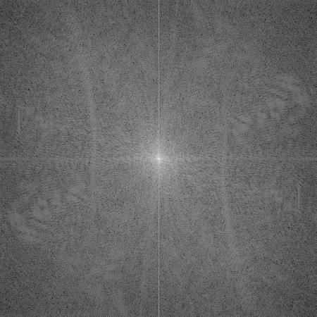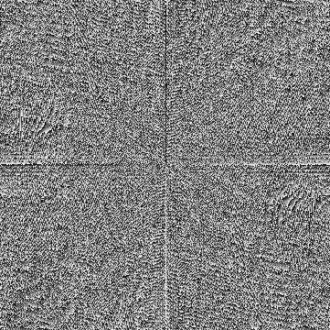
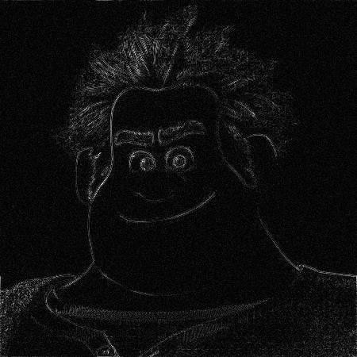
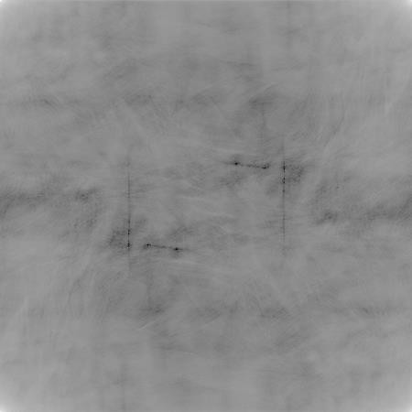
(a) (b) (c)
(d) (e)
Fig. A. Examples of reconstructed images to show the importance of phase spectrum. (a) Original image. (b) Magnitude spectrum. (c) Phase spectrum. (d) Reconstructed image using the phase spectrum only. (e) Reconstructed image using the magnitude spectrum only.

To illustrate this, we reproduce the results in [47] using the original image shown in Fig. A(a). Its magnitude spectrum and phase spectrum are shown in (b) and (c) respectively. It is difficult to visually analyse the phase spectrum, which is the reason why the phase spectrum was not utilized for radar target recognition by human operator. (d) is the reconstructed image using the phase spectrum only and (e) is the reconstructed image using the magnitude spectrum only. We can clearly relate the image of (d) to (a), but we definitely can’t relate (e) to (a). These images show that for image construction, the phase spectrum carries more important information than the magnitude spectrum. To make it clearer, we have added some discussions at the end of Section 2.3 of the revised manuscript. For your convenience, we copy them here:
“In literature, Oppenheim & Lim showed that for signal reconstruction, the phase spectrum carries more important information than the magnitude spectrum [47]. Recently, Guo et al. utilized the phase spectrum of quaternion Fourier transform for salience detection [48]. All these suggest that the phase spectrum may carry important discriminant information for classification and hence should be used for UAV detection.”
In the last version of the manuscript, we compared the proposed signal representation with the CVD. The CVD is directly comparable to the proposed approach in the sense that both perform some sort of 2-D Fourier transform. The key difference is that the CVD does not utilize the phase spectrum but the proposed approach does. The other two approaches, spectrogram and cepstrogram, do not utilize the phase spectrum either. In Fig. 5 of the revised manuscript, we compare the proposed approach with spectrogram, cepstrogram and CVD. We can see that the proposed approach significantly outperforms the compared approaches for all feature dimensions. To better show the performance improvement by

utilizing the phase spectrum, we have added Table 1 in the revised manuscript and some discussions at the end of Section 4.2. We copy them here for your convenience.
Feature | EER | 𝐅𝐀𝐑𝐅𝐑𝐑=𝟏%
Spectrogram | 7.75% | 27.00%
CVD | 6.68% | 28.41%
Cepstrogram | 10.17% | 48.07%
Proposed representation | 3.98% | 4.50%
Table 1: Comparison of different signal representations in terms of EER and FARFRR=1% at the optimal feature dimensionality.
“The error rates of different approaches at the optimal dimensionality are summarized in Table 1. We choose the feature dimensionality where FARFRR=1% is minimum. Take note that all the compared approaches do not utilize the phase spectrum except the proposed approach. Among the compared
approaches, the CVD is most similar to the proposed approach in the sense that both approaches conduct some sort of 2-D Fourier transform. Indeed, the CVD performs the second best in terms of EER. The proposed signal representation consistently and significantly outperforms all the compared ones. Compared with the second best performed methods, the proposed signal representation reduces EER by 2.7% and FARFRR=1% by 22.50%.”

In part 2 and part 3, the author spends a lot of space to describe relative basic knowledge which should be more concise. The proposed algorithm should be more outstanding. For example, instead of description of PCA, the description of the proposed SPA and the distinction between SPA and PCA should be taken more space.

Authors’ reply:
Thank you for your comments. We have removed some basic knowledge of the existing approaches according to your comments. More specifically, we have compressed Section 2.1 from 2 pages to slightly longer than 1 page. We have changed the title of Section 3.1 from “Review of Linear Subspace Approaches” to “Problem Analysis of Subspace Approaches”. Respectively, we have compressed Section 3.1 from 2.5 pages to 1.5 pages.
In the last version of the manuscript, we have highlighted the differences between the proposed approaches with the compared approaches. For example, we have Section 2.2 dedicated for the problem analysis of the existing signal representation. In the revised manuscript, Section 3.1 is dedicated for the problem analysis of the existing subspace approaches. In addition, we have highlighted the difference between the proposed SRA with other subspace approaches in Section 3.3. After these modifications, the proposed algorithm is now more outstanding.

In figure 1, the procedure and difference of Block diagram of spectrogram, cepstrogram and cadence velocity diagram and Block diagram of the proposed signal representation should be elaborate in detail.

Authors’ reply:
Thank you for your comments. We have revised the caption of Fig. 2 (Fig. 1 of the last version of the manuscript) as follow:
“The block diagrams of the existing approaches and the proposed approach are shown in (a) and (b), respectively. The key difference is that the existing approaches do not utilize the phase spectrum, but the proposed approach does. In addition, a complex-log-Fourier transform is proposed to solve the

problem of taking the logarithm of the complex spectrum and a regularization procedure is proposed to suppress the noise in the log-spectrum.”
We have also revised the first paragraph of Section 2.2 as follow:
“The block diagram of spectrogram, cepstrogram and cadence velocity diagram is shown in Fig. 3(a). As shown in the figure, the magnitude spectrum forms the spectrogram, the IFFT on the log-spectrum forms the cepstrogram, and the FFT on the magnitude spectrum along the time axis forms the CVD. The block diagram of the proposed robust 2-D complex spectral analysis is shown in Fig. 3(b).”

In figure 2, the reason why there are 50% overlapping between these two spectrums should be illustrated in detail. Otherwise, figure 2 only shows the plots for two successive spectrums of a UAV and the corresponding log-spectrums, the spectrums of different birds or non-UAVs should be added in this figure as well as the spectrums of UAVs.

Authors’ reply:
Thank you for your comments. The objectives of Fig. 3 (Fig. 2 of the last version of the manuscript) are to show:
  - Log-spectrum enlarges the weak micro-Doppler signature, but at the same time the noise components are enlarged as well.
  - By utilizing the proposed regularization procedure, we can greatly suppress the noise and at the same time preserve the micro-Doppler signature.
We choose two successive spectrums with 50% overlapping to ensure that these two spectrums are similar to each other. From the log-spectrums, we can see that due to the noise components, two log-spectrums differ significantly. From the regularized log-spectrums, we can see that the proposed regularization procedure greatly suppresses the noise, and two regularized log-spectrums indeed are more similar to each other. To make it clearer, we have revised the first paragraph of Section 2.5 as follow:
“The authors choose these two successive spectrums/log-spectrums with 50% overlapping to ensure that these two spectrums/log-spectrums are similar to each other. The time difference between these two is 1.33 ms only. However, due to the noise components, Fig. 3(c) and (d) look different.”
We use two successive windows of an UAV sequence as the example in Fig. 2. Similar results can be obtained for the non-UAV sample. We plot the spectrum/log-spectrum/regularized log-spectrum of two successive windows of a non-UAV sequence as follow:
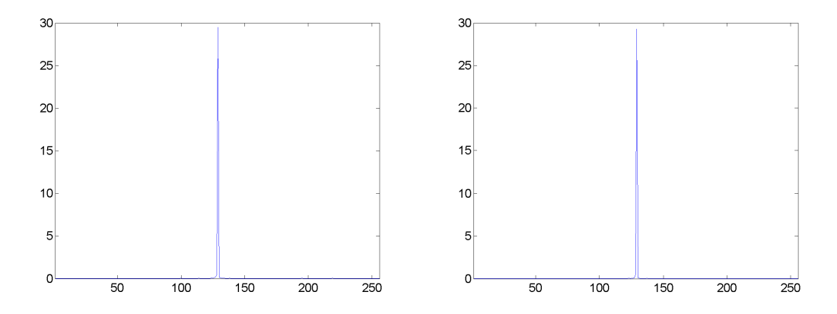
(a) First spectrum. (b) Second spectrum.

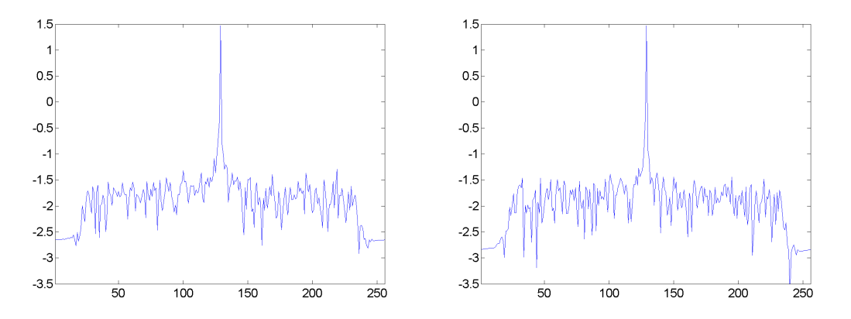
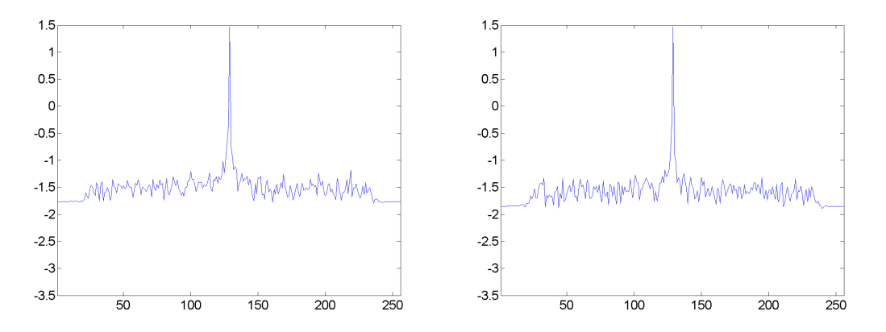
(c) First log-spectrum. (d) Second log-spectrum.
(e) First regularized log-spectrum. (f) Second regularized log-spectrum.
Fig. B. The spectrums, log-spectrums and regularized log-spectrums of two successive windows from the non-UAV sequence with 50% overlapping.

We can draw the same conclusion as we did for the UAV sample. To avoid duplication, we only show the plots for the UAV sequence in the manuscript, and omit the plots for the non-UAV sequence. To make it clearer, we have added the following discussions in the last paragraph of Section 2.5.
“From the spectrums/log-spectrums/regularized log-spectrums of the non-UAV samples, we can draw the same conclusion as that of the UAV samples. To avoid duplication, we omit the plots of the non-UAV samples.”

In 3.1.3, the paragraph “Most subspace approaches are designed for multi-class classification problem….” It is so right to say that PCA and LDA are multi-class method, while the proposed method is 2-class method, then the proposed method is better. Because LDA and PCA can also be used in 2-class problems.

Authors’ reply:
Thank you for your comments. We agreed with your comments and we have removed this paragraph in the revised manuscript.

In experimental part, section 4.3, figure 4 is still need to be analyzed in detail. For instance, the author only analyze the differences between figure 4(a) and (c), but fails to give the analysis between figure 4(b) and (d) which almost have the same effect of PCA and SRA in eigen-spectrums of UAV class. We believe it is much better to set a new paragraph for the whole comparison between the proposed approach and the state-of-the-art methods.

Authors’ reply:
Thank you for your comments. From Fig. 6(a) and (c) of the revised manuscript (Fig. 4 of the last version of the manuscript), we can see that SRA can better remove the unreliable feature dimensions

so that the eigen-spectrums of the testing samples and the training samples after using SRA match better than those after using PCA for the non-UAV class. This is the first advantage of the proposed SRA, i.e. it could better remove the unreliable feature dimensions.
From Fig. 6(b) and (d), the reviewer is correct that the eigen-spectrums of PCA and SRA for the UAV class almost have the same effect. Thanks to the second advantage of the proposed SRA, we could optimally remove the unreliable feature dimensions of two classes separately in two different subspaces. In another word, we could choose different optimal feature dimensions for two classes. For the UAV class, the optimal feature dimensionality is 90 for PCA. We can see that many feature dimensions among those 90 dimensions are unreliable. For SRA, although many feature dimensions of those 90 dimensions are also unreliable, we have the flexibility of further reducing the feature dimensions down to a much lower feature dimensionality, e.g. 10, so that those unreliable feature dimensions are properly removed.
We have added the following discussions in the third paragraph of Section 4.3 to make it clearer:
“3) For the eigen-spectrums of the UAV class shown in Fig. 6(b) and (d), neither PCA nor SRA could well remove the unreliable feature dimensions at 100 dimensions. However, SRA has the flexibility of choosing different dimensionalities for two classes, but PCA does not. SRA could further reduce the feature dimensionality to a much lower number so that those unreliable feature dimensions of the UAV class are properly removed. In contrast, if PCA further reduces the dimensionality, many reliable feature dimensions of the non-UAV class will be removed at the same time.”
We have set up a new section, Section 4.4, to compare the proposed approach with the state-of-the-art approaches, and made the necessary revision accordingly.

Other minor points are:
- The parameters in formulas should be explained at length. Such as the setting of weighting factor in formula (6).

Authors’ reply:
Thank you for your comment. 𝑤 determines the importance of the phase information. We do not aim at searching exhaustingly the best parameter of 𝑤 in this paper. We simply choose 𝑤 = 1/𝜋 so that the phase term is normalized to the range of [−1,1]. We have added the following explanation in the last paragraph of Section 2.4.
“where 𝑤 is a pre-defined weighting factor, which determines the importance of the phase spectrum. In this paper, we set 𝑤 = 1/𝜋 so that the phase term is normalized to the range of [−1,1].”

More recent references should be added.

Authors’ reply:
Thank you for your comment. We have added the following references in the revised manuscript:
- M. Ritchie, F. Fioranelli, H. Griffiths, B. Torvik, Micro-drone RCS analysis, in: IEEE Radar Conference, IEEE, 452–456, 2015.
- N. Mohajerin, J. Histon, R. Dizaji, S. L. Waslander, Feature extraction and radar track classification for detecting UAVs in civilian airspace, in: IEEE Radar Conference, IEEE, 0674-0679, 2014.
- D. Tahmoush, Detection of small UAV helicopters using micro-Doppler, in: SPIE Defense+ Security, International Society for Optics and Photonics, 907717-907717, 2014.
- J. De Wit, R. Harmanny, P. Molchanov, Radar micro-Doppler feature extraction using the singular value decomposition, in: IEEE Radar Conference, IEEE, 1–6, 2014.

The comparison experiments of some more recent proprietary UAV detection method should be added if possible.

Authors’ reply:
Thank you for your comment. To the best of our knowledge, there is no complete automatic UAV-detection system published to date. Either the system is designed for other applications, such as dynamic time warping and robust PCA, or some visual features are extracted for human operator to visually detect UAVs, such as spectrogram, cepstrogram and the CVD. We have compared the proposed approach with these existing approaches in experiments.

*Manuscript
Click here to view linked References

Regularized 2-D Complex-Log Spectral Analysis and Subspace Reliability Analysis of Micro-Doppler Signature for UAV Detection
Jianfeng Ren∗, Xudong Jiang
Electrical & Electronic Engineering, Nanyang Technological University, Nanyang Link, Singapore 639798.

Abstract
Unmanned aerial vehicle (UAV) has become an important radar target recently because of its wide applications and potential security threats. Traditionally, visual features such as spectrogram were often extracted for human operators to identify the micro-Doppler signature (mDS) of UAVs, i.e. sinusoidal mod-ulation. In this paper, the authors aim to design a system for machine au-tomatic classification of UAVs from other targets, particularly from birds as both UAVs and birds are small and slow-moving radar targets. Most exist-ing mDS representations such as spectrogram, cepstrogram and cadence veloc-ity diagram discard the phase spectrum, and only make use of the magnitude spectrum. What’s more, people often take the logarithm of the spectrum to enlarge the weak mDS but without sufficient care, as noise may be enlarged at the same time. The authors thus propose a regularized 2-D complex-log-Fourier transform to address these problems. Furthermore, the authors propose an object-oriented dimension-reduction technique: subspace reliability analysis, which directly removes the unreliable feature dimensions of two class-conditional covariance matrices in two separate subspaces. On the benchmark dataset, the proposed approach demonstrates better performance than the state-of-the-art approaches. More specifically, the proposed approach significantly reduces the

∗Corresponding author. Tel.: +65 6790 5018
Email addresses: jfren@ntu.edu.sg (Jianfeng Ren), exdjiang@ntu.edu.sg
(Xudong Jiang)

Preprint submitted to Pattern Recognition March 15, 2017

equal error rate of the second best approach, cadence velocity diagram, from 6.68% to 3.27%.
Keywords: UAV detection, radar, micro-Doppler signature, 2-D regularized
complex-log-Fourier transform, subspace reliability analysis

1 1. Introduction

2 Unmanned aerial vehicle has become an increasingly important radar target
3 because of its low cost, wide applications and potential threats to public security.
4 Traditional techniques [1, 2] using combinations of observed kinematic and radar
5 cross-section characteristics could not reliably differentiate UAVs from birds,
6 as both are small and slow-moving targets. A fundamentally new approach
7 is needed for radar to detect small UAVs. In this paper, the authors aim to
8 differentiate small UAVs from birds using their radar micro-Doppler signatures.
9 A lot of research work has been done in modeling micro-Doppler signature
10 of micro-motions [3–9]. Chen V.C. [3] modeled micro-motions such as vibration
11 and rotation as sinusoidal modulation in the spectrogram. For example, the
12 micro-motion of human gait can be modeled as the vibration of different body
13 parts [5, 6], and the micro-motion of birds’ wing beating can be modeled as
14 vibration as well [4]. The micro-motion of UAVs is mainly the rotation of
15 rotors, which can be naturally modeled as rotation [8]. However, both vibration
16 of birds’ wing beating and rotation of UAVs’ rotors share the same mDS model:
17 sinusoidal modulation. UAVs cannot be easily differentiated from birds solely
18 based on their mDS models. UAV detection is not a simple detection task, but
19 above all a discrimination problem.
20 In literature, radar micro-Doppler signature has been utilized for many
21 automatic-target-recognition tasks, e.g. airplane classification [10–15], ship de-
22 tection [16], human detection [17], human gait recognition [18–21], action clas-
23 sification [22–25], vehicle classification [26] and many others [27–30]. Some
24 researchers also utilized mDS for bird detection [4] and UAV detection [8]. How-
25 ever, their primary objective is to provide visual clues for human operators, not

1 for automatic UAV/bird detection. In fact, many published works only study
2 the feasibility of using micro-Doppler signature for target recognition without
3 a complete classification solution. To our best knowledge, there is no complete
4 automatic classification-based UAV detection framework published to date. In
5 this paper, the authors propose a complete system for automatic UAV detection
6 using radar micro-Doppler signature.
7 Many different kinds of signal representations were proposed in literature
8 for mDS analysis, such as spectrogram [3, 4, 19, 24, 31, 32], cepstrogram [8],
9 cadence velocity diagram (CVD) [23], and many others [7, 8, 33]. Most of them
10 are closely related to spectrogram. For example, the cepstrogram is obtained by
11 taking the inverse fast Fourier transform (IFFT) of the log-spectrogram [8], and
12 the CVD is obtained by taking the Fourier transform along the time axis of the
13 derived spectrogram [23]. Indeed, spectrogram provides useful visual clues for
14 the operator to differentiate UAVs from birds. Fig. 1 shows the spectrograms of
15 UAVs and birds. When the UAV is close to radar, clear micro-Doppler signature
16 of rotor blades, the parallel lines, can be observed as shown in Fig. 1(a). When
17 the UAV is far away from radar, it is difficult to visually differentiate the UAV
18 shown in Fig. 1(b) from the bird shown in Fig. 1(c), or the group of birds shown
19 in Fig. 1(d).
20 In this paper, the authors aim to derive a robust signal representation using
21 spectral analysis for machine automatic classification. The proposed 2-D com-
22 plex spectral analysis is designed to address the following problems of existing
23 micro-Doppler signal representations: 1) The existing approaches often generate
24 some kind of synthetic image for human operators to visually classify different
25 radar targets. But the machine perceives an image differently from the human.
26 The visual clues for the human may not be the best feature for the machine.
27 The proposed signal representation is designed for machine automatic detec-
28 tion of UAVs. 2) The existing approaches discard some important discriminant
29 information. Spectrogram is formed by stacking the magnitude spectrums of
30 windowed signals, but it discards the phase spectrums. The phase information
31 may be also important for classification. The proposed 2-D complex-log-Fourier

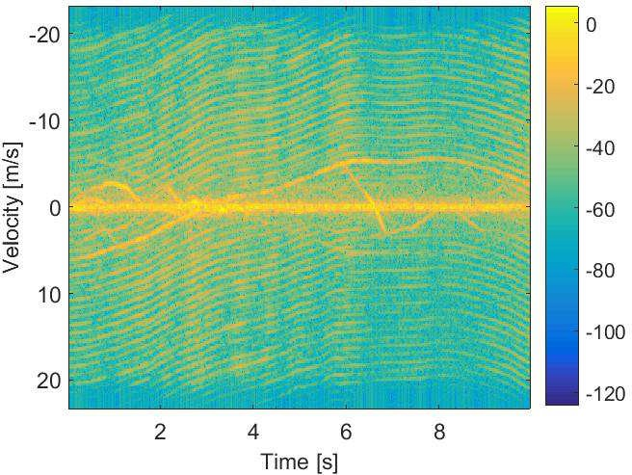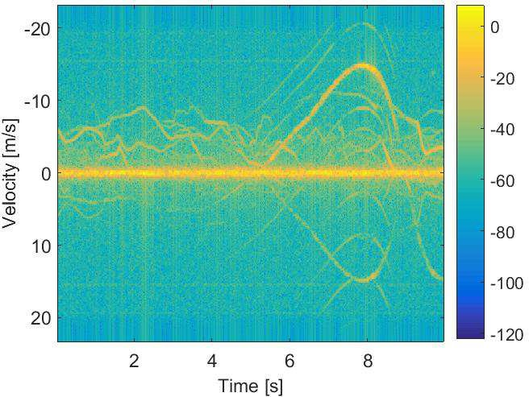

  - The spectrogram of an UAV close to radar.
  - The spectrogram of an UAV far away from radar.

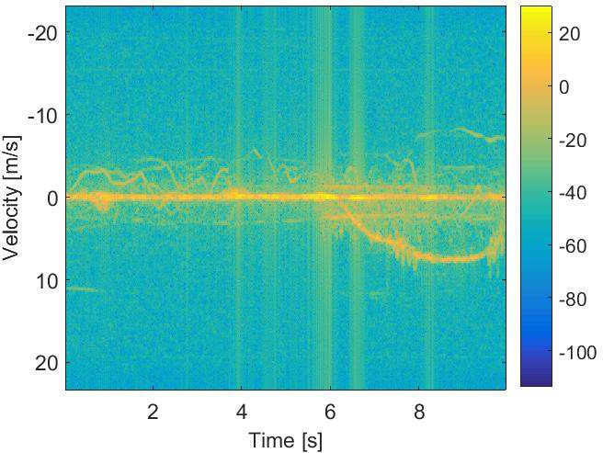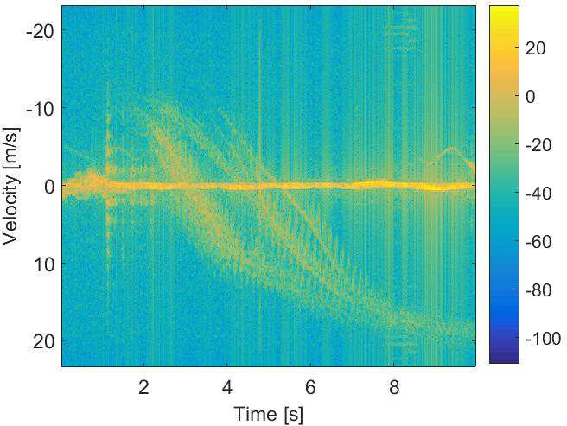
  - The spectrogram of a bird. (d) The spectrogram of a group of birds.

Figure 1: Spectrograms of micro-Doppler signature of two UAVs and birds are shown in (a)
- (d), respectively. When the UAV is close to radar, we can see the clear micro-Doppler signature of the rotor blades of the UAV, shown as the parallel lines in (a). However, when the UAV is far away from radar, the micro-Doppler signature shown in (b) is weak. It is difficult to visually differentiate the UAV shown in (b) from the bird shown in (c), or the group of birds shown in (d).

1 transform makes use of both magnitude and phase spectrums. 3) The log-
2 spectrum is often used in signal processing [8] to provide a better view for weak
3 mDS, but it may enlarge the noise components as well. If the log-spectrum is
4 directly taken as the signal representation, these noise components may ruin the
5 classification process due to their large variations in log-scale. To suppress the
6 noise, the authors propose a regularization procedure when handling the log-
7 spectrum. The proposed regularized 2-D complex-log-Fourier transform better

1 captures the discriminant information residing in the micro-Doppler signatures
2 of UAVs/birds.
3 Our second contribution is an object-oriented dimension-reduction tech-
4 nique: subspace reliability analysis (SRA). In literature, many dimension-reduction
5 techniques have been proposed, e.g. principal component analysis (PCA) [34],
6 linear discriminant analysis (LDA) [35], Bayesian maximum likelihood [36], en-
7 hanced maximum likelihood [37], dual-space LDA [38], null-space approach [39],
8 graph embedding [40], sparse coding [41], asymmetric PCA [42, 43] and eigen-
9 feature regularization and extraction approach [44]. Most of them were designed
10 for recognition tasks, i.e. to decide the testing sample as one of the many classes.
11 UAV detection is a two-class classification problem, i.e. UAVs as the positive
12 class and non-UAVs as the negative class. The proposed SRA is specifically
13 designed for UAV-detection problem.
14 One of the challenges for classification tasks is the small-sample-size prob-
15 lem [45], i.e. the within-class scatter matrix S_{w} is often singular. Even in the
16 case of full rank, the small eigenvalues of S_{w} may still cause problems, as the
17 inverse of S_{w} is often used to weigh the feature dimensions. Those small and
18 unreliable eigenvalues of S_{w} may impose very large and problematic weights on
19 the feature dimensions so that the whole classification process fails. The ob-
20 jective of the proposed subspace reliability analysis is to remove the unreliable
21 feature dimensions that are harmful to reliable classification. By directly tar-
22 geting at the unreliable feature dimensions of two class-conditional covariance
23 matrices and removing them separately in two subspaces, the proposed SRA
24 delivers better classification performance.
25 After deriving the proposed signal representation, subspace reliability anal-
26 ysis is applied to remove the unreliable feature dimensions. Then, a minimum-
27 Mahalanobis-distance classifier [43, 46] is used for classification.
28 The contributions of this paper are summarized as follow: 1) The proposed
29 2-D regularized complex-log-Fourier transform well addresses the problems of
30 the existing signal representations. The existing approaches are often designed
31 for human operator, whereas the proposed one targets at machine automatic

1 classification. The proposed approach utilizes both magnitude and phase spec-
2 trums, whereas the existing approaches often discard the phase spectrum. In
3 addition, the proposed regularization procedure greatly suppresses the noise in
4 the log-spectrum. 2) The existing subspace approaches could not optimally re-
5 move the unreliable feature dimensions of both class-conditional covariance ma-
6 trices in one subspace. The proposed subspace reliability analysis thus removes
7 them separately in two different subspaces. 3) Lastly, the proposed approach
8 is evaluated on a large benchmark dataset, and demonstrates superior perfor-
9 mance compared with various feature representations and other state-of-the-art
10 approaches.

11 2. Proposed Framework of Robust 2-D Complex Spectral Analysis

12 2.1. Review of Time-Frequency Analysis on Micro-Doppler Signature
13 Many time-frequency representations were proposed for micro-Doppler anal-
14 ysis in literature, e.g. spectrogram [3], cepstrogram [8] and cadence velocity
15 diagram (CVD) [23].
16 Time-frequency analysis such as spectrogram is often used for micro-Doppler
17 analysis due to the time-varying nature of mDS [24, 28]. The spectrogram is
18 obtained as follow. The signal s(t) is segmented into M overlapping frames
19 {x₀, x₁, . . . , x_{M−1}}, where each frame x_{i} = {x_{i}[n], n = 0, 1, . . . , N − 1} is a
20 column vector of length N . These M frames form a synthetic image X =
21 [x₀, x₁, . . . , x_{M−1}] of size M × N . Then, the discrete Fourier transform f_{i} =
22 [f_{i,0}, f_{i,1}, . . . , f_{i,N−1}] of x_{i} is computed as:
N −1

23 f_{i,k}
24
= 芷 x [n] exp{−j2π kn }, k = 0, 1, . . . , N − 1. (1)
n=0 N
i

25 Alternatively, people often denote f_{i} = F{x_{i}} as the discrete Fourier transform
26 of x_{i}. The magnitude S = {|f_{i,k}|², i = 0, 1, . . . , M − 1, k = 0, 1, . . . , N − 1}
27 forms the spectrogram of size M × N .
28 Various micro-Doppler features were extracted from spectrograms and cep-
29 strograms in [8] for radar automatic target recognition. The power cepstrum

1 represents the rate of change in the spectrum. Formally, after segmenting s(t)
2 into overlapping windows, the cepstrum c_{i} for x_{i} is defined as:

3 c_{i} = C{x_{i}}
−1 2 2

4 = |F
5
{log(|F{x_{i}}| )}| , (2)

6 where C{∗} denotes the cepstrum and F⁻¹{∗} denotes the inverse fast Fourier
7 transform (IFFT). These cepstrums c_{i} then form the cepstrogram [c₀, c₁, . . . , c_{M−1}].
8 The cepstrogram is often used to determine the spectrogram periodicity.
9 In [23], cadence velocity diagram was proposed to extract micro-Doppler
10 signatures. The CVD provides a measure on how often the different velocities
11 repeat (“cadence frequencies”). Formally, after deriving the spectrogram S, the
12 CVD is derived by applying the Fourier transform on the spectrogram along the
13 time axis, i.e.

14 D = F {S}, (3)
t
15

16 where D denotes the CVD and F_{t}{∗} denotes the Fourier transform along the
17 time axis.

18 2.2. Problem Analysis of Existing Signal Representations
19 The block diagram of spectrogram, cepstrogram and cadence velocity dia-
20 gram is shown in Fig. 2(a). As shown in the figure, the magnitude spectrum
21 forms the spectrogram, the IFFT on the log-spectrum forms the cepstrogram,
22 and the FFT on the magnitude spectrum along the time axis forms the CVD.
23 The block diagram of the proposed robust 2-D complex spectral analysis is
24 shown in Fig. 2(b). The proposed approach addresses the following problems of
25 the existing approaches:
26 1. The existing approaches such as spectrogram [3], cepstrogram [8], and
27 cadence velocity diagram [23] do not fully utilize the information of the
28 synthetic image X. Only the magnitude of the first Fourier transform is
29 utilized and its phase information is discarded. The proposed 2-D complex

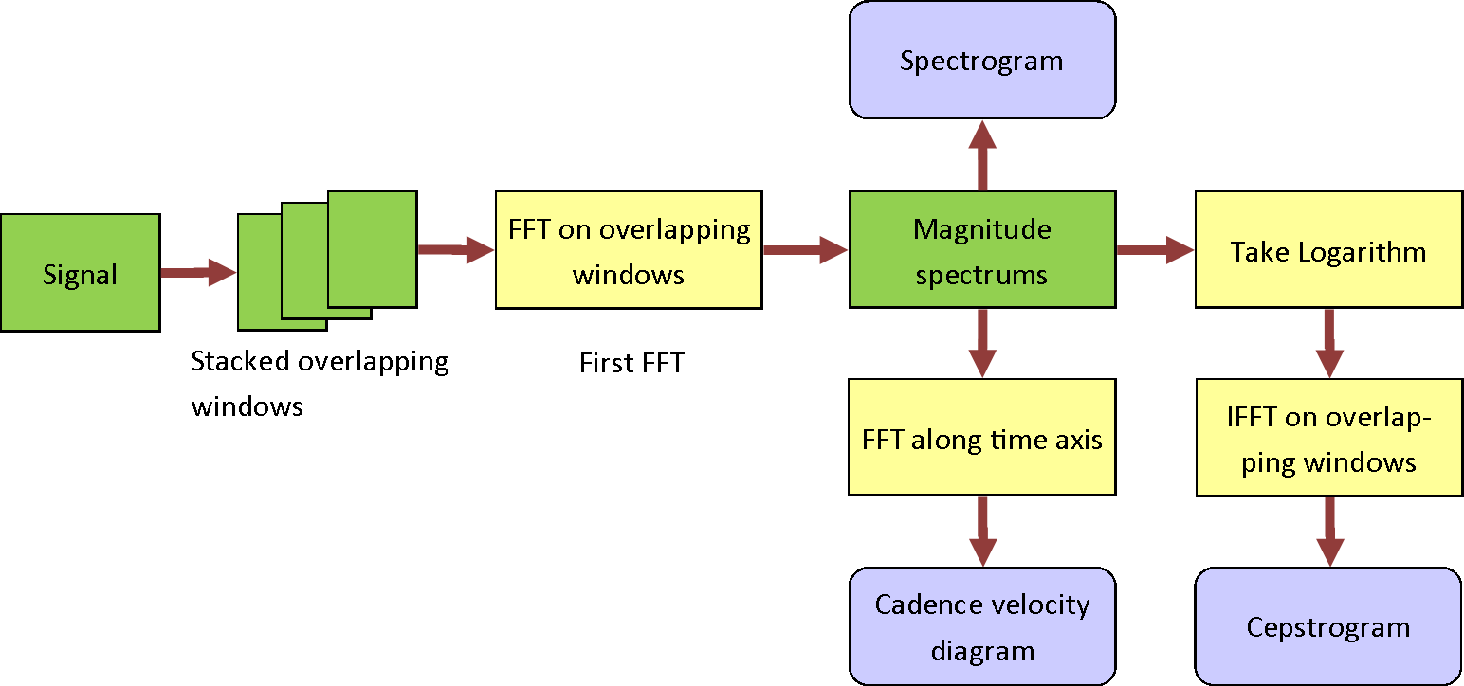
- Block diagram of previous signal representations.
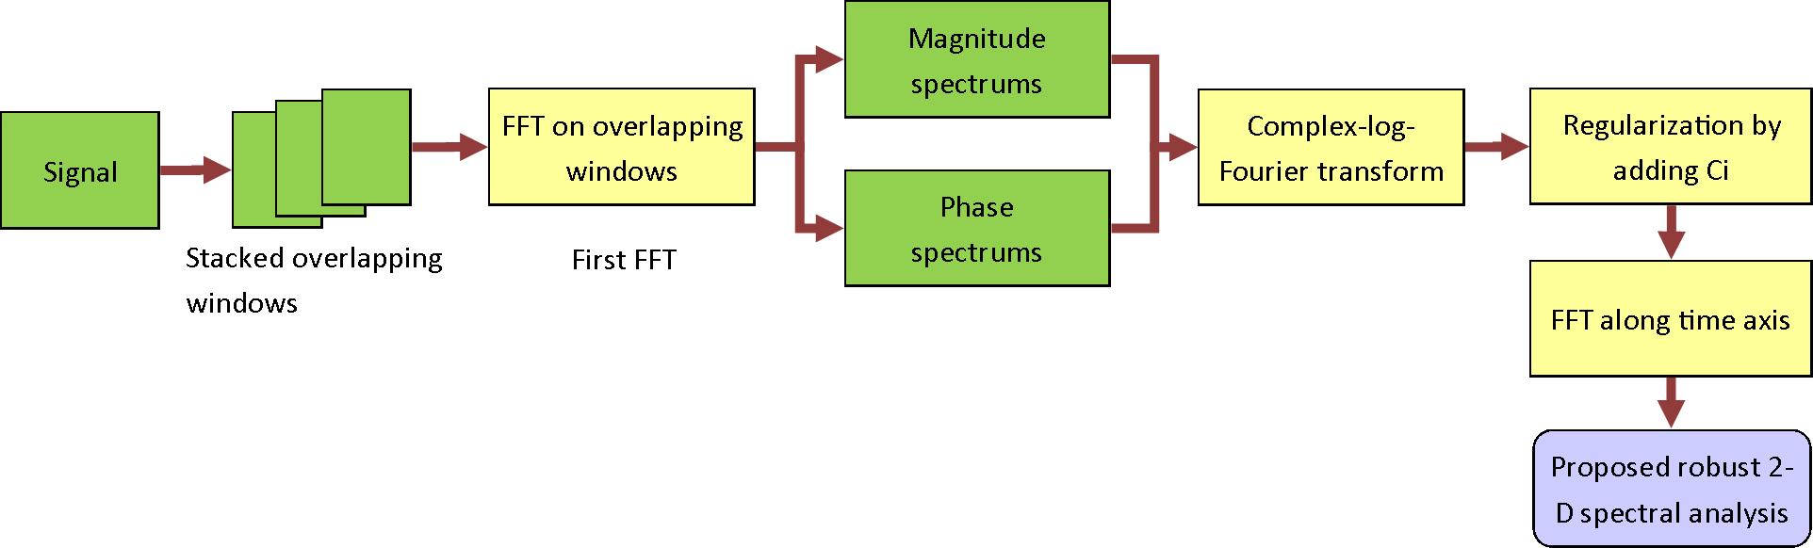
- Block diagram of the proposed signal presentation.

Figure 2: The block diagrams of the existing approaches and the proposed approach are shown in (a) and (b), respectively. The key difference is that the existing approaches do not utilize the phase spectrum, but the proposed approach does. In addition, a complex-log-Fourier transform is proposed to solve the problem of taking the logarithm of the complex spectrum and a regularization procedure is proposed to suppress the noise in the log-spectrum.

1 spectral analysis makes use of both phase and magnitude spectrums of the
2 first Fourier transform.
3 2. The phase spectrum and the magnitude spectrum form a complex spec-
4 trum. For cepstrogram, the log-spectrogram is used to enlarge the weak
5 micro-Doppler signature. However, it is unclear how to take the logarith-
6 m of the complex spectrum. The proposed complex-log-Fourier transform
7 achieves two goals simultaneously: to make use of both phase and magni-
8 tude spectrums, and to emphasize the weak mDS.
9 3. Lastly, by taking the logarithm of the spectrum or spectrogram, it not
10 only enhances the weak mDS, but also enlarges the noise components.
11 Those noise components may lead to large intra-class variations so that
12 two samples of the same class differ significantly. To suppress the noise,
13 the authors propose a regularization procedure when taking the logarithm.

1 2.3. Proposed 2-D Complex Spectral Analysis
2 The proposed 2-D complex spectral analysis is equivalent to two-step 1-D
3 spectral analysis on X. In the first step, the Fourier transform is applied on
4 overlapping windows, and in the second step, the Fourier transform is applied
5 along the time axis. Mathematically, the proposed 2-D complex spectral analysis
6 F_{2D}{∗} on X is given as follows:
7 F_{2D}{X} = F_{t}{F{X}}, (4)
8
9 where F{∗} is the Fourier transform on overlapping windows, and F_{t}{∗} is the
10 Fourier transform along the time axis. Take note that both phase and magni-
11 tude of F{X} are utilized in the second Fourier transform F_{t}{∗}, whereas in
12 the existing approaches the phase information is discarded before the second
13 Fourier transform. In literature, Oppenheim & Lim showed that for signal re-
14 construction, the phase spectrum carries more important information than the
15 magnitude spectrum [47]. Recently, Guo et al. utilized the phase spectrum of
16 quaternion Fourier transform for salience detection [48]. All these suggest that
17 the phase spectrum may carry important discriminant information for classifi-
18 cation and hence should be used for UAV detection.

19 2.4. Proposed 2-D Complex-Log-Fourier Transform
20 To enhance the weak micro-Doppler signature, people often take the loga-
21 rithm of the spectrum, e.g. cepstrogram [8] is obtained by taking the inverse
22 FFT of the log-spectrogram. Complex cepstrum [49], which is often used to ed-
23 it time signals in operational modal analysis, is obtained by taking the inverse
24 Fourier transform of the complex logarithm of the complex spectrum. The au-
25 thors thus propose a complex-log-Fourier transform to take the advantages of
26 the log-spectrogram and to make use of both magnitude and phase spectrums.
27 Mathematically, the Fourier transform f_{i} = F{x_{i}} for the i-th window x_{i} is
28 a vector of complex numbers, i.e. f_{i} = m_{i} exp{jθ_{i}}, where m_{i} is the magnitude
29 spectrum and θ_{i} is the phase spectrum. By taking the logarithm of f_{i}, we have
30 log{f_{i}} = log{m_{i}} + jθ_{i}. (5)
31

1 For the logarithm of a complex number, the logarithm of the magnitude becomes
2 the real part and the phase term becomes the imaginary part. This is very
3 different from traditional log-spectrum/log-spectrogram, where only log{m_{i}} is
4 used and θ_{i} is discarded.
5 Eq. (5) can be seen as a way to combine the log-spectrum log{m_{i}} and
6 the phase information θ_{i}. It is often necessary to normalize the power of the
7 spectrogram and hence to change the range of log{m_{i}}. Similarly, the range of
8 θ_{i} needs to be normalized as well. To balance the effect of log{m_{i}} and θ_{i}, the
9 authors introduce a weighting factor and hence Eq. (5) is modified as:

10 log{f_{i}} = log{m_{i}} + jwθ_{i}, (6)
11

12 where w is a pre-defined weighting factor, which determines the importance of
13 the phase spectrum. In this paper, we set w = 1/π so that the phase term is
14 normalized to the range of [−1, 1]. For the synthetic image X, the proposed
15 2-D complex-log-Fourier transform is hence defined as:

16 F₂{X} = F {log{F{X}}}. (7)
t
17

18 2.5. Proposed Regularized Complex-Log-Fourier Transform
19 By taking the logarithm of the spectrum, the small-amplitude frequency
20 components are emphasized so that the weak micro-Doppler signature could be
21 clearly identified. However, the noise frequency components are enlarged at the
22 same time. Fig. 3(a)-(d) show the plots of two successive spectrums of an UAV
23 and the corresponding log-spectrums, respectively. From the spectrum, it is d-
24 ifficult to see the micro-Doppler signature except the clutter and the main body
25 Doppler. After taking the logarithm, more details of the micro-Doppler signa-
26 ture can be seen from the log-spectrum, but the noise components are enlarged
27 as well. The authors choose these two successive spectrums/log-spectrums with
28 50% overlapping to ensure that these two spectrums/log-spectrums are similar
29 to each other. The time difference between these two is 1.33 ms only. However,
30 due to the noise components, Fig. 3(c) and (d) look different.

1.4 1.4

1.2 1.2

1 1

0.8 0.8

0.6 0.6

0.4 0.4

0.2 0.2

0
50 100 150 200 250

0
50 100 150 200 250

(a) First spectrum. (b) Second spectrum.

0 0

−0.5 −0.5

−1 −1

−1.5 −1.5

−2 −2

−2.5 −2.5

−3 −3

−3.5

50 100 150 200 250

−3.5

50 100 150 200 250

- First log-spectrum.(d) Second log-
spectrum.

0 0

−0.5 −0.5

−1 −1

−1.5 −1.5

−2 −2

−2.5 −2.5

−3 −3

−3.5

50 100 150 200 250

−3.5

50 100 150 200 250

(e) First regularized(f) Second regularized
log-spectrum. log-spectrum

Figure 3: Spectrums, log-spectrums and regularized log-spectrums of two successive windows from an UAV sequence with 50% overlapping. It is difficult to see the micro-Doppler signature from the spectrums. The log-spectrums emphasize the weak micro-Doppler signature, but also enlarge the noise. In contrast, the noise is greatly reduced in the regularized log-spectrums.

1 From the classification point of view, by taking the logarithm of the spec-
2 trum, it emphasizes the discriminative information of UAVs and birds so that
3 their micro-Doppler signatures are very different in log-scale. However, the
4 intra-class variations of the log-spectrums of UAVs/birds are increased as well
5 due to the noise components.
6 To reduce the intra-class variations, the authors propose a regularization
7 procedure for log-spectrum/log-spectrogram. The weak frequency components
8 are vulnerable to noise, as shown in Fig. 3 (c) and (d). Their magnitudes change
9 largely in log-scale due to the noise. The authors thus propose to add a constant

1 when taking the logarithm,

2 log{f_{i}} = log{m_{i} + C_{i}} + jwθ_{i}, (8)
3

4 where C_{i} is a constant.
5 C_{i} is chosen in such a way that it significantly suppresses the variations
6 of the weak frequency components, but does not significantly alter other fre-
7 quency components. For the spectrum, most frequency components have weak
8 response and only some frequency components have strong response. The weak
9 frequency components are easily contaminated by noise in log-scale. Those noise
10 components form the noise floor. The target is thus to preserve the frequency
11 components above the noise floor, but to suppress the variations of the noise
12 components near the noise floor. To estimate the noise floor, the authors choose
13 C_{i} = med{m_{i}}, i.e. the median value of m_{i}. Since most frequency components
14 are noise components, the median value of the spectrum could well approximate
15 the noise floor.
16 By adding such a regularization constant C_{i} in Eq. (8), the logarithms of
17 the strong frequency components above the noise floor will not be significantly
18 altered, whereas the logarithms of the weak frequency components below the
19 noise floor will be regularized close to log C_{i}. In such a way, the variations of the
20 noise components are greatly reduced. Fig. 3(e) and (f) show the regularized
21 versions of log-spectrums in Fig. 3(c) and (d), respectively. It is clear that after
22 the regularization, the variations of the noise components are greatly suppressed.
23 Now two successive regularized log-spectrums shown in Fig. 3(e) and (f) are
24 more similar to each other than the log-spectrums shown in Fig. 3(c) and (d).
25 From the spectrums/log-spectrums/regularized log-spectrums of the non-UAV
26 samples, we can draw the same conclusion as that of the UAV samples. To
27 avoid duplication, we omit the plots of the non-UAV samples.

1 3. Dimension Reduction by Subspace Reliability Analysis

2 3.1. Problem Analysis of Existing Subspace Approaches
3 Many subspace approaches have been proposed in literature [34–46, 50–53].
4 Among them, principal component analysis (PCA) [34] and linear discriminant
5 analysis (LDA) [35, 50] are most popular.
6 PCA was originally designed for optimal signal reconstruction [34]. From
7 the classification point of view, it improves the generalization performance of
8 the novel testing data by removing the subspace spanned by eigenvectors cor-
9 responding to the small unreliable eigenvalues of the total scatter matrix S_{t},
10 which in turn removes the dimensions corresponding to the small eigenvalues
11 of the within-class scatter matrix S_{w} so that the Mahalanobis distance can be
12 evaluated reliably [42, 43].
13 Linear discriminant analysis aims to find a subspace that maximizes the
14 following criterion [35]:
∗ |W^{T} S_{b}W | T

15 W
w
16
= argmaxW |WT S
, s.t.W
W |
W = 1, (9)

17 where S_{b} is the between-class scatter matrix. If S_{w} is full rank, the optimal W
18 is obtained by solving the following generalized eigen-decomposition problem,

19 S Φ = S ΦΛ, (10)
b w
20

21 where Φ and Λ are the matrices of eigenvectors and eigenvalues, respectively.
22 Due to high dimensionality and the limited number of training samples, S_{w} is
23 often singular. Besides, the dimensions corresponding to the small unreliable
24 eigenvalues of S_{w} adversely affect reliable classification. Thus, PCA is applied
25 on the total scatter matrix S_{t} to solve the singularity problem of S_{w} and to
26 remove the unreliable dimensions of S_{w}. After projecting all samples into the
27 subspace, the most discriminative dimensions are derived by solving the gener-
28 alized eigen-decomposition problem similarly defined as in Eq. (10).
29 The proposed subspace reliability analysis aims to solve the following prob-
30 lems of the existing subspace approaches:

1 1. Most existing subspace approaches are linear subspace approach. Due to
2 the limited number of training samples of each class, the class-conditional
3 covariance matrix S_{i} often cannot be reliably estimated, and hence a
4 pooled covariance matrix S_{w} is used instead. Using S_{w} implies linear
5 classification. People aim to find a subspace in which a hyperplane is
6 defined to separate different classes. But the hyperplane has limited dis-
7 criminative power. For UAV detection, there are enough samples for both
8 UAV and non-UAV classes. As such, the authors prefer to use S_{i} directly
9 instead of S_{w}, which leads to a decision boundary much more complex
10 than a hyperplane.
11 2. In many existing approaches, the reliability issues of S_{w} are solved by
12 applying PCA on S_{t} in the hope of removing the unreliable dimensions of
13 S_{w}. However, it is difficult to derive a subspace in which the unreliable
14 feature dimensions of both UAV and non-UAV classes are removed, as the
15 unreliable feature dimensions of two classes may be very different. More
16 details will be given in the coming section.

17 3.2. Proposed Subspace Reliability Analysis
18 For Bayes classification, the feature h = [h₁, h₂, . . . , h_{d}]^{T} ∈ R^{d} is assigned
19 to one of the c categories, i.e. ω_{i}, so that the posteriori probability p(ω_{i}|h)
20 is maximized. This maximum a posterior (MAP) rule is a Bayes decision rule
21 with the 0/1 loss function. As p(ω_{i}|h) = p(h|ω_{i})p(ω_{i})/p(h) and p(h) is not a
22 function of ω_{i}, it is equivalent to maximize the following discriminant function:

23 g_{i}(h) = ln p(h|ω_{i}) + ln p(ω_{i}). (11)
24

25 The natural logarithm is a monotonically increasing function, and hence does
26 not affect the decision result but will simplify the evaluation if p(h|ω_{i}) is an
27 exponential function.
28 Further quantitative analysis requires an analytical form of the class-conditional
29 probability function p(h|ω_{i}). It is often assumed to follow multivariate Gaus-
30 sian distribution because of the following reasons. Firstly, it is the most natural

1 distribution and the sum of many independent random variables, irrespective
2 of their original distribution, obeys Gaussian distribution. Given mean and
3 variance, it has the maximum entropy of all distributions. Secondly, Gaussian
4 mixture model, which is the weighed sum of a number of Gaussian distribu-
5 tions, in theory can closely approximate arbitrarily shaped distribution. Lastly,
6 dimension-reduction techniques such as principal component analysis, linear dis-
7 criminant analysis and many others utilize up to the second-order statistics, and
8 so does the Gaussian distribution. Under Gaussian assumption,

9 p(h|ω ) = 1
1 ¯ T
⁻¹(h − h¯ )], (12)

_{i} (2π)d/2|Σ |1/2 exp[− 2 (h − h_{i}) Σi i
i
10
11 where h¯i is the class mean and Σ_{i} is the class-conditional covariance matrix.
12 The discriminant function Eq. (11) becomes
13 1 ¯ T −1 ¯

g_{i}(h) = −
14
2 (h − h_{i})
Σi (h − h_{i}) + b_{i}. (13)

15 In practice, b_{i} is a threshold to control the error rate of class ω_{i} at the price
16 of others. Eq. (13) is basically a minimum-Mahalanobis-distance classifier. As
17 the covariance matrix Σ_{i} of individual class may not be reliably estimated in
18 many applications, a pooled covariance matrix Σ_{w} called the within-class scatter
19 matrix is often used instead in Eq. (13), which is calculated as:

20 Σ = 芷N Σ
c
1
w

(14)

i i
N
21 i=1
22 where N_{i} is the number of samples in class ω_{i} and N is the total number of
23 samples. The decision rule defined in Eq. (13) is modified as:
24 1 ¯ T −1 ¯

g_{i}(h) = −
25
2 (h − h_{i})
Σw (h − h_{i}) + b_{i}. (15)

26 If eigen-decomposition is applied on Σ_{w}, i.e. Σ_{w} = Φ_{w}Λ_{w}Φ^{T} , the decision rule
w
27 is further simplified to:
d 2
28 g (h) = 芷(yj − y¯i,j ) + b , (16)
i w i
λ
29 j=1 j
30 where y_{j} = φ^{wT} h and y¯_{i,j} = φ^{wT} h¯i are the projections of h and h¯i on φ^{w},
j j j
31 respectively. φ^{w} is the j-th eigenvector of Σ_{w} and λ^{w} is the j-th eigenvalue of
j j

1 Σ_{w}. Unfortunately, the Mahalanobis distance cannot be reliably evaluated in
2 the high-dimensional space due to the limited number of training samples, i.e.
3 the small eigenvalues λ^{w} are unreliable and many of them are zero. In literature,
j
4 many subspace approaches [34–46] have been developed to address this issue.
5 Specifically for UAV-detection problem, two discriminant functions g₁(h) for
6 the UAV class and g₂(h) for the non-UAV class are defined as follow:
7 g₁(h) = (h − h¯1)^{T} Σ⁻¹(h − h¯1) + b₁, (17)
1
8 g₂(h) = (h − h¯2)^{T} Σ⁻¹(h − h¯2) + b₂, (18)
2
9

10 where h¯1, h¯2, Σ₁, Σ₂, b₁ and b₂ are the mean vectors, the class-conditional co-
11 variance matrices and the thresholds for the UAV class and the non-UAV class,
12 respectively. Take note that Σ₁ and Σ₂ are used instead of the pooled co-
13 variance matrix Σ_{w}. A straight-forward way to define the decision rule is: if
14 D(h) = g₁(h) − g₂(h) < b, h belongs to the UAV class, otherwise it belongs to
15 the non-UAV class. b is a threshold to trade-off the error rate of one class at
16 the price of the other.
17 As the inverses of Σ₁ and Σ₂ are used to weigh the feature dimensions, the
18 unreliable feature dimensions of both Σ₁ and Σ₂ should be removed so that
19 g₁(h) and g₂(h) can be evaluated reliably. However, the existing approaches
20 could not achieve this.
21 In PCA [34], the unreliable feature dimensions of Σ_{t} is removed, in the hope
22 of removing the unreliable dimensions of Σ₁ and Σ₂. However, the unreliable
23 feature dimensions of Σ₁ and Σ₂ may be very different from that of Σ_{t}. By
24 definition, Σ_{t} = αΣ₁ +(1− α)Σ₂ +Σ_{b}, where Σ_{b} is the between-class covariance
25 matrix, α = N₁/(N₁ + N₂), N₁ and N₂ are the number of samples in the UAV
26 class and the non-UAV class, respectively. By removing the feature dimensions
27 corresponding to the small eigenvalues of Σ_{t}, it may not be feasible to remove the
28 unreliable feature dimensions of Σ₁ and Σ₂. Particularly, it cannot guarantee
29 that in the resulting subspace the unreliable feature dimensions of both Σ₁
30 and Σ₂ are removed. For example, the remaining subspace may have some
31 dimensions in which the eigenvalues of Σ₁ are large, but the eigenvalues of Σ₂

1 are small. In another word, some feature dimensions of Σ₁ or Σ₂ are still small
2 and unreliable.
3 Asymmetric PCA [42, 43] tackles this problem by assigning a larger weight
4 to the less reliable class-conditional covariance matrix when building the total
5 scatter matrix, e.g. a larger α value if Σ₁ is less reliable than Σ₂. However, the
6 aforementioned problem still remains.
7 In many existing subspace approaches, people aim to find one subspace in
8 which some form of objective function is optimized [34–41, 44, 45]. They do
9 not target at removing the unreliable feature dimensions, and hence improving
10 the classification accuracy. What’s more, it is very difficult to find one subspace
11 in which we could remove all the unreliable feature dimensions of both Σ₁
12 and Σ₂. It may be necessary to remove excessively more feature dimensions,
13 including some feature dimensions corresponding to small eigenvalues of one
14 class-conditional covariance matrix but the large eigenvalues of the other, if
15 targeting at removing all unreliable feature dimensions. Apparently by doing
16 so, a large amount of discriminant information will be lost.
17 In this paper, the authors solve the problem by removing the unreliable
18 feature dimensions of Σ₁ and Σ₂ separately in two different subspaces. More
19 specifically, the authors aim to remove the unreliable feature dimensions of Σ₁
20 by removing the feature dimensions corresponding to the small eigenvalues of

21 S₁ = Σ₁ + Σ . (19)
b
22

23 The between-class covariance matrix Σ_{b} contains the discriminant feature di-
24 mensions that could well separate two classes. Thus, this information is pre-
25 served in the projected subspace. Then, the eigen-decomposition is applied on
26 S₁ as:

27 S₁ = Φ₁Λ₁Φ^{T} . (20)
1
28

29 The dimensions corresponding to the leading m₁ eigenvalues of S₁, i.e. Φ_{1,m}1 ,
30 are chosen as the projection matrix. The discriminant function g₁(h) in the

1 projected subspace becomes:
2 g_{1,m} (h) = (h − h¯1)^{T} Φ_{1,m} (Φ^{T}

Σ1Φ1,m

−1ΦT

(h − h¯1). (21)

3 1 1 1,m1
1 ) 1,m1

4 Now g_{1,m}1 (h) can be evaluated reliably as its unreliable feature dimensions are
5 removed by removing the subspace corresponding to the small eigenvalues of
6 S₁.
7 Similarly, the authors remove the unreliable feature dimensions of Σ₂ by
8 removing the subspace corresponding to the small eigenvalues of S₂,

9 S₂ = Σ₂ + Σ . (22)
b
10
11 Then, the eigen-decomposition is applied on S₂,

12 S₂ = Φ₂Λ₂Φ^{T} . (23)
2
13
14 The dimensions corresponding to the leading m₂ eigenvalues of S₂ are chosen
15 as the project matrix, and the discriminant function g₂(h) in the projected
16 subspace becomes:

17 g_{2,m} (h) = (h − h¯2)^{T} Φ_{2,m} (Φ^{T}
Σ2Φ2,m
−1ΦT
(h − h¯2). (24)

18 2
2 2,m2
2 ) 2,m2

19 g_{1,m}1 (h) and g_{2,m}2 (h) are evaluated in two different subspaces. To take ac-
20 count of the potential scaling effect in these two subspaces, the authors propose
21 the following criterion to fuse g_{1,m}1 (h) and g_{2,m}2 (h):
g_{1,m}1 (h)

22 g(h) =
23

g_{2,m}2 (h)
. (25)

24 Intuitively, if h ∈ ω₁, the Mahalanobis distance of h to the class center of
25 class 1 in the projected subspace, g_{1,m}1 (h), should be small and the Mahalanobis
26 distance of h to the class center of class 2 in the projected subspace, g_{2,m}2 (h),
27 should be large. As such, g(h) should be small. Thus, the decision rule becomes:
28 If g(h) < b, h ∈ ω₁, otherwise h ∈ ω₂, where b is the threshold to control the
29 error rates of these two classes.

1 3.3. Discussion on the Proposed Subspace Reliability Analysis
2 The proposed subspace reliability analysis is different from existing ap-
3 proaches in the following aspects:
4 1. The proposed approach is specifically designed for detection problem. Dif-
5 ferent from multi-class classification problem, in which a pooled covariance
6 matrix Σ_{w} is used to weigh different feature dimensions, in the proposed
7 approach the feature dimensions of each class are weighed by the inverse
8 of its own class-conditional covariance matrices.
9 2. The proposed approach is an object-oriented dimension-reduction tech-
10 nique, which studies the reliability issues of class-conditional covariance
11 matrices, and aims to optimally remove the unreliable feature dimensions
12 of these matrices, towards the objective of improving the classification ac-
13 curacy. Most existing approaches aim to find one subspace in which some
14 optimization criterion is met. However, it is difficult to find one subspace
15 in which the unreliable feature dimensions of two class-conditional covari-
16 ance matrices could be optimally removed. The proposed SRA removes
17 them separately in two subspaces.
18 3. When removing the unreliable feature dimensions of Σ_{i}, the between-
19 class scatter matrix is added into consideration as defined in Eq. (19) and
20 Eq. (22), in order to preserve the discriminative information between two
21 classes. This is different from PCA in which unreliable feature dimensions
22 of S_{t} are removed.
23 4. Lastly, two discriminant functions are fused by Eq. (25), which is very
24 different from existing approaches.
25 By utilizing the proposed approach, the authors optimally remove the unre-
26 liable feature dimensions of two class-conditional covariance matrices separately
27 in two different subspaces. This offers much more flexibility of improving the
28 reliability of these class-conditional covariance matrices, and hence greatly in-
29 creases the classification accuracy.

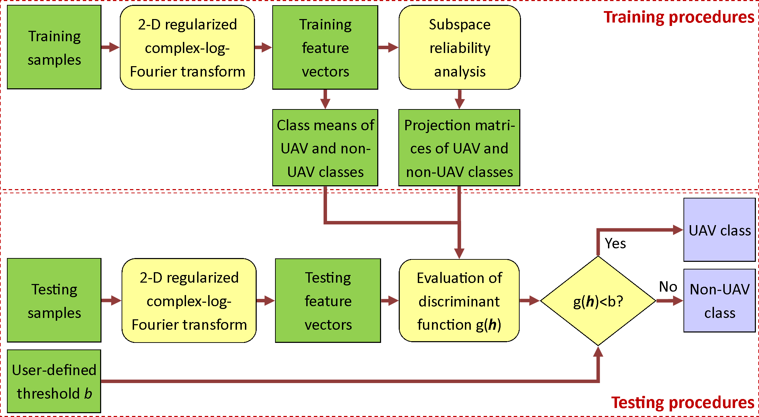

Figure 4: The block diagram of the proposed UAV-detection system.

1 3.4. The Proposed UAV-Detection System
2 The block diagram of the proposed UAV-detection system is shown in Fig. 4.
3 In the training stage, the proposed 2-D regularized complex-log-Fourier trans-
4 form is used to extract the feature vectors, and then the proposed subspace
5 reliability analysis is applied to remove the unreliable feature dimensions and
6 to obtain the projection matrix Φ_{1,m}1 for the UAV class and Φ_{2,m}2 for the
7 non-UAV class. In the testing stage, after extracting the feature vector for the
8 testing sample, the discriminant functions g_{1,m}1 (h) and g_{2,m}2 (h) are evaluated
9 according to Eq. (21) and Eq. (24), respectively. Then, the discriminant func-
10 tion g(h) is evaluated according to Eq. (25). Finally, g(h) is compared with a
11 user-defined threshold b, which is used to control the error rates of two classes.
12 If g(h) < b, h belongs to the UAV class, otherwise h belongs to the non-UAV
13 class.

14 4. Experimental Evaluation

15 4.1. Experimental Setup
16 The original UAV-detection dataset was provided by Thales. A low-power
17 continuous-wave radar operating at X-band was used to acquire measurements.

1 In total, there are 854 seconds of recording for UAVs, and 204 seconds of record-
2 ing for non-UAVs, where non-UAVs mainly contain birds. As a longer duration
3 is needed for dynamic time warping (DTW) approach [28], the recordings are
4 chopped into 1-second samples when evaluating DTW. For all other approaches,
5 the recordings are chopped into 50-ms samples. As a result, there are in total
6 1058 samples when evaluating DTW, and 21160 samples when evaluating oth-
7 ers. The authors randomly partition half of the dataset as the training samples,
8 and the other half as the testing samples. The experiments are repeated 20
9 times, and the average performance is reported.
10 The authors report two evaluation criteria: equal error rate (EER) and
11 false acceptance rate (FAR) at false rejection rate (FRR) of 1% (denoted as
12 FAR_{F} _{RR=1%}). False rejection rate is defined as the percentage of the UAV
13 samples being falsely classified as non-UAVs, and false acceptance rate is defined
14 as the percentage of non-UAV samples being falsely classified as UAVs. By
15 varying threshold b, there are different combinations of FAR and FRR. When
16 these two error rates are the same, it is defined as the equal error rate. The
17 authors report the performance in terms of these two criteria because: 1) EER
18 is commonly used in many verification tasks. 2) The authors would like to
19 evaluate how the system performs at a low missing detection rate (i.e. a low
20 FRR) of UAVs, and hence report FAR_{F} _{RR=1%}.
21 The sampling rates of all sequences are normalized to 96kHz. For all the
22 spectrograms, the spectrum utilizes 256 data points and the windows have 50%
23 overlapping. After removing the clutter and some unreliable high-frequency
24 components, the initial feature vector has 201 × 36 = 7236 dimensions.
25 This paper contains two main contributions: the proposed 2-D regularized
26 complex-log-Fourier transform and the proposed subspace reliability analysis.
27 In the following sections, the performance improvement caused by these two
28 will be evaluated one by one. Finally, we compare the proposed approach with
29 the state-of-the-art approaches.


13

ogram
CVD
Cepstrogram Proposed Feature

Spectr

Spectrogram CVD
Cepstrogram Proposed Feature
12
11
10 40
9
8
FARFRR=1%
7 20
EER

6
10
5

4

0 100 200 300 400 500
Dim

- EER

4
0 100 200 300 400 500
dim

- F ARF RR=1%

Figure 5: Error rates vs. feature dimensions for spectrogram, cepstrogram, CVD and the proposed signal representation. The proposed signal representation significantly outperforms others at all feature dimensions in terms of both EER and F ARF RR=1%.

1 4.2. Performance Evaluation of the Proposed 2-D Regularized Complex-Log-
2 Fourier Transform
3 To evaluate the performance improvement caused by the proposed signal
4 representation, the authors compare it with spectrogram [3], cepstrogram [8]
5 and cadence velocity diagram [23]. The authors treat spectrogram, cepstrogram,
6 CVD and the proposed signal representation as the initial feature vector, and
7 apply principal component analysis to remove the unreliable feature dimensions.
8 A minimum-Mahalanobis-distance classifier is then used for classification.
9 The EER and FAR_{F} _{RR=1%} vs. feature dimensions are shown in Fig. 5.
10 It can be seen that for all different feature dimensions, the proposed signal
11 representation significantly outperforms others in terms of both error rates. It
12 can also be seen that although the original feature dimensionality is high (more
13 than 7000), the optimal feature dimensionality is relatively low, e.g. a few
14 dozen. After 100 feature dimensions, the error rates continuously increase as the
15 feature dimensionality increases. The proposed approach achieves its optimal
16 performance at 90 dimensions, and the performance does not drop significantly
17 in a wide range of feature dimensions. The proposed approach could achieve a
18 near-optimum performance in a wide range of feature dimensions.

1 The error rates of different approaches at the optimal dimensionality are
2 summarized in Table 1. The feature dimensionality is chosen in the way that
FAR_{F} _{RR=1%} is minimum. Take note that all the compared approaches do not

Feature | EER | FARF RR=1%
Spectrogram | 7.75% | 27.00%
CVD | 6.68% | 28.41%
Cepstrogram | 10.17% | 48.07%
Proposed repre-  sentation | 3.98% | 4.50%
Table 1: Comparison of different signal representations in terms of EER and F ARF RR=1%
at the optimal feature dimensionality.

3
4 utilize the phase spectrum except the proposed approach. Among the compared
5 approaches, the CVD is most similar to the proposed approach in the sense that
6 both approaches conduct some sort of 2-D Fourier transform. Indeed, the CVD
7 performs the second best in terms of EER. The proposed signal representation
8 consistently and significantly outperforms all the compared features. Compared
9 with the second best performed methods, the proposed signal representation
10 reduces EER by 2.7% and FAR_{F} _{RR=1%} by 22.50%.

11 4.3. Performance Evaluation of the Proposed Subspace Reliability Analysis
12 To study the effectiveness of the proposed subspace reliability analysis, the
13 authors compare it with standard PCA. The proposed 2-D regularized complex-
14 log-Fourier transform is used to extract the initial feature vector. The authors
15 aim to study the reliability of the class-conditional covariance matrices and re-
16 move those feature dimensions that are harmful to the reliable classification. For
17 those unreliable feature dimensions, the training samples could not well repre-
18 sent the testing samples, as the statistics of the testing samples differ largely
19 from those of the training samples.
20 The authors thus study whether the unreliable feature dimensions are prop-
21 erly removed after dimension reduction. The authors perform so-called eigen-

102 102
Eigenspectrum of training data Eigenspectrum of testing data
Eigenspectrum of training data Eigenspectrum of testing data

101 101
Eigenvalues
Eigenvalues

100
0 20 40 60 80 100
Dim
100
0 20 40 60 80 100
Dim

(a) eigen-spectrums of non-UAV class, PCA (b) eigen-spectrums of UAV class, PCA

102 102
Eigenspectrum of training data Eigenspectrum of testing data
Eigenspectrum of training data Eigenspectrum of testing data

101 101
Eigenvalues
Eigenvalues

100
0 20 40 60 80 100
Dim
100
0 20 40 60 80 100
Dim

(c) eigen-spectrums of non-UAV class, SRA (d) eigen-spectrums of UAV class, SRA

Figure 6: Eigen-spectrum plots for standard PCA and the proposed SRA. Eigen-spectrums of non-UAV and UAV class for the subspace derived using PCA are shown in (a) and (b), respectively. Eigen-spectrums of non-UAV and UAV class for the proposed SRA are shown in
- and (d), respectively.

1 spectrum analysis [42, 43]. The eigen-spectrums of the subspace (100 dimension-
2 s) derived using PCA and the proposed SRA are shown in Fig. 6. More specif-
3 ically, for the non-UAV class, the authors compute the variance of the train-
4 ing/testing data in each dimension. Those variances form the eigen-spectrum
5 of the training/testing data for the non-UAV class. Similarly, we can derive the
6 eigen-spectrum for the UAV class. If the eigen-spectrum of the testing samples
7 is well matched with that of the training samples, it indicates a good gener-
8 alization performance. More details on eigen-spectrum analysis can be found
9 in [42, 43].

1 From these eigen-spectrums shown in Fig. 6, it is clear that the proposed
2 SRA is better than PCA. 1) PCA does not effectively remove all the unreli-
3 able feature dimensions. The optimal feature dimensionality for PCA-based
4 approach is 90, as shown in Fig. 5. However, from Fig. 6(a) and (b), many
5 feature dimensions in the PCA subspace are unreliable, i.e. For both UAV and
6 non-UAV classes, the eigen-spectrum of the testing samples deviates largely
7 from that of the training samples in the PCA subspace. 2) Comparing SRA
8 with PCA in the projected subspace, for the non-UAV class the difference be-
9 tween eigen-spectrum of the testing samples and that of the training samples in
10 the SRA subspace is much smaller than eigen-spectrum difference in the PCA
11 subspace. In another word, the proposed SRA better removes the unreliable
12 feature dimensions so that in the SRA subspace, the eigen-spectrum difference
13 is smaller than that in the PCA subspace. 3) For the eigen-spectrums of the
14 UAV class shown in Fig. 6(b) and (d), neither PCA nor SRA could well remove
15 the unreliable feature dimensions at 100 dimensions. However, SRA has the
16 flexibility of choosing different dimensionalities for two classes, but PCA does
17 not. SRA could further reduce the feature dimensionality to a much lower num-
18 ber so that those unreliable feature dimensions of the UAV class are properly
19 removed. In contrast, if PCA further reduces the dimensionality, many reliable
20 feature dimensions of the non-UAV class will be removed at the same time.
21 The proposed subspace reliability analysis achieves the optimal performance
22 when the dimensionality is 10 for the UAV class and 100 for the non-UAV class.
23 We now show why the optimal feature dimensionalities of two classes are very
24 different using the eigen-spectrum plots. For the non-UAV class, the eigen-
25 spectrum of the testing samples matches well with that of the training samples,
26 as shown in Fig. 6(c). We thus should utilize 100 feature dimensions of the
27 non-UAV class. On the other hand, many feature dimensions are unreliable
28 for the first 100 dimensions of the UAV class, as the eigen-spectrum of the
29 testing samples does not match well with that of the testing samples, as shown
30 in Fig. 6(d). To remove these unreliable feature dimensions, we thus should
31 reduce the feature dimensionality of the UAV class to 10.

1 The performance comparison between PCA and the proposed SRA is shown
2 in Table 2. We can see that the proposed SRA outperforms PCA in terms of both error rates.
Table 2: Comparison between PCA and the proposed SRA in terms of EER and F ARF RR=1%.
Method | EER | FARF RR=1%
Proposed signal repre-  sentation + PCA | 3.98% | 4.50%
Proposed signal repre-  sentation + SRA | 3.27% | 3.89%
3

4 4.4. Comparison to the State-of-the-Art Approaches
5 As no complete solution was published for UAV-detection problem, the au-
6 thors implement two state-of-the-art techniques designed for other mDS recog-
7 nition tasks and adapt them for UAV detection. The proposed approach and
8 the compared approaches are implemented using Matlab R2015a [54–59].
9 Dynamic time warping: dynamic time warping (DTW) [28] was originally
10 designed to classify vehicles and human. The optimal global path derived by
11 DTW ¹ is treated as the distance between two samples. Then, the distances
12 between one sample and all training samples are treated as the feature vector,
13 and classified by a linear support vector machine (SVM). The cost parameter
14 of SVM is set as C = 40.
15 Robust PCA: Robust PCA [24] was originally designed for action classifica-
16 tion. The feature vector is obtained by averaging the spectrogram over time.
17 The Minimum Covariance Determinant (MCD) estimator is then used to remove
18 the outlier. “rrcov” package in R programming is used to implement the MCD
19 estimator. PCA is then applied to reduce the feature dimensionality. After fea-
20 ture vectors are normalized to zero mean with unit variance, they are classified

1 The matlab code of DTW can be downloaded from http://labrosa.ee.columbia.edu/ matlab/dtw/.

1 by a linear support vector machine. The cost parameter is C = 40.
2 The authors summarize the performance comparison between the proposed approach and the state-of-the-art approaches in Table 3. Based on these exper-
Table 3: Comparison between the proposed approach and the state-of-the-art approaches.
Method | EER | FARF RR=1%
DTW [28] | 8.04% | 47.42%
Robust PCA [24] | 8.19% | 54.16%
Spectrogram + PCA | 7.75% | 27.00%
CVD + PCA | 6.68% | 28.41%
Cepstrogram + PCA | 10.17% | 48.07%
Proposed feature rep-  resentation + PCA | 3.98% | 4.50%
Proposed feature rep-  resentation + SRA | 3.27% | 3.89%
3

4 imental results, we could see the following:
5 1. Neither DTW nor robust PCA can well solve the UAV-detection problem.
6 The error rates of both approaches are very high. These two approaches
7 were originally designed for other applications, and hence they are not
8 good at solving the UAV-detection problem.
9 2. The performance of simply taking the spectrogram as features is not sig-
10 nificantly better than DTW or robust PCA. Cepstrogram shows its ef-
11 fectiveness in visually recognizing micro-Doppler signature. However, our
12 experiment results show that cepstrogram-based approach does not yield
13 good performance for machine-automatic UAV detection.
14 3. By utilizing the proposed robust spectral analysis, the error rates are
15 greatly reduced compared with other signal representations. The proposed
16 feature utilizes not only the amplitude, but also the phase information of
17 the first FFT. What’s more, the proposed regularized complex logarithm
18 resolves the noise-amplification problem of the log-spectrogram, and hence

1 significantly improves the performance.
2 4. Lastly, the proposed subspace reliability analysis well resolves the relia-
3 bility issues of two class-conditional covariance matrices in this two-class
4 classification problem. More specifically, the proposed SRA better removes
5 the unreliable feature dimensions of two covariance matrices separately in
6 two different subspaces, which further improves the classification perfor-
7 mance.

8 5. Conclusion

9 In this paper, the authors propose a robust signal representation - 2-D
10 regularized complex-log-Fourier transform and an object-oriented dimension-
11 reduction technique - subspace reliability analysis. The proposed signal repre-
12 sentation addresses the problems of the existing feature representations by mak-
13 ing full use of both magnitude and phase information of the first Fourier trans-
14 form, enlarging the weak micro-Doppler signature and suppressing the noise in
15 the log-spectrogram. The proposed subspace reliability analysis is specifically
16 designed for UAV-detection problem. It removes the unreliable feature dimen-
17 sions of both UAV and non-UAV classes separately in two different subspaces.
18 The proposed approach is compared with the state-of-the-art approaches. It
19 significantly outperforms others on the benchmark dataset.

20 Acknowledgment

21 This research is supported by Singapore Future Systems and Technology
22 Directorate (FSTD) under project reference: MINDEF-NTU-DIRP/2014/01.
23 Thank Thales Solutions Asia for providing the data. Special thanks to Mr.
24 Adriaan Smits, the Director of Centre of Excellence for Radar & Integrated
25 Sensors, Thales Solutions Asia, for the valuable discussion and advice.

1 References

2 | [1] | M. Ritchie, F. Fioranelli, H. Griffiths, B. Torvik, Micro-drone RCS analysis, in: IEEE
3 |  | Radar Conference, IEEE, 452–456, 2015.
4 | [2] | N. Mohajerin, J. Histon, R. Dizaji, S. L. Waslander, Feature extraction and radar track
5 |  | classification for detecting UAVs in civillian airspace, in: IEEE Radar Conference, IEEE,
6 |  | 0674–0679, 2014.
7 | [3] | V. C. Chen, H. Ling, Time-frequency transforms for radar imaging and signal analysis,
8 |  | Artech House, 2001.
9 | [4] | Q. Zhang, Y.-s. Zeng, Y.-q. He, Y. Luo, Avian detection and identification with high-
10 |  | resolution radar, in: IEEE Radar Conference, IEEE, 1–6, 2008.
11 | [5] | V. C. Chen, Doppler signatures of radar backscattering from objects with micro-motions,
12 |  | IET Signal Processing 2 (3) (2008) 291–300.
13 | [6] | D. Tahmoush, J. Silvious, Simplified model of dismount micro-Doppler and RCS, in:
14 |  | IEEE Radar Conference, IEEE, 31–34, 2010.
15 | [7] | B. Peng, X. Wei, B. Deng, H. Chen, Z. Liu, X. Li, A Sinusoidal Frequency Modulation
16 |  | Fourier Transform for Radar-Based Vehicle Vibration Estimation, IEEE Transactions on
17 |  | Instrumentation and Measurement 63 (9) (2014) 2188–2199.
18 | [8] | R. Harmanny, J. de Wit, G. Pr´emel-Cabic, Radar micro-Doppler feature extraction using
19 |  | the spectrogram and the cepstrogram, in: European Radar Conference, IEEE, 165–168,
20 |  | 2014.
21 | [9] | W. Zhang, K. Li, W. Jiang, Parameter Estimation of Radar Targets with Macro-Motion
22 |  | and Micro-Motion Based on Circular Correlation Coefficients, Signal Processing Letters,
23 |  | IEEE 22 (5) (2015) 633–637.
24 | [10] | D. Zhou, G. Liu, J. Wang, Spatio-temporal target identification method of high-range
25 |  | resolution radar, Pattern Recognition 33 (1) (2000) 1 – 7.
26 | [11] | G. Sun, J. Wang, S. Qin, J. Na, Radar target recognition based on the multi-resolution
27 |  | analysis theory and neural network, Pattern Recognition Letters 29 (16) (2008) 2109 –
28 |  | 2115.
29 | [12] | D. Zhou, X. Shen, W. Yang, Radar target recognition based on fuzzy optimal transfor-
30 |  | mation using high-resolution range profile, Pattern Recognition Letters 34 (3) (2013) 256
31 |  | – 264.

1 [13] H. Jiang, L. Xu, K. Zhan, Joint tracking and classification based on aerodynamic model
2 and radar cross section, Pattern Recognition 47 (9) (2014) 3096 – 3105.

3 [14] L. Du, H. He, L. Zhao, P. Wang, Noise Robust Radar HRRP Target Recognition Based
4 on Scatterer Matching Algorithm, IEEE Sensors Journal 16 (6) (2016) 1743–1753.

5 [15] B. Feng, B. Chen, H. Liu, Radar HRRP target recognition with deep networks, Pattern
6 Recognition 61 (2017) 379 – 393.

7 [16] X. Chen, J. Guan, Z. Bao, Y. He, Detection and extraction of target with micromotion
8 in spiky sea clutter via short-time fractional Fourier transform, IEEE Transactions on
9 Geoscience and Remote Sensing 52 (2) (2014) 1002–1018.

10 [17] Y. Wang, Q. Liu, A. E. Fathy, CW and pulse-Doppler radar processing based on FPGA
11 for human sensing applications, IEEE Transactions on Geoscience and Remote Sensing
12 51 (5) (2013) 3097–3107.

13 [18] T. Thayaparan, L. Stankovi´c, I. Djurovi´c, micro-Doppler-based target detection and
14 feature extraction in indoor and outdoor environments, Journal of the Franklin Institute
15 345 (6) (2008) 700–722.

16 [19] D. Tahmoush, J. Silvious, Radar micro-Doppler for long range front-view gait recognition,
17 in: IEEE International Conference on Biometrics: Theory, Applications, and Systems,
18 IEEE, 1–6, 2009.

19 [20] R. G. Raj, V. C. Chen, R. Lipps, Analysis of radar human gait signatures, IET Signal
20 Processing 4 (3) (2010) 234–244.

21 [21] J. Park, J. T. Johnson, N. Majurec, M. Frankford, K. Stewart, G. E. Smith, L. West-
22 brook, Simulation and analysis of polarimetric radar signatures of human gaits, IEEE
23 Transactions on Aerospace and Electronic Systems 50 (3) (2014) 2164–2175.

24 [22] Y. Kim, H. Ling, Human activity classification based on micro-Doppler signatures using
25 a support vector machine, IEEE Transactions on Geoscience and Remote Sensing 47 (5)
26 (2009) 1328–1337.

27 [23] S. Bjo¨rklund, T. Johansson, H. Petersson, Evaluation of a micro-Doppler classification
28 method on mm-wave data, in: IEEE Radar Conference, IEEE, 0934–0939, 2012.

29 [24] J. Zabalza, C. Clemente, G. Di Caterina, J. Ren, J. J. Soraghan, S. Marshall, Robust PCA
30 for micro-Doppler classification using SVM on embedded systems, IEEE Transactions on
31 Aerospace and Electronic Systems 50 (3) (2014) 2304–2310.

1 [25] C. Clemente, L. Pallotta, A. D. Maio, J. J. Soraghan, A. Farina, A novel algorithm
2 for radar classification based on Doppler characteristics exploiting orthogonal Pseudo-
3 Zernike polynomials, IEEE Transactions on Aerospace and Electronic Systems 51 (1)
4 (2015) 417–430.

5 [26] Y. Li, L. Du, H. Liu, Hierarchical classification of moving vehicles based on empirical
6 mode decomposition of micro-Doppler signatures, IEEE Transactions on Geoscience and
7 Remote Sensing 51 (5) (2013) 3001–3013.

8 [27] G. E. Smith, K. Woodbridge, C. J. Baker, Na¨ıve Bayesian radar micro-Doppler recogni-
9 tion, in: International Conference on Radar, IEEE, 111–116, 2008.

10 [28] G. E. Smith, K. Woodbridge, C. J. Baker, Radar micro-Doppler signature classification
11 using dynamic time warping, IEEE Transactions on Aerospace and Electronic Systems
12 46 (3) (2010) 1078–1096.

13 [29] L. M. Novak, G. J. Owirka, C. M. Netishen, Radar target identification using spatial
14 matched filters, Pattern Recognition 27 (4) (1994) 607 – 617.

15 [30] K.-T. Kim, Application of feature space trajectory classifier to identification of multi-
16 aspect radar signals, Pattern Recognition 38 (11) (2005) 2159 – 2173.

17 [31] D. Tahmoush, Detection of small UAV helicopters using micro-Doppler, in: SPIE De-
18 fense+ Security, International Society for Optics and Photonics, 907717–907717, 2014.

19 [32] J. De Wit, R. Harmanny, P. Molchanov, Radar micro-Doppler feature extraction using
20 the singular value decomposition, in: IEEE Radar Conference, IEEE, 1–6, 2014.

21 [33] P. Suresh, T. Thayaparan, T. Obulesu, K. Venkataramaniah, Extracting micro-Doppler
22 radar signatures from rotating targets using Fourier-Bessel transform and time-frequency
23 analysis, IEEE Transactions on Geoscience and Remote Sensing 52 (6) (2014) 3204–3210.

24 [34] M. A. Turk, A. P. Pentland, Face recognition using eigenfaces, in: IEEE Conference on
25 Computer Vision and Pattern Recognition, IEEE, 586–591, 1991.

26 [35] P. N. Belhumeur, J. P. Hespanha, D. J. Kriegman, Eigenfaces vs. fisherfaces: Recognition
27 using class specific linear projection, IEEE Transactions on Pattern Analysis and Machine
28 Intelligence 19 (7) (1997) 711–720.

29 [36] B. Moghaddam, T. Jebara, A. Pentland, Bayesian face recognition, Pattern Recognition
30 33 (11) (2000) 1771–1782.

31 [37] X. Jiang, B. Mandal, A. Kot, Enhanced maximum likelihood face recognition, Electronics
32 Letters 42 (19) (2006) 1089–1090.

1 [38] X. Wang, X. Tang, Dual-space linear discriminant analysis for face recognition, in: IEEE
2 Conference on Computer Vision and Pattern Recognition, vol. 2, IEEE, II–564, 2004.

3 [39] W. Liu, Y. Wang, S. Z. Li, T. Tan, Null space approach of fisher discriminant analysis
4 for face recognition, in: Biometric Authentication, Springer, 32–44, 2004.

5 [40] S. Yan, D. Xu, B. Zhang, H.-J. Zhang, Q. Yang, S. Lin, Graph embedding and extensions:
6 a general framework for dimensionality reduction, IEEE Transactions on Pattern Analysis
7 and Machine Intelligence 29 (1) (2007) 40–51.

8 [41] J. Wright, A. Y. Yang, A. Ganesh, S. S. Sastry, Y. Ma, Robust face recognition via sparse
9 representation, IEEE Transactions on Pattern Analysis and Machine Intelligence 31 (2)
10 (2009) 210–227.

11 [42] X. Jiang, Asymmetric principal component and discriminant analyses for pattern classi-
12 fication, IEEE Transactions on Pattern Analysis and Machine Intelligence 31 (5) (2009)
13 931–937.

14 [43] X. Jiang, Linear subspace learning-based dimensionality reduction, Signal Processing
15 Magazine, IEEE 28 (2) (2011) 16–26.

16 [44] X. Jiang, B. Mandal, A. Kot, Eigenfeature regularization and extraction in face recog-
17 nition, IEEE Transactions on Pattern Analysis and Machine Intelligence 30 (3) (2008)
18 383–394.

19 [45] L.-F. Chen, H.-Y. M. Liao, M.-T. Ko, J.-C. Lin, G.-J. Yu, A new LDA-based face recog-
20 nition system which can solve the small sample size problem, Pattern recognition 33 (10)
21 (2000) 1713–1726.

22 [46] J. Ren, X. Jiang, J. Yuan, A Chi-squared-transformed subspace of LBP histogram for
23 visual recognition, IEEE Transactions on Image Processing 24 (6) (2015) 1893–1904.

24 [47] A. V. Oppenheim, J. S. Lim, The importance of phase in signals, Proceedings of the
25 IEEE 69 (5) (1981) 529–541.

26 [48] C. Guo, Q. Ma, L. Zhang, Spatio-temporal saliency detection using phase spectrum of
27 quaternion fourier transform, in: Computer vision and pattern recognition, 2008. cvpr
28 2008. ieee conference on, IEEE, 1–8, 2008.

29 [49] R. Randall, B. Peeters, J. Antoni, S. Manzato, New cepstral methods of signal prepro-
30 cessing for operational modal analysis, in: Proc. Int. Conference on Noise and Vibration
31 Engineering (ISMA), 2012.

32 [50] S. Wang, J. Lu, X. Gu, H. Du, J. Yang, Semi-supervised linear discriminant analysis for
33 dimension reduction and classification, Pattern Recognition 57 (2016) 179 – 189.

1 [51] T. I. Dhamecha, R. Singh, M. Vatsa, On incremental semi-supervised discriminant anal-
2 ysis, Pattern Recognition 52 (2016) 135 – 147.

3 [52] P. Chen, L. Jiao, F. Liu, J. Zhao, Z. Zhao, S. Liu, Semi-supervised double sparse graphs
4 based discriminant analysis for dimensionality reduction, Pattern Recognition 61 (2017)
5 361 – 378.

6 [53] Z. Zhao, L. Jiao, J. Zhao, J. Gu, J. Zhao, Discriminant deep belief network for high-
7 resolution SAR image classification, Pattern Recognition 61 (2017) 686 – 701.

8 [54] M. Valipour, M. E. Banihabib, S. M. R. Behbahani, Comparison of the ARMA, ARIMA,
9 and the autoregressive artificial neural network models in forecasting the monthly inflow
10 of Dez dam reservoir, Journal of hydrology 476 (2013) 433–441.

11 [55] M. Valipour, Variations of land use and irrigation for next decades under different sce-
12 narios, IRRIGA 1 (01) (2016) 262–288.

13 [56] M. Rezaei, M. Valipour, M. Valipour, Modelling evapotranspiration to increase the ac-
14 curacy of the estimations based on the climatic parameters, Water Conservation Science
15 and Engineering 1 (3) (2016) 197–207.

16 [57] M. Valipour, How much meteorological information is necessary to achieve reliable accu-
17 racy for rainfall estimations?, Agriculture 6 (4) (2016) 53.

18 [58] M. Valipour, M. A. G. Sefidkouhi, Temporal analysis of reference evapotranspiration to
19 detect variation factors, International Journal of Global Warming (2017) in press.

20 [59] M. Valipour, M. A. G. Sefidkouhi, M. Raeini, et al., Selecting the best model to estimate
21 potential evapotranspiration with respect to climate change and magnitudes of extreme
22 events, Agricultural Water Management 180 (2017) 50–60.

*Author Biography

Jianfeng Ren received M.Sc. and Ph.D. in 2009 and 2015, respectively, both from Nanyang Technological University (NTU). Before that, he graduated with B.Eng. from National University of Singapore in 2001. He received Professional Engineers Board Gold Medal for his outstanding academic results among all EEE M.Sc. graduates in 2009. From 2003 to 2007, he worked in industry sections. In Dec 2007, he joined NTU as a project officer, responsible for the development of the face verification system on mobile devices. In Sept 2011, he
joined BeingThere Centre, Institute of Media Innovation, NTU as a research associate. Currently he worked in School of EEE, NTU as a post-doc research fellow. Since 2009, he has published 9 journal papers and 9 conference papers, include two TIP papers, two PR papers, three SPL papers and one TMM paper. His research interests include face recognition, image/video processing, statistical pattern recognition and machine learning.

Xudong Jiang received the B.Eng. and M.Eng. degrees from the University of Electronic Science and Technology of China and the Ph.D. degree from Helmut Schmidt University, Hamburg, Germany, all in electrical engineering. He received two Science and Technology Awards from the Ministry for Electronic Industry of China. From 1998 to 2004, he was with the Institute for Infocomm Research, A*STAR, Singapore, as a lead Scientist,
and the Head of the Biometrics Laboratory, where he developed a system that achieved the highest efficiency and the second highest accuracy at the International Fingerprint Verification Competition in 2000. He joined Nanyang Technological University (NTU), Singapore, as a Faculty Member in 2004, and served as the Director of the Centre for Information Security from 2005 to 2011. He is currently a Tenured Associate Professor with the School of EEE, NTU. He holds 7 patents and has authored over 100 papers with 28 papers in the IEEE journals, including 8 TIP papers and 5 TPAMI papers. He has published 12 papers in Pattern Recognition. His research interests include image processing, pattern recognition, computer vision, machine learning, and biometrics. He is IFS TC member of the IEEE Signal Processing Society, and serves as an Associate Editor of the IEEE Transactions on Image Processing, IEEE Signal Processing Letters and IET Biometrics.

