1. Create a flask app using MongoDB
   1. Create an ETL file that parses the CSV and Creates the MongoDB
2. The flask app will consist of a base.html and < Visualization>.html files. The Base has a standard header/footer/navbar to inherit.
3. We are using Movie DB information to provide the following visuals:
   1. We have a Bubble diagram of the keywords associates with each genre of music.
      1. Here is an example: <https://bl.ocks.org/jyucsiro/767539a876836e920e38bc80d2031ba7>
      2. Note: This is called cloud.js, and it extends d3. We are using this library for this project
      3. Note: there may be thick manipulations on the data if the word count is too long.
   2. The second Visualization is a scatter plot of profit versus budget with the dots color-coded based upon the movie genre.
      1. [https://ibb.co/zxFhyMp](https://ibb.co/zxFhyMp%20) the IMG for my visualization proposal, credited to [https://towardsdatascience.com/](https://towardsdatascience.com/exploring-movie-data-with-interactive-visualizations-c22e8ce5f663)
   3. The final Visualization will showcase a world map of movie production countries. It will showcase via pop-up the highest-grossing movie for each country. The pop-up will appear when a user clicks on the country.

Here is a mock-up of the Bubble Chart:

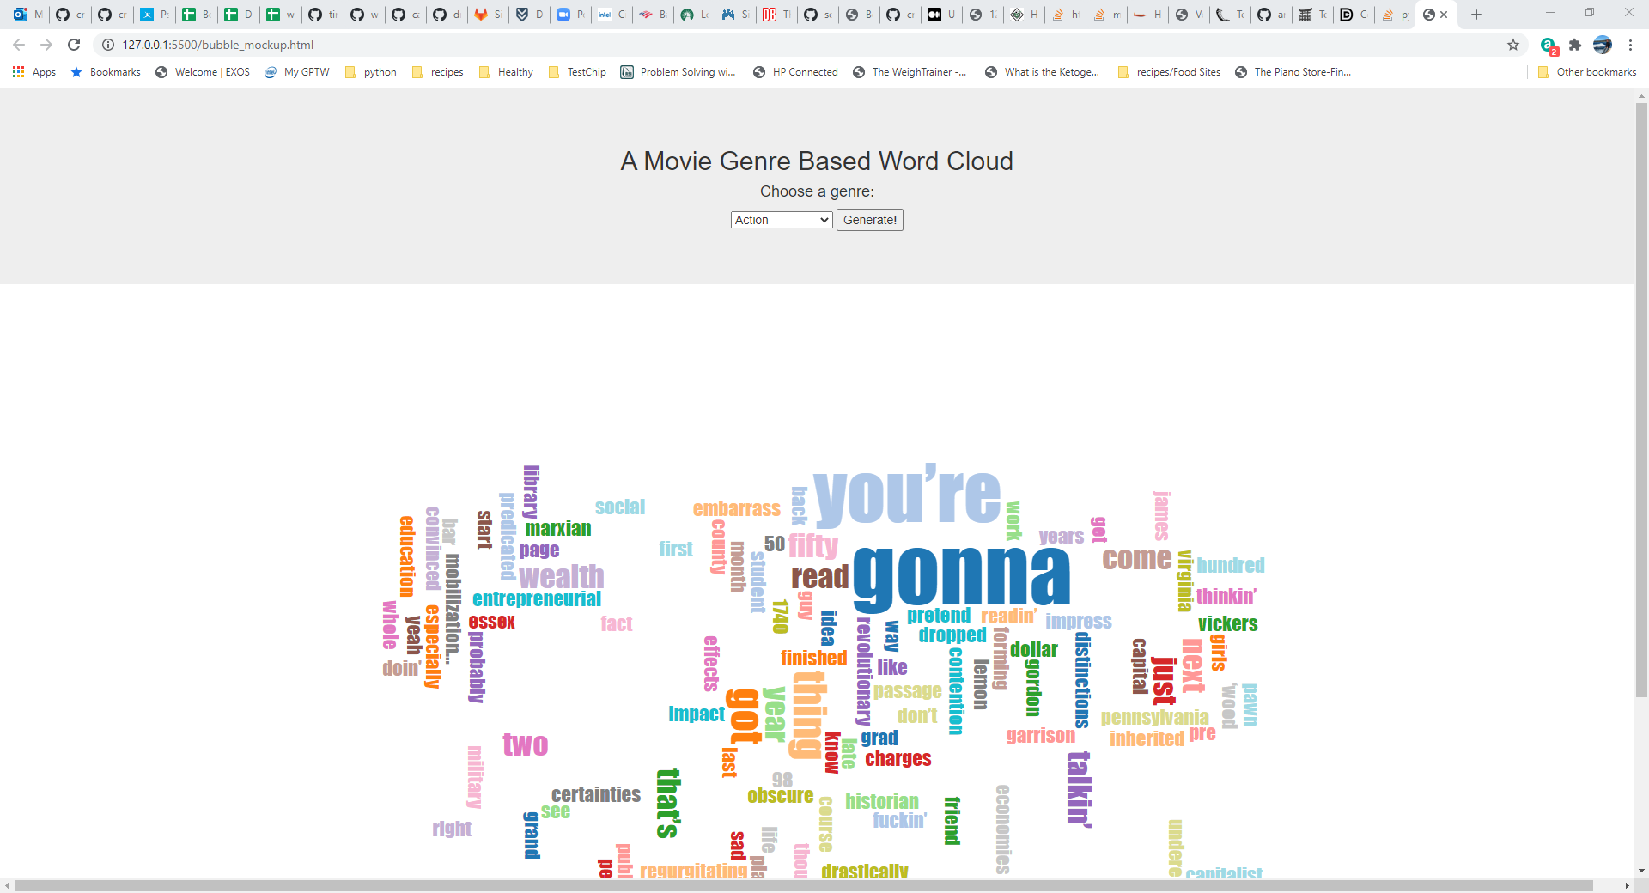

A Scatter Plot proposal:

The third Visualization will look something like this:

