Tuna Pâté
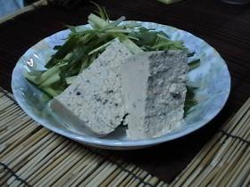

Ingredients （ for 6 to 8 people serving ）
1 can of tuna
¼ of large onion
1 boiled eggs
2 pickles (or use pickles relish 2 to 3 Tbls)
100cc Milk
6 Tbls of mayo
1 package (7g) of gelatin
Chopped parsley (optional)
A pinch of Salt for taste
A pinch of Pepper for taste

In a microwavable small bowl, add 1 Tbls of water to gelatin. Microwave for 30 seconds to dissolve it.
- 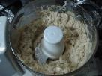
- Using food processor, mix boiled eggs, onions, pickles, and drained canned tuna until it becomes smooth.
- Add mayo and milk. Season with salt and pepper. Add the dissolved gelatin and parsley and mix well.
- Pour it to a molding container and place it in the refrigerator until it hardens.

