 | 純生ロール (Authentic Roll Cake)  by ゆきらいん (by Yukirain)  This recipe is the one of the popular roll recipe under CookPad, a very popular Japanese recipe site. More than 2000 people tried this and gave thumbs up.  My translation in English as follows:

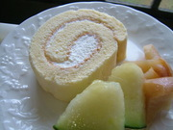
しっとり絹どけの生地にたっぷり生クリームを巻き込んで。シンプルな物だからこそ丁寧に作って欲しい。レシピ通り作って貰えればこれ以上は無いというくらいのキメの細かい生地が出来上がります♪（＾－＾） | 

Very important…
The crucial step of this recipe is when you add the dry ingredients to the batter. Do not over mix it but mix well with bottom-to- top scoop-and-fold motion. I tried to use a electric hand mixer for this step before but it wasn’t the same. It tastes best when you do this step by hand. Also, I used 150cc of heavy whipped cream to make the filling in the above photo. You can adjust the amount for your taste.

Ingredients：
(one ２８cm×２８cm jelly roll pan)
Eggs | 4 Large ones（room temperature）
Sugar | ９０ｇ
Pastry Flour | ７０g
Mattcha(green tea powder) | 7g (this is optional)
For Filling:
Heavy Whipping Cream
１５０ｃｃ～
Sugar | ９ｇ～

このレシピの生い立ち
私の大好きな純生ロールです。（＾－＾）
1. | Only the three ingredients shown in the right photo are used to make the sheet cake. Flour (and optionally Mattcha) is shifted. | 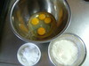
2. | Break up the eggs and mix until whites are all mixed in, add the sugar and mix it briefly. | 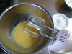
3. | Over the double boiler, start whipping the mixture. | 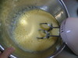
4. | With high speed, whip the mixture until it reaches the body temperature. Remove the mixing bowl from the double boiler. | 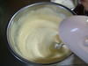
5. | Continue mixing with high speed. When you can make a soft peak with the batter dripping as shown in the photo, stop mixing. | 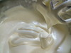
6. | Add shifted dry ingredient(s) in 6 increments. Each time, drop small amount closed to the batter surface and quickly incorporate it using a rubber spatula.
7. | After adding all the dry ingredients, hold the mixing bowl with one hand and fold the mixture with the spatula, scooping from bottom to top. | 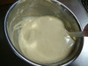
8. | Continue the mixing even after all the flour gets incorporated. If the scooped batter make the dripping trace shown in the photo, the mixture needs more mixing. | 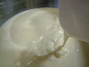
9. | When the scooped batter drips into a line and it disappears quickly into the mixture, the batter is ready. (this mixing and folding process takes about 3 to 5 minutes) | 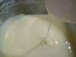
10. | ※ Atthis point, the volume becomes a half of Step 5 but do not worry. This step is to make the big bubbles created by the handmixer to finer bubbles. If you do not do this step right, the cake may cave down after baking or the texture becomes rough.
11. | Pour the batter into the baking pan lined up with parchment paper. Knock the bottom of the pan to get the air out of the batter. Make its surface even. | 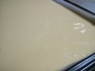
12. | Preheat oven at 350 degrees. Bake 10 to 12minutes. Take it out of the oven. Drop the pan from 20cm height to get the steam out of the cake to prevent caving down. | 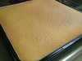
13. | Cool down to be able to handle. Cover it with another baking sheet to avoid drying out and continue cooling. | 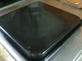
14. | Take the cover and place another parchment paper or wax paper a little larger than the case over it. Flip the pan to get it out of the pan. Peel the original parchment paper slowly and gently. | 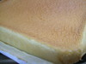
15. | Prepare the filling by mixing cream and sugar until forming soft peaks. Spread the filling on the cake. More filling at the beginning of rolling end and less filling towards the end. Spread all the way to the edges. | 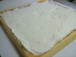
16. | Place a rolling pin under the parchment paper and lift it to begin rolling. Roll it tight first to make the core. | 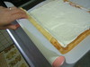
17. | Slowly and gently roll it all the way, guiding the roll pin. | 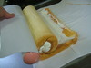
18. | Remove excess filling with spatula. Gently press it to make the round shape. | 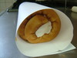
19. | Wrap it with plastic wrap and rest it in the refrigerator at least 1 hour. (A half day rest is the best) | 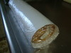
20. | It should look like the picture. | 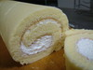
21. | Top with your favorite fruits. | 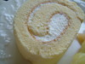
http://cookpad.com/recipe/46433

