Chris Mikus

George Washington University

Data Analytics and Visualization

April 11, 2020

VBA Challenge Screenshots

2016 Stock Results

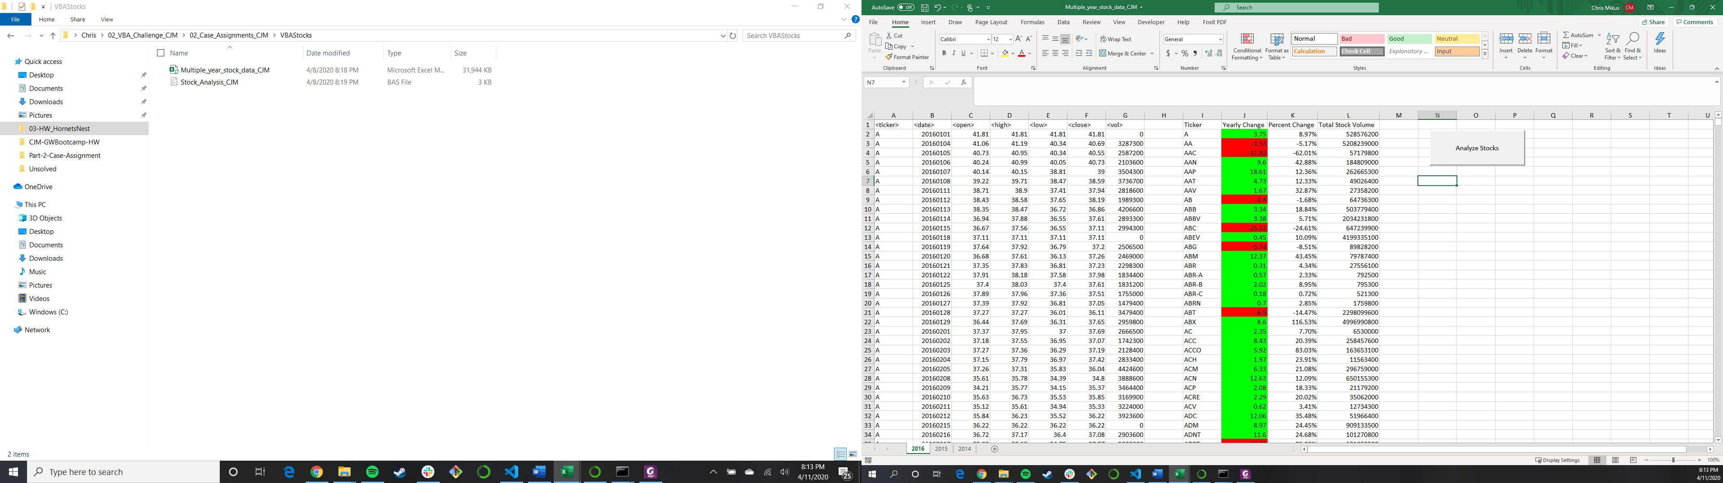

2015 Stock Results

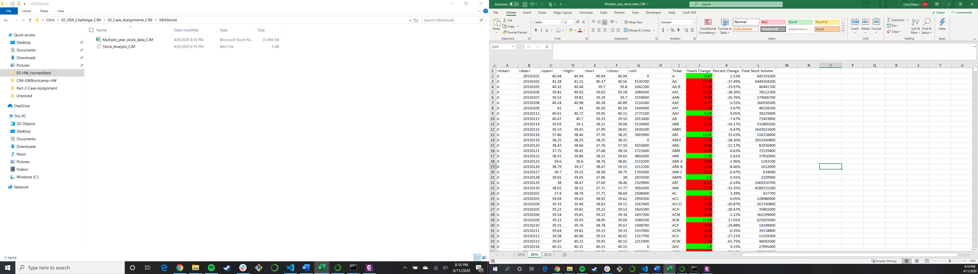

2014 Stock Results

