

HL7 Implementation Guide: XML Implementation for Virtual Medical Record, Release 1

Project Coordinator and Document Editor

Kensaku Kawamoto, MD, PhD, University of Utah

Claude Nanjo, MPH, MAAS, Zynx Health Incorporated

Collaborators

David Shields, University of Utah

Victor Lee, MD, Zynx Health Incorporated

Aziz Boxwala, MD, PhD, FACMI, Meliorix Inc

Mark Roche, MD, MSMI, Roche Consulting

Bryn Rhodes, Veracity Solutions

Davide Sottara, PhD, Arizona State University

Andrew K. McIntyre, FRACP, MBBS, Medical-Objects

Yongjian Bao, PhD, GE Healthcare

Howard R. Strasberg, MD, MS, Wolters Kluwer Health

Peter R. Tattam, Tattam Software Enterprises Pty Ltd

Scott Bolte, MS, GE Healthcare

Peter Scott, MBBS, Medical-Objects

Keith Boone, GE Healthcare

Zhijing Liu, PhD, Siemens Healthcare

Chris Melo, Philips Healthcare

Nathan Hulse, PhD, Intermountain Healthcare

Jim Basilakis, MBBS, MS, University of Western Sydney

Robert Worden, Open Mapping Software, Limited

Daryl Chertcoff, HLN Consulting

Clayton Curtis, MD, PhD, U.S. Veterans Health Administration

Guilherme Del Fiol, MD, PhD, University of Utah

Emory Fry, MD, Uniformed Service University Health Sciences

Jean-Charles Dufour, MD, PhD, Université Aix-Marseille

Laurent CHARLOIS, Université de la Méditerranée

Project Sponsor

HL7 Clinical Decision Support

HL7 Project #939

Draft Standard for Trial Use

Identifying Information for Specification:

Specification Name and Release Number: HL7 Implementation Guide: XML Implementation for Virtual Medical Record, Release 1

Ballot Cycle: May 2013

Date Submitted for Publication: August 2013

Specification Date: August 2013

Version Number within Release 1: 1.0

Note:

As of August 2013, Release 2 of the vMR XML Implementation Guide is under active development. Please note that Release 2 of the specification may NOT be backward-compatible with Release 1 of the specification.

Table of Contents

Table of Contents 3

1 Executive Summary 4

2 XML implementation Guide for VMR 5

2.1 Overview 5

2.2 datatypes.xsd 5

2.3 vmr.xsd 6

2.4 cdsInput.xsd 9

2.5 cdsInputSpecification.xsd 9

2.6 cdsOutput.xsd 10

2.1 cdsOutputSpecification.xsd 11

2.2 Examples 11

# Executive Summary

A Virtual Medical Record (vMR) for Clinical Decision Support (CDS) is a data model for representing clinical information *inputs* and *outputs* that can be used by CDS engines and local clinical information systems, through mechanisms such as CDS services, or execution of standardised clinical support logic such as a GELLO execution engine. The vMR encompasses data about a patient's demographics and clinical history, as well as CDS inferences about the patient (e.g., recommended clinical interventions). A vMR for CDS is needed to enable the design and development of scalable CDS resources that can be used across multiple healthcare institutions and health information systems. Existing clinical data, from any source, is virtualised to present a façade compliant with the vMR class model. Clinical logic can then be executed against the data represented in the vMR model.

The objective of the HL7 CDS Work Group’s vMR XML Implementation Guide is to define a set of schemas for the serialization and exchange of vMR-compliant clinical data between parties.

Note that the proposed XML schemas shall be considered *normative* while all accompanying examples and diagrams shall be considered *informative*. The proposed XML schemas are based on the vMR DAM Release 2.

# XML implementation Guide for VMR

## Overview

The vMR XML specification consists of 5 XSD schema files which follow a similar conceptual categorization compared to the categorization defined in the vMR Domain Analysis Model, release 2:

1. datatypes.xsd
2. vmr.xsd
3. cdsInput.xsd
4. cdsInputSpecification.xsd
5. cdsOutput.xsd

Diagrams have been added for illustrative purposes only. Please note that it is the schemas and not these diagrams that represent the actual specification and source of truth.

The following table lists the schema namespaces

|  |  |
| --- | --- |
| Schema | Namespace |
| Datatypes.xsd | urn:hl7-org:v3:cdsdt:r2 |
| vmr.xsd | urn:hl7-org:v3:vmr:r2 |
| cdsInput.xsd | urn:hl7-org:v3:cdsinput:r2 |
| cdsOutput.xsd | urn:hl7-org:v3:cdsoutput:r2 |
| cdsInputSpecification.xsd | urn:hl7-org:v3:cdsinputspecification:r2 |
| cdsOutputSpecification.xsd | urn:hl7-org:v3:cdsoutputspecification:r2 |

Figure 1 - Schema Namespaces

## datatypes.xsd

This schema defines the base vMR data types which consist of a simplified/constrained subset of ISO 21090 data types. This implementation is based on the abstract HL7 version 3 data types specification, release 2 and derives directly from its corresponding XSD representation. They were originally imported from the ISO21090 XML schema file (source: <http://gforge.hl7.org/svn/hl7v3/trunk/dt/iso/iso-21090-datatypes.xsd>). For a list of the ISO 21090 data types represented in this schema, please refer to the documentation for the vMR Domain Analysis Model (DAM), Release 2. Note that the HL7 V3 Release 2 data type specification is abstract and cannot be used directly. The ISO21090 XML schema files define content, but not operations.

This schema is imported by all other schemas.

## vmr.xsd

This schema specifies information about a patient relevant for CDS. Note that, associated with each evaluated person, such as a patient, is a set of clinical statements and demographic information about this person. An evaluated person may be associated with other entities such as people or facilities. Also note that clinical statements may be related to other clinical statements. The vMR schema also allows for the addition of new attributes to clinical statements and entities using a coded name-value pair extension mechanism.

This schema is imported by both the cdsInput.xsd and cdsOutput.xsd schemas. The main components of the vmr.xsd schema are shown below. Please refer to the schema for the actual specification.

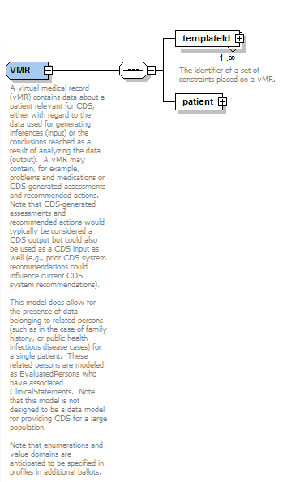

Figure 2 - The VMR complex type

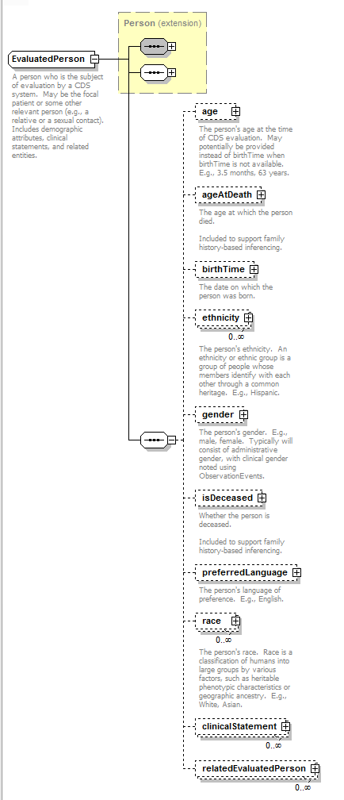

Figure 3 - EvaluatedPerson

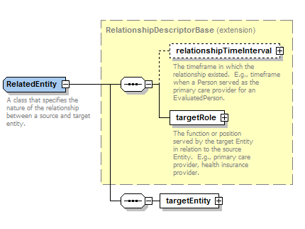

Figure 4 - RelatedEntity relates a target entity to a source entity or clinical statement

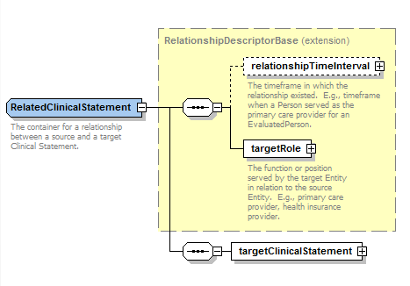

Figure 5 - RelatedClinicalStatement relates a target clinical statement to a source clinical statement

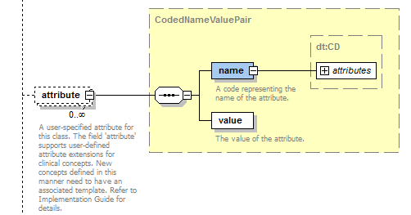

Figure 6 - Name-Value-Pair extension mechanism for clinical statement subclasses and entities

## cdsInput.xsd

The cdsInput.xsd schema represents input data used by a CDS system. The main components of the cdsInput.xsd schema are shown below. Please refer to the schema for the actual specification.

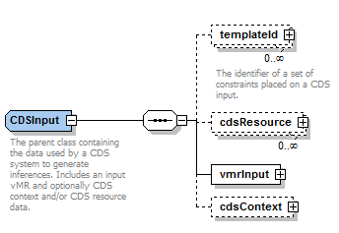

Figure 7 – CDSInput complex type

## cdsInputSpecification.xsd

This schema specifies the specific CDS input data required for a specific CDS use case. The main components of the cdsInputSpecification.xsd schema are shown below. Please refer to the schema for the actual specification.

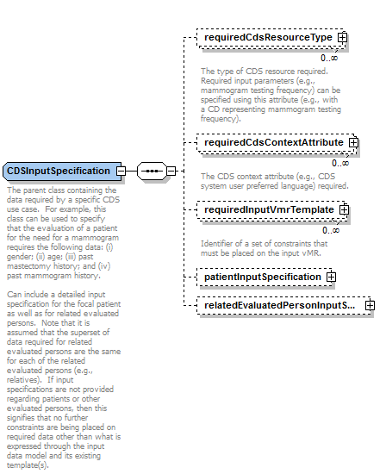

Figure 8 – CDSInputSpecification complex type

## cdsOutput.xsd

This schema specifies output data generated by CDS systems. The main components of the cdsOutput.xsd schema are shown below. Please refer to the schema for the actual specification.

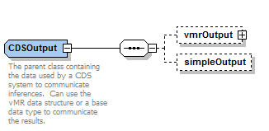

Figure 9 – CDSOutput complex type

## cdsOutputSpecification.xsd

This schema specifies the specific CDS output data to be provided by a specific CDS use case. The main components of the cdsOutputSpecification.xsd schema are shown below. Please refer to the schema for the actual specification.

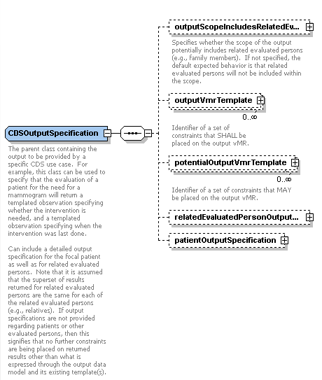

Figure 10 – CDSOutputSpecification complex type

## Examples

An *informative* vMR is provided in the supplemental files.

## 