

|  |
| --- |
| DealerSetup_10_14_2015 |
| 14/10/15 03:00 |
| **Author:** John Doe  **File name:** DealerSetup_10_14_2015.vp  **Version** 1.0 |

|  |
| --- |
| Site Map |
|  |

|  |
| --- |
|  |

01. Site Map / DealerSetup_10_14_2015 

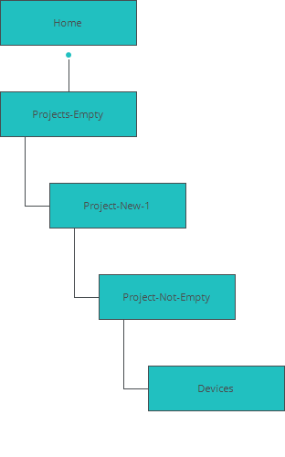

|  |
| --- |
| Screens |
|  |

|  |
| --- |
|  |

02. Screens / DealerSetup_10_14_2015 

Home

|  |
| --- |
|  |

Lorem ipsum dolor sit amet, sapien etiam, nunc amet dolor ac odio mauris justo. Luctus arcu, urna praesent at id quisque ac. Arcu massa arcu, urna praesent at id quisque urna ac quiqueac. Arcu

02. Screens / DealerSetup_10_14_2015 

Devices

|  |
| --- |
|  |

Interactions

|  |  |
| --- | --- |
| 1 | **on Click:** goes to 'Project-Not-Empty' 🡪 |
| 2 | **on Click:** goes to 'Project-Not-Empty' 🡪 |

02. Screens / DealerSetup_10_14_2015 

Projects-Empty

|  |
| --- |
|  |

Interactions

|  |  |
| --- | --- |
| 3 | **on Click:** goes to 'Project-New-1' 🡪 |

02. Screens / DealerSetup_10_14_2015 

Project-Not-Empty

|  |
| --- |
|  |

Interactions

|  |  |
| --- | --- |
| 4 | **on Click:** goes to 'Devices' 🡪 |
| 5 | **on Click:** goes to 'Devices' 🡪 |
| 6 | **on Click:** goes to 'Project-New-1' 🡪 |

02. Screens / DealerSetup_10_14_2015 

Project-New-1

|  |
| --- |
|  |

Interactions

|  |  |
| --- | --- |
| 7 | **on Click:** goes to 'Project-Not-Empty' 🡪 |

|  |
| --- |
| Templates |
|  |

|  |
| --- |
|  |

03. Templates / DealerSetup_10_14_2015 

banner extralarge

|  |
| --- |
|  |

Interactions

|  |  |
| --- | --- |
| 8 | **on Click:** goes to 'Projects-Empty' 🡪 |
| 9 | **on Click:** goes to 'Home' 🡪 |

|  |
| --- |
| Scenarios |
|  |

|  |
| --- |
|  |

04. Scenarios /