**Using Yeoman to Create a Web Application**

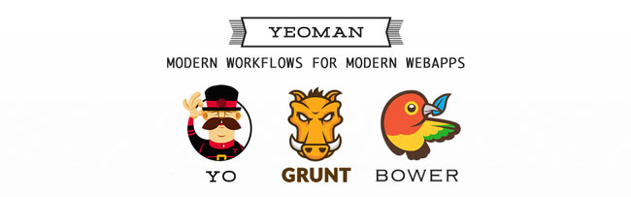

Step 1: Installing **npm** (which comes bundled with Node)

* Visit <http://nodejs.org> and click the “install” button to download a Windows MSI installer.
* The **npm** package manager is bundled with Node

# check Node and npm  
$ npm –version && node --version  
# update npm  
$ npm install –global npm@latest

# configure the proxy for npm  
$ npm config set proxy http://10.10.10.10:8080  
$ npm config set https-proxy http:// 10.10.10.1:8080

Step 2: Installing **Git**

* Download Git from <http://git-scm.com/downloads>
* Run the Git exe and keep the defaults.
* When asked about “Adjusting your PATH environment” choose “Run Git form the Windows Command Prompt”
* On the next screen, “Choosing the SSH executable“, choose “Use OpenSSH”
* On the next screen, “Configuring the line ending conversions“, choose “Checkout Windows-style, commit Unix-style line endings”
* Clicking next will start the install process, just let it run.
* When the installer completes, just click the “Finish” button.

# confirm installation  
$ git –version  
# config git   
$ git config --global url."https://".insteadOf git://

Step 3: Setup HTTP_PROXY & HTTPS_PROXY environment variable for your proxy (only use in TMA)

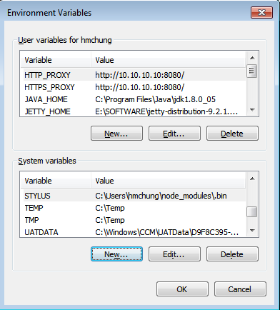

Variable: HTTP_PROXY

Value: http://10.10.10.10:8080/

Variable: HTTPS_PROXY

Value: http://10.10.10.10:8080/

Step 4: Installing Yeoman, Grunt & Bower

As long as you have installed the last Node version, you’ll have the lasts version of NPM and installing all three tools requires(yo, grunt, bower) just one command line command:

# install yeoman toolset  
$ npm install -global yo bower grunt-cli grunt  
# confirm installation  
$ yo –version && bower –version && grunt --version

If you run into installation issues please visit the [Getting Started Wiki site](https://github.com/yeoman/yeoman/wiki).

Step 5: Installing Generators

Next, let’s install a Yeoman generator-angular

$ npm install –global generator-angular

You can find [generators](http://yeoman.io/generators/) now available

Step 6. Creating the Project

Let’s create the directory where our project will be stored. So, execute the following command:

$ mkdir my-new-project && cd $_

Run yo angular, optionally passing an app name:

$ yo angular

Step 7: Running the Project

To start the local web server run the following command:

$ grunt server

The last command starts a web server, opening a browser to: http://localhost:9000