# Yeoman - The workflow Tool

* Introduction
* Yeoman & AngularJS
  + Installing Yeoman
  + Running your app

# Introduction

Yeoman is an open source project leaded by the Chrome Developers relation team with Paul Irish in the head. As they said in Yeoman’s website, is not just a tool but a complete workflow with Yeoman (scaffolding tool), Grunt (building tool) and Bower (package management).

Yeoman itself is a collection of three tools: Yo, Grunt, and Bower. Combined together these tools provide everything a developer needs to get started on a project:

1. [yo](https://github.com/yeoman/yo) - the scaffolding tool from Yeoman and using the numerous generators available. It is maintained by the Yeoman project and offers web application scaffolding, utilizing scaffolding templates we refer to as generators.
2. [bower](http://bower.io/) -  the package management tool for the web. It helps to manage the dependencies needed for your application so you don’t have to download them manually and automatically search and download the necessary scripts.
3. [grunt](http://gruntjs.com/) –  the task runner is a tool that can automate things like compiling Stylus files or optimizing images. This is used to run the tasks that will help you preview, test, and build the app

# Yeoman & AngularJS

Yeoman and AngularJS are a powerful combination. Yeoman provides a lot of cool features to scaffold your AngularJS application.

## Installing Yeoman

To install the Yeoman suite of tools you will need to have npm and [Git](http://git-scm.com/downloads) already installed on your system. If this is not the case you can install npm by downloading the appropriate version of [Node.js](http://nodejs.org/) for your system. The Node package manager (npm) is included with the install of Node.js. Git can be downloaded from the [project website](http://git-scm.com/).

When the installer completes, let’s config [Git](http://git-scm.com/downloads) to use http:// instead of git:// using command line:

|  |  |
| --- | --- |
| 1 | **git** config --global url."https://".insteadOf git:// |

Once you have npm up and running you can install the Yeoman tools using the following command.

|  |  |
| --- | --- |
| 1 | **npm** install –g yo |

This will install Yo as well as Grunt and Bower if they are not already on your system.

Next, let’s install the AngularJS generator using the following command:

|  |  |
| --- | --- |
| 1 | **npm** install -g generator-angular |

Some of the most popular generators are listed below. You can find a full list of the official generators by browsing the list of repositories on the <https://github.com/yeoman>.

* [Web App](https://github.com/yeoman/generator-webapp) (generator-webapp)
* [Backbone](https://github.com/yeoman/generator-backbone) (generator-backbone)
* [Ember.js](https://github.com/yeoman/generator-ember) (generator-ember)
* [Angular.js](https://github.com/yeoman/generator-angular) (generator-angular)
* [jQuery](https://github.com/yeoman/generator-jquery) (generator-jquery)

Now, let’s create our project directory and create the skeleton for our project. Enter the following command in the terminal:

|  |  |
| --- | --- |
| 1  2  3  4 | # create a directory for your new project  **mkdir** my-project && **cd** my-project  # and then run  **yo** webapp |

It's now going to start asking a series of questions, answer Y for all except the question if you want to include common libraries like Twiter Bootstrap or AngularJS Resource, "Would you like to use Sass (with Compass)?". Answer N for this one.

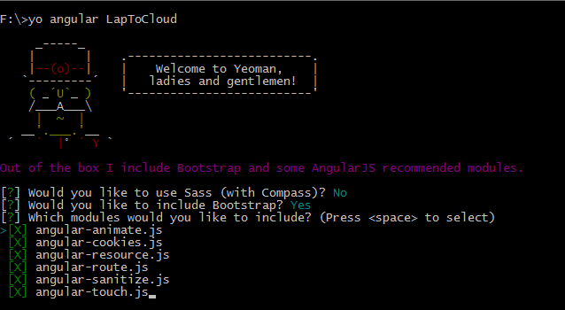

 * The reason we say no here is because for now we will use [Stylus](http://learnboost.github.io/stylus/).

If you open up your project folder you'll see that Yo has created a number of files and folders to get you started

**Directory structure and the meaning of files and folders are as follows:**

* **node_modules** - Node.js modules for various Grunt tasks, usually you don’t have to do anything about this folder
* **test –** this contains folders for the files like karma tests
* **src** - source files, development is done here
  + **images –** with yeoman.png image
  + **scripts -** with app.js and controllers/main.js with a default AngularJS application
  + **bower_components** – this contains folders for the various vendor libraries such as AngularJS, Angular Animate, JQuery and Bootstrap and 3rd party libraries managed via [Bower](http://www.google.com/url?q=http%3A%2F%2Fbower.io%2F&sa=D&sntz=1&usg=AFrqEzcpTSWwwDVICUwT9u-6T4lo5gHGUw),
  + **styles** – with bootstrap.css and main.css
  + **views** - HTML partials like head.html, scripts.html, etc.
  + .buildignore
  + .htaccess
  + 404.html – this is the 404 error page that will show up, when the user types in a wrong URL or the Angular app couldn’t find the page mentioned in the URL
  + bower.json - Bower dependencies in the project
  + favicon.ico – this is the icon that will show up in the browser tab of your app.
  + index.html – this will be the home page for your app.
  + robot.txt – this is the file where you set rules for the search engine robots or crawlers, telling them what pages they can index and which sections of the app should not be indexed.
* Gruntfile.js - [Grunt](http://www.google.com/url?q=http%3A%2F%2Fgruntjs.com%2F&sa=D&sntz=1&usg=AFrqEzfhy_19FGZ_lTba0sEEeufi5EPPhg) file with various automation tasks defined in it
* package.json - npm packages dependencies
* .yo-rc.json - Yeoman generator configuration file
* .bowerrc - configuration file for Bower
* .editorconfig - [EditorConfig](http://www.google.com/url?q=http%3A%2F%2Feditorconfig.org%2F&sa=D&sntz=1&usg=AFrqEzfknQlosdkilhNlH5QVJbfI06vOOg) configuration file to achieve consistent coding
* .gitattributes - [Git](http://www.google.com/url?q=http%3A%2F%2Fgit-scm.com%2F&sa=D&sntz=1&usg=AFrqEzdDN-WxlNAp0BLVVg0b2-ltMcAo6g) configuration file to force Unix line ending in all text files
* .gitignore - default Git ignore files and folders
* .jshitrc - [JSHint](http://www.google.com/url?q=http%3A%2F%2Fwww.jshint.com%2F&sa=D&sntz=1&usg=AFrqEzeGqTiKioi3nUU18ekpFqGZYuwH8w) configuration

## Running your app

The generated Gruntfile includes a task that will set up a simple web server so that you can preview your app. You can start this by executing the following command in your Terminal.

|  |  |
| --- | --- |
| 1  2  3 | **grunt** serve  # or  **grunt** server |

Once the server has started, grunt will launch the web app in your default browser. You can also access the app by going to <http://127.0.0.1:9000>

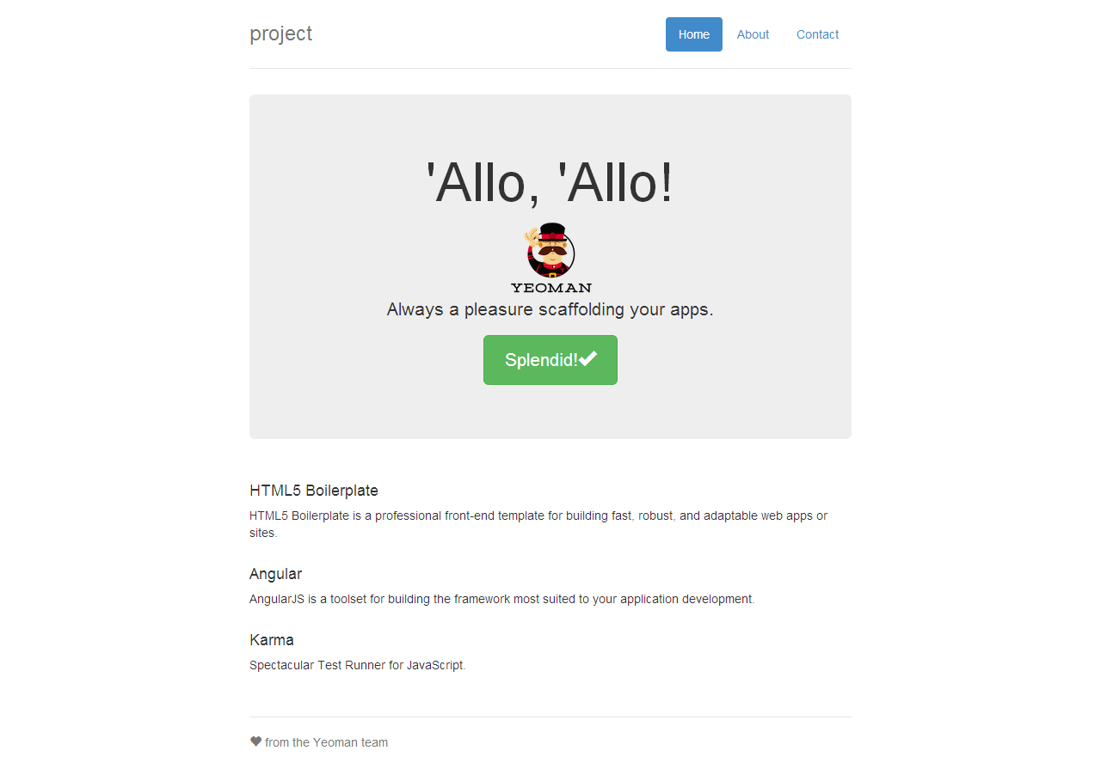

The basic application created with the angular generator.

hmchung@tma