1. Go to [www.python.org](http://www.python.org)
2. Hover over “Downloads” and click on the button under “Download for Windows”

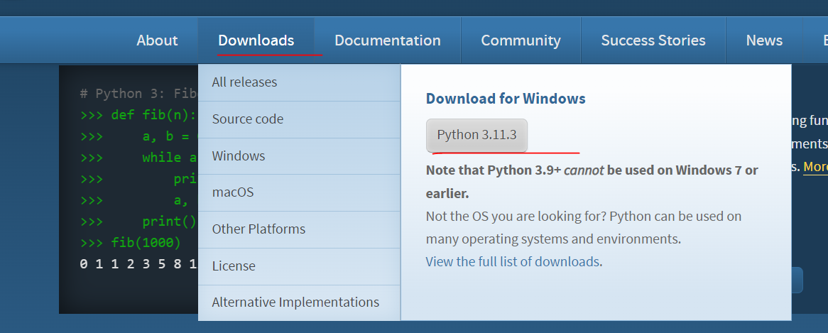

1. Run the downloaded exe file
2. **Select “Add python.exe to PATH”**

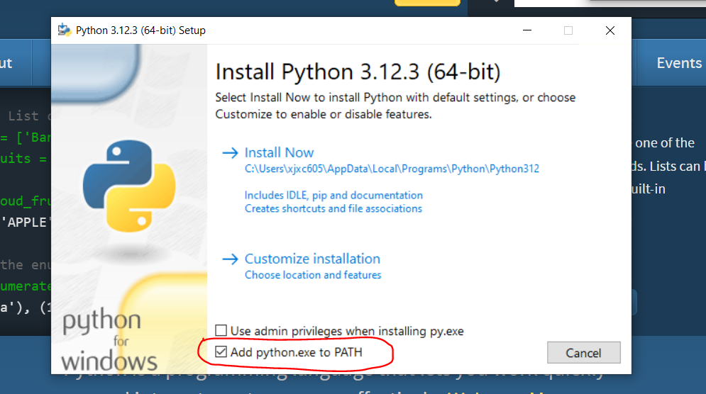

1. Click “install Now”
2. Click “Close”
3. Download C++ Build Tools from [Microsoft C++ Build Tools - Visual Studio](https://visualstudio.microsoft.com/visual-cpp-build-tools/)

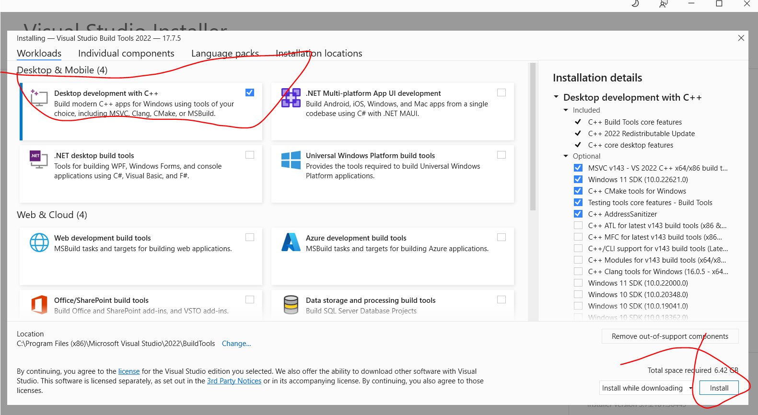

1. Press the WINDOWS KEY and search “CMD” and open command prompt

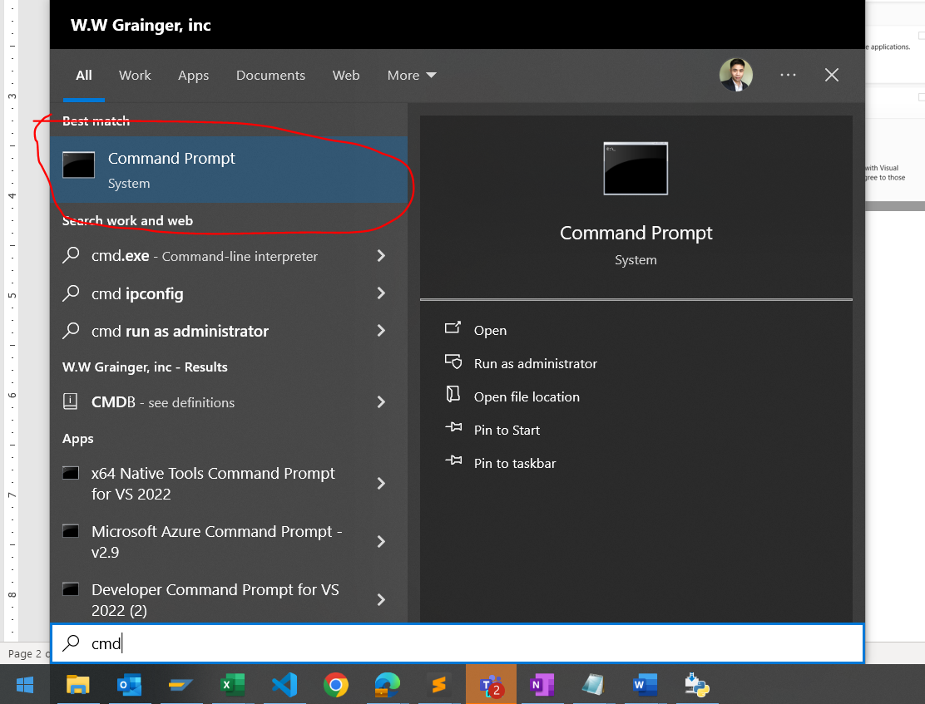

1. Type “pip install snowflake-connector-python” and press ENTER

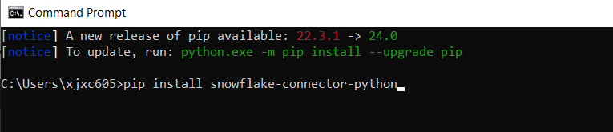

1. Type “pip install setuptools” and press ENTER

