1. Go to [www.python.org](http://www.python.org)
2. **Hover mouse** over **Downloads** and click on the button under **Download for Windows**

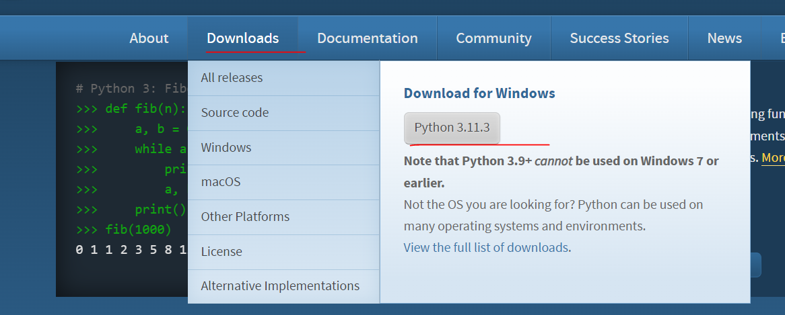

1. Run the downloaded exe file
2. **Select “Add python.exe to PATH”**

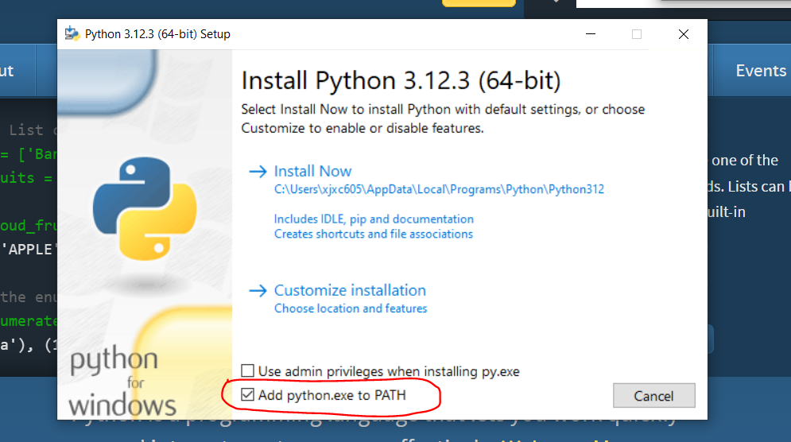

1. Click **Install Now**
2. Click **Close**
3. Download C++ Build Tools from [Microsoft C++ Build Tools - Visual Studio](https://visualstudio.microsoft.com/visual-cpp-build-tools/)

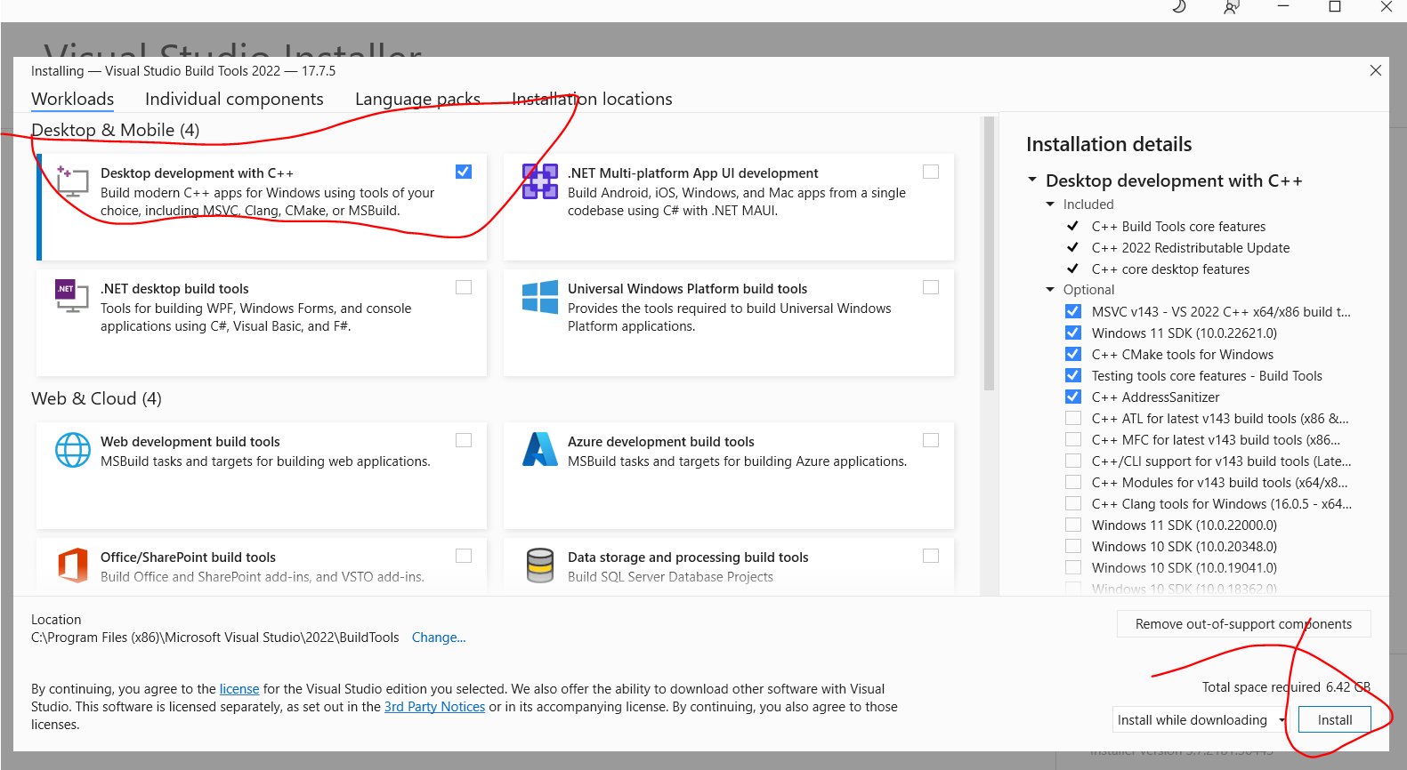

1. Double click on setup.bat

A black box with text will pop up, wait for it to close and you’re done.