Name: Min Sung Cha Student Id: 85408485

Analysis of a few functions and any embedded functions

Show code snippets with screenshots or copy/pasted code

Show : **deposit_coins,extract_exact_change,has_exact_change_for_coins**

And any other function that you think is useful for grading.

**Coins.h**

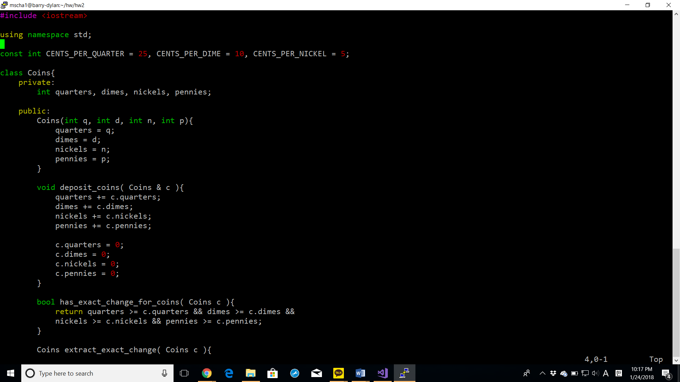

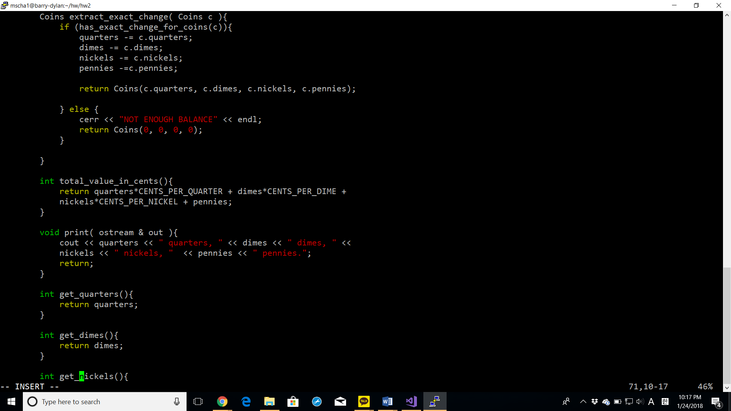

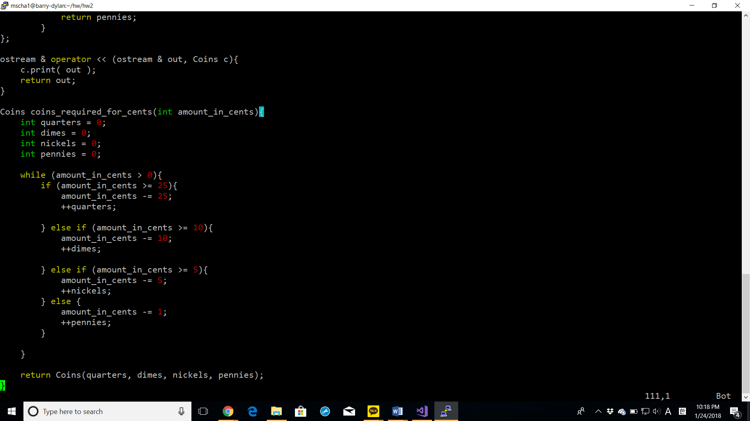

**simple_main.cpp**

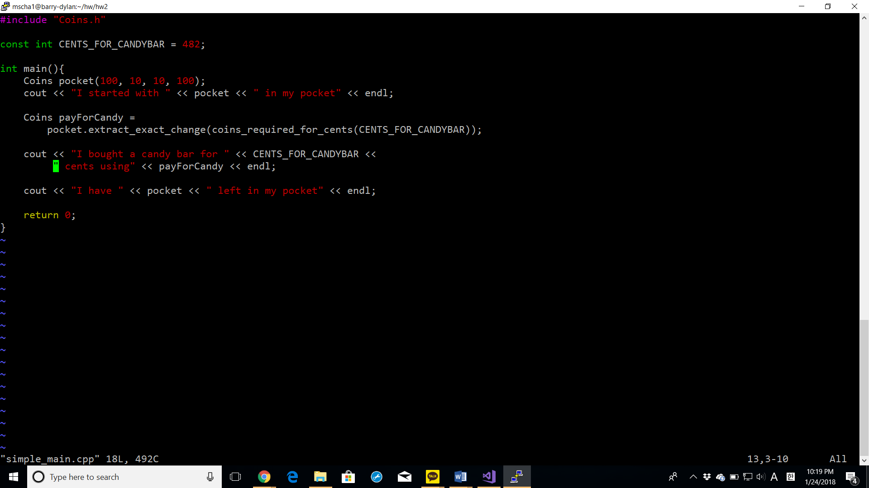

**coins_main.cpp**

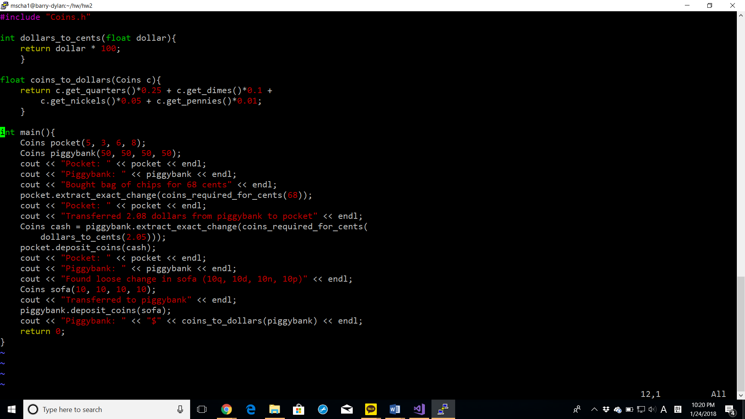

**coins_menu.cpp**

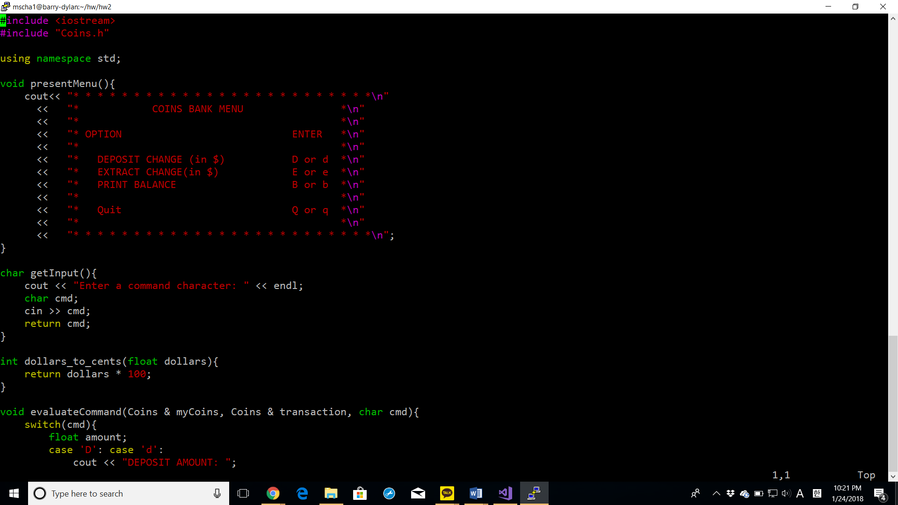

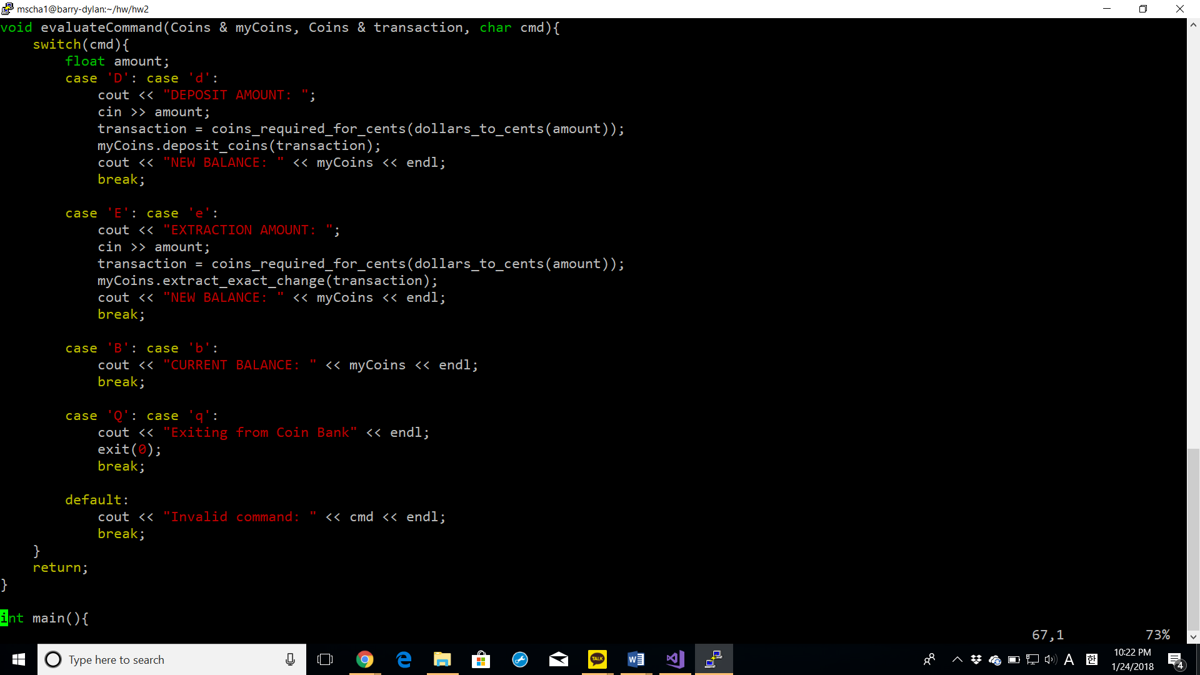

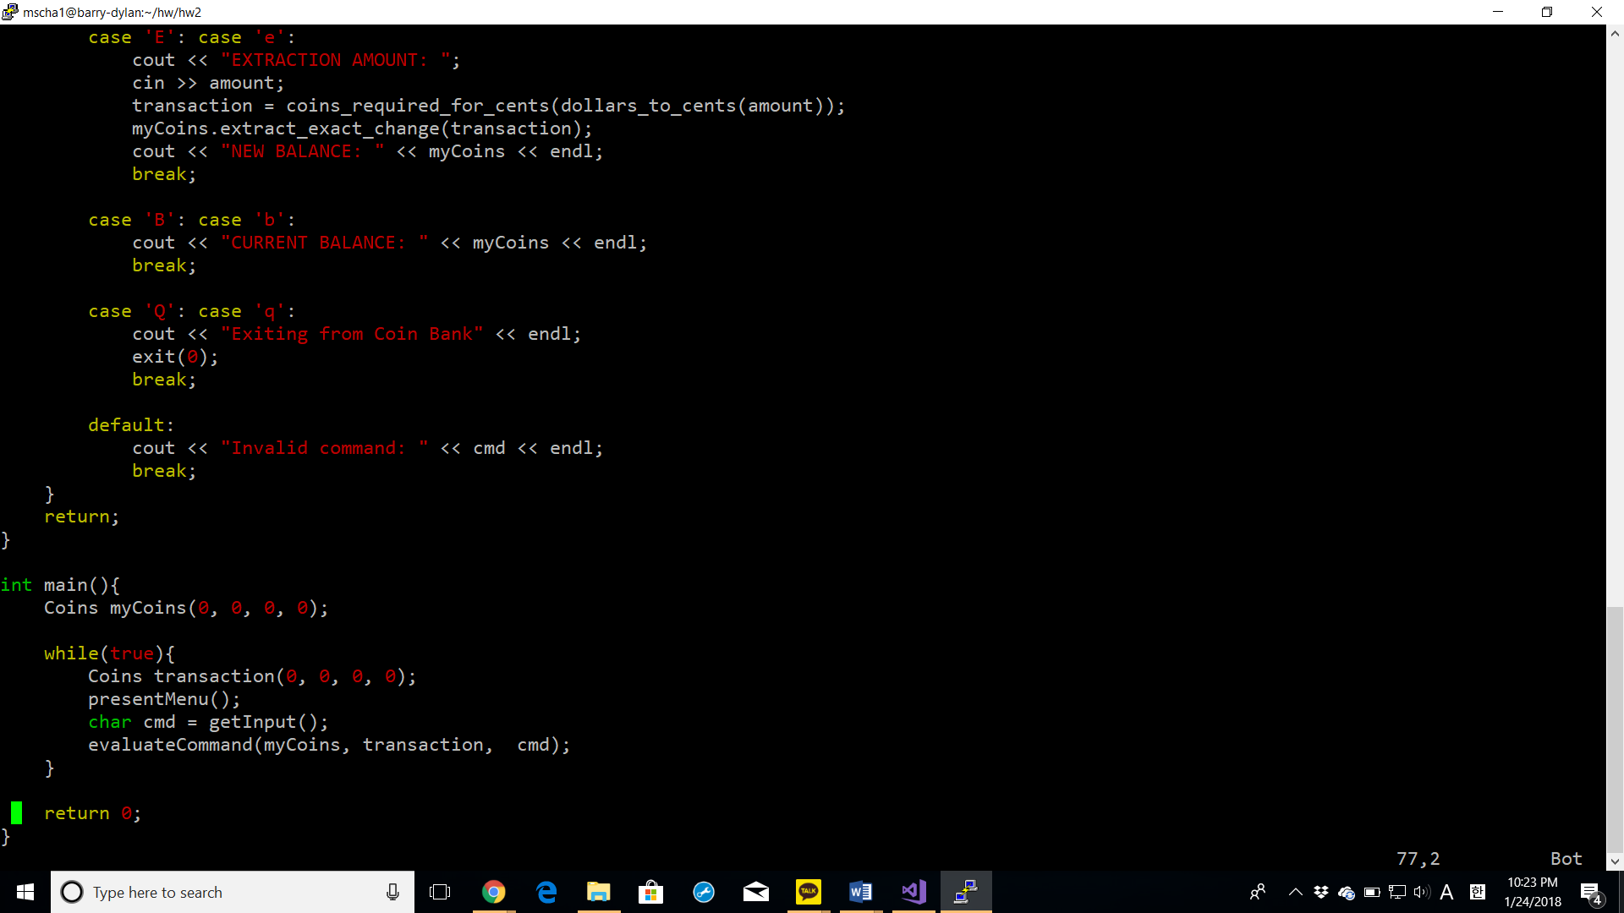

Successful execution with Valgrind screenshot

**simple_main.cpp**

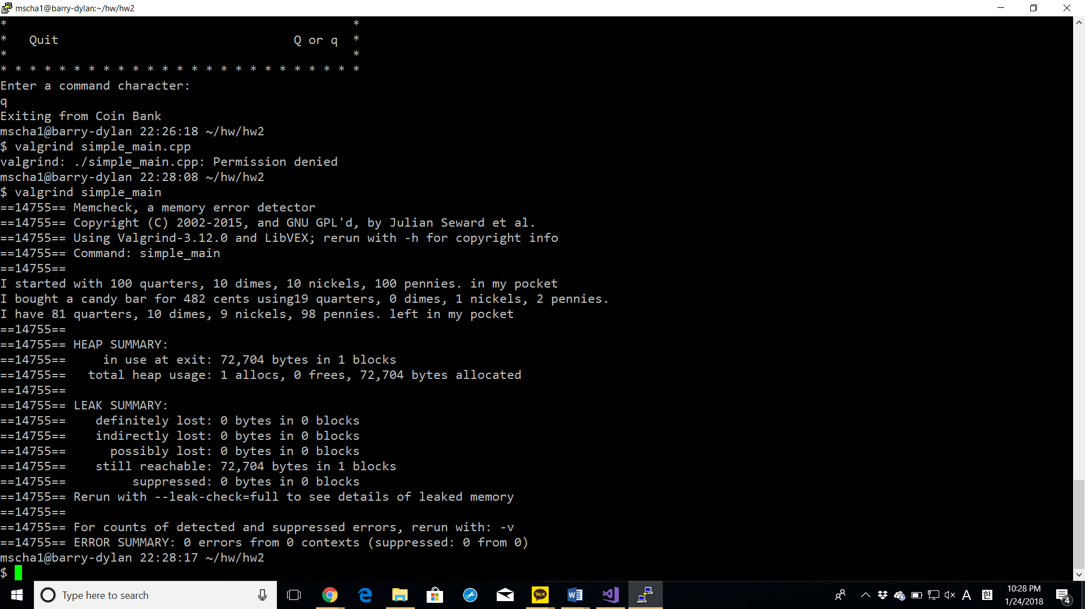

**coins_main.cpp**

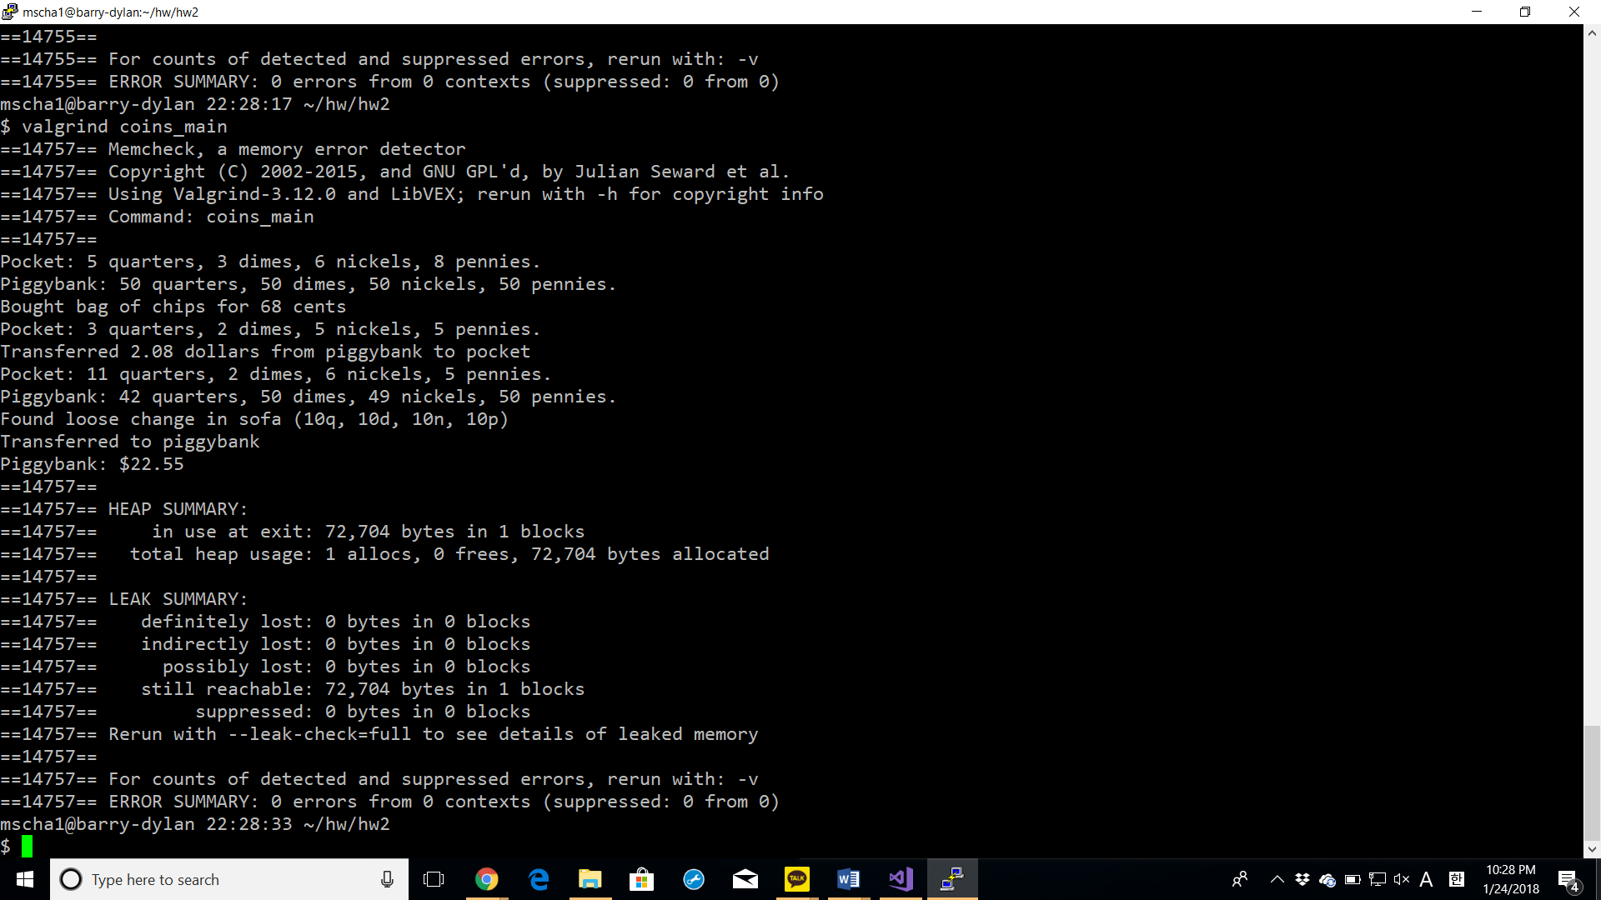

**coins_menu.cpp**

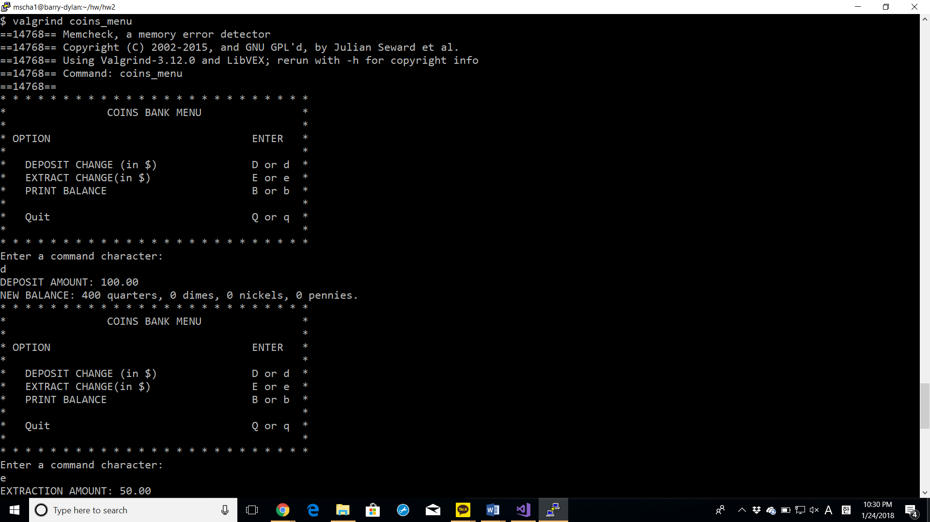

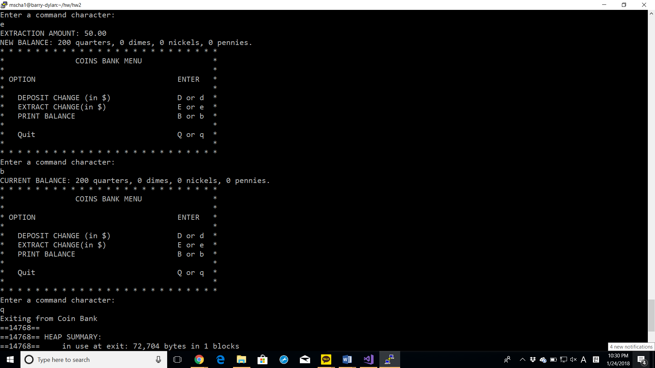

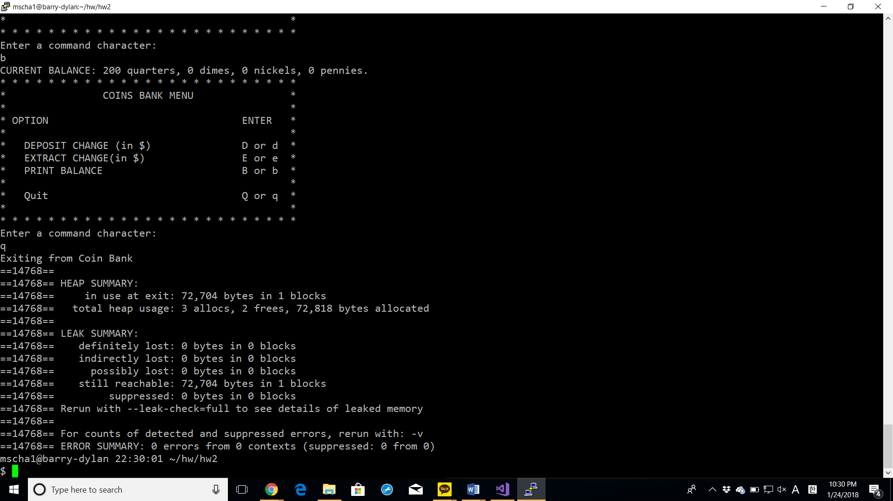

Test Output screenshots with descriptions of each test

**simple_main.cpp**

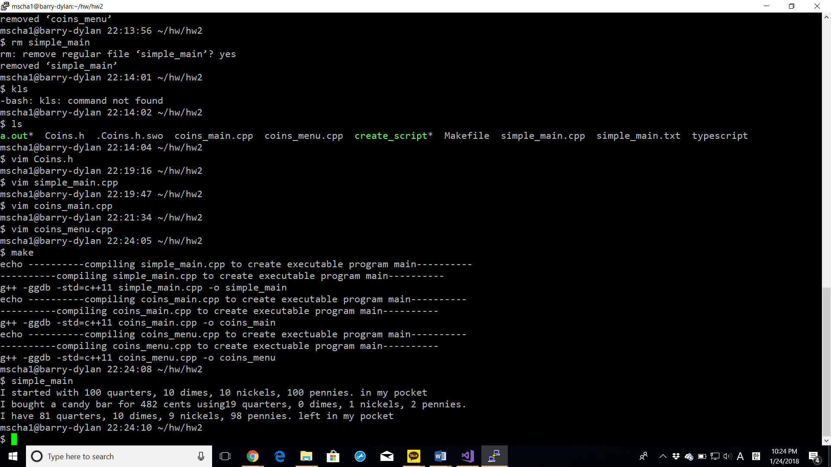

* Executed simple_main.cpp as outlined in hw2 problem 1

**coins_main.cpp**

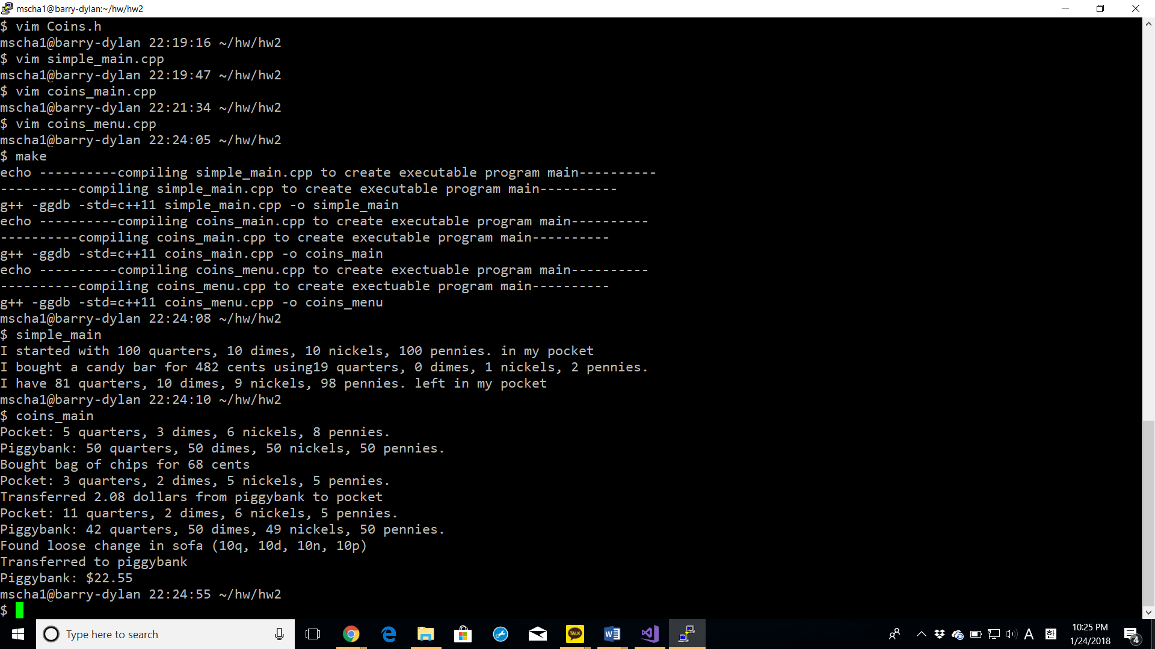

* Executed coins_main.cpp as outlined in hw2 problem 2

**coins_menu.cpp**

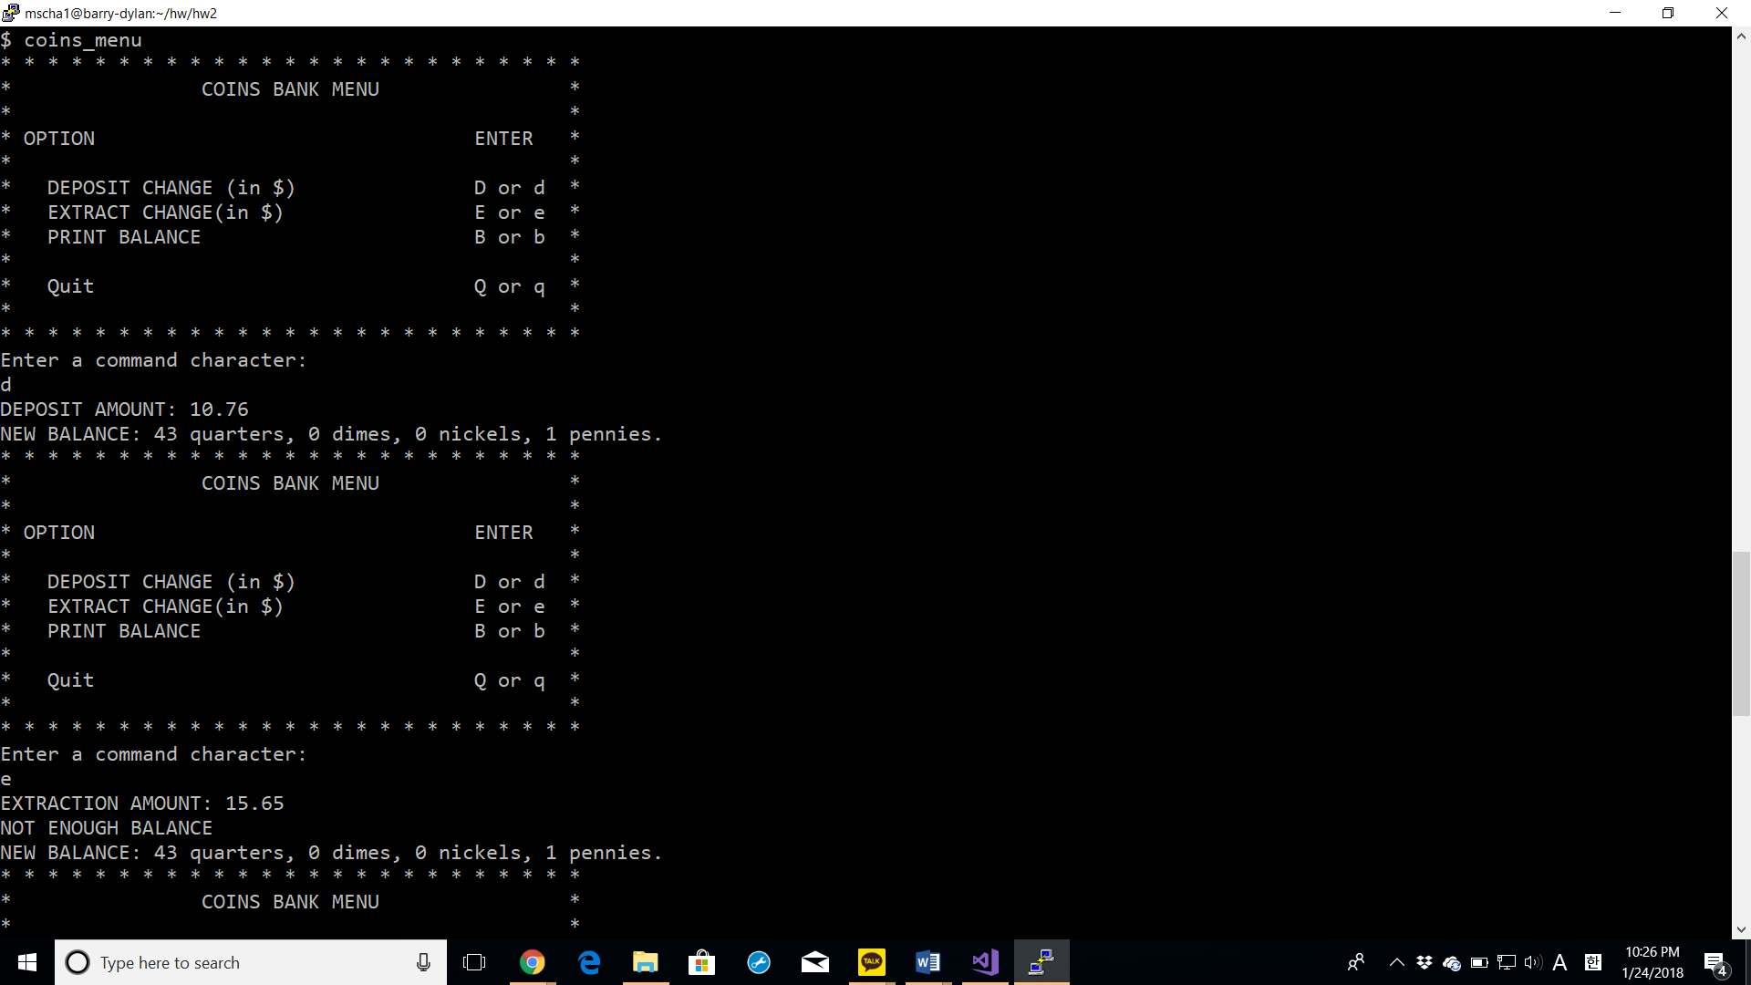

* Deposited $10.76 dollars to the coin bank.
* Unable to extract $15.65 dollars from the coin bank. Error: NOT ENOUGH BALANCE appeared.

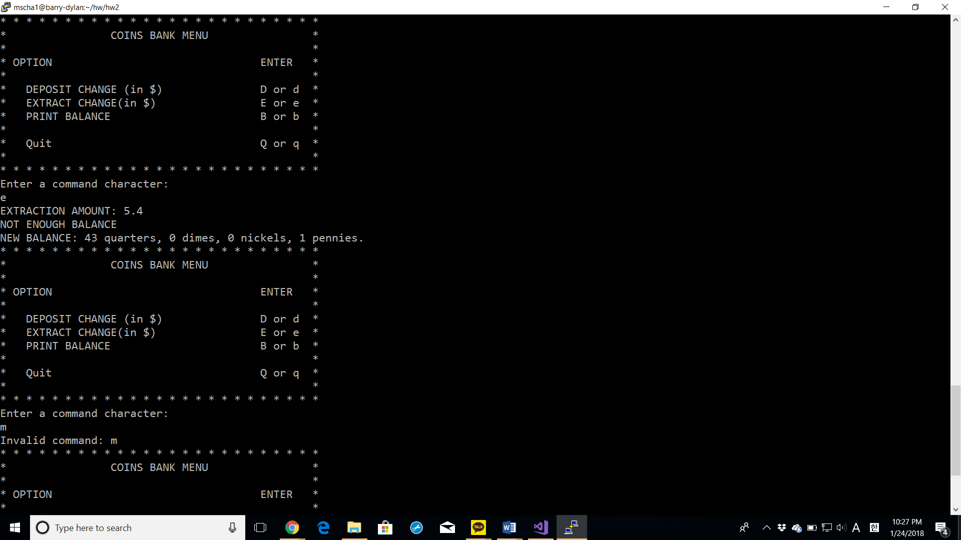

* Extracted $5.4 dollars from the coin bank.

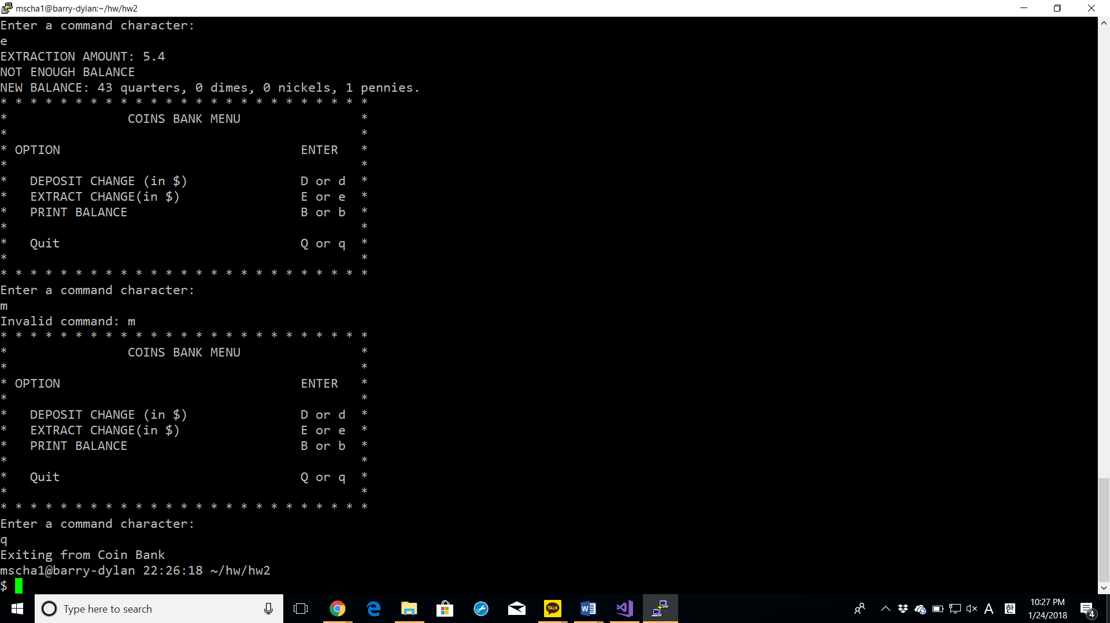

* Entered invalid command “m”.

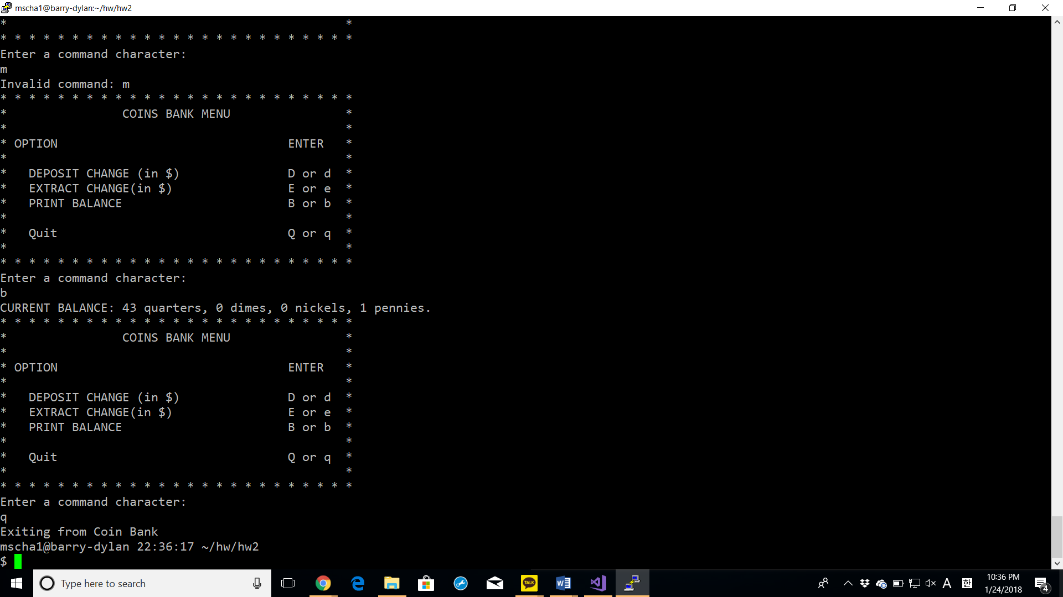

* Displayed current balance “b”
* Exited from the program “q”