Name: Min Sung Cha Student ID: 85408485

Analysis of a few functions and any embedded functions

**String.cpp**

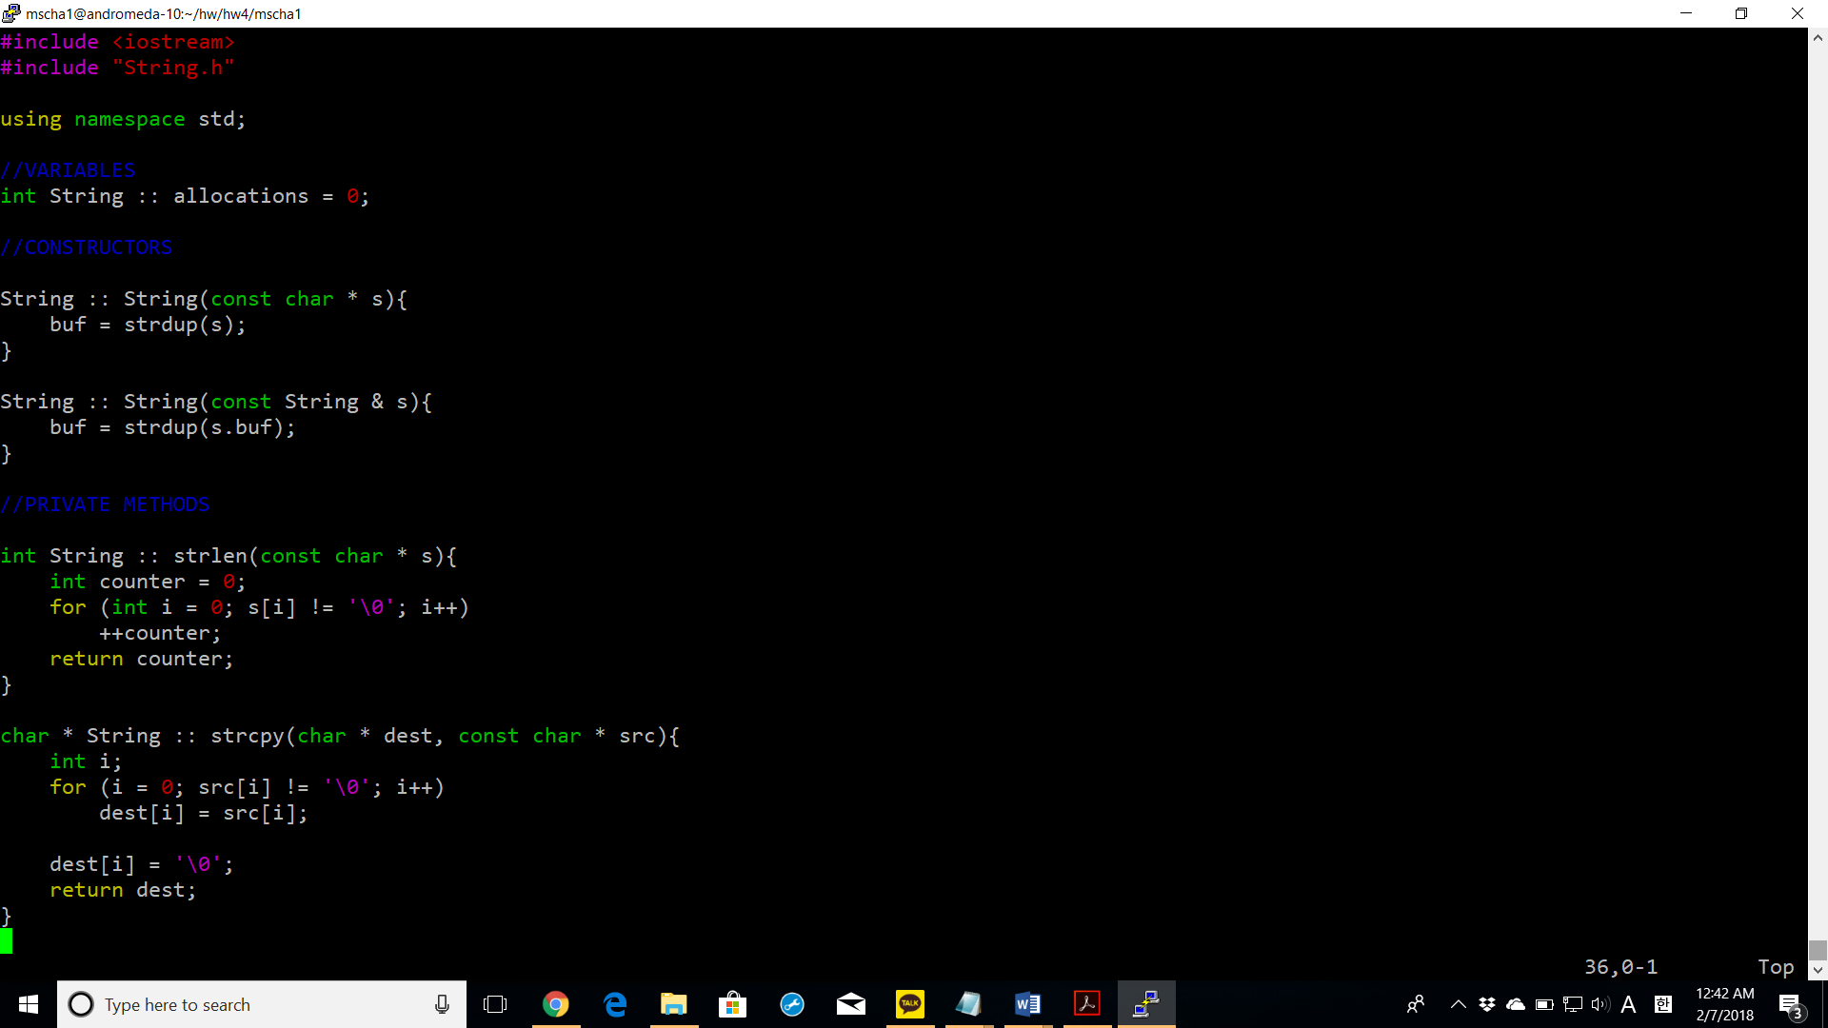

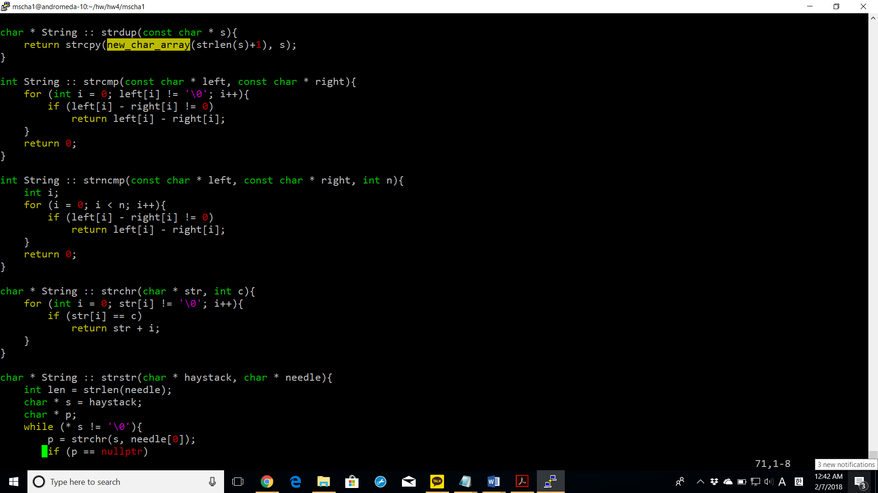

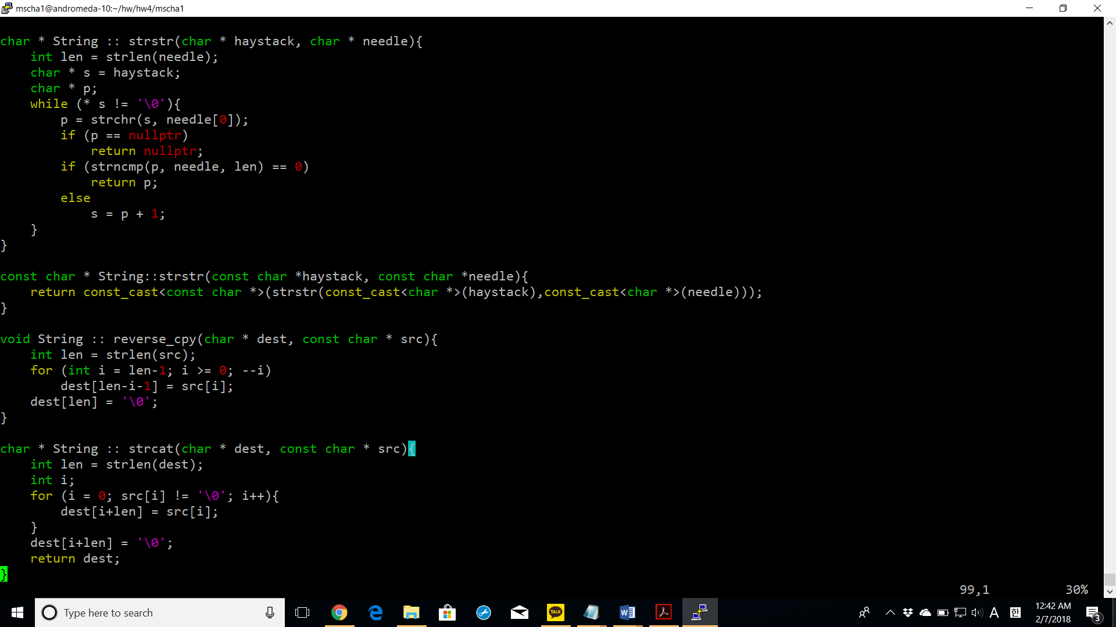

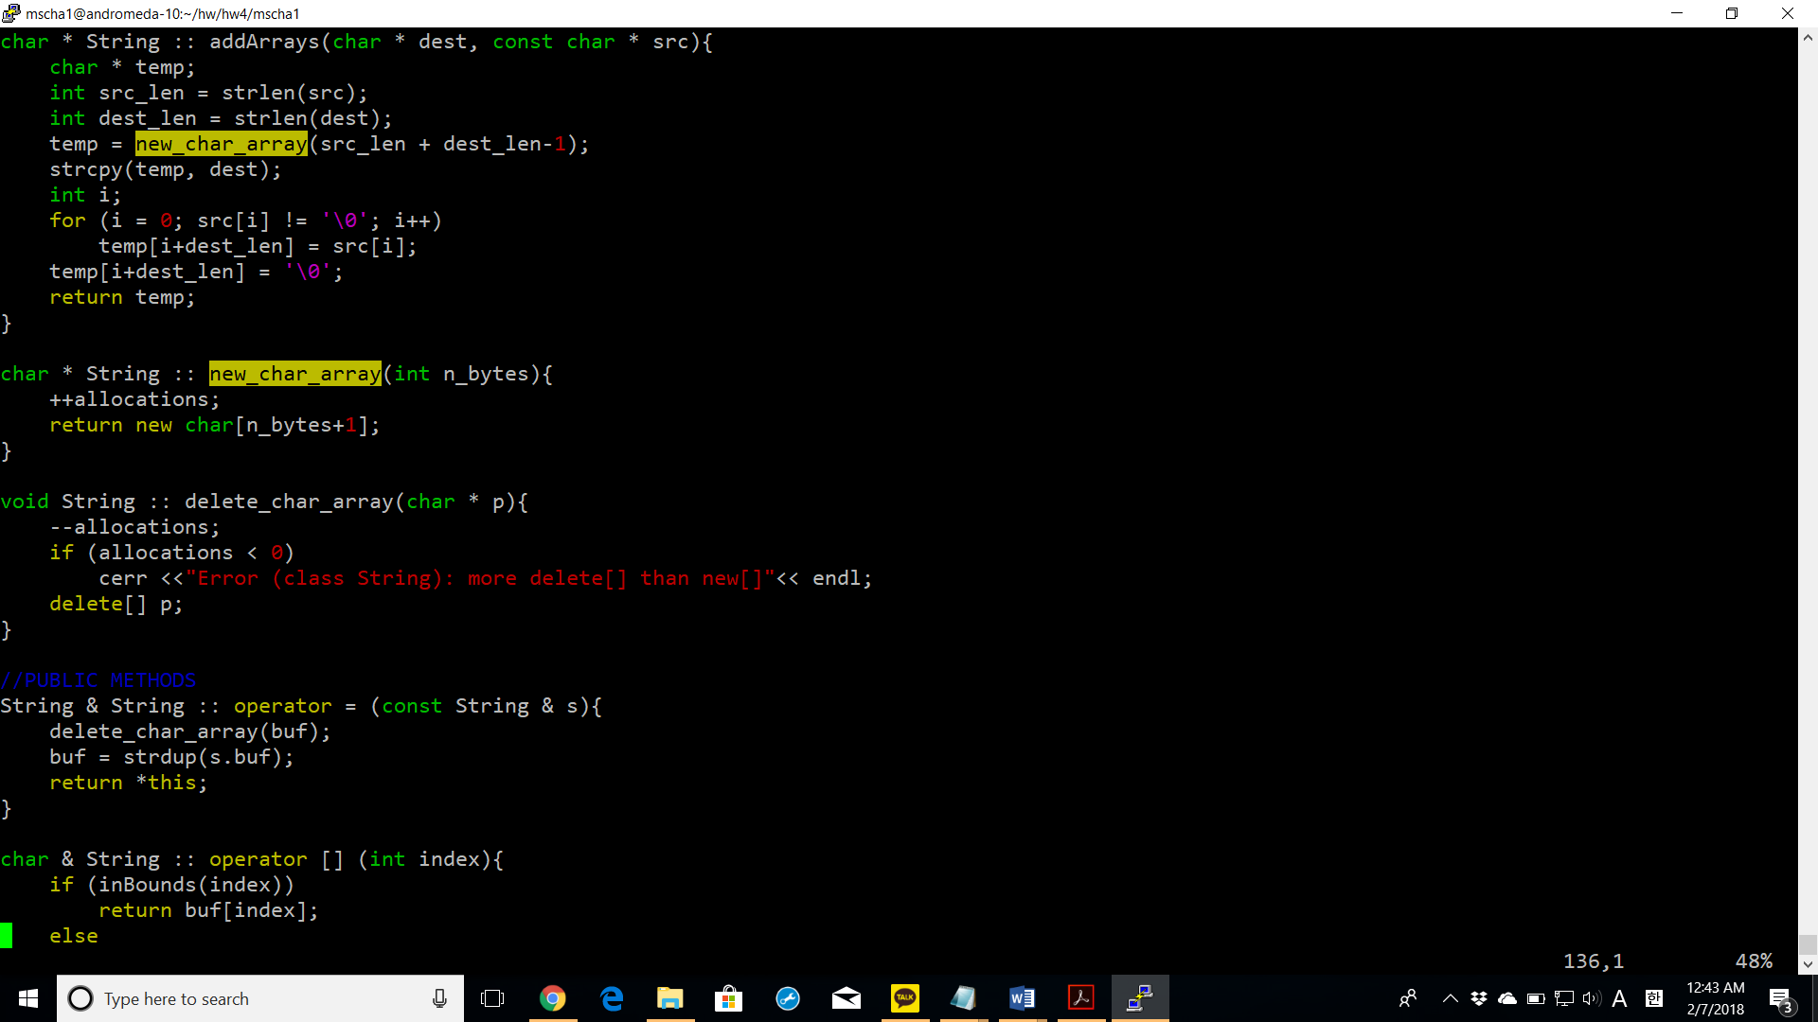

addArrays: creates a temporary pointer that points to a new array of the size of both dest and src arrays and dest and src are copied inside the temporary pointer.

new_char_array: creates a new array of characters of the size passed in the parameter.

delete_char_array: deletes the array specified in the parameter.

operator = : deletes the current array and assigns it to the array of the String passed in the parameter.

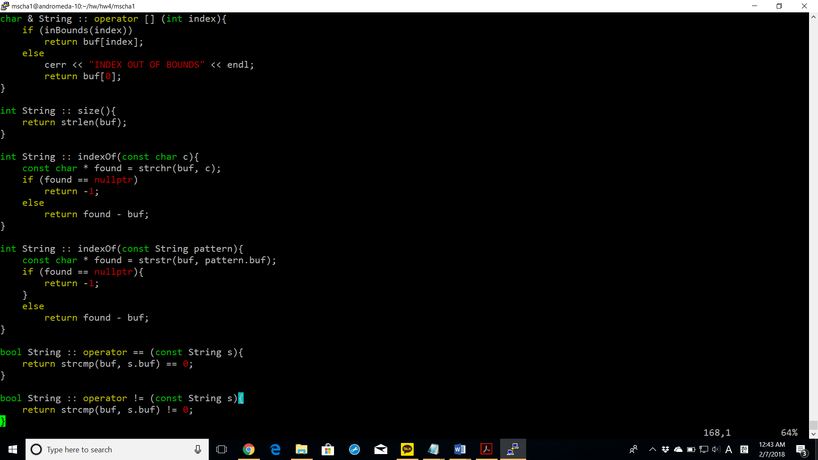

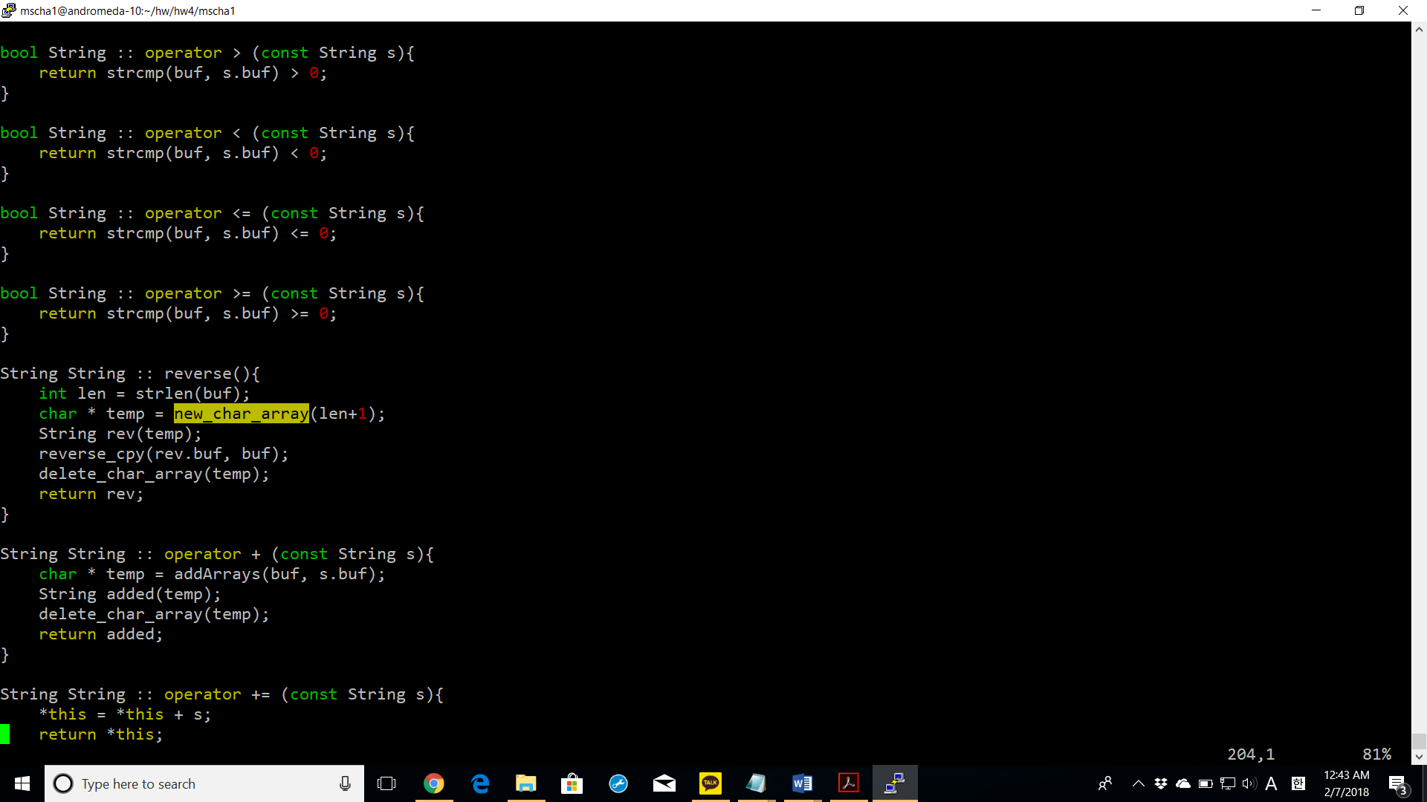

reverse(): creates a new String object passed with a temporary array of characters and the reverse of the current string is copied to the new String object.

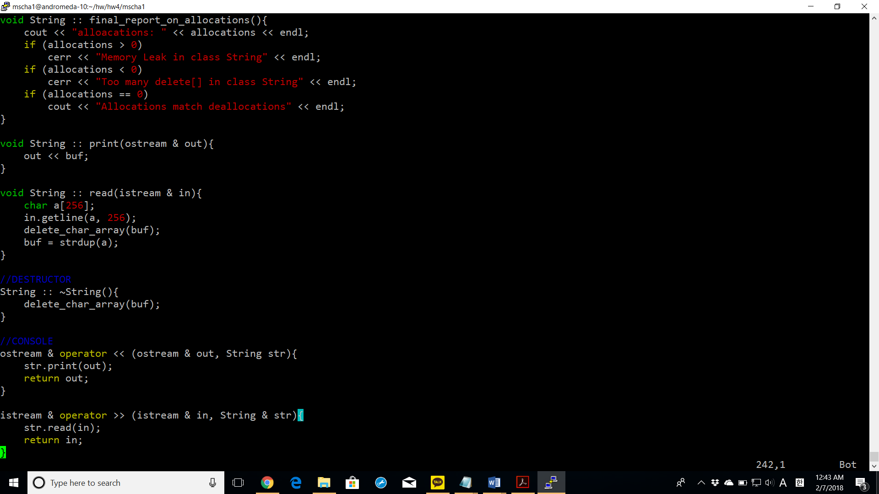

~String(): the buf of this String is deleted.

**test_string.cpp**

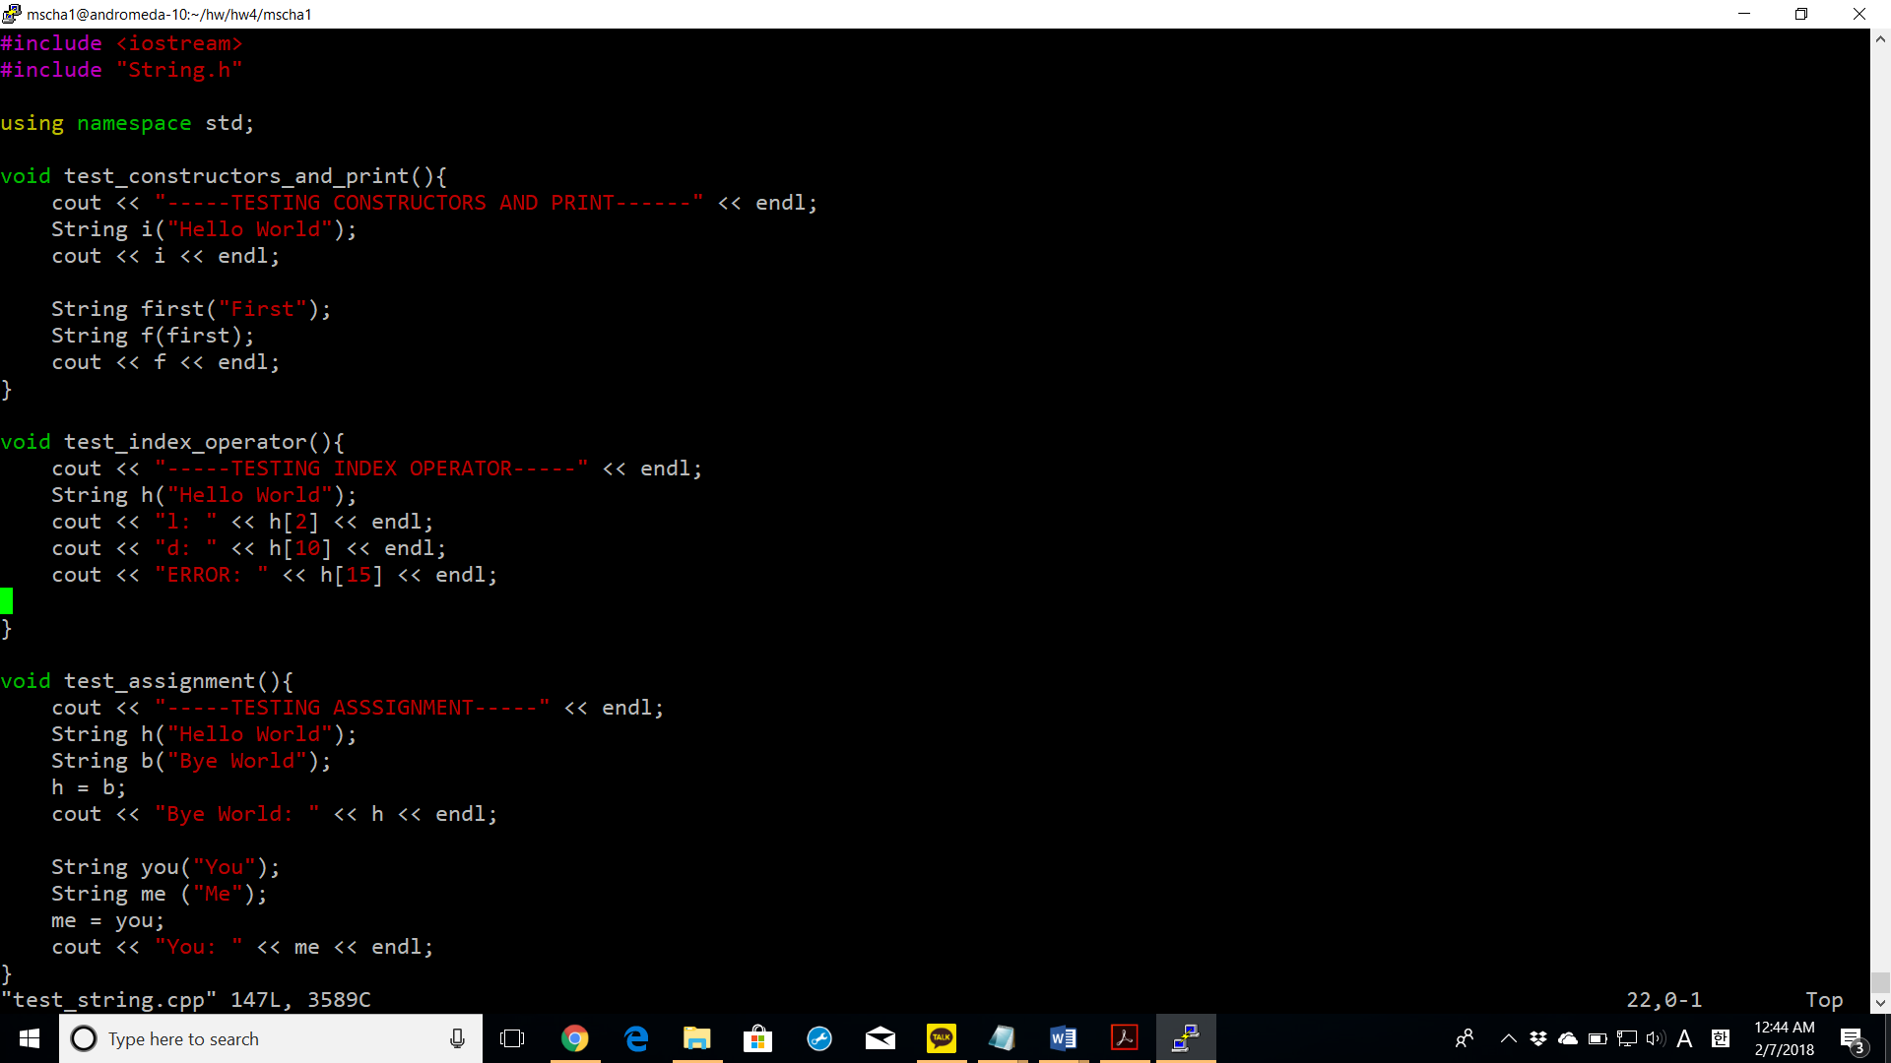

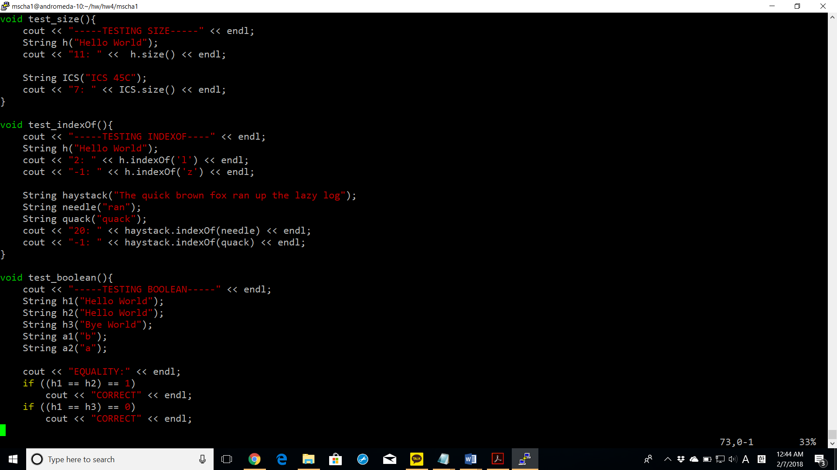

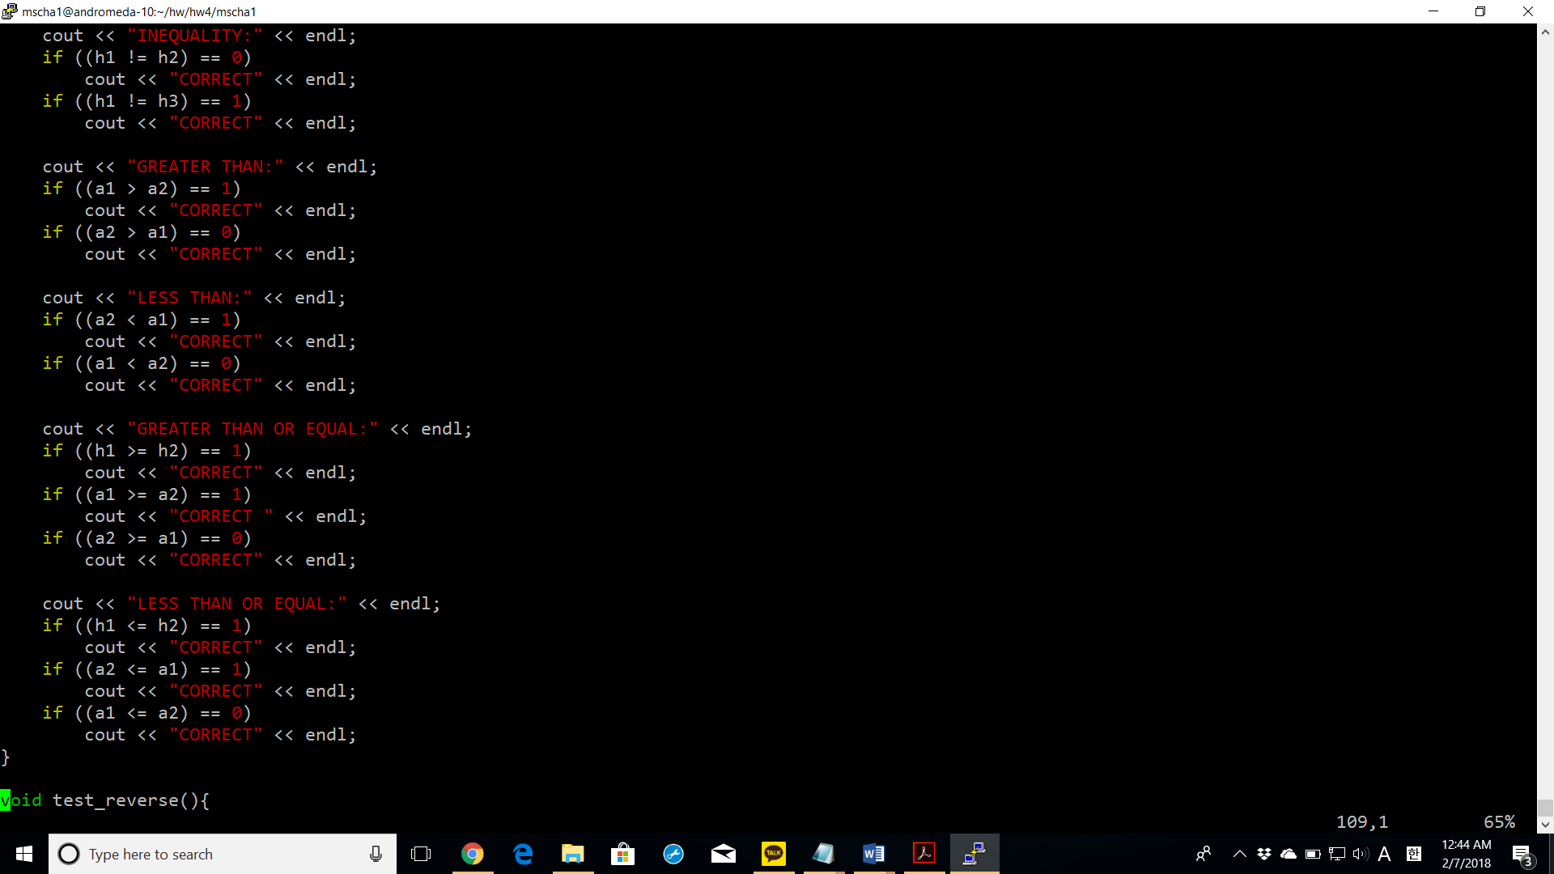

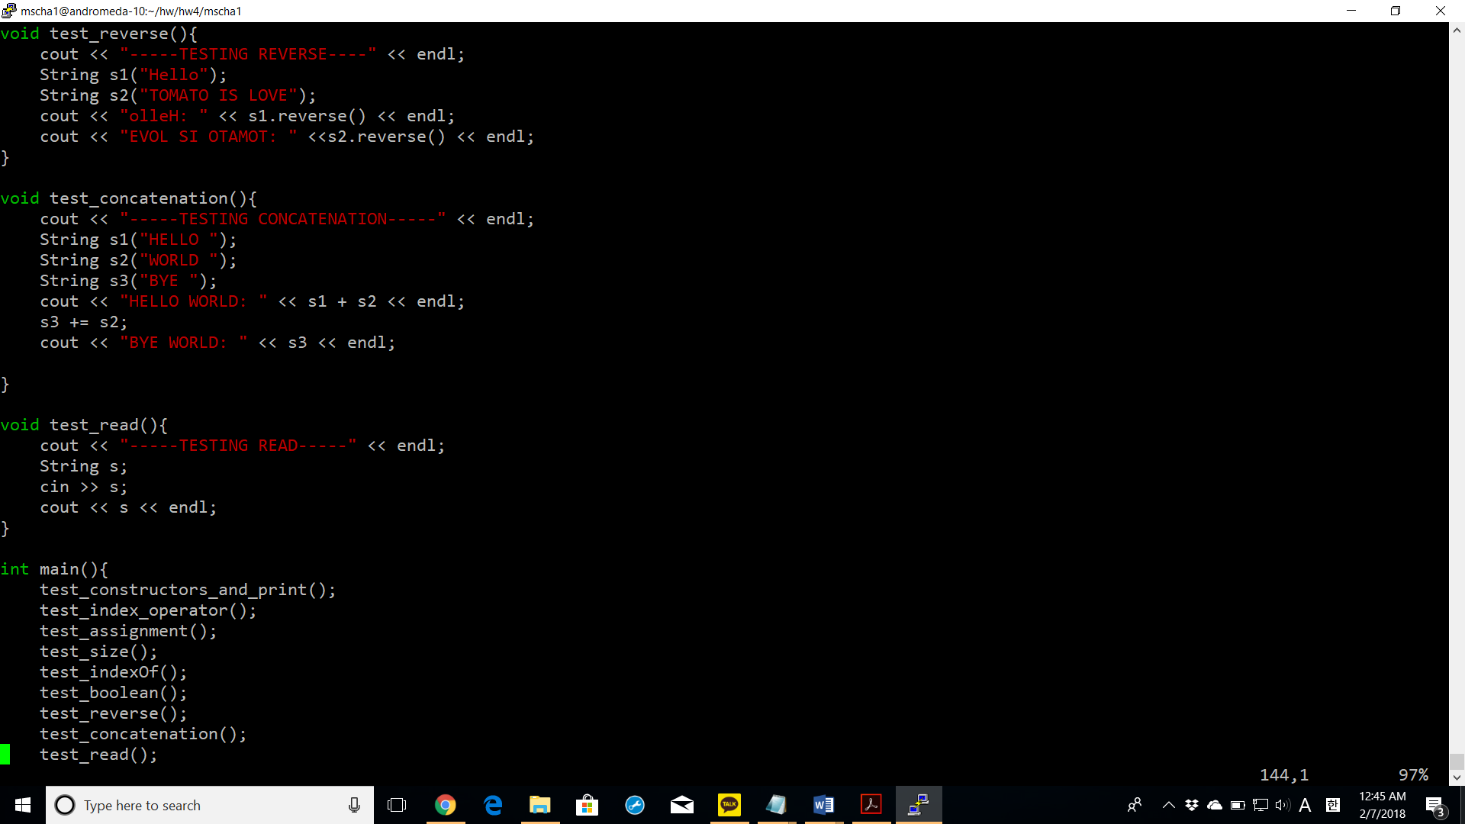

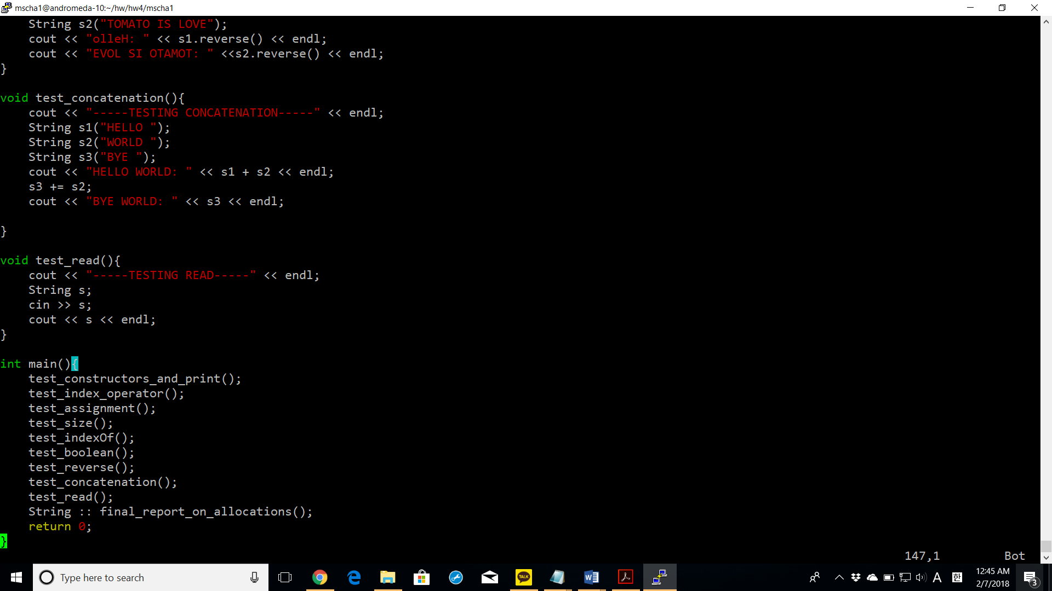

Screenshots of successful compiling with make command

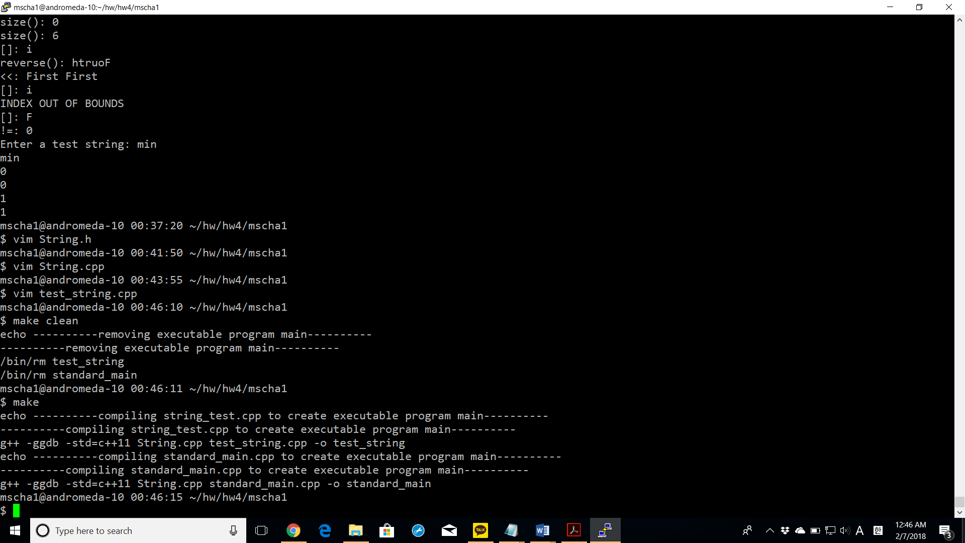

Screenshots of successful execution with valgrind command

