Name: Min Sung Cha Student ID: 85408485

Analysis of functions

**Shape.h**

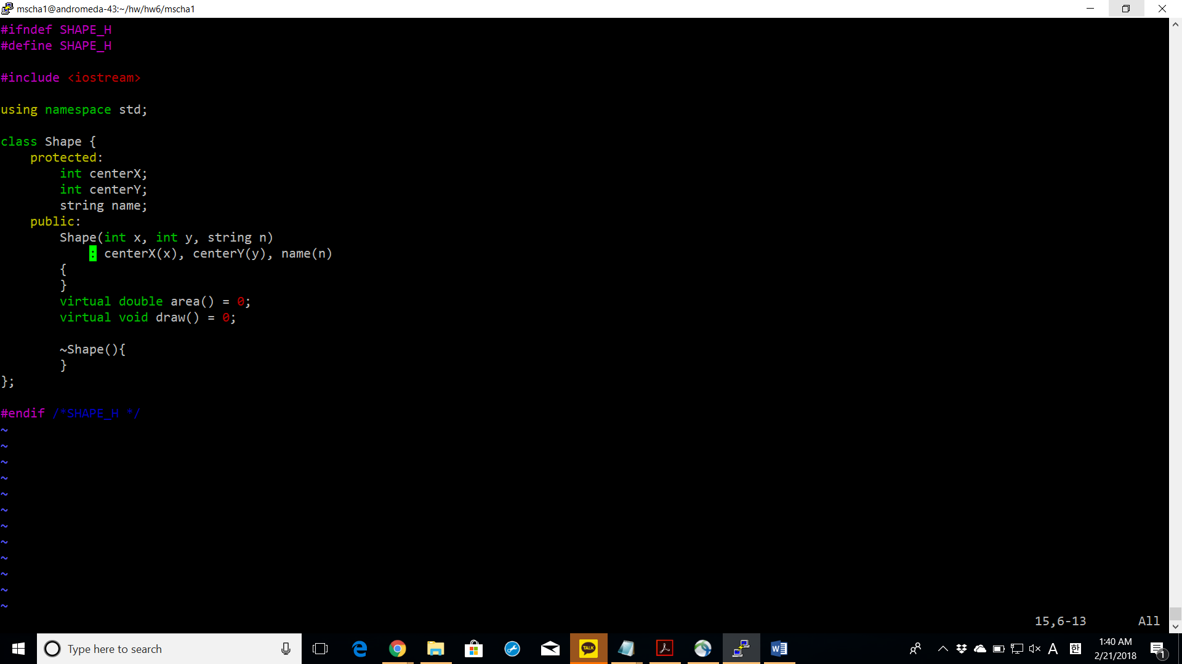

**Circle.h**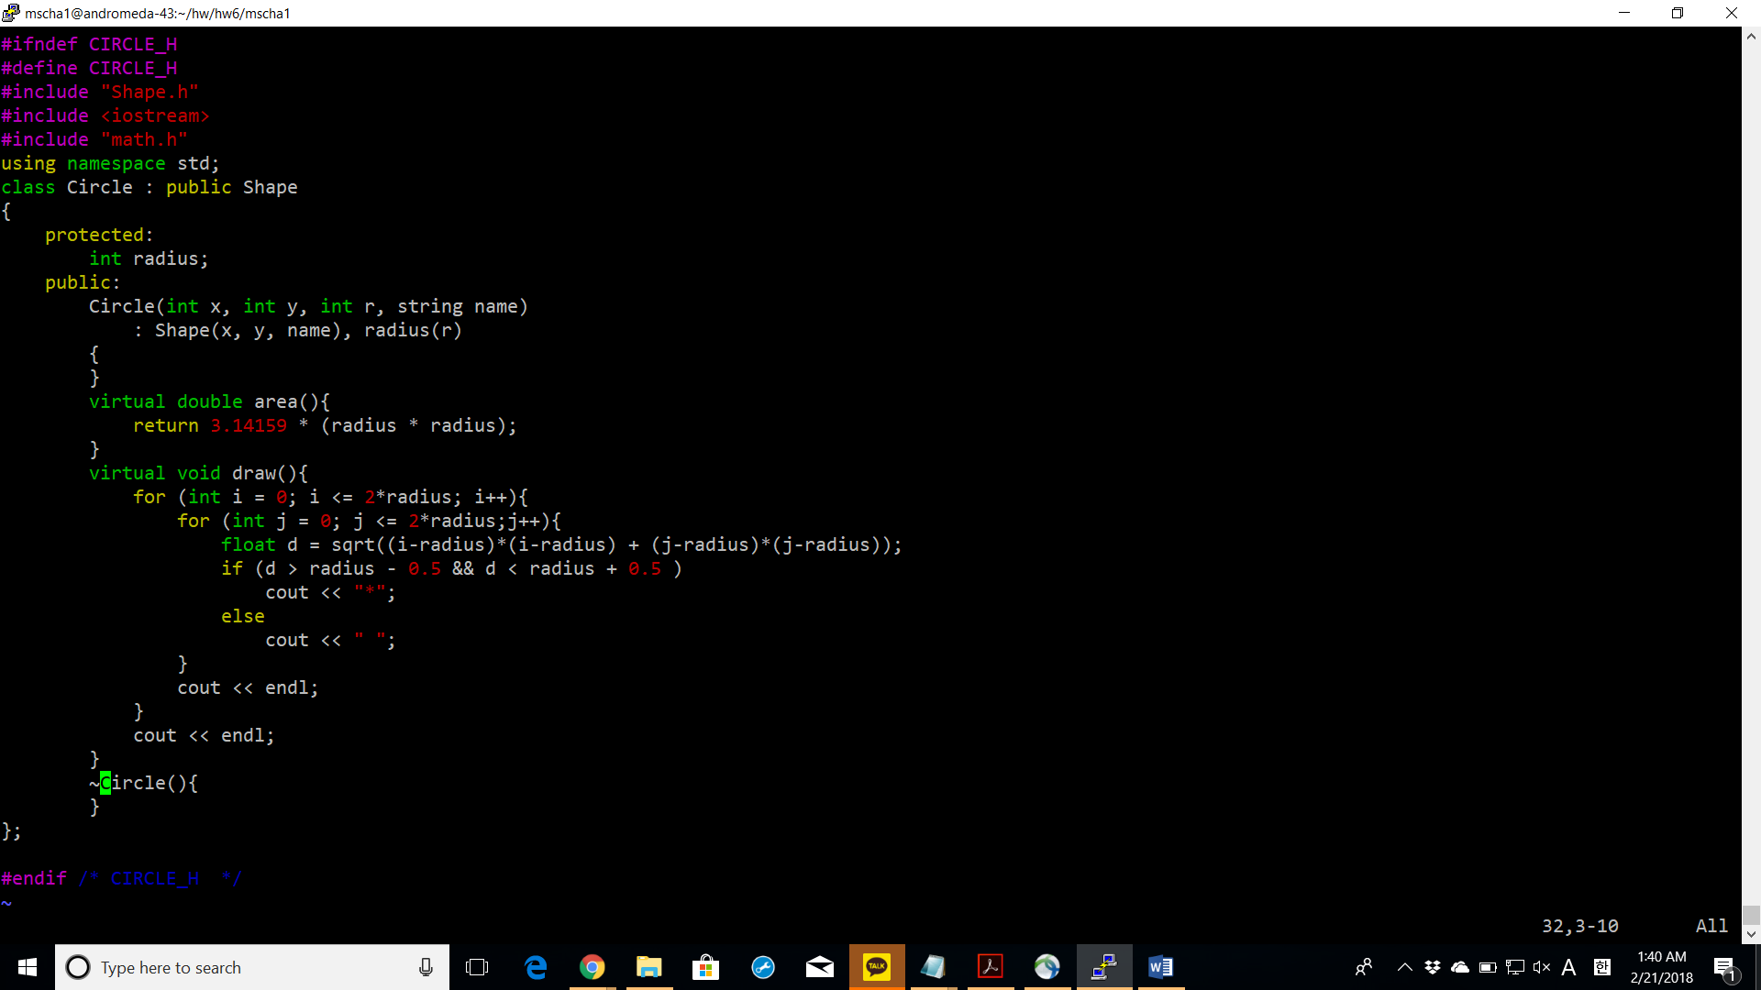

area: calculates the area by squaring the radius and multiplying it by pi.

Draw: calculates the distance from the center of the circle to the circumference and prints the * symbol accordingly.

**Rectangle.h**

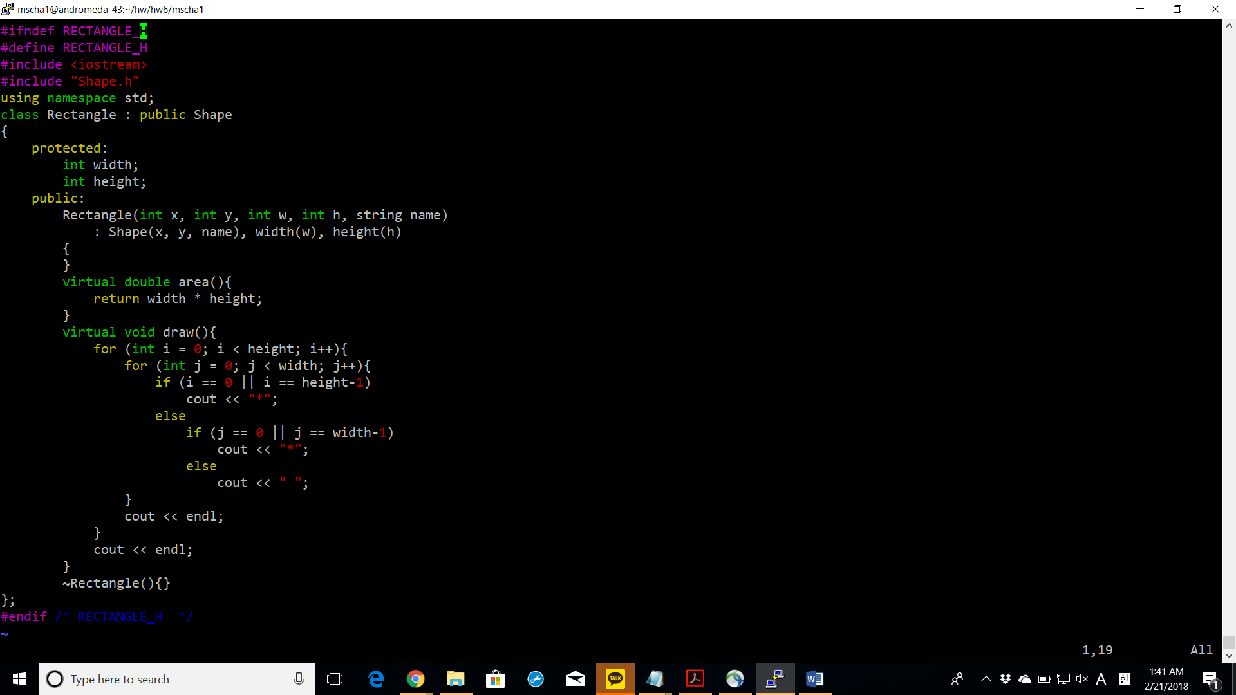

Draw: draws the entire line for the first and last row of the rectangle and for the rest of the rows only the two dots at the perimeter are drawn.

**Square.h**

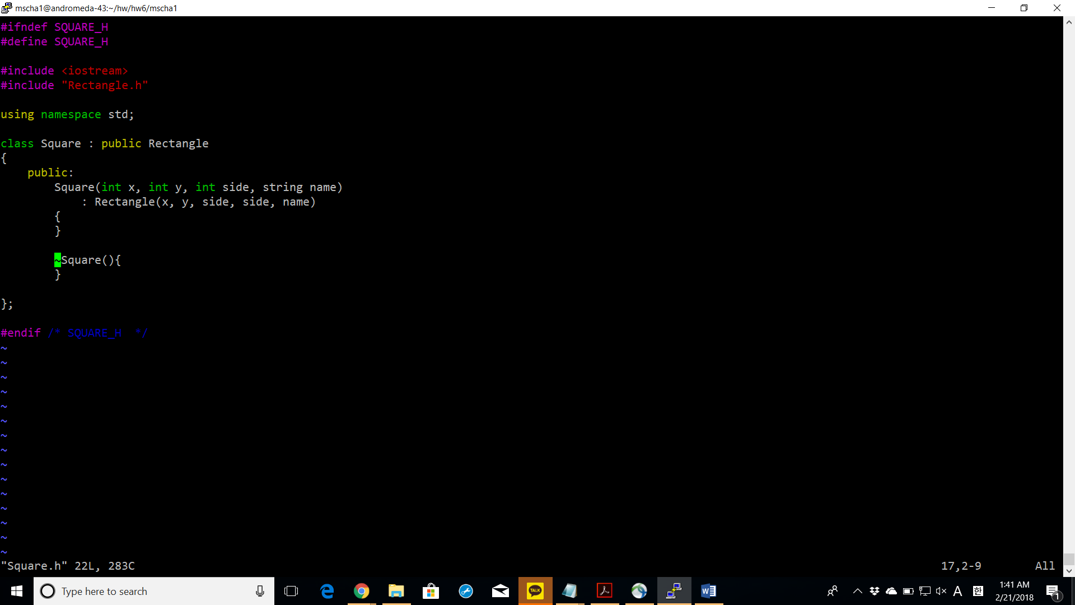

**Triangle.h**

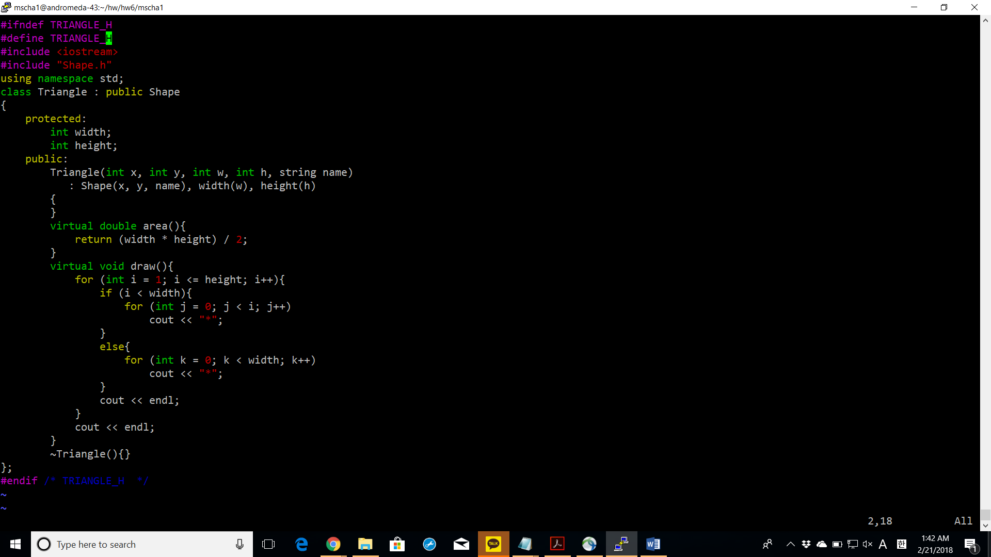

Draw: draws incrementally starting from the leftmost corner until the size of the base is reached. Once it is reached it keeps drawing the size of the base.

**Picture.h**

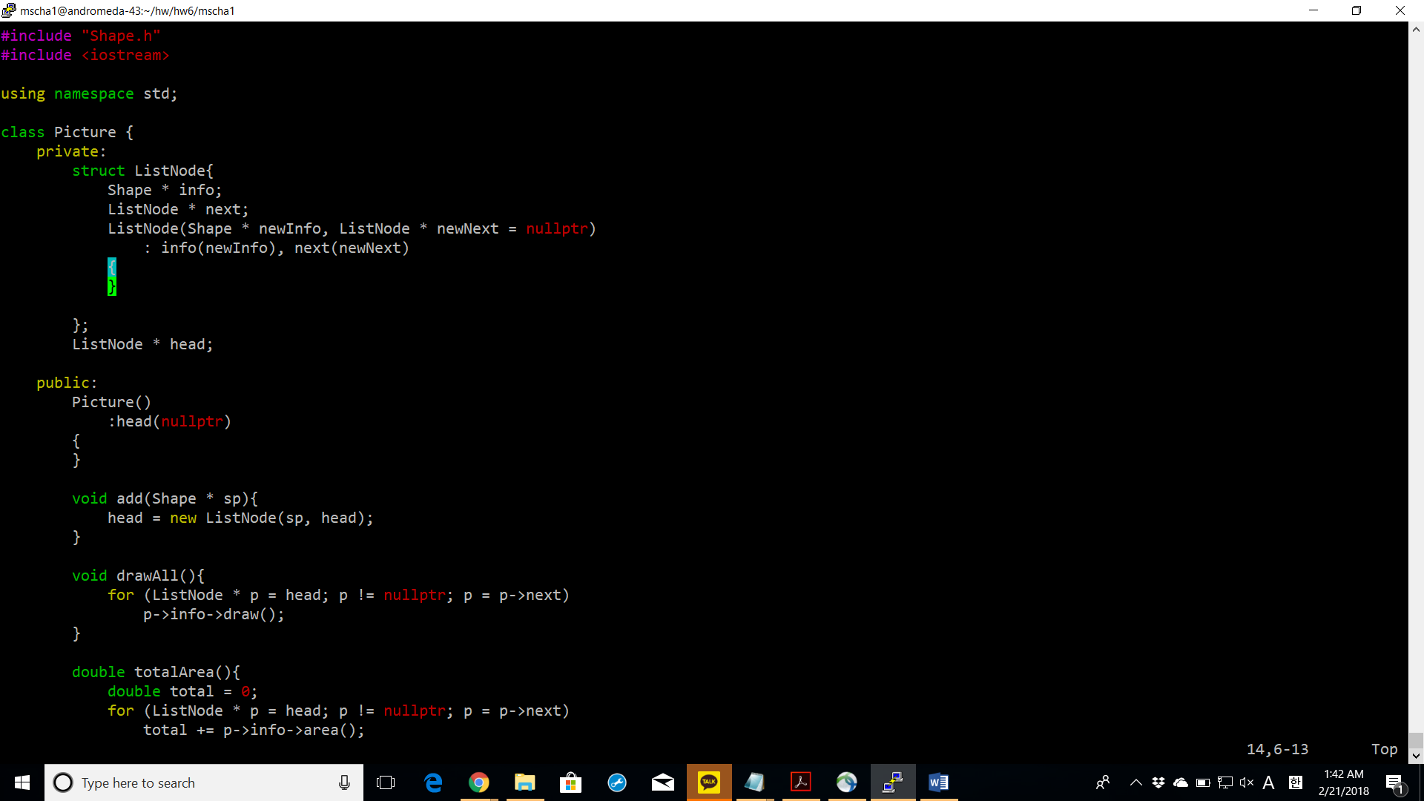

add: adds a list node at the beginning of the linked list.

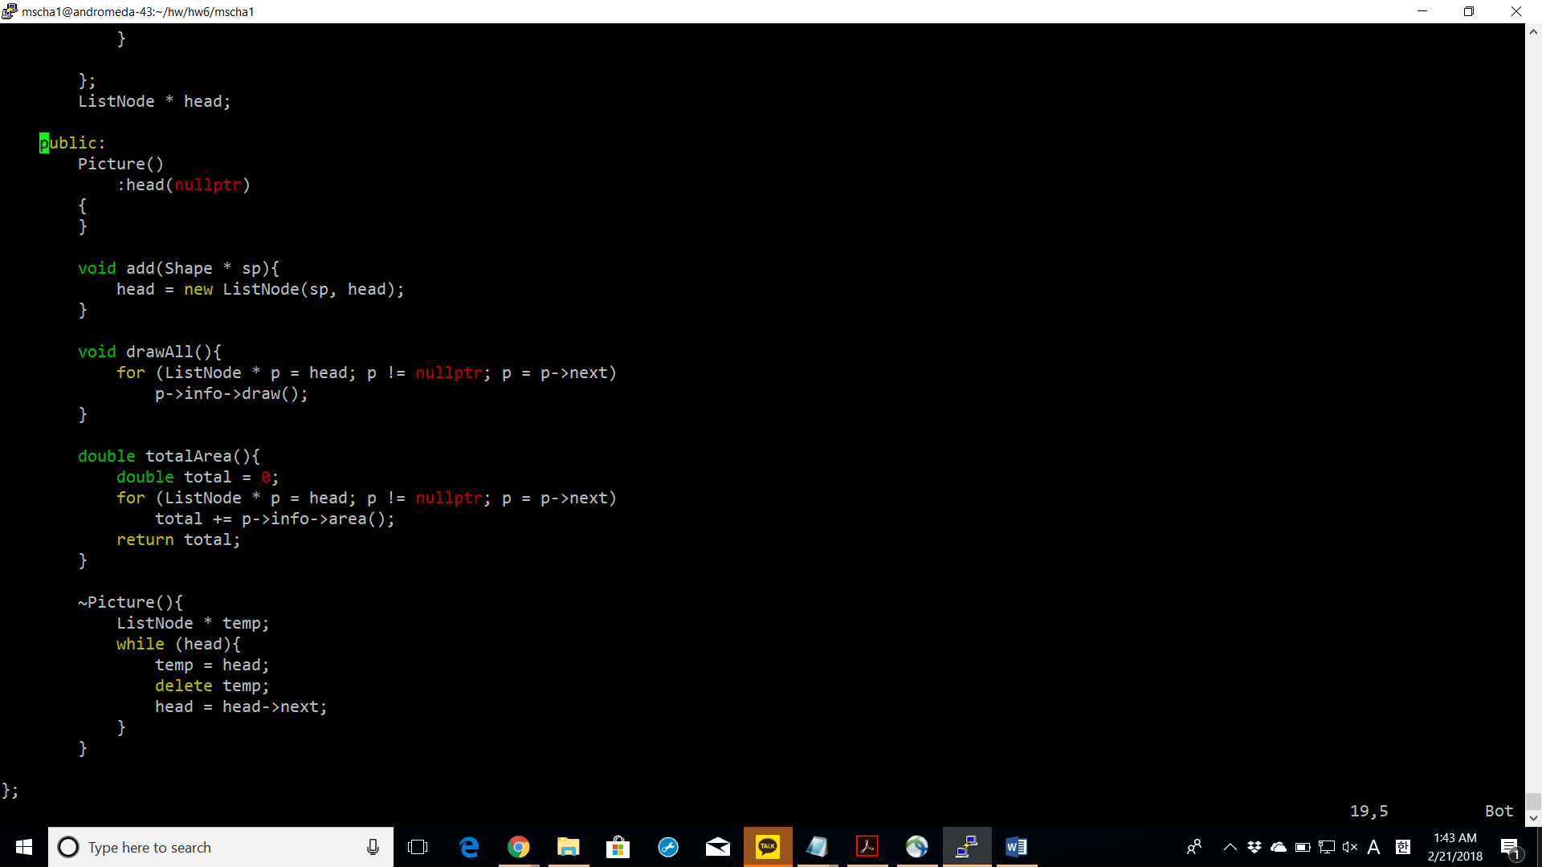

drawAll: draws all the Shape pointers inside the linked lists by referencing its info and then calling their virtual draw function.

**main.cpp**

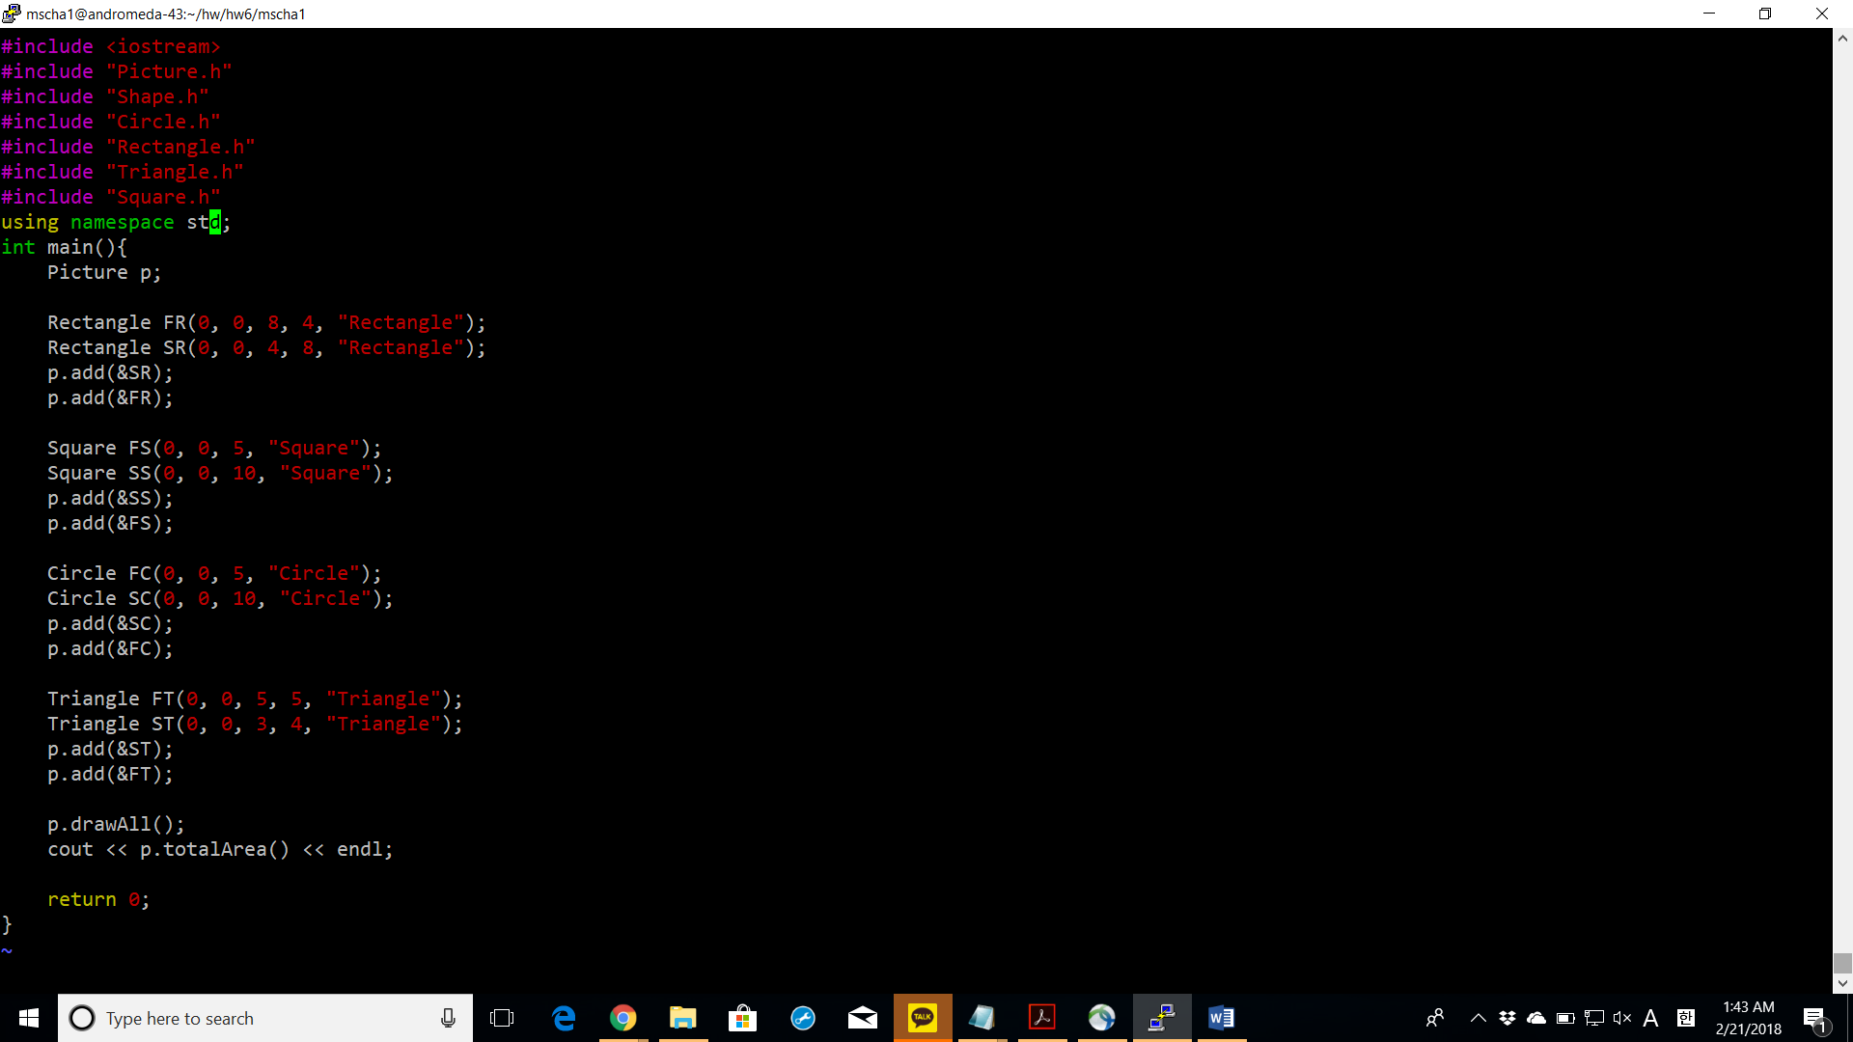

Screenshots of successful compiling with make command

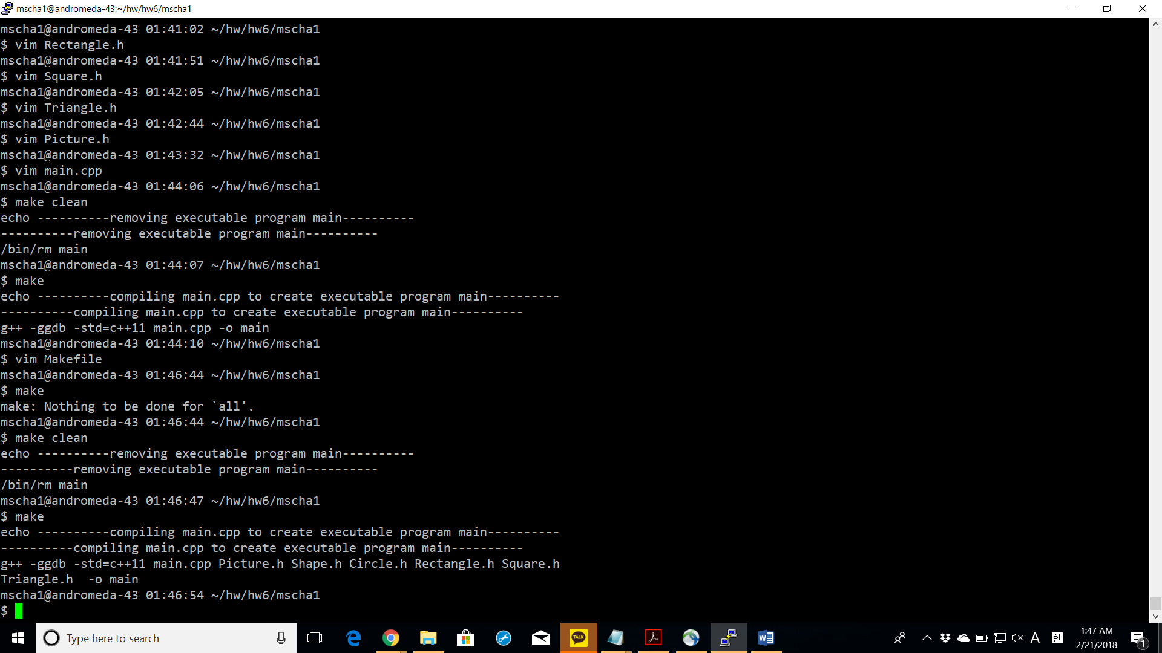

Screenshots of successful execution with valgrind command.

