Name: Min Sung Cha Student ID: 85408485

Analysis of functions

**Exception.h**

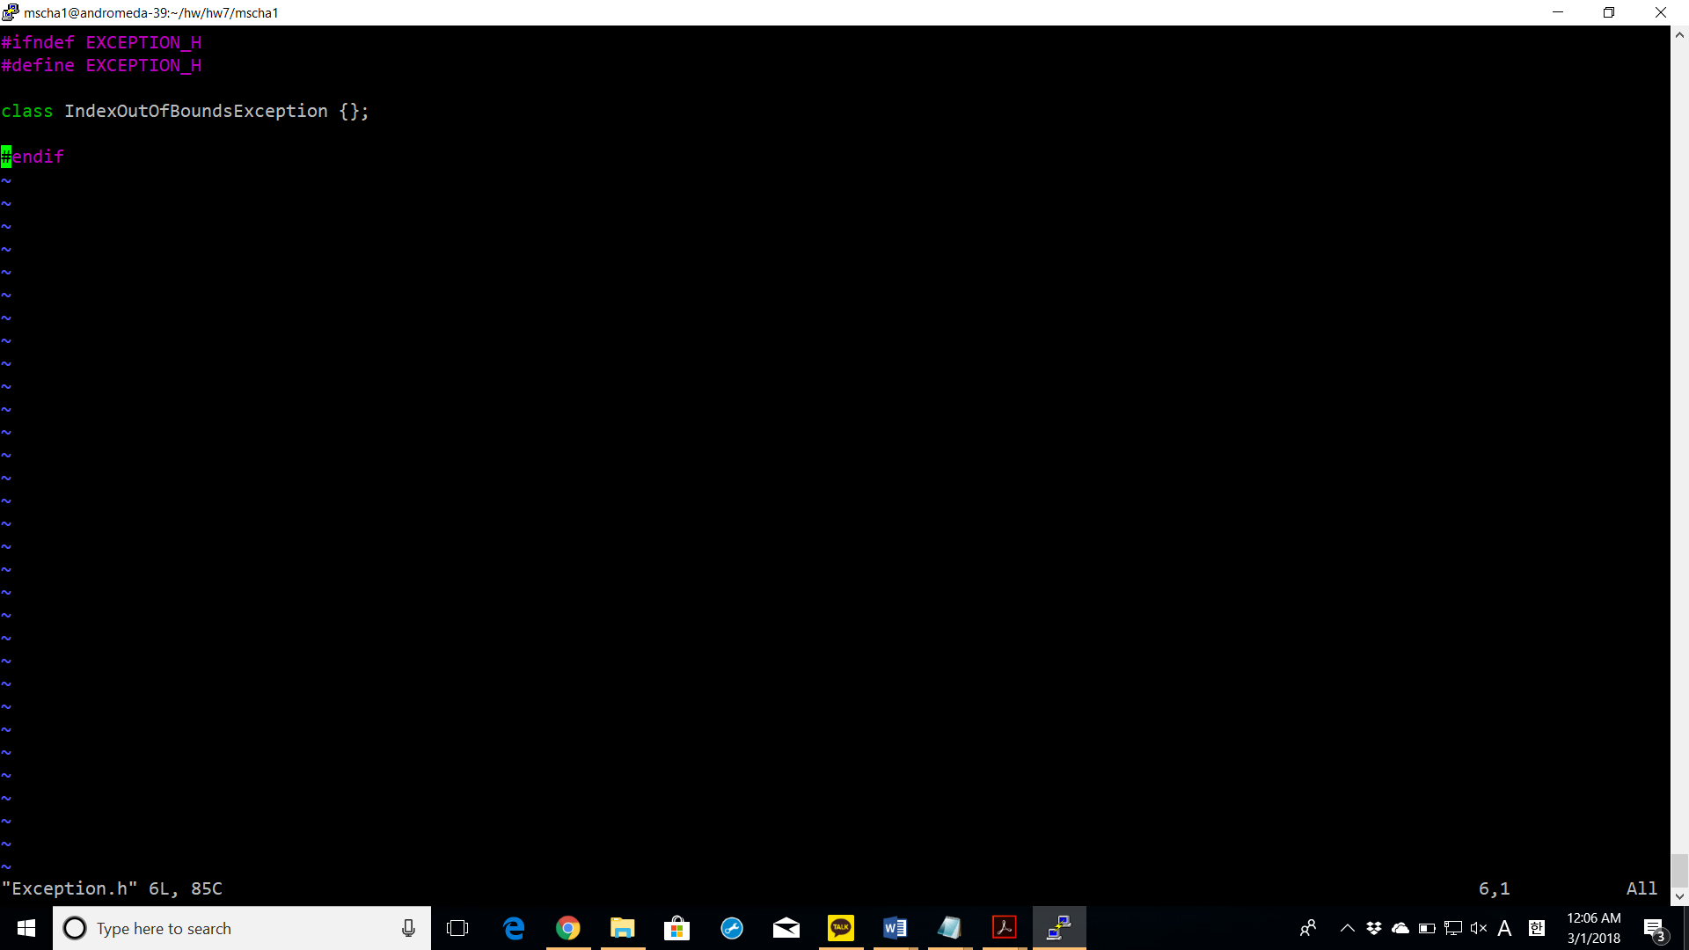

The exception header contains the IndexOutOfBoundsException class which is used when the index goes out of bounds for the indexing operator.

**Array.h**

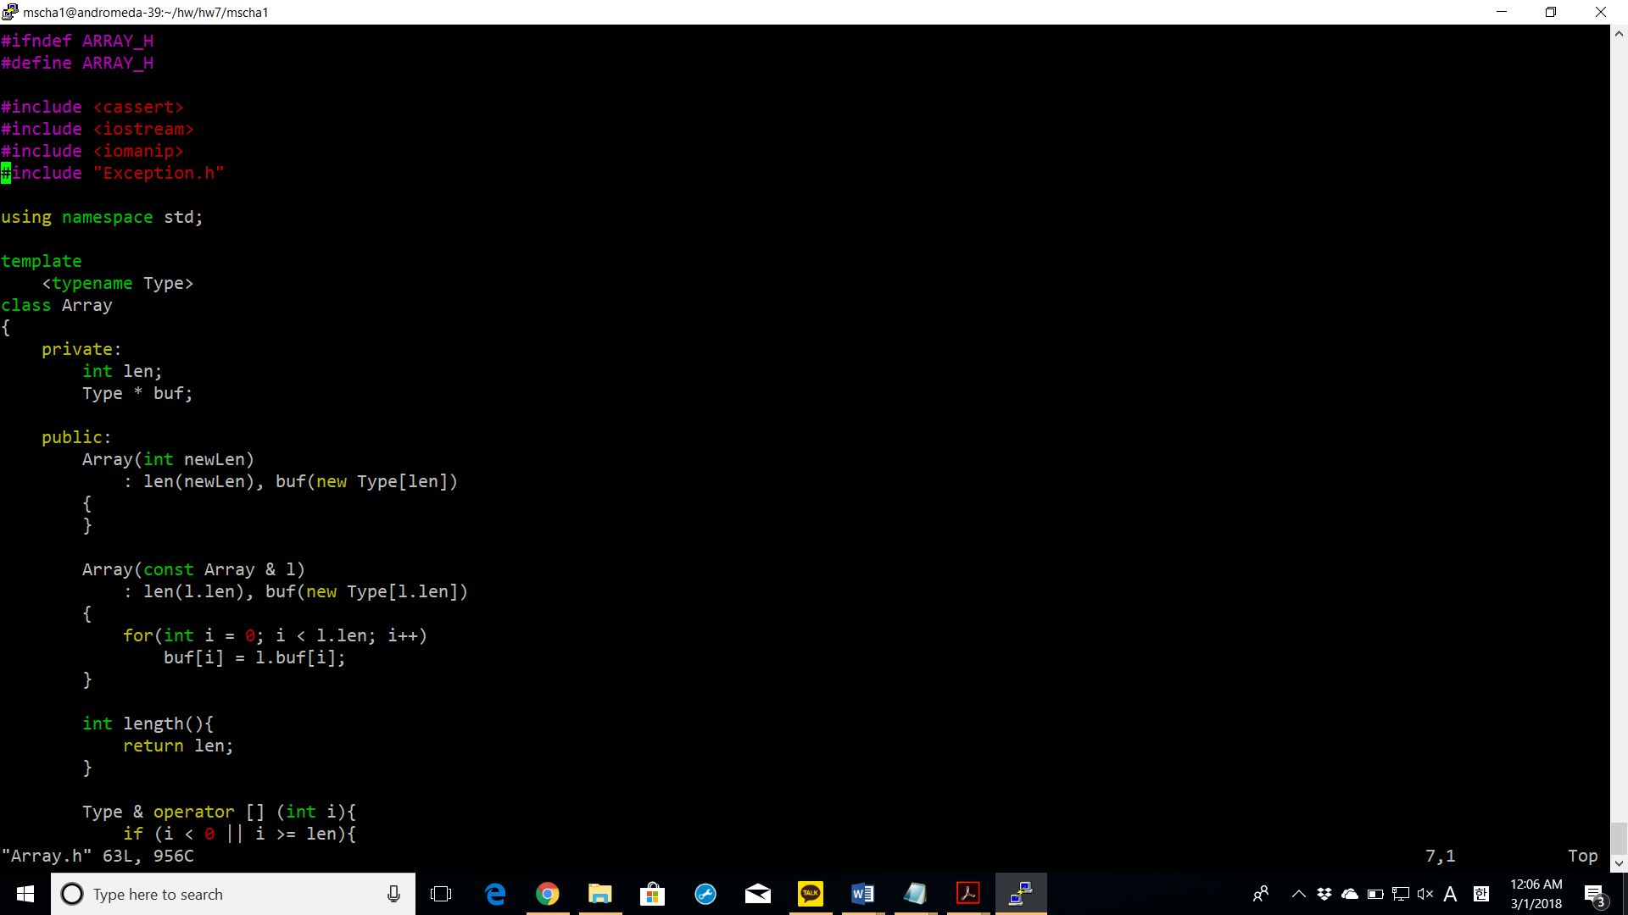

Array(const Array & I): the copy constructor takes in an array object as a parameter and copies its length and buf into this Array.

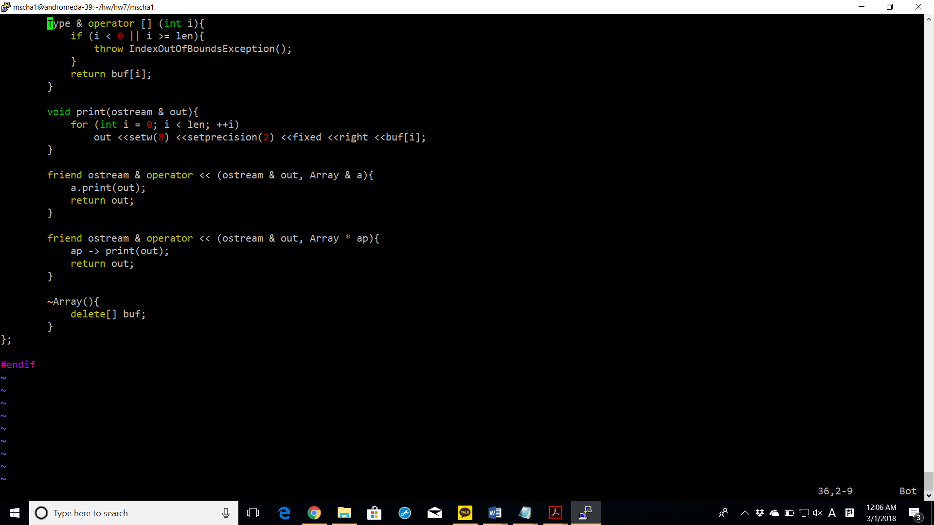

Operator []: if the index supplied as the parameter from the user is smaller than 0 or bigger than or equal to the length, then an IndexOutOfBoundsException is raised. Otherwise, the appropriate element in the index is returned.

**Matrix.h**

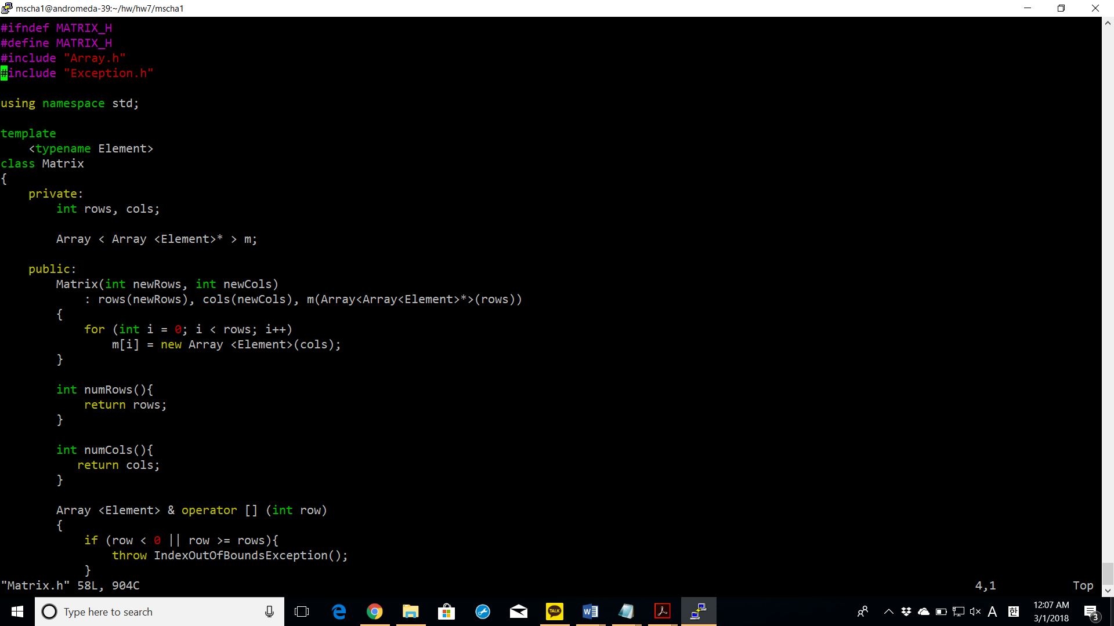Matrix(int newRows, int newCols) – constructs a Matrix objects with the number of rows and columns specified by the user. The constructor defines m, which is an array of arraypointers constructed by calling the Array constructor first on the Array pointer object and then on the type object.

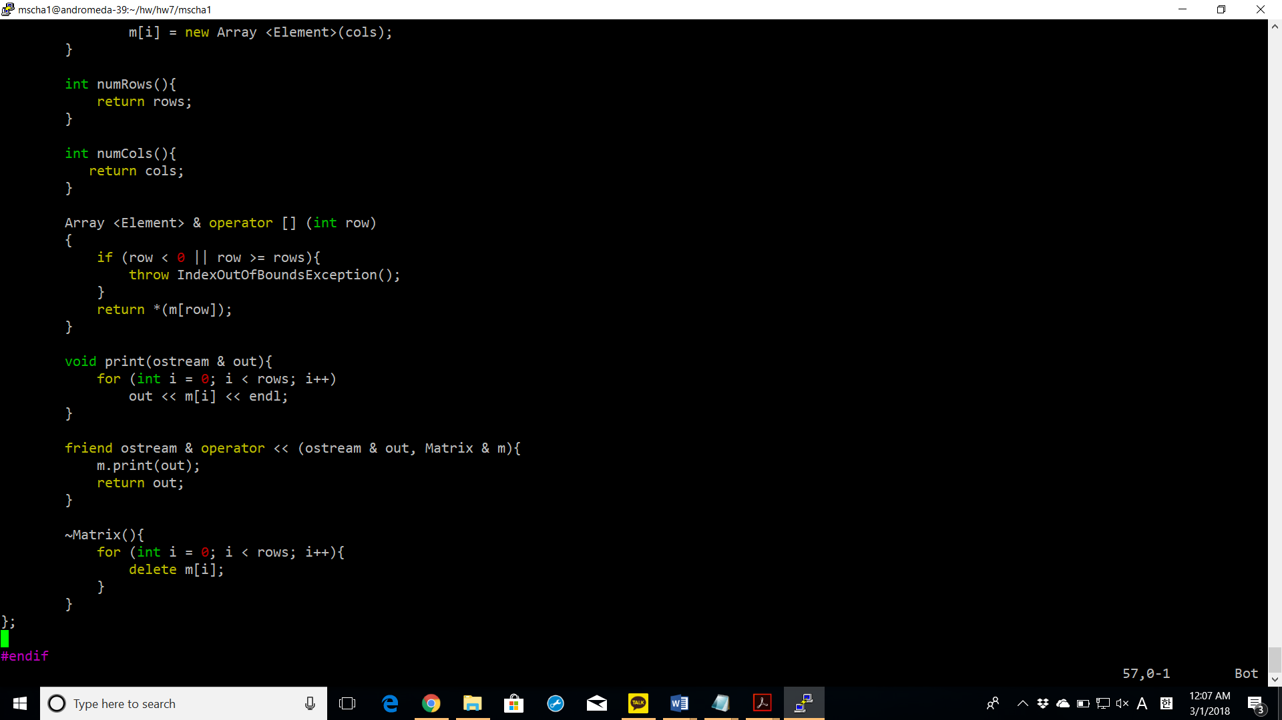

~Matrix(): it destructs the Matrix object by deleting every array pointer in every row.

**test_matrix.cpp**

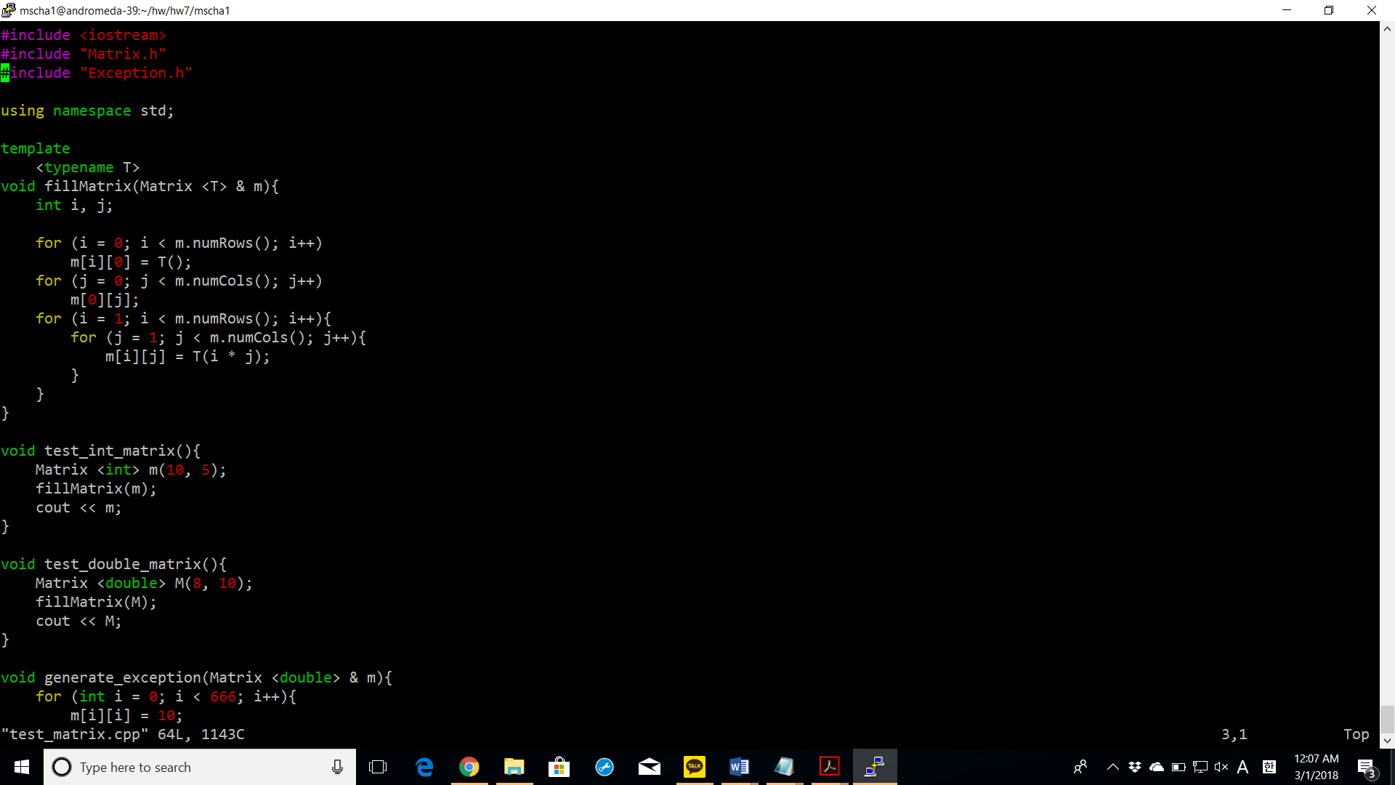

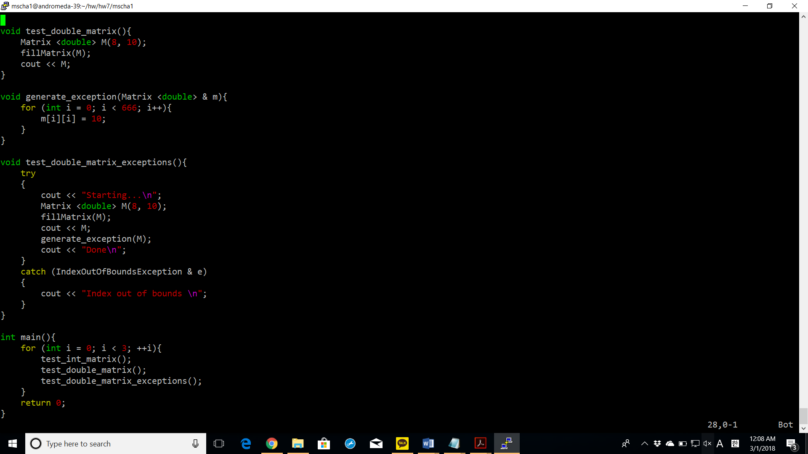

Screenshots of successful compiling with **make** command

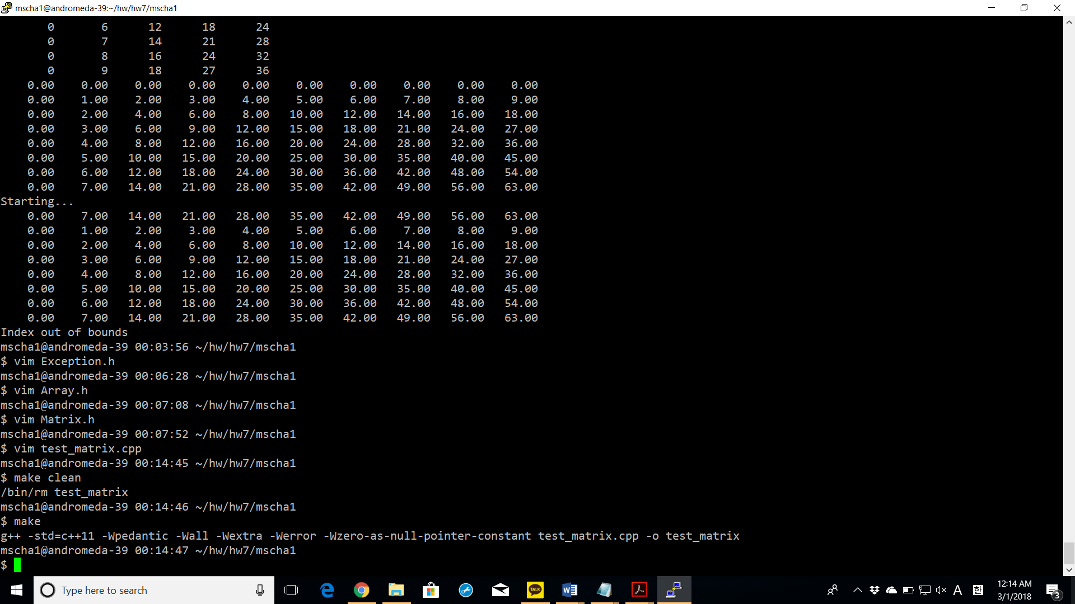

Screenshots of successful execution with **valgrind** command.

