Name: Min Sung Cha ID: 85408485

Include your whole mapset.cpp and process_numbers.cpp for the function analysis. And explain each function in each file.

**mapset.cpp**

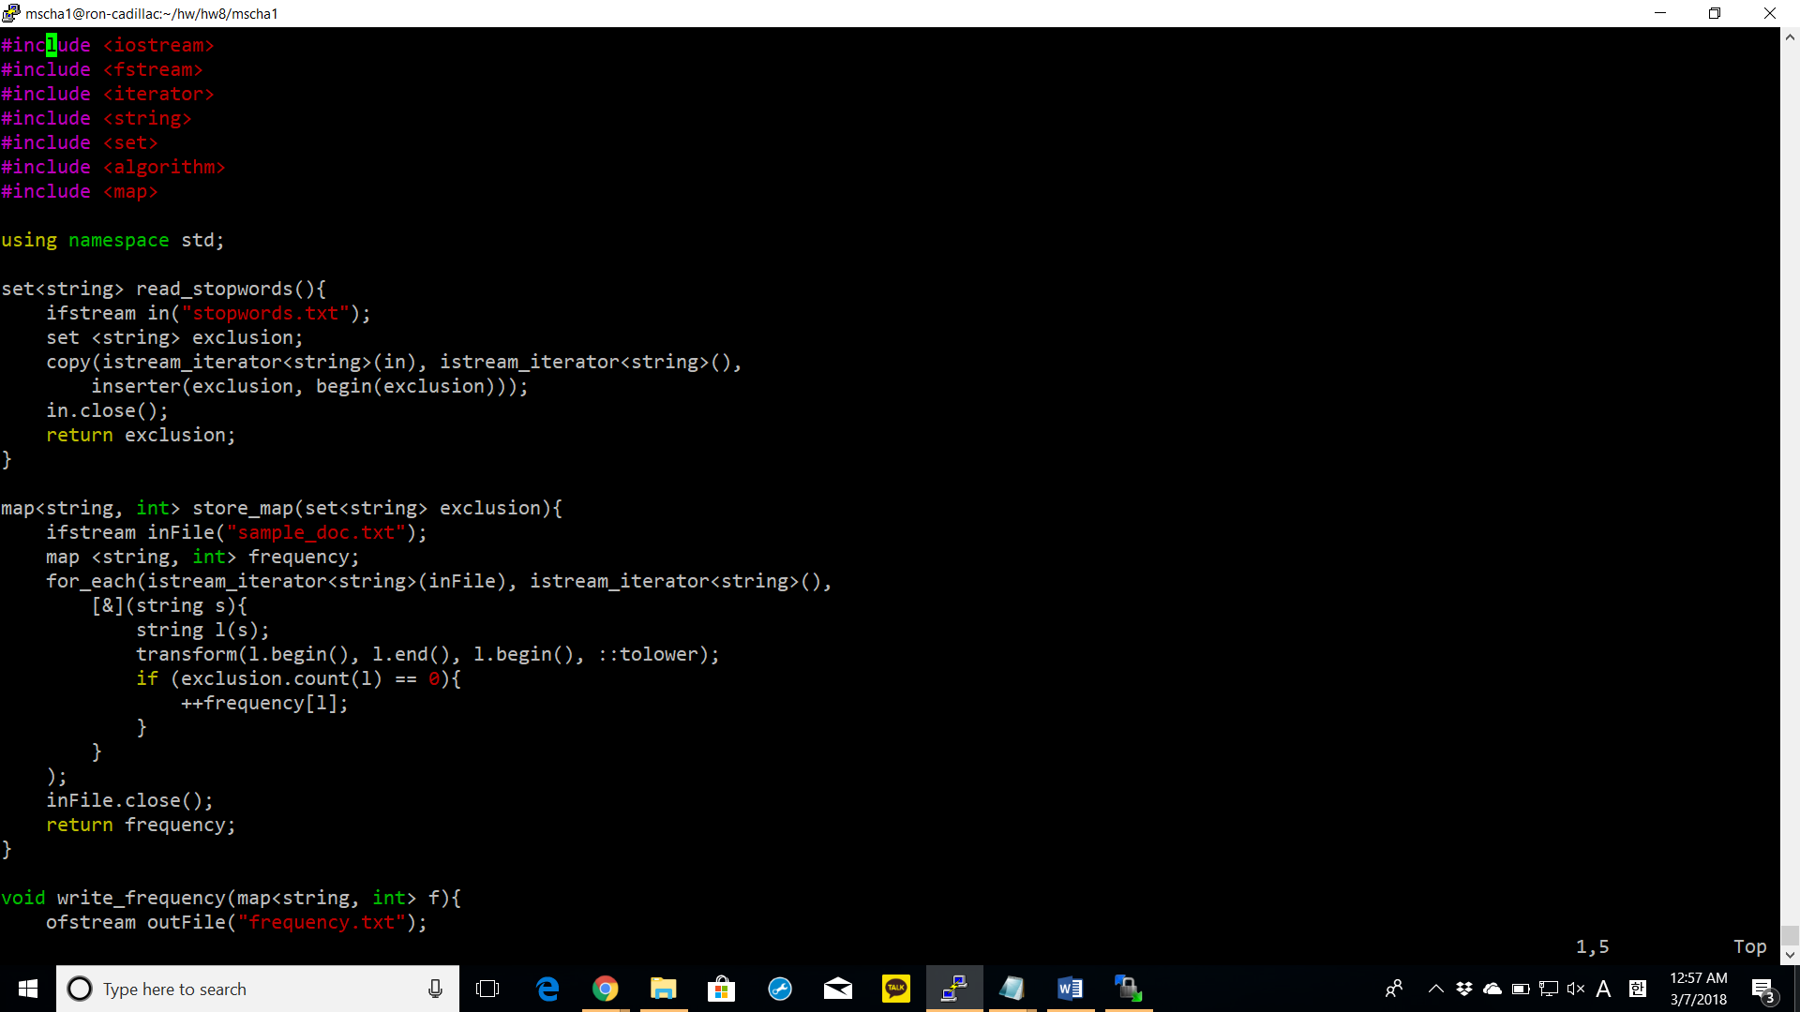

read_stopwords: this function reads “stopwords.txt” and copies it into set of strings using the algorithm copy. The beginning and end of the file are obtained by istream_iterator<string>(in) and istream_iterator<string>(). The inserter function is used to insert the strings at the back from the beginning.

store_map: reads “sample_doc.txt” and creates a map called frequency. It loops over every element in the file by using the algorithm for_each. For_each takes in a lambda which takes in a string as a parameter, duplicates it, changes to lowercase by using transform and checks if the count of the string is zero in the exclusion set (set creates with the words in stopwords.txt). If zero, the corresponding int info of the key is incremented by 1.

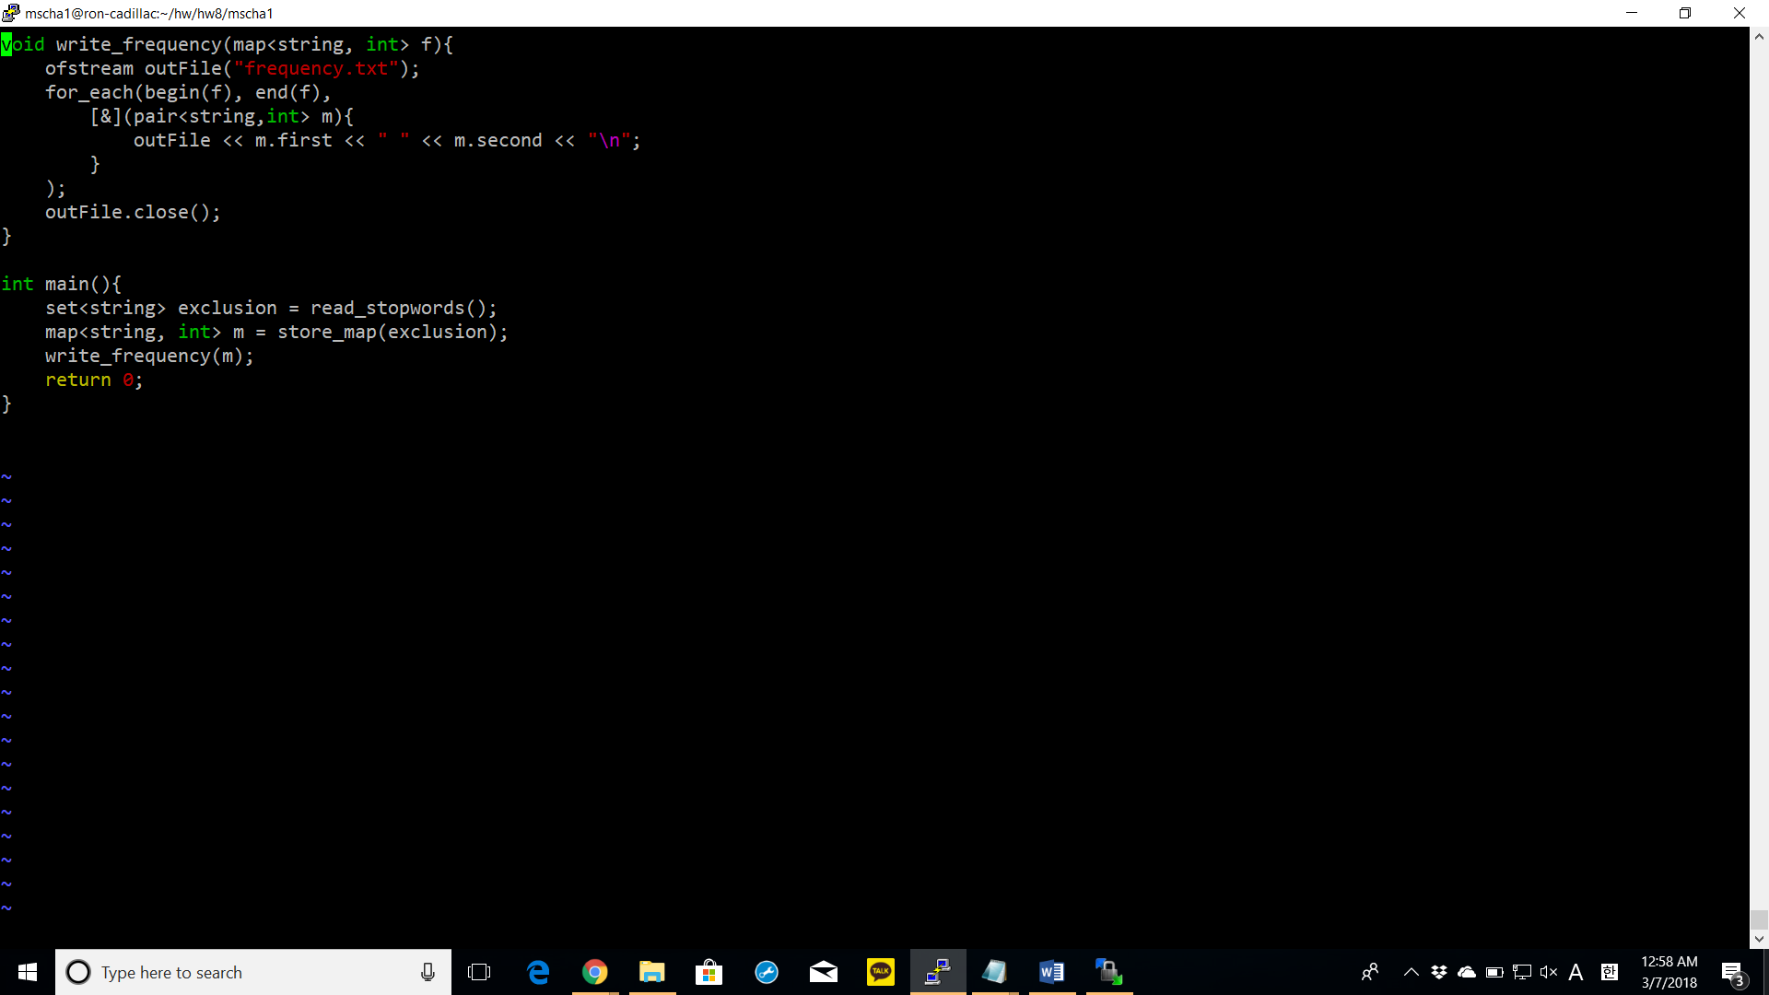

write_frequency: takes in a map as a parameter and creates the file “frequency.txt”. loops through the map by using for_each algorithm which takes a lambda as a parameter. The lambda takes in a pair of string and int as a parameter and writes to the file by using the ostream operator <<.

**process_numbers.cpp**

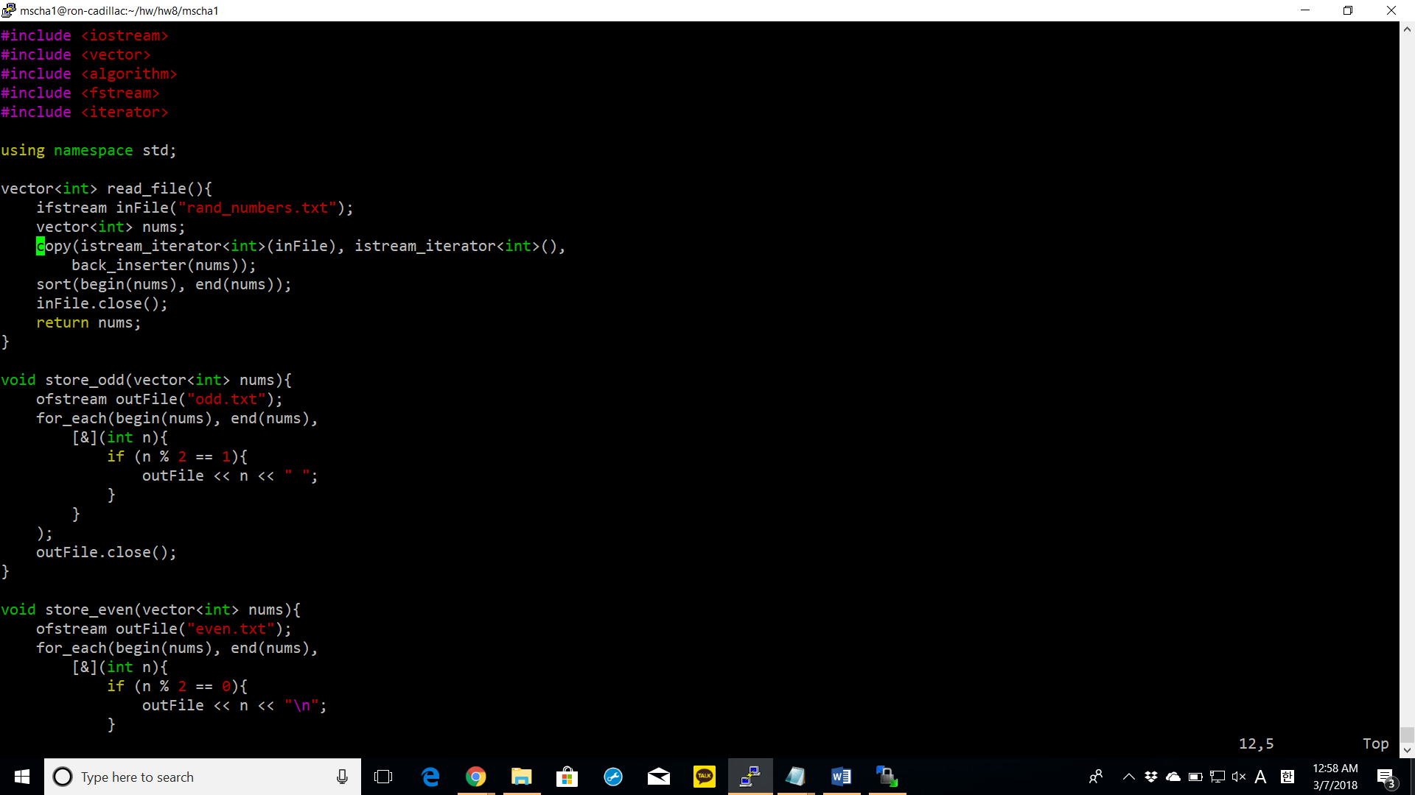

read_file: it reads rand_numbers.txt and copies all the integers in the file to the integer vector by back inserting them. Then, the vector of integers is sorted by using the sort algorithm.

store_odd: creates file “odd.txt” and loops through the vector integer using the for_each loop which takes a lambda as a parameter. The lambda takes in every integer in the vector and determines if it is odd by calculating if the modulus is 1. Then, if odd, the integer is written in the file with a whitespace at the end.

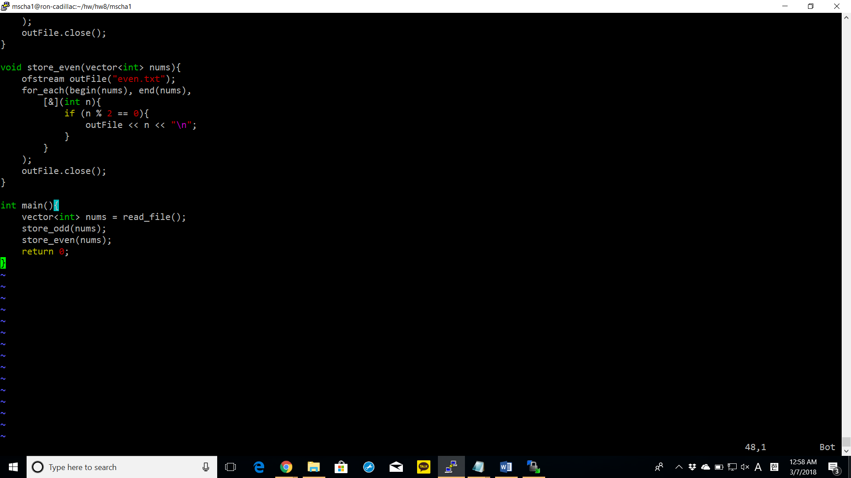

store_even: creates a file named “even.txt” and loops through the vector of integers using for_each algorithm which takes a lambda as a parameter. The lambda has an formal parameter of int which is used to calculate if the modulus is 0. If even, it is written onto the file with a newline at the end.

Show screenshot of compiling for both programs with make command

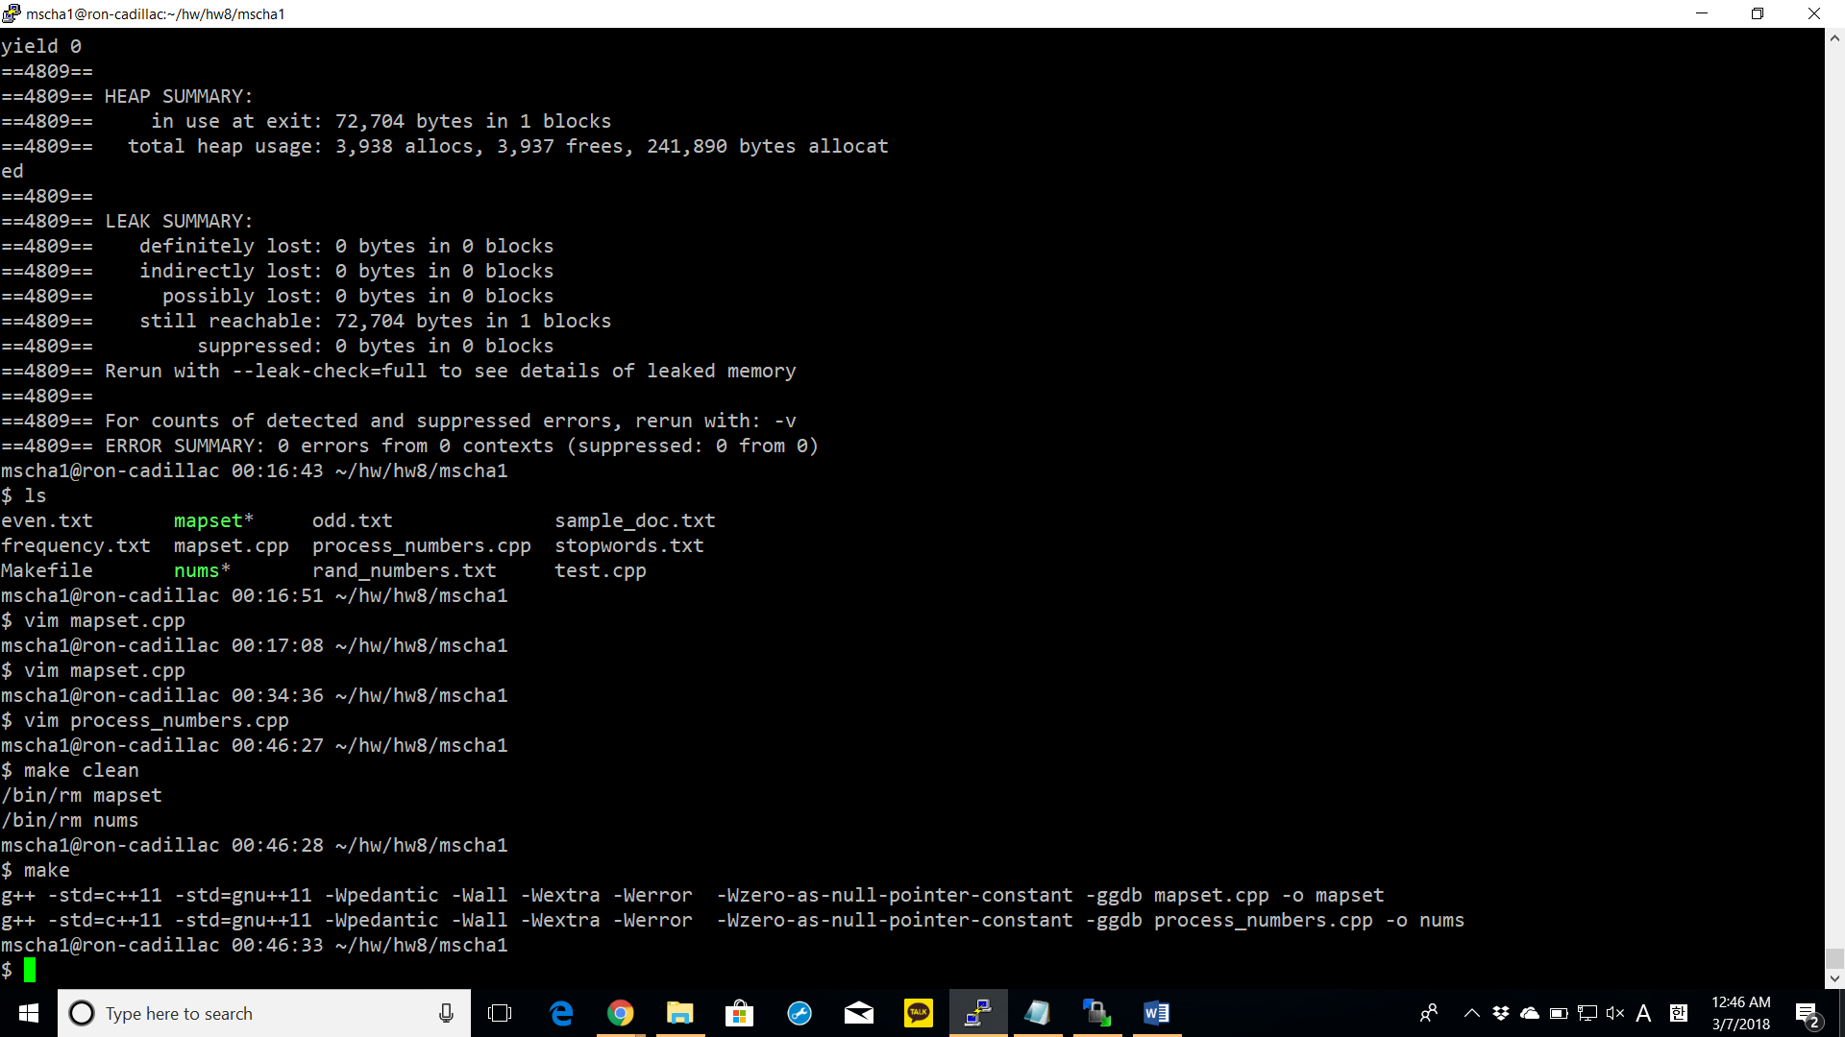

Run your programs with valgrind and include the screenshot for each of the programs

**mapset.cpp**

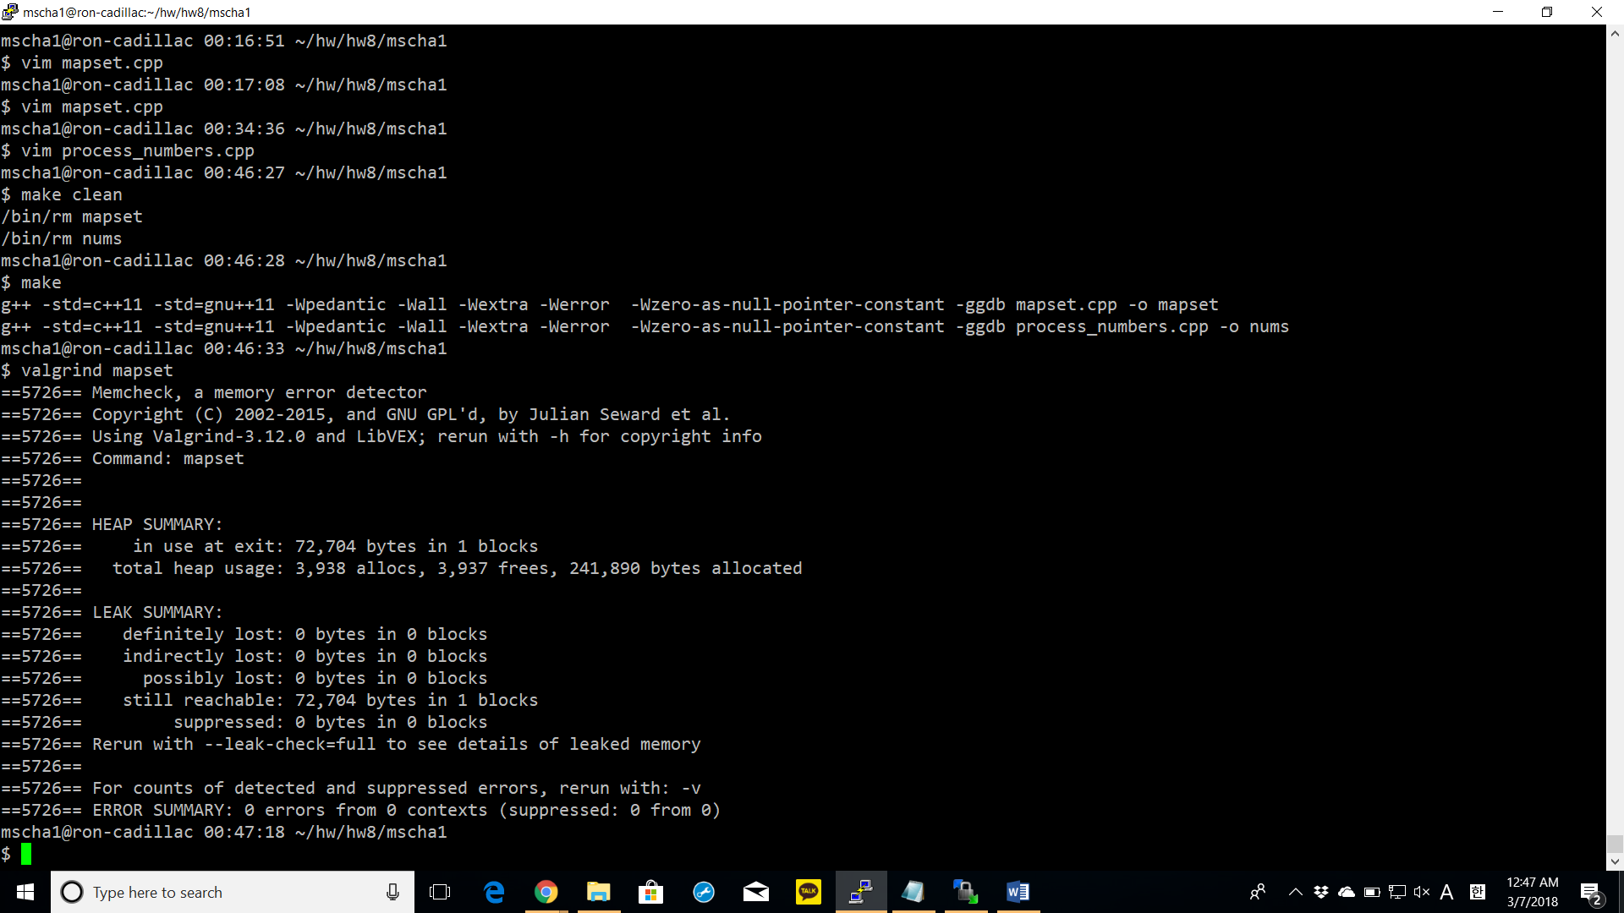

**process_numbers.cpp**

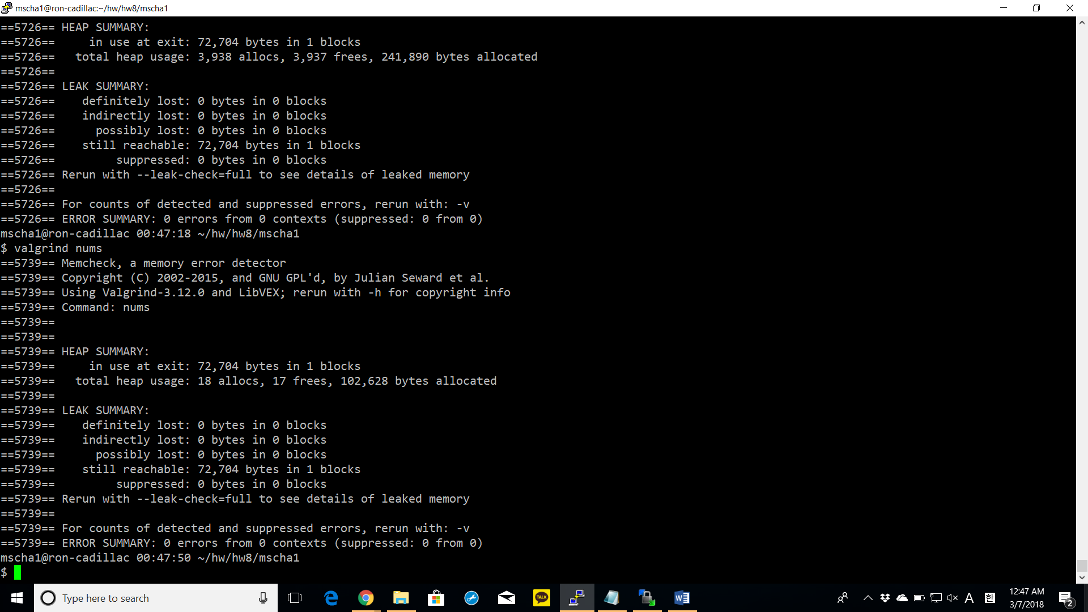

copy and title your, odd.txt,even.txt,frequency.txt in the report.

**odd.txt**

1 3 5 7 9 11 13 15 17 19 21 23 25 27 29 31 33 35 37 39 41 43 45 47 49 51 53 55 57 59 61 63 65 67 69 71 73 75 77 79 81 83 85 87 89 91 93 95 97 99

**even.txt**

-98

-96

-94

-92

-90

-88

-86

-84

-82

-80

-78

-76

-74

-72

-70

-68

-66

-64

-62

-60

-58

-56

-54

-52

-50

-48

-46

-44

-42

-40

-38

-36

-34

-32

-30

-28

-26

-24

-22

-20

-18

-16

-14

-12

-10

-8

-6

-4

-2

0

2

4

6

8

10

12

14

16

18

20

22

24

26

28

30

32

34

36

38

40

42

44

46

48

50

52

54

56

58

60

62

64

66

68

70

72

74

76

78

80

82

84

86

88

90

92

94

96

98

100

**frequency.txt**

abacus 1

abbreviations 1

abstract 2

abstracted 2

abstraction 1

accredited 1

acknowledges 1

act 1

action 1

actionscript 1

activities 1

actual 1

ad 1

ada 1

adacore 1

adaptations 1

add 1

addition 1

addresses 1

adopted 1

affects 1

air 1

al-jazari 1

algebra 1

algorithms 4

allow 1

allowed 5

allows 1

along 1

also 2

although 1

analogous 1

analysis 1

analytical 2

ancient 2

another 1

antikythera 1

application 2

applications 2

architecture 1

areas 2

arithmetic 1

around 2

art 1

artifacts 1

assembly 6

automata 1

automate 1

babbage 1

basic 1

bc 2

became 2

become 1

becoming 1

beginning 1

bernoulli 1

besides 1

beyond 2

binary 1

build 1

building 1

built 1

c 3

calculate 1

calculating 1

calculation 1

calculations 2

calculator 1

calculators 1

calculus 1

calendars 1

call 1

called 1

cams 1

card 3

cards 8

career 2

cases 1

certification 1

challenges 1

changes 1

charles 1

china 1

circa 1

clearance 1

cloth 1

cobol 1

code 6

coding 2

cognitive 1

combines 1

commercial 1

commonly 1

community 1

company 1

compiler 1

complicated 1

computation 1

computational 1

compute 1

computer 11

computers 3

computing 2

conceive 1

conception 1

condition 1

configuration 1

considerably 1

considered 2

consistent 1

consumption 1

control 4

convenient 1

converted 1

core 1

corrections 1

correctness 1

cost 1

countries 3

covers 1

craft 1

crafted 1

created 1

criteria 1

critical 1

cultures 1

cycle 1

data 4

dates 1

debatable 1

debate 3

debugging 1

decisions 1

defined 1

derived 1

design 1

develop 1

developed 7

developing 1

development 5

device 2

devices 2

devising 1

different 10

differs 1

directly 2

discarded 1

discipline 4

domain 1

dozens 1

drive 1

drum 2

drummer 1

due 1

early 1

easier 1

easily 1

easy 1

economic 1

editors 1

efficient 2

efficiently 1

eg 4

elementary 1

elements 1

employed 1

engine 5

engineer 1

engineering 4

engineers 1

enough 1

entered 1

entering 3

entirely 1

entities 1

environments 1

era 2

error 2

europe 1

even 1

every 1

evolvable 2

executable 1

exhaustion 1

existed 1

expertise 1

expressed 1

extent 2

fact 1

faster 1

final 1

find 1

first 4

follow 1

force 1

form 3

formal 1

format 1

forms 1

formula 2

formulation 1

fortran 3

found 1

foundation 2

founded 1

functional 1

fundamental 1

gears 1

general 3

generating 1

geometry 1

giant 1

given 1

goal 1

good 1

governmentally 1

greater 1

greece 1

habitual 1

hardware 2

haskell 1

herman 1

high 2

high-level 3

higher 1

history 1

hole 1

holes 1

hollerith 2

however 2

human 2

humans 1

hypothesis 1

ibm 3

idea 1

ie 1

illegal 1

implementation 5

importing 1

impractical 1

include 3

including 3

increase 1

increasing 1

increasingly 2

incur 1

india 1

industry 1

inexpensive 1

influences 1

initial 1

input 1

instead 1

institution 1

instruction 2

instructions 7

instruments 2

intent 1

invented 5

invention 1

inventions 1

involves 1

jacquard 3

japan 1

java 1

javascript 1

jobs 1

joseph 1

just 1

keypunch 1

knowledge 1

known 2

kurdish 1

labor 1

language 16

languages 11

larger 1

late 2

later 3

leads 1

leaps 1

learn 1

led 1

less 3

let 1

level 2

levers 1

license 1

licensed 1

licensing 1

likely 1

linguistics 1

list 1

lists 1

little 1

locations 1

logic 1

loom 3

looms 1

lovelace 1

low-level 1

lower 1

lunar-to-solar 1

machine 10

machines 4

made 3

maintaining 1

making 1

management 1

manner 1

many 5

marie 1

mathematician 1

maximum 1

may 2

meant 1

measured 1

mechanical 2

mechanism 2

mechanisms 1

mechanized 1

media 1

medieval 1

medium 1

memory 1

method 1

metonic 1

might 2

model 1

modern 4

mostly 1

much 3

musical 1

mutual 1

name 1

nature 1

necessary 1

need 1

neumann 1

new 1

notation 3

number 2

numbers 2

numerical 2

objective-c 1

objects 1

occasionally 1

often 4

olympiads 1

one 4

oneself 1

ongoing 2

operated 1

operating 1

operation 2

operations 3

opportunities 1

opposed 1

order 1

organize 1

original 2

output 2

outsourcing 1

overhead 1

painstakingly 1

panel 1

panels 1

paper 3

part 1

particular 2

particularly 2

parts 1

pass 1

past 1

pasteboard 1

pattern 2

patterns 3

pegs 1

percussion 1

perfectly 1

perform 1

performing 1

perl 1

phase 1

php 1

physically 1

placed 1

playing 1

plugboard 1

popular 2

possibility 1

postulates 1

power 1

practical 1

practices 1

predetermined 1

prior 1

problem 2

process 6

processing 3

produce 2

producing 1

profession 1

professional 1

professions 1

program 6

programmable 2

programmed 1

programmer 4

programmers 5

programming 24

programs 10

progressed 1

prone 1

punch 1

punched 7

punching 1

purpose 1

python 1

read 1

readable 1

rebuilt 1

record 2

recording 1

referred 1

regarded 1

regulated 1

related 1

relations 1

relatively 1

replace 1

represented 1

representing 2

require 1

required 1

requirements 1

requires 1

reserved 1

resources 1

rhythms 1

ruby 1

s 3

sapirwhorf 1

science 2

scientist 1

security 1

see 1

seemed 1

self-governed 1

sequence 3

sequentially 1

series 1

services 1

sets 2

settled 1

several 1

shortened 1

sizes 1

small 1

smalltalk 1

software 9

solution 1

solving 1

sometimes 1

sorter 1

source 5

speaker 1

speakers 1

special 1

specialized 1

specific 2

specified 1

specify 2

specifying 1

speed 2

spoken 1

sql 1

standardized 1

stands 1

states 2

still 3

storage 1

stored 1

strict 1

subject 1

subjects 1

sumeria 1

surrounding 1

susceptible 1

symbolic 1

symbols 1

synthesis 1

system 2

systems 1

tabulating 1

tabulator 2

takes 1

tape 2

target 1

task 2

tasks 1

technical 1

techniques 1

term 2

terminals 1

terms 2

testing 1

tests 1

text 3

theorized 1

things 1

thought 2

thoughts 1

three 1

thus 2

time 2

total 1

tracked 1

translates 1

translation 1

trials 1

trigger 1

turn 1

two 1

type 1

typically 1

typing 1

underlying 1

understanding 1

unit 2

united 2

upon 1

use 5

used 3

uses 2

using 5

usually 4

utilizing 1

various 2

vary 1

verification 1

visual 1

vital 1

von 1

wage 1

way 1

weaves 1

weaving 1

well 1

whether 1

whole 1

whose 2

widely-used 1

will 1

within 1

without 2

wooden 1

world 3

worlds 1

write 1

writing 3

written 1

wrote 1

x 3

y 1

yield 1