Name: Min Sung Cha ID: 85408485

Include your whole SetList.h and MapArray.h and also main.cpp for the function analysis. And explain how insertion is done in each of your SetList and MapArray.

**SetList.h**

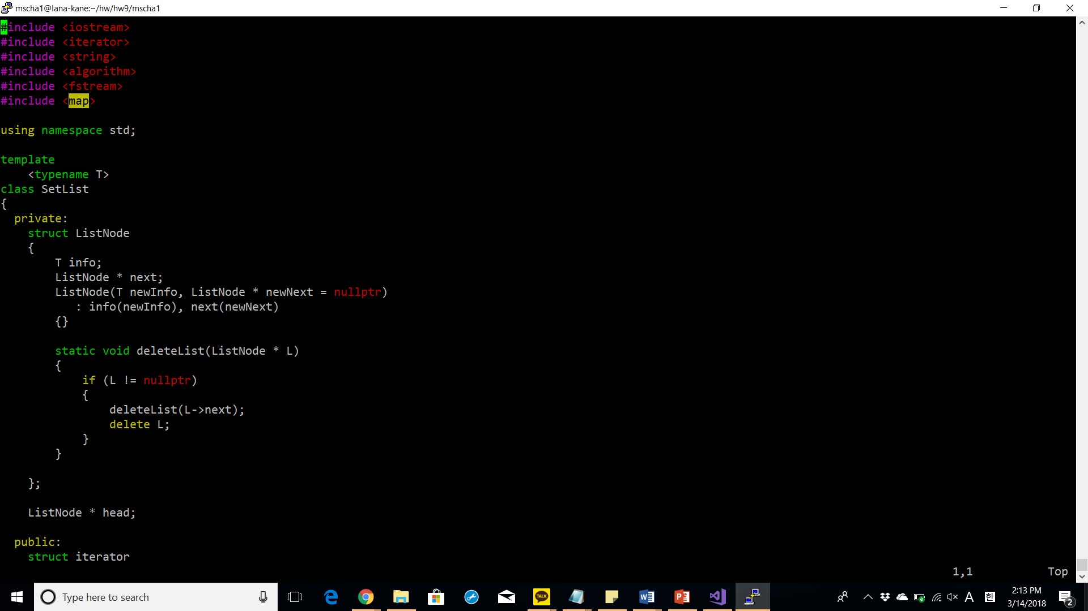

deleteList: recursively loops over the linked list and deletes the list nodes until the list node pointer reaches the nullptr.

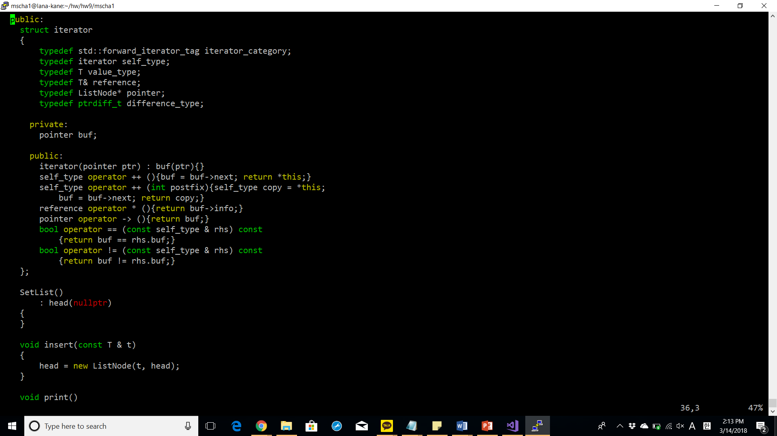

operator ++: list node pointer iterates over the linked list by calling next on the list node.

insert: inserts a new list node to the linked list by creating a new list node with the info being the parameter passed in and next being the current head of the linked list.

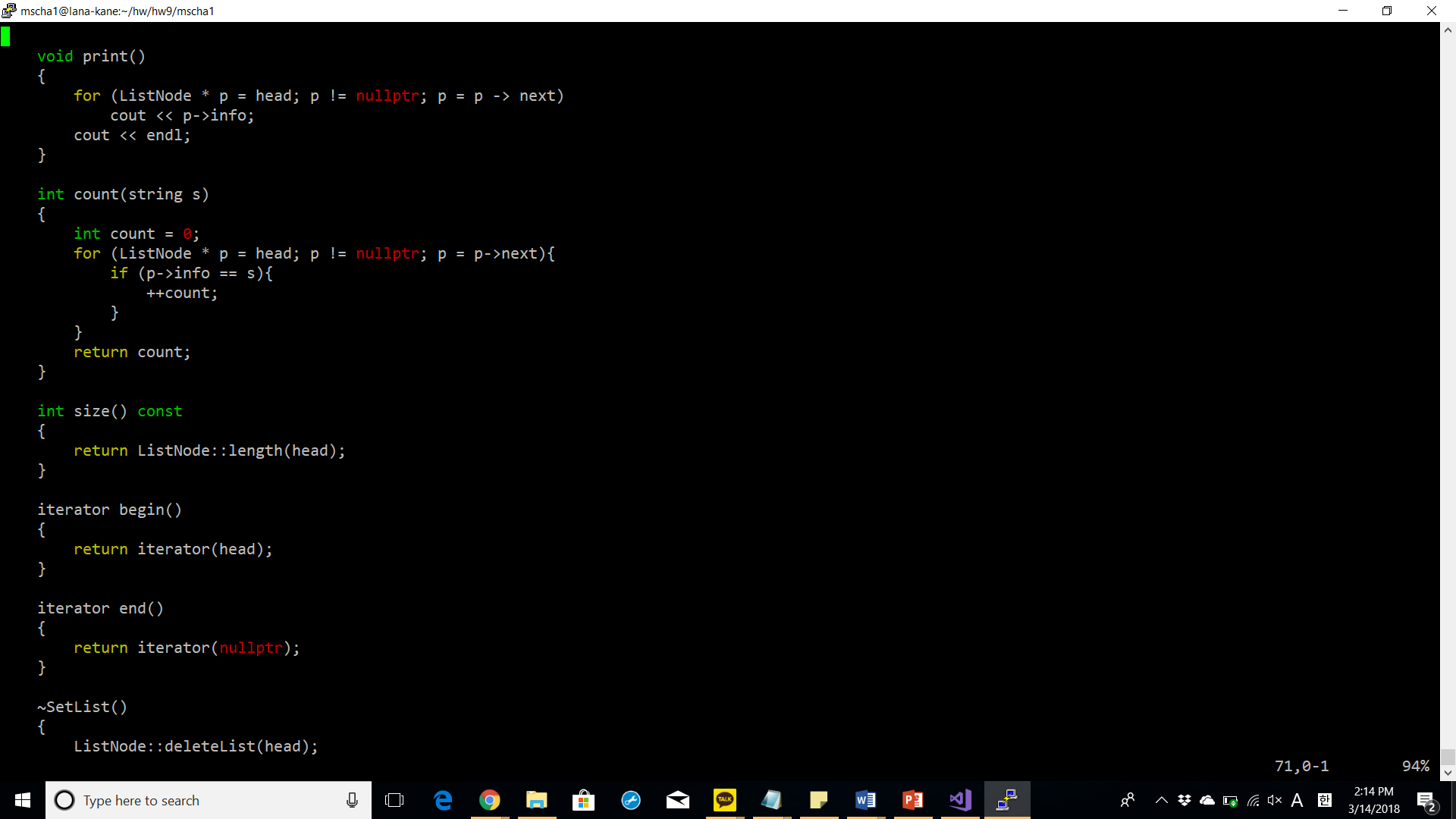

count: iterates over the linked list and if the info of the list node equals the string s parameter the count is increased.

**MapArray.h**

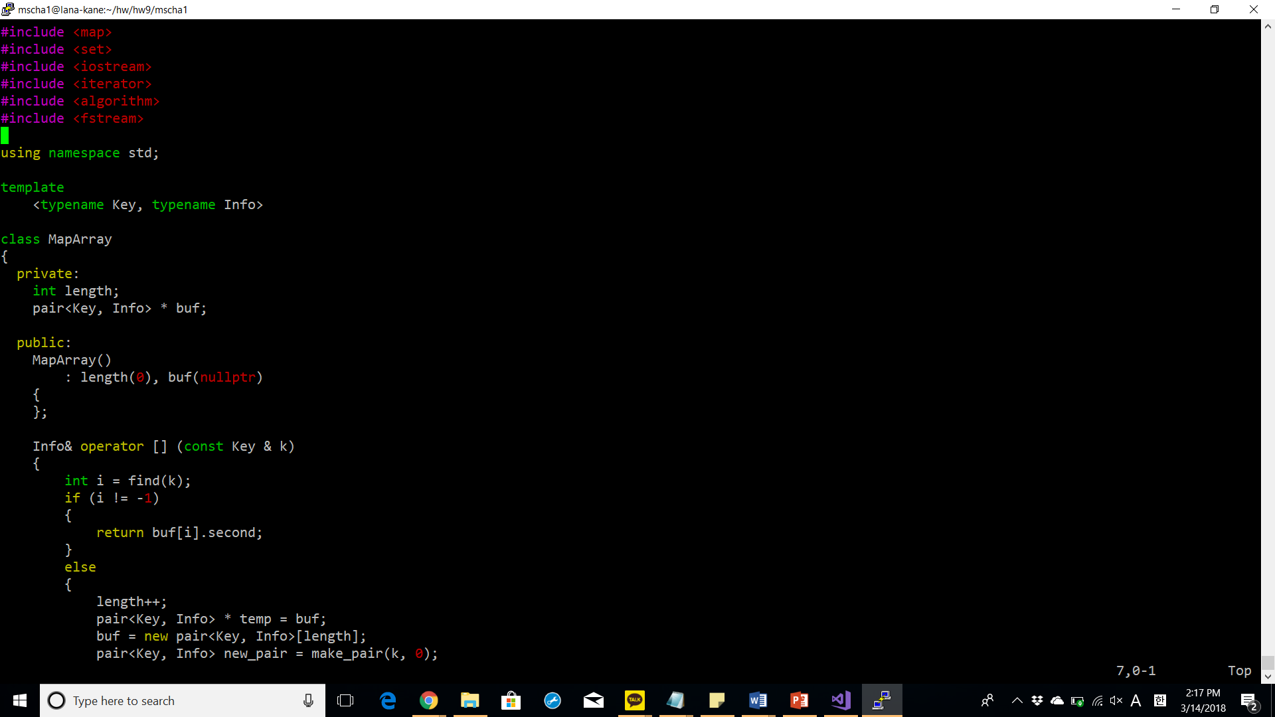

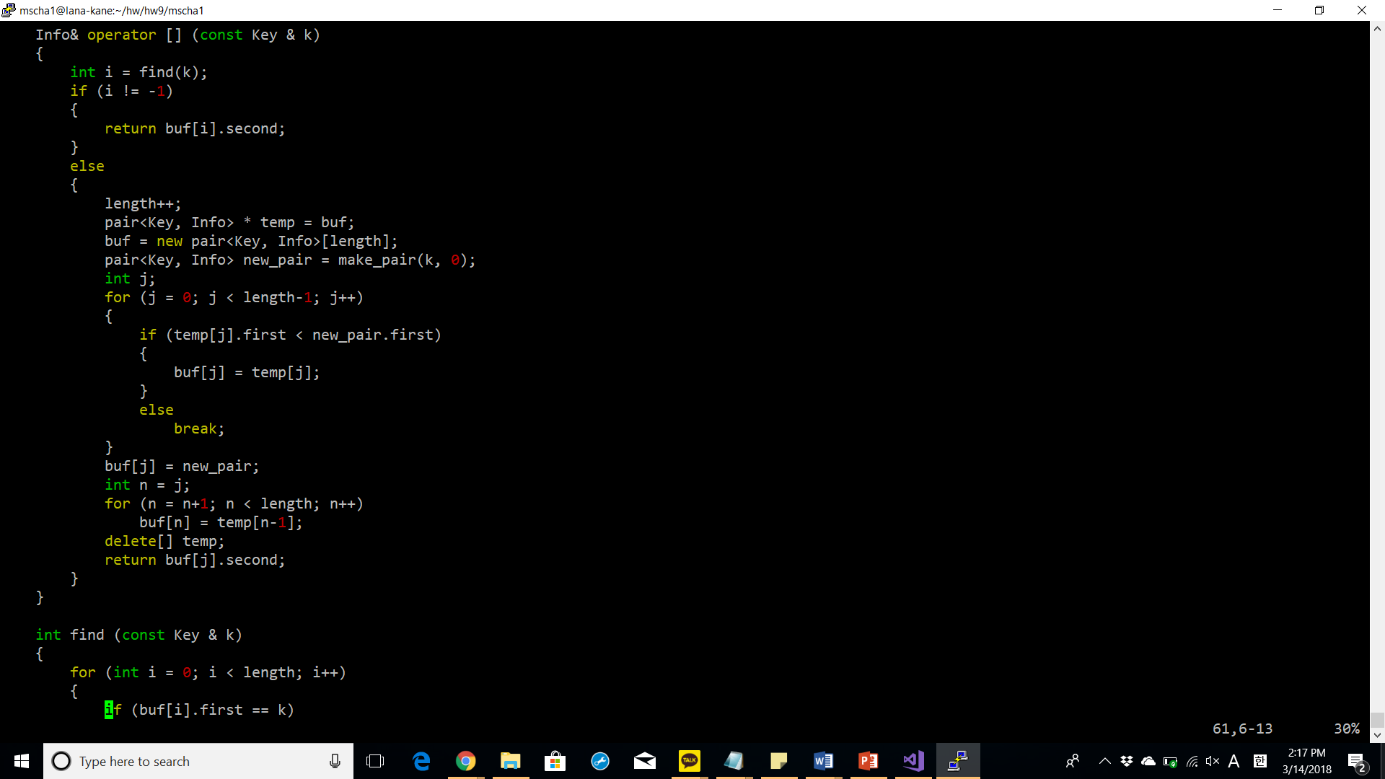

operator []: if the key is found in the MapArray, then the reference of info is returned. Else, the length is increased, the current buf is stored in a temporary pair pointer, and a new array of pairs is constructed. It loops over temp for all the values smaller than the key. The key is inserted. Then, the rest of the temp is copied to the new buf. At the end, temp is deleted and the info of the new pair is returned.

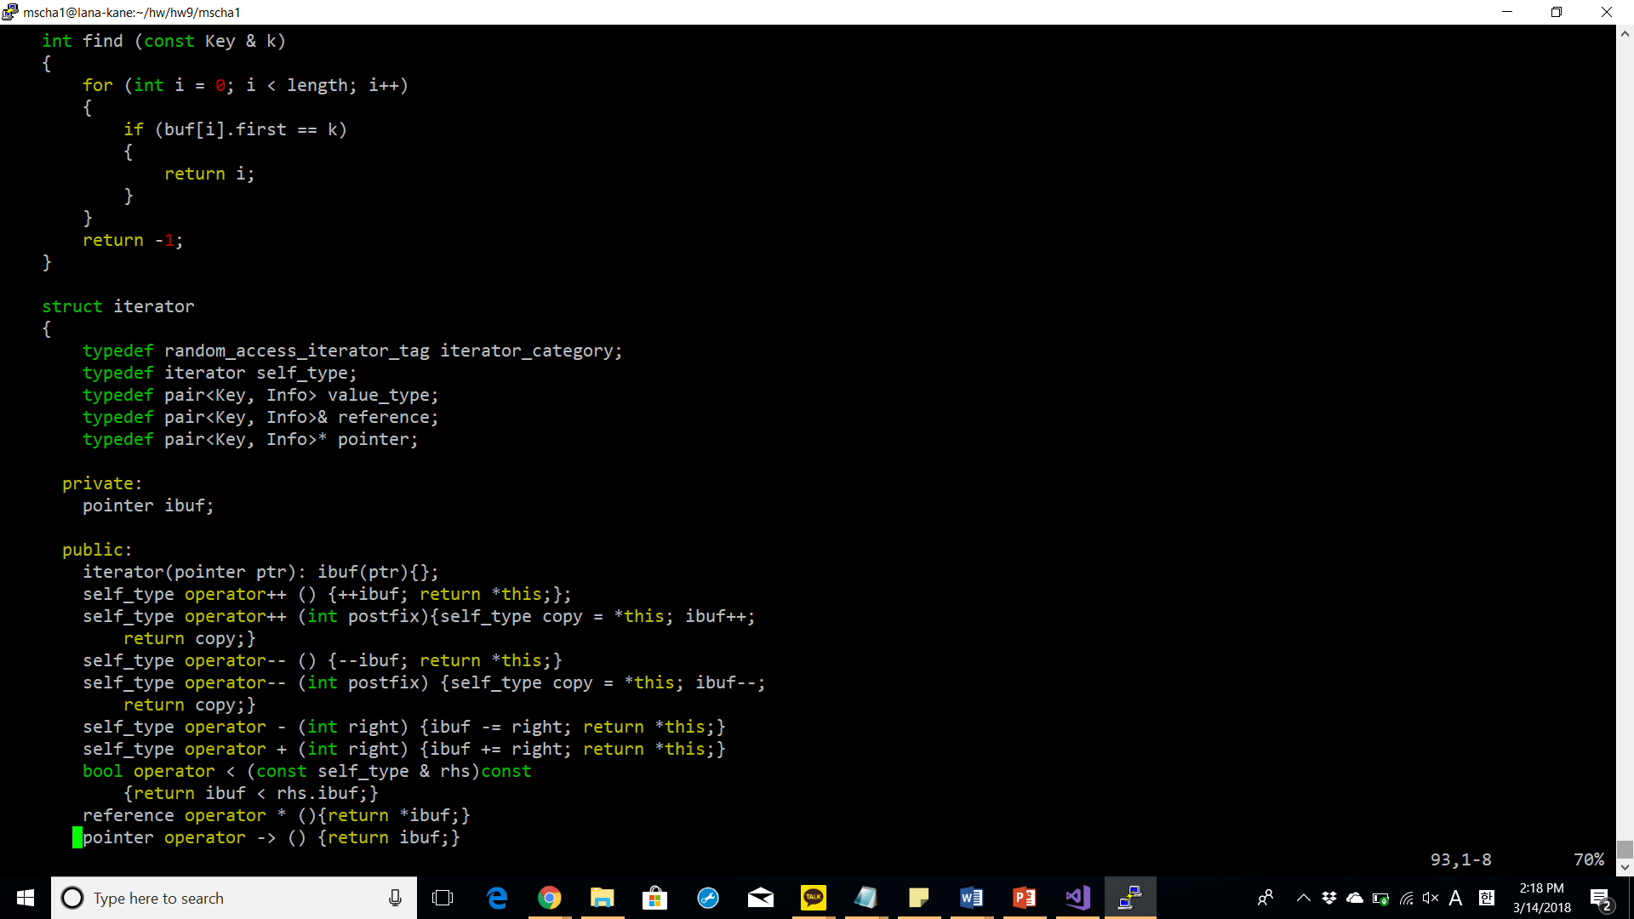

Find: returns the index if the key is found in the array, else -1 is returned.

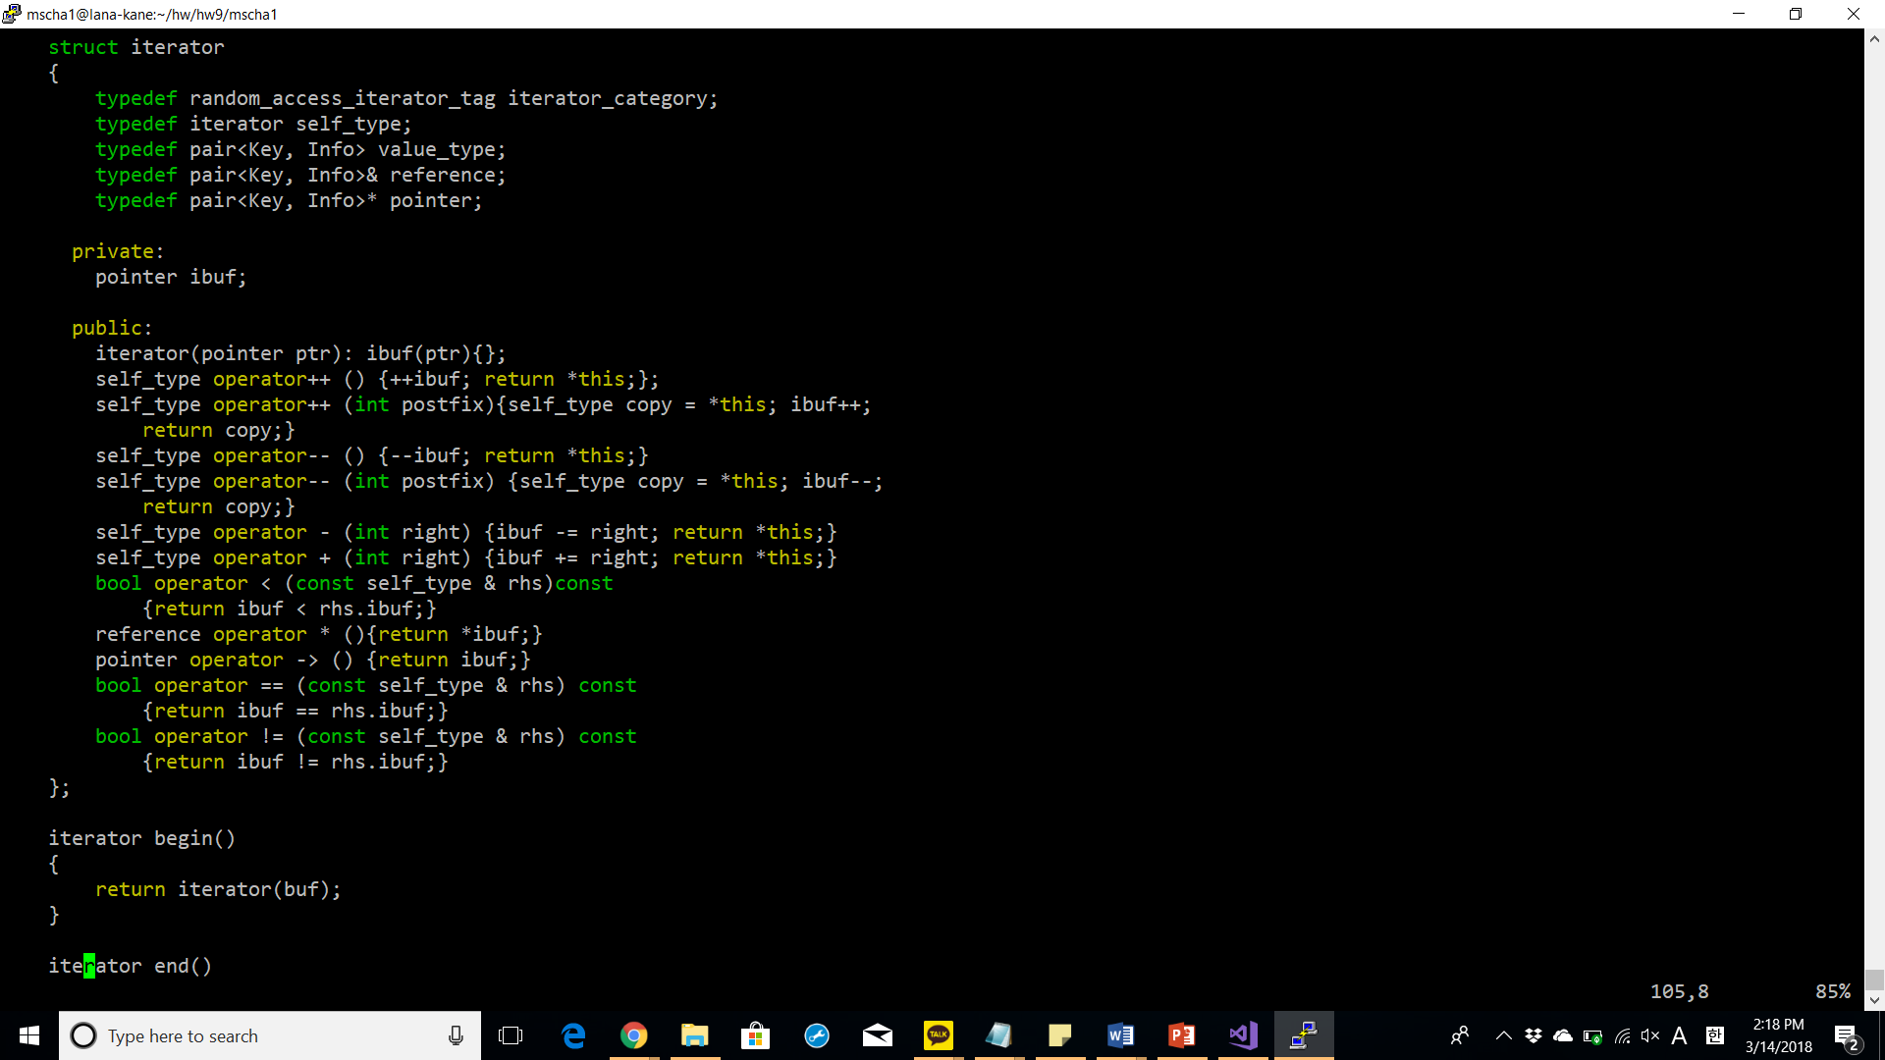

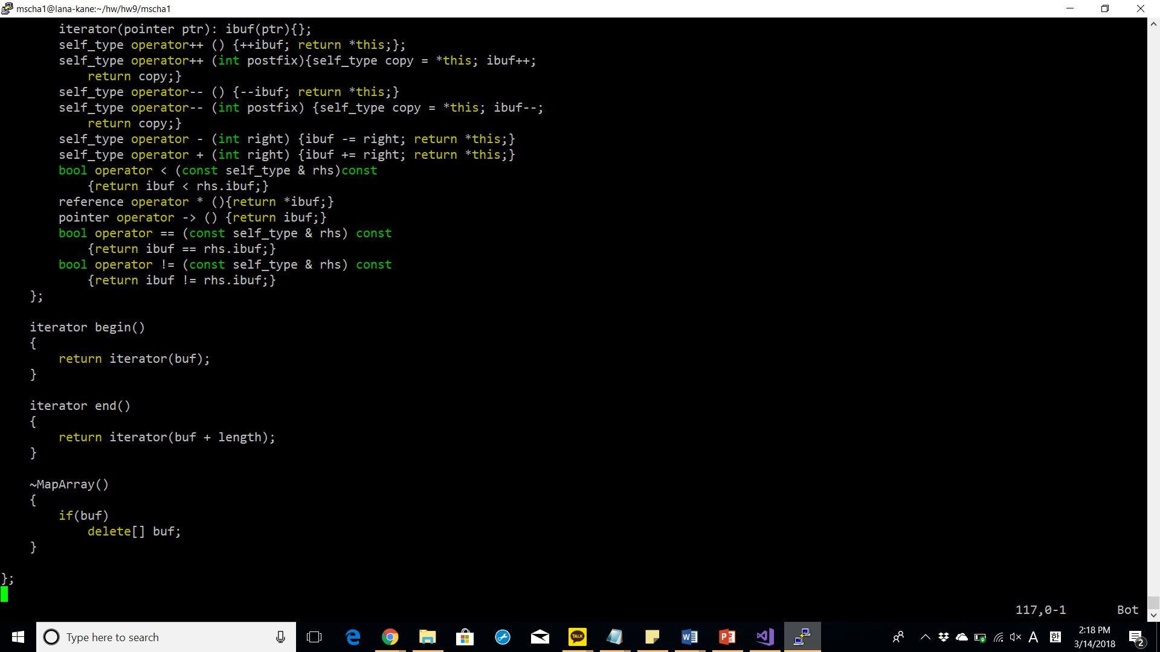

**main.cpp**

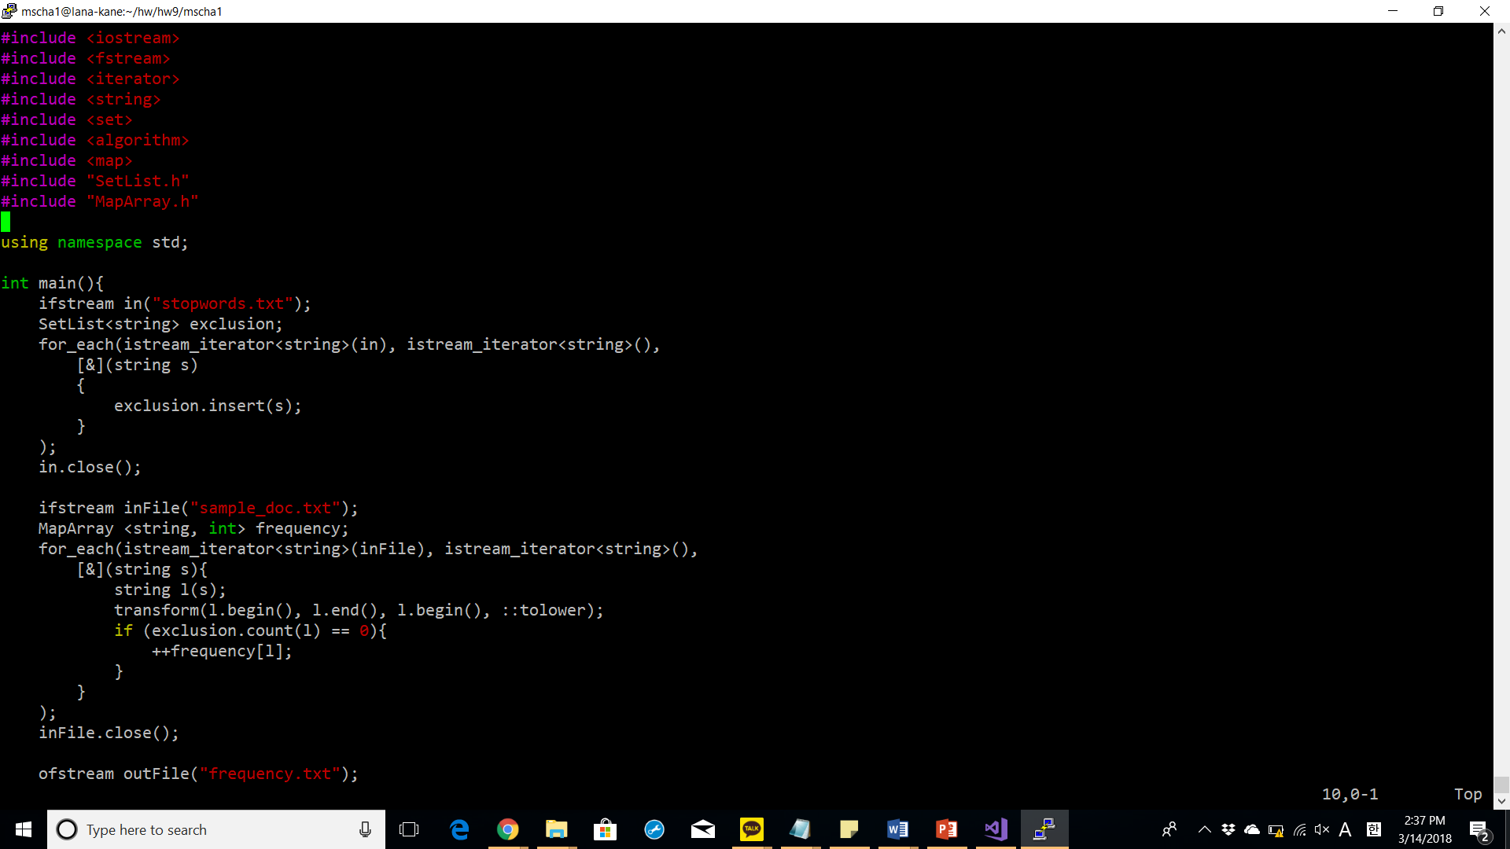

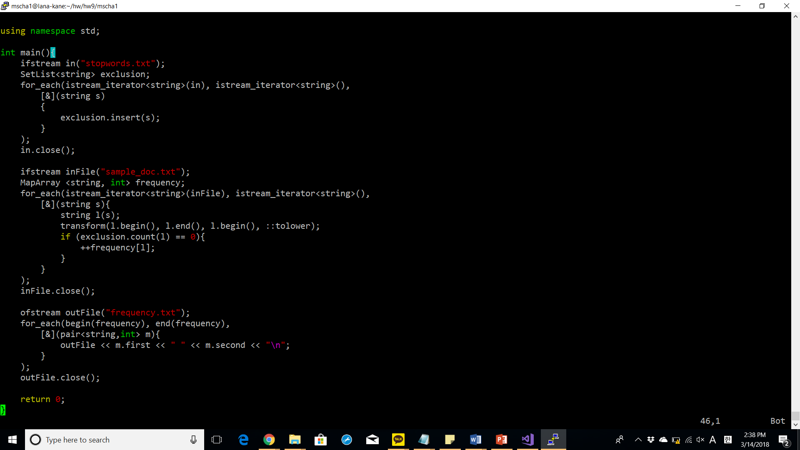

show screenshot of compiling for your program with make command

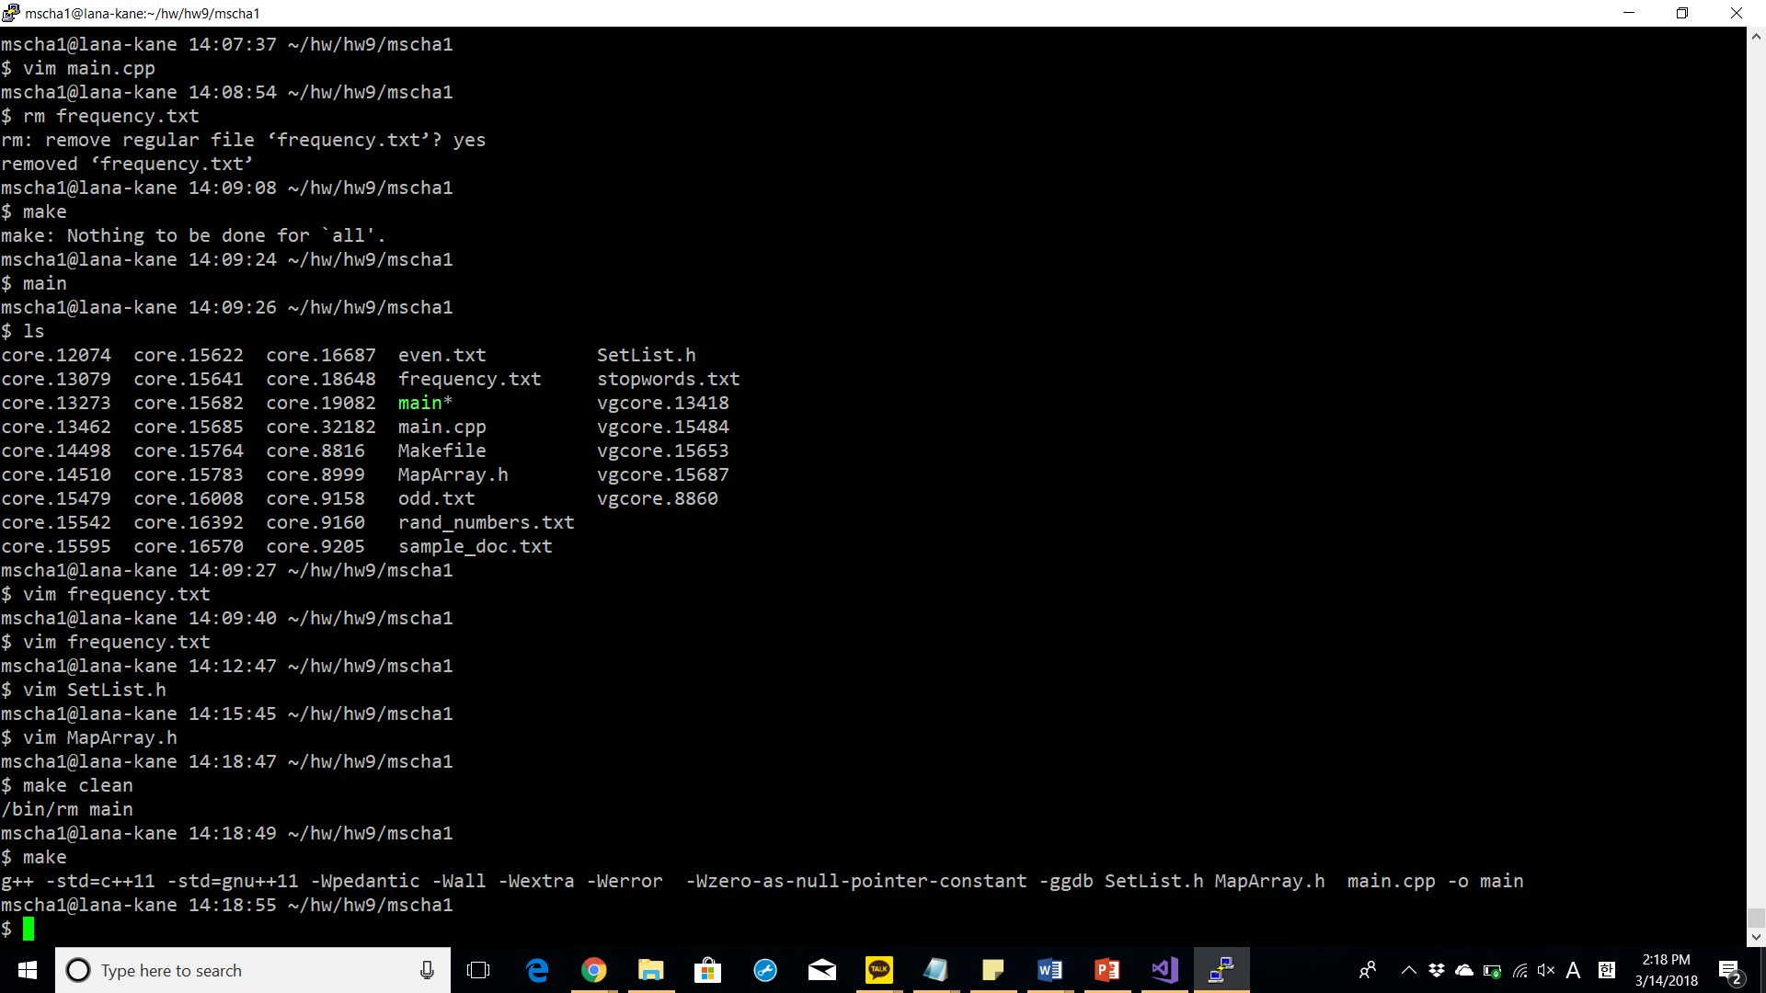

Run your programs with valgrind and include the screenshot.

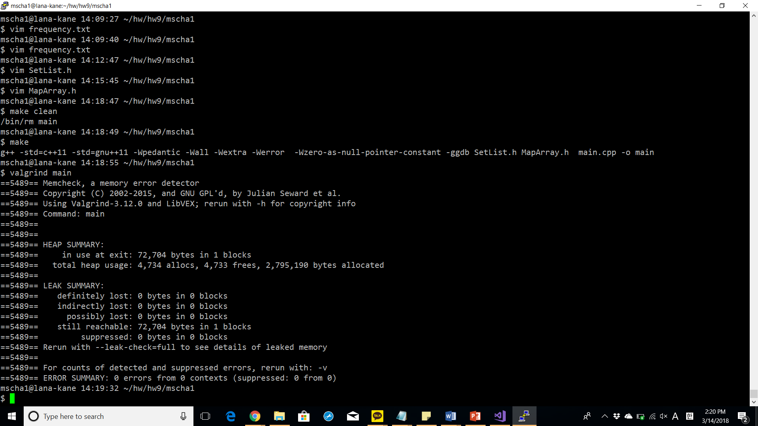

copy and title your,frequency.txt in the report.

**frequency.txt**

abacus 1

abbreviations 1

abstract 2

abstracted 2

abstraction 1

accredited 1

acknowledges 1

act 1

action 1

actionscript 1

activities 1

actual 1

ad 1

ada 1

adacore 1

adaptations 1

add 1

addition 1

addresses 1

adopted 1

affects 1

air 1

al-jazari 1

algebra 1

algorithms 4

allow 1

allowed 5

allows 1

along 1

also 2

although 1

analogous 1

analysis 1

analytical 2

ancient 2

another 1

antikythera 1

application 2

applications 2

architecture 1

areas 2

arithmetic 1

around 2

art 1

artifacts 1

assembly 6

automata 1

automate 1

babbage 1

basic 1

bc 2

became 2

become 1

becoming 1

beginning 1

bernoulli 1

besides 1

beyond 2

binary 1

build 1

building 1

built 1

c 3

calculate 1

calculating 1

calculation 1

calculations 2

calculator 1

calculators 1

calculus 1

calendars 1

call 1

called 1

cams 1

card 3

cards 8

career 2

cases 1

certification 1

challenges 1

changes 1

charles 1

china 1

circa 1

clearance 1

cloth 1

cobol 1

code 6

coding 2

cognitive 1

combines 1

commercial 1

commonly 1

community 1

company 1

compiler 1

complicated 1

computation 1

computational 1

compute 1

computer 11

computers 3

computing 2

conceive 1

conception 1

condition 1

configuration 1

considerably 1

considered 2

consistent 1

consumption 1

control 4

convenient 1

converted 1

core 1

corrections 1

correctness 1

cost 1

countries 3

covers 1

craft 1

crafted 1

created 1

criteria 1

critical 1

cultures 1

cycle 1

data 4

dates 1

debatable 1

debate 3

debugging 1

decisions 1

defined 1

derived 1

design 1

develop 1

developed 7

developing 1

development 5

device 2

devices 2

devising 1

different 10

differs 1

directly 2

discarded 1

discipline 4

domain 1

dozens 1

drive 1

drum 2

drummer 1

due 1

early 1

easier 1

easily 1

easy 1

economic 1

editors 1

efficient 2

efficiently 1

eg 4

elementary 1

elements 1

employed 1

engine 5

engineer 1

engineering 4

engineers 1

enough 1

entered 1

entering 3

entirely 1

entities 1

environments 1

era 2

error 2

europe 1

even 1

every 1

evolvable 2

executable 1

exhaustion 1

existed 1

expertise 1

expressed 1

extent 2

fact 1

faster 1

final 1

find 1

first 4

follow 1

force 1

form 3

formal 1

format 1

forms 1

formula 2

formulation 1

fortran 3

found 1

foundation 2

founded 1

functional 1

fundamental 1

gears 1

general 3

generating 1

geometry 1

giant 1

given 1

goal 1

good 1

governmentally 1

greater 1

greece 1

habitual 1

hardware 2

haskell 1

herman 1

high 2

high-level 3

higher 1

history 1

hole 1

holes 1

hollerith 2

however 2

human 2

humans 1

hypothesis 1

ibm 3

idea 1

ie 1

illegal 1

implementation 5

importing 1

impractical 1

include 3

including 3

increase 1

increasing 1

increasingly 2

incur 1

india 1

industry 1

inexpensive 1

influences 1

initial 1

input 1

instead 1

institution 1

instruction 2

instructions 7

instruments 2

intent 1

invented 5

invention 1

inventions 1

involves 1

jacquard 3

japan 1

java 1

javascript 1

jobs 1

joseph 1

just 1

keypunch 1

knowledge 1

known 2

kurdish 1

labor 1

language 16

languages 11

larger 1

late 2

later 3

leads 1

leaps 1

learn 1

led 1

less 3

let 1

level 2

levers 1

license 1

licensed 1

licensing 1

likely 1

linguistics 1

list 1

lists 1

little 1

locations 1

logic 1

loom 3

looms 1

lovelace 1

low-level 1

lower 1

lunar-to-solar 1

machine 10

machines 4

made 3

maintaining 1

making 1

management 1

manner 1

many 5

marie 1

mathematician 1

maximum 1

may 2

meant 1

measured 1

mechanical 2

mechanism 2

mechanisms 1

mechanized 1

media 1

medieval 1

medium 1

memory 1

method 1

metonic 1

might 2

model 1

modern 4

mostly 1

much 3

musical 1

mutual 1

name 1

nature 1

necessary 1

need 1

neumann 1

new 1

notation 3

number 2

numbers 2

numerical 2

objective-c 1

objects 1

occasionally 1

often 4

olympiads 1

one 4

oneself 1

ongoing 2

operated 1

operating 1

operation 2

operations 3

opportunities 1

opposed 1

order 1

organize 1

original 2

output 2

outsourcing 1

overhead 1

painstakingly 1

panel 1

panels 1

paper 3

part 1

particular 2

particularly 2

parts 1

pass 1

past 1

pasteboard 1

pattern 2

patterns 3

pegs 1

percussion 1

perfectly 1

perform 1

performing 1

perl 1

phase 1

php 1

physically 1

placed 1

playing 1

plugboard 1

popular 2

possibility 1

postulates 1

power 1

practical 1

practices 1

predetermined 1

prior 1

problem 2

process 6

processing 3

produce 2

producing 1

profession 1

professional 1

professions 1

program 6

programmable 2

programmed 1

programmer 4

programmers 5

programming 24

programs 10

progressed 1

prone 1

punch 1

punched 7

punching 1

purpose 1

python 1

read 1

readable 1

rebuilt 1

record 2

recording 1

referred 1

regarded 1

regulated 1

related 1

relations 1

relatively 1

replace 1

represented 1

representing 2

require 1

required 1

requirements 1

requires 1

reserved 1

resources 1

rhythms 1

ruby 1

s 3

sapirwhorf 1

science 2

scientist 1

security 1

see 1

seemed 1

self-governed 1

sequence 3

sequentially 1

series 1

services 1

sets 2

settled 1

several 1

shortened 1

sizes 1

small 1

smalltalk 1

software 9

solution 1

solving 1

sometimes 1

sorter 1

source 5

speaker 1

speakers 1

special 1

specialized 1

specific 2

specified 1

specify 2

specifying 1

speed 2

spoken 1

sql 1

standardized 1

stands 1

states 2

still 3

storage 1

stored 1

strict 1

subject 1

subjects 1

sumeria 1

surrounding 1

susceptible 1

symbolic 1

symbols 1

synthesis 1

system 2

systems 1

tabulating 1

tabulator 2

takes 1

tape 2

target 1

task 2

tasks 1

technical 1

techniques 1

term 2

terminals 1

terms 2

testing 1

tests 1

text 3

theorized 1

things 1

thought 2

thoughts 1

three 1

thus 2

time 2

total 1

tracked 1

translates 1

translation 1

trials 1

trigger 1

turn 1

two 1

type 1

typically 1

typing 1

underlying 1

understanding 1

unit 2

united 2

upon 1

use 5

used 3

uses 2

using 5

usually 4

utilizing 1

various 2

vary 1

verification 1

visual 1

vital 1

von 1

wage 1

way 1

weaves 1

weaving 1

well 1

whether 1

whole 1

whose 2

widely-used 1

will 1

within 1

without 2

wooden 1

world 3

worlds 1

write 1

writing 3

written 1

wrote 1

x 3

y 1

yield 1