Esuabom Dijemeni

Agile coaching skills – certified facilitator

Evidence File

**Table of Contents**

1 Setting the Stage 2

1.1 What is facilitation? 2

1.1.1 LO 1.1 **define** facilitation as a process of guiding a group or team through interactions that help them create meaningful outcomes. 2

1.1.2 LO 1.2 **recognize** when a facilitation stance is appropriate. 3

1.2 Who is a facilitator? 4

1.2.1 LO 1.3 **define** the characteristics of an effective facilitator. 4

1.2.2 LO 1.4 - **practice** the mindset of an effective facilitator 5

# Setting the Stage

## What is facilitation?

### LO 1.1 **define** facilitation as a process of guiding a group or team through interactions that help them create meaningful outcomes.

Facilitation is a set of skills that is used in working with a group, enabling and supporting them to achieve their objectives in a way that involves and respects all contributions, builds ownership and releases the potential of the group and its members. It helps differentiate between process and content.

Facilitation is the ability to guide effective group work. It’s a way to help move people forward, harness contribution and create tangible impact.

Facilitation can be used to lead people toward an agreed-upon objectives in a manner that encourages participation, ownership and creativity by all involved.

Reference

1. What is Facilitation? - <https://ica-uk.org.uk/what-we-mean-by-facilitation/>
2. What is Facilitation? - <https://www.facilitator.school/blog/what-is-facilitation>
3. What is Facilitation? <https://www.scrum.org/resources/what-facilitation>

### LO 1.2 **recognize** when a facilitation stance is appropriate.

Answer 1 – Facilitation Stance

A facilitator stance is appropriate when:

1. **Need to maintain neutrality** – When there is a need to have neutrality in a meeting where you need someone to own the process and the team owning the content i.e bridging competing ideas, sharing what you see in the process with facts, without judgement, a facilitator can help maintain neutrality within the meeting
2. **Stand in the storm** – When there is a need for seeking out and listening to differing stances, perspectives, and options without taking sides, a facilitator can hold the space for all to speak and be heard during a meeting
3. **Honour the wisdom of the group** – When the core is about trust – trusting that the group has its own wisdom and developing an environment where each member of the team can grow, stretch, and achieve as a respected and valued collaborator, a facilitator can help honour the wisdom of the Group
4. **Hold the group’s agenda** – When you need to continually ask “How can I best serve this group?” or “What does this group really need right now?”, A facilitator is required to support the team to focus and be curious by holding the group’s agenda
5. **Uphold the Agile Mindset** – When there is a need implementing or building a culture of agility, modelling agile values, and maintaining a servant leadership stance, a facilitator can help the team / organisation adapt the agile mindset, methods, practices and actions.

Answer 2 – Application Based

A facilitator stance is appropriate when:

1. **Value Delivery** – when a group needs to deliver a key business value which required multiple stakeholders in a complex environment, a facilitator can help structure the process, keep the group focused on value delivery
2. **Group Decision-Making** – when a group needs to make a decision collectively and ensure that all voices are heard, a facilitator can guide the process to ensure participation and help reach a consensus
3. **Meeting** – when a group needs a meeting to run on time, achieve its desired value and be productive, a facilitator can help keep a meeting on tract and ensure that everyone has a chance to participate and meeting objectives is achieved
4. **Conflict resolution** – In a situation where there is conflict or disagreement within a group, a facilitator can help mediate discussions and ensure that perspectives are considered, and work towards a resolution
5. **Learning and Development** – During training session, workshops or education activities, a facilitator can help guide learning and development, encourage engagement, and help participants apply new concepts.

Reference

1. Five Guiding Principles of an Agile Team Facilitation Stance – <https://teamcatapult.com/5-guiding-principles-of-effective-facilitation/>

## Who is a facilitator?

### LO 1.3 **define** the characteristics of an effective facilitator.

A facilitator is a person who guides a group of people through a process that achieves their client’s desired outcome. Everyone in the group contributes to, understands and accepts the results because the facilitator supports a process that maximizes participation, creativity, and productivity.

The characteristics of a facilitator are:

1. tenacious about understanding the value gained from a meeting or event
2. believes in the power of collaboration to come to the best outcomes and designs processes around that belief
3. observant of participants’ behaviour, energy, and interactions and can address dysfunctions as they arise
4. Excels at facilitative listening, creating a productive and creative environment and holding that space for people to step into and do their best work
5. keeps track of the time and where they are in their plan, changing their plan as needed by the participants to reach the desired outcome
6. continues to evaluate and learn new tools and techniques and how to apply them appropriately to achieve the outcomes they are asked for.
7. passionate about their craft, practicing it to the best of their ability, and engaging in continuous learning to support them in their craft

Reference

1. What Is a Facilitator? - <https://resources.scrumalliance.org/article/facilitator>

### LO 1.4 - **practice** the mindset of an effective facilitator

**Case Study**

Your client is a one of the largest financial institutions with specialisation Insurance, asset management and pension management. They have different businesses and departments within its group structure. They are currently undergoing a strategic data transformation programme. There is a need to send strategic ESG data across two businesses with the financial group. There is lack of clarify, structure and progress with sending strategic ESG data. What would you do as an effective facilitator to ensure the delivery of strategic ESG data using strategic solutions?

**Answer**

**Situation** – My client is a one of the largest financial institutions with specialisation Insurance, asset management and pension management. They have different businesses and departments within its group structure. They are currently undergoing a strategic data transformation programme. There is a need to send strategic ESG data across two businesses with the financial group. There is lack of clarify, structure and progress with sending strategic ESG data.

**Task** – Facilitate enterprise data delivery for ESG data across different businesses within one of the largest financial institutions with specialisation Insurance, asset management and pension management.

**Actions**

1. **Created an environment to help move people forward, harness contribution and create tangible impact**
   1. Setup up a bi weekly (Tuesday and Thursday) sync up call between the technical teams and business teams across the two business
2. **Honour the wisdom of the group**
   1. Facilitated brainstorming sessions and technical workshops with key stakeholders across the group to create a working solution after the initial strategic solution was not feasible to meet the strategic delivery data
3. **Stand in the storm**
   1. Created an working environment where both business parities could constructive discuss differing perspectives and technical viewpoint
   2. Supported teams navigating healthy dissatisfactions and disappointment
4. **Maintained Neutrality** 
   1. Ensured there was a strong sense of neutrality in ensuring we create a working solution for ensuring strategic ESG data is delivered
   2. Ensured neutrality within the meeting – no judgment, no abuse and no rude form of communication
5. **Hold the group’s agenda**
   1. Ensured the cross-functional teams were focussed on the key goal fo our working group
      1. How can we best delivery strategic ESG data?
      2. What does this group really need right now?
6. **Uploaded Agile/Lean mindset**
   1. Created an agile & lean mindset within the group
   2. Implemented a continuous feedback mechanism between the two business groups
   3. Reduced waste in the process and focussed the team in value delivery

**Outcome**

1. A working solution design and implementation for delivering strategic ESG data was implemented based on the group’s wisdom in an agile way
2. Empowered investment teams, reporting teams, risk team, marketing team and more business team with strategic ESG data
3. Built a strong collaborative cross-business team within the bigger group, enabling and supporting them to achieve their strategic objectives

# Understanding Group’s Context and Needs

## Before Facilitation

### LO 2.1 **identify** the purpose and intended outcomes for the session.

**Case Study**

A new scrum master at a growing EdTech company has approved you as an experienced Scrum Master to support in improving her facilitation skills as a Scrum Master. She has observed that she has challenges in identifying the purpose and intended outcomes for her session. She is seeking coaching on how to structure / frame the identified purpose and intended outcome for a session

**Solution**

**Situation**

A new scrum master at a growing EdTech company has approved you as an experienced Scrum Master to support in improving her facilitation skills as a Scrum Master. She has observed that she has challenges in identifying the purpose and intended outcomes for her session. She is seeking coaching on how to structure / frame the identified purpose and intended outcome for a session

**Task**

Coach a growing Scrum Master on how to structure / frame an identified purpose and intended outcome for a session

**Action**

The key actions taken:

1. Create a coaching working agreement
2. Coached on the use of Facilitation Canvas for structuring and framing the identified purpose and intended outcomes for a session
   1. Purpose
      1. What are we looking to achieve?
   2. Outcomes
      1. What are the outcomes needed to make the session a success?
   3. People
      1. Who needs to be part of this session and what is their role?
   4. Inputs
      1. What inputs need to be brought along to the session for background and discussions?
   5. Agenda
      1. How will we structure the session?
   6. Environment
      1. How will you create the environment in which participants can achieve their intended purpose and desired outcome?
   7. Outputs
      1. What outputs / deliverables are expected to be produced in the session?
   8. Pitfalls
      1. What could hinder the session
3. Coached on how to fill Facilitation Canvas individually, with Scrum Team and with stakeholders using Miro

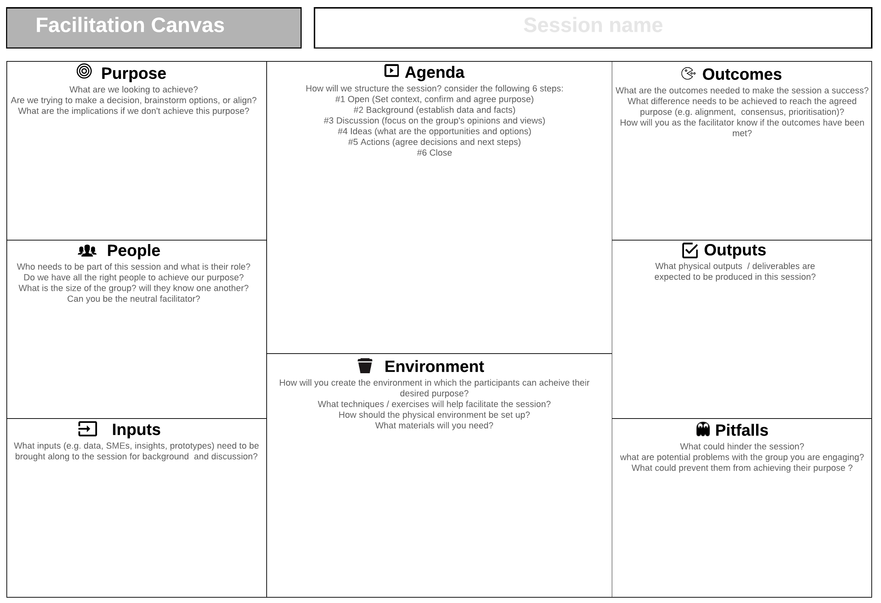

Figure 1 - Facilitation Canvas

**Outcomes**

At the end of the Facilitation Coaching Sessions,

1. New Scrum Master gained new understanding on how to collaboratively set the intended purpose and desired outcome of a session using Facilitation Canvas
2. New Scrum Master gained confidence in facilitation session especially technical session with challenging stakeholders with unclear desired outcome
3. New Scrum Master acknowledge personal growth as a facilitator

Reference:

1. Facilitation Canvas - <https://nomad8.com/articles/facilitation-canvas>

Facilitation Canvas - <https://miro.com/miroverse/facilitation-canvas/?social=copy-link>

## During Facilitation