Caleb Klenda

Homework 1

1/26/2025

**Part 1**

1.1)

digraph BST {

// General graph attributes

graph [

label="Binary Search Tree (BST)"

labelloc="t"

fontsize=20

];

node [

shape=circle

style=filled

color=lightblue

];

// Edges representing the BST structure

5 -> 3;

5 -> 8;

3 -> 2;

3 -> 4;

8 -> 7;

8 -> 9;

9 -> 10;

7 -> 6;

2 -> 1;

1 [label="1"];

2 [label="2"];

3 [label="3"];

4 [label="4"];

5 [label="5" fillcolor=yellow];

6 [label="6"];

7 [label="7"];

8 [label="8"];

9 [label="9"];

10 [label="10"];

}

1.2)

graph Konigsberg {

graph [label="Seven Bridges of Königsberg", labelloc="t", fontsize=20, splines=true, overlap=false];

node [shape=circle, style=filled, color=lightblue];

A [pos="0,1!"];

B [pos="2,-1!"];

C [pos="-1,-1!"];

D [pos="1,0!"];

// Edges representing bridges

A -- C;

A -- C;

A -- D;

B -- C;

B -- C;

B -- D;

C -- D;

}

1.3)

digraph SyntaxTree {

graph [label="Syntax Tree: 'The man took the book'", labelloc="t", fontsize=20];

node [shape=ellipse, style=filled, color=lightblue];

S [label="#Sentence#"];

NP1 [label="NP"];

VP [label="VP"];

V [label="Verb"];

NP2 [label="NP"];

N1 [label="N"];

Man [label="The man"];

Took [label="took"];

Book [label="the book"];

// Relationships

S -> NP1;

S -> VP;

NP1 -> N1;

N1 -> Man;

VP -> NP2;

NP2 -> Book;

VP -> V;

V -> Took;

}

**Part 2**

2.1)

2.2)

Expression: (S(NP(Det The)(N man))(VP(V took)(NP(Det the)(N book))))

**Part 3**

Expression: (5(3(2(1))(4))(8(7(6))(9(10))))

**Part 4**

4.1)

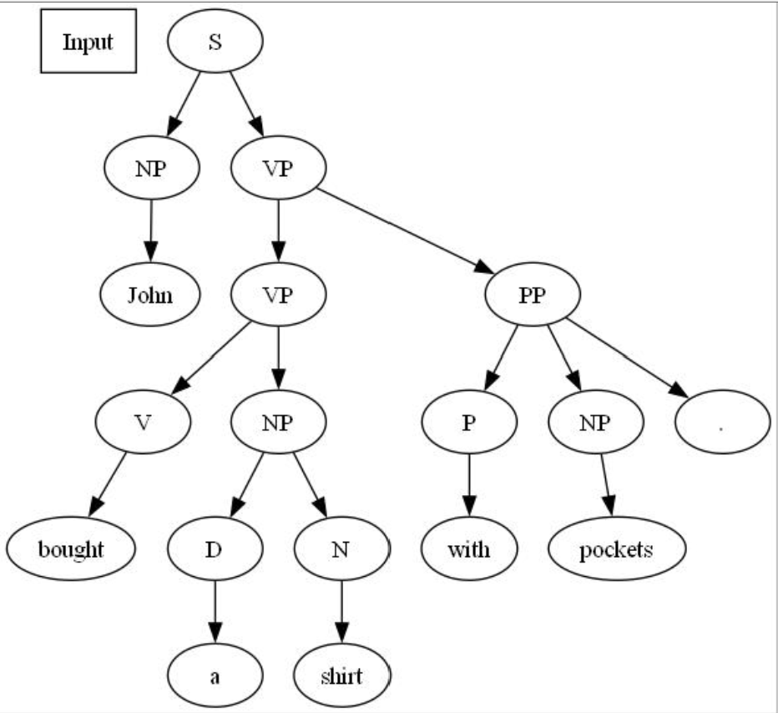

4.2)

In this case, pockets_1.txt (left graph) generates a more coherent sentence. It defines the whole phrase “a shirt with pockets” as a singular noun phrase. Pockets_2.txt creates a syntax tree that implies “with pockets” is applied to the verb “bought” which of course makes no real sense.

4.3)

In this case, the semantic implications are inverted from 4.2. “Cash” only makes sense in the sentence when applied as a modifier to the verb “bought”. So the second syntax tree makes more sense.

**Part 5**

5.1)

The Constituency parse with cash matches the expectation in that the “with cash” part is a prepositional phrase applied to verb phrase “bought”. The Constituency parse for the pocket sentence is identical to the parse for the cash sentence. In the case of the pockets, it is incorrect still as it applies the prepositional phrase “with pockets” to the verb phrase “bought” instead of correctly to the noun phrase “a shirt”.

5.2)

POS in this context refers to part-of-speech. It is a symbolic categorization of each word of a sentence by its use in that sentence.