Supplement E: Design Elements of Management Scenarios
Claire Kouba
2026-02-13
## png
## 2
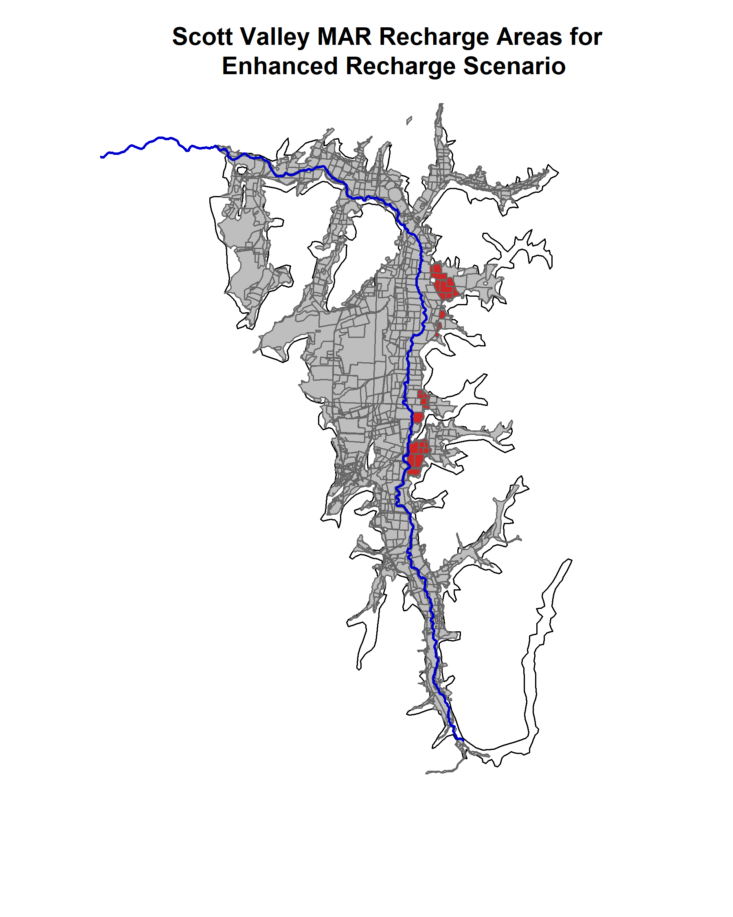
Figure 1: Fields used in the 2024 MAR recharge pilot program. These fields were used to specify areas where winter recharge (Jan-March) was applied each year in the Enhanced Recharge scenario.
## png
## 2
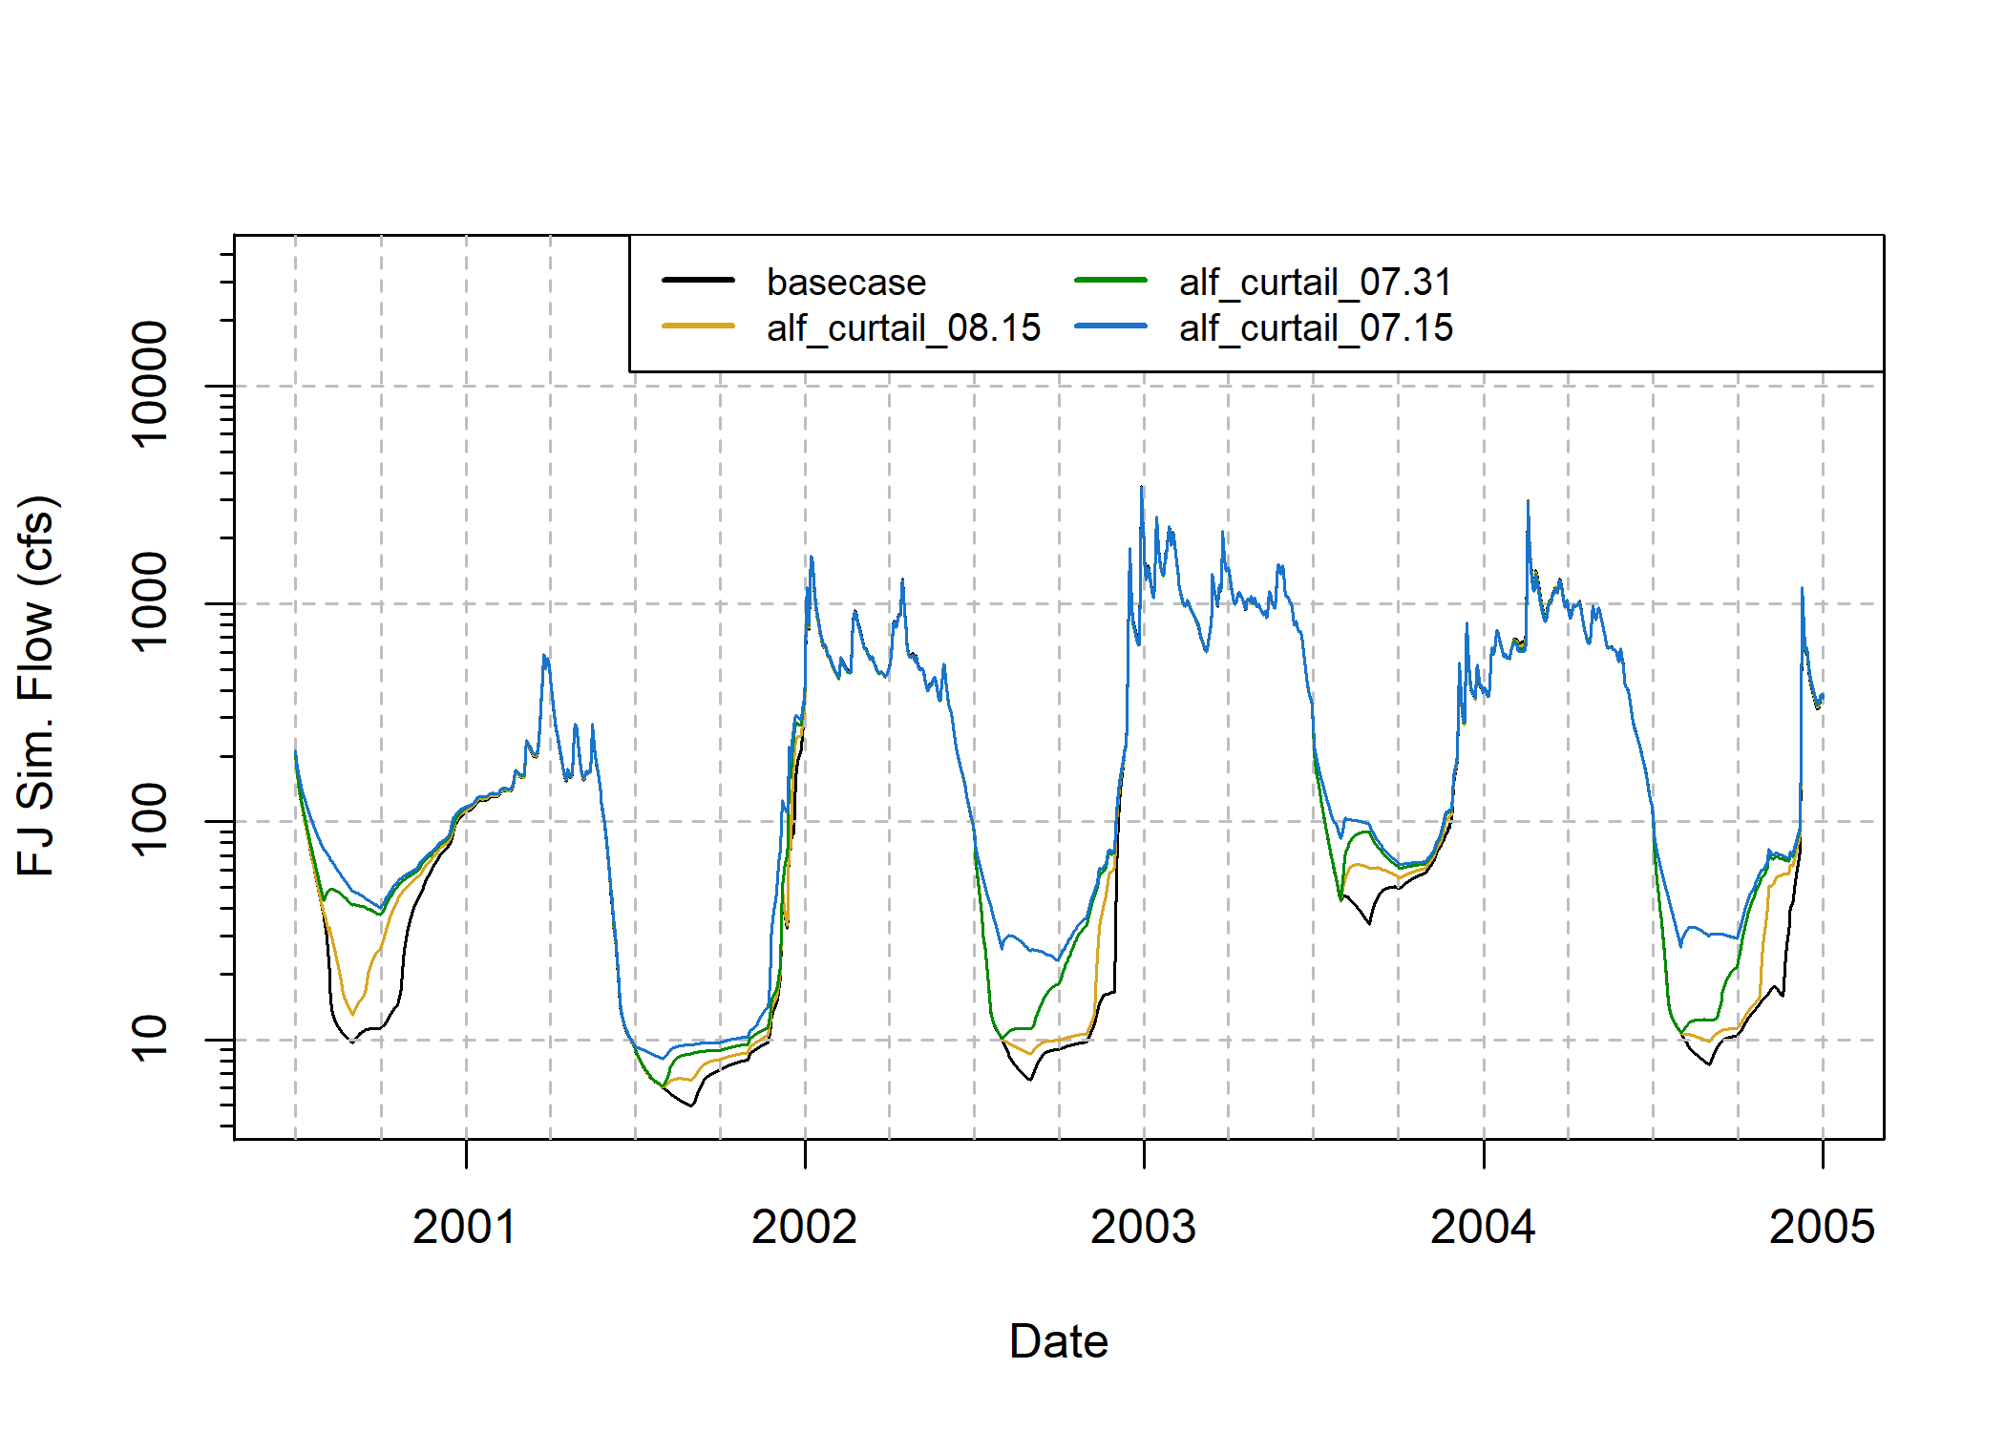
Figure 2: Example scenario impacts on river flow: simulated FJ daily average flow (the basis for functional flows, which is the basis for HB function values) for multiple scenarios.

