Multi-objective assessment of a stakeholder-defined portfolio of groundwater and stream management actions in an agricultural basin
Claire Kouba
2024-11-27

Abstract
In rural areas of western North America, agricultural and environmental water needs often come into conflict, and robust management of water resources may require predicting the hydrologic response of complex interconnected surface and groundwater systems to various management actions. Increasingly, to support policy choices, managers in California rely on analyses using hydrologic models, but in many cases these models can provide confusing or overwhelming amounts of information. In this study, we address these challenges for a case study jurisdiction in northern California, which recently finalized a long-term Groundwater Sustainability Plan (GSP). We developed a summary statistic or proxy for each of the three primary policy objectives in the GSP (environmental, agricultural, and project cost). We then used them to summarize the results of 40 management scenarios developed for the GSP in Scott Valley in Northern California, which were simulated using an existing integrated surface- and groundwater model.
We found that a trade-off in benefits for fish and farms was evident in every category of infrastructure investment (a proxy for project cost), though greater infrastructure investment can achieve some reductions in this trade-off. Additionally, although the GSP management priorities emphasized infrastructure investments, both infrastructure-based and regulatory approaches fell within the Pareto-optimal set of management options under a strict application of these objective functions. Finally, regarding regulatory actions, management interventions targeted at low-flow periods produced a more efficient gain in environmental flow value per cost in agricultural productivity. The development of basin-specific objective functions, especially ones using output from existing hydrologic models, could help quantify management decision trade-offs and improve stakeholder communication in ongoing water planning efforts throughout the region.

1 Introduction
Sustainable development of water resources, in an era of climate change and increasing human water consumption (e.g., Williams et al. 2020; Rodell et al. 2018), requires an interdisciplinary understanding of connected socio-hydrologic systems (Reuss 1992; Di Baldassarre et al. 2019). One such interdisciplinary approach is water resources systems analysis (WRSA), which involves applying optimization methods to water resource planning (Maass et al. 1962; Cohon and Marks 1975; C. M. Brown et al. 2015). The utility of such studies typically depends on robust definitions of the “objective function(s)”, which summarize and quantify the desired outcome(s) of the proposed project or management scenario (Gorelick 1983). In practice, classical WRSA approaches have been criticized as being too removed from stakeholder concerns (e.g., Rogers and Fiering 1986). In this study, we take advantage of the authors’ involvement in an existing water resource planning process, and a previously-developed integrated surface- and groundwater model [the Scott Valley Integrated Hydrologic Model, or SVIHM; Tolley, Foglia, and Harter (2019)], to test the utility of introducing elements of multi-objective optimization into the prioritization of groundwater management alternatives.
In our study area, the intermontane rural Scott Valley in northern California (Figure 1), the local government and public stakeholders recently spent three years developing a plan for the long-term use of groundwater (a Groundwater Sustainability Plan or GSP). In that process, they evaluated dozens of potential water management scenarios (Siskiyou County 2021). In public meetings, different objectives were often championed by individual stakeholders or interest groups. An integrated hydrologic model was available to support this policy-making process, and the numerical streamflow results of simulated management scenarios drove decision-making, but discussions on the balancing of multiple objectives were typically qualitative. In effect, the optimization framework used to arrive at the ultimate list of management priorities was implicit, and the conceptual weight given to different objectives varied between stakeholders.
Differences between stakeholders in what is considered an acceptable trade-off are common in policy decisions (Monarchi, Kisiel, and Duckstein 1973). Consequently, multi-objective optimization studies commonly avoid proposing a single optimal solution; instead they identify a Pareto-optimal or non-inferior set of options, which can clarify the unavoidable trade-offs in the performance of various system objectives (e.g., Cohon and Marks 1973). Methods for finding the non-inferior set often involve uniform or randomized initial sampling of the decision space (e.g., Monarchi, Kisiel, and Duckstein 1973; Yeh and Becker 1982; Kapelan, Savic, and Walters 2005). In the case of the Scott Valley GSP, the management actions considered by stakeholders covered a wide range of decision variables (e.g., land use changes, technology and/or infrastructure investment, and regulatory interventions on a range of growing season dates). Because a full randomized sampling of this decision space would be computationally prohibitive, this study instead focused on a set of simulated management scenarios that were effectively pre-screened by stakeholders for feasibility in the landscape of existing land uses and political dynamics.
To investigate whether an explicit optimization framework would yield different prioritization of management actions than the set agreed upon in public meetings, we developed numerical representations of three objectives: 1) maximizing specific environmental flows, 2) minimizing reduction in agricultural water supplies, and 3) minimizing new infrastructure costs. With these, we quantitatively summarized the management benefits and trade-offs within the existing suite of several dozen stakeholder-proposed management scenarios.
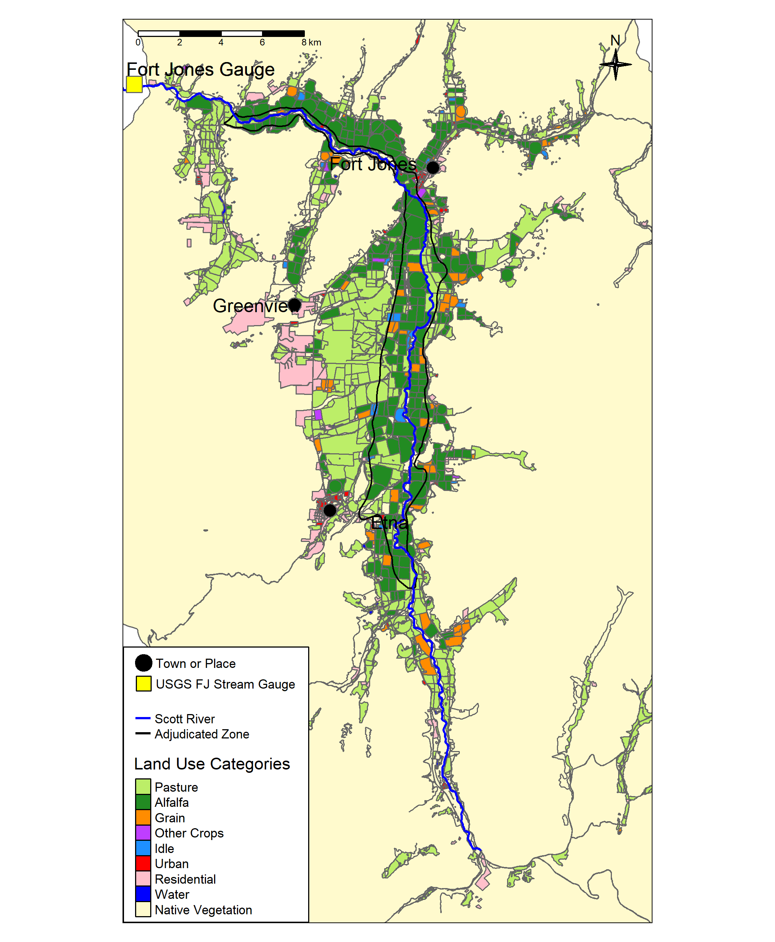
Figure 1: The Scott River flows south to north through Scott Valley before flowing through a canyon and joining the Klamath River. Land uses in the cultivated areas of the Scott River watershed are shown (adapted from the 2016 DWR Land Use Survey), as well as the location of several communities and the Fort Jones streamflow gauge (USGS Station ID 11519500).

2 Case study and summary of GSP development

2.1 Hydrography and climate
The Scott River drains a 2,109 km² (814 square mile) intermontane watershed known as Scott Valley, surrounded by several mountain ranges, including the Scott Bar, Marble, Salmon and Scott Mountains to the north, west, southwest, and south, respectively. The valley floor overlies unconsolidated alluvial sediments of up to 79 m (260 ft) thickness (SWRCB 1975). The sediments form a mostly unconfined aquifer system bordered by low permeable, fractured underlying and adjacent bedrock composed of mostly Paleozoic metasedimentary formations (Mack 1958).
The Scott River begins near the community of Callahan, where the East and South Forks of the Scott River converge, and flows north through the agricultural and residential areas of Scott Valley (Figure 1). Then, 58.0 km (36.0 mi) downstream of Callahan, it passes a key stream gauge (USGS Station ID 11519500, or the Fort Jones Gauge or FJ Gauge) and enters more rugged terrain, flowing 34.7 km (21.6 mi) through a steep canyon until it meets the Klamath River. Because practically all water use in Scott Valley occurs upgradient of the FJ Gauge, it is used to assess hydrologic conditions and inform water management decisions in the populated areas of the valley (e.g., Siskiyou County 2021).
Scott Valley has a Mediterranean precipitation regime with distinctive seasons of cold, wet winters and warm, dry summers (Figure 2), panels A and B). Melting snowpack in the surrounding mountains generates streamflow from April through July, though onset and duration of snowmelt varies based on the snowpack volume and timing of warm air temperatures. This seasonality in water input creates seasonal flow in the Scott River and tributary streams, which experience a pronounced wet season and dry season with high and low flows, respectively (Figure 2, panel C).
Streams and groundwater are highly interconnected in the Scott River watershed. Tributary streams and the Scott River are a source of recharge to the aquifer, and groundwater discharge sustains streamflow in some areas, especially during the dry season of August-October or November. In the past two decades, in most dry-to-average type water years, the water table elevation has fallen below the stream bed and reaches of the Scott River have gone dry (Tolley, Foglia, and Harter 2019).
## png
## 2
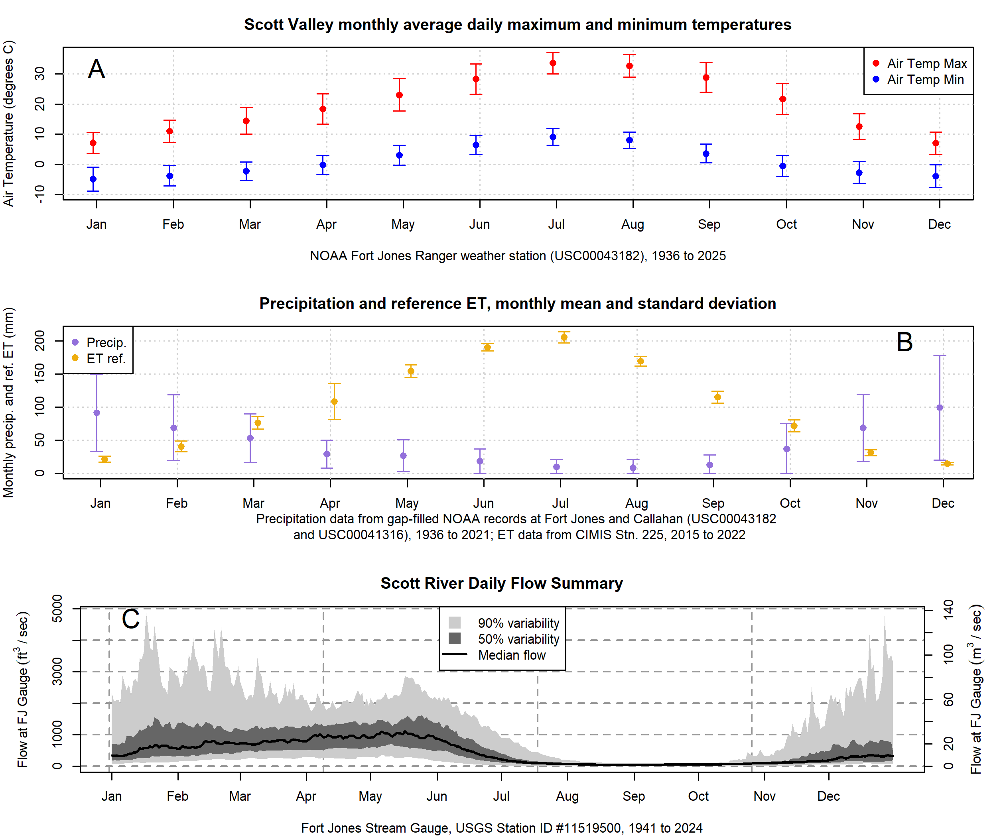
Figure 2: Summary of temperature (Panel A), rainfall and reference evapotranspiration (Panel B), and daily streamflow values (Panel C) in Scott Valley. For precipitation, regression relationships between the Callahan and Fort Jones weather station records and the records of NOAA stations in Greenview, Etna, and Yreka (USC00042899, USC00043614, USC00049866, and US1CASK0005) were used to predict missing values (i.e., fill gaps) in the Callahan and Fort Jones records; the daily mean of the two stations was used as the final precipitation record for purposes of this figure and the SVIHM precipitation input.

2.2 Human population, land use, and local economy
The population of Scott Valley is approximately 5,200, based on area-weighted block-level 2020 census data, including the populations of the two incorporated towns of Etna and Fort Jones [population 678 and 695, respectively; U.S. Census Bureau (2021)]. About two thirds of the land within the Scott River watershed is under private ownership with the remaining area managed by the Quartz Valley Indian Reservation, the United States (U.S.) Department of the Interior Bureau of Land Management (BLM) and U.S. Forest Service (USFS) (Harter and Hines 2008). Much of the upper mountainous area of the watershed is part of the Klamath National Forest. On the valley floor, according to land use surveys conducted by DWR (DWR 2017), half of the area overlying the alluvial aquifer is covered by agriculture, with most of that split approximately evenly between pasture and an alfalfa/grain rotation (Figure 1; Table 1).
Fort Jones and Etna are categorized as severely economically disadvantaged (defined as communities with an annual median household income [MHI] of less than 60% of the average annual MHI in California). Based on the 2013-2017 American Community Survey Five Year Estimates, the statewide annual MHI is $67,169, and Fort Jones and Etna both qualify as SDACs with annual MHIs of $29,662 and $35,333, respectively (U.S. Census Bureau 2018). The unincorporated community of Greenview is listed in government databases as a disadvantaged community (defined as an MHI of less than 80% of average state MHI), but no MHI data are available for this community (DWR 2019).
Table 1: Acreage and percent of total Basin area covered by generalized land uses as reported in DWR's 2016 land use survey.
Land Use Category | Acres | Percent of Watershed Area
Native Vegetation | 378,005 | 89.4
Pasture | 20,483 | 4.8
Alfalfa | 13,931 | 3.3
Residential | 4,908 | 1.2
Grain | 2,152 | 0.5
Urban | 1,584 | 0.4
Water | 1,220 | 0.3
Idle | 454 | 0.1
Other Crops | 175 | 0.0

2.3 Water uses and management objectives
Like many rural watersheds in arid to semi-arid regions, balancing environmental and agricultural water demands is a significant challenge faced by local water managers. Water uses, land management, and the measurement units used in local regulatory documents were discussed in Chapter 1 of this dissertation:
“Water in Scott Valley is used for agricultural, domestic, and municipal supply. It also facilitates recreation and provides Native American cultural services, among other designated beneficial uses (NCRWQCB 2006). Because the watershed is undammed, managers and water users influence Scott River flow primarily via diversion of surface waters or pumping of groundwater. Consequently the most powerful tool available to manage Scott River water flow is regulation of land use and thus water demand (Siskiyou County 2021).
Historically, local regulation of land use has focused on maintaining the rural and agricultural character of Scott Valley (Scott Valley Area Plan Committee 1980). Regulating land use to improve ecological outcomes would entail significant economic, political and social risks, because much of the economic activity in this area is related to agriculture. The primary crops grown in Scott Valley are alfalfa and pasture for cattle feed (Siskiyou County 2021). In addition to local economic impact, Scott River conditions influence fish population dynamics both within the watershed and in the broader Klamath system. The health of the Klamath salmon run has implications for commercial fishing, recreational activities, and cultural practices of Native American tribes in the region, including the Quartz Valley Indian Community and the Karuk and Yurok Tribes (Graham 2012).
All of the regulatory and management programs in this region, including recommended instream flows (CDFW 2017) and legal rights governing surface water diversion (Superior Court of Siskiyou County 1980), are tabulated in units of cubic feet per second (cfs). For consistency, this document will also use primarily cfs units, with metric units in parentheses.”

2.3.1 Environmental stream flows
Sufficient environmental flows at certain times of year are necessary to the survival of vulnerable species in the Scott River watershed. Coho salmon (Oncorhynchus kisutch) in Scott Valley belong to the Southern Oregon / Northern California Coast (SONCC) Evolutionarily Significant Unit (ESU), and were listed as threatened under the federal and California Endangered Species Acts (ESAs) in 1997 and 2005, respectively. Statewide coho populations have declined by an estimated >90% since the 1940s (L. R. Brown, Moyle, and Yoshiyama 1994).
To complete their life cycle, coho salmon require several key functional flows in the Scott Valley freshwater stream system, including the following:
- Fall flows, increasing after the dry season in response to early wet season storms, that occur early enough to provide adult fall-run spawners access to preferred spawning reaches
- Flows providing habitat for rearing juvenile salmon for their ~12-15 months of freshwater residence
- Sufficient flow in the spring for yearling smolts to emigrate to the ocean
Other species may require other functional flows [e.g., cottonwood trees require flood-stage flows to disperse their seeds; Mahoney and Rood (1998)], but in this work we focus on coho salmon, the most vulnerable species in the watershed. Future work could evaluate the suite of flows needed by a larger set of species in Scott Valley.

2.3.2 Agricultural water demand
Agricultural water demand in Scott Valley has been simulated for a historical model period of water years 1991-2018 (Oct. 1 of 1990 to Sept. 30 of 2018), using the calibrated Scott Valley Integrated Hydrologic Model [SVIHM; Harter and Hines (2008); Foglia et al. (2013); Tolley, Foglia, and Harter (2019)]. Water demand for crops and native vegetation (ET in Figure 3) and applied irrigation volumes (diverted surface water and pumped groundwater, noted as SW and GW Irrigation in Figure 3) are highest in the late summer. In dry water years, initial soil moisture levels may be lower, and irrigation demand may be somewhat higher, though annual crop ET and irrigation demand is relatively stable year to year Figure 4).
In this intermontane valley, the growing season is constrained by hard frosts, and begins in March-April and extends through September-October. Both of the primary crops (alfalfa and pasture) are perennial, and will continue producing through the growing season as long as soil moisture is available. Alfalfa cultivation since the 1970s has commonly involved three to four harvests (referred to as cuttings) per growing season; it is typically irrigated several times and then left to dry before cutting (Tolley, Foglia, and Harter 2019).
In the mid-twentieth century, farms and ranches irrigated grain, alfalfa and pasture crops mainly with diverted surface water, which was abundant until mid or late summer, and many utilized flood irrigation. On this schedule two alfalfa cuttings were harvested, with the last irrigation typically occurring in July. Since the 1970s, widespread construction of irrigation wells has effectively extended the irrigation season and allowed alfalfa farmers to harvest three or four cuttings in a growing season. (Additionally, higher-irrigation efficiency technology like wheel-line and center-pivot sprinklers became common, though this does not alter the consumptive demand of the cultivated crops.) Based on historical crop coverage and water demand estimates by Harter and Hines (2008), “the amount of water likely used by crops has increased from 1958 to 2000 by between 15 percent (10,000 more acre feet) and 30 percent (20,000 acre feet) depending on the date when surface irrigation [is assumed to have ceased historically], i.e. July 15, Aug 1 or Aug 15.”
The tension between agricultural and ecological water demands is highest at the end of the dry season, when groundwater elevations and surface flows are at their lowest, crop demand remains high, and anadromous fish require access to spawning habitat. The management of these fall flows was a central concern of GSP development in 2018-2021.
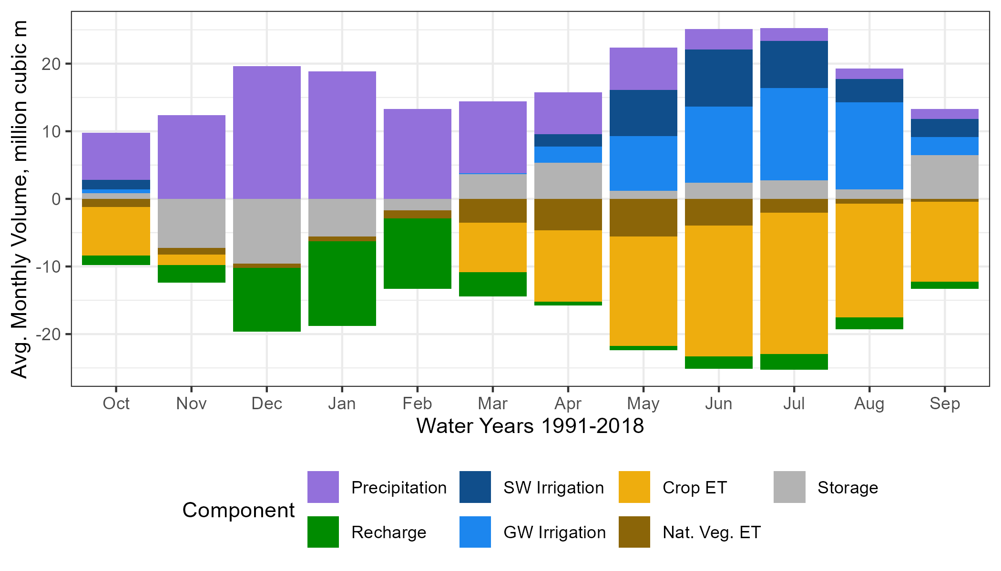
Figure 3: Average monthly water budget for the soil zone, simulated with SVIHM, for the model simulation period (water years 1991-2018). Positive and negative values indicate average net monthly fluxes into and out of the soil zone, respectively.
## png
## 2
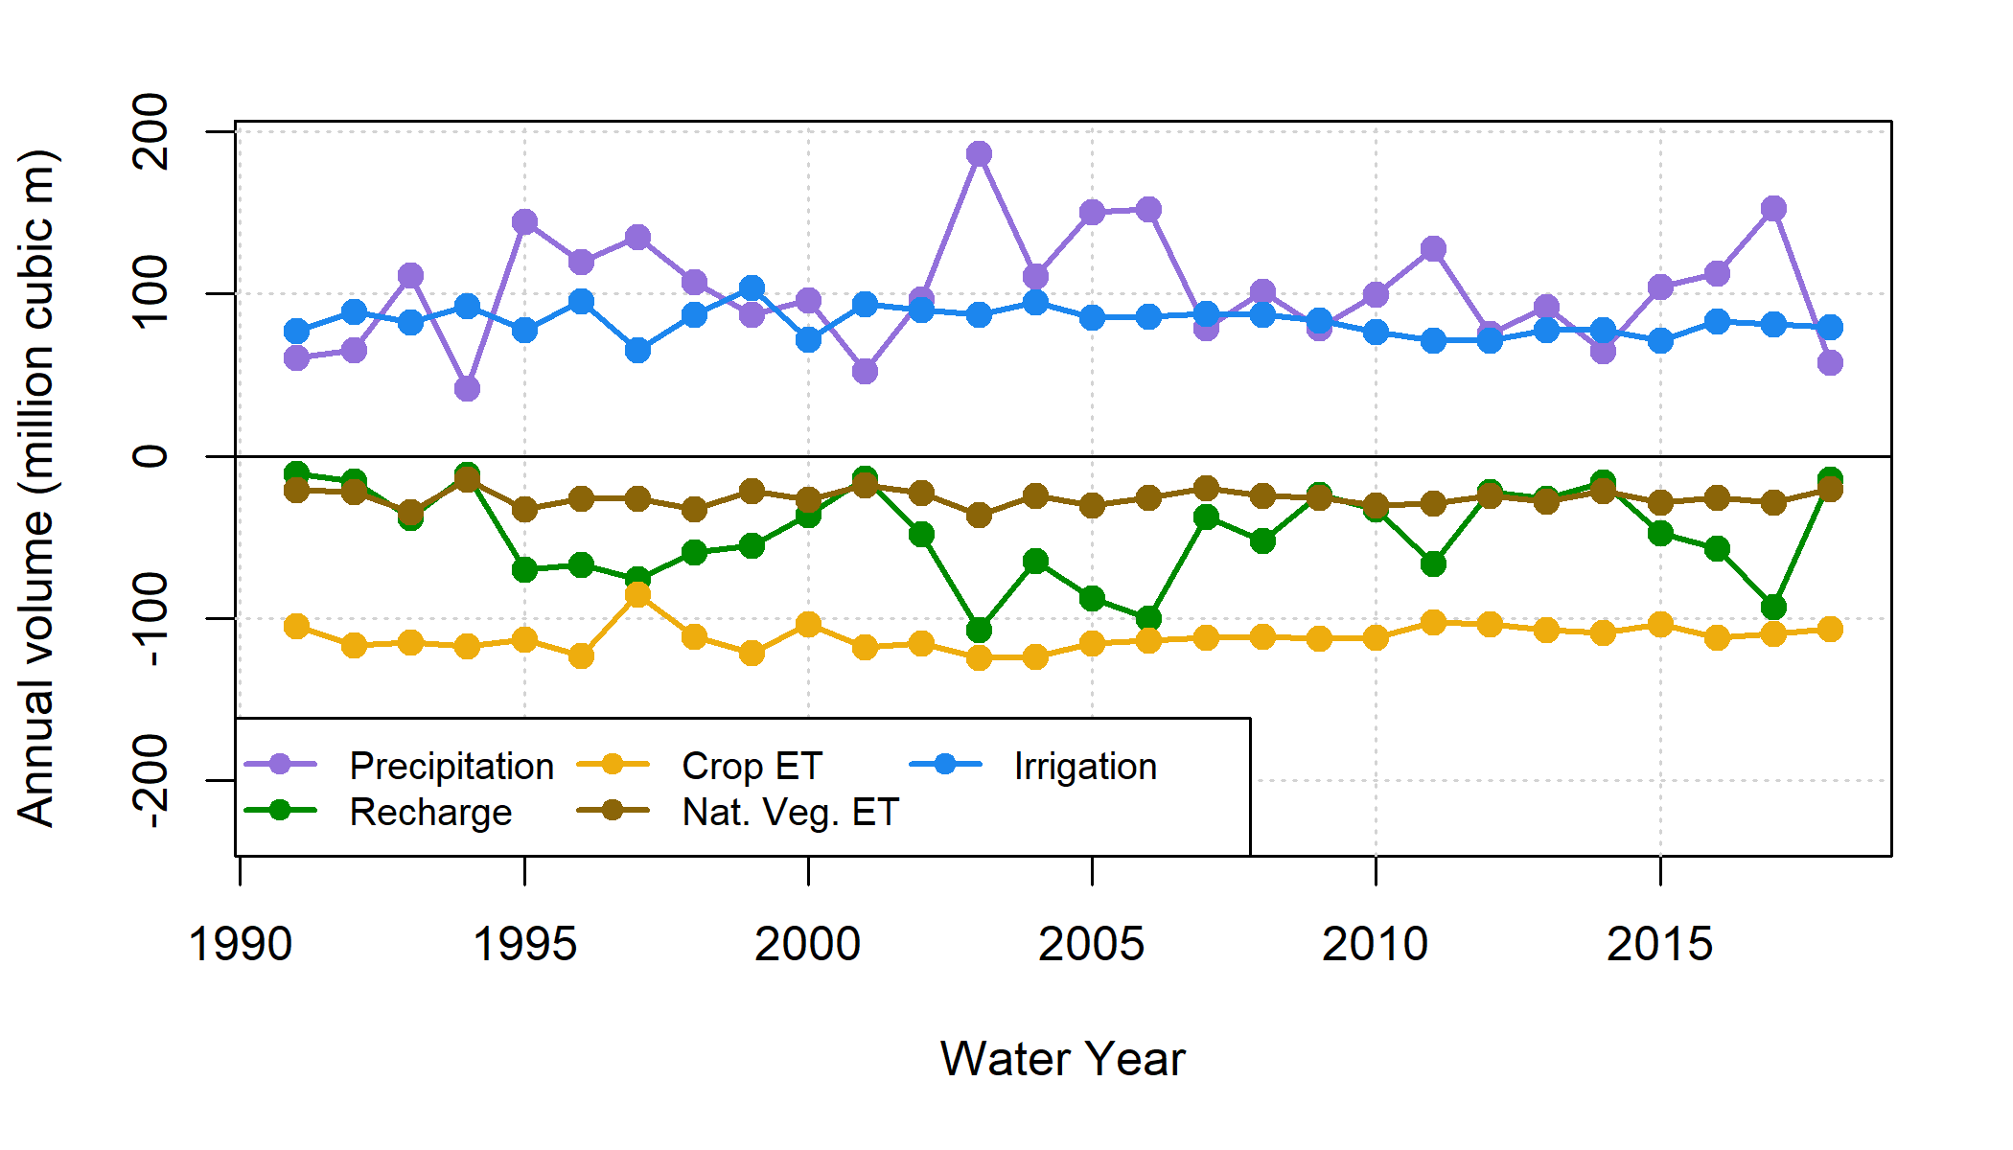
Figure 4: Annual values for inflowing (positive) and outflowing (negative) water budget components in the SVIHM soil zone (historical basecase simulation). Irrigation refers to both groundwater and surface water sources; Recharge refers to water percolating through the soil column and recharging the aquifer below. Both crop ET and ET from native vegetation remain relatively stable year to year, while precipitation inputs, and thus recharge to the aquifer, have higher interannual variability.

2.4 GSP development
The Scott Valley Groundwater Sustainability Plan (GSP) was developed by the Siskiyou County Flood Control and Water Conservation District, which is the designated Groundwater Sustainability Agency (GSA) charged by the state of California to sustainably manage local groundwater resources pursuant to the Sustainable Groundwater Management Act (SGMA) of 2014. GSP development took place between 2018 and 2021, and was guided by discussions in the monthly public meetings of an Advisory Committee composed of nine local stakeholders. Technical analyses supporting the public meeting deliberations and GSP policies were provided by several technical experts, including the authors of this study (Siskiyou County 2021).
SGMA requires each local GSA to define sustainability in the negative, by quantifying and then avoiding “undesirable results” that would be “significant and unreasonable”. The central undesirable result in Scott Valley is streamflow depletion due to groundwater pumping. Consequently, a central challenge of GSP development was defining a reasonable amount of streamflow depletion reversal, accounting for environmental water demand and what degree of agricultural water security was necessary to sustain the local economy.
The authors of this study simulated dozens of land and water use scenarios to facilitate the comparison of management alternatives that could reduce streamflow depletion to various degrees. Simulations were conducted with a spatially explicit, integrated surface water-groundwater model (Tolley, Foglia, and Harter 2019), as described below.

2.5 Hydrologic model summary
The Scott Valley Integrated Hydrologic Model (SVIHM) is a surface and groundwater model driven by tributary stream inflows, precipitation inputs, and reference evapotranspiration (ET₀). The boundary of the model domain corresponds approximately to the extent of the alluvial aquifer. For detailed information about the model structure, sensitivity, calibration, uncertainty, and validation of results, see recent work by Tolley et al. (2019). Like all models, it does not perfectly reproduce observed historical measurements, but it successfully captures key watershed-scale hydrologic phenomena that can be used to evaluate potential outcomes of specific management actions.
The SVIHM is composed of three cascading sub-models. First, complete daily records of tributary stream inflow are generated using a statistical streamflow regression model, in which the continuous Fort Jones record was used to predict missing values in the daily flow records of 12 major tributaries (Foglia et al. 2013). Second, a custom-built soil water budget model simulated irrigation demand, irrigation applied (surface and groundwater), ET and percolation to aquifer calculated on a field-by-field, daily time step basis. This model simulates individual irrigation applications and assumes the farmer has perfect foresight of daily irrigation demand. Finally, the boundary conditions of stream inflow, aquifer recharge, and groundwater extraction are used to drive an integrated groundwater-surface water model using MODFLOW; stream-aquifer flux and surface flow routing was simulated using the MODFLOW SFR package (Tolley, Foglia, and Harter 2019).
For GSP development, SVIHM was used extensively to perform what-if scenarios using the historic climate and land use forcing period, 1991-2018. Scenario simulations repeat the calibrated historical basecase simulation of SVIHM using specified sets of changes in SVIHM boundary conditions (BCs). The set of changes in the BCs of a particular scenario represent specific changes in land use, irrigation management, climate, water management rules, etc. Scenario outcomes are compared against those of the basecase simulation. Key results of each SVIHM scenario, used in the objective functions described below, are:
- A prediction of Scott River flow the Fort Jones Gauge, which is co-located with the surface water outlet of the model domain; and
- Simulated total ET of crops and native vegetation within the model domain.

3 Methods
We developed two objective functions and one categorical objective proxy to evaluate the management scenarios developed for the GSP. The three objectives were: maximizing specific environmental flows, maintain current levels of agricultural productivity (represented as minimizing reduction in agricultural water use), and minimizing new infrastructure costs (represented as a categorical infrastructure/feasibility proxy) (Table 2). We then applied these to the results of each simulated management scenario, found the Pareto-optimal set of scenarios, and compared them to the prioritization of management actions adopted in the GSP (Siskiyou County 2021).
We should note that protecting domestic water use was also discussed as a management objective, but this was not evaluated as an objective function in management scenarios, for three main reasons: it was assumed that solving the environmental flows problem would intrinsically keep groundwater levels sufficiently high to protect domestic groundwater use from well outages; the number of reported well outages in recent dry years was minimal; and the data necessary to assess domestic well outages (specifically, total well depth and pump depth information) was available only for a small number of wells.
Table 2: Management objectives and description of objective functions applied to summarize scenario performance.
Management Objective | Objective Function
Maximize specific environmental flows | Hydrologic Benefit function, based on flow metrics empirically correlated with coho salmon reproduction rates (higher values preferred)
Minimize reduction of agricultural water use | Crop ET volume over model domain (higher values preferred)
Minimize new infrastructure investment | Feasibility category of 1-4 (lower values preferred)

3.1 Objective functions

3.1.1 Hydrologic Benefit function
In Chapter 1 of this dissertation, we showed that the degree to which the water year provided ecological services needed by coho salmon can be estimated using a Hydrologic Benefit (HB) function, which summarizes environmental flows in a single index value for a given water year. A set of streamflow metrics related to the timing, amplitude, and duration of flow phenomena were weighted according to their power to predict salmon coho smolt production per female spawner. These weighted metrics are combined linearly to predict a value for coho salmon reproduction. See Chapter 1 for more details on these calculations. Specifically, the HB function predicts a higher number of coho salmon produced per female spawner (coho smolts per female, or coho spf-equivalent) when fall flows rise above 10 and 100 cfs earlier in the fall, when the wet season onset is earlier, and when the wet season duration is longer. The equation to calculate the HB value for a given water year is as follows:
$$HB_{wy}=b+m_{1}*metric_{1, wy}+...+m_{4}*metric_{4, wy}$$
Where:
$HB_{wy}$ is the Hydrologic Benefit value for a given water year (predicted coho spf or coho spf equivalent)
$b=87.4$ coho spf equiv.
$m_{1}=−0.030$ coho spf equiv. per day of reconnection after Aug. 31 (100 cfs)
$m_{2}=−0.365$ coho spf equiv. per day of reconnection after Aug. 31 (200 cfs)
$m_{3}=0.033$ coho spf equiv. per day of disconnection after Aug. 31 (200 cfs)
$m_{4}=−0.191$ coho spf equiv. per day of reconnection after Aug. 31 (8 cfs)
$m_{5}=−0.004$ coho spf equiv. per cubic meter of lower dry season flow magnitude
The HB function was formulated based on functional flow metrics of the observed daily average flow record of the FJ gauge ($FJ_{obs}$). One key result of the historical basecase scenario is a simulated estimate of the historical FJ gauge record ($FJ_{sim, basecase}$); however, although SVIHM was extensively calibrated (Tolley, Foglia, and Harter 2019), because all models involve structural simplifications of a full-scale watershed, $FJ_{sim, basecase}$ sometimes over- or under-estimates $FJ_{obs}$. As a result of these differences, HB values calculated from flow metrics of $FJ_{sim, basecase}$ tend to be higher than HB values derived from $FJ_{obs}$ by a mean of 4.5 coho spf-equiv.
To control for this, all basecase HB values used in this study are derived from $FJ_{sim, basecase}$, making them directly comparable to HB values derived from the simulated FJ flow records in the hypothetical management scenarios.

3.1.2 ET volume function (agricultural benefit proxy)
The annual crop ET volume, which is explicitly simulated in the hydrologic model, is used here as a proxy for agricultural productivity. Other options for framing the agricultural water use objective function include crop yields and total revenue, which may be of greater concern to stakeholders; however, annual crop ET was selected because the impacts of reduced water availability on yield or revenue will likely vary by grower and over time.
Specifically, conversion of ET to yield or revenue would introduce multiple uncertainties, such as those related to marginal crop production costs and available technology (Howitt 1995). In studies that do implement a water-to-yield or -revenue conversion, multi-year average values for per-acre yield and/or revenue are commonly used (e.g., Cole and Medellín-Azuara 2021 for the Scott Valley case), since those are typically the only values available. This approach is most valid when the marginal change in productivity is small relative to the average (Howitt 1995). Additionally, average values cannot account for time-varying costs of a management action (e.g., the increase in cost of lettuce cultivation due to banning a certain pesticide is higher in some seasons than in others, as described in Sunding 1996).
Additionally, for alfalfa and pasture, which continue growing as long as water is available, a strong relationship between crop ET and yield is assumed (Carter and Sheaffer 1983). The assumption that crop ET is consistently related to yield or revenue breaks down for a management scenario that includes changing crops; this is explored further in the Discussion section. But on the merits of these options, annual crop ET was selected to represent agricultural benefit.

3.1.3 Proxy for scenario infrastructure investment
In lieu of detailed cost estimates or feasibility studies, we chose to group management alternatives in qualitative categories approximating the degree of new infrastructure investment needed in each alternative. The categories describing project feasibility and timeframe are as follows:
- No feasibility barriers (basecase; maintain current practices)
- Implementable with current infrastructure
- Requires new infrastructure that would take 1-2 years to build
- Requires new infrastructure that would take 3-5 years to build
- Requires new infrastructure that would take 5+ years to build
This reflects the first-order understanding that, for example, building a reservoir (assigned to category 4) will take more effort and resources in terms of permitting and construction than widespread installation of highly efficient irrigation systems (assigned to category 2). See Table 4 for full list of assigned categories.

3.2 Analyses of objective function values

3.2.1 Trade-off efficiency and “low-coho” years
As discussed previously, balancing agricultural and environmental water demands in this watershed typically takes the form of seeking management actions that can improve flow conditions while minimizing the resulting reduction in agricultural water availability. These objectives are non-commensurable (i.e., an estimated level of fish reproduction cannot be converted into units of agricultural productivity), making an explicit quantification and consideration of benefit trade-offs a critical feature of this decision-support analysis (Cohon and Marks 1975). Environmental benefits are less commonly quantified than agricultural costs (e.g., Sunding 1996, which assessed numerical costs of a management action and assumed qualitative environmental/human health benefits), but the HB function makes this trade-off quantification possible in the Scott Valley case.
For this analysis, which is not intended to identify one “best” or optimal solution, these trade-offs can be considered using scenario objective value differences relative to their basecase (historical simulated) values. We will call this quantity the “trade-off efficiency” of a management scenario. For a given scenario, the trade-off efficiency, or Eff_{scen}, is unitless (i.e., it has units of coho spf-equiv. per coho spf-equiv. / million m³ per million m³), as shown in the formula below.
An efficiency for a subset of years can be calculated by averaging the efficiency values over that set of water years only. The set of years with low basecase HB values (operationally defined as values lower than 45 coho spf-equivalent, composed of 1993, 1995, 2002, and 2014-16) is relevant to water managers (see Discussion), and is henceforth referred to as the set of “low-coho” years. A low-coho year efficiency was calculated in addition to the efficiencies averaged over all water years.
$$HB_{avg}=\frac{1}{n_{wy}}\sum_{i=wy_{1}}^{wy_{n}}{HB_{wy_{i}}}$$
$$ET_{avg}=\frac{1}{n_{wy}}\sum_{i=wy_{1}}^{wy_{n}}{Crop ET_{annual, wy_{i}}}$$
$$Eff_{scen}=\frac{\left(HB_{avg, scen}−HB_{avg, basecase}\right)/HB_{avg, basecase}}{−1*\left(ET_{avg, scen}−ET_{avg, basecase}\right)/ET_{avg, basecase}}$$

3.2.2 Pareto-optimal set of management actions
After calculating the objective function values for each scenario, we applied a simple algorithm to identify the Pareto-optimal set of scenarios (Pareto 1896). A scenario was identified as Pareto-optimal if there were no other scenarios that performed better in two or more objectives. In other words, the Pareto-optimal set is the collection of scenarios in which it is not possible to improve on one objective without reducing performance in another objective. By definition, this set cannot identify a single best scenario or evaluate trade-offs between objectives; we use it here to identify obviously suboptimal scenarios.
For example, the objective function values for the scenario simulating managed aquifer recharge and in-lieu recharge (MAR and ILR, or scenario identifier mar_ilr) are 76.1 predicted coho smolts per female equivalent (HB value), 111.0 million m³ of crop ET, and infrastructure category 3. Most scenarios (33) have a higher HB value than mar_ilr, but only eight have a higher ET value. Only the reservoir scenarios show up in both sets, with higher ET and higher HB value than mar_ilr. However, the reservoir scenarios are more difficult to implement, so any of those scenarios would have less desirable performance on the infrastructure objective. Consequently, since no scenarios perform better than mar_ilr in more than one objective, it must be included in the Pareto-optimal set.

3.3 Scenario descriptions
For the Scott Valley GSP, this study simulated 64 management action scenarios, compared to between one and five scenarios modeled in most other California GSPs (e.g., FCGMA 2019; YSGA 2022). This high number of scenarios was possible because the SVIHM had been under development for 8 years prior to the start of GSP work (e.g., Foglia et al. 2013; Tolley, Foglia, and Harter 2019), and cost-effective technical support was provided by graduate students at the University of California, Davis. Of the 64 scenarios, only 40 are considered here. Several were ruled out as obviously unfeasible (e.g., construction of a 134 thousand acre-foot reservoir to ensure 100% flow reliability even during severe drought, in an area with topography that could not support such a large capacity), and some were excluded because they are largely redundant with some of the 40 considered here.
The scenarios are grouped here by category (Table 3). Within each category various details were altered (e.g., an alfalfa irrigation cessation date of July 10 versus August 15, or an assumed crop water consumption of 80% versus 90% of historical). See Chapter 2 Supplement for more detailed scenario descriptions.
Table 3: Management scenario categories (abbreviated), a general description, the number of scenarios in each category, the feasibility proxy and the type of management action.
Category | Scenario Category Description | Num. Scen. | Infra. Proxy | Mgmt. Type
Basecase | Basecase | 1 | 0 | Basecase
EnhRch | Enhanced Recharge | 3 | 3 | Infrastructure
EnhRchEx | Expanded Enhanced Recharge | 3 | 3 | Infrastructure
IrrEff | Improved Irrigation Efficiency | 2 | 2 | Infrastructure
Res | Small Reservoir | 5 | 4 | Infrastructure
CropCh | Crop Change (lower ET) | 2 | 2 | Infrastructure
AlfIrr | Cease Alfalfa Irrigation Early | 5 | 1 | Regulatory
Curtail | Cease (Curtail) All Irrigation Early | 6 | 1 | Regulatory
FlowLims | Low Flow Diversion Limits | 1 | 1 | Regulatory
NatVeg | Some Nat. Veg. Land Use | 6 | 2 | Nat. Veg.
NatVegET | Some Nat. Veg. (higher ET) | 6 | 2 | Nat. Veg.

3.4 Results
As described above, objective functions were used to quantitatively summarize the achievement of environmental and agricultural goals for the basecase and 39 management scenarios. A Hydrologic Benefit (HB) value (in units of predicted coho smolt production per spawning female, or coho spf-equivalent) and a total crop ET volume was calculated for each water year in the 28-year simulation period, for each scenario. Each scenario has also been given an infrastructure feasibility proxy (Table 4).

3.4.1 Environmental and agricultural objective function values
## png
## 2
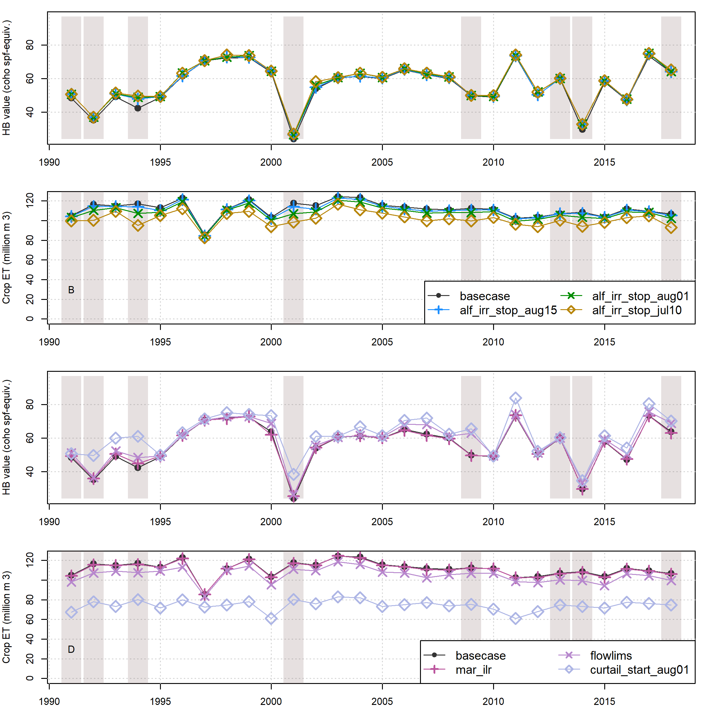
Figure 5: Comparison of annual performance in two objective functions (HB and ET, representing environmental and agricultural objectives, respectively), in the basecase (black circles) and management scenarios (diamond, cross or x symbols) for water years 1991-2018. Panels A and B show comparisons between basecase and one example scenario in each of three categories: Enhanced Recharge, Low Flow Diversion Limits, and Curtailment. Panels C and D show comparisons between basecase and different cutoff dates within the Alfalfa Irrigation category: July 10th, August 1st and August 15th. Dry-type water years (vertical bars) are 1991, ’92, ’94, 2001, ’09, ’13, ’14, and ’18.
## png
## 2
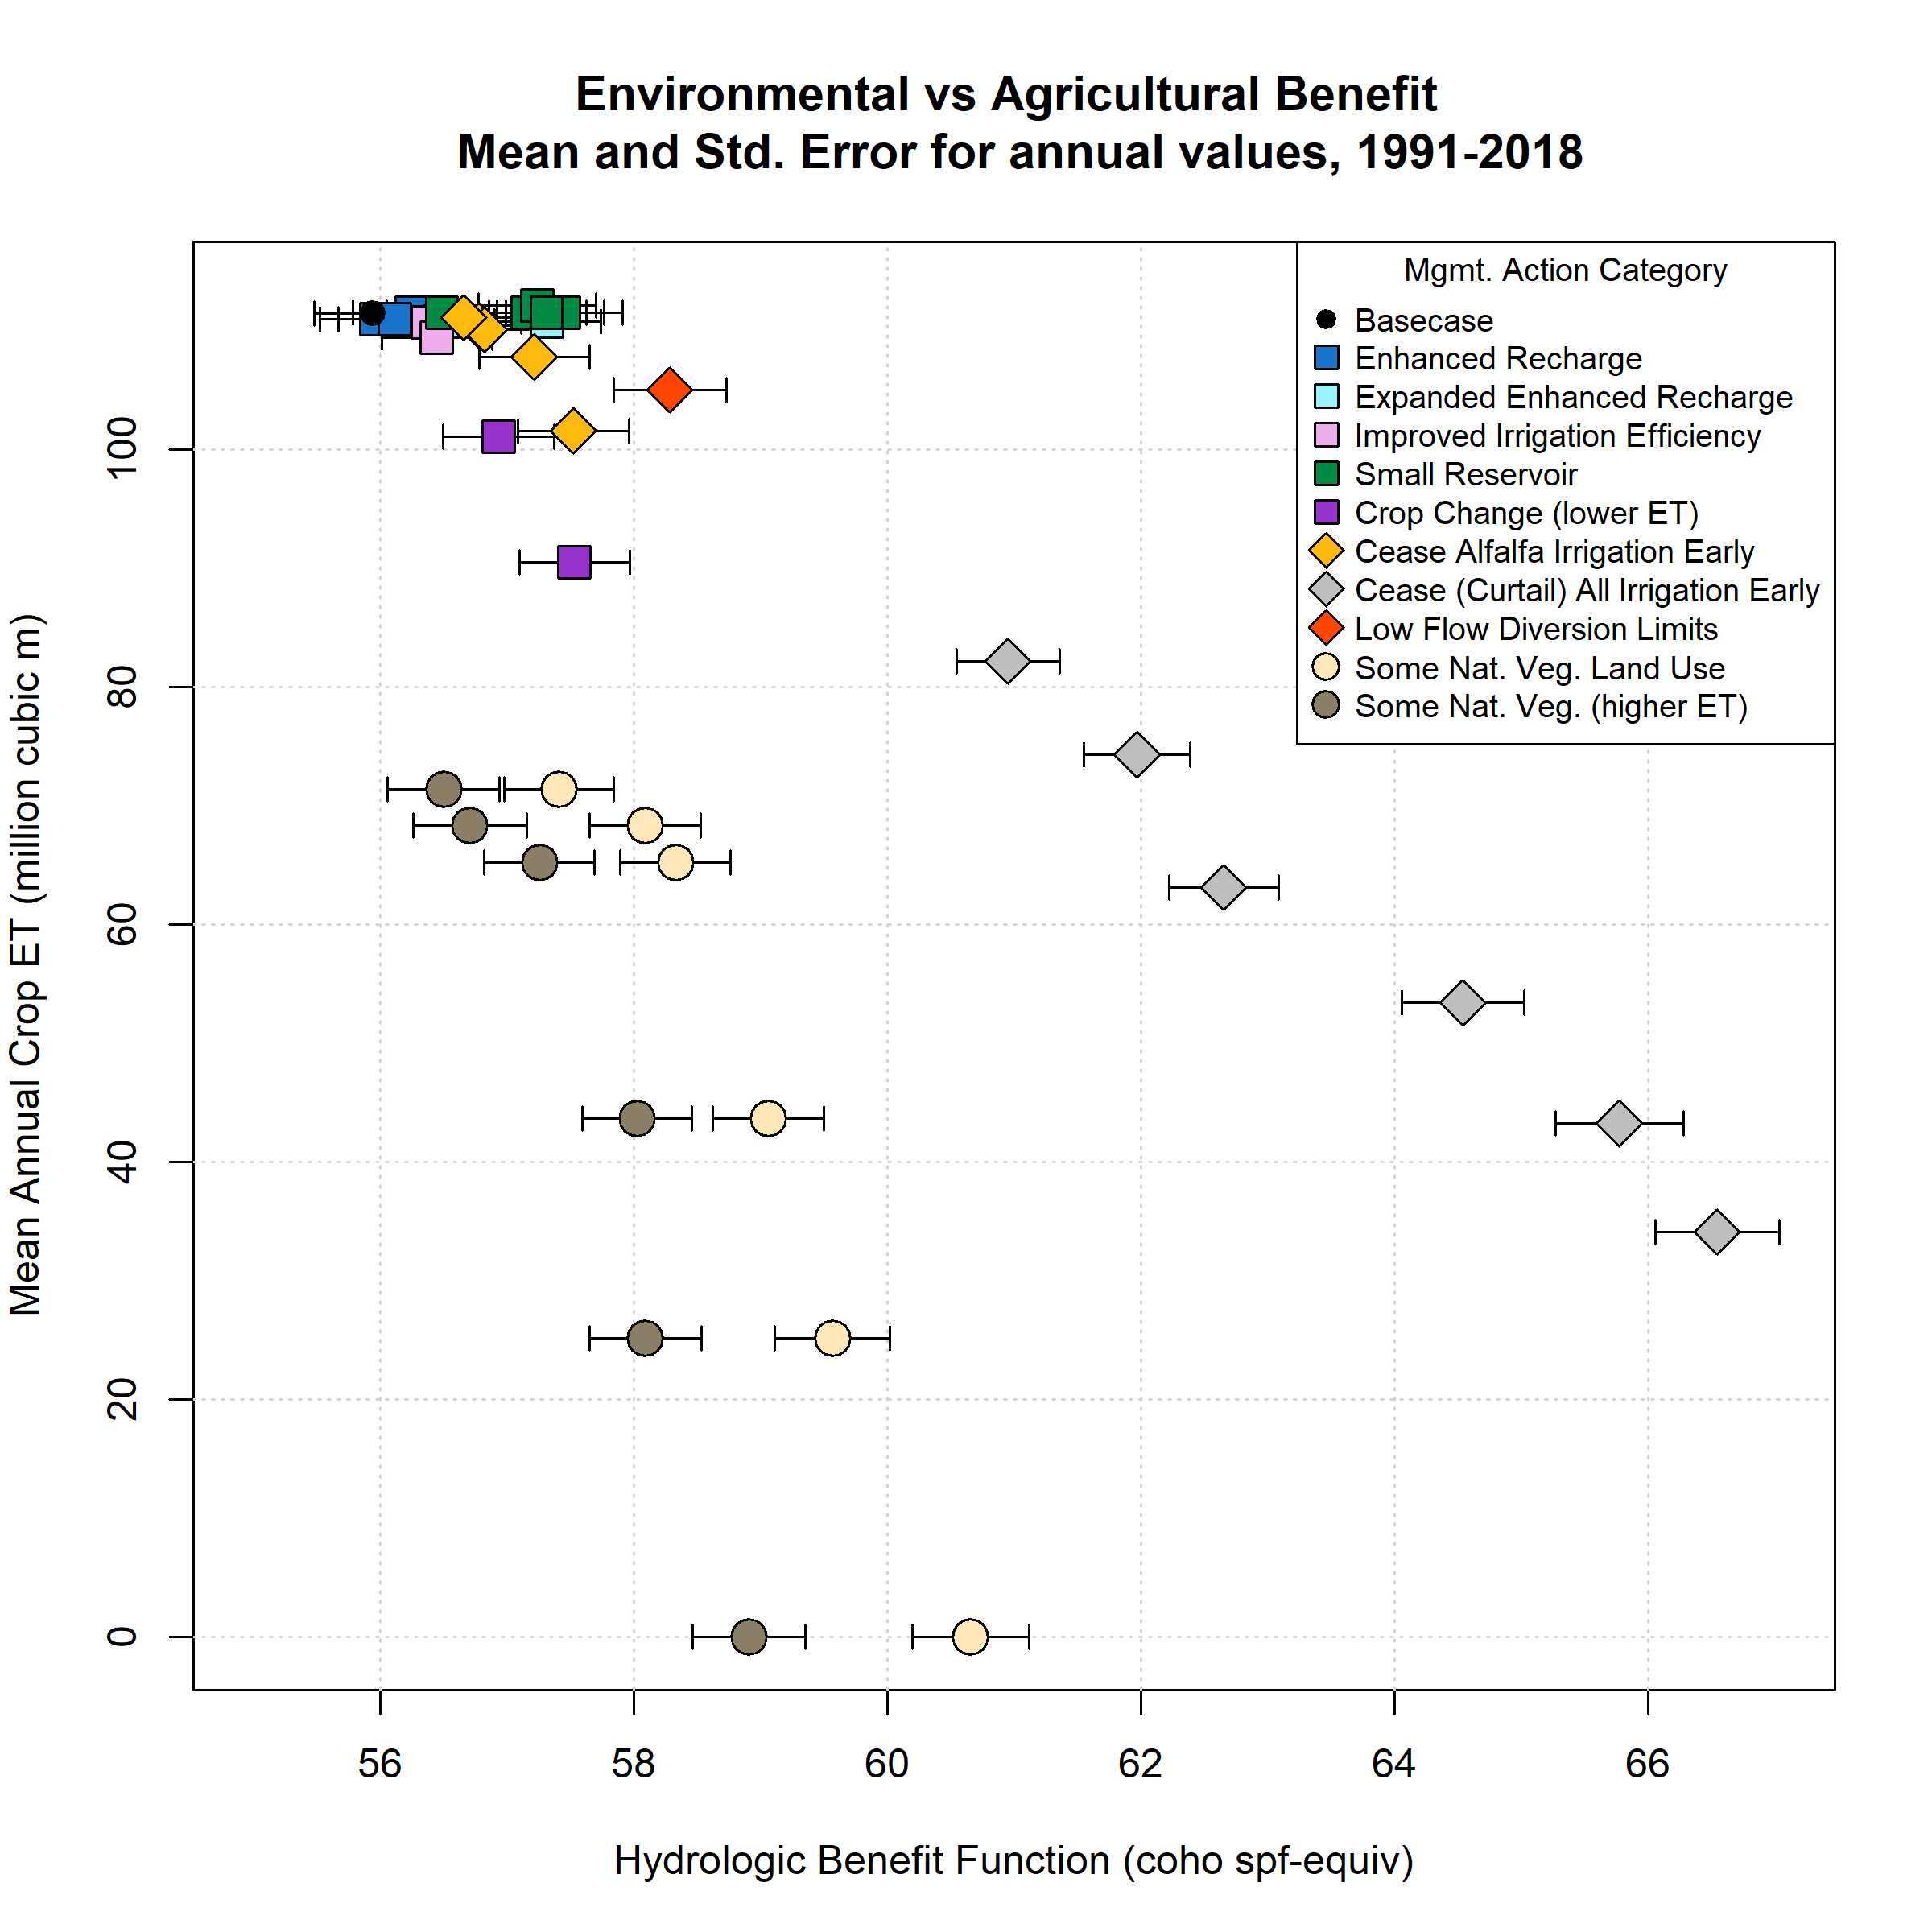
Figure 6: Environmental and agricultural objective function performance (in terms of Hydrologic Benefit, or HB, value; and crop ET volume) for basecase (black circle in upper left) and 39 management scenarios. Symbol x and y coordinates are the average of 28 annual HB and ET values for each scenario over the full model period (water years 1991-2018). Whiskers show standard error of the 28 years of annual HB values; standard errors in the direction of the y-axis are smaller than the height covered by each symbol.
## png
## 2
The aggregate hydrologic impact of each management scenario can be compared against the historical basecase using the annual objective function values over the full 28-year record (e.g., Figure 5) or using the 28-year mean values for each scenario (Figure 6; Table 4). In the basecase scenario, the 28-year mean annual ET volume is 111 million m³ of water, and the 28-year mean of annual HB values is 55.9 coho spf-equivalent (Table 4). Annual ET volume is relatively stable over the model period of water years 1991-2018, while annual HB values are much more variable (Figure 5). Among the 39 management scenarios, mean ET values ranged from 0 to 112 million m³ of water, while HB values ranged from 56 to 66.5 coho spf-equivalent.
Four scenario categories fall in a cluster with relatively high ET values, indicating that these scenarios conserve nearly all the basecase economic benefits for local growers: Enhanced Recharge, Expanded Enhanced Recharge, Irrigation Efficiency, and Small Reservoir (Figure 6). The scenarios in this group all require some degree of infrastructure investment, and they have a minimal impact on crop ET: the mean ET values of scenarios in this cluster are 109 to 112 million m³, or 2 percent less to 0.6 percent more than basecase. Their mean improvement in HB values over the basecase ranges from 0 to 2 coho spf-equivalent.
The mean ET volumes of the two Crop Change scenarios fall below those in the aforementioned cluster, with 90 and 101 million m³, while HB values are 57.5 and 56.9 respectively (Figure 6). In these scenarios, existing crop coefficients are multiplied by a factor of 0.8 or 0.9; conceptually, this would involve replacing all existing irrigated acreage with unspecified crops which had a designated 80% and 90% of historical ET demand. As discussed later, in this scenario the relationship between water use and revenue may be distinctly different from that of alfalfa and pasture, so the actual “farmer benefit” may be higher or lower than this proxy suggests.
Two regulatory management categories, Alfalfa Irrigation and Curtailment, involve irrigation schedule changes, and result in a range of reductions in applied irrigation volume, depending on the date of intervention. The scenarios in these categories trace two trade-off arcs in average HB-ET space (Figure 6). The first category, early cessation of alfalfa irrigation (during all or only dry water years), is intended to simulate growers harvesting two cuttings only (i.e., one or two fewer cuttings than current) in a given year. This was simulated by ceasing alfalfa irrigation earlier in the growing season (with cutoff dates on July 10, August 1 and August 15) than the basecase default date of Sept. 1. (The Sept. 1 cutoff date assumes that growers obtain three cuttings, but does not incorporate the known small number of growers which occasionally irrigate longer to obtain a fourth cutting.) Alfalfa acreage is concentrated near the Scott River channel, much of it in the Adjudicated Zone (Figure 1), with predominately groundwater irrigation sources. The second regulatory category, Curtailment of all irrigation starting on a range of dates (June 1st through August 15th), represent book-end scenario simulations to approximate regulatory actions proposed by state resource management agencies in response to extreme drought conditions (CDFW 2021). The mean ET values of scenarios in these two categories are 34 to 111 million m³, or 69 to 0.3 percent less than basecase; HB gains over basecase are 1 to 11 coho spf-equivalent.
The third regulatory category, Low Flow Diversion Limits, regulates surface water diversion for irrigation, and contains only one scenario (Figure 6). Among all scenarios, it is the only scenario that focuses solely on management of surface water diversions for irrigation. It assumes the FJ Gauge flowrate is representative of watershed conditions, and limits diversions of surface water from all tributaries on days when the FJ Gauge flowrate falls below a recently proposed instream flow regime that is considered to be protective of anadromous fish in the Scott River (CDFW 2017). Under this Low Flow Diversion Limits scenario, the mean crop ET volume is 6 million m³ (~6%) less than basecase, while the mean HB value is 2 coho spf-equivalent greater than basecase.
The remaining two categories, abbreviated as “NatVeg” and “NatVegET”, relate to land cover type and are not proposed as management actions. Rather, these provide reference scenarios for conditions in some or all parts of the valley that could be considered to stand in for undefined “pre-historic”, “unimpaired”, or “conservation” conditions. They involve simulating native vegetation in place of irrigated acreage, and were designed to estimate the streamflow depletion attributable to agricultural water use in different areas of Scott Valley. These scenarios produce substantial HB gains at a high ET cost relative to basecase (Figure 6).
The key geographic feature in the NatVeg and NatVegET scenarios is the “Interconnected Zone” in the 1980 Scott Valley surface water adjudication (Superior Court of Siskiyou County 1980), referred to here as the “adjudicated zone” of groundwater pumping (Figure 1), and the six scenarios in each category represent the cessation of all irrigation or the cessation of only groundwater pumping in three spatial configurations: within the adjudicated zone, outside of the adjudicated zone, or in both areas. All areas where irrigation or pumping is turned off are assumed to return to (unirrigated) native vegetation.
On average, area-normalized ET from native vegetation is 45 cm/year (56% of average annual crop ET). Simulating native vegetation in place of irrigated acreage results in a greater proportion of water leaving the SVIHM model domain via surface flows rather than as transpiration. Consequently the NatVeg and NatVeg ET scenarios generate higher simulated FJ streamflow in most months of the model period. The first category (NatVeg) assumes a native vegetation crop coefficient of 0.6, while the second category (NatVegET) assumes a native vegetation crop coefficient of 1.0 and a maximum rooting depth of 4.5 m. The first category could be interpreted as chaparral or sage scrub-type vegetation cover, while the second category could represent a mixed bunchgrass and clover prairie with extensive riparian vegetation corridors and wetlands. (See Supplemental Material for more details on this scenario design.)
Table 4: Scenario attributes for 40 scenarios. Units for Hydrologic Benefit (HB) value are coho smolt per female-equivalent; for ET are million cubic meters; both are averages of 28 annual values. Efficiency not calculated for scenarios with no average ET loss. (L-C) indicates the efficiency is averaged over the six low-coho years that occurred within that period, rather than the full model period 1991-2018.
Scenario ID | Category | Feas. | Mean HB | Mean ET | Pareto | Efficiency | Eff. (L-C)
basecase | basecase | 0 | 55.9 | 111.49 | Yes | -- | --
mar | EnhRch | 3 | 56.2 | 111.51 | Yes | -- | --
ilr | EnhRch | 3 | 56.0 | 110.97 | -- | 0.1 | 1.1
mar_ilr | EnhRch | 3 | 56.1 | 110.99 | -- | 0.7 | 1.3
mar_ilr_max_0.003 | EnhRchEx | 3 | 56.5 | 110.80 | -- | 1.5 | 3.4
mar_ilr_max_0.019 | EnhRchEx | 3 | 56.7 | 110.80 | Yes | 2.2 | 4
mar_ilr_max_0.035 | EnhRchEx | 3 | 57.3 | 110.80 | Yes | 4 | 4.7
irr_eff_improve_0.1 | IrrEff | 2 | 56.4 | 110.71 | -- | 1.1 | 1.1
irr_eff_improve_0.2 | IrrEff | 2 | 56.4 | 109.43 | -- | 0.5 | 0.6
reservoir_shackleford | Res | 4 | 56.5 | 111.53 | Yes | -- | --
reservoir_etna | Res | 4 | 57.2 | 111.53 | Yes | -- | --
reservoir_french | Res | 4 | 57.4 | 111.49 | Yes | -- | --
reservoir_sfork | Res | 4 | 57.2 | 112.12 | Yes | -- | --
reservoir_etna_29kAF | Res | 4 | 57.3 | 111.54 | Yes | -- | --
irrig_0.8 | CropCh | 2 | 57.5 | 90.47 | -- | 0.1 | 0.2
irrig_0.9 | CropCh | 2 | 56.9 | 101.10 | -- | 0.2 | 0.3
alf_irr_stop_jul10 | AlfIrr | 1 | 57.5 | 101.58 | Yes | 0.3 | 0.2
alf_irr_stop_aug01 | AlfIrr | 1 | 57.2 | 107.79 | Yes | 0.7 | 0.4
alf_irr_stop_aug01_dry_yrs_only | AlfIrr | 1 | 56.8 | 110.45 | Yes | 1.6 | 0.8
alf_irr_stop_aug15 | AlfIrr | 1 | 56.8 | 110.10 | Yes | 1.3 | 1.3
alf_irr_stop_aug15_dry_yrs_only | AlfIrr | 1 | 56.7 | 111.11 | Yes | 3.8 | 2.4
curtail_start_jun01 | Curtail | 1 | 66.5 | 34.09 | Yes | 0.3 | 0.2
curtail_start_jun15 | Curtail | 1 | 65.8 | 43.22 | Yes | 0.3 | 0.2
curtail_start_jul01 | Curtail | 1 | 64.5 | 53.39 | Yes | 0.3 | 0.3
curtail_start_jul15 | Curtail | 1 | 62.7 | 63.09 | Yes | 0.3 | 0.3
curtail_start_aug01 | Curtail | 1 | 62.0 | 74.31 | Yes | 0.3 | 0.4
curtail_start_aug15 | Curtail | 1 | 61.0 | 82.17 | Yes | 0.3 | 0.4
flowlims | FlowLims | 1 | 58.3 | 105.02 | Yes | 0.7 | 0.4
natveg_all | NatVeg | 2 | 60.7 | 0.00 | -- | 0.1 | --
natveg_gwmixed_all | NatVeg | 2 | 59.6 | 25.14 | -- | 0.1 | 0.1
natveg_inside_adj | NatVeg | 2 | 58.1 | 68.33 | -- | 0.1 | 0.1
natveg_gwmixed_inside_adj | NatVeg | 2 | 57.4 | 71.40 | -- | 0.1 | 0.1
natveg_outside_adj | NatVeg | 2 | 59.1 | 43.62 | -- | 0.1 | 0.1
natveg_gwmixed_outside_adj | NatVeg | 2 | 58.3 | 65.21 | -- | 0.1 | 0.1
natveg_all_et_check_1.0nvkc_4.5m_ext | NatVegET | 2 | 58.9 | 0.00 | -- | -- | --
natveg_gwmixed_all_et_check_1.0nvkc_4.5m_ext | NatVegET | 2 | 58.1 | 25.14 | -- | -- | --
natveg_inside_adj_et_check_1.0nvkc_4.5m_ext | NatVegET | 2 | 56.7 | 68.33 | -- | -- | --
natveg_gwmixed_inside_adj_et_check_1.0nvkc_4.5m_ext | NatVegET | 2 | 56.5 | 71.40 | -- | -- | --
natveg_outside_adj_et_check_1.0nvkc_4.5m_ext | NatVegET | 2 | 58.0 | 43.62 | -- | 0.1 | 0.1
natveg_gwmixed_outside_adj_et_check_1.0nvkc_4.5m_ext | NatVegET | 2 | 57.3 | 65.21 | -- | 0.1 | 0.1

3.4.2 Agricultural-environmental trade-off efficiency
The trade-off efficiency between the environmental and agricultural objective functions is defined as the average HB value gained, relative to HB_{basecase}, per ET value lost relative to ET_{basecase} (see formula in Methods). However, six scenarios (the five reservoir scenarios and managed aquifer recharge, or MAR) actually resulted in an average ET volume slightly greater than the basecase, and so avoided any ET cost. These scenarios were excluded from the efficiency calculations because including them would produce nonsensical negative efficiencies.
For all other scenarios, trade-off efficiencies ranged from 0.03 to 4 when averaged over all years, and were higher (ranging from 0.04 to 4.7) in low-coho years (Table 4). The range covers two orders of magnitude because the denominator of the ratio, lost ET, ranges from 0.3% to 100%, while the HB gains fall more narrowly between 0.1% to 19%. Efficiencies greater than 1 indicate that a scenario produces more than a 1% increase in HB value per 1% loss in ET value. However, because the HB and ET units are non-commensurable, the absolute value of the trade-off efficiency is not of great significance; the trade-off efficiency metric is most useful for scenario comparisons.
Four scenario categories form a “low-efficiency” cluster, with all-years efficiencies of less than 1: Crop Change, Curtailment, and the two Natural Vegetation categories (Figure 7). These scenarios can produce substantial HB gains (ranging from 0 to 11) coho spf-equiv., but result in severe agricultural productivity reductions (0.4% to 100%). The “high-efficiency” scenarios, which have an all-years trade-off efficiency greater than 1 (the Enhanced Recharge, Low Flow Diversion Limits, Irrigation Efficiency and Alfalfa Irrigation scenarios), tend to be associated with a small ET cost relative to basecase (0.4 to 1.4 million m³, or 0.3 to 1.2 percent of basecase crop ET).
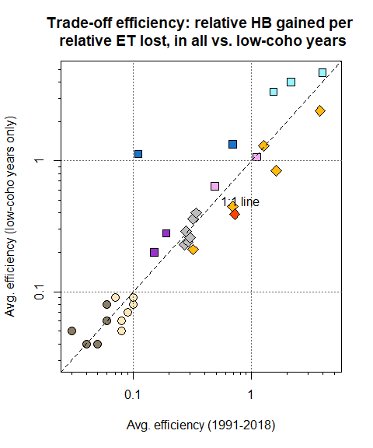
Figure 7: Scenario trade-off efficiencies, or average HB value gained per crop ET value lost (normalized to average basecase HB and ET values, respectively), in all 28 years (x-axis) and in six low-coho years (y-axis; i.e., the six years with basecase predicted HB values of less than 45 coho spf-equiv.). Basecase, Reservoir scenarios and one Enhanced Recharge scenario (MAR) are not included as they have on average no or negative ET loss.

3.4.3 Infrastructure objective, Pareto-optimal set and GSP priorities
By plotting the environmental, agricultural, and infrastructure objectives in a three-dimensional scatterplot, it is possible to visualize the combined set of management scenarios as four different trade-off arcs in different infrastructure categories (Figure 8).
The Pareto-optimal set of management actions include more than half (25) of the simulated scenarios (Table 4; Figure 8). All the suboptimal scenarios are in infrastructure category 2 (infrastructure timeline of 1-2 years). The suboptimal set are either related to land use change (Crop Change, NatVeg, and NatVegET), which reduce crop ET demand or irrigated acreage, or they involve deployment of more efficient irrigation (Irrigation Efficiency), which has little impact on either HB or ET values.
Infrastructure category 1 (no infrastructure investment needed) contains all the Regulation-type scenarios. In the Alfalfa Irrigation and Curtailment scenario categories, the trade-off arcs show the effect of intervention date: an earlier date of intervention (irrigation cutoff) produces a greater HB value at a higher ET cost, compared to a later date of intervention. The scenarios in infrastructure categories 3 and 4 (infrastructure timeline of 3-5 and 5+ years) involve no or minimal ET cost, and a range of HB gains on the middle-to-lower end of the HB gain spectrum (Reservoirs, Enhanced Recharge, and Expanded Enhanced Recharge; Figure 6).
To determine if the strict application of objective functions would produce different management priorities than the public policy development process that took place 2018-2021, we made a high-level, conceptual comparison of the Pareto-optimal set of management actions and the management actions and projects listed for consideration in the GSP (Siskiyou County 2021). Management actions considered in the GSP have some analogs in the set of 40 simulated scenarios.
High-priority scenarios tend to be associated with higher average crop ET values and modest HB gains relative to basecase (Table 5); i.e., the GSP priorities demonstrate a preference for management actions with high trade-off efficiencies. Specifically, Enhanced Recharge and Irrigation Efficiency are represented in Tiers I and II, signifying they are considered implementable in the short- or medium-term. Another high-efficiency scenario, Low Flow Diversion Limits, is represented three times in Table 5: the two analogs for it in Tier I are limited either in time (Water Trust Leasing, which occurs opportunistically in extreme droughts) or in space (the current two-creek extent of the existing watermaster program). An expanded watermaster program, which would more closely resemble the Low Flow Diversion Limits scenario, appears in Tier III.
The final high-efficiency scenario category, Alfalfa Irrigation, is not included in the list of management actions; conversely, low-efficiency scenarios in categories NatVeg and Crop Change were included, in a spatially-limited form, in Tier II under the umbrella of “Voluntary Managed Land Repurposing”. This indicates that political considerations not currently included in the three objective functions produce a preference for some amount of land repurposing rather than imposing limitations on alfalfa irrigation.
Notably, direct comparisons between the set of simulated scenarios and the management actions listed in the GSP are somewhat limited. The primary reason for this is that the simulated scenarios assume that all water users in the valley are acting in concert. Conversely, management actions included in the GSP generally assumed voluntary/incentivized participation by individual landowners in scenarios involving land use change, and in some cases are located only in specific sub-areas of the watershed.
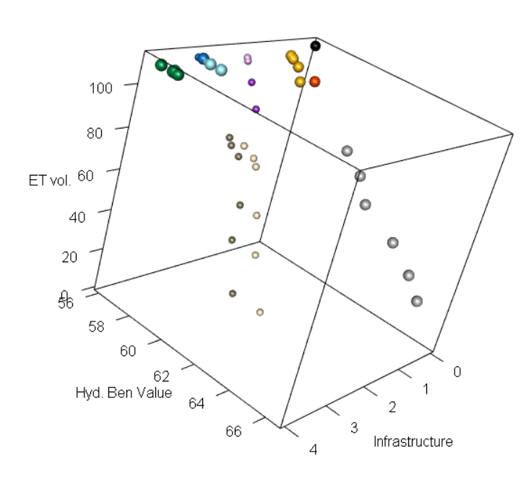
Figure 8: A three-dimensional scatter plot of the objective function values for basecase and 39 management scenarios, averaged over 28 water years (1991-2018). Larger spheres are shown for the Pareto-optimal set of scenarios. Scenario colors correspond to legend in Figures 6 and 7.
Table 5: List of management actions in Chapter 4 of the GSP and analogues in the set of 40 simulated scenarios. The Tier indicate the priority given to each management action, though the Tier also incorporates information about difficulty of implementation (hence Reservoirs being placed in Tier 3).
Tier | GSP Management Action | Closest Simulated Analogue | HB Range | ET Range
I | Watermaster Program (two creeks) | Low Flow Diversion Limits (FlowLims) | 58 | 105
I | Scott River Water Trust Leasing Program | Low Flow Diversion Limits (FlowLims) | 58 | 105
I | Irrigation Improvements | Improved Irrigation Efficiency (IrrEff) | 56-56 | 109-111
II | Irrigation Efficiency Improvements | Improved Irrigation Efficiency (IrrEff) | 56-56 | 109-111
II | MAR & ILR - NFWF  Scott Recharge Project | Enhanced Recharge (Enh- Rch) | 56-56 | 111-112
II | MAR & ILR | Enhanced Recharge (Enh- Rch) | 56-56 | 111-112
II | Voluntary Managed Land Repurposing | Possibly Crop Change (CropCh) and possibly some amount of Natural Vegetation Land Use (NatVeg) | 56-59 | 44-101
III | Alternative, lower ET crops | Crop Change (CropCh) | 57-58 | 90-101
III | Floodplain Reconnection/ Expansion | Enhanced Recharge (Enh- Rch) | 56-56 | 111-112
III | Reservoirs | Small Reservoir (Res) | 56-57 | 111-112
III | Strategic Groundwater Pumping Curtailment | Possibly Cease Alfalfa Irrigation Early (AlfIrr); Possibly Curtail Irrigation Early (Curtail) | 57-67 | 34-111
III | Watermaster Program (expanded) | Low Flow Diversion Limits (FlowLims) | 58 | 105

4 Discussion
The portfolio of scenarios proposed by stakeholders and simulated for this study included a range of infrastructure investments, regulatory actions and major land use changes. The number and diversity of simulated scenarios was made possible by a surface- and groundwater model designed to approximate existing land use and agricultural water use behavior in the local context [SVIHM; Tolley, Foglia, and Harter (2019)]. Though the ultimate future effect of these management actions would depend on climate variability and implementation details that have not been explicitly simulated (e.g., the precise location of pumps needed to divert surface water for the expanded enhanced recharge scenarios), it is possible to use objective functions and historical climate records to draw some high-level findings regarding their relative merits.

4.1 Contextualizing low objective function values
The HB function incorporates several hydrologic metrics, but years with low HB values (i.e., low predicted coho-spf equivalent) usually share several characteristics. A water year with a low HB value (e.g., <45 coho spf-equiv.) commonly occurs after a dry season with multiple dried-out mainstem Scott River reaches, culminating in a prolonged fall period (e.g., 4 to 8 weeks after September 1st) of FJ Gauge flows lower than 10 cfs. In a low-HB water year, high winter baseflows (e.g., > 200 cfs) may not arrive until December or January, and the rainy season may be short (e.g., < 100 days). These hydrologic features have implications for fishery stability. In water year 2014, for example, salmon access flows were significantly delayed, and coho salmon laid their eggs in the mainstem of the Scott River rather than in their preferred tributary stream habitat, which put them at higher risk of getting scoured away in a winter storm (CDFW 2015).
Because no recent precedent exists for a low-crop-ET year, interpreting the numerical values of the ET objective function requires more speculation, and the specific impact of ET loss on the agricultural community depends on the specific management action and its enforcement. One method to address uncertainty related to impact of management actions on agricultural objectives is to survey regional agricultural practitioners and experts about the likely costs of a proposed management action (Sunding 1996). In the public meetings during GSP development, some informal (i.e., non-quantitative) surveying of stakeholder expectations of the costs of management actions took place. In terms of operational impacts, Scott Valley agricultural stakeholders stated that short-term interventions (such as fallowing an alfalfa field for one year, or curtailing pasture irrigation for a growing season) could have long-term impacts (such as affecting alfalfa yield the following year, or forcing a rancher to sell a herd (SVGAC 2021). The current agricultural benefit proxy, annual crop ET, does not capture these multi-year costs to the local agricultural sector, or the regional impact that reduced agricultural productivity will have on economically disadvantaged local communities.
These predicted on-the-ground consequences can facilitate interpretation of scenario results.

4.2 Environmental objective performance in historically low-coho years
Management scenario performance in dry years, rather than over the whole model period, is another informative metric for resource managers. For example, in potentially unstable fish populations, conditions during critical dry years can be more significant than long-term average conditions (e.g., Ohlberger et al. 2018). Eight dry years occurred during the 1991-2018 model period: 1991, ’92, ’94, 2001, ’09, ’13, ’14, and ’18 (Figure 5). Dry years were classified using quartiles of the distribution of total annual FJ Gauge flow over the full record of water years 1942-2021. The lowest to highest quartiles of total annual flow are classified as Dry, Below Average, Above Average, and Wet water year types, respectively.
However, in this system, the years following dry periods may be more informative. As mentioned in Methods, the lowest basecase HB values, operationally defined here as years with basecase HB values of less than 45 predicted coho spf-equivalent, tend to occur in years following one or more dry years (i.e., 1993, 1995, 2002, and 2014-16 in Figure 5; “low-coho years”). In the Scott River watershed, one mechanism producing this pattern is delayed onset of winter storms, which cannot be managed through policy. Another mechanism is the depletion of stored groundwater in dry years, which can reduce dry-season baseflow and delay stream system reconnection during the onset of the following wet season (Tolley, Foglia, and Harter 2019). Regardless of the primary cause of the low fall flows in a particular year, the HB value for each water year is sensitive to long periods in the fall with flow below 10 and 100 cfs (see Chapter 1 of this dissertation for more details on coho salmon sensitivity to low fall flows).
Because many aspects of scenario performance are relatively consistent (i.e., for any given scenario, ET costs are relatively static year to year, and most scenarios demonstrate consistently small HB gains over basecase in high-coho spf years; Figure 5), the low-coho year HB performance of various model scenarios is a key scenario differentiator.

4.3 Environmental-agricultural trade-offs
Balancing agricultural and environmental water demands in this watershed commonly takes the form of seeking management actions that can improve flow conditions while minimizing the resulting reduction in agricultural water availability. Consequently, a subset of the proposed scenarios rely on infrastructure investments to produce modest HB improvements with minimal-to-no ET reductions (Enhanced Recharge, Expanded Enhanced Recharge, Irrigation Efficiency, and Reservoirs) (Figure 6). The remaining categories tend to include some level of ET reduction, due to reduced water availability for irrigation.
The environmental gain-agricultural cost trade-off is evident both within individual categories and between distinct scenario categories, especially in HB performance in low-coho years.
Among Alfalfa Irrigation scenarios, HB gains in low-coho years are modest under cutoff dates of August 15th and August 1st (averaging 3 and 4 more coho spf than basecase in low-coho years, respectively), and ET costs are small (averaging 1 and 4 million m³, respectively, in all years); conversely, the more extreme July 10th cutoff date produces an average of 4 more predicted coho-spf in low-coho years and an average of 10 million m³, or 9%, reduction in ET in all years (panels A and B of Figure 5).
Trade-off is also evident between scenario categories. The Enhanced Recharge scenario mar_ilr has a minimal ET cost (an average of 0.5 million m³ less than basecase in all years) and improves HB performance only slightly (1 coho spf gain over basecase in low-coho years). At the other extreme, the Curtailment scenario in which all irrigation is cut off on August 1st (curtail_start_aug01) produces significant HB improvements in low-coho years (with mean HB improvements of 13 coho spf-equiv.), but reduces ET by an average of 37 million m³ or 33% (panels C and D of Figure 5). Compared to curtail_start_aug01, the Low Flow Diversion Limits (flowlims) scenario tends to have an intermediate effect on HB values in low-coho water years (HB improvement of 3 coho spf-equiv.), while reducing ET by an average of 6%.
The 33 scenarios with ET lower than basecase sort clearly into one high- and one low-efficiency cluster (Figure 7). The high-efficiency scenarios are composed of three infrastructure-type management actions (Enhanced Recharge, Expanded Enhanced Recharge and Irrigation Efficiency) and two regulatory-type management actions (Alfalfa Irrigation and Low Flow Diversion Limits), while the low-efficiency group contains one infrastructure-type (Crop Change), one regulatory-type (Curtailment), and the two native vegetation-type scenarios. The previously-stated caveat regarding the Crop Change scenario’s true agricultural benefit potentially being higher or lower than the values in Table 4 apply to these efficiency calculations as well. The trade-off efficiencies provide an informal cost-benefit assessment, though interpretation is somewhat limited, as the unitless quantity tends to group together scenarios with widely varying absolute values of HB and ET (e.g., Crop Change and some Curtailment scenarios).
There is a clear positive relationship between efficiency in all years and in low-coho years, but in nearly all scenarios the low-coho year efficiency average is higher than over the 28-year model period (Figure 7). In other words, in low-coho years, a given amount of crop ET reduction produces a greater environmental flow enhancement than on average over all years. This is corroborated by annual scenario HB values: in high-coho years, HB gains are small or minimal, while substantial improvements are seen for some scenarios in low-coho years (panels A and C in Figure 5). One possible explanation is that, in high-coho years, environmental flows tend to already be sufficient, and most management scenarios can generate only marginal improvements in hydrologic conditions. This suggests that targeting management actions to dry years (which tend to precede the low-coho water years) may produce the highest efficiency management actions. This possibility was supported by the two cases where this comparison was explicitly simulated: the efficiencies for the Alfalfa Irrigation scenarios for dry years only (alf_irr_stop_aug01_dry_yrs_only and alf_irr_stop_aug15_dry_yrs_only) are higher than for their corresponding scenarios with an intervention in all years (alf_irr_stop_aug01 and alf_irr_stop_aug15; Table 4).

4.4 Pareto-optimal solution set and GSP priority management actions
Within the proposed suite of management actions, more than half (25 of 40, including the basecase) fall within the Pareto-optimal set based on the infrastructure category and the 28-year average values of objective functions. This same set remains Pareto-optimal when the objective functions are averaged only over the six low-coho water years, with one exception (the French Creek reservoir scenario is Pareto-optimal when averaged in all years, but not in low-coho years).
The non-Pareto-optimal scenarios (i.e. the scenarios outperformed in multiple objectives) are in the Irrigation Efficiency, Crop Change and Native Vegetation categories. (The 20% improved Irrigation Efficiency scenario is outperformed in both HB and ET objectives by both of the alfalfa irrigation scenarios with a cutoff date of August 15; Table 4). Native Vegetation scenarios, under two different assumptions about vegetation type/ET demand of the vegetation replacing cultivated agriculture, can produce significant HB improvements, but at a relatively high cost in regional agricultural productivity; these two scenario categories have the lowest trade-off efficiency (Figure 7; Table 4).
Pareto-suboptimal status is less certain in the case of the Crop Change scenario, since the ET volume proxy for agricultural revenue/benefit may not be valid for alternative crops. (Crops that have been mentioned during stakeholder meetings as possibly suited to the climate of Scott Valley or have been cultivated in a trial setting are high(er) value annuals in lieu of the current perennial crops, e.g., potatoes, sunflowers, and carrots for seed, though notably, to the authors’ knowledge no local grower has cultivated any of these commercially.)
Many of the simulated scenarios were included in the ultimate list of management priorities in the adopted GSP (Siskiyou County 2021), though in a variety of forms (e.g., the Low Flow Diversion Limits scenario, which is the closest simulated analogue for a watermaster program and a surface water leasing program; Table 5). Although the GSP management priorities emphasized infrastructure, in a strict application of these objective functions, both infrastructure-based and regulatory approaches fell within the Pareto-optimal set of management options.

4.5 Policy implications
Although the HB values are based on well-studied hydro-biological relationships (late spawning flows leads to lower fishery reproduction rates), the actual predicted values of coho smolt production per female spawner (coho spf) remain uncertain, because when the HB function was developed only 11 full years of coho spf data were available. If monitoring continues in future years and this sample size increases, the predictive power and weights of various hydrologic metrics may be reexamined. The ET values are estimated based on climate data, crop coefficients, and assumptions regarding grower decisions, and thus are subject to uncertainty in those data sources.
Due to this uncertainty, the results of this study should not be considered direct policy recommendations. However, some of the insights below could be used to support future management decisions, simply by summarizing the wealth of information provided in each model simulation using the proposed objective functions.
- Targeted interventions that only regulate water use in dry periods produce higher trade-off efficiencies than continuous interventions, as illustrated by the Alfalfa Irrigation scenarios (i.e., dry years only versus all years; Table 4).
- The Low Flow Diversion Limits scenario takes this concept to its logical extreme, by limiting intervention only to low-flow days in the hydrologic record, rather than low-flow years or seasons in the Alfalfa Irrigation category. As a result it produces considerable low-coho year HB gains with a trade-off efficiency of greater than 1.
- Key data gaps limit interpretability of some scenario results. An agronomic study of alternate crops that could be cultivated in Scott Valley, for example, could better constrain the agricultural benefits of a Crop Change scenario. Conversely, the acreage of land converted in various Native Vegetation scenarios is likely higher than any realistic land use change scenario, meaning that for a hypothetical management action involving a reduction of irrigated acreage in the valley, the HB gains and ET costs may be smaller than shown in Figure 6.
- In recent years, drought conditions have prompted state regulatory agencies to consider and then impose significant irrigation curtailments (CDFW 2021). The objective function summary of existing model results could help stakeholders and regulators weigh the trade-offs of various actions and potential irrigation cutoff dates in the context of the consequences of other proposed management scenarios. The modeling results suggest that if a decision is made to regulate water use, some later intervention dates may produce minimal gains in environmental flows in some water years (e.g., an alfalfa irrigation cutoff date of August 15 in water years 1995 or 2002 in panel A of Figure 5).

5 Conclusion
In this study, functions quantifying the achievement of the two management objectives (environmental and agricultural) were applied to 40 simulated management scenarios (including a historical basecase). In addition, scenarios were assigned a categorical proxy for new infrastructure costs. We used these numerical values to quantitatively explore trade-offs in environmental and agricultural benefit among the suite of proposed actions.
Due to decades of investment and significant ongoing labor, aggregate agricultural productivity in Scott Valley (as estimated through crop ET) is buffered against the weather and is relatively stable year-to-year. Conversely, flow in the undammed Scott River is subject to the full range of climate variability and human water uses. As a result, the historical performance in the environmental flows objective is much more variable than in the agricultural objective, and environmental flows measured with this objective function seem particularly vulnerable to multi-year dry periods.
Many management actions were proposed over the past four years to enhance environmental flows while minimizing negative effects on agricultural water security. In general, targeting irrigation reductions during low-flow periods (e.g. Early Cessation of Alfalfa Irrigation and Low Flow Diversion Limits) tends to be more efficient in terms of higher environmental flows per lost agricultural productivity than irrigation reduction over the whole growing season, such as the Native Vegetation scenarios (Figure 7).
Objective functions summarizing the predicted consequences of management actions is not a new technique; however, to be useful in a decision support context, they require careful design, sensitivity to local conditions, and ongoing feedback from affected stakeholders. Introducing these elements of optimization into existing water resource management processes can improve communication of management consequences and priorities, and thus potentially improve decision-making and our understanding of the interconnected socio-hydrologic system.

References
Brown, Casey M, Jay R Lund, Ximing Cai, Patrick M Reed, Edith A Zagona, Avi Ostfeld, Jim Hall, Gregory W Characklis, Winston Yu, and Levi Brekke. 2015. “The future of water resources systems analysis: Toward a scientific framework for sustainable water management.” Water Resources Research 51: 6110–24. https://doi.org/10.1002/2015WR017114.Received.
Brown, Larry R., Peter B. Moyle, and Ronald M. Yoshiyama. 1994. “Historical Decline and Current Status of Coho Salmon in California.” North American Journal of Fisheries Management 14 (2): 237–61. https://doi.org/10.1577/1548-8675(1994)014<0237:hdacso>2.3.co;2.
California Department of Fish and Wildlife (CDFW). 2015. “Cooperative Report of the Scott River Coho Salmon Rescue and Relocation Effort: 2014 Drought Emergency.” August. California Department of Fish; Wildlife (CDFW). https://www.fs.usda.gov/Internet/FSE{\_}DOCUMENTS/stelprd3850544.pdf.
———. 2017. “Interim Instream Flow Criteria for the Protection of Fishery.” file:///Users/kelseymcneill/Downloads/Scott River{\_}FINAL 02-10-17.pdf.
California Department of Water Resources (DWR). 2017. “Crop Mapping 2016.” https://data.cnra.ca.gov/dataset/crop-mapping-2016.
California State Water Resources Control Board (SWRCB). 1975. “Report on Hydrogeologic Conditions, Scott River Valley, Scott River Valley.”
Carter, P. R., and C. C. Sheaffer. 1983.“Alfalfa Response to Soil Water Deficits. I. Growth, Forage Quality, Yield, Water Use, and Water‐Use Efficiency 1 .” Crop Science 23 (4): 669–75. https://doi.org/10.2135/cropsci1983.0011183x002300040016x.
CDFW. 2021. “Minimum Flow Recommendations for the Shasta and Scott Rivers to Inform the 2021 Drought Emergency Regulations.” Redding, CA: CDFW to the SWB. https://www.waterboards.ca.gov/drought/scott{\_}shasta{\_}rivers/docs/swb{\_}2021{\_}shasta{\_}scott{\_}drought{\_}emergency{\_}final.pdf.
Cohon, Jared L., and David H. Marks. 1973. “Multiobjective screening models and water resource investment.” Water Resources Research 9 (4): 826–36. https://doi.org/10.1029/WR009i004p00826.
———. 1975. “A review and evaluation of multiobjective programing techniques.” Water Resources Research 11 (2): 208–20. https://doi.org/10.1029/WR011i002p00208.
Cole, Spencer A., and Josué Medellín-Azuara. 2021. “Siskiyou County Agricultural Economics Analysis Considering Groundwater Regulation.” Merced, CA: University of California, Merced.
Di Baldassarre, Giuliano, Murugesu Sivapalan, Maria Rusca, Christophe Cudennec, Margaret Garcia, Heidi Kreibich, Megan Konar, et al. 2019. “Sociohydrology: Scientific Challenges in Addressing the Sustainable Development Goals.” Water Resources Research 55 (8): 6327–55. https://doi.org/10.1029/2018WR023901.
DWR. 2019. “Sustainable Groundwater Management Act 2019 Basin Prioritization.” April. https://data.cnra.ca.gov/dataset/13ebd2d3-4e62-4fee-9342-d7c3ef3e0079/resource/ffafd27b-5e7e-4db3-b846-e7b3cb5c614c/download/sgma{\_}bp{\_}process{\_}document.pdf.
Foglia, Laura, Alison McNally, Courtney Hall, Lauren Ledesma, Ryan Hines, and Thomas Harter. 2013. “Scott Valley Integrated Hydrologic Model : Data Collection , Analysis , and Water Budget.” April. University of California, Davis. http://groundwater.ucdavis.edu/files/165395.pdf.
Fox Canyon Groundwater Management Agency. 2019. “Groundwater Sustainability Plan for the Oxnard Subbasin.” December. Ventura, CA. https://fcgma.org/groundwater-sustainability-plan.
Gorelick, Steven M. 1983. “A review of distributed parameter groundwater management modeling methods.” Water Resources Research 19 (2): 305–19. https://doi.org/10.1029/WR019i002p00305.
Graham, Rhea. 2012. “Klamath River Basin Restoration Nonuse Value Survey Klamath River Basin Restoration Nonuse Value Survey Final Report Prepared by.” https://kbifrm.psmfc.org/wp-content/uploads/2016/12/Graham{\_}2012{\_}0010{\_}Klamath-River-Basin-Restoration-Nonuse-Value-Survey-Final-Report.pdf.
Harter, Thomas, and Ryan Hines. 2008. “Scott Valley Community Groundwater Study Plan.” Davis. CA: Groundwater Cooperative Extension Program University of California, Davis. http://groundwater.ucdavis.edu/files/136426.pdf.
Howitt, Richard E. 1995. “Positive Mathematical Programming.” American Journal of Agricultural Economics 77 (2): 329–42. https://doi.org/10.2307/1243543.
Kapelan, Zoran S., Dragan A. Savic, and Godfrey A. Walters. 2005. “Multiobjective design of water distribution systems under uncertainty.” Water Resources Research 41 (11): 1–15. https://doi.org/10.1029/2004WR003787.
Maass, Arthur, Maynard M. Hufschmidt, Robert Dorfman, Harold A. Thomas, Stephen A. Marglin, and Gordon Maskew Fair. 1962. Design of Water-Resource Systems: New Techniques for Relating Economic Objectives, Engineering Analysis, and Governmental Planning. Cambridge, Mass.: Harvard University Press. https://doi.org/10.4159/harvard.9780674421042.
Mack, Seymour. 1958. “Geology and Ground-Water Features of Scott Valley Siskiyou County, California.” Geological Survey Water-Supply Paper 1462. https://pubs.usgs.gov/wsp/1462/report.pdf.
Mahoney, John M., and Stewart B. Rood. 1998. “Streamflow requirements for cottonwood seedling recruitment-An integrative model.” Wetlands 18 (4): 634–45. https://doi.org/10.1007/BF03161678.
Monarchi, David E., Chester C. Kisiel, and Lucien Duckstein. 1973. “Interactive multiobjective programing in water resources: A case study.” Water Resources Research 9 (4): 837–50. https://doi.org/10.1029/WR009i004p00837.
North Coast Regional Water Quality Control Board (NCRWQCB). 2006. “Action Plan for the Scott River Sediment and Temperature Total Maximum Daily Loads (Basin Plan Language).”
Ohlberger, Jan, Thomas W. Buehrens, Samuel J. Brenkman, Patrick Crain, Thomas P. Quinn, and Ray Hilborn. 2018. “Effects of past and projected river discharge variability on freshwater production in an anadromous fish.” Freshwater Biology 63 (4): 331–40. https://doi.org/10.1111/fwb.13070.
Pareto, Vilfredo. 1896. Cours D’Economie Politique. Lausanne.
Reuss, M. 1992. “Coping with uncertainty: social scientists, engineers, and federal water resources planning.” Natural Resources Journal 32 (1): 101–35.
Rodell, M., J. S. Famiglietti, D. N. Wiese, J. T. Reager, H. K. Beaudoing, F. W. Landerer, and M. H. Lo. 2018. “Emerging trends in global freshwater availability.” Nature 557 (7707): 651–59. https://doi.org/10.1038/s41586-018-0123-1.
Rogers, Peter P., and Myron B. Fiering. 1986. “Use of systems analysis in water management.” Water Resources Research 22 (9 S): 146S–158S. https://doi.org/10.1029/WR022i09Sp0146S.
Scott Valley Area Plan Committee. 1980. “Scott Valley Area Plan (SVAP).”
Siskiyou County Flood Control and Water Conservation District. 2021. “Scott Valley Groundwater Sustainability Plan.” Siskiyou County Flood Control; Water Conservation District. https://www.co.siskiyou.ca.us/naturalresources/page/scott-valley-gsp-chapters.
Siskiyou County GSA - Scott Valley Groundwater Advisory Committee. 2021. “Siskiyou County Groundwater Sustainability Agency: Scott Valley Advisory Committee Meeting.” Fort Jones, CA: Siskiyou County. https://www.co.siskiyou.ca.us/scottvga/page/scott-valley-groundwater-advisory-committee-meeting-15.
Sunding, David L. 1996. “Measuring the Marginal Cost of Nonuniform Environmental Regulations.” American Journal of Agricultural Economics 78 (4): 1098–1107. https://doi.org/10.2307/1243866.
Superior Court of Siskiyou County. 1980. “Scott River Adjudication, Decree No. 30662. Scott River stream system, Siskiyou County. California State Water Resources Conrol Board.” Sacramento. https://www.waterboards.ca.gov/waterrights/board{\_}decisions/adopted{\_}orders/judgments/docs/scottriver{\_}jd.pdf.
Tolley, Douglas G., Laura Foglia, and Thomas Harter. 2019. “Sensitivity Analysis and Calibration of an Integrated Hydrologic Model in an Irrigated Agricultural Basin with a Groundwater-Dependent Ecosystem.” Water Resources Research 55 (8). https://doi.org/10.1029/2018WR024209.
U.S. Census Bureau. 2018. “2013-2017 American Community Survey 5-Year Estimates.” http://www.dof.ca.gov/Reports/Demographic{\_}Reports/American{\_}Community{\_}Survey/{\#}ACS2017x5.
———. 2021. “2020 Decennial Census.” https://data.census.gov/cedsci.
Williams, AP, ER Cook, JE Smerdon, BI Cook, JT Abatzoglou, Kasey Bolles, SH Baek, AM Badger, and Ben Livne. 2020. “Large contribution from anthropogenic warming to an emerging North American megadrought.” Science In press (April): 314–18.
Yeh, William W‐G, and Leonard Becker. 1982. “Multiobjective analysis of multireservoir operations.” Water Resources Research 18 (5): 1326–36. https://doi.org/10.1029/WR018i005p01326.
Yolo Subbasin Groundwater Agency. 2022. “Yolo Subbasin Groundwater Agency 2022 Groundwater Sustainability Plan.” Woodland, CA.

