Supplement A: Management Scenario Details
Claire Kouba
2026-02-13

1 Scenario Design
## png
## 2
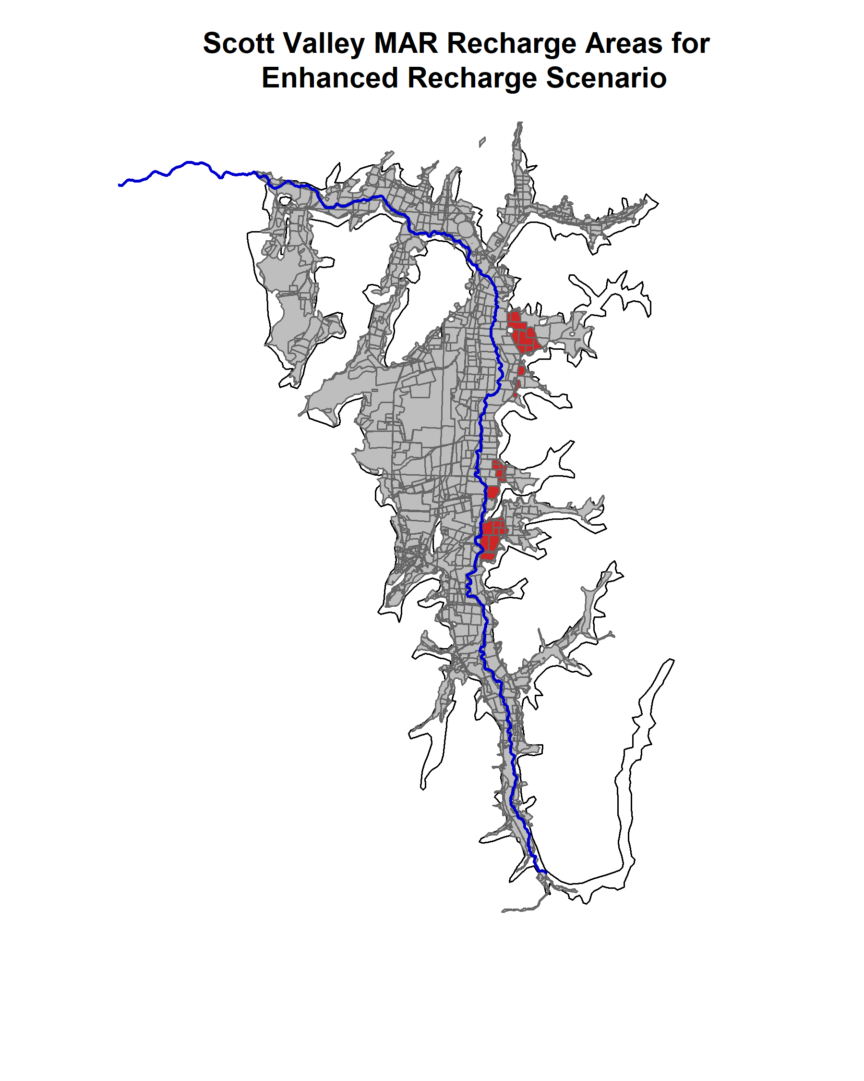
Figure 1: Fields used in the 2024 MAR recharge pilot program. These fields were used to specify areas where winter recharge (Jan-March) was applied each year in the Enhanced Recharge scenario.
## png
## 2
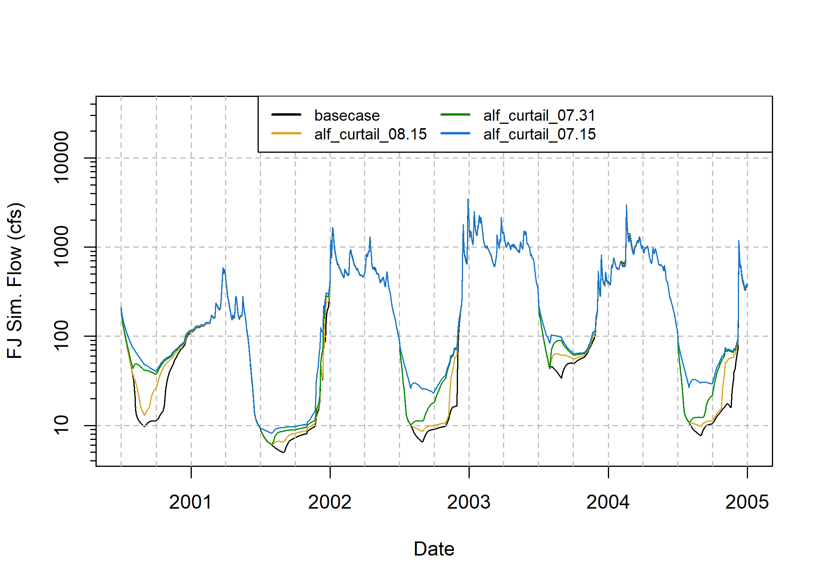
Figure 2: Example scenario impacts on river flow: simulated FJ daily average flow (the basis for functional flows, which is the basis for HB function values) for multiple scenarios.
## png
## 2

Figure 3: In Crop Change scenarios, these randomly-selected fields were simulated in permanent grain cultivation rather than alfalfa, up to a threshold acreage of 6,000, 12,000, and 14,000 acres.

