Farms, fish, and cost: stakeholder-driven scenario design and objective functions clarify trade-offs in an active local water planning process, Northern California
Claire Kouba
2026-05-05

Abstract
In rural semi-arid places, water needs of agriculture and ecosystems are often in complex competition, particularly in connected surface- and groundwater systems. Managing this trade-off with buy-in from the local community requires an understanding of “reasonable” options and trade-offs. In this study, we propose that combining hydrologic models with stakeholder-driven design of both management scenarios and objective functions can 1) identify a politically-relevant, computationally feasible set of scenarios; 2) build a management “landscape” of outcomes to assess reasonableness of any one scenario; and 3) clarify water use trade-offs.
We test this in a case study jurisdiction in northern California, which is in the process of implementing a long-term Groundwater Sustainability Plan (GSP). We developed a summary statistic or proxy for each of the three primary policy considerations in the GSP (environmental, agricultural, and project cost). We then used them to summarize the results of 25 management scenarios developed for the GSP, which were simulated using an existing integrated surface- and groundwater model. We found that, among the set of options considered here, it takes a high infrastructure cost (i.e., reservoir scenarios) to escape the trade-offs defined in the lower-cost regulatory scenario categories. Furthermore, although the existing GSP management priorities emphasized minimal agricultural water cuts, the Pareto-optimal set of management actions included many regulatory approaches and high-cost reservoirs. This work demonstrates that basin-specific, stakeholder-informed scenario design and objective functions can increase the value of existing hydrologic models, and can help clarify trade-offs in ongoing local water planning efforts.

1 Introduction
Sustainable use and management of water resources, in an era of climate change and increasing human water consumption (Williams et al. 2020; Rodell et al. 2018), requires an interdisciplinary understanding of connected socio-hydrologic systems (Reuss 1992; Di Baldassarre et al. 2019). One such interdisciplinary approach is water resources systems analysis (WRSA), which involves applying optimization methods to water resource planning (Design of Water-Resource Systems: New Techniques for Relating Economic Objectives, Engineering Analysis, and Governmental Planning 1962; Cohon and Marks 1975; C. M. Brown et al. 2015). The utility of such studies typically depends on robust definitions of the “objective function(s)”, which summarize and quantify the desired outcome(s) of the proposed project or management scenario (Gorelick 1983). In practice, classical WRSA approaches have been criticized as being too removed from stakeholder concerns (e.g., Rogers and Fiering 1986).
This is unfortunate, as climate adaptation in the water sector, in its many facets – e.g., securing water and food supplies, updating infrastructure to reduce flood and drought risk, and preserving ecosystem function – is often most effective when implemented at the local level (e.g., Van Steenbergen 2006). Local water managers face a complex regulatory landscape and serve diverse stakeholders, and typically have unmet knowledge needs (Bork and Hirokawa 2021; Nordgren, Stults, and Meerow 2016). Academic hydrologists have many tools to fill such knowledge gaps; however, when seeking broadly-relevant findings, they commonly avoid time-consuming engagement with specific local water organizations, which can reduce the utility of the resulting research to the relevant decisionmakers (Freeman 2000).
A further limitation of WRSA is that much of modern water management involves balancing multiple competing objectives (e.g., Cardwell, Jager, and Sale 1996; Jager and Rose 2003; Sun et al. 2018), yet, even with modern methods like genetic optimization algorithms or surrogate modeling, multi-objective optimization (or identification of a Pareto-optimal set) using a complex model is often computationally prohibitive (Labadie 2004; Kapelan, Savic, and Walters 2005; Wu et al. 2015). We propose that even without applying advanced optimization methods, the careful development and application of locally-tailored objective functions can clarify trade-offs and add value to public discourse surrounding local water management. Furthermore, because a full randomized sampling of the decision space facing water managers would be computationally prohibitive (such as which of several projects or policies to implement, in which areas, on what timeframe), stakeholder-driven scenario design can yield a (computationally-tractable) set of simulated management scenarios that are effectively pre-screened by stakeholders for political and approximate technical feasibility.
In this study, we take advantage of the authors’ involvement with an existing informal transdisciplinary collaboratory – a water resource planning process that includes development and maintenance of an integrated surface- and groundwater model and local, regional, and statewide stakeholder engagement - to test the utility of introducing quantitative objective functions into the public prioritization of groundwater management alternatives in a case study jurisdiction. Specifically, we developed numerical representations of three objectives: 1) maximizing specific environmental flows, 2) minimizing reduction in agricultural water supplies, and 3) minimizing new infrastructure costs. With these, we quantitatively summarized the management benefits and trade-offs within the existing suite of several dozen stakeholder-proposed management scenarios. We hypothesized that an explicit objective function framework would yield different prioritization of management actions than the set agreed upon in public meetings (as recorded in the 2021 GSP) and potentially new insights about the holistic management option landscape.
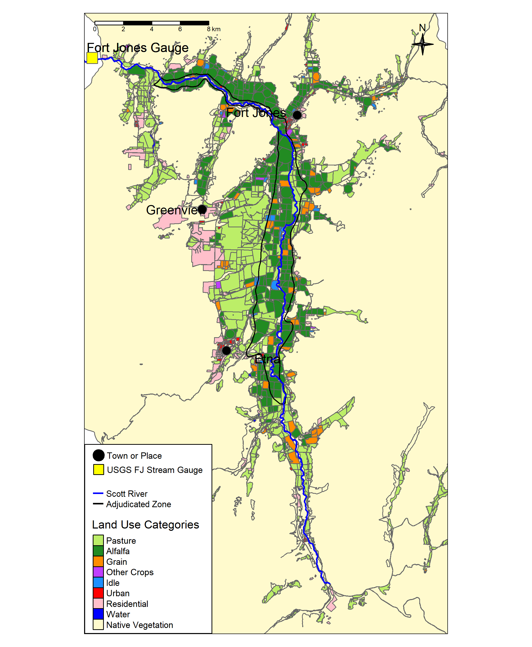
Figure 1: The Scott River flows south to north through Scott Valley before flowing through a canyon and joining the Klamath River. Land uses in the cultivated areas of the Scott River watershed are shown (adapted from the 2016 DWR Land Use Survey), as well as the location of several communities and the Fort Jones streamflow gauge (USGS Station ID 11519500).

2 Background: Case study and GSP development
In our study area, the intermontane rural Scott Valley in Northern California (Figure 1), the local government, diverse public stakeholders, and state regulatory agencies spent three years (2018-2021) developing a plan for the long-term use of groundwater (a Groundwater Sustainability Plan or GSP). In that process, they evaluated dozens of potential water management scenarios (Siskiyou County 2021). In public meetings, different objectives were often championed by individual stakeholders or interest groups. An integrated hydrologic model developed in collaboration with the community, the Scott Valley Integrated Hydrologic Model, or SVIHM (Tolley, Foglia, and Harter 2019), was available to support this policy-making process. The numerical streamflow results of simulated management scenarios drove decision-making, but discussions on the balancing of multiple objectives were typically qualitative. In effect, the optimization framework used to arrive at the ultimate list of management priorities was implicit, and the conceptual weight given to different objectives varied between stakeholders.
Differences between stakeholders in what is considered an acceptable trade-off are common in policy decisions (Monarchi, Kisiel, and Duckstein 1973). Consequently, multi-objective optimization studies often avoid proposing a single optimal solution; instead they identify a Pareto-optimal or non-inferior set of options, which can clarify the unavoidable trade-offs in the performance of various system objectives (e.g., Cohon and Marks 1973). Methods for finding the non-inferior set often involve uniform or randomized initial sampling of the decision space (e.g., Monarchi, Kisiel, and Duckstein 1973; Yeh and Becker 1982; Kapelan, Savic, and Walters 2005). In the case of the Scott Valley GSP, the management actions considered by stakeholders covered a wide range of decision variables (e.g., land use changes in a variety of spatial configurations, technology and/or infrastructure investment, and regulatory interventions on a range of growing season dates). This study avoids this computationally-prohibitive exercise by selecting a set of simulated management scenarios proposed by stakeholders during GSP development, effectively a feasibility pre-screening step.

2.1 Hydrography and climate
The Scott River drains a 2,109 km² (814 square mile) intermontane watershed known as Scott Valley, with forested uplands and a largely agricultural valley floor (Figure 1) overlying an alluvial aquifer up to 79 m (260 ft) thick (SWRCB 1975; Mack 1958). A key stream gauge (USGS Station ID 11519500, or the Fort Jones Gauge or FJ Gauge) is located downstream of the watershed’s cultivated areas (Figure 1).
Scott Valley has a Mediterranean precipitation regime with distinctive seasons of cold, wet winters and warm, dry summers (Figure 2, panels A and B). Winter storms (October-April) and melting mountain snowpack (April-July) generate streamflow during the wet and growing seasons. As a result, the Scott River and tributary streams experience seasonal high and low flows (Figure 2, panel C).
Streams and groundwater are highly interconnected in the Scott River watershed (Tolley, Foglia, and Harter 2019). Tributary streams and the Scott River are a source of recharge to the aquifer, and groundwater discharge sustains streamflow in some areas, especially during the dry season of August-October or November. Some streams are ephemeral, i.e., some tributaries or reaches of the Scott River go dry in average-to-dry water years (Tolley, Foglia, and Harter 2019).
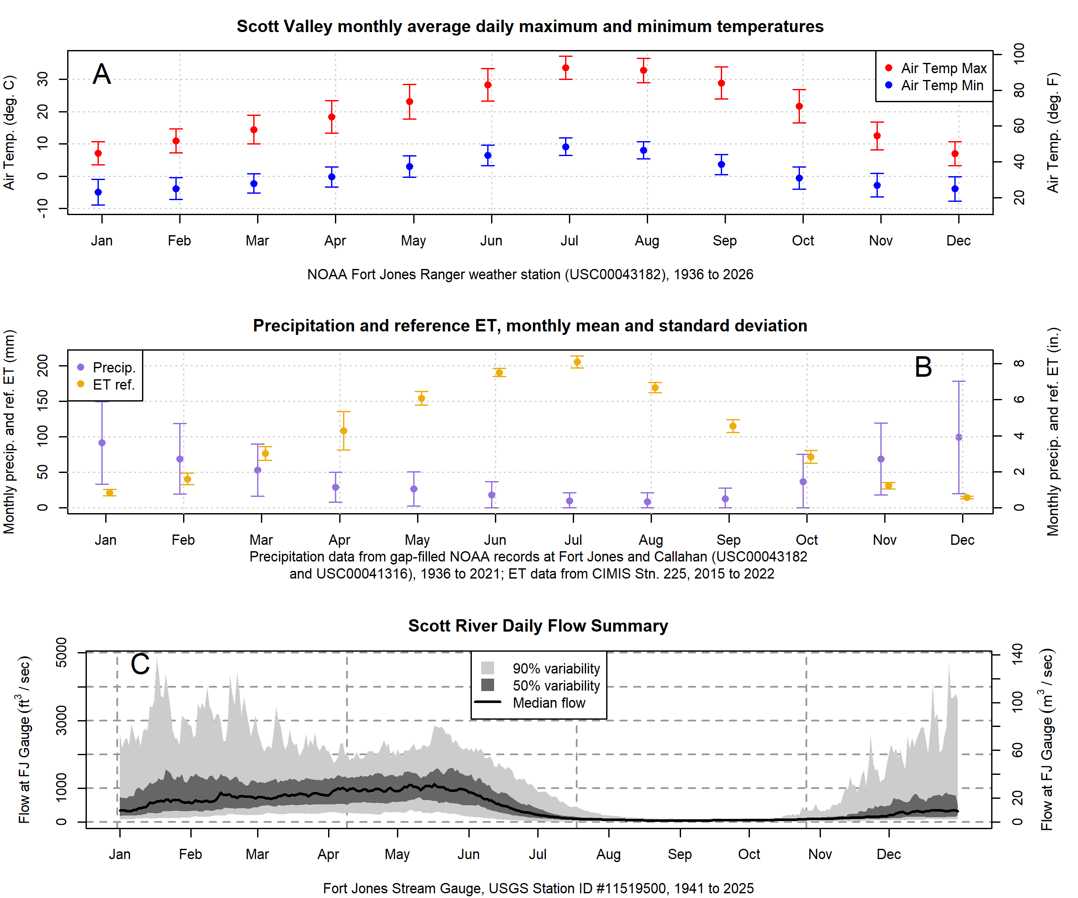
Figure 2: Summary of temperature (Panel A), rainfall and reference evapotranspiration (Panel B), and daily streamflow values (Panel C) in Scott Valley. For precipitation, regression relationships between the Callahan and Fort Jones weather station records and the records of NOAA stations in Greenview, Etna, and Yreka (USC00042899, USC00043614, USC00049866, and US1CASK0005) were used to predict missing values (i.e., fill gaps) in the Callahan and Fort Jones records; the daily mean of the two stations was used as the final precipitation record for purposes of this figure and the SVIHM precipitation input.

2.2 Land and water uses
Because the watershed is undammed, managers and water users influence Scott River flow primarily via diversion of surface waters or pumping of groundwater. Consequently the most powerful tool available to manage Scott River water flow is regulation of land use and thus water demand (Siskiyou County 2021).
About two thirds of the land within the Scott River watershed is under private ownership with the remaining area managed by the Quartz Valley Indian Reservation, the United States (U.S.) Department of the Interior Bureau of Land Management (BLM) and U.S. Forest Service (USFS) (Harter and Hines 2008). On the valley floor, according to land use surveys conducted by the California Department of Water Resources (DWR 2017), half of the area overlying the alluvial aquifer is covered by irrigated agriculture, notably pasture for cattle and an alfalfa/grain rotation (Figure 1; Table 1).
Historically, local regulation of land use has focused on maintaining the rural and agricultural character of Scott Valley (Scott Valley Area Plan Committee 1980). However, during recent declarations of emergency drought conditions, water use has been periodically curtailed to preserve flows for aquatic species (SWRCB 2021, 2024a, 2024b).
Table 1: Acreage and percent of total Basin area covered by generalized land uses as reported in DWR's 2016 land use survey.
Land Use Category | Acres | Percent of Watershed Area
Native Vegetation | 378,005 | 89.4
Pasture | 20,483 | 4.8
Alfalfa | 13,931 | 3.3
Residential | 4,908 | 1.2
Grain | 2,152 | 0.5
Urban | 1,584 | 0.4
Water | 1,220 | 0.3
Idle | 454 | 0.1
Other Crops | 175 | 0.0

2.2.1 Environmental stream flows
Sufficient environmental flows, varying by season, are necessary to the survival of vulnerable species in the Scott River watershed (Scott River Watershed Council 2018). Coho salmon (Oncorhynchus kisutch) in Scott Valley belong to the Southern Oregon / Northern California Coast (SONCC) Evolutionarily Significant Unit (ESU), and were listed as threatened under the federal and California Endangered Species Acts (ESAs) in 1997 and 2005, respectively. Statewide coho populations have declined by an estimated >90% since the 1940s (L. R. Brown, Moyle, and Yoshiyama 1994).
To complete their life cycle, coho salmon require several key functional flows in the Scott Valley freshwater stream system (Kouba et al. 2025), including the following:
- Fall flows, increasing after the dry season in response to early wet season storms, that are sufficient to provide coho spawners access to preferred spawning reaches within the fall-run time window;
- Flows providing habitat for rearing juvenile salmon for their ~12-15 months of freshwater residence; and
- Sufficient flow in the spring for yearling smolts to migrate to the ocean.
While Chinook also require fall flows for spawning, their specific flow requirements are somewhat distinct from coho due to their different life histories:
- Chinook juveniles spend less than one year in the freshwater environment (Agrawal et al. 2005), while coho overwinter and typically migrate to the ocean at 1+ years old (Moyle 2002; McMahon 1983);
- Chinook tend to spawn earlier in the fall than coho (Knechtle and Giudice 2020; Magranet 2015, 2017);
- Chinook prefer to spawn in the main stem of the Scott River, while coho prefer to spawn in tributaries (e.g., Magranet 2018; Magranet and Yokel 2017), making juvenile Chinook salmon more vulnerable than coho to egg burial or bed scour during high-flow storm conditions.
Different functional flows are needed by other species, such as cottonwood trees, which require flood-stage flows to disperse their seeds (Mahoney and Rood 1998); but in this work we focus on coho and Chinook salmon as two examples in developing a single-species environmental objective function. Alternative objective function formulations are discussed in later sections.

2.2.2 Agricultural water demand
Agricultural water demand in Scott Valley has been investigated [Cite Orloff/Snyder work?] and simulated for a historical model period of Oct. 1, 1990 to Sept. 30, 2025, using the calibrated Scott Valley Integrated Hydrologic Model (SVIHM) (Harter and Hines 2008; Foglia et al. 2013; Tolley, Foglia, and Harter 2019). Water demand for crops and native vegetation (evapotranspiration, or ET, in Figure 3) and applied irrigation volumes (diverted surface water and pumped groundwater, noted as SW and GW Irrigation in Figure 3) are highest in the late summer. Annual crop ET and irrigation demand is relatively stable year to year while precipitation, and thus recharge to groundwater, are more variable (Figure 4).
In this intermontane valley, the growing season is constrained by hard frosts, and begins in March-April and extends through September-October. Both of the primary crops (alfalfa and pasture) are perennial, and will continue producing through the growing season as long as soil moisture is available. Alfalfa cultivation since the 1970s has commonly involved three to four harvests (referred to as cuttings) per growing season; it is typically irrigated several times and then left to dry before cutting (Tolley, Foglia, and Harter 2019).
The tension between agricultural and ecological water demands is highest at the end of the dry season, when groundwater elevations and surface flows are at their lowest, crop demand remains high, and anadromous fish require access to spawning habitat. The management of these fall flows was a central concern of GSP development in 2018-2021.
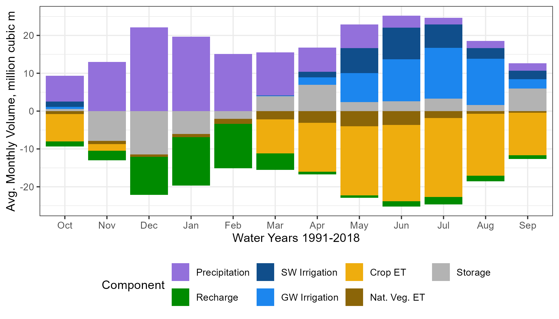
Figure 3: Average monthly water budget for the soil zone, simulated with SVIHM, for the model simulation period (water years 1991-2018). Positive and negative values indicate average net monthly fluxes into and out of the soil zone, respectively.
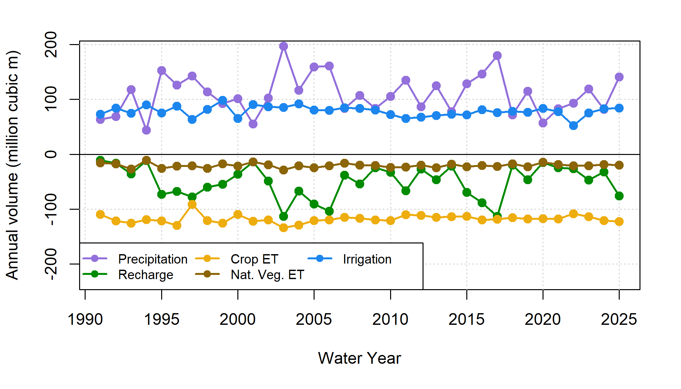
Figure 4: Annual values for inflowing (positive) and outflowing (negative) water budget components in the SVIHM soil zone (historical basecase simulation). Irrigation refers to both groundwater and surface water sources; Recharge refers to water percolating through the soil column and recharging the aquifer below. Both crop ET and ET from native vegetation remain relatively stable year to year, while precipitation inputs, and thus recharge to the aquifer, have higher interannual variability.

2.3 GSP development
The Scott Valley Groundwater Sustainability Plan (GSP) was developed by the Siskiyou County Flood Control and Water Conservation District, which is the designated Groundwater Sustainability Agency (GSA) charged by the state of California to sustainably manage local groundwater resources pursuant to the Sustainable Groundwater Management Act (SGMA) of 2014. GSP development took place between 2018 and 2021, and was guided by discussions in the monthly public meetings of an Advisory Committee composed of nine local stakeholders. Technical analyses supporting the public meeting deliberations and GSP policies were provided by several technical experts, including the authors of this study (Siskiyou County 2021). The plan was subsequently subject to statewide public review and regulatory review by the California State Department of Water Resources (CDWR). In their approval, CDWR suggested several necessary improvements to be addressed by 2027 including updated criteria for degraded water quality, and a clearer definition of what would constitute an undesirable result for groundwater-related stream depletion.
SGMA requires each local GSA to define sustainability in the negative, by quantifying and then avoiding “undesirable results” that would be “significant and unreasonable”. The central undesirable result in Scott Valley is streamflow depletion due to groundwater pumping. Consequently, a central challenge of GSP development was balancing and deciding the amount of (estimated) streamflow depletion that the GSA should aim to reverse by accounting for environmental water demand versus the degree of water security that was owed to local agriculture.
During GSP development, the authors of this study simulated dozens of land and water use scenarios to facilitate the comparison of management alternatives that could reduce streamflow depletion to various degrees. Simulations were conducted with a spatially explicit, integrated surface water-groundwater model (Tolley, Foglia, and Harter 2019), as described below in Section 3.3.

3 Methods
After 2021, we expanded on this public planning effort with a research study, based on the suite of management scenarios designed for the GSP, in the hopes that it could inform water management decisions during 5-year GSP updates over the coming decades.
In particular, we developed two quantitative objective functions and one categorical objective proxy to evaluate the management scenarios developed for the GSP. The three objectives were:
- maximize specific environmental flows,
- maintain current levels of agricultural productivity (represented as minimizing reduction in agricultural water use), and
- minimize new infrastructure costs (represented as a categorical infrastructure/feasibility proxy) (Table 2).
We then applied these to the results of each simulated management scenario, found the Pareto-optimal set of scenarios, and compared them to the prioritization of management actions adopted in the GSP (Siskiyou County 2021).
Table 2: Management objectives and description of objective functions applied to summarize scenario performance.
Management Objective | Objective Function
Maximize specific environmental flows | Hydrologic Benefit function, based on flow metrics empirically correlated with coho salmon reproduction rates (higher values preferred)
Minimize reduction of agricultural water use | Crop ET volume over model domain (higher values preferred)
Minimize new infrastructure investment | Feasibility category of 1-4 (lower values preferred)

3.1 Objective functions

3.1.1 Hydrologic Benefit function
Conceptually, the Hydrologic Benefit (HB) function aims to answer the question: to what degree does this water year provide enough flow, at the right time, for this species?
In a previous study, we empirically identified hydrograph features of high importance to Scott River coho and Chinook, based on correlations between hydrology and ecological observations such as outmigrating juvenile abundance (Kouba et al. 2025). The HB function is represented as a linear combination of these high-importance annual functional flow values.
Functional flows are set of streamflow metrics related to the timing, amplitude, and duration of flow phenomena (Yarnell et al. 2015; Patterson et al. 2020; Carpenter 2024). In the HB function, these were weighted according to their power to predict coho and Chinook outcomes, such as smolt production or smolt production normalized per female spawner. The combination of these weighted metrics can be interpreted as a prediction of coho reproduction that is empirically associated with and appears to be supported by hydrologic factors. Importantly, the HB functions developed in this exercise explain only about 40% to 60% of variation in observed smolt abundance, and the remaining 60%-40% of variation is assumed related to other life conditions, e.g., number of returning spawners, water quality, food resources, and internal fishery population dynamics (Kouba et al. 2025).
There are many different possible HB function formulations; one example HB function is included below and three additional formulations are explored in Supplemental Material. These four HB functions correspond to the best-fit statistical model for two species (coho and Chinook) as measured using two different units of annual salmon reproduction (outmigrating smolt abundance and normalized smolt-per-adult-spawner in the relevant brood year). See Supplemental Material for more HB function design information.
The example HB function highlighted here is based on coho juvenile outmigrant abundance. It predicts that a higher number of coho smolt produced (coho smolt-equivalent) is related to higher fall flows during a cohort’s parents’ spawning, lower fall flows during a cohort’s time as overwintering yearlings, and a slower spring recession (see coefficient values in Table 3).
Table 3: Coefficients for the Hydrologic Benefit function, an emperical estimate of ecological services provided to coho salmon by specific functional flows. The predicted value is in units of log10(juvenile abundance) produced, modeled using only hydrological factors.
Predictor | Value | Greater Hydrologic Benefit value associated with
Intercept | 3.872 | Intercept Term
f1_FA_Dif_num | 0.162 | Larger fall flow increase (during parents' spawning)
s1_SP_ROC | -0.020 | Slower rate of change, spring recession (as recent hatchlings)
f2_FA_Dif_num | -0.130 | Smaller fall pulse (as juvenile fish)
Functional flow metrics informing the HB function were calculated from the observed daily average flow record of the FJ gauge ($FJ_{obs}$), using signal processing algorithms developed by the California Environmental Flows Framework (Yarnell et al. 2015; Patterson et al. 2020; Carpenter 2024). One key model result of the historical basecase scenario in SVIHM is a simulated estimate of the historical FJ gauge record ($FJ_{sim, basecase}$). However, although SVIHM was extensively calibrated (Tolley, Foglia, and Harter 2019), because all models involve structural simplifications of a full-scale watershed, $FJ_{sim, basecase}$ sometimes over- or under-estimates $FJ_{obs}$. To control for this, all basecase HB values used in this study are derived from $FJ_{sim, basecase}$, making them directly comparable to HB values derived from the simulated FJ flow records in the hypothetical management scenarios.

3.1.2 ET volume function (agricultural benefit proxy)
The annual crop ET volume, which is explicitly simulated in the hydrologic model, is used here as a proxy for agricultural productivity. Other options for framing the agricultural water use objective function include crop yields and total revenue, which may be of greater concern to stakeholders; however, annual crop ET was selected because the impacts of reduced water availability on yield or revenue will likely vary by grower and over time.
Additionally, for alfalfa and pasture, which continue growing as long as water is available, a strong relationship between crop ET and yield is assumed (Carter and Sheaffer 1983). However, we assume that grain, another important local crop, has a different relationship than alfalfa between ET and revenue, as grain is harvested once per year in mid-to-late summer and alfalfa is harvested three to four times per year in this region (Harter and Hines 2008). This makes interpretation of the agricultural objective functions more complicated for three crop change scenarios in which alfalfa is converted to grain; this is explored further in the Discussion section.

3.1.3 Proxy for scenario infrastructure investment
In lieu of detailed cost estimates or feasibility studies, we chose to group management alternatives in qualitative categories approximating the degree of new infrastructure investment needed in each alternative. The categories describing project feasibility and timeframe are as follows:
- No feasibility barriers (basecase; maintain current practices)
- Implementable with current infrastructure
- Requires new infrastructure that would take 1-2 years to build
- Requires new infrastructure that would take 3-5 years to build
- Requires new infrastructure that would take 5+ years to build
This reflects the first-order understanding that, for example, building a reservoir (assigned to category 4) will take more effort and resources in terms of permitting and construction than widespread installation of higher-efficiency irrigation technology (assigned to category 2). See Table 6 for full list of assigned categories.

3.2 Analyses of objective function values

3.2.1 Trade-off efficiency
Combining two of the three objectives, scenarios can also be compared in terms of environmental benefit per agricultural cost. This “trade-off efficiency” of a management scenario, or $Eff_{scen}$, is unitless (i.e., it has units of smolt-equiv. per smolt-equiv. / million m³ per million m³) (see equations below).
$$HB_{avg}=\frac{1}{n_{wy}}\sum_{i=wy_{1}}^{wy_{n}}{HB_{wy_{i}}}$$
$$ET_{avg}=\frac{1}{n_{wy}}\sum_{i=wy_{1}}^{wy_{n}}{Crop ET_{annual, wy_{i}}}$$
$$Eff_{scen}=\frac{\left(HB_{avg, scen}-HB_{avg, basecase}\right)/HB_{avg, basecase}}{-1*\left(ET_{avg, scen}-ET_{avg, basecase}\right)/ET_{avg, basecase}}$$

3.2.2 Pareto-optimal set of management actions
After calculating the objective function values for each scenario, we applied a simple algorithm to identify the Pareto-optimal set of scenarios (Pareto 1896). A scenario was identified as Pareto-optimal if there were no other scenarios that performed better in two or more objectives. In other words, the Pareto-optimal set is the collection of scenarios in which it is not possible to improve on one objective without reducing performance in another objective. By definition, this set cannot evaluate trade-offs between objectives; we use it here to identify quantitatively suboptimal scenarios.

3.3 Hydrologic model summary
The Scott Valley Integrated Hydrologic Model (SVIHM) (2019) is a surface and groundwater model driven by tributary stream inflows, precipitation, and reference evapotranspiration (ET₀). Like all models, it does not perfectly reproduce historical observations, but it successfully captures key watershed-scale hydrologic phenomena that can be used to evaluate potential outcomes of specific management actions.
The SVIHM is composed of three cascading sub-models. First, complete daily records of tributary stream inflow are generated using a statistical streamflow regression model, in which the continuous Fort Jones record was used to predict missing values in the daily flow records of 12 major tributaries (Foglia et al. 2013). Second, a custom-built soil water budget model simulated irrigation demand, irrigation applied (surface and groundwater), ET and percolation to aquifer calculated on a field-by-field, daily time step basis. This model simulates individual irrigation applications and assumes the farmer has perfect foresight of daily irrigation demand. Finally, the boundary conditions of stream inflow, aquifer recharge, and groundwater extraction are used to drive an integrated groundwater-surface water model using MODFLOW; stream-aquifer flux and surface flow routing was simulated using the MODFLOW SFR package (Tolley, Foglia, and Harter 2019).
For GSP development, SVIHM was used extensively to perform what-if scenarios using the historic climate and land use, covering 1991-2018. (For purposes of this study, the model period has been extended through Sept. 30, 2025.) Scenario simulations repeat the calibrated historical basecase simulation of SVIHM while varying specific changes in SVIHM boundary conditions (BCs). The set of changes in the BCs of a particular scenario represent specific changes in land use, irrigation management, climate, water management rules, etc. Scenario outcomes are compared against those of the basecase simulation. Key results of each SVIHM scenario, used in the objective functions described below, are:
- A prediction of Scott River daily average flow at the Fort Jones Gauge, which is co-located with the surface water outlet of the model domain; and
- Simulated total ET of crops and native vegetation within the model domain.

3.4 Management scenario descriptions
For the Scott Valley GSP, SVIHM was used to simulate 64 management action scenarios; in most other California GSPs, between one and five scenarios was more common (e.g., FCGMA 2019; YSGA 2022). This high number of scenarios was possible because the SVIHM had been under development for 8 years prior to the start of GSP work (e.g., Foglia et al. 2013; Tolley, Foglia, and Harter 2019), and cost-effective technical support was provided by graduate students and researchers at the University of California, Davis. Of the 64 scenarios, only 25 are considered here. Several were ruled out as obviously unfeasible (e.g., construction of a 134 thousand acre-foot reservoir to ensure 100% flow reliability even during severe drought, in an area with topography that could not support such a large capacity), and some were excluded due to redundancy.
The scenarios are grouped here by category (Table 4). Within each category various details were altered (e.g., an alfalfa irrigation cessation date of July 10 versus August 15). Additional scenario descriptions are included below in Results and in Supplement A.
Table 4: Management scenario categories (abbreviated), a general description, the number of scenarios in each category, the feasibility proxy and the type of management action.
Category | Scenario Category Description | Num. Scen. | Infra. Proxy | Mgmt. Type
Basecase | Basecase | 1 | 0 | Basecase
EnhRch | Enhanced Recharge | 1 | 3 | Infrastructure
IrrEff | Improved Irrigation Efficiency | 2 | 2 | Infrastructure
Res | Small Reservoir | 3 | 4 | Infrastructure
CropCh | Crop Change (Alfalfa Rot. to Perm. Grain) | 3 | 2 | Infrastructure
AlfIrr | Cease Alfalfa Irrigation Early | 3 | 1 | Regulatory
Curtail | Cease (Curtail) All Irrigation Early | 3 | 1 | Regulatory
FlowLims | Low Flow Diversion Limits | 1 | 1 | Regulatory
NatVegH | Some Nat. Veg. Land Use (high ET) | 4 | 2 | Nat. Veg.
NatVegL | Some Nat. Veg. Land Use (low ET) | 4 | 2 | Nat. Veg.

4 Results
As described above, the degree to which the basecase and 24 scenarios achieved local management goals was summarized using two objective functions. A summary value for the agricultural objective (total crop ET volume) and for the environmental objective (a Hydrologic Benefit [HB] value in units of predicted smolt abundance for coho) were calculated for each water year/brood year in the 35-year simulation period, for each scenario (Table 6). (See Supplemental Material for HB function results in different units; Table 5.) In addition to the two objective functions, each scenario has been assigned an infrastructure feasibility category (Tables 4 and 6).
Table 5: Units of Hydrologic Benefit (HB) function and location in document.
units | coho | Chinook
juvenile abundance | Highlighted in text and Supp. B | Supplement D
juveniles per adult | Supplement C | Supplement E
In the basecase scenario, the 35-year mean annual ET volume is 118 million m³ of water, and the 35-year mean of annual HB values is 7812 coho spf-equivalent (Table 6). Annual ET volume is relatively stable over the model period of water years 1991-2025, while about annual HB values are more variable, with about 10% being high outliers (Figure 5). Among the 24 management scenarios, mean ET values ranged from 0 (i.e., no irrigated agriculture) to 118 million m³ of water (i.e., no reduction from basecase crop ET), while HB values ranged from 7696 to 8446 coho smolt-equivalent.

4.1 Hydrologic Benefit function basis: selected functional flows
As stated above, the environmental objective (HB function) results can be interpreted as a prediction of the 40% to 60% of variation in coho smolt production that is empirically associated with and appears to be supported by hydrologic factors; correspondingly, it is assumed that the remaining variation in observed smolt abundance is due to non-hydrologic factors like water quality or population dynamics (Kouba et al. 2025).
Because functional flow values were standardized (Z-score transformed) before the statistical modeling exercise, absolute values of HB function coefficients for flow metrics can be interpreted as relative degree of influence on the relevant ecological outcome (Table 3; see Supplement B for tabulated, untransformed functional flow values).
The HB formulations represent four ways of answering the question, “how good was this water year for this species, and which flows matter?” For coho, in both absolute and spawner-normalized smolt units, the high-importance flows were fall-to-wet season transition metrics; for units of absolute smolt abundance, the spring recession rate was also important (Supplements B and C , Table 1). For Chinook, in both absolute and spawner-normalized smolt units, the wet season baseflow median magnitude was of greatest importance; for normalized smolt units, maximum spring recession rate was also selected (Supplements D and E, Table 1). Effectively, in the context of LASSO regression, the flows that explain the most variation in smolt production (with minimal overfitting, as determined by k-fold validation) were related to, for coho, the timing of wet season onset and the magnitude of changes in fall flows; and for Chinook, the wet season baseflow.

4.2 Objective function results over time
Management scenarios tended to have a uniform effect on total ET over time, shifting it by about the same amount each year relative to basecase (Figure 5). Conversely, in some years, many scenarios seem to have very little effect on HB function, though this is variable over time, regardless of which HB units are used (Figure 5 and Supplements B-E, Figure 1).
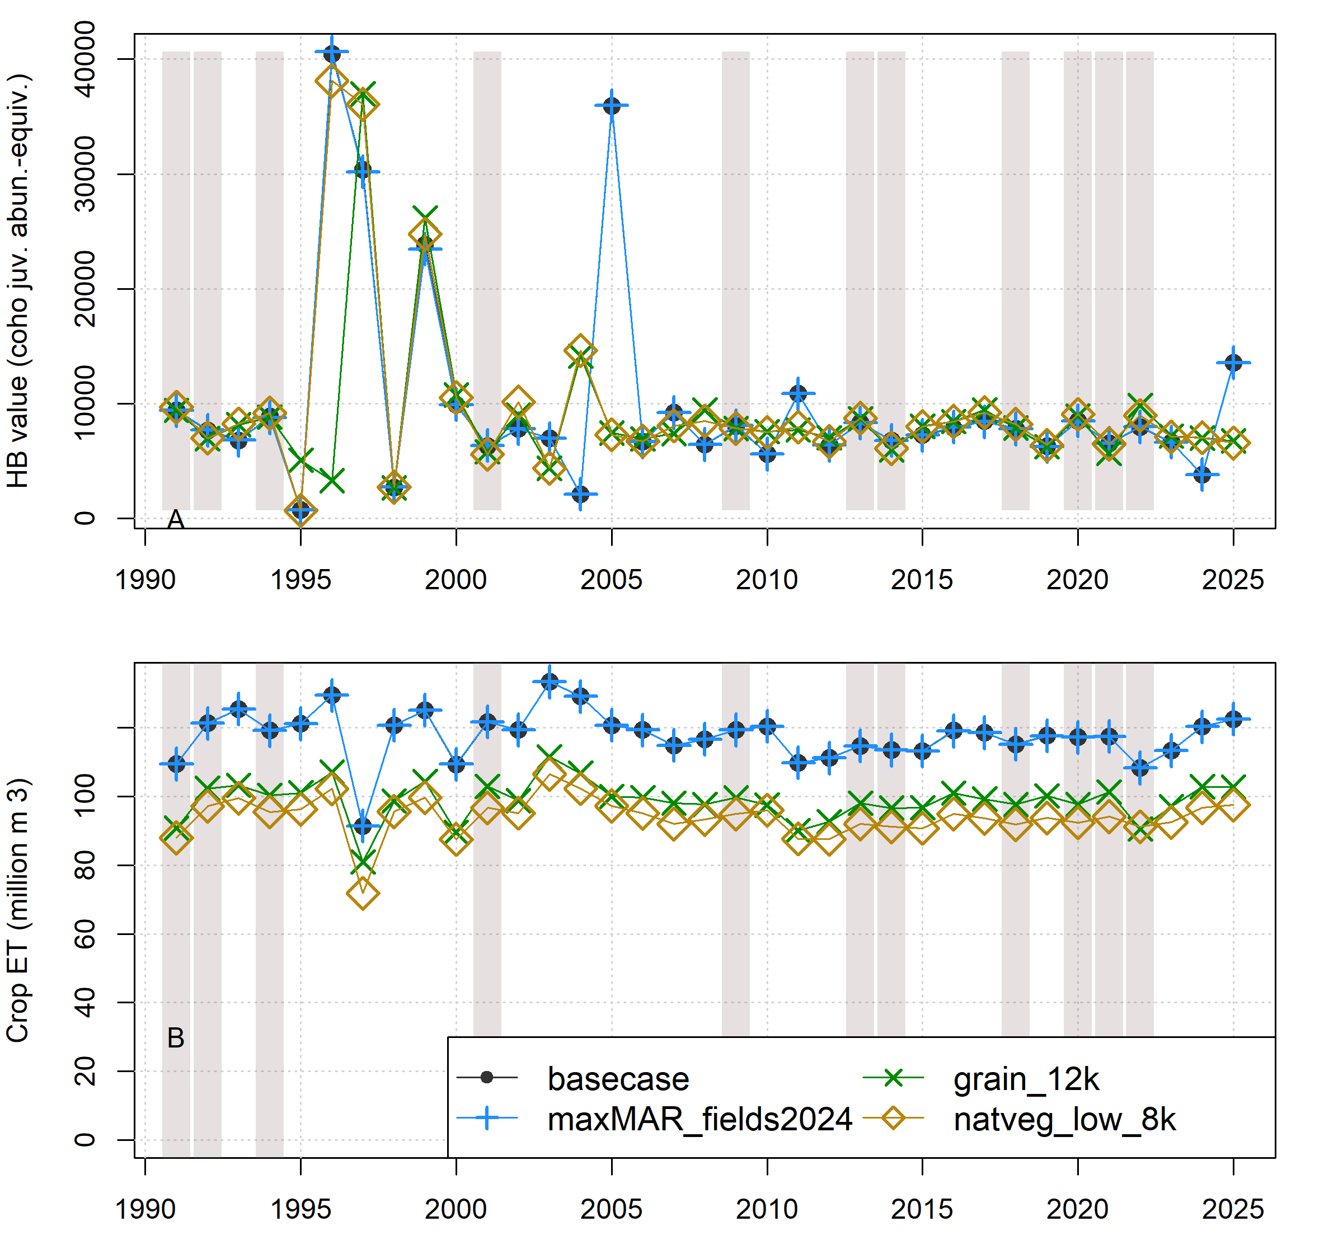
Figure 5: Comparison of annual performance in two objective functions (Hydrologic Benefit and ET, representing environmental and agricultural objectives, respectively) for brood years 1991-2025. The scenarios pictured are basecase (black circles) and a scenario from each of three categories: Enhanced Recharge, Crop Change, and eight thousand acres of irrigated crops converted to low-ET Native Vegetation. Dry-type water years (vertical bars) are 1991, ’92, ’94, 2001, ’09, ’13, ’14, ’18, and ’20-’22. Shown also in Supplement B.
The small effect of some scenarios on HB values implies that these scenarios do not alter the HB function component flows relative to basecase (Supplements B-E, Figure 2). For coho juvenile abundance, in the basecase scenario, it seems that when the HB function predicts a particularly good year (i.e., > 20,000 coho smolt-equiv.), it is driven by a large magnitude fall flow difference, or fall pulse. Conversely, in the years where the HB function predicts a particularly bad year (i.e., ’95, ’98, ’04), it is driven by a rapid first spring recession rate (Supplement B, Figure 2). Conversely, for coho juveniles per spawner (basecase), both good and bad years seem to be largely driven by wet season onset timing (Supplement C, Figure 2).
In both cases for coho, second fall flow difference makes minor contributions (Supplements B and C , Figure 2), and is assigned a negative coefficient (Table 3). This suggests higher flows in the second fall (for juvenile overwintering coho) are consistently associated with lower smolt production, but other factors such as first fall flow difference and wet season timing seem to exert greater overall influence.
For Chinook, predictions of both high and low smolt production are driven by wet season baseflow magnitude (with a small contribution from maximum spring recession rate for juveniles per adult): high wet season flows are associated with lower smolt abundance (Supplements D and E, Figure 2).

4.3 Environmental-agricultural tradeoffs within and between scenario categories
The 35-year mean values of HB and ET can be used to map all scenarios on one two-dimensional landscape, which is useful for evaluating trade-offs between objectives (Figure 6).
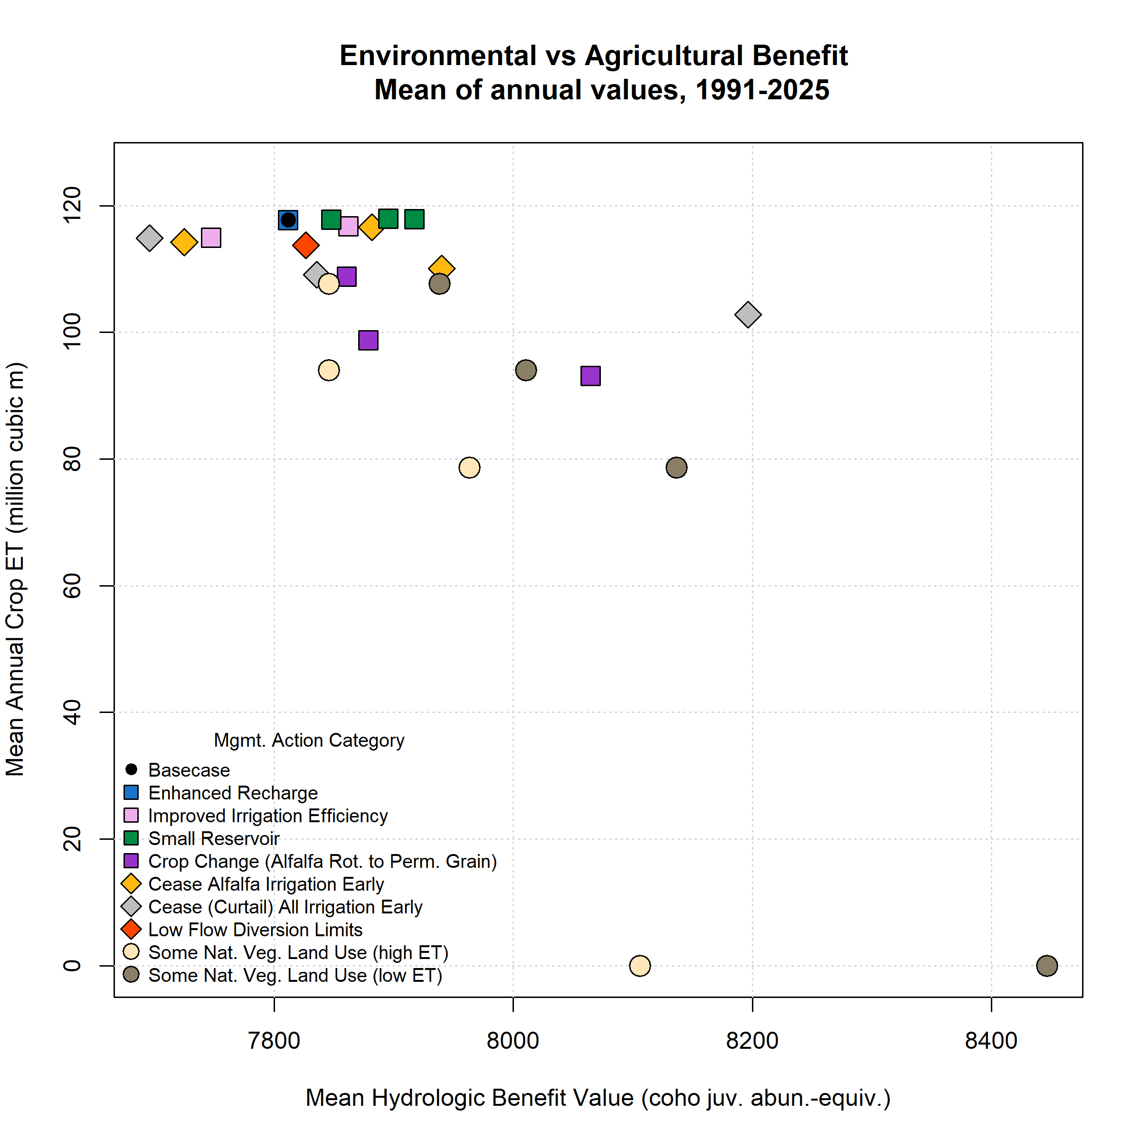
Figure 6: Environmental and agricultural objective function performance (in terms of Hydrologic Benefit, or HB, value; and crop ET volume) for basecase (black circle in upper left) and 25 management scenarios. Symbol x and y coordinates are the average of 35 annual HB and ET values for each scenario over the full model period (water years 1991-2025); for exampe time series of annual values, see previous figure.

Table 6: Scenario attributes for 25 scenarios. Values in the Mean Hydrologic Benefit (HB) and Mean ET columns are averages of 35 annual values for each scenario. Efficiency not calculated for scenarios with no average ET loss.
Scenario ID | Category | Feas. | Mean HB / 1000 | Mean ET | Pareto | Efficiency
basecase | basecase | 0 | 7.81 | 117.76 | Yes | --
alf_curtail_07.15 | AlfIrr | 1 | 7.94 | 110.09 | Yes | 0.25
alf_curtail_07.31 | AlfIrr | 1 | 7.72 | 114.26 | -- | --
alf_curtail_08.15 | AlfIrr | 1 | 7.88 | 116.61 | Yes | 0.92
curtail_all_07.15 | Curtail | 1 | 8.20 | 102.83 | Yes | 0.39
curtail_all_07.31 | Curtail | 1 | 7.84 | 109.13 | Yes | 0.04
curtail_all_08.15 | Curtail | 1 | 7.70 | 114.91 | -- | --
eflows25_div_lims | FlowLims | 1 | 7.83 | 113.75 | Yes | 0.05
grain_12k | CropCh | 2 | 7.88 | 98.75 | -- | 0.05
grain_14k | CropCh | 2 | 8.06 | 93.16 | -- | 0.15
grain_6k | CropCh | 2 | 7.86 | 108.81 | -- | 0.08
irr_eff_0.1 | IrrEff | 2 | 7.86 | 116.74 | Yes | 0.74
irr_eff_0.2 | IrrEff | 2 | 7.75 | 114.98 | -- | --
maxMAR_fields2024 | EnhRch | 3 | 7.81 | 117.75 | -- | --
natveg_high_12k | NatVegH | 2 | 7.96 | 78.66 | -- | 0.06
natveg_high_4k | NatVegH | 2 | 7.85 | 107.70 | -- | 0.05
natveg_high_8k | NatVegH | 2 | 7.85 | 94.02 | -- | 0.02
natveg_high_all | NatVegH | 2 | 8.11 | 0.00 | -- | 0.04
natveg_low_12k | NatVegL | 2 | 8.14 | 78.66 | -- | 0.13
natveg_low_4k | NatVegL | 2 | 7.94 | 107.70 | -- | 0.19
natveg_low_8k | NatVegL | 2 | 8.01 | 94.02 | -- | 0.13
natveg_low_all | NatVegL | 2 | 8.45 | 0.00 | Yes | 0.08
reservoir_etna | Res | 4 | 7.92 | 117.87 | Yes | --
reservoir_french | Res | 4 | 7.85 | 117.84 | Yes | --
reservoir_shackleford | Res | 4 | 7.90 | 117.98 | Yes | --
In units of coho smolt abundance, three management scenarios actually produce poorer fish outcomes than basecase, but the majority of scenarios produce more favorable flows for smolt production (Figure 6). This is larguly due to scenario impacts on the largest single component of the HB function for coho smolt abundance, first fall flow difference or f1_FA_Dif_num. This metric is calculated as the difference between dry season median discharge and peak fall pulse discharge; in years with no detectable fall pulse flow, this value is set to 0 (Carpenter 2024; Baruch et al. 2024) (see also Supplement B, Table 3, and Supplement B, Figure 2). The high degree of correlation between this flow and coho smolt abundance is corroborated by the species’ natural history: fall run timing is somewhat more flexible for coho than Chinook, and coho seem to respond strongly to pulse flows, possibly due to olfactory signals from their natal streams (CDFW 2021). Because changes in water use can affect both the dry season minimum and the magnitude of a fall pulse flow, management scenarios may have positive or negative effect on this functional flow, which in turn will influence the total calculated HB value.

4.3.1 Small Reservoir
Reservoir scenarios simulate how flows would change if a small reservoir (9 thousand acre-feet, or 11.1 10⁶ m³), located in the headwaters on one of 3 tributaries, were operated with the following objectives: retain winter flow until full (Dec-Mar), pass along growing season flow (Apr-Aug), and supplement dry season flow (Sep-Nov).
Somewhat contrary to expectations, reservoir scenarios have limited benefit to coho populations, relative to other management options: small reservoirs may not have capacity to add fall flow during dry years when baseflows are lowest (Figure 6, green squares, and Supplements B and C, Figure 3). Reservoir scenarios seem to support Chinook significantly more than coho populations: even a small reservoir on one tributary appears to dampen wet season stormflows enough to benefit Chinook (Supplements D and E, Figure 3).

4.3.2 Enhanced Recharge and Irrigation Efficiency
The two Irrigation Efficiency scenarios simulate widespread adoption of higher-efficiency irrigation technology, such as Low Energy Precision Application (LEPA) or Mid-Elevation Spray Application (MESA) adaptations to spray infrastructure. These upgrades are simulated to result in 10% or 20% greater irrigation efficiency. Efficiency reflects the fraction of applied water used by the plant relative to the total applied (the remainder percolating through the soil to become aquifer recharge).
The Enhanced Recharge scenario simulates a Managed Aquifer Recharge (MAR) program diverting the maximum permitted diversion rate of 23 cfs (0.65 m³/sec), or 4151 acre-feet 5.1 10⁶ m³) total water volume from the Scott River over 90 or 91 days Jan-March (depending on leap year status). This water is applied as excess winter recharge on 32 fields, totaling 5.6 10⁶ m² (1395 acres; see Supplement A for map of recharge areas).
Scenarios in these two categories have a minimal effect on crop ET (Figure 6 and Table 6; see also Supplements B-E, Figure 3). The lack of farmer cost is by design; this management strategy is intended to avoid any impacts on growing season operations.
In all four HB formulations, Enhanced Recharge has a minimal effect, while Irrigation Efficiency has a small positive or negative effect, on environmental benefit. For Irrigation Efficiency, these results may reflect that the practice reduces growing-season recharge to the aquifer as well as stream diversion or well pumping. For Enhanced Recharge, the lack of any fish benefit suggests that any flow increases from winter recharge may dissipate by the end of the dry season, and correspondingly that current maximum permitted surface water diversions are insufficient to improve flow conditions for fish in the fall.

4.3.3 Irrigation Curtailment (alfalfa; all crops)
Early cessation of irrigation on alfalfa fields effectively means that growers forgo the harvest of one or more hay cuttings, which can be a significant economic impact for a farm; however, in watershed-wide total ET terms, the effects are relatively small for scenarios in this category (Figure 6, orange diamonds). The second category simulated a blanket curtailment on all irrigation, including on pasture, the other primary crop besides alfalfa (Table 1; Figure 6, gray diamonds). In both categories, cutoff dates for irrigation were August 15 [closest to the basecase alfalfa irrigation cutoff date of September 5; Foglia et al. (2013)], July 31, and July 15.
In general, this series of cutoff dates has a progressive effect on fall flows: the earlier the cutoff date, the greater the impact on raising summer low flows, producing earlier fall flow increases, and slowing the spring recession rate (see alfalfa scenario flow results in Supplement A, Figure 2). For Chinook HB units, the impact on HB values is similarly progressive (Supplements D and E, Table 2 and Figure 3), but for coho units, the impact on HB values is more variable, since management scenarios may have a positive or negative effect on a f1_FA_Dif_num (see above).

4.3.4 Crop Change
In the Crop Change category, we simulate permanent grain cultivated on acreage that, in the basecase, is cultivated in an alfalfa-grain rotation (7 years alfalfa followed by 1 year of grain). During scenario design, fields were randomly assigned to be under permanent grain until a target acreage was reached: 6, 12, and 14 thousand acres.
Because permanent grain is harvested once in the mid-to-late growing season, it has lower consumptive water use per year than an alfalfa field with perennial growth and multiple harvests. Thus, increasing grain acreage yields progressive HB increase for coho, and a progressive HB decrease for Chinook (Figure @ref(fig:farmerFishTradeoffFigureMainText and (Table 6)). As mentioned before, the ET values in the Crop Change category are challenging to compare directly to those in other categories (see Discussion).

4.3.5 Low Flow Diversion Limits
In the basecase, surface water diversions to meet crop water demand are permitted until the stream volume is totally depleted (which is a common occurrence in some reaches of this ephemeral stream system); conversely, in this scenario, surface water was not diverted if flow fell below minimum tributary flowrates corresponding to the CDFW emergency drought flow regime (SWRCB 2024a) (Figure 6 and Table 6).
Preservation of low flows seems to have a small agricultural cost, indicating that crop water deficits due to this practice may be small on average. However, it also has only a small positive environmental benefit, suggesting that targeting low flows may not have a substantial influence on all relevant parts on the hydrograph.

4.3.6 Native Vegetation
The two categories of Native Vegetation scenario (NatVegL and NatVegH, for low and and high ET) are two end-member answers to the question: if currently-cultivated land were converted to native vegetation, what water consumption pattern would replace it? The first category (NatVeg) assumes a native vegetation crop coefficient of 0.6, while the second category (NatVegET) assumes a native vegetation crop coefficient of 1.0 and a maximum rooting depth of 4.5 m. The first category could be interpreted as chaparral or sage scrub-type vegetation cover, while the second category could represent a mixed bunchgrass and clover prairie with extensive riparian vegetation corridors and wetlands.
On average, area-normalized ET from native vegetation is 36 cm/year (42% of average annual crop ET). Simulating native vegetation in place of irrigated acreage results in a greater proportion of water leaving the SVIHM model domain via surface flows rather than as transpiration. Consequently the two NatVeg scenarios generate higher simulated FJ streamflow in most months of the model period.
For both coho and Chinook, as we would expect, increasing acreage of native vegetation reduces total crop ET (Figure 6 and Table 6; see also Supplements B-E, Figure 3). For coho (juvenile abundance), the effect on the environmental benefit is not strictly monotonic, but generally, more native vegetation produces higher HB values, and low-ET vegetation produces higher HB values than high-ET vegetation (Supplements B and C , Figure 3). For Chinook, the environmental effects of native vegetation scenarios are more variable (Supplpments D and E, Figure 3)

4.4 Infrastructure objective and Pareto-optimal set
By plotting the environmental, agricultural, and infrastructure objectives in a three-dimensional scatterplot, it is possible to visualize the combined set of management scenarios as four different trade-off arcs in the five infrastructure categories 0-4. Some differences emerge when using coho juvenile abundance units (Figure 7; see also Supplements B, Figure 5) versus the other three HB units evaluated here (Supplements C-E, Figure 5), but overall patterns are similar. Among all 4 HB formulations, categories containing at least one Pareto-optimal solution were:
- Reservoir (3 of 3 scenarios)
- FlowLims (0-1 of 1)
- IrrEff (0-1 of 2)
- NatVeg low-ET (for coho) and high-ET (for Chinook) (1 of 4, full conversion only)
- AlfIrr (2-3 of 3), and
- Curtail (2-3 of 3).
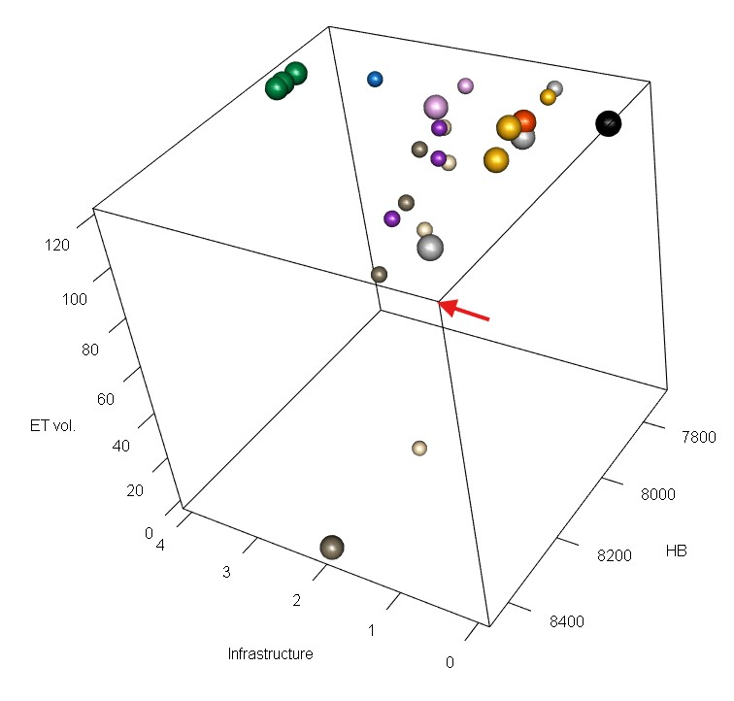
Figure 7: A three-dimensional scatter plot of the objective function values for basecase and 24 management scenarios, averaged over 35 water years (1991-2025). Larger spheres are shown for the Pareto-optimal set of scenarios. Scenario colors correspond to legend in Figure 6. The corner corresponding to optimal values of all objective functions (the ‘best’ corner) is highlighted with a red arrow.
For HB function in coho juvenile abundance units, the Pareto-optimal set of management actions (i.e., the scenarios with an objective/category value that cannot be improved upon without sacrificing value in another objective/category) includes 11 of the 35 simulated scenarios (Table 6; Figure 7). This set includes the basecase, as it is the only scenario with an infrastructure category of 0 (no change needed); it includes five regulatory scenarios in category 1 (no new infrastructure needed); it includes two scenarios from category 2 (1-2 years timeline); and it includes all three reservoir scenarios, as they trace a small trade-off curve within their own category (5+ years timeline).
Several categories (such as Alfalfa Irrigation) include Pareto-optimal and suboptimal scenarios, suggesting that the details of implementation may be more important than selecting any one strategy in determining management impact. Also, the Pareto-optimality of Crop Change scenarios is difficult to evaluate here, since the relationship between total ET and conceptual farmer benefit is different than in the remainder of the scenarios.

4.5 Comparison to GSP Priorities
To determine if the strict application of objective functions would produce different management priorities than the public policy development process that took place 2018-2021, we made a high-level, conceptual comparison (Table 7) of the Pareto-optimal set of management actions and the management actions and projects listed for consideration in the GSP (Siskiyou County 2021).
Tier I and II scenarios, assigned highest priority and considered implementable in the near term and medium term, respectively, tend to be associated with higher crop ET values (e.g., six out of seven scenarios with > 114 10⁶ m³), reflecting the community’s commitment to avoid negative impacts on growers. With one exception, the scenarios with relatively high environmental benefit (e.g., > 7.9 10³ coho smolt-equiv. HB value) are in Tier III, reflecting that they are technically and/or politically more challenging than Tiers I and II, and thus considered potentially implementable in the long-term.
Notably, direct comparisons between the set of simulated scenarios and the management actions listed in the GSP are somewhat limited. The primary reason for this is that the simulated scenarios assume that all water users in the valley are acting in concert. Conversely, management actions included in the GSP generally assumed voluntary/incentivized participation by individual landowners in scenarios involving land use change, and in some cases are located only in specific sub-areas of the watershed.
Table 7: List of management actions in Chapter 4 of the GSP and analogues in the set of 25 simulated scenarios. The Tier indicate the priority given to each management action, though the Tier also incorporates information about difficulty of implementation (hence Reservoirs being placed in Tier 3).
Tier | GSP Management Action | Closest Simulated Analogue | HB Range/1000 | ET Range/10^6
I | Watermaster Program (two creeks) | Low Flow Diversion Limits (FlowLims) | 7.83 | 114
I | Scott River Water Trust Leasing Program | Low Flow Diversion Limits (FlowLims) | 7.83 | 114
I | Irrigation Improvements | Improved Irrigation Efficiency (IrrEff) | 7.75-7.86 | 115-117
II | Irrigation Efficiency Improvements | Improved Irrigation Efficiency (IrrEff) | 7.75-7.86 | 115-117
II | MAR & ILR - NFWF  Scott Recharge Project | Enhanced Recharge (Enh- Rch) | 7.81 | 118
II | MAR & ILR | Enhanced Recharge (Enh- Rch) | 7.81 | 118
II | Voluntary Managed Land Repurposing | Possibly Crop Change (CropCh) and possibly some amount of Natural Vegetation Land Use (NatVegH or L) | 7.85-8.45 | 0-109
III | Alternative, lower ET crops | Crop Change (CropCh) | 7.86-8.06 | 93-109
III | Floodplain Reconnection/ Expansion | Enhanced Recharge (Enh- Rch) | 7.81 | 118
III | Reservoirs | Small Reservoir (Res) | 7.85-7.92 | 118-118
III | Strategic Groundwater Pumping Curtailment | Possibly Cease Alfalfa Irrigation Early (AlfIrr); Possibly Curtail Irrigation Early (Curtail) | 7.7-8.2 | 103-117
III | Watermaster Program (expanded) | Low Flow Diversion Limits (FlowLims) | 7.83 | 114

5 Discussion

5.1 Alternative options for the environmental objective function
This study uses a physical model to predict changes in flow, and a statistical model to extrapolate these changes into ecological impacts. However, even within just one watershed, there are many other possible ways to design an environmental benefit objective function based on a statistical model.
Regardless of the design, the first requirement is sufficient data. The present study is based off of 15 to 23 years of ecological observations (depending on which units are selected) (Kouba et al. 2025). Hydrologic data is often relatively abundant, with ecological observations as the limiting factor; the authors recommend at least a decade of ecological data, ideally covering all water year types, to build a new hydrologic-ecological relationship.
Although salmon are often considered a “keystone species” (Mills and Doak 1993), one obvious alternative to a salmon-based HB function is to base it on another suitable aquatic species. Suitability would depend on a strong known or suspected relationship between flow and an observable ecological outcome.; candidates in the Scott River watershed might be steelhead trout or potentially Pacific lamprey. Another alternative would be to investigate the specific hydrology that supports groundwater-dependent ecosystems; i.e., flowrates associated with sufficient spatial habitat in specific reaches, or groundwater elevation supporting riparian vegetation. All of these options are “bottom-up” descriptions (Tharme 2003) of relationships between flow and isolated ecological functions; still another option would be to base the HB function on a “top-down” method, such as indices of alteration, that aims to preserve all ecological functions of the unimpaired stream (e.g., Richter et al. 1996; Poff et al. 1997; discussed further in Kouba et al. 2025).
Finally, it is worth noting that the utility of the environmental function is somewhat dependent on which flows are considered important. While the Chinook HB function is valuable in highlighting which flows are of highest importance statistically, Chinook plots of fish versus farmer tradeoffs are effectively meaningless, since wet season median flows are largely beyond human control in this undammed watershed.

5.2 Trade-offs among all three objectives
For all HB formulations, reservoirs and regulatory scenarios (curtailment, alfalfa irrigation, diversion limits) were the categories with highest fraction of Pareto-optimal scenarios (Table 6; Figure 7). This suggests that the regulatory scenarios in category 1 (no new infrastructure needed) define an arc of trade-offs between environmental benefit and agricultural cost, and the low-to-moderate infrastructure cost scenarios (categories 2 and 3) do not improve on this. Among the set of options considered here, it takes a high infrastructure cost (reservoir scenarios) to escape the trade-offs defined in the regulatory scenario categories.
It’s clear that design details (date of implementation, number of acres affected) produce greater variation within scenario categories than between categories, and so it may well be possible to design, for instance, a Pareto-optimal enhanced recharge scenario for this watershed, if the recharge areas and total water volume diverted were altered. The current popularity of enhanced recharge (e.g., CNRA et al. 2022) points to a need for more research (in Scott Valley, and in California and semi-arid agricultural regions more broadly) regarding spatial, timing, and water volume/permitting elements of an effective and feasible MAR program in a variety of settings.
Additionally, it is difficult to evaluate the total ET value, and thus the Pareto-optimality, of scenarios in the Crop Change category. If we assume, based on current practices, that a yearly alfalfa harvest is worth more than a yearly grain harvest, a widespread conversion to permanent grain could reduce profits in Scott Valley; however, permanent grain might provide more certainty and potentially better economic yield if the choice were between a widespread conversion to permanent grain and frequent mid-season irrigation cutoffs (on alfalfa or all crops).

5.3 Pareto-optimal solution set and GSP priority management actions
Within the proposed suite of management actions, across all four HB formulations, approximately half (10-13 of 25) fall within the Pareto-optimal set, based on the cost proxy and the 35-year average values of two objective functions (Supplements B-E, Figure 5 and Table 2). (As mentioned above, Pareto-suboptimal status is less certain in the case of the Crop Change scenarios.)
Many of the simulated scenarios were included in the ultimate list of management priorities in the adopted GSP (Siskiyou County 2021), though in a variety of forms (e.g., the Low Flow Diversion Limits scenario, which is the closest simulated analogue for a watermaster program and a surface water leasing program; Table 7). Although the GSP management priorities emphasized infrastructure and minimal farmer cost, in a strict application of these objective functions, regulatory approaches and high-cost reservoir scenarios were represented most frequently within the Pareto-optimal set of management options.

6 Conclusion
In Scott Valley, like in many semi-arid rural areas, agricultural and ecological water demands are in competition. For this study, functions quantifying the achievement of two regional management priorities (environmental and agricultural objectives) were applied to the results of 25 simulated water management scenarios (including a historical basecase). In addition, scenarios were assigned a categorical proxy for new infrastructure costs. We used these numerical values to quantitatively explore trade-offs in environmental and agricultural benefit among the suite of actions proposed by stakeholders, at multiple levels of infrastructure investment.
Total agricultural productivity in Scott Valley (as estimated through crop ET) is buffered against the weather and is relatively stable year-to-year. Conversely, flow in the undammed Scott River is subject to the full range of climate variability and human water uses. As a result, the historical performance in the environmental flows objective is much more variable than in the agricultural objective, and is influenced by the specific flow metrics included in the environmental objective function (explored further in Discussion.)
Among the set of options considered here, it takes a high infrastructure cost (reservoir scenarios) to escape the trade-offs defined in the regulatory scenario categories. Furthermore, although the existing GSP management priorities emphasized minimal agricultural water cuts, the Pareto-optimal set of management actions included many regulatory approaches and high-cost reservoir scenarios. Of course, three objective functions cannot capture all the technical, political and economic dimensions of water management. However, this objective-function approach could be used in future stakeholder discussions to clarify group goals and make trade-offs more explicit.
In this case study, we demonstrate that in basins using hydrologic models for water management, a scenario design process conducted in a public collaborative setting can yield a politically-relevant set of scenarios, and stakeholder-driven objective functions can be used to clarify tradeoffs and build a management “landscape” of outcomes. Such a landscape can be a valuable tool in assessing reasonableness of any proposed management action, and in generating community buy-in, as rural semi-arid regions work to implement adaptive water management.

Acknowledgments

7 References
Agrawal, A, R S Schick, E P Bjorkstedt, R G Szerlong, M N Goslin, B C Spence, T H Williams, and K M Burnett. 2005. “PREDICTING THE POTENTIAL FOR HISTORICAL COHO, CHINOOK AND STEELHEAD HABITAT IN NORTHERN CALIFORNIA.” National Marine Fisheries Service.
Baruch, Ethan M., Sarah M. Yarnell, Theodore E. Grantham, Jessica R. Ayers, Andrew L. Rypel, and Robert A. Lusardi. 2024. “Mimicking Functional Elements of the Natural Flow Regime Promotes Native Fish Recovery in a Regulated River.” Ecological Applications 34 (6): e3013. https://doi.org/10.1002/eap.3013.
Bork, Karrigan, and Keith Hirokawa. 2021. “Trends in Local Ecosystem Governance.” Frontiers in Climate 3 (September): 719150. https://doi.org/10.3389/fclim.2021.719150.
Brown, Casey M., Jay R. Lund, Ximing Cai, Patrick M. Reed, Edith A. Zagona, Avi Ostfeld, Jim Hall, Gregory W. Characklis, Winston Yu, and Levi Brekke. 2015. “The Future of Water Resources Systems Analysis: Toward a Scientific Framework for Sustainable Water Management.” Water Resources Research 51 (8): 6110–24. https://doi.org/10.1002/2015WR017114.
Brown, Larry R., Peter B. Moyle, and Ronald M. Yoshiyama. 1994. “Historical Decline and Current Status of Coho Salmon in California.” North American Journal of Fisheries Management 14 (2): 237–61. https://doi.org/10.1577/1548-8675(1994)014<0237:HDACSO>2.3.CO;2.
California Department of Fish and Wildlife. 2021. “Appendix 2: Influence of Scott River in-Stream Flow on the Distribution and Migration Timing of Fall Chinook Salmon and Coho Salmon.”
California Department of Water Resources. 2017. “Statewide Crop Mapping - 2016 Statewide Crop Mapping GIS Shapefiles - California Natural Resources Agency Open Data.” 2016 Statewide Crop Mapping GIS Shapefiles. https://data.cnra.ca.gov/dataset/statewide-crop-mapping/resource/3b57898b-f013-487a-b472-17f54311edb5.
California Natural Resources Agency, California For All, California Department of Water Resources, California Water Boards, California Environmental Protection Agency, and California Department of Food & Agriculture. 2022. “CALIFORNIA’S WATER SUPPLY STRATEGY: Adapting to a Hotter, Drier Future.”
California State Water Resources Control Board (SWRCB). 1975. “Report on Hydrogeologic Conditions, Scott River Valley, Scott River Valley.”
Cardwell, Hal, Henriette I. Jager, and Michael J. Sale. 1996. “Designing Instream Flows to Satisfy Fish and Human Water Needs.” Journal of Water Resources Planning and Management 122 (5): 356–63. https://doi.org/10.1061/(ASCE)0733-9496(1996)122:5(356).
Carpenter, Cameron. 2024. “Accurately Identifying Functional Flow Metrics in Flashy and Highly Altered Stream Systems.” Master’s thesis, University of California, Davis.
Carter, P. R., and C. C. Sheaffer. 1983. “Alfalfa Response to Soil Water Deficits. I. Growth, Forage Quality, Yield, Water Use, and Water-Use Efficiency¹.” Crop Science 23 (4): 669–75. https://doi.org/10.2135/cropsci1983.0011183X002300040016x.
Cohon, Jared L., and David H. Marks. 1973. “Multiobjective Screening Models and Water Resource Investment.” Water Resources Research 9 (4): 826–36. https://doi.org/10.1029/WR009i004p00826.
———. 1975. “A Review and Evaluation of Multiobjective Programing Techniques.” Water Resources Research 11 (2): 208–20. https://doi.org/10.1029/WR011i002p00208.
Design of Water-Resource Systems: New Techniques for Relating Economic Objectives, Engineering Analysis, and Governmental Planning. 1962. Harvard University Press. https://doi.org/10.4159/harvard.9780674421042.intro.
Di Baldassarre, Giuliano, Murugesu Sivapalan, Maria Rusca, Christophe Cudennec, Margaret Garcia, Heidi Kreibich, Megan Konar, et al. 2019. “Sociohydrology: Scientific Challenges in Addressing the Sustainable Development Goals.” Water Resources Research 55 (8): 6327–55. https://doi.org/10.1029/2018WR023901.
Foglia, Laura, Alison McNally, Courtney Hall, Lauren Ledesma, Ryan Hines, and Thomas Harter. 2013. “Scott Valley Integrated Hydrologic Model: Data Collection, Analysis, and Water Budget.” Davis, CA: North Coast Regional Water Quality Control Board.
Fox Canyon Groundwater Management Agency. 2019. “Groundwater Sustainability Plan for the Oxnard Subbasin.” Ventura, CA: Fox Canyon Groundwater Manegement Agency.
Freeman, David M. 2000. “WICKED WATER PROBLEMS: SOCIOLOGY AND LOCAL WATER ORGANIZATIONS IN ADDRESSING WATER RESOURCES POLICY.” Journal of the American Water Resources Association 36 (3): 483–91. https://doi.org/10.1111/j.1752-1688.2000.tb04280.x.
Gorelick, Steven M. 1983. “A Review of Distributed Parameter Groundwater Management Modeling Methods.” Water Resources Research 19 (2): 305–19. https://doi.org/10.1029/WR019i002p00305.
Harter, Thomas, and Ryan Hines. 2008. “SCOTT VALLEY COMMUNITY GROUNDWATER STUDY PLAN.” University of California, Davis.
Jager, Henriette I., and Kenneth A. Rose. 2003. “Designing Optimal Flow Patterns for Fall Chinook Salmon in a Central Valley, California, River.” North American Journal of Fisheries Management 23 (1): 1–21. https://doi.org/10.1577/1548-8675(2003)023<0001:DOFPFF>2.0.CO;2.
Kapelan, Zoran S., Dragan A. Savic, and Godfrey A. Walters. 2005. “Multiobjective Design of Water Distribution Systems Under Uncertainty.” Water Resources Research 41 (11): 2004WR003787. https://doi.org/10.1029/2004WR003787.
Knechtle, Morgan, and Domenic Giudice. 2020. “2019 SCOTT RIVER SALMON STUDIES FINAL REPORT.” California Department of Fish and Wildlife.
Kouba, Claire, Leland Scantlebury, Jason Wiener, Sarah Yarnell, and Thomas Harter. 2025. “A Watershed-Specific Approach to Identify Key Functional Flow Metrics Supporting Salmon Reproduction.” Ecohydrology : Ecosystems, Land and Water Process Interactions, Ecohydrogeomorphology 18 (5): e70098. https://doi.org/10.1002/eco.70098.
Labadie, John W. 2004. “Optimal Operation of Multireservoir Systems: State-of-the-Art Review.” Journal of Water Resources Planning and Management 130 (2): 93–111. https://doi.org/10.1061/(ASCE)0733-9496(2004)130:2(93).
Mack, Seymour. 1958. “Geology and Ground-Water Features of Scott Valley, Siskiyou County, California.” Geological {{Survey Water-Supply Paper}} 1462. United States Geological Survey. https://doi.org/10.3133/wsp1462.
Magranet, Lindsay. 2015. “Scott River Fall Chinook Spawning Ground Surveys.” Etna, CA: Siskiyou Resource Conservation District.
———. 2017. “Scott River Fall Chinook Spawning Ground Surveys.” Etna, CA: Siskiyou Resource Conservation District.
———. 2018. “Scott River Fall Chinook Spawning Ground Surveys 2017 Season.” Etna, CA: Siskiyou Resource Conservation District.
Magranet, Lindsay, and Erich Yokel. 2017. “Scott River Adult Coho Spawning Ground Surveys 2016-2017 Season.” Etna, CA: Siskiyou Resource Conservation District.
Mahoney, John M., and Stewart B. Rood. 1998. “Streamflow Requirements for Cottonwood Seedling Recruitment—An Integrative Model.” Wetlands 18 (4): 634–45. https://doi.org/10.1007/BF03161678.
McMahon, Thomas E. 1983. “Habitat Suitability Index Models: Coho Salmon.” FWS/OBS-82/10.49. U.S. Fish and Wildlife Service.
Mills, L. Scott, and Daniel F. Doak. 1993. “The Keystone-Species Concept in Ecology and Conservation.” BioScience 43 (4): 219–24. https://doi.org/10.2307/1312122.
Monarchi, David E., Chester C. Kisiel, and Lucien Duckstein. 1973. “Interactive Multiobjective Programing in Water Resources: A Case Study.” Water Resources Research 9 (4): 837–50. https://doi.org/10.1029/WR009i004p00837.
Moyle, Peter B. 2002. “Coho Salmon, Oncorhynchus Kisutch (Walbaum).” In Inland Fishes of California, 245–51. University of California Press.
Nordgren, John, Missy Stults, and Sara Meerow. 2016. “Supporting Local Climate Change Adaptation: Where We Are and Where We Need to Go.” Environmental Science & Policy 66 (December): 344–52. https://doi.org/10.1016/j.envsci.2016.05.006.
Pareto, Vilfredo. 1896. Cours D’Economie Politique. Lausanne.
Patterson, Noelle K., Belize A. Lane, Samuel Sandoval-Solis, Gregory B. Pasternack, Sarah M. Yarnell, and Yexuan Qiu. 2020. “A Hydrologic Feature Detection Algorithm to Quantify Seasonal Components of Flow Regimes.” Journal of Hydrology 585 (June): 124787. https://doi.org/10.1016/j.jhydrol.2020.124787.
Poff, N. LeRoy, J. David Allan, Mark B. Bain, James R. Karr, Karen L. Prestegaard, Brian D. Richter, Richard E. Sparks, and Julie C. Stromberg. 1997. “The Natural Flow Regime.” BioScience 47 (11): 769–84. https://doi.org/10.2307/1313099.
Reuss, Martin. 1992. “Coping With Uncertainty: Social Scientists, Engineers, and Federal Water Resources Planning.” Natural Resources Journal 32 (1): 101–36.
Richter, Brian D., Jeffrey V. Baumgartner, Jennifer Powell, and David P. Braun. 1996. “A Method for Assessing Hydrologic Alteration Within Ecosystems.” Conservation Biology 10 (4): 1163–74. https://doi.org/10.1046/j.1523-1739.1996.10041163.x.
Rodell, M., J. S. Famiglietti, D. N. Wiese, J. T. Reager, H. K. Beaudoing, F. W. Landerer, and M.-H. Lo. 2018. “Emerging Trends in Global Freshwater Availability.” Nature 557 (7707): 651–59. https://doi.org/10.1038/s41586-018-0123-1.
Rogers, Peter P., and Myron B Fiering. 1986. “Use of Systems Analysis in Water Management.” Water Resources Research 22 (9S). https://doi.org/10.1029/WR022i09Sp0146S.
Scott River Watershed Council. 2018. “Restoring Priority Coho Habitat in the Scott River Watershed Modeling and Planning Report.”
Scott Valley Area Plan Committee. 1980. “Scott Valley Area Plan.” Siskiyou County.
Siskiyou County. 2021. “Scott Valley Groundwater Sustainability Plan.”
State Water Resources Control Board. 2021. “Establishment of Minimum Instream Flow Requirements, Curtialment Authority, and Information Order in the Klamath Watershed.” {{NOTICE OF APPROVAL OF EMERGENCY REGULATORY ACTION}} OAL 2021-0820-05.
———. 2024a. “Establishment of Minimum Instream Flow Requirements, Curtialment Authority, and Information Order in the Scott River and Shasta River Watersheds.” {{NOTICE OF APPROVAL OF EMERGENCY REGULATORY ACTION}} OAL 2024-0123-03.
———. 2024b. “RESOLUTION NO. 2024-0036: REGARDING FLOW EFFORTS IN THE SCOTT RIVER AND SHASTA RIVER WATERSHEDS.” 2024-0036.
Sun, Zan, Yi Zheng, Xi Li, Yong Tian, Feng Han, Ye Zhong, Jie Liu, and Chunmiao Zheng. 2018. “The Nexus of Water, Ecosystems, and Agriculture in Endorheic River Basins: A System Analysis Based on Integrated Ecohydrological Modeling.” Water Resources Research 54 (10): 7534–56. https://doi.org/10.1029/2018WR023364.
Tharme, R. E. 2003. “A Global Perspective on Environmental Flow Assessment: Emerging Trends in the Development and Application of Environmental Flow Methodologies for Rivers.” River Research and Applications 19 (5-6): 397–441. https://doi.org/10.1002/rra.736.
Tolley, D., L. Foglia, and T. Harter. 2019. “Sensitivity Analysis and Calibration of an Integrated Hydrologic Model in an Irrigated Agricultural Basin With a Groundwater-Dependent Ecosystem.” Water Resources Research 55 (9): 7876–7901. https://doi.org/10.1029/2018WR024209.
Van Steenbergen, Frank. 2006. “Promoting Local Management in Groundwater.” Hydrogeology Journal 14 (3): 380–91. https://doi.org/10.1007/s10040-005-0015-y.
Williams, A. Park, Edward R. Cook, Jason E. Smerdon, Benjamin I. Cook, John T. Abatzoglou, Kasey Bolles, Seung H. Baek, Andrew M. Badger, and Ben Livneh. 2020. “Large Contribution from Anthropogenic Warming to an Emerging North American Megadrought.” Science 368 (6488): 314–18. https://doi.org/10.1126/science.aaz9600.
Wu, Bin, Yi Zheng, Xin Wu, Yong Tian, Feng Han, Jie Liu, and Chunmiao Zheng. 2015. “Optimizing Water Resources Management in Large River Basins with Integrated Surface Water-Groundwater Modeling: A Surrogate-Based Approach.” Water Resources Research 51 (4): 2153–73. https://doi.org/10.1002/2014WR016653.
Yarnell, Sarah M., Geoffrey E. Petts, John C. Schmidt, Alison A. Whipple, Erin E. Beller, Clifford N. Dahm, Peter Goodwin, and Joshua H. Viers. 2015. “Functional Flows in Modified Riverscapes: Hydrographs, Habitats and Opportunities.” BioScience 65 (10): 963–72. https://doi.org/10.1093/biosci/biv102.
Yeh, William W-G., and Leonard Becker. 1982. “Multiobjective Analysis of Multireservoir Operations.” Water Resources Research 18 (5): 1326–36. https://doi.org/10.1029/WR018i005p01326.
Yolo Subbasin Groundwater Agency. 2022. “Yolo Subbasin Groundwater Sustainability Plan.” Woodland, CA.

