Supplement to “A watershed-specific formula to predict salmon reproduction using functional flow metrics”

Claire Kouba, Jason Wiener, Leland Scantlebury and Thomas Harter

Feb. 2025

# 1 Scott River watershed setting and water use

## 1.1 Geography, climate and hydrology

The Scott River drains a 2,109 km2 (814 square mile) watershed known as Scott Valley, flowing generally from south to north and joining the Klamath River after flowing through a steep canyon (Figure ??). The Scott is a major tributary to the Klamath, which drains an area spanning sections of Northern California and Southern Oregon (Figure ??, inset map). Scott Valley has a Mediterranean climate with distinctive seasons of cool, wet winters and warm, dry summers. This seasonality in water input creates highly seasonal flow in the Scott River and tributary streams, where the beginning of a water year coincides with low flow conditions that immediately precede the onset of winter precipitation (Figure 1).

In most dry-to-average water years, sections of the Scott River become seasonally dewatered (NCRWQCB 2005; Figure 5 in Tolley, Foglia, and Harter 2019). This occurs when the elevation of the water table drops below the bottom of the river channel, as streams and groundwater are highly interconnected in the Scott River watershed. Tributary streams, particularly along their alluvial fan apeces, and the upper Scott River are sources of recharge to the aquifer (Mack 1958; Harter and Hines 2008). Groundwater discharge sustains streamflow in low-lying areas, especially during the dry season of August through October or November (Tolley, Foglia, and Harter 2019). For consistency with regulatory and management programs in this region, this document uses units of cubic feet per second (cfs) when reporting hydrologic fluxes.

## png   
## 2

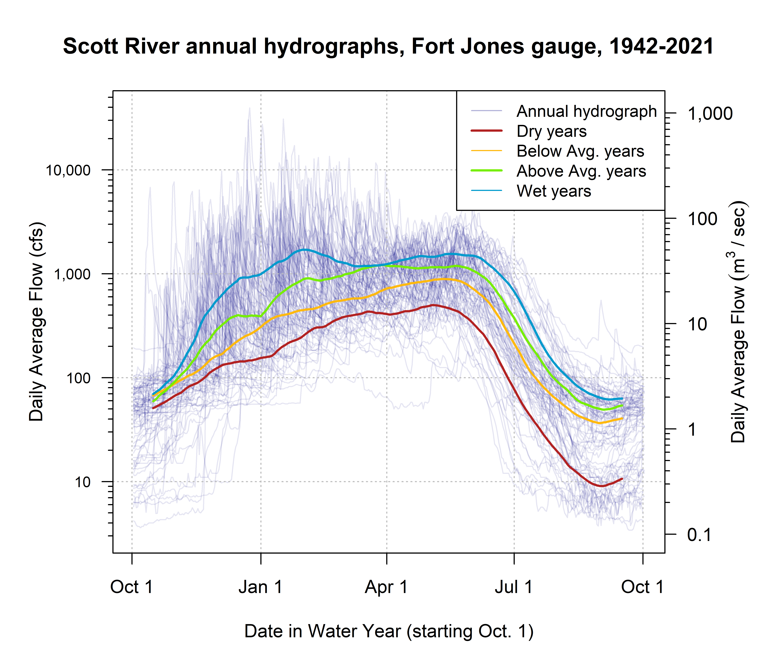

Figure 1: Each translucent line traces one annual hydrograph measured at the Fort Jones gauge, and the darker lines illustrate the 30-day smoothed median daily flow in Dry, Below Average, Above Average, and Wet water year types, for water years 1942-2023. The water year type is defined by quartiles of the distribution of total annual flow.

## 1.2 Water uses and management objectives

Water in Scott Valley is used for agricultural, domestic, and municipal supply. It also facilitates recreation and provides Native American cultural services, among other designated beneficial uses (NCRWQCB 2006). Because the watershed is undammed, managers and water users influence Scott River flow primarily via diversion of surface waters and pumping of groundwater. Consequently, the most powerful tool available to manage Scott River water flow is regulation of land use and thus water demand (Siskiyou County 2021).

Historically, local regulation of land use has focused on maintaining the rural and agricultural character of Scott Valley (Scott Valley Area Plan Committee 1980). Regulating land use to improve ecological outcomes would entail significant economic, political and social risks, because much of the economic activity in this area is related to agriculture. The primary crops grown in Scott Valley are pasture for cattle feed and alfalfa (Siskiyou County 2021). In addition to local economic impact, Scott River conditions influence fish population dynamics both within the watershed and in the broader Klamath system. The health of the Klamath salmon run has implications for commercial fishing, recreational activities, and cultural practices of Native American tribes in the region, including the Quartz Valley Indian Community and the Karuk and Yurok Tribes (Mansfield et al. 2012).

# 2 Species of concern - coho and Chinook salmon

### 2.0.1 Life cycle and status of coho salmon (*Oncorhynchus kisutch*)

Returning adult coho spawn in natal streams between November and January (Knechtle and Giudice 2020), and juvenile coho spend approximately one full year in freshwater streams before migrating to the ocean as smolts (Moyle 2002; McMahon 1983). In the Scott River system these natal streams are the tributaries along the margins of the valley floor (SRCD 2004).

In previous studies, the strongest predictor of juvenile coho abundance in a stream system was spatial habitat (Bradford, Taylor, and Allan 1997; Nickelson et al. 1992; Bustard and Narver 1975), although adequate food and cover were also important (McMahon 1983). The primary mechanism for spatial constraints on abundance appears to be that juvenile coho become more territorial as they grow (McMahon 1983).

Some coho salmon return to spawn at age 2 as grilse, but the majority (e.g., 92.4% in 2020) return after more than one year in the ocean, giving the Scott coho salmon run its characteristic 3-year cohort return interval (Knechtle and Giudice 2020).

Coho salmon in the Scott Valley are listed as threatened under the federal and California Endangered Species Acts (ESAs). They belong to the Southern Oregon / Northern California Coast (SONCC) Evolutionarily Significant Unit (ESU), which was listed as threatened under the federal and state ESAs in 1997 and 2005, respectively. State-wide, coho populations have declined more than 90% since the 1940s (Brown, Moyle, and Yoshiyama 1994).

### 2.0.2 Life cycle and status of Chinook salmon (*Onchorhynchus tsawytscha*)

Chinook salmon in the Scott Valley are a candidate for listing under the federal ESA, and are not listed under the California ESA. They belong to the Southern Oregon / Northern California Coast (SONCC) Evolutionarily Significant Unit (ESU). Typically, adult Chinook salmon return to spawn in Scott Valley streams in the fall months September-December when flows are sufficient for salmon passage (Knechtle and Giudice 2020; Magranet 2015, 2017). Chinook in this watershed hatch in the spring and migrate to the ocean in their first year of life (Agrawal et al. 2005). Chinook spend the majority of their life in the ocean, and return to their natal streams shortly before spawning (Groot and Margolis 1991). However, substantial variability exists within this broader structure: Chinook salmon exhibit variation in multiple life stages, including time of seaward migration, age of maturity, and timing of return to natal stream (Groot and Margolis 1991; Bourret, Caudill, and Keefer 2016).

As recently as 2013, the SONCC Chinook population was stable and becoming more complex (Wainwright et al. 2013). However, in monitoring from 2015-2020, the number of returning adults (the escapement) was 65% below historical average, and the change in the Scott River Chinook population has been more rapid than the decline in the overall Klamath Basin Chinook run (California Department of Fish and Wildlife 2021). Ocean conditions may have contributed to a broad decline in Chinook populations from Alaska to California (Welch, Porter, and Rechisky 2021). Some studies have found that the leading cause of declining Chinook populations are ocean conditions, including including temperature, upwelling currents and food resources (Hunt, Mulligan, and Komori 1999), while others have identified hatchery practices as the primary cause (Quiñones et al. 2014).

# 3 Functional Flows Background

Table 1: TO UPDATE. Explanation of hydrologic metrics used in this analysis. Each type of metric, for each threshold value (e.g., 100 cfs or 50th flow percentile), produces one value per water year. Example metric names also include abbreviations for salmon life periods described in Table 2 below.

| Abbrev. | Full Name | Thresholds | Description |
| --- | --- | --- | --- |
| DS_Dur_WS | Dry Season Duration | -- | Dry-season baseflow duration (# of days from start of dry season to start of wet season) |
| DS_Tim | Dry Season Onset Timing | -- | Dry-season baseflow start timing (water year day of dry season) |
| DS_Mag | Dry Season Flow Magnitude | 50th and 90th flow percentile | Percentile of daily flow within dry season. |
| FA_Dur | Fall Pulse Duration | -- | Duration (# of days) of the fall pulse event |
| FA_Tim | Fall Pulse Timing | -- | Start date of fall pulse event in water year days |
| FA_Mag | Fall Pulse Magnitude | -- | Peak magnitude of fall pulse event (maximum daily peak flow during event) (cfs) in relevant lifestage. |
| FA_Dif_num | Fall Pulse Magnitude (modified) |  | Difference between peak fall pulse discharge and dry season median discharge (Baruch et al. 2024). |
| Wet_BFL_Dur | Wet Season Baseflow Duration | -- | Wet-season baseflow duration (# of days from start of wet-season to start of spring season) |
| Wet_BFL_Mag | Wet Season Baseflow Magnitude | 50th and 10th percentile | The magnitude of the median rate of baseflow (i.e., non-storm flow) during the wet season. |
| Wet_Tim | Wet Season Onset Timing | -- | Start date of wet-season in water year days |
| Peak_Dur | Duration of high-flow events | 2, 5, and 10-year return interval | Number of days exceeding the 2, 5 and 10 year recurrence intervals of annual peak flow (50%, 20%, and 10% exceedance values). |
| Peak_Fre | Frequency of high-flow events | 2, 5, and 10-year return interval | Number of times that flow crosses over the threshold values for the 2-, 5- and 10-year flow (50%, 20%, and 10% exceedance values). |
| Peak_Tim | Timing of first high-flow event in a water year | 2, 5, and 10-year return interval | Timing of first exceedance of threshold value for the 2-, 5- and 10-year flow (50%, 20% and 10% exceedance values), in water year days |
| Peak | Magnitude of high-flow events | 2, 5, and 10-year return interval | Single value for each threshold corresponding to the 2-, 5- and 10- year flow exceedance values, in cfs |
| SP_ROC | Spring Recession Rate of Change | -- | Spring flow recession rate (median daily rate of change over decreasing periods during the recession) |
| SP_ROC_Max | Maximum Spring Recession Rate of Change |  | Maximum daily rate of change over decreasing periods during the recession |
| SP_Dur | Duration of Spring Recession |  | Period elapsed from the start date of the spring recession until the start date of the following dry season. |
| SP_Mag | Magnitude of Spring Recession |  | Flow magnitude on the start date of the spring recession (the "peak" of the snowmelt pulse). |
| SP_Tim | Spring Onset Timing | -- | Start date of spring flow recession in water year days |
| Mean_Ann_Flow | Mean Annual Flow | -- | Mean daily flow rate over a full water year. |
| WY_Cat | Water Year Category | -- | Category of water year (Dry, Moderate, Wet) |

## [1] FALSE

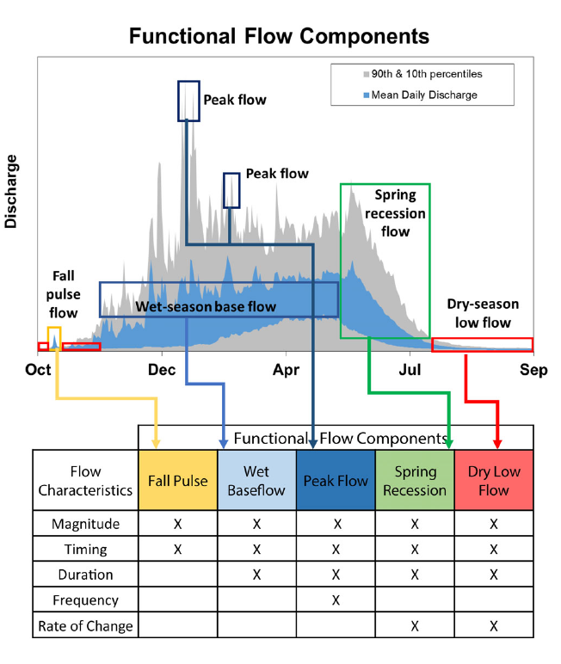

Figure 2: Figure 2 from Yarnell et al., 2020. Illustration of five functional flow categories identified for a mixed rain-snowmelt runoff river in California.

# 4 Hydrologic Metrics Designed for This Study

Table 2: Explanation of custom hydrologic metrics designed for this study, which are less complex than functional flows in that they do not rely on signal processing techniques. Each type of metric, for each threshold value (e.g., 120 cfs), produces one value per water year. Metric names used in predictive modeling also include abbreviations for salmon life periods (Table 3 below); e.g., f1_recon_120, referring to the timing of flow exceeding 120 cfs in a ohort's first fall season.

| Abbrev. | Full Name | Thresholds | Description |
| --- | --- | --- | --- |
| recon | River Reconnection Day (for a given life stage and threshold) | 20, 120 | The day, usually in the fall, on which the Scott River gains a certain degree of connectivity. Defined as the first day on which FJ Gauge flow rises above a designated threshold (e.g., 20 cfs) (units of days after Aug. 31). Assigned to a salmon lifestage using a season identifier such as f1 (first fall, experienced by a cohort's spawning parents). Example: f1_recon_20 |
| discon | River Disconnection Day (for a given life stage and threshold) | 20, 120 | The day, usually in the spring or early summer, on which the Scott River loses a certain degree of connectivity. Defined as the first day on which FJ Gauge flow drops below a designated threshold (e.g., 120 cfs) (units of days after Aug. 31). Assigned to a salmon lifestage using a season identifier such as s2 (second spring, experienced as outmigrating smolt). Example: s2_discon_120 |
| num_days_gt_90_pctile | Number of days of high-flow events | 90th flow percentile | Number of days in a water year in which the FJ daily average flow exceeded the 90th percentile flowrate in the full FJ Gauge record. |

## png   
## 2

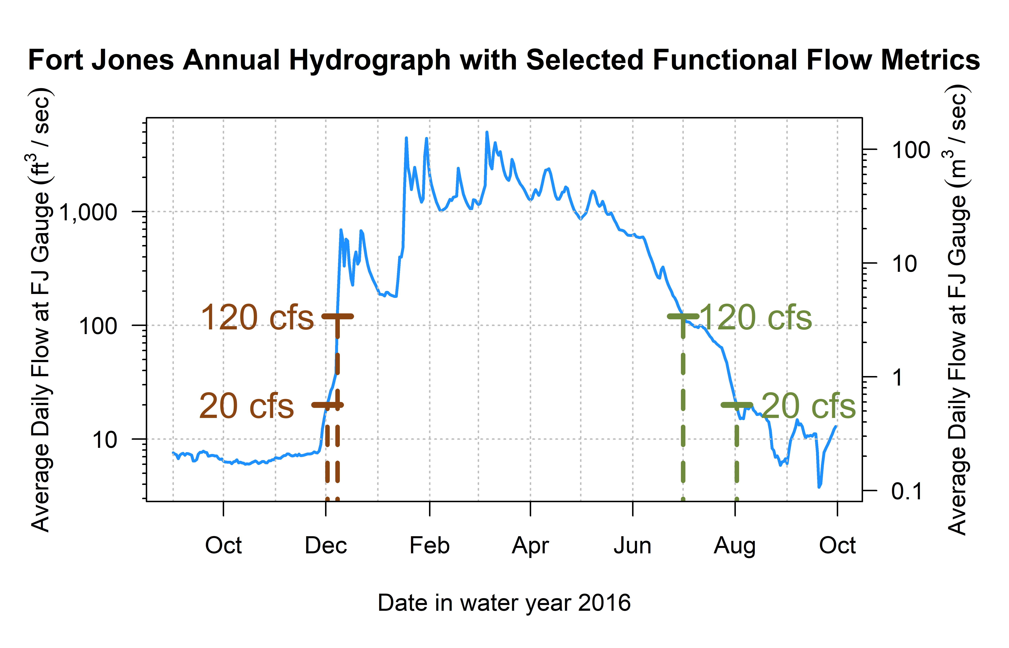

Figure 3: Reconnection and disconnection dates are highlighted for one water year. Two example thresholds, 20 and 120 cfs (0.57 and 3.4 cms, respectively) are highlighted, which correspond to distinct river connectivity (and salmon habitat access) conditions in the Scott River watershed as observed at the Fort Jones gauge (see Results for more detail on selection of flow thresholds).

# 5 Screening Predictors for Collinearity

## 5.1 Groups 1 and 2

These metrics describe the magnitude and timing of wet-season flows (years 1 and 2), effectively characterized by the question, how wet was the wet season?. We selected w1_Wet_BFL_Mag_50 and w2_Wet_BFL_Mag_50 as the most conceptually central metric to represent the amount of water passing through the watershed during two wet seasons: w1, the first wet season, experienced by a cohort as eggs and newly-hatched alevin and fry, and w2, experienced by the cohort as overwintering parr.

## 5.2 Group 3

These metrics describe the magnitude and timing of dry-season flows before the cohort’s spawning. We selected d1_DS_Mag_50 as the most conceptually central metric to represent the amount of water passing through the watershed during the dry season before a cohort’s parents’ spawning.

## 5.3 Groups 4 and 5

These metrics quantify the timing of the wet season onset and duration (year 2). We selected w2_Wet_Tim, the timing of the onset of the second wet season, and w2_Wet_BFL_Dur, the duration of wet season baseflow, to characterize the timing of the wet season experienced by a cohort of coho as overwintering juveniles.

## 5.4 Groups 6 and 7:

These metrics quantify the magnitude of the fall pulse flow (years 1 and 2). Although FA_num_diff had a higher sample size, we selected f1_FA_Mag and f2_FA_Mag to better reflect the years in which an identifiable fall pulse occurred before the onset of the wet season.

# 6 Ecological Data Features

Plot spawners vs juveniles and spawners vs redds (color coded by year?)

Plot ACF for each eco record

## png   
## 2

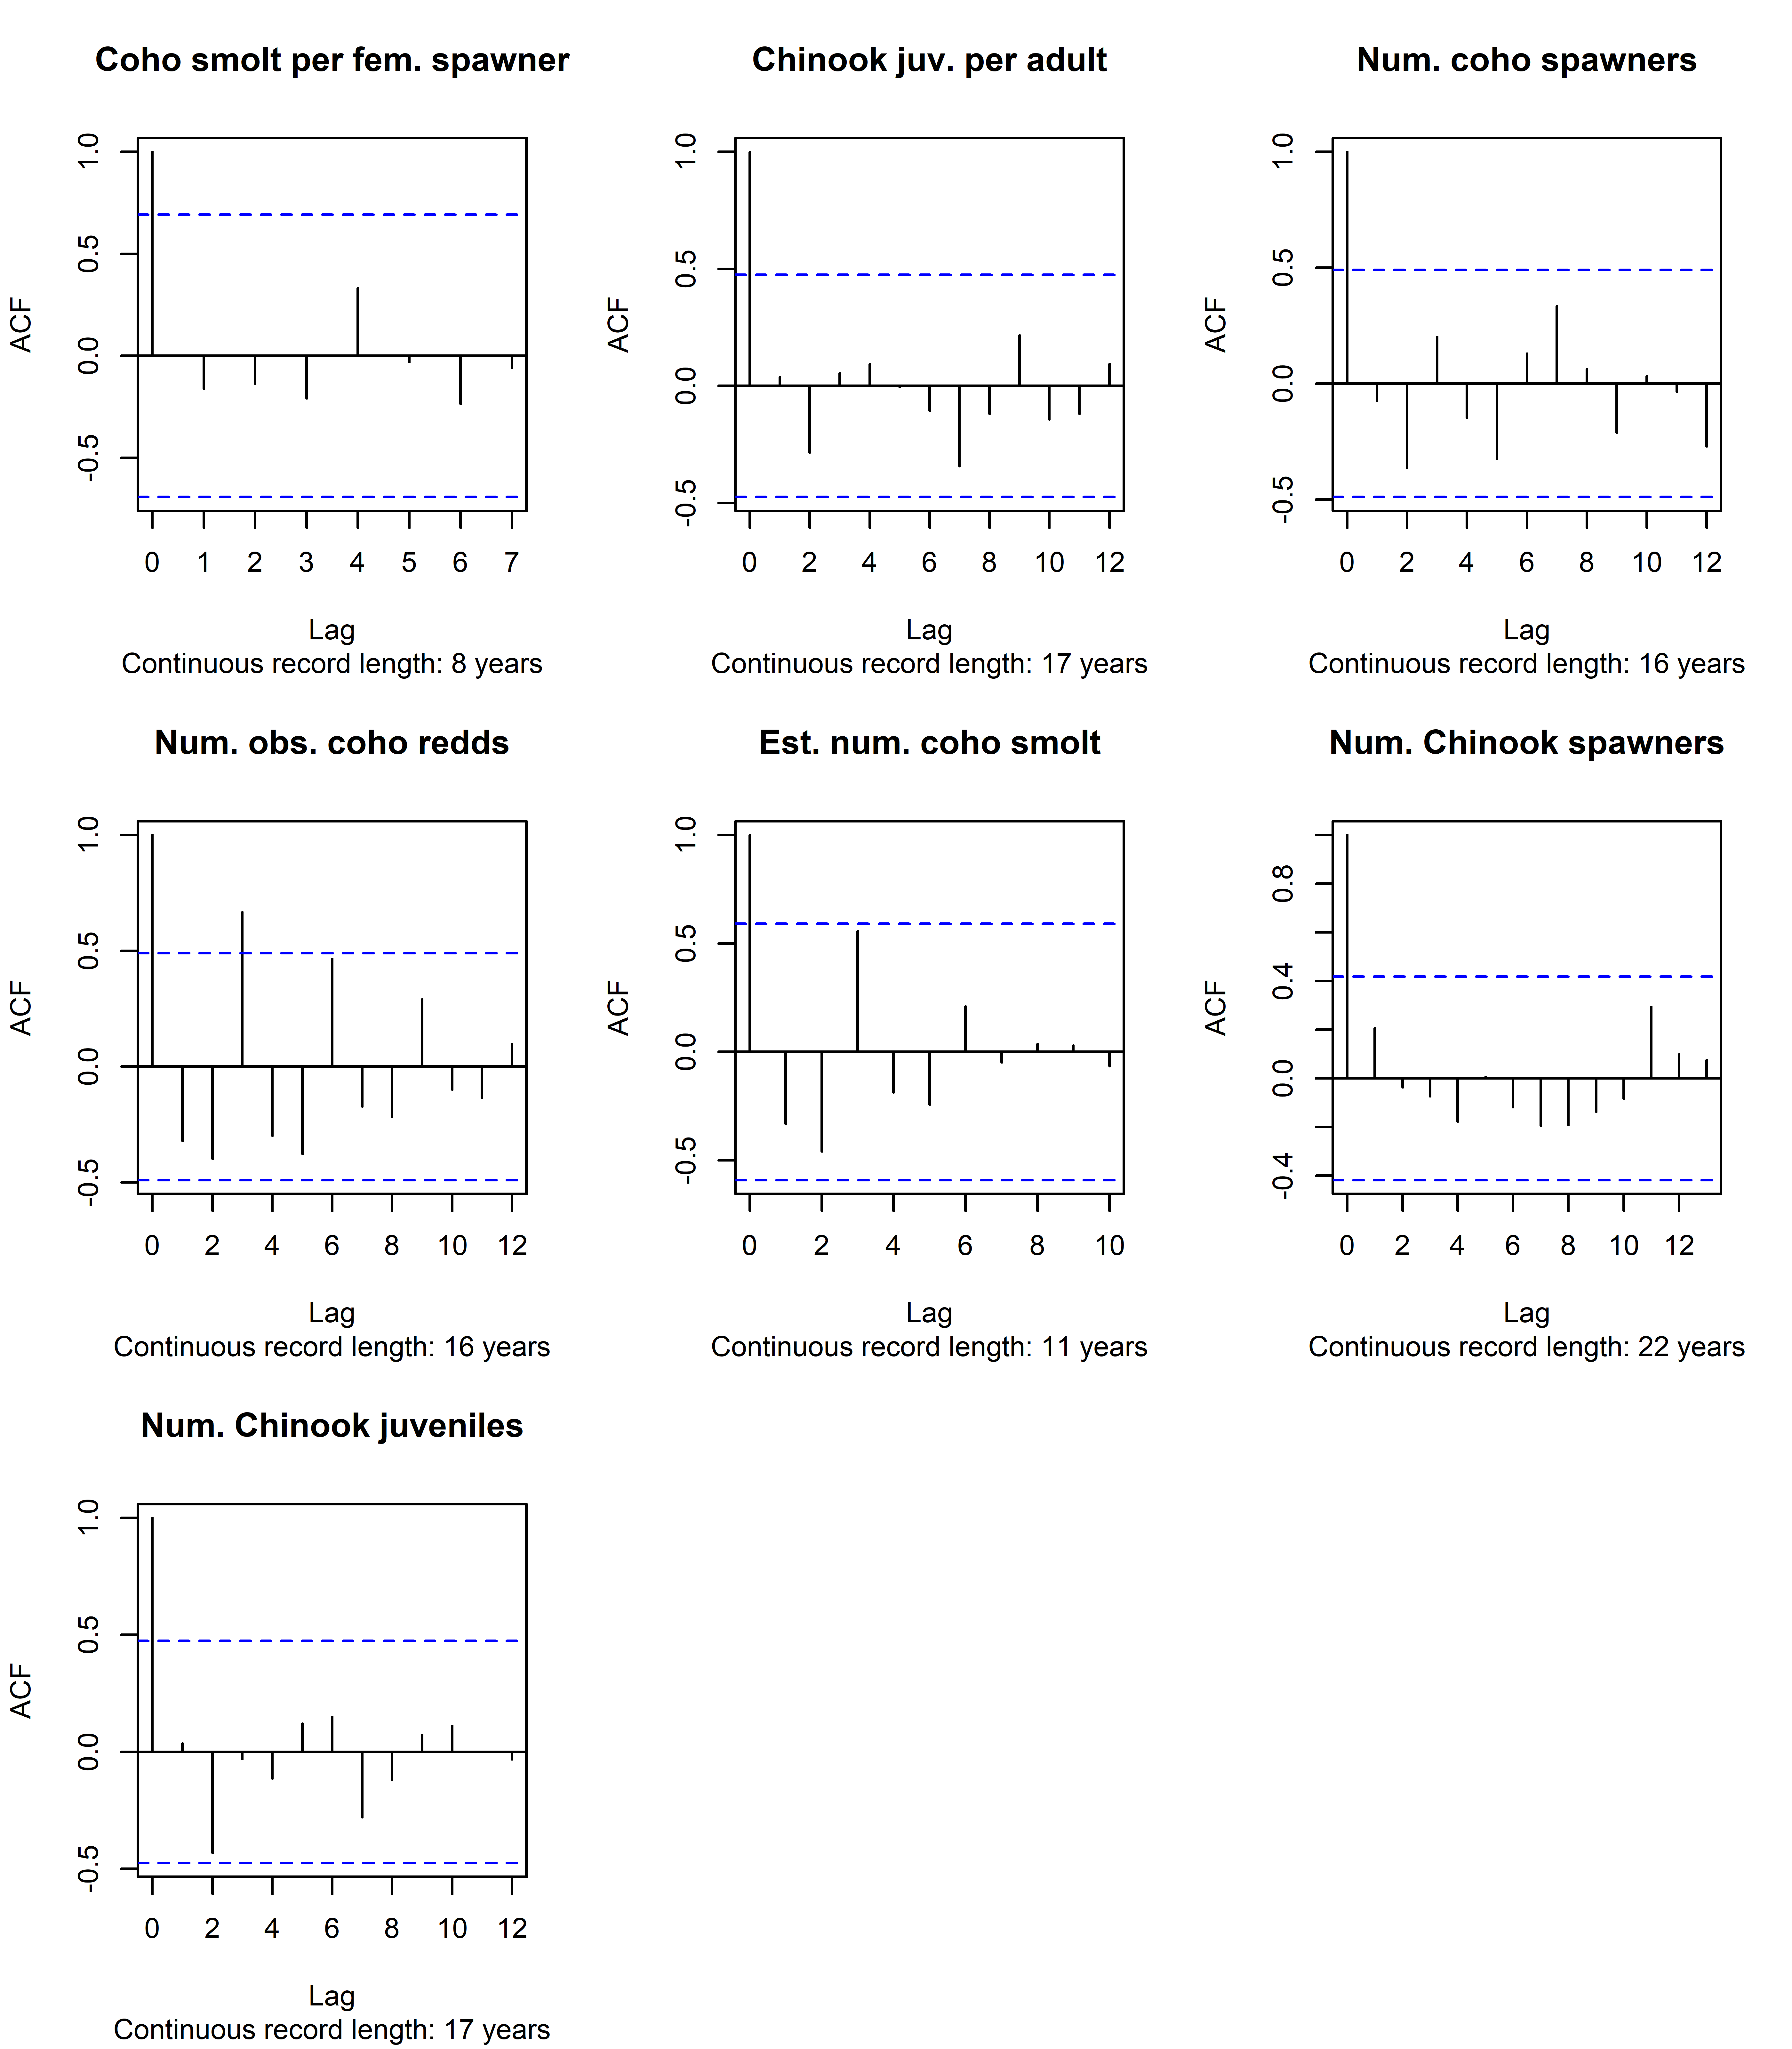

Figure 4: Autocorrelation function estimates for all available ecological outcome records.

# 7 Statistical Method Details

## 7.1 Lasso Regression, juveniles per spawner

## Warning: Option grouped=FALSE enforced in cv.glmnet, since < 3 observations per  
## fold  
## Warning: Option grouped=FALSE enforced in cv.glmnet, since < 3 observations per  
## fold

## png   
## 2

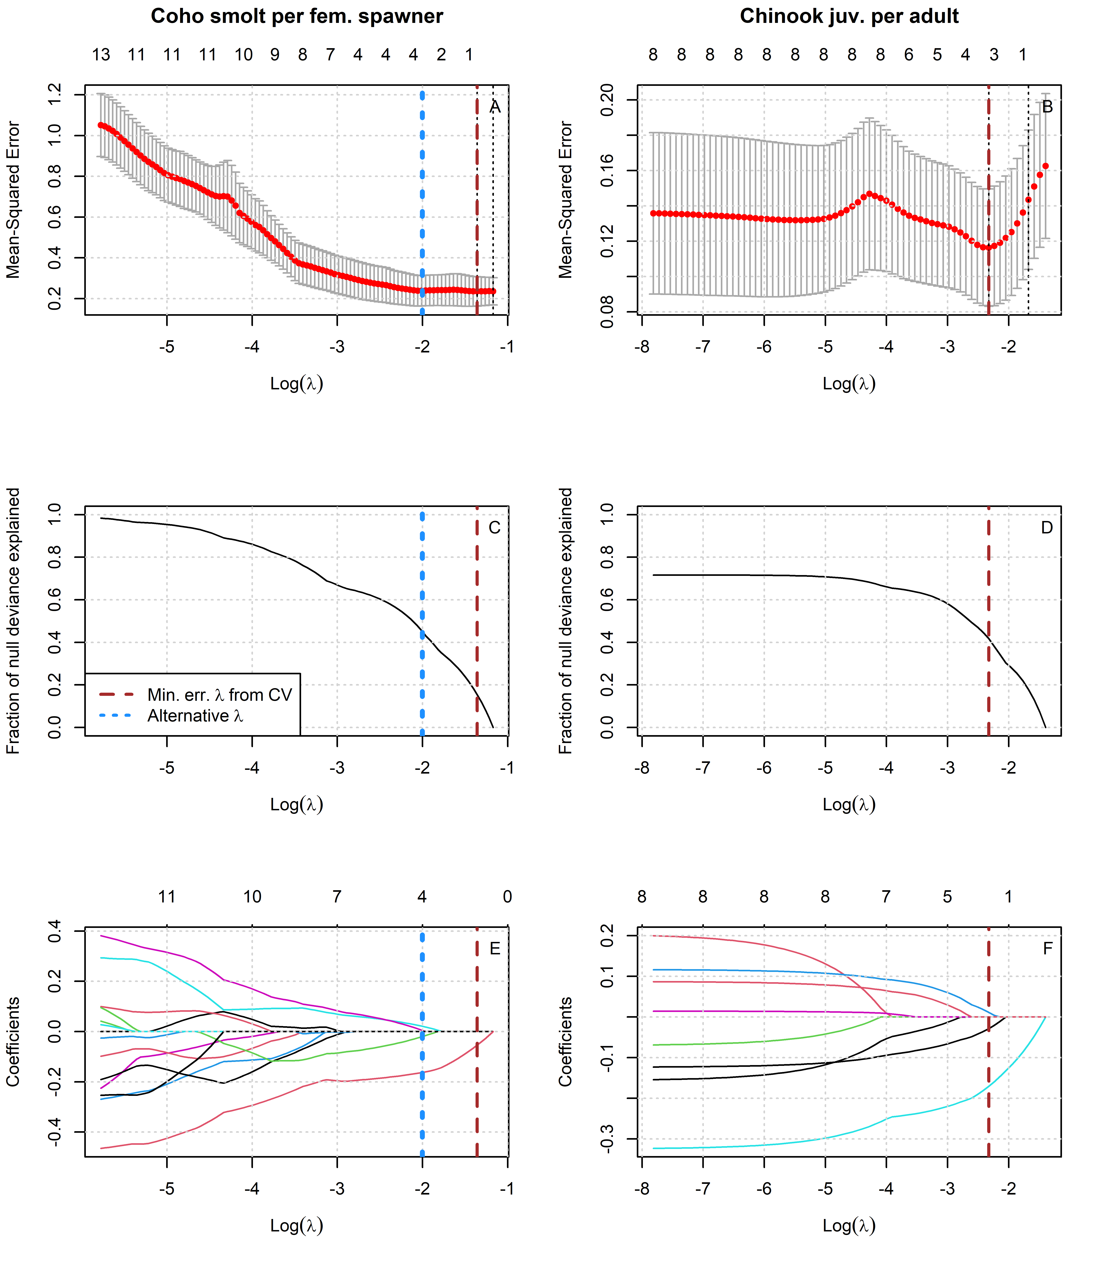

Figure 5: Results of lasso regression to predict log-transformed coho and Chinook outcomes with Z-scored hydrologic metrics. Models with more coefficients explain a greater fraction of deviance in the dataset (middle panel), but also produce higher test errors (top panel), indicating some overfitting at lower lambda values. Higher values of lambda tend to shrink the absolute values of regression coefficients toward 0 (bottom panel).

Table 3: Values for the intercept and coefficient terms in the Hydrologic Benefit function for estimated coho smolts per female spawner, including a description of which phenomena are associated with higher ecological outcome values.

| Predictor | Value | Greater Hydrologic Benefit value associated with |
| --- | --- | --- |
|  | 1.591 | (Intercept) |
| f1_recon_120 | -0.163 | Earlier fall reconnection (during parents' spawning) |
| w1_Wet_BFL_Dur | 0.021 | Longer wet season (as eggs and hatchlings) |
| f2_FA_Dif_num | -0.020 | Smaller fall pulse (as juvenile fish) |
| s2_SP_ROC | 0.005 | Faster rate of change, spring recession (as outmigrating smolts) |

Table 4: Values for the intercept and coefficient terms in the Hydrologic Benefit function for estimated Chinook juvenile abundance, including a description of which phenomena are associated with higher ecological outcome values.

| Predictor | Value | Greater Hydrologic Benefit value associated with |
| --- | --- | --- |
|  | 1.946 | (Intercept) |
| w1_Wet_BFL_Mag_50 | -0.171 | Smaller wet season baseflows (as eggs and hatchlings) |
| s1_SP_ROC_Max | -0.029 | Slower max. rate of change, spring recession (as outmigrating smolt) |
| w1_Wet_BFL_Dur | 0.011 | Longer wet season duration (as eggs and hatchlings) |

## 7.2 MARSS Models

### 7.2.1 MARSS models of juveniles per spawner, single hydrologic covariate

Multi-variate autoregressive state-space (MARSS) models are often used to model time series data (in which )

(#tab:MARSS_single_covar_table_co)Characteristics of MARSS models ofcoho spfusing one hydrologic metric as the single covariate in each model.

| Covariate | AICc | Coefficient |
| --- | --- | --- |
| f1_recon_120 | 21.24 | -0.403 |
| f1_FA_Dif_num | 23.13 | 0.306 |
| w1_Wet_BFL_Mag_50 | 26.46 | 0.136 |
| d1_DS_Mag_90 | 27.05 | 0.102 |
| f1_FA_Dur | 27.05 | 0.102 |
| f1_FA_Tim | 27.05 | 0.102 |
| s2_SP_ROC_Max | 27.34 | -0.093 |
| f2_recon_120 | 27.50 | -0.173 |
| s2_SP_ROC | 27.55 | 0.085 |
| d1_DS_Mag_50 | 27.74 | -0.109 |
| w2_Wet_BFL_Mag_50 | 27.93 | 0.085 |
| s1_SP_ROC_Max | 28.25 | 0.046 |
| f2_FA_Dur | 28.25 | 0.046 |
| s2_SP_Tim | 28.26 | 0.029 |
| w2_Wet_Tim | 28.47 | -0.023 |
| f2_FA_Dif_num | 28.50 | 0.036 |
| s1_SP_ROC | 28.55 | 0.007 |
| w1_Wet_BFL_Dur | 28.55 | 0.003 |

(#tab:MARSS_single_covar_table_ch)Values for the intercept and coefficient terms in the Hydrologic Benefit function for estimated Chinook juvenile abundance, including a description of which phenomena are associated with higher ecological outcome values.

| Covariate | AICc | Coefficient |
| --- | --- | --- |
| d1_DS_Mag_90 | 28.91 | 0.069 |
| f1_FA_Dur | 28.91 | 0.069 |
| f1_FA_Tim | 28.91 | 0.069 |
| s1_SP_ROC_Max | 29.17 | -0.057 |
| f1_recon_120 | 29.61 | -0.039 |
| w1_Wet_BFL_Dur | 29.70 | -0.019 |
| d1_DS_Mag_50 | 29.72 | -0.039 |
| w1_Wet_BFL_Mag_50 | 29.74 | 0.031 |
| f1_FA_Dif_num | 29.88 | -0.013 |
| s1_SP_ROC | 29.89 | 0.002 |
| f2_recon_120 |  |  |
| f2_FA_Dur |  |  |
| f2_FA_Dif_num |  |  |
| w2_Wet_BFL_Mag_50 |  |  |
| w2_Wet_Tim |  |  |
| s2_SP_ROC |  |  |
| s2_SP_ROC_Max |  |  |
| s2_SP_Tim |  |  |

### 7.2.2 MARSS models, two covariates (spawner abundance and one hydrologic)

As another technique, we could attempt to model observed juvenile abundance using each hydrologic metric paired with the observed spawner abundance among the parents of a given cohort.

| pred | aicc | flow | spawn |
| --- | --- | --- | --- |
| f1_FA_Dif_num | 36.27 | 0.464 | -0.016 |
| d1_DS_Mag_90 | 38.37 | 0.310 | -0.036 |
| f1_FA_Dur | 38.37 | 0.310 | -0.036 |
| f1_FA_Tim | 38.37 | 0.310 | -0.036 |
| w1_Wet_BFL_Mag_50 | 39.58 | 0.245 | -0.020 |
| s1_SP_ROC | 40.58 | -0.228 | -0.033 |
| f2_recon_120 | 41.31 | -0.242 | 0.000 |
| f1_recon_120 | 41.47 | -0.238 | -0.001 |
| w2_Wet_Tim | 41.65 | 0.154 | -0.023 |
| s2_SP_Tim | 41.74 | -0.091 | -0.021 |
| w2_Wet_BFL_Mag_50 | 41.79 | 0.134 | -0.012 |
| s1_SP_ROC_Max | 41.93 | 0.115 | -0.017 |
| f2_FA_Dur | 41.93 | 0.115 | -0.017 |
| s2_SP_ROC_Max | 42.08 | 0.093 | -0.014 |
| d1_DS_Mag_50 | 42.16 | 0.070 | -0.006 |
| f2_FA_Dif_num | 42.26 | -0.055 | -0.002 |
| s2_SP_ROC | 42.29 | -0.019 | -0.005 |
| w1_Wet_BFL_Dur | 42.30 | -0.011 | -0.006 |

| Hydrologic Covariate | AICc | Hydro Coef. | Spawner Coef. |
| --- | --- | --- | --- |
| w1_Wet_BFL_Mag_50 | 35.80 | -0.152 | 0.0025 |
| s1_SP_ROC_Max | 36.60 | -0.106 | 0.0004 |
| d1_DS_Mag_50 | 37.65 | 0.113 | -0.0022 |
| f1_recon_120 | 37.80 | -0.083 | -0.0021 |
| w1_Wet_BFL_Dur | 38.14 | 0.032 | 0.0002 |
| f1_FA_Dif_num | 38.27 | -0.072 | 0.0014 |
| s1_SP_ROC | 38.49 | 0.028 | 0.0024 |
| d1_DS_Mag_90 | 38.57 | -0.010 | 0.0004 |
| f1_FA_Dur | 38.57 | -0.010 | 0.0004 |
| f1_FA_Tim | 38.57 | -0.010 | 0.0004 |
| f2_recon_120 |  |  |  |
| f2_FA_Dur |  |  |  |
| f2_FA_Dif_num |  |  |  |
| w2_Wet_BFL_Mag_50 |  |  |  |
| w2_Wet_Tim |  |  |  |
| s2_SP_ROC |  |  |  |
| s2_SP_ROC_Max |  |  |  |
| s2_SP_Tim |  |  |  |

# References

Agrawal, A, R S Schick, E P Bjorkstedt, R G Szerlong, M N Goslin, B C Spence, T H Williams, and K M Burnett. 2005. “PREDICTING THE POTENTIAL FOR HISTORICAL COHO, CHINOOK AND STEELHEAD HABITAT IN NORTHERN CALIFORNIA.” National Marine Fisheries Service.

Bourret, Samuel L., Christopher C. Caudill, and Matthew L. Keefer. 2016. “Diversity of Juvenile Chinook Salmon Life History Pathways.” *Reviews in Fish Biology and Fisheries* 26 (3): 375–403. <https://doi.org/10.1007/s11160-016-9432-3>.

Bradford, Michael J., Garth C. Taylor, and J. Andrew Allan. 1997. “Empirical Review of Coho Salmon Smolt Abundance and the Prediction of Smolt Production at the Regional Level.” *Transactions of the American Fisheries Society* 126 (1): 49–64. <https://doi.org/10.1577/1548-8659(1997)126<0049:EROCSS>2.3.CO;2>.

Brown, Larry R., Peter B. Moyle, and Ronald M. Yoshiyama. 1994. “Historical Decline and Current Status of Coho Salmon in California.” *North American Journal of Fisheries Management* 14 (2): 237–61. <https://doi.org/10.1577/1548-8675(1994)014<0237:HDACSO>2.3.CO;2>.

Bustard, David R., and David W. Narver. 1975. “Aspects Ofthe Winter Ecology of Juvenile Coho Sahnon (Oncorhynchus Kisutch) and Steelhead Trout (Salmo Gairdneri).” *Journal of the Fisheries Resources Board of Canada* 32 (5): 667–80. <https://doi.org/10.1139/f75-086>.

California Department of Fish and Wildlife. 2021. “Scott River Best Available Scientific Information for Instream Flow Criteria.”

Groot, Cornelis, and Leo Margolis, eds. 1991. “Life History of Chinook Salmon (Onchorhynchus Tshawytscha).” In *Pacific Salmon Life Histories*. Vancouver: UBC Press.

Harter, Thomas, and Ryan Hines. 2008. “SCOTT VALLEY COMMUNITY GROUNDWATER STUDY PLAN.” University of California, Davis.

Hunt, Sharon L, Timothy J Mulligan, and Kenichiro Komori. 1999. “Oceanic Feeding Habits of Chinook Salmon, Oncorhynchus Tshawytscha, Off Northern Californi.” *Fishery Bulletin* 97 (3): 717–21.

Knechtle, Morgan, and Domenic Giudice. 2020. “2019 SCOTT RIVER SALMON STUDIES FINAL REPORT.” California Department of Fish and Wildlife.

Mack, Seymour. 1958. “Geology and Ground-Water Features of Scott Valley, Siskiyou County, California.” Geological {{Survey Water-Supply Paper}} 1462. United States Geological Survey. <https://doi.org/10.3133/wsp1462>.

Magranet, Lindsay. 2015. “Scott River Fall Chinook Spawning Ground Surveys.” Etna, CA: Siskiyou Resource Conservation District.

———. 2017. “Scott River Fall Chinook Spawning Ground Surveys.” Etna, CA: Siskiyou Resource Conservation District.

Mansfield, Carol, George Van Houtven, Amy Hendershott, Patrick Chen, Jeremy Porter, Vesall Nourani, and Vikram Kilambi. 2012. “Klamath River Basin Restoration Nonuse Value Survey.”

McMahon, Thomas E. 1983. “Habitat Suitability Index Models: Coho Salmon.” FWS/OBS-82/10.49. U.S. Fish and Wildlife Service.

Moyle, Peter. 2002. “Coho Salmon, Oncorhynchus Kisutch (Walbaum).” In *Inland Fishes of California*, 245–51. University of California Press.

Nickelson, Thomas E., Jeffrey D. Rodgers, Steven L. Johnson, and Mario F. Solazzi. 1992. “Seasonal Changes in Habitat Use by Juvenile Coho Salmon (Oncorhynchus Kisutch) in Oregon Coastal Streams.” *Canadian Journal of Fisheries and Aquatic Sciences* 49 (4): 783–89. <https://doi.org/10.1139/f92-088>.

North Coast Regional Water Quality Control Board. 2005. “Staff Report for the Action Plan for the Scott River Watershed Sediment and Temperature Total Maximum Daily Loads.” Santa Rosa, CA.

———. 2006. “ACTION PLAN FOR THE SCOTT RIVER SEDIMENT AND TEMPERATURE TOTAL MAXIMUM DAILY LOADS.” *Basin Plan Language*. https://www.waterboards.ca.gov/northcoast/water_issues/programs/tmdls/scott_river/060307/bpl/Basin_Plan_Language.pdf.

Quiñones, Rebecca M., Marcel Holyoak, Michael L. Johnson, and Peter B. Moyle. 2014. “Potential Factors Affecting Survival Differ by Run-Timing and Location: Linear Mixed-Effects Models of Pacific Salmonids (Oncorhynchus Spp.) in the Klamath River, California.” Edited by Christopher J. Fulton. *PLoS ONE* 9 (5): e98392. <https://doi.org/10.1371/journal.pone.0098392>.

Scott Valley Area Plan Committee. 1980. “Scott Valley Area Plan.” Siskiyou County.

Siskiyou County. 2021. “Scott Valley Groundwater Sustainability Plan.” *Scott Valley FINAL GSP*. https://www.co.siskiyou.ca.us/naturalresources/page/scott-valley-final-gsp.

Siskiyou Resource Conservation District. 2004. “Final Report Scott River Coho Spawning Assessment: 2003-2004.” Etna, CA: Siskiyou Resource Conservation District.

Tolley, D., L. Foglia, and T. Harter. 2019. “Sensitivity Analysis and Calibration of an Integrated Hydrologic Model in an Irrigated Agricultural Basin With a Groundwater-Dependent Ecosystem.” *Water Resources Research* 55 (9): 7876–7901. <https://doi.org/10.1029/2018WR024209>.

Wainwright, Thomas C, Thomas H Williams, Kurt L Fresh, and Brian K Wells. 2013. “CCIEA PHASE II REPORT: ECOSYSTEM COMPONENTS, FISHERIES AND PROTECTED SPECIES - SALMON: Chinook and Coho Salmon.” National Marine Fisheries Service.

Welch, David Warren, Aswea Dawn Porter, and Erin Leanne Rechisky. 2021. “A Synthesis of the Coast-Wide Decline in Survival of West Coast Chinook Salmon (Oncorhynchus Tshawytscha, Salmonidae).” *Fish and Fisheries* 22 (1): 194–211. <https://doi.org/10.1111/faf.12514>.