Supplement to “A watershed-specific formula to predict salmon reproduction using functional flow metrics”
Claire Kouba, Jason Wiener, Leland Scantlebury, Sarah Yarnell and Thomas Harter
Aug. 2025

Supplement to “A watershed-specific formula to predict salmon reproduction using functional flow metrics”

1 Overview of research on flow-ecology relationships
Work on this topic of quantifying ecological responses to changes in flow spans multiple categories of ecological response, hydrologic predictor, and ultimate cause of hydrologic alteration. Two widely studied ecological response metric categories are, firstly, the stream health index, based on density and species richness of macroinvertebrates observed at designated sampling sites (e.g., Monk et al. 2006; Guareschi et al. 2014; Kevic et al. 2018; Mazor et al. 2018; Larsen et al. 2021; Peek et al. 2022), and secondly, fish diversity and community assemblage (e.g., McManamay et al. 2013; Peterson and Freeman 2016; Cartwright et al. 2017; Sinnathamby et al. 2018; Hain et al. 2018; Guedes et al. 2020; Yao et al. 2021). Ecological responses can also be based on the abundance of a single or a few species, often of fish (Stewart-Koster et al. 2011; Booth et al. 2014; DeWeber and Peterson 2020; Hale et al. 2023), as well as the extent of habitat types (Chowdhury and Driver 2007; Arriana Brand et al. 2011) and the presence of organisms including vegetation and plankton (Riis et al. 2008; Catford et al. 2014; Qian, Liu, and Chen 2016; Tesfaye et al. 2017; Saby et al. 2022). Hydrologic predictors range widely, with a heavy emphasis on extreme (low or high) flow events and the duration of components of the flow regime (e.g., Ayllón et al. 2014; Lamouroux and Olivier 2015; McManamay and Frimpong 2015; Bower et al. 2022). Alteration from a natural flow regime is a widely-used framework for calculating hydrologic predictors (Richter et al. 1996; Poff et al. 2010). Causes of the change in hydrology include the operation of dams, changes in human water use, climate change, and natural flow variability (e.g., Alomía Herrera and Carrera Burneo 2017; Gao, Xie, and Zou 2020; White et al. 2018; Daneshvar et al. 2017; Herbst et al. 2019).
Investigations of flow-ecology relationships can also be grouped by approach (as in Tharme 2003; Brummer et al. 2016). In experimental flow studies the flow is directly manipulated with dam releases and biological responses are monitored (e.g., Konrad et al. 2011). In longitudinal studies, long-term ecological and hydrological records can be used to infer local or regional correlations (e.g., Mellado-Díaz et al. 2019). Finally, in space-for-time approaches, the hydrology of multiple river systems in a region is used to populate the distribution of different hydrologic behavior, and ecological monitoring is related to flow differences between streams (e.g., Monk et al. 2008; Riis et al. 2008; Catford et al. 2014; Bower et al. 2022). Space-for-time analyses require considerably fewer resources than experimental flows and longitudinal studies, and thus are more numerous (Brummer et al. 2016).

2 Brief history of Scott River water use, management, and investigations
Water in Scott Valley is used for agricultural, domestic, and municipal supply. It also facilitates recreation and provides Native American cultural services, among other designated beneficial uses (NCRWQCB 2006). Because the watershed is undammed, managers and water users influence Scott River flow primarily via diversion of surface waters and pumping of groundwater. Consequently, the most powerful tool available to manage Scott River water flow is regulation of land use and thus water demand (Siskiyou County 2021). This summary focuses on work relevant to the current study; for a more comprehensive list of natural resource work in the region see the library at Siskiyou Resource Conservation District (2025).
Historically, local regulation of land use has focused on maintaining the rural and agricultural character of Scott Valley (Scott Valley Area Plan Committee 1980). Regulating land use to improve ecological outcomes would entail significant economic, political and social risks, because much of the economic activity in this area is related to agriculture. The primary crops grown in Scott Valley are pasture for cattle feed and alfalfa (Siskiyou County 2021). In addition to local economic impact, Scott River conditions influence fish population dynamics both within the watershed and in the broader Klamath system. The health of the Klamath salmon run has implications for commercial fishing, recreational activities, and cultural practices of Native American tribes in the region, including the Quartz Valley Indian Community and the Karuk and Yurok Tribes (Mansfield et al. 2012).
Recent management activity has included the leasing of surface water rights from landowners to enhance summer flows (e.g., SRWT 2018), the prioritization of stream reaches for habitat restoration (SRWC 2018), several pilot projects to construct and assess the impact of beaver dam analogs (BDAs) on aquatic habitat and fish populations (Yokel 2018), a coordinated rescue effort to relocate juvenile salmon that were cut off from outmigrating by disconnected river reaches (CDFW 2015), and the development of long-term groundwater management plan by Siskiyou County and local stakeholders (Siskiyou County 2021).
Although the empirical “flow-to-ecology” link described above has not been quantified, flow-ecology relationships have been investigated by multiple entities in the Scott River Watershed. Over the past three decades, several organizations and agencies have conducted extensive monitoring and published a series of reports and plans regarding the salmon fisheries in the Scott River watershed. In the 1990s, fall flows in the Scott River were reported to be too low in some years to allow for Chinook spawning in September-November (CRMP and SRWC 2000), but in the mid-2000s it was reported that low fall flows rarely affected the later (November-January) spawning runs of steelhead and coho salmon (SRWC and Siskiyou RCD 2005). More recently, fall flows have affected coho salmon as well as Chinook, as the late onset of winter storms has delayed coho spawning in some water years (e.g., CDFW 2015). In the mid-2000s, a local conservation organization identified the lack of suitable summer and winter rearing habitat as a probable limitation on Scott River coho smolt production (SRWC and Siskiyou RCD 2005). Several years later, in a NOAA Fisheries Coho Recovery Plan, NMFS identified the juvenile life stage as the most limited in the population (NMFS 2014).

3 Species of concern - coho and Chinook salmon

3.0.1 Life cycle and status of coho salmon (Oncorhynchus kisutch)
Returning adult coho spawn in natal streams between November and January (Knechtle and Giudice 2020), and juvenile coho spend approximately one full year in freshwater streams before migrating to the ocean as smolts (Moyle 2002; McMahon 1983). In the Scott River system these natal streams are the tributaries along the margins of the valley floor (SRCD 2004).
In previous studies, the strongest predictor of juvenile coho abundance in a stream system was spatial habitat (Bradford, Taylor, and Allan 1997; Nickelson et al. 1992; Bustard and Narver 1975), although adequate food and cover were also important (McMahon 1983). The primary mechanism for spatial constraints on abundance appears to be that juvenile coho become more territorial as they grow (McMahon 1983).
Some coho salmon return to spawn at age 2 as grilse, but the majority (e.g., 92.4% in 2020) return after more than one year in the ocean, giving the Scott coho salmon run its characteristic 3-year cohort return interval (Knechtle and Giudice 2020).
Coho salmon in the Scott Valley are listed as threatened under the federal and California Endangered Species Acts (ESAs). They belong to the Southern Oregon / Northern California Coast (SONCC) Evolutionarily Significant Unit (ESU), which was listed as threatened under the federal and state ESAs in 1997 and 2005, respectively. State-wide, coho populations have declined more than 90% since the 1940s (Brown, Moyle, and Yoshiyama 1994).

3.0.2 Life cycle and status of Chinook salmon (Onchorhynchus tsawytscha)
Chinook salmon in the Scott Valley are a candidate for listing under the federal ESA, and are not listed under the California ESA. They belong to the Southern Oregon / Northern California Coast (SONCC) Evolutionarily Significant Unit (ESU). Typically, adult Chinook salmon return to spawn in Scott Valley streams in the fall months September-December when flows are sufficient for salmon passage (Knechtle and Giudice 2020; Magranet 2015, 2017). Chinook in this watershed hatch in the spring and migrate to the ocean in their first year of life (Agrawal et al. 2005). Chinook spend the majority of their life in the ocean, and return to their natal streams shortly before spawning (Groot and Margolis 1991). However, substantial variability exists within this broader structure: Chinook salmon exhibit variation in multiple life stages, including time of seaward migration, age of maturity, and timing of return to natal stream (Groot and Margolis 1991; Bourret, Caudill, and Keefer 2016).
As recently as 2013, the SONCC Chinook population was stable and becoming more complex (Wainwright et al. 2013). However, in monitoring from 2015-2020, the number of returning adults (the escapement) was 65% below historical average, and the change in the Scott River Chinook population has been more rapid than the decline in the overall Klamath Basin Chinook run (California Department of Fish and Wildlife 2021). Ocean conditions may have contributed to a broad decline in Chinook populations from Alaska to California (Welch, Porter, and Rechisky 2021). Some studies have found that the leading cause of declining Chinook populations are ocean conditions, including including temperature, upwelling currents and food resources (Hunt, Mulligan, and Komori 1999), while others have identified hatchery practices as the primary cause (Quiñones et al. 2014).

4 Hydrologic Metrics

4.1 Functional Flows Background
The annual functional flow metrics calculated from Fort Jones average daily flow (USGS Gauge 11519500) (Patterson et al. 2020; Carpenter 2024) are shown in Tables 2 through 7 below. These are then aligned with a salmon cohort for the statistical modeling exercise.
Table 1: Explanation of functional flows used in this analysis (Patterson et al. 2020; Carpenter 2024; Baruch et al. 2024). Each type of metric, for each threshold value (e.g., 100 cfs or 50th flow percentile), produces one value per water year.
Abbrev. | Full Name | Thresholds | Description
DS_Dur_WS | Dry Season Duration | -- | Dry-season baseflow duration (# of days from start of dry season to start of wet season)
DS_Tim | Dry Season Onset Timing | -- | Dry-season baseflow start timing (water year day of dry season)
DS_Mag | Dry Season Flow Magnitude | 50th and 90th flow percentile | Percentile of daily flow within dry season (with 90th and 50th %ile flows representing early summer flows and median summer baseflow, respectively).
FA_Dur | Fall Pulse Duration | -- | Duration (# of days) of the fall pulse event (does not occur every year).
FA_Tim | Fall Pulse Timing | -- | Start date of fall pulse event in water year days (does not occur every year).
FA_Mag | Fall Pulse Magnitude | -- | Peak magnitude of fall pulse event (maximum daily peak flow during event) (cfs) in relevant lifestage (does not occur every year).
FA_Dif_num | Fall Pulse Magnitude (modified) |  | Difference between peak fall pulse discharge and dry season median discharge (Baruch et al. 2024) (occurs every year).
Wet_BFL_Dur | Wet Season Baseflow Duration | -- | Wet-season baseflow duration (# of days from start of wet-season to start of spring season)
Wet_BFL_Mag | Wet Season Baseflow Magnitude | 50th and 10th percentile | The magnitude of flow during the wet season, with the 10th %ile corresponding to baseflow levels and 50th %ile corresponding to the median flow including winter storms.
Wet_Tim | Wet Season Onset Timing | -- | Start date of wet-season in water year days
Peak_Dur | Duration of high-flow events | 2, 5, and 10-year return interval | Number of days exceeding the 2, 5 and 10 year recurrence intervals of annual peak flow (50%, 20%, and 10% exceedance values).
Peak_Fre | Frequency of high-flow events | 2, 5, and 10-year return interval | Number of times that flow crosses over the threshold values for the 2-, 5- and 10-year flow (50%, 20%, and 10% exceedance values).
Peak_Tim | Timing of first high-flow event in a water year | 2, 5, and 10-year return interval | Timing of first exceedance of threshold value for the 2-, 5- and 10-year flow (50%, 20% and 10% exceedance values), in water year days
Peak | Magnitude of high-flow events | 2, 5, and 10-year return interval | Single value for each threshold corresponding to the 2-, 5- and 10- year flow exceedance values, in cfs
SP_ROC | Spring Recession Rate of Change | -- | Spring flow recession rate (median daily rate of change over decreasing periods during the recession)
SP_ROC_Max | Maximum Spring Recession Rate of Change |  | Maximum daily rate of change over decreasing periods during the recession
SP_Dur | Duration of Spring Recession |  | Period elapsed from the start date of the spring recession until the start date of the following dry season.
SP_Mag | Magnitude of Spring Recession |  | Flow magnitude on the start date of the spring recession (the "peak" of the snowmelt pulse).
SP_Tim | Spring Onset Timing | -- | Start date of spring flow recession in water year days
Mean_Ann_Flow | Mean Annual Flow | -- | Mean daily flow rate over a full water year.
WY_Cat | Water Year Category | -- | Category of water year (Dry, Moderate, Wet)
## [1] FALSE
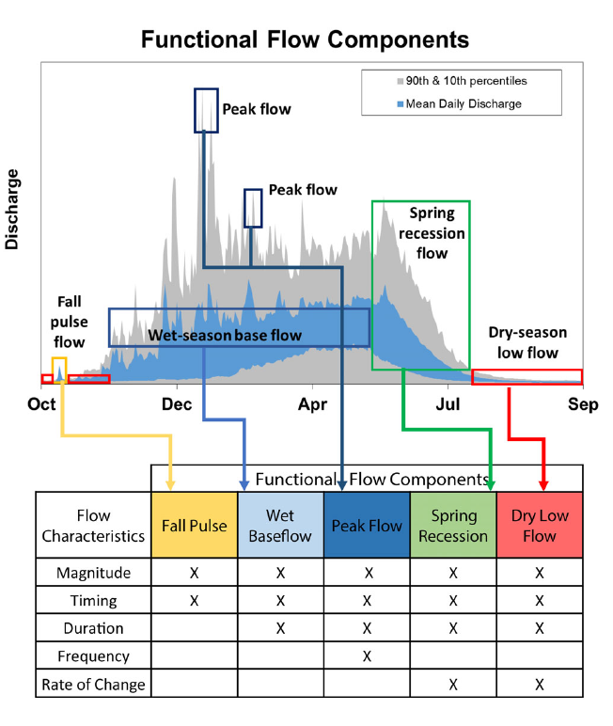
Figure 1: Figure 2 from Yarnell et al., 2020. Illustration of five functional flow categories identified for a mixed rain-snowmelt runoff river in California.

4.2 Data tables: annual values for Fort Jones Gauge functional flows
Table 2: Functional Flows calculated for Scott River Gauge 11519500, columns 1 through 7 of 32, using the Flashy Calculator (Carpenter 2024).
Year | DS_Dur_WS | DS_Tim | DS_Mag_50 | DS_Mag_90 | FA_Dur | FA_Mag
1942 |  | 326
1943 | 90 | 325 | 69.0 | 147.0 | 8 | 129.0
1944 | 87 | 335 | 48.0 | 151.4 | 3 | 190.0
1945 | 95 | 319 | 54.0 | 174.5 | 3 | 470.0
1946 | 154 | 327 | 84.0 | 380.8 | 4 | 614.0
1947 | 104 | 292 | 48.0 | 156.6 | 2 | 1,020.0
1948 | 120 | 310 | 89.0 | 141.0 | 3 | 634.0
1949 | 120 | 302 | 51.0 | 74.0 | 7 | 216.0
1950 | 67 | 323 | 59.0 | 76.9 | 3 | 82.0
1951 | 90 | 315 | 61.0 | 115.0 | 1 | 103.0
1952 | 141 | 313 | 104.5 | 243.9 | 4 | 200.0
1953 | 118 | 326 | 128.0 | 644.0 | 8 | 614.0
1954 | 101 | 309 | 93.0 | 105.0 | 5 | 698.0
1955 | 101 | 312 | 38.0 | 60.9 | 1 | 399.0
1956 | 74 | 361 | 167.0 | 333.8 | 1 | 66.0
1957 | 106 | 301 | 91.0 | 421.4 | 3 | 258.0
1958 | 90 | 361 | 116.0 | 195.0 | 10 | 1,010.0
1959 | 145 | 317 | 53.5 | 63.0 | 6 | 265.0
1960 | 115 | 310 | 61.0 | 75.0
1961 | 87 | 331 | 67.5 | 107.3 | 3 | 97.0
1962 | 79 | 341 | 271.5 | 1,136.0 | 3 | 109.0
1963 | 75 | 325 | 66.0 | 117.0 | 6 | 6,780.0
1964 | 138 | 287 | 57.0 | 113.6 | 2 | 123.0
1965 | 94 | 359 | 110.0 | 290.0 | 5 | 139.0
1966 | 89 | 320 | 57.0 | 64.0 | 4 | 516.0
1967 | 87 | 342 | 88.5 | 120.3 | 3 | 88.0
1968 | 128 | 306 | 53.0 | 221.0 | 3 | 191.0
1969 | 65 | 335 | 81.0 | 113.5 | 13 | 250.0
1970 | 71 | 317 | 50.5 | 60.0 | 2 | 127.0
1971 | 71 | 359 | 123.0 | 353.2 | 4 | 80.0
1972 | 123 | 318 | 78.5 | 132.7 | 5 | 259.0
1973 | 87 | 298 | 25.0 | 53.3 | 3 | 135.0
1974 | 86 | 342 | 74.0 | 137.8 | 1 | 66.0
1975 | 130 | 279 | 100.0 | 424.0 | 1 | 119.0
1976 | 161 | 346 | 82.0 | 93.0 | 4 | 905.0
1977 | 109 | 290 | 15.0 | 22.1
1978 | 204 | 262 | 116.0 | 356.0 | 4 | 25.0
1979 | 117 | 293 | 24.0 | 196.0 | 4 | 184.0
1980 | 115 | 311 | 38.0 | 75.5 | 11 | 1,040.0
1981 | 132 | 276 | 14.0 | 56.6 | 3 | 80.0
1982 | 85 | 327 | 81.5 | 210.5 | 2 | 27.0
1983 | 51 | 360 | 203.0 | 553.9 | 2 | 210.0
1984 | 89 | 316 | 59.5 | 166.0 | 4 | 427.0
1985 | 127 | 299 | 43.5 | 107.2 | 12 | 131.0
1986 | 91 | 302 | 46.5 | 89.8 | 6 | 129.0
1987 | 145 | 280 | 18.0 | 41.0 | 1 | 81.0
1988 | 107 | 291 | 16.5 | 34.0 | 1 | 30.0
1989 | 88 | 298 | 27.0 | 47.0 | 3 | 35.0
1990 | 107 | 292 | 17.5 | 39.0 | 1 | 49.0
1991 | 146 | 284 | 16.0 | 51.2 | 2 | 28.0
1992 | 103 | 293 | 22.0 | 75.0 | 7 | 53.0
1993 | 143 | 317 | 70.0 | 132.8 | 2 | 53.0
1994 | 192 | 271 | 10.0 | 66.0 | 6 | 109.0
1995 | 102 | 333 | 69.0 | 96.2 | 7 | 45.0
1996 | 98 | 314 | 34.0 | 97.0 | 5 | 193.0
1997 | 253 | 165 | 128.0 | 829.2 | 7 | 97.0
1998 | 81 | 346 | 115.0 | 1,270.0 | 4 | 216.0
1999 | 100 | 324 | 63.0 | 182.0 | 3 | 174.0
2000 | 154 | 308 | 50.0 | 97.0 | 5 | 141.0
2001 | 170 | 260 | 5.3 | 16.0
2002 | 137 | 301 | 15.1 | 78.1 | 4 | 502.0
2003 | 97 | 329 | 61.4 | 114.6 | 15 | 37.5
2004 | 127 | 305 | 25.3 | 95.3 | 5 | 99.0
2005 | 109 | 310 | 27.8 | 204.7 | 3 | 103.0
2006 | 115 | 321 | 61.9 | 286.0 | 9 | 488.0
2007 | 129 | 279 | 12.6 | 91.5 | 12 | 103.0
2008 | 86 | 310 | 19.4 | 39.7 | 11 | 778.0
2009 | 117 | 286 | 10.6 | 27.6 | 11 | 39.9
2010 | 84 | 318 | 47.3 | 316.6 | 2 | 32.9
2011 | 124 | 330 | 94.8 | 108.6 | 4 | 755.0
2012 | 109 | 306 | 20.5 | 55.0
2013 | 209 | 276 | 46.0 | 56.2 | 2 | 55.4
2014 | 156 | 260 | 8.1 | 70.7
2015 | 248 | 221 | 9.4 | 225.4 | 5 | 192.0
2016 | 129 | 305 | 18.5 | 527.4 | 14 | 692.0
2017 | 95 | 319 | 61.2 | 84.4 | 7 | 486.0
2018 | 173 | 268 | 13.4 | 62.4 | 4 | 114.0
2019 | 174 | 305 | 53.5 | 134.0 | 4 | 108.0
2020 | 158 | 278 | 8.8 | 15.5 | 6 | 273.0
2021 | 131 | 268 | 9.3 | 18.1 | 2 | 35.0
2022 | 159 | 290 | 9.3 | 45.1 | 2 | 501.0
2023 | 117 | 310 | 47.5 | 83.3 | 16 | 40.0
2024 |  | 301 | 33.2 | 43.4 | 8 | 83.8

Table 3: Functional Flows calculated for Scott River Gauge 11519500, columns 7 through 12 of 32, using the Flashy Calculator (Carpenter 2024).
Year | FA_Mag | FA_Tim | FA_Dif_num | SP_ROC | SP_ROC_Max | SP_Dur
1942 |  |  |  | 0.042 | 0.165 | 77
1943 | 129.0 | 40 | 58.0 | 0.040 | 0.300 | 122
1944 | 190.0 | 26 | 120.0 | 0.031 | 0.141 | 90
1945 | 470.0 | 35 | 422.0 | 0.037 | 0.203 | 94
1946 | 614.0 | 31 | 560.0 | 0.044 | 0.136 | 96
1947 | 1,020.0 | 50 | 935.5 | 0.057 | 0.150 | 77
1948 | 634.0 | 17 | 586.0 | 0.064 | 0.172 | 55
1949 | 216.0 | 35 | 127.0 | 0.055 | 0.182 | 77
1950 | 82.0 | 42 | 30.5 | 0.045 | 0.160 | 80
1951 | 103.0 | 9 | 43.0 | 0.046 | 0.450 | 187
1952 | 200.0 | 24 | 138.5 | 0.073 | 0.222 | 62
1953 | 614.0 | 68 | 508.0 | 0.048 | 0.133 | 65
1954 | 698.0 | 45 | 570.0 | 0.058 | 0.403 | 103
1955 | 399.0 | 40 | 305.0 | 0.072 | 0.593 | 58
1956 | 66.0 | 35 | 27.0 | 0.052 | 0.385 | 125
1957 | 258.0 | 27 | 91.0 | 0.045 | 0.270 | 58
1958 | 1,010.0 | 11 | 919.0 | 0.048 | 0.163 | 130
1959 | 265.0 | 45 | 139.5 | 0.056 | 0.384 | 91
1960 |  |  | 6.0 | 0.063 | 0.395 | 61
1961 | 97.0 | 50 | 35.0 | 0.056 | 0.164 | 86
1962 | 109.0 | 28 | 41.0 | 0.051 | 0.315 | 121
1963 | 6,780.0 | 13 | 6,492.0 | 0.038 | 0.127 | 92
1964 | 123.0 | 12 | 55.0 | 0.069 | 0.107 | 36
1965 | 139.0 | 43 | 82.0 | 0.054 | 0.531 | 148
1966 | 516.0 | 46 | 402.0 | 0.067 | 0.281 | 102
1967 | 88.0 | 5 | 31.0 | 0.062 | 0.566 | 79
1968 | 191.0 | 46 | 102.0 | 0.067 | 0.411 | 122
1969 | 250.0 | 41 | 196.0 | 0.074 | 0.419 | 87
1970 | 127.0 | 18 | 46.0 | 0.054 | 0.569 | 177
1971 | 80.0 | 10 | 27.0 | 0.052 | 0.370 | 134
1972 | 259.0 | 44 | 136.0 | 0.049 | 0.232 | 129
1973 | 135.0 | 36 | 48.5 | 0.060 | 0.211 | 61
1974 | 66.0 | 2 | 41.0 | 0.058 | 0.177 | 122
1975 | 119.0 | 42 | 43.5 | 0.059 | 0.180 | 22
1976 | 905.0 | 26 | 804.5 | 0.045 | 0.193 | 119
1977 |  |  | 15.0 | 0.063 | 0.141 | 37
1978 | 25.0 | 26 | 10.0 | 0.080 | 0.174 | 79
1979 | 184.0 | 62 | 68.0 | 0.058 | 0.208 | 60
1980 | 1,040.0 | 25 | 1,016.0 | 0.049 | 0.124 | 99
1981 | 80.0 | 42 | 41.0 | 0.074 | 0.206 | 63
1982 | 27.0 | 26 | 13.0 | 0.055 | 0.236 | 174
1983 | 210.0 | 24 | 125.0 | 0.040 | 0.206 | 119
1984 | 427.0 | 38 | 222.0 | 0.047 | 0.225 | 91
1985 | 131.0 | 21 | 71.0 | 0.057 | 0.150 | 84
1986 | 129.0 | 25 | 85.0 | 0.061 | 0.342 | 143
1987 | 81.0 | 2 | 34.0 | 0.055 | 0.129 | 60
1988 | 30.0 | 37 | 12.0 | 0.071 | 0.213 | 41
1989 | 35.0 | 19 | 16.0 | 0.057 | 0.230 | 76
1990 | 49.0 | 4 | 19.5 | 0.073 | 0.329 | 52
1991 | 28.0 | 7 | 10.0 | 0.088 | 0.250 | 37
1992 | 53.0 | 50 | 36.0 | 0.072 | 0.156 | 72
1993 | 53.0 | 3 | 31.0 | 0.065 | 0.365 | 73
1994 | 109.0 | 65 | 39.0 | 0.066 | 0.156 | 51
1995 | 45.0 | 68 | 35.0 | 0.067 | 0.194 | 99
1996 | 193.0 | 63 | 123.5 | 0.058 | 0.122 | 79
1997 | 97.0 | 26 | 61.0 | 0.029 | 0.168 | 41
1998 | 216.0 | 32 | 87.0 | 0.053 | 0.135 | 92
1999 | 174.0 | 48 | 59.0 | 0.053 | 0.159 | 87
2000 | 141.0 | 30 | 78.0 | 0.069 | 0.138 | 71
2001 |  |  | 15.0 | 0.106 | 0.315 | 32
2002 | 502.0 | 53 | 496.7 | 0.062 | 0.134 | 59
2003 | 37.5 | 34 | 22.4 | 0.066 | 0.190 | 87
2004 | 99.0 | 29 | 35.1 | 0.065 | 0.158 | 88
2005 | 103.0 | 25 | 77.0 | 0.072 | 0.181 | 70
2006 | 488.0 | 38 | 460.2 | 0.060 | 0.156 | 89
2007 | 103.0 | 42 | 39.5 | 0.056 | 0.142 | 102
2008 | 778.0 | 20 | 764.3 | 0.050 | 0.144 | 68
2009 | 39.9 | 12 | 19.3 | 0.070 | 0.197 | 55
2010 | 32.9 | 17 | 21.5 | 0.069 | 0.148 | 60
2011 | 755.0 | 25 | 707.6 | 0.056 | 0.255 | 58
2012 |  |  | 36.0 | 0.064 | 0.191 | 77
2013 | 55.4 | 45 | 34.6 | 0.063 | 0.133 | 55
2014 |  |  | 22.2 | 0.051 | 0.119 | 68
2015 | 192.0 | 26 | 183.8 | 0.051 | 0.505 | 91
2016 | 692.0 | 71 | 682.5 | 0.060 | 0.166 | 110
2017 | 486.0 | 17 | 467.0 | 0.059 | 0.247 | 102
2018 | 114.0 | 42 | 52.6 | 0.081 | 0.159 | 50
2019 | 108.0 | 61 | 94.5 | 0.067 | 0.237 | 77
2020 | 273.0 | 69 | 219.0 | 0.093 | 0.146 | 34
2021 | 35.0 | 47 | 26.1 | 0.066 | 0.149 | 40
2022 | 501.0 | 25 | 491.6 | 0.084 | 0.215 | 41
2023 | 40.0 | 62 | 30.6 | 0.063 | 0.181 | 78
2024 | 83.8 | 40 | 36.2 | 0.063 | 0.121 | 71

Table 4: Functional Flows calculated for Scott River Gauge 11519500, columns 12 through 18 of 32, using the Flashy Calculator (Carpenter 2024).
Year | SP_Dur | SP_Mag | SP_Tim | Wet_BFL_Dur | Wet_BFL_Mag_10 | Wet_BFL_Mag_50 | Wet_Tim
1942 | 77 | 1,850 | 249
1943 | 122 | 2,110 | 203 | 151 | 657.6 | 1,385.0 | 52
1944 | 90 | 598 | 245 | 195 | 140.5 | 281.0 | 50
1945 | 94 | 1,790 | 225 | 168 | 187.0 | 419.0 | 57
1946 | 96 | 1,710 | 231 | 182 | 399.0 | 764.0 | 49
1947 | 77 | 1,110 | 215 | 99 | 278.0 | 545.5 | 116
1948 | 55 | 1,980 | 255 | 224 | 120.0 | 349.0 | 31
1949 | 77 | 2,300 | 225 | 160 | 147.0 | 434.0 | 65
1950 | 80 | 1,400 | 243 | 186 | 84.6 | 760.0 | 57
1951 | 187 | 8,340 | 128 | 103 | 604.2 | 1,175.0 | 25
1952 | 62 | 2,610 | 251 | 211 | 380.8 | 1,335.0 | 40
1953 | 65 | 2,180 | 261 | 172 | 720.8 | 1,290.0 | 89
1954 | 103 | 2,050 | 206 | 127 | 452.2 | 1,240.0 | 79
1955 | 58 | 815 | 254 | 209 | 169.0 | 211.0 | 45
1956 | 125 | 2,860 | 236 | 188 | 536.0 | 1,520.0 | 48
1957 | 58 | 1,480 | 243 | 173 | 210.6 | 973.0 | 70
1958 | 130 | 3,330 | 231 | 189 | 436.5 | 1,340.0 | 42
1959 | 91 | 1,220 | 226 | 140 | 333.0 | 680.0 | 86
1960 | 61 | 1,470 | 249 | 152 | 103.0 | 622.0 | 97
1961 | 86 | 1,820 | 245 | 185 | 261.0 | 732.5 | 60
1962 | 121 | 1,200 | 220 | 167 | 211.5 | 448.5 | 53
1963 | 92 | 2,480 | 233 | 178 | 399.4 | 1,050.0 | 55
1964 | 36 | 1,000 | 251 | 216 | 375.0 | 546.0 | 35
1965 | 148 | 2,570 | 211 | 151 | 626.4 | 1,110.0 | 60
1966 | 102 | 1,850 | 218 | 130 | 343.0 | 604.0 | 88
1967 | 79 | 1,630 | 263 | 219 | 359.7 | 693.0 | 44
1968 | 122 | 900 | 184 | 120 | 134.0 | 665.0 | 64
1969 | 87 | 2,270 | 248 | 179 | 475.6 | 1,155.0 | 69
1970 | 177 | 1,840 | 140 | 105 | 105.0 | 653.5 | 35
1971 | 134 | 2,780 | 225 | 202 | 304.8 | 1,180.0 | 23
1972 | 129 | 2,070 | 189 | 124 | 234.8 | 686.0 | 65
1973 | 61 | 1,120 | 237 | 161 | 338.4 | 552.5 | 76
1974 | 122 | 3,120 | 220 | 200 | 716.0 | 1,600.0 | 20
1975 | 22 | 2,180 | 257 | 194 | 188.0 | 1,160.0 | 63
1976 | 119 | 1,660 | 227 | 183 | 309.6 | 502.5 | 44
1977 | 37 | 262 | 253 | 111 | 54.0 | 94.0 | 142
1978 | 79 | 1,920 | 183 | 149 | 65.0 | 1,050.0 | 34
1979 | 60 | 1,400 | 233 | 132 | 197.0 | 547.0 | 101
1980 | 99 | 1,520 | 212 | 167 | 415.2 | 798.5 | 45
1981 | 63 | 866 | 213 | 152 | 166.4 | 480.0 | 61
1982 | 174 | 3,310 | 153 | 110 | 748.0 | 1,400.0 | 43
1983 | 119 | 4,830 | 241 | 194 | 637.6 | 1,460.0 | 47
1984 | 91 | 2,780 | 225 | 179 | 713.7 | 1,060.0 | 46
1985 | 84 | 964 | 215 | 175 | 325.0 | 531.5 | 40
1986 | 143 | 6,690 | 159 | 98 | 146.6 | 611.0 | 61
1987 | 60 | 1,100 | 220 | 192 | 134.4 | 378.0 | 28
1988 | 41 | 720 | 250 | 190 | 304.0 | 469.0 | 60
1989 | 76 | 1,870 | 222 | 189 | 131.5 | 349.5 | 33
1990 | 52 | 2,100 | 240 | 219 | 128.9 | 276.5 | 21
1991 | 37 | 480 | 247 | 213 | 56.0 | 202.0 | 34
1992 | 72 | 593 | 221 | 156 | 103.4 | 320.0 | 65
1993 | 73 | 4,600 | 244 | 213 | 70.3 | 674.0 | 31
1994 | 51 | 829 | 220 | 125 | 184.5 | 262.0 | 95
1995 | 99 | 2,290 | 234 | 136 | 872.2 | 1,530.0 | 98
1996 | 79 | 2,600 | 235 | 165 | 826.0 | 1,435.0 | 70
1997 | 41 | 2,440 | 124 | 77 | 947.6 | 1,905.0 | 47
1998 | 92 | 2,390 | 254 | 201 | 227.1 | 1,390.0 | 53
1999 | 87 | 2,820 | 237 | 175 | 527.0 | 1,240.0 | 62
2000 | 71 | 1,770 | 237 | 178 | 209.0 | 1,030.0 | 59
2001 | 32 | 1,040 | 228 | 131 | 99.1 | 177.0 | 97
2002 | 59 | 1,030 | 242 | 177 | 410.8 | 638.0 | 65
2003 | 87 | 2,300 | 242 | 169 | 633.3 | 1,240.0 | 73
2004 | 88 | 1,470 | 217 | 156 | 308.0 | 756.0 | 61
2005 | 70 | 1,570 | 240 | 173 | 329.3 | 555.0 | 67
2006 | 89 | 3,600 | 232 | 178 | 607.0 | 1,580.0 | 54
2007 | 102 | 1,120 | 177 | 106 | 330.6 | 670.0 | 71
2008 | 68 | 1,340 | 242 | 199 | 166.6 | 502.5 | 43
2009 | 55 | 1,160 | 231 | 200 | 101.0 | 228.0 | 31
2010 | 60 | 1,690 | 258 | 220 | 54.4 | 472.0 | 38
2011 | 58 | 2,310 | 272 | 235 | 411.5 | 1,025.0 | 37
2012 | 77 | 1,680 | 229 | 140 | 175.0 | 635.0 | 89
2013 | 55 | 1,060 | 221 | 171 | 259.1 | 427.0 | 50
2014 | 68 | 443 | 192 | 72 | 82.1 | 421.0 | 120
2015 | 91 | 12,800 | 130 | 79 | 282.9 | 532.0 | 51
2016 | 110 | 2,380 | 195 | 91 | 1,060.0 | 1,560.0 | 104
2017 | 102 | 3,650 | 217 | 148 | 813.4 | 1,720.0 | 69
2018 | 50 | 606 | 218 | 169 | 146.0 | 372.5 | 49
2019 | 77 | 2,100 | 228 | 152 | 239.2 | 918.0 | 76
2020 | 34 | 517 | 244 | 130 | 174.0 | 268.0 | 114
2021 | 40 | 422 | 228 | 157 | 89.1 | 279.5 | 71
2022 | 41 | 539 | 249 | 215 | 112.5 | 259.0 | 34
2023 | 78 | 3,000 | 232 | 148 | 268.0 | 693.0 | 84
2024 | 71 | 1,910 | 230 | 168 | 251.0 | 917.0 | 62

Table 5: Functional Flows calculated for Scott River Gauge 11519500, columns 18 through 23 of 32, using the Flashy Calculator (Carpenter 2024).
Year | Wet_Tim | Peak_Tim_10 | Peak_Tim_2 | Peak_Tim_5 | Peak_Dur_10 | Peak_Dur_2
1942
1943 | 52 |  | 101.5 |  |  | 2
1944 | 50
1945 | 57
1946 | 49 |  | 89.0 |  |  | 2
1947 | 116
1948 | 31 |  | 99.0 |  |  | 2
1949 | 65
1950 | 57
1951 | 25 |  | 47.0 |  |  | 7
1952 | 40 |  | 125.0 |  |  | 2
1953 | 89 |  | 101.0 | 110.0 |  | 6
1954 | 79 |  | 148.0 |  |  | 3
1955 | 45
1956 | 48 | 83.0 | 82.0 | 83.0 | 2 | 9
1957 | 70 |  | 148.0 |  |  | 3
1958 | 42 |  | 128.0 | 148.0 |  | 14
1959 | 86
1960 | 97 |  | 131.0 |  |  | 2
1961 | 60 |  | 134.0 |  |  | 1
1962 | 53
1963 | 55 |  | 12.0 |  |  | 9
1964 | 35
1965 | 60 | 83.0 | 99.5 | 83.0 | 3 | 8
1966 | 88
1967 | 44 |  | 121.0 |  |  | 1
1968 | 64 |  | 144.0 | 146.0 |  | 4
1969 | 69 |  | 113.0 |  |  | 1
1970 | 35 | 116.5 | 82.0 | 116.5 | 4 | 11
1971 | 23 | 110.0 | 55.0 | 109.0 | 1 | 8
1972 | 65 |  | 114.0 | 155.0 |  | 8
1973 | 76
1974 | 20 | 108.0 | 42.0 | 107.0 | 2 | 13
1975 | 63 |  | 173.0 |  |  | 2
1976 | 44
1977 | 142
1978 | 34 |  | 91.0 |  |  | 5
1979 | 101
1980 | 45 |  | 104.0 | 105.0 |  | 4
1981 | 61
1982 | 43 | 81.0 | 64.0 | 80.0 | 1 | 14
1983 | 47 |  | 78.0 |  |  | 10
1984 | 46
1985 | 40
1986 | 61 | 141.0 | 140.0 | 141.0 | 1 | 7
1987 | 28
1988 | 60
1989 | 33 |  | 161.0 |  |  | 1
1990 | 21
1991 | 34
1992 | 65
1993 | 31 |  | 205.5 |  |  | 4
1994 | 95
1995 | 98 |  | 103.5 |  |  | 8
1996 | 70 |  | 132.0 |  |  | 1
1997 | 47 | 92.0 | 50.0 | 92.0 | 3 | 10
1998 | 53 |  | 141.0 | 174.0 |  | 5
1999 | 62
2000 | 59
2001 | 97
2002 | 65
2003 | 73 |  | 89.0 |  |  | 2
2004 | 61 |  | 141.0 |  |  | 1
2005 | 67
2006 | 54 | 92.0 | 83.0 | 92.0 | 1 | 12
2007 | 71
2008 | 43
2009 | 31
2010 | 38
2011 | 37
2012 | 89 |  | 183.0 |  |  | 1
2013 | 50 |  | 66.0 |  |  | 1
2014 | 120
2015 | 51 |  | 130.0 | 130.0 |  | 3
2016 | 104 |  | 158.0 |  |  | 1
2017 | 69 |  | 104.5 | 133.0 |  | 8
2018 | 49
2019 | 76 |  | 191.0 |  |  | 1
2020 | 114
2021 | 71
2022 | 34
2023 | 84
2024 | 62

Table 6: Functional Flows calculated for Scott River Gauge 11519500, columns 23 through 28 of 32, using the Flashy Calculator (Carpenter 2024).
Year | Peak_Dur_2 | Peak_Dur_5 | Peak_10 | Peak_2 | Peak_5 | Peak_Fre_10
1942 |  |  | 13,440 | 4,520 | 10,960
1943 | 2 |  | 13,440 | 4,520 | 10,960
1944 |  |  | 13,440 | 4,520 | 10,960
1945 |  |  | 13,440 | 4,520 | 10,960
1946 | 2 |  | 13,440 | 4,520 | 10,960
1947 |  |  | 13,440 | 4,520 | 10,960
1948 | 2 |  | 13,440 | 4,520 | 10,960
1949 |  |  | 13,440 | 4,520 | 10,960
1950 |  |  | 13,440 | 4,520 | 10,960
1951 | 7 |  | 13,440 | 4,520 | 10,960
1952 | 2 |  | 13,440 | 4,520 | 10,960
1953 | 6 | 2 | 13,440 | 4,520 | 10,960
1954 | 3 |  | 13,440 | 4,520 | 10,960
1955 |  |  | 13,440 | 4,520 | 10,960
1956 | 9 | 2 | 13,440 | 4,520 | 10,960 | 1
1957 | 3 |  | 13,440 | 4,520 | 10,960
1958 | 14 | 1 | 13,440 | 4,520 | 10,960
1959 |  |  | 13,440 | 4,520 | 10,960
1960 | 2 |  | 13,440 | 4,520 | 10,960
1961 | 1 |  | 13,440 | 4,520 | 10,960
1962 |  |  | 13,440 | 4,520 | 10,960
1963 | 9 |  | 13,440 | 4,520 | 10,960
1964 |  |  | 13,440 | 4,520 | 10,960
1965 | 8 | 4 | 13,440 | 4,520 | 10,960 | 1
1966 |  |  | 13,440 | 4,520 | 10,960
1967 | 1 |  | 13,440 | 4,520 | 10,960
1968 | 4 | 1 | 13,440 | 4,520 | 10,960
1969 | 1 |  | 13,440 | 4,520 | 10,960
1970 | 11 | 4 | 13,440 | 4,520 | 10,960 | 2
1971 | 8 | 2 | 13,440 | 4,520 | 10,960 | 1
1972 | 8 | 1 | 13,440 | 4,520 | 10,960
1973 |  |  | 13,440 | 4,520 | 10,960
1974 | 13 | 4 | 13,440 | 4,520 | 10,960 | 1
1975 | 2 |  | 13,440 | 4,520 | 10,960
1976 |  |  | 13,440 | 4,520 | 10,960
1977 |  |  | 13,440 | 4,520 | 10,960
1978 | 5 |  | 13,440 | 4,520 | 10,960
1979 |  |  | 13,440 | 4,520 | 10,960
1980 | 4 | 1 | 13,440 | 4,520 | 10,960
1981 |  |  | 13,440 | 4,520 | 10,960
1982 | 14 | 2 | 13,440 | 4,520 | 10,960 | 1
1983 | 10 |  | 13,440 | 4,520 | 10,960
1984 |  |  | 13,440 | 4,520 | 10,960
1985 |  |  | 13,440 | 4,520 | 10,960
1986 | 7 | 1 | 13,440 | 4,520 | 10,960 | 1
1987 |  |  | 13,440 | 4,520 | 10,960
1988 |  |  | 13,440 | 4,520 | 10,960
1989 | 1 |  | 13,440 | 4,520 | 10,960
1990 |  |  | 13,440 | 4,520 | 10,960
1991 |  |  | 13,440 | 4,520 | 10,960
1992 |  |  | 13,440 | 4,520 | 10,960
1993 | 4 |  | 13,440 | 4,520 | 10,960
1994 |  |  | 13,440 | 4,520 | 10,960
1995 | 8 |  | 13,440 | 4,520 | 10,960
1996 | 1 |  | 13,440 | 4,520 | 10,960
1997 | 10 | 4 | 13,440 | 4,520 | 10,960 | 1
1998 | 5 | 2 | 13,440 | 4,520 | 10,960
1999 |  |  | 13,440 | 4,520 | 10,960
2000 |  |  | 13,440 | 4,520 | 10,960
2001 |  |  | 13,440 | 4,520 | 10,960
2002 |  |  | 13,440 | 4,520 | 10,960
2003 | 2 |  | 13,440 | 4,520 | 10,960
2004 | 1 |  | 13,440 | 4,520 | 10,960
2005 |  |  | 13,440 | 4,520 | 10,960
2006 | 12 | 1 | 13,440 | 4,520 | 10,960 | 1
2007 |  |  | 13,440 | 4,520 | 10,960
2008 |  |  | 13,440 | 4,520 | 10,960
2009 |  |  | 13,440 | 4,520 | 10,960
2010 |  |  | 13,440 | 4,520 | 10,960
2011 |  |  | 13,440 | 4,520 | 10,960
2012 | 1 |  | 13,440 | 4,520 | 10,960
2013 | 1 |  | 13,440 | 4,520 | 10,960
2014 |  |  | 13,440 | 4,520 | 10,960
2015 | 3 | 1 | 13,440 | 4,520 | 10,960
2016 | 1 |  | 13,440 | 4,520 | 10,960
2017 | 8 | 1 | 13,440 | 4,520 | 10,960
2018 |  |  | 13,440 | 4,520 | 10,960
2019 | 1 |  | 13,440 | 4,520 | 10,960
2020 |  |  | 13,440 | 4,520 | 10,960
2021 |  |  | 13,440 | 4,520 | 10,960
2022 |  |  | 13,440 | 4,520 | 10,960
2023 |  |  | 13,440 | 4,520 | 10,960
2024 |  |  | 13,440 | 4,520 | 10,960

Table 7: Functional Flows calculated for Scott River Gauge 11519500, columns 28 through 32 of 32, using the Flashy Calculator (Carpenter 2024).
Year | Peak_Fre_10 | Peak_Fre_2 | Peak_Fre_5 | Mean_Ann_Flow | WY_Cat
1942 |  |  |  | 707.8 | mod year
1943 |  | 2 |  | 831.3 | wet year
1944 |  |  |  | 232.5 | dry year
1945 |  |  |  | 404.8 | dry year
1946 |  | 1 |  | 632.3 | mod year
1947 |  |  |  | 302.4 | dry year
1948 |  | 1 |  | 487.6 | mod year
1949 |  |  |  | 399.2 | dry year
1950 |  |  |  | 473.7 | mod year
1951 |  | 4 |  | 924.6 | wet year
1952 |  | 1 |  | 1,019.4 | wet year
1953 |  | 3 | 1 | 954.9 | wet year
1954 |  | 2 |  | 799.8 | wet year
1955 |  |  |  | 219.2 | dry year
1956 | 1 | 3 | 1 | 1,252.8 | wet year
1957 |  | 1 |  | 581.2 | mod year
1958 |  | 4 | 1 | 1,304.2 | wet year
1959 |  |  |  | 396.1 | dry year
1960 |  | 1 |  | 389.3 | dry year
1961 |  | 1 |  | 528.5 | mod year
1962 |  |  |  | 398.7 | dry year
1963 |  | 3 |  | 910.0 | wet year
1964 |  |  |  | 434.7 | mod year
1965 | 1 | 2 | 1 | 1,078.2 | wet year
1966 |  |  |  | 476.9 | mod year
1967 |  | 1 |  | 651.3 | mod year
1968 |  | 1 | 1 | 446.5 | mod year
1969 |  | 1 |  | 785.2 | wet year
1970 | 2 | 3 | 2 | 863.0 | wet year
1971 | 1 | 3 | 1 | 1,084.7 | wet year
1972 |  | 3 | 1 | 744.2 | wet year
1973 |  |  |  | 378.0 | dry year
1974 | 1 | 3 | 1 | 1,495.8 | wet year
1975 |  | 2 |  | 811.0 | wet year
1976 |  |  |  | 401.6 | dry year
1977 |  |  |  | 74.9 | dry year
1978 |  | 2 |  | 793.6 | wet year
1979 |  |  |  | 318.7 | dry year
1980 |  | 1 | 1 | 694.8 | mod year
1981 |  |  |  | 300.2 | dry year
1982 | 1 | 4 | 1 | 1,183.5 | wet year
1983 |  | 7 |  | 1,265.7 | wet year
1984 |  |  |  | 821.2 | wet year
1985 |  |  |  | 425.8 | mod year
1986 | 1 | 3 | 1 | 719.1 | mod year
1987 |  |  |  | 313.8 | dry year
1988 |  |  |  | 309.3 | dry year
1989 |  | 1 |  | 492.3 | mod year
1990 |  |  |  | 280.2 | dry year
1991 |  |  |  | 164.2 | dry year
1992 |  |  |  | 202.3 | dry year
1993 |  | 2 |  | 690.4 | mod year
1994 |  |  |  | 167.8 | dry year
1995 |  | 4 |  | 948.2 | wet year
1996 |  | 1 |  | 871.1 | wet year
1997 | 1 | 3 | 1 | 969.7 | wet year
1998 |  | 2 | 1 | 998.9 | wet year
1999 |  |  |  | 868.2 | wet year
2000 |  |  |  | 582.2 | mod year
2001 |  |  |  | 132.4 | dry year
2002 |  |  |  | 411.0 | mod year
2003 |  | 1 |  | 807.0 | wet year
2004 |  | 1 |  | 489.7 | mod year
2005 |  |  |  | 435.7 | mod year
2006 | 1 | 3 | 1 | 1,251.8 | wet year
2007 |  |  |  | 410.4 | mod year
2008 |  |  |  | 411.8 | mod year
2009 |  |  |  | 269.3 | dry year
2010 |  |  |  | 462.9 | mod year
2011 |  |  |  | 768.9 | wet year
2012 |  | 1 |  | 434.2 | mod year
2013 |  | 1 |  | 326.5 | dry year
2014 |  |  |  | 169.6 | dry year
2015 |  | 1 | 1 | 404.7 | dry year
2016 |  | 1 |  | 677.0 | mod year
2017 |  | 4 | 1 | 1,193.4 | wet year
2018 |  |  |  | 255.2 | dry year
2019 |  | 1 |  | 565.8 | mod year
2020 |  |  |  | 168.1 | dry year
2021 |  |  |  | 151.2 | dry year
2022 |  |  |  | 190.1 | dry year
2023 |  |  |  | 513.3 | mod year
2024 |  |  |  | 553.9 | mod year

4.3 Hydrologic Metrics Designed for This Study
Table 8: Explanation of custom hydrologic metrics designed for this study, which are less complex than functional flows in that they do not rely on signal processing techniques. Each type of metric, for each threshold value (e.g., 120 cfs), produces one value per water year. Metric names used in predictive modeling also include abbreviations for salmon life periods (defined in Methods section); e.g., f1_recon_120, referring to the timing of flow exceeding 120 cfs in a cohort's first fall season (f1).
Abbrev. | Full Name | Thresholds | Description
recon | River Reconnection Day (for a given life stage and threshold) | 20, 120 | The day, usually in the fall, on which the Scott River gains a certain degree of connectivity. Defined as the first day on which FJ Gauge flow rises above a designated threshold (e.g., 20 cfs) (units of days after Aug. 31). Assigned to a salmon lifestage using a season identifier such as f1 (first fall, experienced by a cohort's spawning parents). Example: f1_recon_20
discon | River Disconnection Day (for a given life stage and threshold) | 20, 120 | The day, usually in the spring or early summer, on which the Scott River loses a certain degree of connectivity. Defined as the first day on which FJ Gauge flow drops below a designated threshold (e.g., 120 cfs) (units of days after Aug. 31). Assigned to a salmon lifestage using a season identifier such as s2 (second spring, experienced as outmigrating smolt). Example: s2_discon_120
## png
## 2
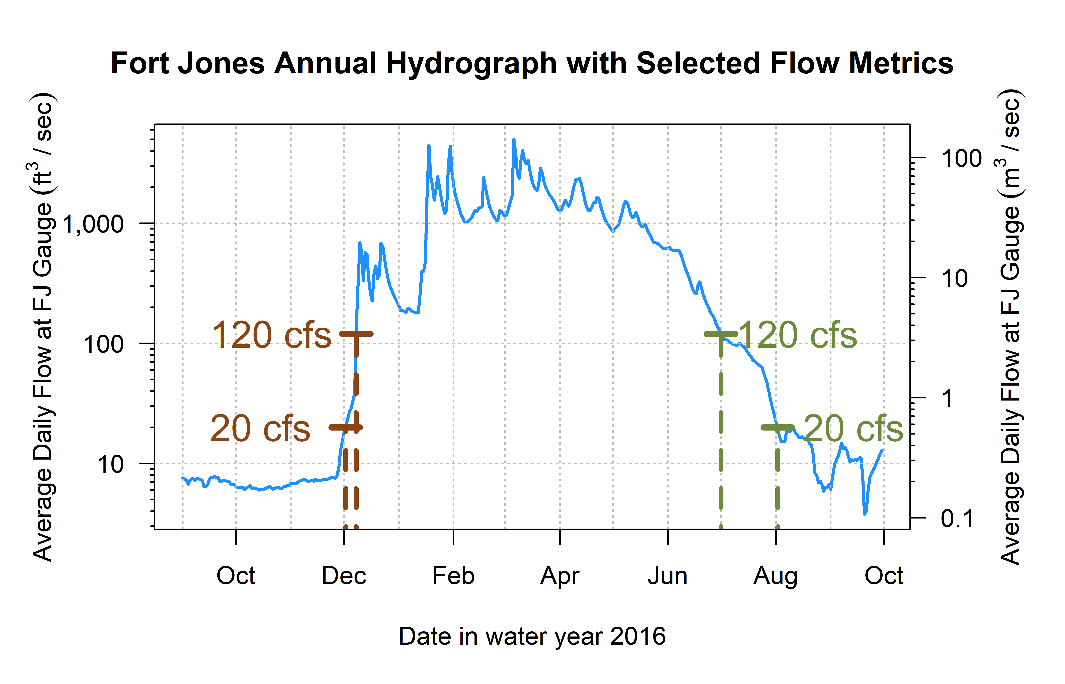
Figure 2: Reconnection and disconnection dates are highlighted for one water year. Two example thresholds, 20 and 120 cfs (0.57 and 3.4 cms, respectively) are highlighted, which correspond to distinct river connectivity (and salmon habitat access) conditions in the Scott River watershed as observed at the Fort Jones gauge (see Results for more detail on selection of flow thresholds).

4.4 Screening Predictors for Collinearity
Table 9: Groups of collinear predictors (absolute value of R greater than 0.7), interpretation of their hydrologic significance, and the predictor selected from each group to reduce collinearity.
ID | Group of Collinear Predictors | Hydrologic Significance (Coho Life Stage) | Predictor Selected from Group
1 | wy1_Mean_Ann_Flow, s1_discon_20, s1_discon_40, s1_discon_120, f2_recon_20, f2_recon_40, w1_Wet_BFL_Mag_10, w1_Wet_BFL_Mag_50, s1_SP_Dur, s1_SP_Mag, wy1_WY_Cat, d2_DS_Tim, d2_DS_Mag_50, d2_DS_Mag_90 | How wet was the wet season? (year 1, as eggs and fry) | w1_Wet_BFL_Mag_50
2 | wy2_Mean_Ann_Flow, s2_discon_120, w2_Wet_BFL_Mag_10, w2_Wet_BFL_Mag_50, s2_SP_Dur, s2_SP_Mag, wy2_WY_Cat | How wet was the wet season? (year 2, as rearing juv.) | w2_Wet_BFL_Mag_50
3 | d1_DS_Tim, f1_recon_20, f1_recon_40, d1_DS_Dur_WS, d1_DS_Mag_50 | How dry was the dry season? (pre-spawning) | d1_DS_Mag_50
4 | w2_Wet_Tim, d2_DS_Dur_WS, f2_FA_Tim, w2_Wet_BFL_Dur | Dry to wet season transition timing (juvenile fish) | w2_Wet_Tim
5 | w1_Wet_BFL_Dur, w1_Wet_Tim, s1_SP_Tim | Dry to wet season transition timing (as eggs and fry) | w1_Wet_Tim
6 | f1_FA_Mag, f1_FA_Dif_num | Fall pulse magnitude (parents' spawning) | f1_FA_Dif_num
7 | f1_FA_Tim, w1_Wet_Tim | Dry to wet season transition timing (parents' spawning or as eggs) | w1_Wet_Tim
8 | f2_FA_Mag, f2_FA_Dif_num | Fall pulse magnitude (rearing juv.) | f2_FA_Dif_num

4.4.1 Groups 1 and 2
These metrics describe the magnitude and timing of wet-season flows (years 1 and 2), as well as (for w1) conditions during the following dry season, which can be summarized by the question, ‘how wet was the wet season?’ We selected median wet season flows w1_Wet_BFL_Mag_50 and w2_Wet_BFL_Mag_50 as the most conceptually central metric to represent the amount of water passing through the watershed. Seasons w1 and w2 are experienced by a coho cohort as eggs and newly-hatched alevin and fry, and as overwintering parr, respectively.

4.4.2 Group 3
These metrics describe the magnitude and timing of dry-season and end-of-dry-season flows before the cohort’s spawning. We selected the dry season median flow, d1_DS_Mag_50, as the most conceptually central metric to represent the amount of water passing through the watershed during the dry season before a cohort’s parents’ spawning.

4.4.3 Groups 4, 5 and 7
These metrics relate to the timing of the transition from dry to wet season in year 2 (Group 4) and year 1 (Groups 5 and 7). We selected w2_Wet_Tim and w1_Wet_Tim, the timing of the wet season onset. In w1 and w2, hydrology is experienced by a cohort of coho as eggs or new hatchlings and overwintering juveniles, respectively.

4.4.4 Groups 6 and 8
These metrics quantify the magnitude of the fall pulse flow (years 1 and 2), with two similar metrics: FA_Mag, with a tighter definition of a fall pulse flow (and missing values for years in which these fall pulse criteria are not met), and FA_Dif_num, with a looser definition (and no missing values). We selected the fall flow increase FA_dif_num (from Baruch et al. 2024) for both f1 and f2.

5 Ecological Data Features

5.1 Sources and methods
Table 10: Description and source information for ecological observations of the two salmonid species of concern.
Obs. ID | Abbrev. | Description | Monitoring Details | Source(s) | Predictor Seasons
A | coho_spawner_abundance | Num. coho spawners (escapement) | Scott River Fish Counting Facility | Knechtle and Guidice 2023, CDFW | d1, f1, w1
B | coho_redds_in_brood | Num. obs. coho redds | Spawning ground surveys | Sources in Section 3.2 | d1, f1, w1, s1
C | coho_smolt_abun_est | Est. num. coho smolt | Rotary Screw Trap | Romero and Robinson, 2023 | d1, f1, w1, s1, d2, f2, w2, s2
D | chinook_spawner_abundance | Num. Chinook spawners (escapement) | Scott River Fish Counting Facility | Knechtle and Guidice 2023, CDFW | d1, f1, w1
E | chinook_spawner_old_method (NOT USED in this analysis) | Num. Chinook spawners (escapement) | Temporary fish marking weir, 1985-1991; capture-recapture method, 1992-2012; video fish counting facility post-2012 | Knechtle and Chesney 2012 | d1, f1, w1
F | chinook_juvenile_abundance | Num. Chinook juveniles | Rotary Screw Trap | Romero and Robinson, 2023 | d1, f1, w1, s1
-- | coho_smolt_per_fem | Coho smolt per fem. spawner | Ratio (C/A) for relevant cohort | Knechtle and Guidice 2023, CDFW | d1, f1, w1, s1, d2, f2, w2, s2
-- | chinook_juv_per_adult | Chinook juv. per adult | Ratio (F/D) for relevant cohort | Knechtle and Guidice 2023, CDFW | d1, f1, w1, s1

5.2 Autocorrelation in ecological records
Autocorrelation, with a lag of 3, is evident in two ecological records: the abundances of coho redds and coho smolt (Figure 3). In other words, the 3-year-lagged record of coho smolt approaches, and for redds exceeds, the 95% confidence interval that it is not random noise.
Interestingly, for coho spawner abundance, although the sign of the autocorrelation is positive at 3 and 6 year lags (which we would expect, reflecting the cohort structure), autocorrelation in the coho spawner record is weaker than in the redd and smolt records.
No significant autocorrelation is evident in the three Chinook data types, and none is observed for coho smolt per female.
## png
## 2
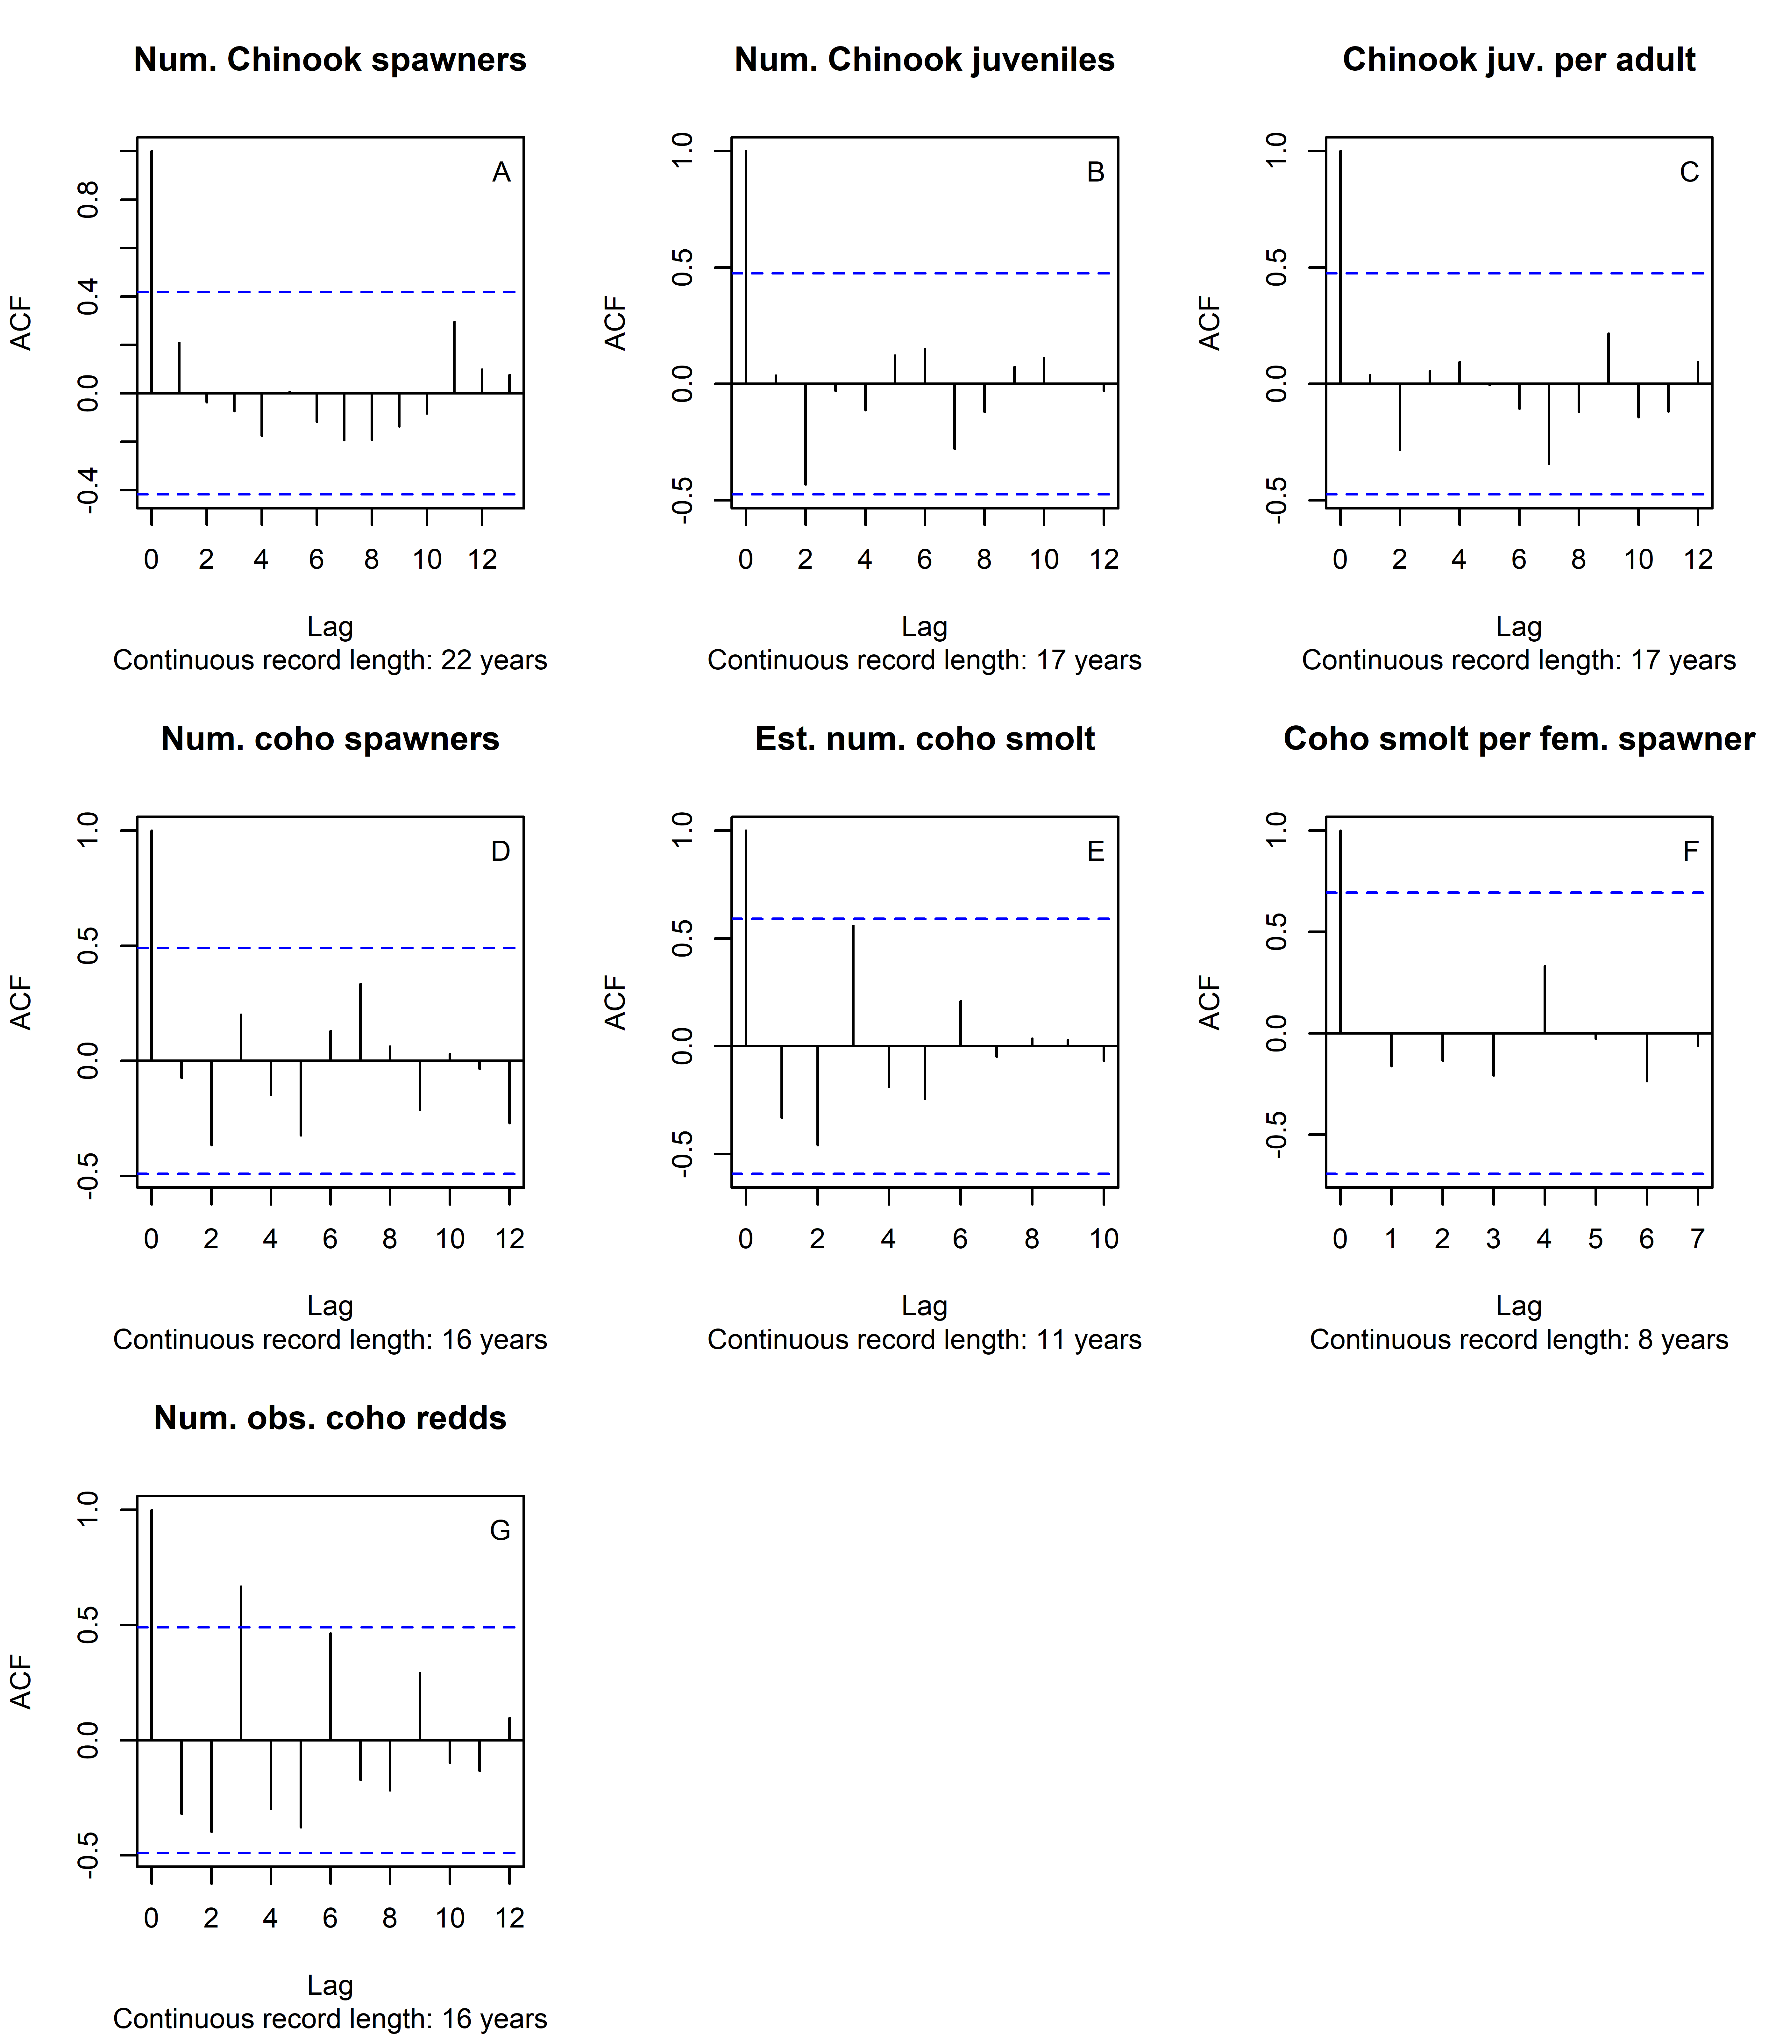
Figure 3: Autocorrelation function estimates for all available ecological outcome records.

6 Data tables: Alignment of predictor and response data
The aligned hydrologic predictor and ecological response data are shown in Tables 11 through 22 below. The first eight columns (Table 11) are composed of ecological responses observed for each brood year. The remaining 72 columns tabulate the functional flow and other hydrologic metrics, covering two years of coho salmon freshwater life stages, associated with each brood year. As discussed in methods, the seasonal abbreviations d1, f1, w1, s1, d2, f2, w2 and s2 indicate the season (first or second dry, fall, wet, or spring) in which or coho salmon cohort would experience the hydrology quantified in a given metric. (Juvenile Chinook salmon experience only one year of freshwater conditions before outmigrating.)

Table 11: Hydrologic metrics and ecological observations aligned by brood year of each salmon cohort, columns 1 through 8 of 80.
brood year | coho smolt per fem | chinook juv per adult | coho spawner abundance | coho redds in brood | coho smolt abun est | chinook spawner abundance | chinook juvenile abundance
1999 |  | 44.9 |  |  |  | 3,584 | 160,906
2000 |  | 100.8 |  |  |  | 6,253 | 630,151
2001 |  | 47.4 |  | 212 |  | 6,142 | 291,207
2002 |  | 29.2 |  | 20 |  | 4,308 | 125,909
2003 |  | 100.5 |  | 6 |  | 12,053 | 1,211,604
2004 |  | 453.6 |  | 960 | 95,815 | 467 | 211,847
2005 |  | 17.6 |  | 31 | 3,931 | 756 | 13,279
2006 |  | 74.7 |  | 14 | 1,142 | 4,960 | 370,622
2007 | 85.2 | 159.4 | 1,622 | 250 | 73,232 | 4,505 | 717,948
2008 | 101.8 | 229.1 | 63 | 24 | 3,257 | 4,673 | 1,070,520
2009 | 8.6 | 435.7 | 81 | 5 | 353 | 2,211 | 963,392
2010 | 98.7 | 64.9 | 907 | 162 | 63,135 | 2,508 | 162,706
2011 | 54.6 | 39.7 | 355 | 26 | 9,283 | 5,521 | 219,304
2012 | 78.3 | 82.1 | 201 | 24 | 6,734 | 9,532 | 782,804
2013 | 5.8 | 106.8 | 2,752 | 354 | 8,758 | 4,624 | 493,721
2014 | 18.8 | 22.8 | 485 | 103 | 3,372 | 12,470 | 284,329
2015 |  | 45.9 | 212 | 60 |  | 2,113 | 97,027
2016 | 83.6 |  | 226 | 95 | 14,628 | 1,515
2017 | 90.3 | 159.4 | 382 |  | 15,705 | 2,576 | 410,688
2018 | 34.7 | 108.6 | 739 |  | 14,628 | 1,279 | 138,947
2019 | 9.0 | 187.4 | 346 | 79 | 1,762 | 2,090 | 391,643
2020 | 77.7 | 266.3 | 1,766 |  |  | 855 | 227,716
2021 |  |  | 852
2022 |  |  | 238

Table 12: Hydrologic metrics and ecological observations aligned by brood year of each salmon cohort, columns 9 through 15 of 80.
brood year | f1 recon 20 | f1 recon 40 | f1 recon 120 | s1 discon 20 | s1 discon 40 | s1 discon 120 | f2 recon 20
1999 | 1 | 1 | 59 | 346 | 337 | 319 | 7
2000 | 7 | 43 | 172 | 292 | 287 | 228 | 83
2001 | 83 | 83 | 83 | 341 | 329 | 306 | 56
2002 | 56 | 69 | 70 | 365 | 362 | 323 | 1
2003 | 1 | 1 | 70 | 341 | 332 | 309 | 29
2004 | 29 | 49 | 98 | 347 | 338 | 317 | 25
2005 | 25 | 55 | 67 | 365 | 357 | 324 | 1
2006 | 1 | 4 | 74 | 334 | 313 | 289 | 46
2007 | 46 | 49 | 49 | 348 | 340 | 313 | 27
2008 | 27 | 52 | 63 | 327 | 314 | 300 | 46
2009 | 46 | 70 | 113 | 365 | 346 | 328 | 1
2010 | 1 | 19 | 54 | 365 | 365 | 343 | 1
2011 | 1 | 1 | 84 | 345 | 337 | 310 | 33
2012 | 33 | 57 | 81 | 323 | 305 | 286 | 30
2013 | 30 | 30 | 164 | 294 | 289 | 256 | 55
2014 | 55 | 55 | 56 | 300 | 294 | 257 | 93
2015 | 93 | 99 | 99 | 337 | 332 | 305 | 42
2016 | 42 | 45 | 46 | 365 | 356 | 326 | 1
2017 | 1 | 3 | 74 | 312 | 299 | 282 | 64
2018 | 64 | 83 | 108 | 340 | 334 | 312 | 15
2019 | 15 | 29 | 99 | 312 | 305 | 294 | 77
2020 | 77 | 108 | 108 | 300 | 296 | 281 | 54
2021 | 54 | 54 | 55 | 333 | 318 | 301 | 84
2022 | 84 | 95 | 116 | 347 | 340 | 316 | 1

Table 13: Hydrologic metrics and ecological observations aligned by brood year of each salmon cohort, columns 16 through 22 of 80.
brood year | f2 recon 40 | f2 recon 120 | s2 discon 120 | d1 DS Dur WS | d1 DS Tim | d1 DS Mag 50 | d1 DS Mag 90
1999 | 43 | 172 | 228 | 100 | 324 | 63.0 | 182.0
2000 | 83 | 83 | 365 | 154 | 308 | 50.0 | 97.0
2001 | 69 | 70 | 365 | 170 | 260 | 5.3 | 16.0
2002 | 1 | 70 | 366 | 137 | 301 | 15.1 | 78.1
2003 | 49 | 98 | 365 | 97 | 329 | 61.4 | 114.6
2004 | 55 | 67 | 365 | 127 | 305 | 25.3 | 95.3
2005 | 4 | 74 | 289 | 109 | 310 | 27.8 | 204.7
2006 | 49 | 49 | 366 | 115 | 321 | 61.9 | 286.0
2007 | 52 | 63 | 300 | 129 | 279 | 12.6 | 91.5
2008 | 70 | 113 | 365 | 86 | 310 | 19.4 | 39.7
2009 | 19 | 54 | 365 | 117 | 286 | 10.6 | 27.6
2010 | 1 | 84 | 366 | 84 | 318 | 47.3 | 316.6
2011 | 57 | 81 | 286 | 124 | 330 | 94.8 | 108.6
2012 | 30 | 164 | 256 | 109 | 306 | 20.5 | 55.0
2013 | 55 | 56 | 257 | 209 | 276 | 46.0 | 56.2
2014 | 99 | 99 | 305 | 156 | 260 | 8.1 | 70.7
2015 | 45 | 46 | 365 | 248 | 221 | 9.4 | 225.4
2016 | 3 | 74 | 282 | 129 | 305 | 18.5 | 527.4
2017 | 83 | 108 | 365 | 95 | 319 | 61.2 | 84.4
2018 | 29 | 99 | 294 | 173 | 268 | 13.4 | 62.4
2019 | 108 | 108 | 281 | 174 | 305 | 53.5 | 134.0
2020 | 54 | 55 | 301 | 158 | 278 | 8.8 | 15.5
2021 | 95 | 116 | 365 | 131 | 268 | 9.3 | 18.1
2022 | 25 | 94 | 366 | 159 | 290 | 9.3 | 45.1

Table 14: Hydrologic metrics and ecological observations aligned by brood year of each salmon cohort, columns 23 through 29 of 80.
brood year | f1 FA Dur | f1 FA Mag | f1 FA Tim | f1 FA Dif num | w1 Wet BFL Dur | w1 Wet BFL Mag 10 | w1 Wet BFL Mag 50
1999 | 5 | 141.0 | 30 | 78.0 | 178 | 209.0 | 1,030.0
2000 |  |  |  | 15.0 | 131 | 99.1 | 177.0
2001 | 4 | 502.0 | 53 | 496.7 | 177 | 410.8 | 638.0
2002 | 15 | 37.5 | 34 | 22.4 | 169 | 633.3 | 1,240.0
2003 | 5 | 99.0 | 29 | 35.1 | 156 | 308.0 | 756.0
2004 | 3 | 103.0 | 25 | 77.0 | 173 | 329.3 | 555.0
2005 | 9 | 488.0 | 38 | 460.2 | 178 | 607.0 | 1,580.0
2006 | 12 | 103.0 | 42 | 39.5 | 106 | 330.6 | 670.0
2007 | 11 | 778.0 | 20 | 764.3 | 199 | 166.6 | 502.5
2008 | 11 | 39.9 | 12 | 19.3 | 200 | 101.0 | 228.0
2009 | 2 | 32.9 | 17 | 21.5 | 220 | 54.4 | 472.0
2010 | 4 | 755.0 | 25 | 707.6 | 235 | 411.5 | 1,025.0
2011 |  |  |  | 36.0 | 140 | 175.0 | 635.0
2012 | 2 | 55.4 | 45 | 34.6 | 171 | 259.1 | 427.0
2013 |  |  |  | 22.2 | 72 | 82.1 | 421.0
2014 | 5 | 192.0 | 26 | 183.8 | 79 | 282.9 | 532.0
2015 | 14 | 692.0 | 71 | 682.5 | 91 | 1,060.0 | 1,560.0
2016 | 7 | 486.0 | 17 | 467.0 | 148 | 813.4 | 1,720.0
2017 | 4 | 114.0 | 42 | 52.6 | 169 | 146.0 | 372.5
2018 | 4 | 108.0 | 61 | 94.5 | 152 | 239.2 | 918.0
2019 | 6 | 273.0 | 69 | 219.0 | 130 | 174.0 | 268.0
2020 | 2 | 35.0 | 47 | 26.1 | 157 | 89.1 | 279.5
2021 | 2 | 501.0 | 25 | 491.6 | 215 | 112.5 | 259.0
2022 | 16 | 40.0 | 62 | 30.6 | 148 | 268.0 | 693.0

Table 15: Hydrologic metrics and ecological observations aligned by brood year of each salmon cohort, columns 30 through 36 of 80.
brood year | w1 Wet Tim | w1 Peak Tim 10 | w1 Peak Tim 2 | w1 Peak Tim 5 | w1 Peak Dur 10 | w1 Peak Dur 2 | w1 Peak Dur 5
1999 | 59
2000 | 97
2001 | 65
2002 | 73 |  | 89.0 |  |  | 2
2003 | 61 |  | 141.0 |  |  | 1
2004 | 67
2005 | 54 | 92 | 83.0 | 92 | 1 | 12 | 1
2006 | 71
2007 | 43
2008 | 31
2009 | 38
2010 | 37
2011 | 89 |  | 183.0 |  |  | 1
2012 | 50 |  | 66.0 |  |  | 1
2013 | 120
2014 | 51 |  | 130.0 | 130 |  | 3 | 1
2015 | 104 |  | 158.0 |  |  | 1
2016 | 69 |  | 104.5 | 133 |  | 8 | 1
2017 | 49
2018 | 76 |  | 191.0 |  |  | 1
2019 | 114
2020 | 71
2021 | 34
2022 | 84

Table 16: Hydrologic metrics and ecological observations aligned by brood year of each salmon cohort, columns 37 through 43 of 80.
brood year | w1 Peak 10 | w1 Peak 2 | w1 Peak 5 | w1 Peak Fre 10 | w1 Peak Fre 2 | w1 Peak Fre 5 | s1 SP ROC
1999 | 13,440 | 4,520 | 10,960 |  |  |  | 0.069
2000 | 13,440 | 4,520 | 10,960 |  |  |  | 0.106
2001 | 13,440 | 4,520 | 10,960 |  |  |  | 0.062
2002 | 13,440 | 4,520 | 10,960 |  | 1 |  | 0.066
2003 | 13,440 | 4,520 | 10,960 |  | 1 |  | 0.065
2004 | 13,440 | 4,520 | 10,960 |  |  |  | 0.072
2005 | 13,440 | 4,520 | 10,960 | 1 | 3 | 1 | 0.060
2006 | 13,440 | 4,520 | 10,960 |  |  |  | 0.056
2007 | 13,440 | 4,520 | 10,960 |  |  |  | 0.050
2008 | 13,440 | 4,520 | 10,960 |  |  |  | 0.070
2009 | 13,440 | 4,520 | 10,960 |  |  |  | 0.069
2010 | 13,440 | 4,520 | 10,960 |  |  |  | 0.056
2011 | 13,440 | 4,520 | 10,960 |  | 1 |  | 0.064
2012 | 13,440 | 4,520 | 10,960 |  | 1 |  | 0.063
2013 | 13,440 | 4,520 | 10,960 |  |  |  | 0.051
2014 | 13,440 | 4,520 | 10,960 |  | 1 | 1 | 0.051
2015 | 13,440 | 4,520 | 10,960 |  | 1 |  | 0.060
2016 | 13,440 | 4,520 | 10,960 |  | 4 | 1 | 0.059
2017 | 13,440 | 4,520 | 10,960 |  |  |  | 0.081
2018 | 13,440 | 4,520 | 10,960 |  | 1 |  | 0.067
2019 | 13,440 | 4,520 | 10,960 |  |  |  | 0.093
2020 | 13,440 | 4,520 | 10,960 |  |  |  | 0.066
2021 | 13,440 | 4,520 | 10,960 |  |  |  | 0.084
2022 | 13,440 | 4,520 | 10,960 |  |  |  | 0.063

Table 17: Hydrologic metrics and ecological observations aligned by brood year of each salmon cohort, columns 44 through 50 of 80.
brood year | s1 SP ROC Max | s1 SP Dur | s1 SP Mag | s1 SP Tim | wy1 Mean Ann Flow | wy1 WY Cat | d2 DS Dur WS
1999 | 0.138 | 71 | 1,770 | 237 | 582 | mod year | 154
2000 | 0.315 | 32 | 1,040 | 228 | 132 | dry year | 170
2001 | 0.134 | 59 | 1,030 | 242 | 411 | mod year | 137
2002 | 0.190 | 87 | 2,300 | 242 | 807 | wet year | 97
2003 | 0.158 | 88 | 1,470 | 217 | 490 | mod year | 127
2004 | 0.181 | 70 | 1,570 | 240 | 436 | mod year | 109
2005 | 0.156 | 89 | 3,600 | 232 | 1,252 | wet year | 115
2006 | 0.142 | 102 | 1,120 | 177 | 410 | mod year | 129
2007 | 0.144 | 68 | 1,340 | 242 | 412 | mod year | 86
2008 | 0.197 | 55 | 1,160 | 231 | 269 | dry year | 117
2009 | 0.148 | 60 | 1,690 | 258 | 463 | mod year | 84
2010 | 0.255 | 58 | 2,310 | 272 | 769 | wet year | 124
2011 | 0.191 | 77 | 1,680 | 229 | 434 | mod year | 109
2012 | 0.133 | 55 | 1,060 | 221 | 327 | dry year | 209
2013 | 0.119 | 68 | 443 | 192 | 170 | dry year | 156
2014 | 0.505 | 91 | 12,800 | 130 | 405 | dry year | 248
2015 | 0.166 | 110 | 2,380 | 195 | 677 | mod year | 129
2016 | 0.247 | 102 | 3,650 | 217 | 1,193 | wet year | 95
2017 | 0.159 | 50 | 606 | 218 | 255 | dry year | 173
2018 | 0.237 | 77 | 2,100 | 228 | 566 | mod year | 174
2019 | 0.146 | 34 | 517 | 244 | 168 | dry year | 158
2020 | 0.149 | 40 | 422 | 228 | 151 | dry year | 131
2021 | 0.215 | 41 | 539 | 249 | 190 | dry year | 159
2022 | 0.181 | 78 | 3,000 | 232 | 513 | mod year | 117

Table 18: Hydrologic metrics and ecological observations aligned by brood year of each salmon cohort, columns 51 through 57 of 80.
brood year | d2 DS Tim | d2 DS Mag 50 | d2 DS Mag 90 | f2 FA Dur | f2 FA Mag | f2 FA Tim | f2 FA Dif num
1999 | 308 | 50.0 | 97.0 |  |  |  | 15.0
2000 | 260 | 5.3 | 16.0 | 4 | 502.0 | 53 | 496.7
2001 | 301 | 15.1 | 78.1 | 15 | 37.5 | 34 | 22.4
2002 | 329 | 61.4 | 114.6 | 5 | 99.0 | 29 | 35.1
2003 | 305 | 25.3 | 95.3 | 3 | 103.0 | 25 | 77.0
2004 | 310 | 27.8 | 204.7 | 9 | 488.0 | 38 | 460.2
2005 | 321 | 61.9 | 286.0 | 12 | 103.0 | 42 | 39.5
2006 | 279 | 12.6 | 91.5 | 11 | 778.0 | 20 | 764.3
2007 | 310 | 19.4 | 39.7 | 11 | 39.9 | 12 | 19.3
2008 | 286 | 10.6 | 27.6 | 2 | 32.9 | 17 | 21.5
2009 | 318 | 47.3 | 316.6 | 4 | 755.0 | 25 | 707.6
2010 | 330 | 94.8 | 108.6 |  |  |  | 36.0
2011 | 306 | 20.5 | 55.0 | 2 | 55.4 | 45 | 34.6
2012 | 276 | 46.0 | 56.2 |  |  |  | 22.2
2013 | 260 | 8.1 | 70.7 | 5 | 192.0 | 26 | 183.8
2014 | 221 | 9.4 | 225.4 | 14 | 692.0 | 71 | 682.5
2015 | 305 | 18.5 | 527.4 | 7 | 486.0 | 17 | 467.0
2016 | 319 | 61.2 | 84.4 | 4 | 114.0 | 42 | 52.6
2017 | 268 | 13.4 | 62.4 | 4 | 108.0 | 61 | 94.5
2018 | 305 | 53.5 | 134.0 | 6 | 273.0 | 69 | 219.0
2019 | 278 | 8.8 | 15.5 | 2 | 35.0 | 47 | 26.1
2020 | 268 | 9.3 | 18.1 | 2 | 501.0 | 25 | 491.6
2021 | 290 | 9.3 | 45.1 | 16 | 40.0 | 62 | 30.6
2022 | 310 | 47.5 | 83.3 | 8 | 83.8 | 40 | 36.2

Table 19: Hydrologic metrics and ecological observations aligned by brood year of each salmon cohort, columns 58 through 64 of 80.
brood year | w2 Wet BFL Dur | w2 Wet BFL Mag 10 | w2 Wet BFL Mag 50 | w2 Wet Tim | w2 Peak Tim 10 | w2 Peak Tim 2 | w2 Peak Tim 5
1999 | 131 | 99.1 | 177.0 | 97
2000 | 177 | 410.8 | 638.0 | 65
2001 | 169 | 633.3 | 1,240.0 | 73 |  | 89.0
2002 | 156 | 308.0 | 756.0 | 61 |  | 141.0
2003 | 173 | 329.3 | 555.0 | 67
2004 | 178 | 607.0 | 1,580.0 | 54 | 92 | 83.0 | 92
2005 | 106 | 330.6 | 670.0 | 71
2006 | 199 | 166.6 | 502.5 | 43
2007 | 200 | 101.0 | 228.0 | 31
2008 | 220 | 54.4 | 472.0 | 38
2009 | 235 | 411.5 | 1,025.0 | 37
2010 | 140 | 175.0 | 635.0 | 89 |  | 183.0
2011 | 171 | 259.1 | 427.0 | 50 |  | 66.0
2012 | 72 | 82.1 | 421.0 | 120
2013 | 79 | 282.9 | 532.0 | 51 |  | 130.0 | 130
2014 | 91 | 1,060.0 | 1,560.0 | 104 |  | 158.0
2015 | 148 | 813.4 | 1,720.0 | 69 |  | 104.5 | 133
2016 | 169 | 146.0 | 372.5 | 49
2017 | 152 | 239.2 | 918.0 | 76 |  | 191.0
2018 | 130 | 174.0 | 268.0 | 114
2019 | 157 | 89.1 | 279.5 | 71
2020 | 215 | 112.5 | 259.0 | 34
2021 | 148 | 268.0 | 693.0 | 84
2022 | 168 | 251.0 | 917.0 | 62

Table 20: Hydrologic metrics and ecological observations aligned by brood year of each salmon cohort, columns 65 through 71 of 80.
brood year | w2 Peak Dur 10 | w2 Peak Dur 2 | w2 Peak Dur 5 | w2 Peak 10 | w2 Peak 2 | w2 Peak 5 | w2 Peak Fre 10
1999 |  |  |  | 13,440 | 4,520 | 10,960
2000 |  |  |  | 13,440 | 4,520 | 10,960
2001 |  | 2 |  | 13,440 | 4,520 | 10,960
2002 |  | 1 |  | 13,440 | 4,520 | 10,960
2003 |  |  |  | 13,440 | 4,520 | 10,960
2004 | 1 | 12 | 1 | 13,440 | 4,520 | 10,960 | 1
2005 |  |  |  | 13,440 | 4,520 | 10,960
2006 |  |  |  | 13,440 | 4,520 | 10,960
2007 |  |  |  | 13,440 | 4,520 | 10,960
2008 |  |  |  | 13,440 | 4,520 | 10,960
2009 |  |  |  | 13,440 | 4,520 | 10,960
2010 |  | 1 |  | 13,440 | 4,520 | 10,960
2011 |  | 1 |  | 13,440 | 4,520 | 10,960
2012 |  |  |  | 13,440 | 4,520 | 10,960
2013 |  | 3 | 1 | 13,440 | 4,520 | 10,960
2014 |  | 1 |  | 13,440 | 4,520 | 10,960
2015 |  | 8 | 1 | 13,440 | 4,520 | 10,960
2016 |  |  |  | 13,440 | 4,520 | 10,960
2017 |  | 1 |  | 13,440 | 4,520 | 10,960
2018 |  |  |  | 13,440 | 4,520 | 10,960
2019 |  |  |  | 13,440 | 4,520 | 10,960
2020 |  |  |  | 13,440 | 4,520 | 10,960
2021 |  |  |  | 13,440 | 4,520 | 10,960
2022 |  |  |  | 13,440 | 4,520 | 10,960

Table 21: Hydrologic metrics and ecological observations aligned by brood year of each salmon cohort, columns 72 through 78 of 80.
brood year | w2 Peak Fre 2 | w2 Peak Fre 5 | s2 SP ROC | s2 SP ROC Max | s2 SP Dur | s2 SP Mag | s2 SP Tim
1999 |  |  | 0.106 | 0.315 | 32 | 1,040 | 228
2000 |  |  | 0.062 | 0.134 | 59 | 1,030 | 242
2001 | 1 |  | 0.066 | 0.190 | 87 | 2,300 | 242
2002 | 1 |  | 0.065 | 0.158 | 88 | 1,470 | 217
2003 |  |  | 0.072 | 0.181 | 70 | 1,570 | 240
2004 | 3 | 1 | 0.060 | 0.156 | 89 | 3,600 | 232
2005 |  |  | 0.056 | 0.142 | 102 | 1,120 | 177
2006 |  |  | 0.050 | 0.144 | 68 | 1,340 | 242
2007 |  |  | 0.070 | 0.197 | 55 | 1,160 | 231
2008 |  |  | 0.069 | 0.148 | 60 | 1,690 | 258
2009 |  |  | 0.056 | 0.255 | 58 | 2,310 | 272
2010 | 1 |  | 0.064 | 0.191 | 77 | 1,680 | 229
2011 | 1 |  | 0.063 | 0.133 | 55 | 1,060 | 221
2012 |  |  | 0.051 | 0.119 | 68 | 443 | 192
2013 | 1 | 1 | 0.051 | 0.505 | 91 | 12,800 | 130
2014 | 1 |  | 0.060 | 0.166 | 110 | 2,380 | 195
2015 | 4 | 1 | 0.059 | 0.247 | 102 | 3,650 | 217
2016 |  |  | 0.081 | 0.159 | 50 | 606 | 218
2017 | 1 |  | 0.067 | 0.237 | 77 | 2,100 | 228
2018 |  |  | 0.093 | 0.146 | 34 | 517 | 244
2019 |  |  | 0.066 | 0.149 | 40 | 422 | 228
2020 |  |  | 0.084 | 0.215 | 41 | 539 | 249
2021 |  |  | 0.063 | 0.181 | 78 | 3,000 | 232
2022 |  |  | 0.063 | 0.121 | 71 | 1,910 | 230

Table 22: Hydrologic metrics and ecological observations aligned by brood year of each salmon cohort, columns 79 through 80 of 80.
brood year | wy2 Mean Ann Flow | wy2 WY Cat
1999 | 132 | dry year
2000 | 411 | mod year
2001 | 807 | wet year
2002 | 490 | mod year
2003 | 436 | mod year
2004 | 1,252 | wet year
2005 | 410 | mod year
2006 | 412 | mod year
2007 | 269 | dry year
2008 | 463 | mod year
2009 | 769 | wet year
2010 | 434 | mod year
2011 | 327 | dry year
2012 | 170 | dry year
2013 | 405 | dry year
2014 | 677 | mod year
2015 | 1,193 | wet year
2016 | 255 | dry year
2017 | 566 | mod year
2018 | 168 | dry year
2019 | 151 | dry year
2020 | 190 | dry year
2021 | 513 | mod year
2022 | 554 | mod year

7 Six statistical modeling structures - method details
LASSO model of juveniles-per-spawner: Cross-validation produced a clear minimum-error $λ$ value for Chinook (Figure 4). For coho, we proposed an alternate lambda value that explained more percent deviance (Figure 4, middle left panel) while retaining a near-minimum test error (Figure 4, top left panel). This produced a model with three non-zero coefficients for both species (Figure 4, lower two panels; Tables 23 and 24)
LASSO model of juvenile abundance, hydrology and spawners: the selected predictors included spawners only for Chinook (Tables 27 and 28).
Lasso model of juvenile abundance, hydrologic metrics only: replicating the approach for the LASSO model of juveniles-per-spawner, we proposed an alternate lambda value for the coho model (Figure 5). Selected predictors for coho were similar to the juvenile abundance, hydrology-plus-spawners LASSO model, while for Chinook, the minimum-error model selected only one predictor (Tables 25 and 26).
MARSS models of juveniles-per-spawner, single hydrologic covariate: hydrology order of importance is taken from the small-sample-size-corrected Akaike Information Criterion (AICc), i.e., the lower the AICc, the better the prediction based on that hydrologic metric (Tables 29 and 30).
MARSS models of juveniles abundance, single hydrologic covariate: hydrology order of importance interpreted as described above (Tables 29 and 30); this is used to test the utility of adding spawners as a covariate.
MARSS models of juvenile abundance, two covariates: This model structure calculates a coefficient value for spawners and for any single hydrologic metric (Tables 33 and 34). For the four best models, hydrology coefficients are equal to or greater than coefficients for spawners. For worse, higher-AICc models, spawner influence grows to be much greater than the hydrology.
MARSS models tended to perform better at predicting coho than Chinook (Figures 7, 8, and 9, possibly because Chinook records did not contain significant autocorrelation (Figure 3).

8 LASSO regression
LASSO (Least Absolute Shrinkage and Selection Operator) regression minimizes the following quantity:
$$\sum_{i=1}^{n}{{\left(y_{i}−β_{0}−\sum_{j=1}^{p}{β_{j}x_{ij}}\right)}^{2}}+λ\sum_{j=1}^{p}{\left|β_{j}\right|}$$
Where:
- $n$ is the number of ecological observations;
- $i$ enumerates the brood years;
- $p$ is the number of predictors;
- $j$ enumerates the hydrologic predictors;
- $x_{ij}$ is the observed value of hydrologic predictor $j$ for brood year $i$ (independent variable);
- $y_{i}$ is the observed value of ecological response in the salmon cohort with brood year $i$ (dependent variable);
- $β_{0}$ is the intercept value for the resulting linear model;
- $β_{j}$ is the coefficient value for hydrologic predictor $j$ in the resulting linear model; and
- $λ$ is a tuning parameter, referred to as a shrinkage penalty.
In this formulation, sufficiently large values of lambda generally shrink the values of all coefficients to 0 (the infinite-lambda case). The infinite-lambda case produces a model consisting solely of the $β_{0}$ intercept term, which takes on a value that is the average of all the observed $y$ values. Conversely, sufficiently small values of $λ$ will produce linear models incorporating information from many predictors. The selection of the appropriate $λ$ value is a critical step in the regression procedure, and is best done using cross-validation within the training dataset (James et al. 2013).

8.1 LASSO results: juveniles-per-spawner based on hydrologic metrics
For purposes of statistical model comparison, we predicted the ratio of juveniles per spawner for coho and Chinook based on a predictor set that included only Z-scored hydrologic metrics.
## png
## 2
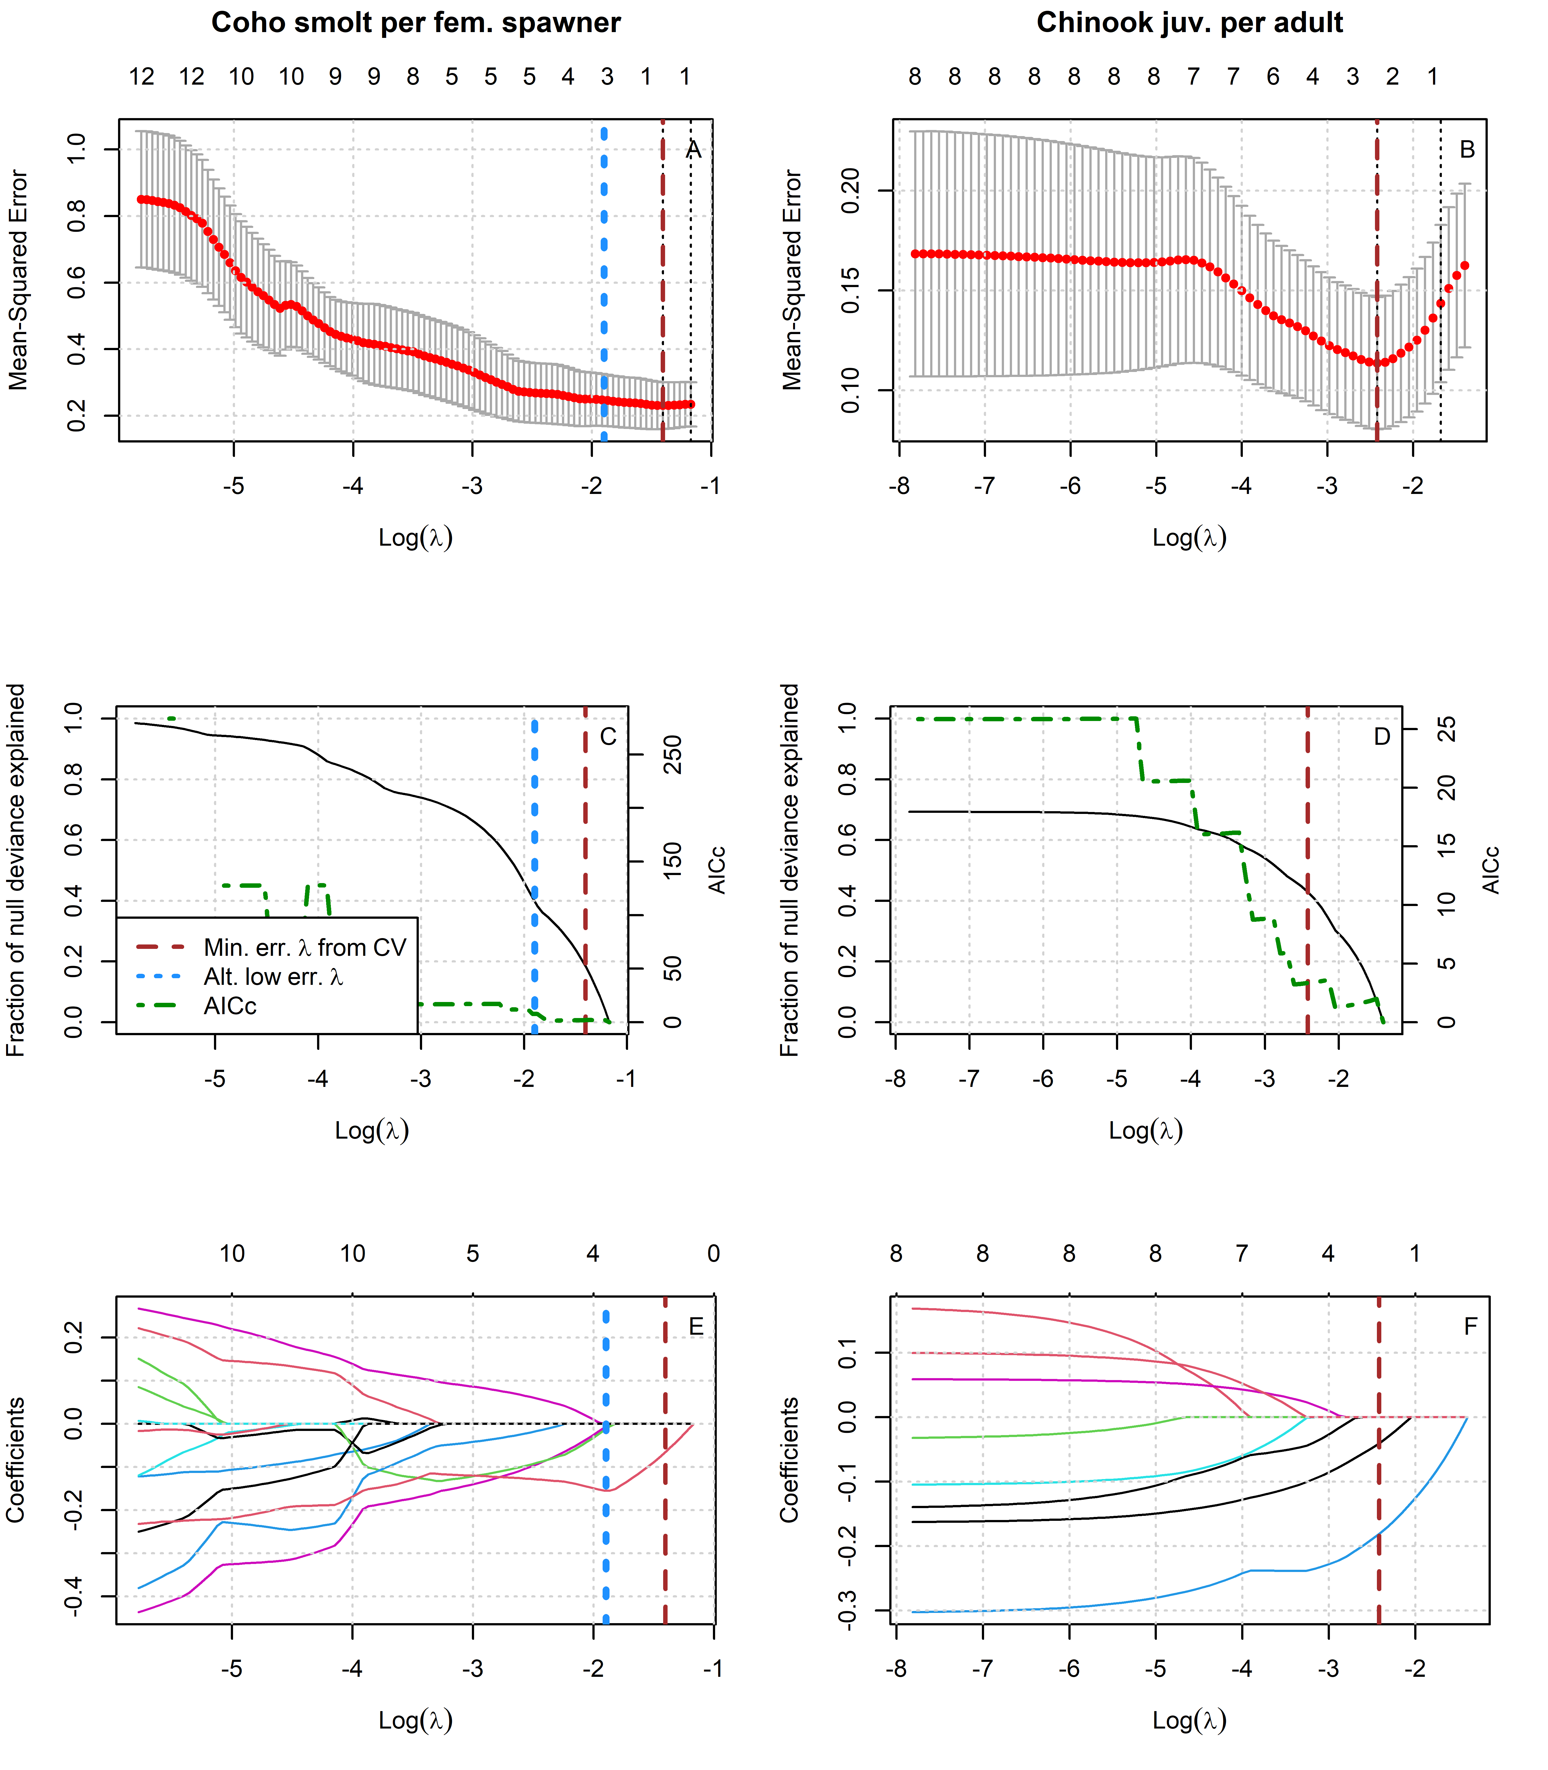
Figure 4: Results of lasso regression to predict log-transformed coho and Chinook outcomes with Z-scored hydrologic metrics. Models with more coefficients explain a greater fraction of deviance in the dataset (middle panel), but also produce higher test errors (top panel), indicating some overfitting at lower lambda values. Higher values of lambda tend to shrink the absolute values of regression coefficients toward 0 (bottom panel).
Table 23: Values for the intercept and coefficient terms in the Hydrologic Benefit function for estimated coho spf based on hydrology only, including a description of which phenomena are associated with higher ecological outcome values.
Predictor | Value | Greater Hydrologic Benefit value associated with
 | 1.592 | (Intercept)
f1_recon_120 | -0.155 | Earlier fall reconnection (during parents' spawning)
f2_FA_Dif_num | -0.012 | Smaller fall pulse (as juvenile fish)
w1_Wet_Tim | -0.007 | Earlier wet season onset (as eggs and fry)
Table 24: Values for the intercept and coefficient terms in the Hydrologic Benefit function for estimatedChinook jpa based on hydrology only, including a description of which hydrologic phenomena are associated with higher ecological outcome values.
Predictor | Value | Greater Hydrologic Benefit value associated with
 | 1.944 | (Intercept)
w1_Wet_BFL_Mag_50 | -0.181 | Smaller wet season baseflows (as eggs and hatchlings)
s1_SP_ROC_Max | -0.041 | Slower max. rate of change, spring recession (as outmigrating smolt)

8.2 LASSO results: juvenile abundance on hydrologic metrics only
For purposes of statistical model comparison, we predicted juvenile abundance of coho and Chinook based on a predictor set that included only Z-scored hydrologic metrics.
## png
## 2
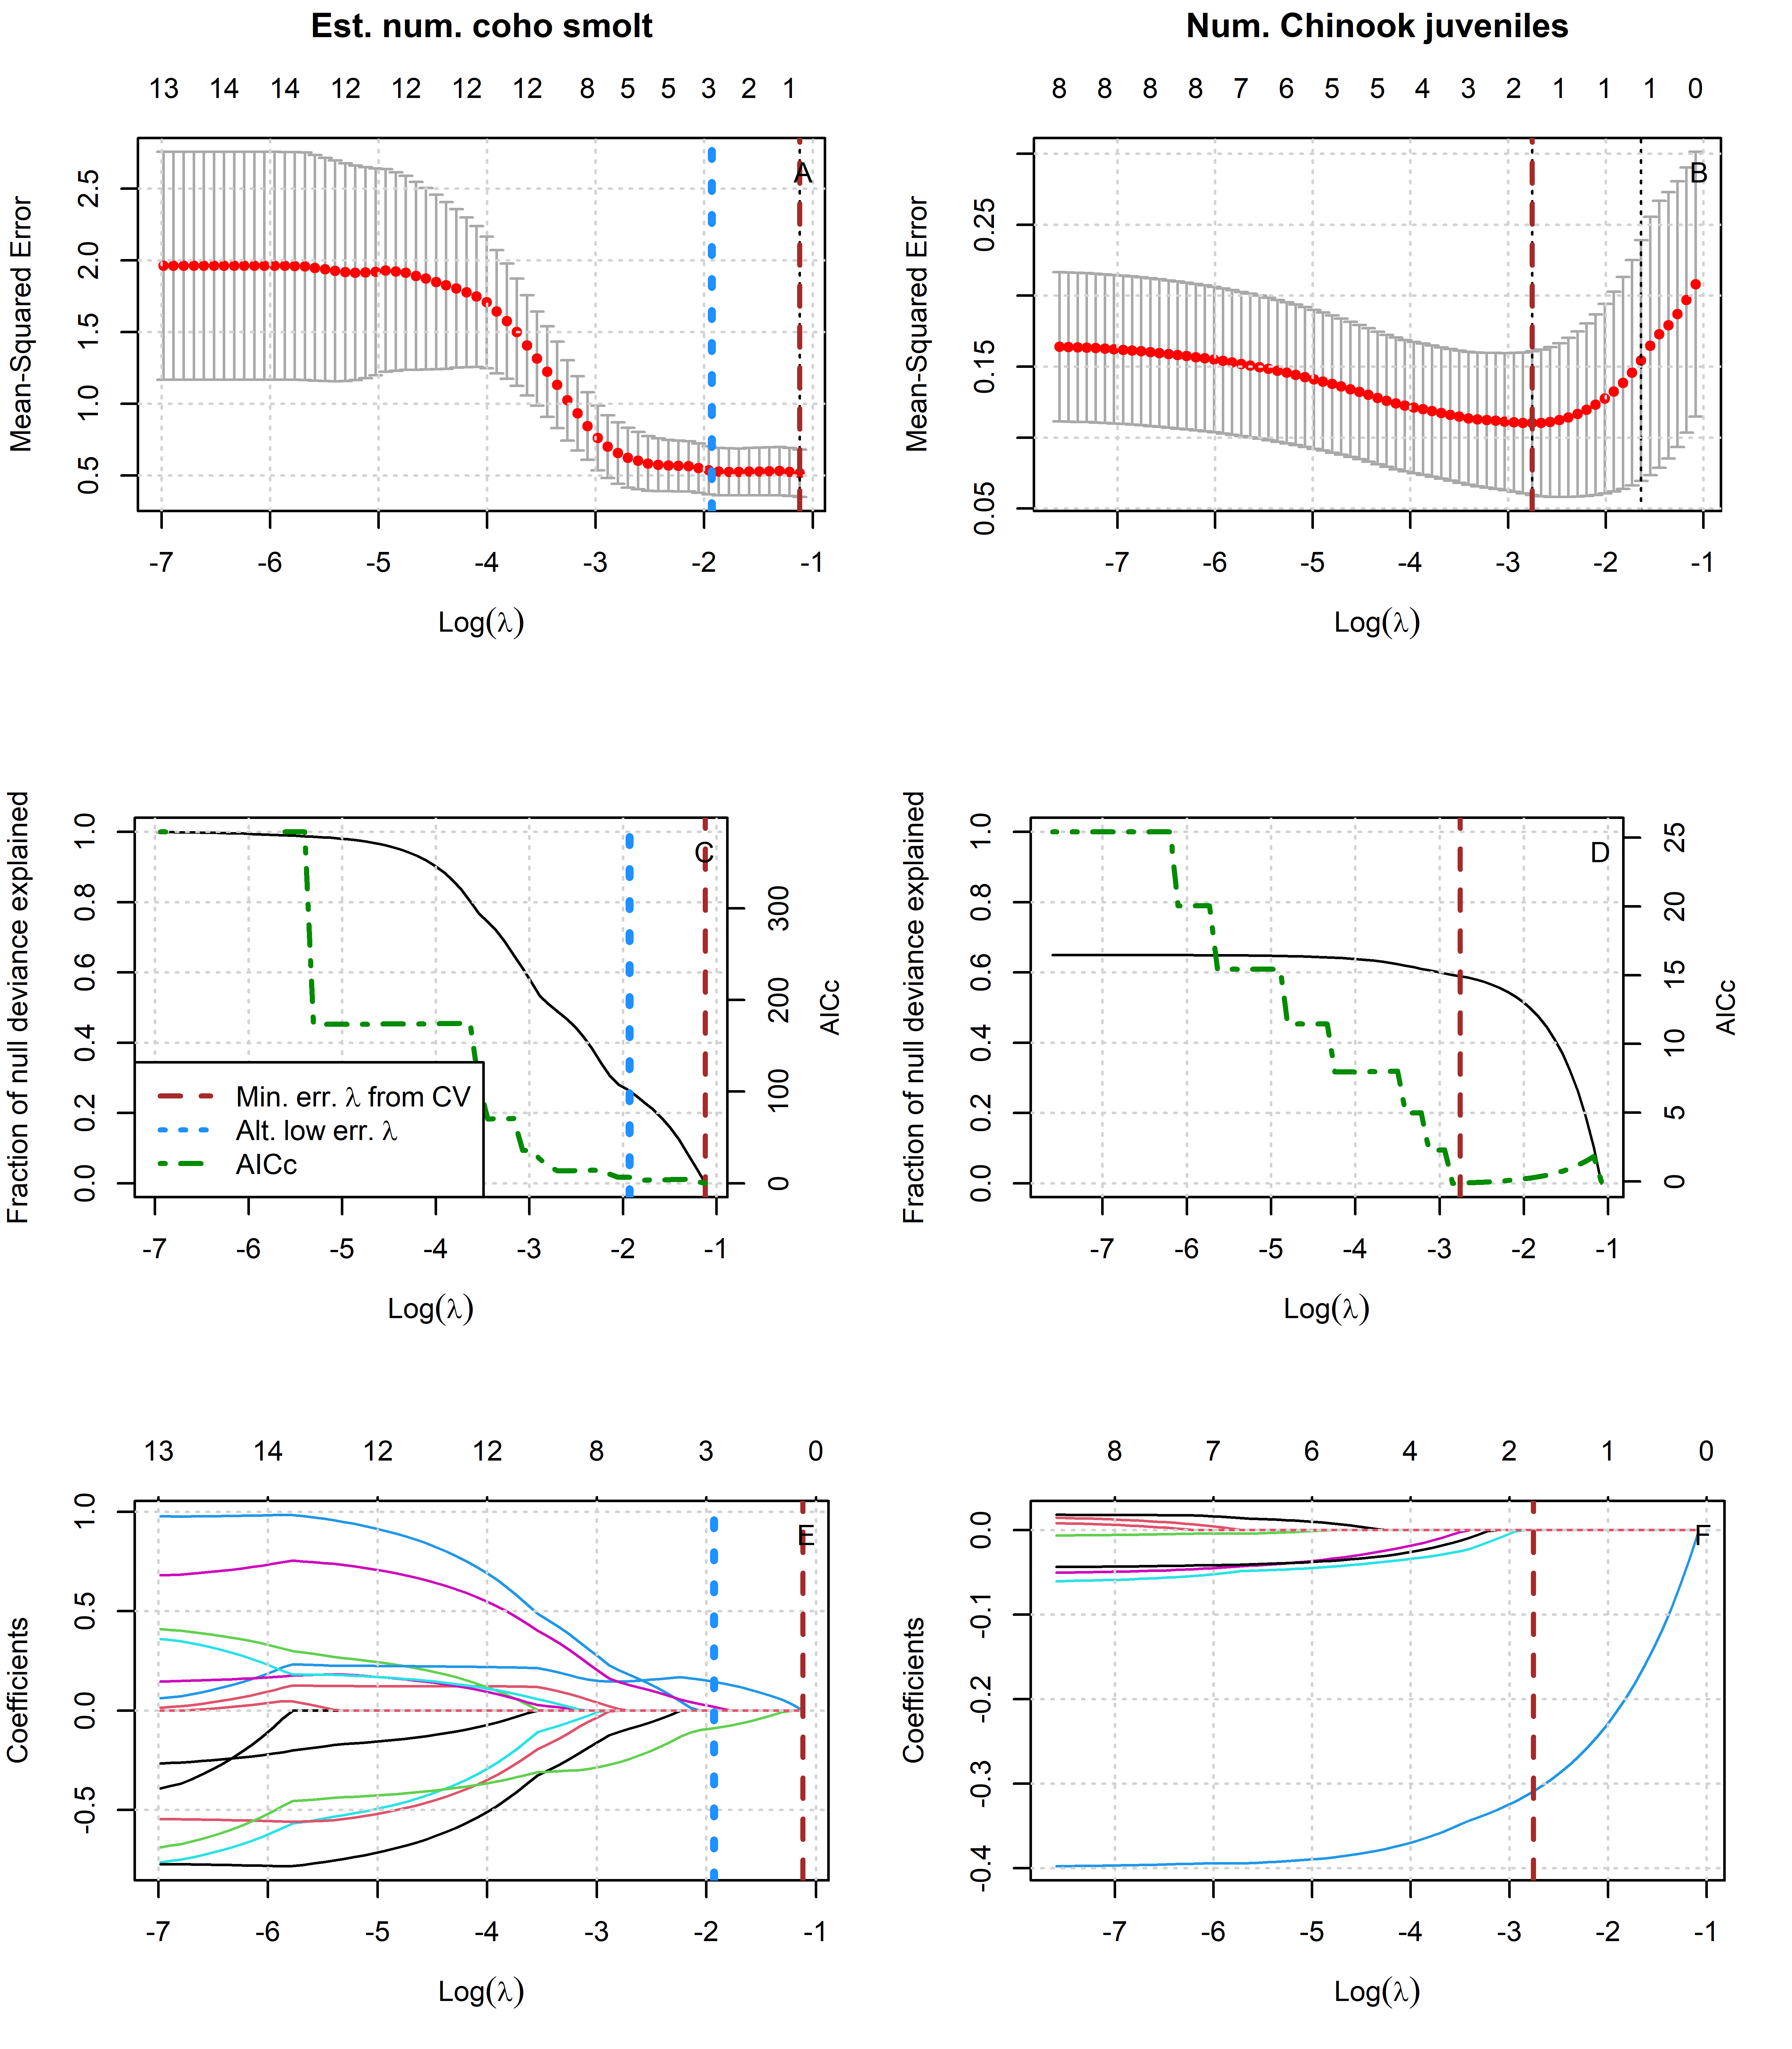
Figure 5: Results of lasso regression to predict log-transformed coho and Chinook outcomes with Z-scored hydrologic metrics. Models with more coefficients explain a greater fraction of deviance in the dataset (middle panel), but also produce higher test errors (top panel), indicating some overfitting at lower lambda values. Higher values of lambda tend to shrink the absolute values of regression coefficients toward 0 (bottom panel).
Table 25: Values for the intercept and coefficient terms in the Hydrologic Benefit function for estimated coho smolt abundance based on hydrology only, including a description of which phenomena are associated with higher ecological outcome values.
Predictor | Value | Greater Hydrologic Benefit value associated with
 | 3.901 | (Intercept)
f1_FA_Dif_num | 0.145 | Larger fall flow increase (during parents' spawning)
f2_FA_Dif_num | -0.088 | Smaller fall flow increase (as juvenile fish)
s2_SP_ROC | 0.019 | Faster rate of change, spring recession (as outmigrating smolt)
Table 26: Values for the intercept and coefficient terms in the Hydrologic Benefit function for estimatedChinook juv. abundance based on hydrology only, including a description of which hydrologic phenomena are associated with higher ecological outcome values.
Predictor | Value | Greater Hydrologic Benefit value associated with
 | 5.450 | (Intercept)
w1_Wet_BFL_Mag_50 | -0.309 | Lower wet season baseflows (as eggs and hatchlings)

8.3 LASSO results: juvenile abundance on hydrologic metrics and spawner abundance
For purposes of statistical model comparison, we predicted juvenile abundance of coho and Chinook based on a predictor set that included Z-scored hydrologic metrics as well as Z-scored spawner abundances.
## png
## 2
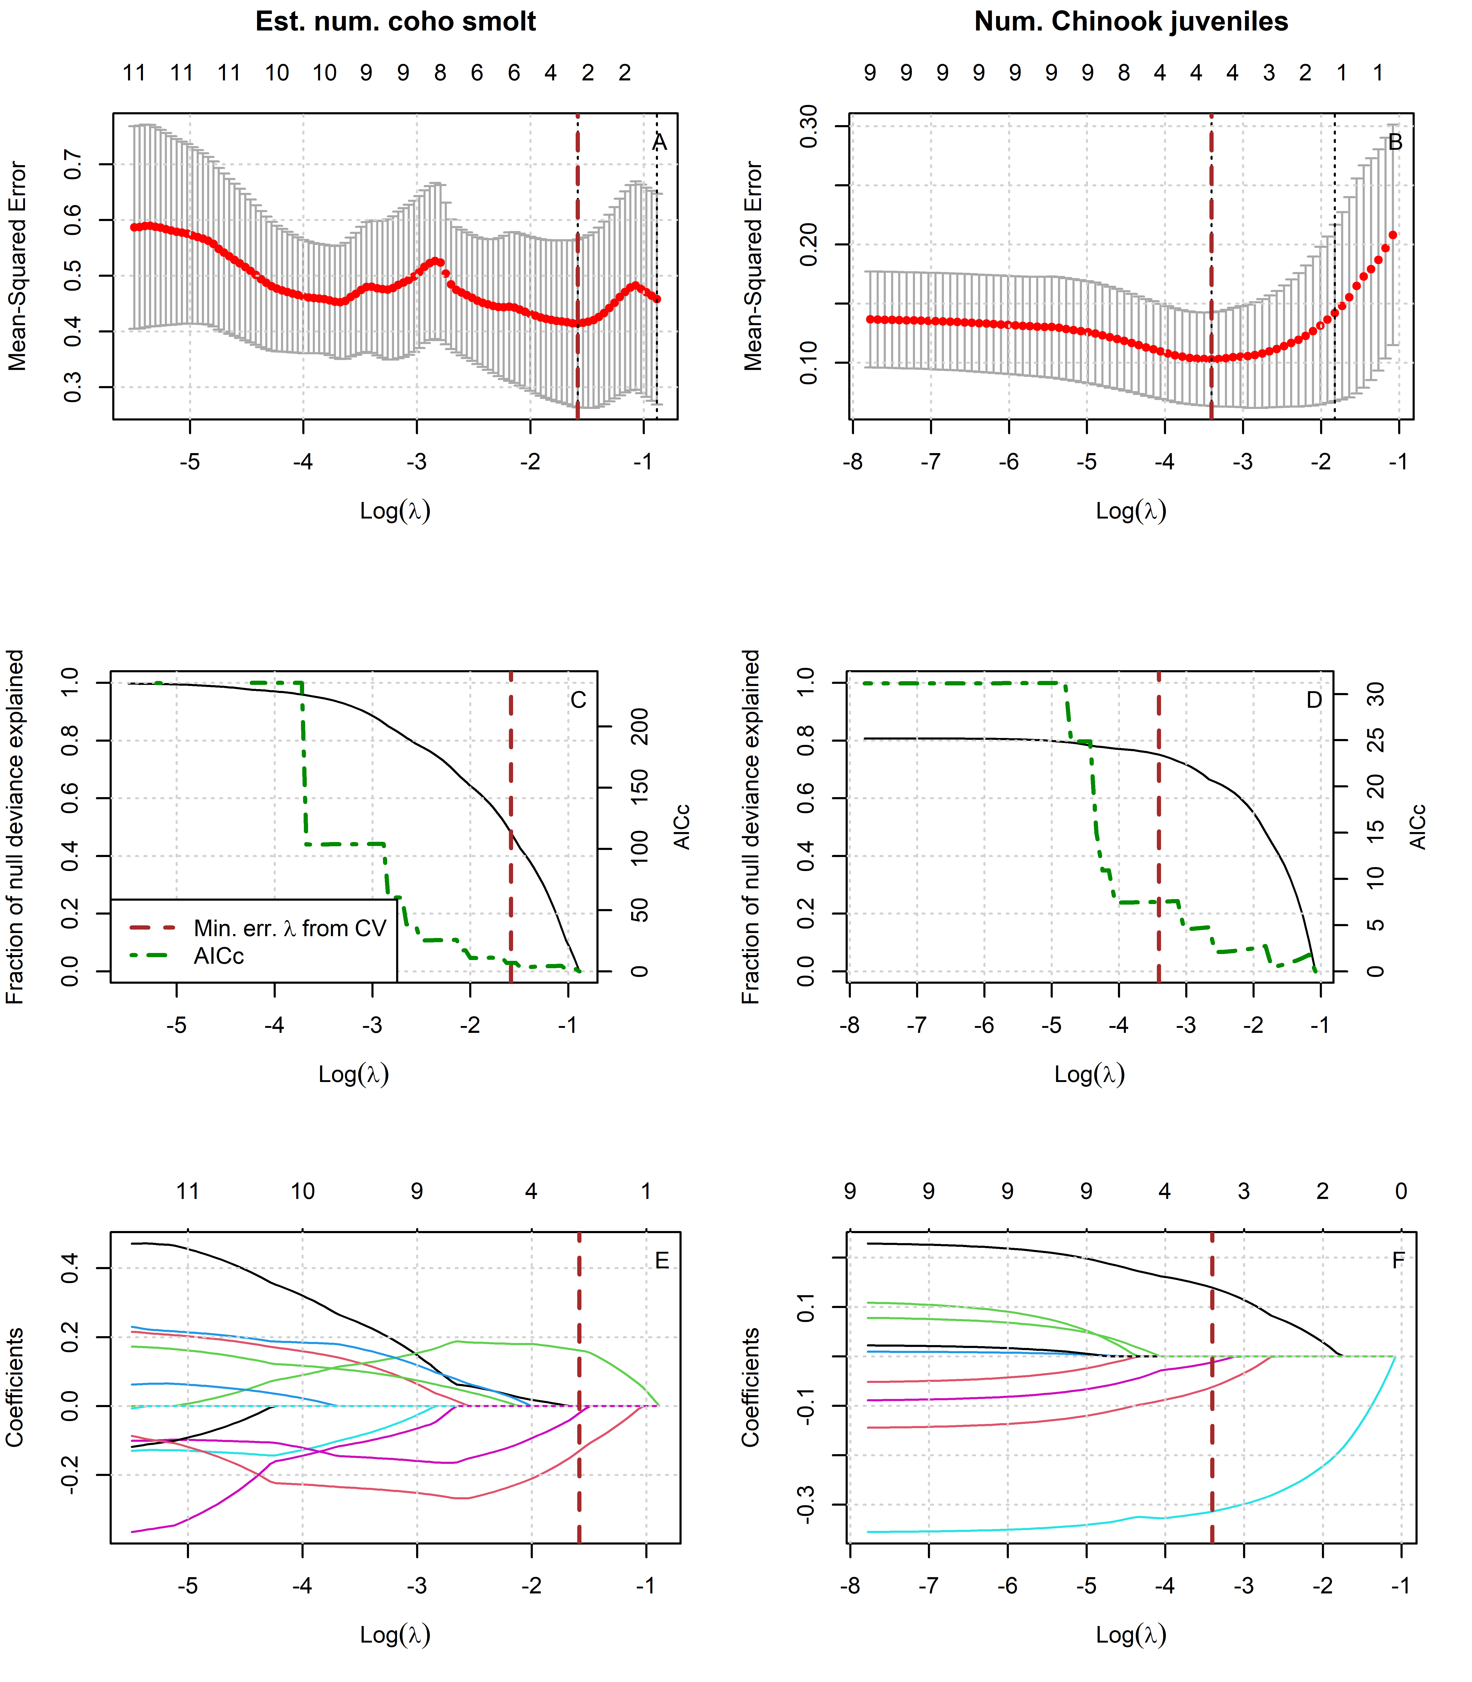
Figure 6: Results of lasso regression to predict log-transformed coho and Chinook outcomes with Z-scored hydrologic metrics and spawner abundance.
Table 27: Values for the intercept and coefficient terms in the Hydrologic Benefit function for estimated coho smolt abundance based on hydrologic metrics and spawner abundance, including a description of which phenomena are associated with higher ecological outcome values.
Predictor | Value | Greater Hydrologic Benefit value associated with
 | 3.872 | (Intercept)
f1_FA_Dif_num | 0.162 | Larger fall flow increase (during parents' spawning)
f2_FA_Dif_num | -0.130 | Smaller fall flow increase (as juvenile fish)
s1_SP_ROC | -0.020 | Slower rate of change, spring recession (as recent hatchlings)
Table 28: Values for the intercept and coefficient terms in the Hydrologic Benefit function for estimatedChinook juv. abundance based on hydrologic metrics and spawner abundance, including a description of which hydrologic phenomena are associated with higher ecological outcome values.
Predictor | Value | Greater Hydrologic Benefit value associated with
 | 5.442 | (Intercept)
w1_Wet_BFL_Mag_50 | -0.314 | Lower wet season baseflows (as eggs and hatchlings)
chinook_spawners_zscored | 0.139 | Abundance of spawners (parents of designated cohort)
s1_SP_ROC_Max | -0.062 | Slower max. rate of change, spring recession (as outmigrating smolt)
w1_Wet_Tim | -0.012 | Earlier wet season onset (as eggs and hatchlings)

9 MARSS Models

9.1 MARSS models of juveniles per spawner, single hydrologic covariate
For purposes of statistical model comparison, we calculated multiple MARSS models (15 for coho and 8 for Chinook) that predicted the observed ratio of juveniles-per-spawner for coho and Chinook based on a single Z-scored hydrologic metric.
## Success! abstol and log-log tests passed at 59 iterations.
## Alert: conv.test.slope.tol is 0.5.
## Test with smaller values (<0.1) to ensure convergence.
##
## MARSS fit is
## Estimation method: kem
## Convergence test: conv.test.slope.tol = 0.5, abstol = 0.001
## Estimation converged in 59 iterations.
## Log-likelihood: -7.969089
## AIC: 23.93818 AICc: 26.29112
##
## Estimate
## R.r 0.09146
## Q.Q 0.00886
## x0.x0 3.35438
## C.ScottR 0.19118
## Initial states (x0) defined at t=0
##
## Standard errors have not been calculated.
## Use MARSSparamCIs to compute CIs and bias estimates.
##
## Success! abstol and log-log tests passed at 279 iterations.
## Alert: conv.test.slope.tol is 0.5.
## Test with smaller values (<0.1) to ensure convergence.
##
## MARSS fit is
## Estimation method: kem
## Convergence test: conv.test.slope.tol = 0.5, abstol = 0.001
## Estimation converged in 279 iterations.
## Log-likelihood: -8.492405
## AIC: 24.98481 AICc: 27.33775
##
## Estimate
## R.r 0.1267
## Q.Q 0.0000
## x0.x0 3.5251
## C.ScottR -0.0828
## Initial states (x0) defined at t=0
##
## Standard errors have not been calculated.
## Use MARSSparamCIs to compute CIs and bias estimates.
##
## Success! abstol and log-log tests passed at 384 iterations.
## Alert: conv.test.slope.tol is 0.5.
## Test with smaller values (<0.1) to ensure convergence.
##
## MARSS fit is
## Estimation method: kem
## Convergence test: conv.test.slope.tol = 0.5, abstol = 0.001
## Estimation converged in 384 iterations.
## Log-likelihood: -9.192339
## AIC: 26.38468 AICc: 28.73762
##
## Estimate
## R.r 0.135
## Q.Q 0.000
## x0.x0 3.465
## C.ScottR -0.065
## Initial states (x0) defined at t=0
##
## Standard errors have not been calculated.
## Use MARSSparamCIs to compute CIs and bias estimates.
##
## Success! abstol and log-log tests passed at 208 iterations.
## Alert: conv.test.slope.tol is 0.5.
## Test with smaller values (<0.1) to ensure convergence.
##
## MARSS fit is
## Estimation method: kem
## Convergence test: conv.test.slope.tol = 0.5, abstol = 0.001
## Estimation converged in 208 iterations.
## Log-likelihood: -6.352019
## AIC: 20.70404 AICc: 23.05698
##
## Estimate
## R.r 0.104
## Q.Q 0.000
## x0.x0 3.653
## C.ScottR -0.161
## Initial states (x0) defined at t=0
##
## Standard errors have not been calculated.
## Use MARSSparamCIs to compute CIs and bias estimates.
##
## Success! abstol and log-log tests passed at 765 iterations.
## Alert: conv.test.slope.tol is 0.5.
## Test with smaller values (<0.1) to ensure convergence.
##
## MARSS fit is
## Estimation method: kem
## Convergence test: conv.test.slope.tol = 0.5, abstol = 0.001
## Estimation converged in 765 iterations.
## Log-likelihood: -8.911139
## AIC: 25.82228 AICc: 28.17522
##
## Estimate
## R.r 0.1316
## Q.Q 0.0000
## x0.x0 3.4481
## C.ScottR -0.0492
## Initial states (x0) defined at t=0
##
## Standard errors have not been calculated.
## Use MARSSparamCIs to compute CIs and bias estimates.
##
## Success! abstol and log-log tests passed at 601 iterations.
## Alert: conv.test.slope.tol is 0.5.
## Test with smaller values (<0.1) to ensure convergence.
##
## MARSS fit is
## Estimation method: kem
## Convergence test: conv.test.slope.tol = 0.5, abstol = 0.001
## Estimation converged in 601 iterations.
## Log-likelihood: -9.472243
## AIC: 26.94449 AICc: 29.29743
##
## Estimate
## R.r 0.1385
## Q.Q 0.0000
## x0.x0 3.4926
## C.ScottR -0.0112
## Initial states (x0) defined at t=0
##
## Standard errors have not been calculated.
## Use MARSSparamCIs to compute CIs and bias estimates.
##
## Success! abstol and log-log tests passed at 316 iterations.
## Alert: conv.test.slope.tol is 0.5.
## Test with smaller values (<0.1) to ensure convergence.
##
## MARSS fit is
## Estimation method: kem
## Convergence test: conv.test.slope.tol = 0.5, abstol = 0.001
## Estimation converged in 316 iterations.
## Log-likelihood: -11.92755
## AIC: 31.8551 AICc: 34.3551
##
## Estimate
## R.r 0.1823
## Q.Q 0.0000
## x0.x0 5.3042
## C.ScottR 0.0887
## Initial states (x0) defined at t=0
##
## Standard errors have not been calculated.
## Use MARSSparamCIs to compute CIs and bias estimates.
##
## Success! abstol and log-log tests passed at 299 iterations.
## Alert: conv.test.slope.tol is 0.5.
## Test with smaller values (<0.1) to ensure convergence.
##
## MARSS fit is
## Estimation method: kem
## Convergence test: conv.test.slope.tol = 0.5, abstol = 0.001
## Estimation converged in 299 iterations.
## Log-likelihood: -12.28761
## AIC: 32.57521 AICc: 35.07521
##
## Estimate
## R.r 0.18869
## Q.Q 0.00000
## x0.x0 5.46926
## C.ScottR -0.00591
## Initial states (x0) defined at t=0
##
## Standard errors have not been calculated.
## Use MARSSparamCIs to compute CIs and bias estimates.
##
## Success! abstol and log-log tests passed at 315 iterations.
## Alert: conv.test.slope.tol is 0.5.
## Test with smaller values (<0.1) to ensure convergence.
##
## MARSS fit is
## Estimation method: kem
## Convergence test: conv.test.slope.tol = 0.5, abstol = 0.001
## Estimation converged in 315 iterations.
## Log-likelihood: -12.17525
## AIC: 32.35051 AICc: 34.85051
##
## Estimate
## R.r 0.1867
## Q.Q 0.0000
## x0.x0 5.4377
## C.ScottR -0.0531
## Initial states (x0) defined at t=0
##
## Standard errors have not been calculated.
## Use MARSSparamCIs to compute CIs and bias estimates.
##
## Success! abstol and log-log tests passed at 300 iterations.
## Alert: conv.test.slope.tol is 0.5.
## Test with smaller values (<0.1) to ensure convergence.
##
## MARSS fit is
## Estimation method: kem
## Convergence test: conv.test.slope.tol = 0.5, abstol = 0.001
## Estimation converged in 300 iterations.
## Log-likelihood: -11.07278
## AIC: 30.14555 AICc: 32.64555
##
## Estimate
## R.r 0.168
## Q.Q 0.000
## x0.x0 5.584
## C.ScottR -0.135
## Initial states (x0) defined at t=0
##
## Standard errors have not been calculated.
## Use MARSSparamCIs to compute CIs and bias estimates.
##
## Success! abstol and log-log tests passed at 284 iterations.
## Alert: conv.test.slope.tol is 0.5.
## Test with smaller values (<0.1) to ensure convergence.
##
## MARSS fit is
## Estimation method: kem
## Convergence test: conv.test.slope.tol = 0.5, abstol = 0.001
## Estimation converged in 284 iterations.
## Log-likelihood: -11.96788
## AIC: 31.93575 AICc: 34.43575
##
## Estimate
## R.r 0.1830
## Q.Q 0.0000
## x0.x0 5.4256
## C.ScottR -0.0432
## Initial states (x0) defined at t=0
##
## Standard errors have not been calculated.
## Use MARSSparamCIs to compute CIs and bias estimates.
##
## Success! abstol and log-log tests passed at 307 iterations.
## Alert: conv.test.slope.tol is 0.5.
## Test with smaller values (<0.1) to ensure convergence.
##
## MARSS fit is
## Estimation method: kem
## Convergence test: conv.test.slope.tol = 0.5, abstol = 0.001
## Estimation converged in 307 iterations.
## Log-likelihood: -12.27941
## AIC: 32.55882 AICc: 35.05882
##
## Estimate
## R.r 0.18855
## Q.Q 0.00000
## x0.x0 5.46661
## C.ScottR 0.00668
## Initial states (x0) defined at t=0
##
## Standard errors have not been calculated.
## Use MARSSparamCIs to compute CIs and bias estimates.
##
## Success! abstol and log-log tests passed at 266 iterations.
## Alert: conv.test.slope.tol is 0.5.
## Test with smaller values (<0.1) to ensure convergence.
##
## MARSS fit is
## Estimation method: kem
## Convergence test: conv.test.slope.tol = 0.5, abstol = 0.001
## Estimation converged in 266 iterations.
## Log-likelihood: -11.30741
## AIC: 30.61483 AICc: 33.11483
##
## Estimate
## R.r 0.172
## Q.Q 0.000
## x0.x0 5.384
## C.ScottR -0.106
## Initial states (x0) defined at t=0
##
## Standard errors have not been calculated.
## Use MARSSparamCIs to compute CIs and bias estimates.
##
## Success! abstol and log-log tests passed at 291 iterations.
## Alert: conv.test.slope.tol is 0.5.
## Test with smaller values (<0.1) to ensure convergence.
##
## MARSS fit is
## Estimation method: kem
## Convergence test: conv.test.slope.tol = 0.5, abstol = 0.001
## Estimation converged in 291 iterations.
## Log-likelihood: -11.99751
## AIC: 31.99502 AICc: 34.49502
##
## Estimate
## R.r 0.1836
## Q.Q 0.0000
## x0.x0 5.4495
## C.ScottR -0.0619
## Initial states (x0) defined at t=0
##
## Standard errors have not been calculated.
## Use MARSSparamCIs to compute CIs and bias estimates.
##
## Success! abstol and log-log tests passed at 416 iterations.
## Alert: conv.test.slope.tol is 0.5.
## Test with smaller values (<0.1) to ensure convergence.
##
## MARSS fit is
## Estimation method: kem
## Convergence test: conv.test.slope.tol = 0.5, abstol = 0.001
## Estimation converged in 416 iterations.
## Log-likelihood: -9.610803
## AIC: 27.22161 AICc: 29.72161
##
## Estimate
## R.r 0.1462
## Q.Q 0.0000
## x0.x0 2.0294
## C.ScottR -0.0393
## Initial states (x0) defined at t=0
##
## Standard errors have not been calculated.
## Use MARSSparamCIs to compute CIs and bias estimates.
##
## Success! abstol and log-log tests passed at 287 iterations.
## Alert: conv.test.slope.tol is 0.5.
## Test with smaller values (<0.1) to ensure convergence.
##
## MARSS fit is
## Estimation method: kem
## Convergence test: conv.test.slope.tol = 0.5, abstol = 0.001
## Estimation converged in 287 iterations.
## Log-likelihood: -9.204387
## AIC: 26.40877 AICc: 28.90877
##
## Estimate
## R.r 0.1407
## Q.Q 0.0000
## x0.x0 1.9419
## C.ScottR 0.0688
## Initial states (x0) defined at t=0
##
## Standard errors have not been calculated.
## Use MARSSparamCIs to compute CIs and bias estimates.
##
## Success! abstol and log-log tests passed at 452 iterations.
## Alert: conv.test.slope.tol is 0.5.
## Test with smaller values (<0.1) to ensure convergence.
##
## MARSS fit is
## Estimation method: kem
## Convergence test: conv.test.slope.tol = 0.5, abstol = 0.001
## Estimation converged in 452 iterations.
## Log-likelihood: -9.689252
## AIC: 27.3785 AICc: 29.8785
##
## Estimate
## R.r 0.1473
## Q.Q 0.0000
## x0.x0 1.9491
## C.ScottR -0.0129
## Initial states (x0) defined at t=0
##
## Standard errors have not been calculated.
## Use MARSSparamCIs to compute CIs and bias estimates.
##
## Success! abstol and log-log tests passed at 370 iterations.
## Alert: conv.test.slope.tol is 0.5.
## Test with smaller values (<0.1) to ensure convergence.
##
## MARSS fit is
## Estimation method: kem
## Convergence test: conv.test.slope.tol = 0.5, abstol = 0.001
## Estimation converged in 370 iterations.
## Log-likelihood: -9.620686
## AIC: 27.24137 AICc: 29.74137
##
## Estimate
## R.r 0.1464
## Q.Q 0.0000
## x0.x0 1.9299
## C.ScottR 0.0308
## Initial states (x0) defined at t=0
##
## Standard errors have not been calculated.
## Use MARSSparamCIs to compute CIs and bias estimates.
##
## Success! abstol and log-log tests passed at 379 iterations.
## Alert: conv.test.slope.tol is 0.5.
## Test with smaller values (<0.1) to ensure convergence.
##
## MARSS fit is
## Estimation method: kem
## Convergence test: conv.test.slope.tol = 0.5, abstol = 0.001
## Estimation converged in 379 iterations.
## Log-likelihood: -9.689104
## AIC: 27.37821 AICc: 29.87821
##
## Estimate
## R.r 0.14733
## Q.Q 0.00000
## x0.x0 1.96274
## C.ScottR 0.00637
## Initial states (x0) defined at t=0
##
## Standard errors have not been calculated.
## Use MARSSparamCIs to compute CIs and bias estimates.
##
## Success! abstol and log-log tests passed at 491 iterations.
## Alert: conv.test.slope.tol is 0.5.
## Test with smaller values (<0.1) to ensure convergence.
##
## MARSS fit is
## Estimation method: kem
## Convergence test: conv.test.slope.tol = 0.5, abstol = 0.001
## Estimation converged in 491 iterations.
## Log-likelihood: -9.696212
## AIC: 27.39242 AICc: 29.89242
##
## Estimate
## R.r 0.14743
## Q.Q 0.00000
## x0.x0 1.95600
## C.ScottR 0.00235
## Initial states (x0) defined at t=0
##
## Standard errors have not been calculated.
## Use MARSSparamCIs to compute CIs and bias estimates.
##
## Success! abstol and log-log tests passed at 397 iterations.
## Alert: conv.test.slope.tol is 0.5.
## Test with smaller values (<0.1) to ensure convergence.
##
## MARSS fit is
## Estimation method: kem
## Convergence test: conv.test.slope.tol = 0.5, abstol = 0.001
## Estimation converged in 397 iterations.
## Log-likelihood: -9.336887
## AIC: 26.67377 AICc: 29.17377
##
## Estimate
## R.r 0.1425
## Q.Q 0.0000
## x0.x0 1.9110
## C.ScottR -0.0574
## Initial states (x0) defined at t=0
##
## Standard errors have not been calculated.
## Use MARSSparamCIs to compute CIs and bias estimates.
##
## Success! abstol and log-log tests passed at 331 iterations.
## Alert: conv.test.slope.tol is 0.5.
## Test with smaller values (<0.1) to ensure convergence.
##
## MARSS fit is
## Estimation method: kem
## Convergence test: conv.test.slope.tol = 0.5, abstol = 0.001
## Estimation converged in 331 iterations.
## Log-likelihood: -9.553808
## AIC: 27.10762 AICc: 29.60762
##
## Estimate
## R.r 0.1454
## Q.Q 0.0000
## x0.x0 1.9450
## C.ScottR -0.0385
## Initial states (x0) defined at t=0
##
## Standard errors have not been calculated.
## Use MARSSparamCIs to compute CIs and bias estimates.
##
## Success! abstol and log-log tests passed at 410 iterations.
## Alert: conv.test.slope.tol is 0.5.
## Test with smaller values (<0.1) to ensure convergence.
##
## MARSS fit is
## Estimation method: kem
## Convergence test: conv.test.slope.tol = 0.5, abstol = 0.001
## Estimation converged in 410 iterations.
## Log-likelihood: -8.945809
## AIC: 25.89162 AICc: 29.52798
##
## Estimate
## R.r 0.179
## Q.Q 0.000
## x0.x0 2.700
## C.ScottR 0.136
## Initial states (x0) defined at t=0
##
## Standard errors have not been calculated.
## Use MARSSparamCIs to compute CIs and bias estimates.
##
## Success! abstol and log-log tests passed at 361 iterations.
## Alert: conv.test.slope.tol is 0.5.
## Test with smaller values (<0.1) to ensure convergence.
##
## MARSS fit is
## Estimation method: kem
## Convergence test: conv.test.slope.tol = 0.5, abstol = 0.001
## Estimation converged in 361 iterations.
## Log-likelihood: -9.65959
## AIC: 27.31918 AICc: 30.95554
##
## Estimate
## R.r 0.1958
## Q.Q 0.0000
## x0.x0 2.6320
## C.ScottR 0.0477
## Initial states (x0) defined at t=0
##
## Standard errors have not been calculated.
## Use MARSSparamCIs to compute CIs and bias estimates.
##
## Success! abstol and log-log tests passed at 393 iterations.
## Alert: conv.test.slope.tol is 0.5.
## Test with smaller values (<0.1) to ensure convergence.
##
## MARSS fit is
## Estimation method: kem
## Convergence test: conv.test.slope.tol = 0.5, abstol = 0.001
## Estimation converged in 393 iterations.
## Log-likelihood: -9.815864
## AIC: 27.63173 AICc: 31.26809
##
## Estimate
## R.r 0.1997
## Q.Q 0.0000
## x0.x0 2.6075
## C.ScottR 0.0126
## Initial states (x0) defined at t=0
##
## Standard errors have not been calculated.
## Use MARSSparamCIs to compute CIs and bias estimates.
##
## Success! abstol and log-log tests passed at 399 iterations.
## Alert: conv.test.slope.tol is 0.5.
## Test with smaller values (<0.1) to ensure convergence.
##
## MARSS fit is
## Estimation method: kem
## Convergence test: conv.test.slope.tol = 0.5, abstol = 0.001
## Estimation converged in 399 iterations.
## Log-likelihood: -9.819273
## AIC: 27.63855 AICc: 31.27491
##
## Estimate
## R.r 0.19979
## Q.Q 0.00000
## x0.x0 2.62418
## C.ScottR -0.00457
## Initial states (x0) defined at t=0
##
## Standard errors have not been calculated.
## Use MARSSparamCIs to compute CIs and bias estimates.
##
## Success! abstol and log-log tests passed at 327 iterations.
## Alert: conv.test.slope.tol is 0.5.
## Test with smaller values (<0.1) to ensure convergence.
##
## MARSS fit is
## Estimation method: kem
## Convergence test: conv.test.slope.tol = 0.5, abstol = 0.001
## Estimation converged in 327 iterations.
## Log-likelihood: -9.34129
## AIC: 26.68258 AICc: 30.31894
##
## Estimate
## R.r 0.1882
## Q.Q 0.0000
## x0.x0 2.7859
## C.ScottR 0.0723
## Initial states (x0) defined at t=0
##
## Standard errors have not been calculated.
## Use MARSSparamCIs to compute CIs and bias estimates.
##
## Success! abstol and log-log tests passed at 304 iterations.
## Alert: conv.test.slope.tol is 0.5.
## Test with smaller values (<0.1) to ensure convergence.
##
## MARSS fit is
## Estimation method: kem
## Convergence test: conv.test.slope.tol = 0.5, abstol = 0.001
## Estimation converged in 304 iterations.
## Log-likelihood: -8.60946
## AIC: 25.21892 AICc: 28.85528
##
## Estimate
## R.r 0.172
## Q.Q 0.000
## x0.x0 2.886
## C.ScottR 0.230
## Initial states (x0) defined at t=0
##
## Standard errors have not been calculated.
## Use MARSSparamCIs to compute CIs and bias estimates.
##
## Success! abstol and log-log tests passed at 701 iterations.
## Alert: conv.test.slope.tol is 0.5.
## Test with smaller values (<0.1) to ensure convergence.
##
## MARSS fit is
## Estimation method: kem
## Convergence test: conv.test.slope.tol = 0.5, abstol = 0.001
## Estimation converged in 701 iterations.
## Log-likelihood: -15.00554
## AIC: 38.01108 AICc: 42.01108
##
## Estimate
## R.r 0.4329
## Q.Q 0.0000
## x0.x0 3.8508
## C.ScottR -0.0181
## Initial states (x0) defined at t=0
##
## Standard errors have not been calculated.
## Use MARSSparamCIs to compute CIs and bias estimates.
##
## Success! abstol and log-log tests passed at 695 iterations.
## Alert: conv.test.slope.tol is 0.5.
## Test with smaller values (<0.1) to ensure convergence.
##
## MARSS fit is
## Estimation method: kem
## Convergence test: conv.test.slope.tol = 0.5, abstol = 0.001
## Estimation converged in 695 iterations.
## Log-likelihood: -15.00529
## AIC: 38.01058 AICc: 42.01058
##
## Estimate
## R.r 0.433
## Q.Q 0.000
## x0.x0 3.900
## C.ScottR -0.015
## Initial states (x0) defined at t=0
##
## Standard errors have not been calculated.
## Use MARSSparamCIs to compute CIs and bias estimates.
##
## Success! abstol and log-log tests passed at 737 iterations.
## Alert: conv.test.slope.tol is 0.5.
## Test with smaller values (<0.1) to ensure convergence.
##
## MARSS fit is
## Estimation method: kem
## Convergence test: conv.test.slope.tol = 0.5, abstol = 0.001
## Estimation converged in 737 iterations.
## Log-likelihood: -14.88805
## AIC: 37.77611 AICc: 41.77611
##
## Estimate
## R.r 0.4262
## Q.Q 0.0000
## x0.x0 3.7999
## C.ScottR 0.0576
## Initial states (x0) defined at t=0
##
## Standard errors have not been calculated.
## Use MARSSparamCIs to compute CIs and bias estimates.
##
## Success! abstol and log-log tests passed at 879 iterations.
## Alert: conv.test.slope.tol is 0.5.
## Test with smaller values (<0.1) to ensure convergence.
##
## MARSS fit is
## Estimation method: kem
## Convergence test: conv.test.slope.tol = 0.5, abstol = 0.001
## Estimation converged in 879 iterations.
## Log-likelihood: -14.18261
## AIC: 36.36523 AICc: 40.36523
##
## Estimate
## R.r 0.388
## Q.Q 0.000
## x0.x0 3.647
## C.ScottR 0.206
## Initial states (x0) defined at t=0
##
## Standard errors have not been calculated.
## Use MARSSparamCIs to compute CIs and bias estimates.
##
## Success! abstol and log-log tests passed at 695 iterations.
## Alert: conv.test.slope.tol is 0.5.
## Test with smaller values (<0.1) to ensure convergence.
##
## MARSS fit is
## Estimation method: kem
## Convergence test: conv.test.slope.tol = 0.5, abstol = 0.001
## Estimation converged in 695 iterations.
## Log-likelihood: -14.91428
## AIC: 37.82856 AICc: 41.82856
##
## Estimate
## R.r 0.428
## Q.Q 0.000
## x0.x0 3.861
## C.ScottR 0.059
## Initial states (x0) defined at t=0
##
## Standard errors have not been calculated.
## Use MARSSparamCIs to compute CIs and bias estimates.
##
## Success! abstol and log-log tests passed at 695 iterations.
## Alert: conv.test.slope.tol is 0.5.
## Test with smaller values (<0.1) to ensure convergence.
##
## MARSS fit is
## Estimation method: kem
## Convergence test: conv.test.slope.tol = 0.5, abstol = 0.001
## Estimation converged in 695 iterations.
## Log-likelihood: -15.00648
## AIC: 38.01295 AICc: 42.01295
##
## Estimate
## R.r 0.43300
## Q.Q 0.00000
## x0.x0 3.91106
## C.ScottR 0.00731
## Initial states (x0) defined at t=0
##
## Standard errors have not been calculated.
## Use MARSSparamCIs to compute CIs and bias estimates.
##
## Success! abstol and log-log tests passed at 714 iterations.
## Alert: conv.test.slope.tol is 0.5.
## Test with smaller values (<0.1) to ensure convergence.
##
## MARSS fit is
## Estimation method: kem
## Convergence test: conv.test.slope.tol = 0.5, abstol = 0.001
## Estimation converged in 714 iterations.
## Log-likelihood: -14.98931
## AIC: 37.97863 AICc: 41.97863
##
## Estimate
## R.r 0.4320
## Q.Q 0.0000
## x0.x0 3.8424
## C.ScottR -0.0167
## Initial states (x0) defined at t=0
##
## Standard errors have not been calculated.
## Use MARSSparamCIs to compute CIs and bias estimates.
##
## Success! abstol and log-log tests passed at 715 iterations.
## Alert: conv.test.slope.tol is 0.5.
## Test with smaller values (<0.1) to ensure convergence.
##
## MARSS fit is
## Estimation method: kem
## Convergence test: conv.test.slope.tol = 0.5, abstol = 0.001
## Estimation converged in 715 iterations.
## Log-likelihood: -14.89166
## AIC: 37.78333 AICc: 41.78333
##
## Estimate
## R.r 0.4264
## Q.Q 0.0000
## x0.x0 3.9396
## C.ScottR 0.0609
## Initial states (x0) defined at t=0
##
## Standard errors have not been calculated.
## Use MARSSparamCIs to compute CIs and bias estimates.
##
## Success! abstol and log-log tests passed at 672 iterations.
## Alert: conv.test.slope.tol is 0.5.
## Test with smaller values (<0.1) to ensure convergence.
##
## MARSS fit is
## Estimation method: kem
## Convergence test: conv.test.slope.tol = 0.5, abstol = 0.001
## Estimation converged in 672 iterations.
## Log-likelihood: -14.77297
## AIC: 37.54595 AICc: 41.54595
##
## Estimate
## R.r 0.420
## Q.Q 0.000
## x0.x0 4.141
## C.ScottR -0.136
## Initial states (x0) defined at t=0
##
## Standard errors have not been calculated.
## Use MARSSparamCIs to compute CIs and bias estimates.
##
## Success! abstol and log-log tests passed at 683 iterations.
## Alert: conv.test.slope.tol is 0.5.
## Test with smaller values (<0.1) to ensure convergence.
##
## MARSS fit is
## Estimation method: kem
## Convergence test: conv.test.slope.tol = 0.5, abstol = 0.001
## Estimation converged in 683 iterations.
## Log-likelihood: -14.86831
## AIC: 37.73663 AICc: 41.73663
##
## Estimate
## R.r 0.4251
## Q.Q 0.0000
## x0.x0 3.8239
## C.ScottR 0.0799
## Initial states (x0) defined at t=0
##
## Standard errors have not been calculated.
## Use MARSSparamCIs to compute CIs and bias estimates.
##
## Success! abstol and log-log tests passed at 688 iterations.
## Alert: conv.test.slope.tol is 0.5.
## Test with smaller values (<0.1) to ensure convergence.
##
## MARSS fit is
## Estimation method: kem
## Convergence test: conv.test.slope.tol = 0.5, abstol = 0.001
## Estimation converged in 688 iterations.
## Log-likelihood: -14.94022
## AIC: 37.88044 AICc: 41.88044
##
## Estimate
## R.r 0.4292
## Q.Q 0.0000
## x0.x0 3.9904
## C.ScottR 0.0387
## Initial states (x0) defined at t=0
##
## Standard errors have not been calculated.
## Use MARSSparamCIs to compute CIs and bias estimates.
##
## Success! abstol and log-log tests passed at 695 iterations.
## Alert: conv.test.slope.tol is 0.5.
## Test with smaller values (<0.1) to ensure convergence.
##
## MARSS fit is
## Estimation method: kem
## Convergence test: conv.test.slope.tol = 0.5, abstol = 0.001
## Estimation converged in 695 iterations.
## Log-likelihood: -14.91651
## AIC: 37.83303 AICc: 41.83303
##
## Estimate
## R.r 0.428
## Q.Q 0.000
## x0.x0 4.051
## C.ScottR 0.045
## Initial states (x0) defined at t=0
##
## Standard errors have not been calculated.
## Use MARSSparamCIs to compute CIs and bias estimates.
##
## Success! abstol and log-log tests passed at 736 iterations.
## Alert: conv.test.slope.tol is 0.5.
## Test with smaller values (<0.1) to ensure convergence.
##
## MARSS fit is
## Estimation method: kem
## Convergence test: conv.test.slope.tol = 0.5, abstol = 0.001
## Estimation converged in 736 iterations.
## Log-likelihood: -14.90072
## AIC: 37.80144 AICc: 41.80144
##
## Estimate
## R.r 0.4269
## Q.Q 0.0000
## x0.x0 3.9280
## C.ScottR 0.0595
## Initial states (x0) defined at t=0
##
## Standard errors have not been calculated.
## Use MARSSparamCIs to compute CIs and bias estimates.
##
## Success! abstol and log-log tests passed at 698 iterations.
## Alert: conv.test.slope.tol is 0.5.
## Test with smaller values (<0.1) to ensure convergence.
##
## MARSS fit is
## Estimation method: kem
## Convergence test: conv.test.slope.tol = 0.5, abstol = 0.001
## Estimation converged in 698 iterations.
## Log-likelihood: -15.00854
## AIC: 38.01709 AICc: 42.01709
##
## Estimate
## R.r 0.43312
## Q.Q 0.00000
## x0.x0 3.89118
## C.ScottR -0.00236
## Initial states (x0) defined at t=0
##
## Standard errors have not been calculated.
## Use MARSSparamCIs to compute CIs and bias estimates.
##
## Success! abstol and log-log tests passed at 710 iterations.
## Alert: conv.test.slope.tol is 0.5.
## Test with smaller values (<0.1) to ensure convergence.
##
## MARSS fit is
## Estimation method: kem
## Convergence test: conv.test.slope.tol = 0.5, abstol = 0.001
## Estimation converged in 710 iterations.
## Log-likelihood: -14.99074
## AIC: 37.98148 AICc: 41.98148
##
## Estimate
## R.r 0.4321
## Q.Q 0.0000
## x0.x0 3.8386
## C.ScottR -0.0349
## Initial states (x0) defined at t=0
##
## Standard errors have not been calculated.
## Use MARSSparamCIs to compute CIs and bias estimates.
##
## Success! abstol and log-log tests passed at 367 iterations.
## Alert: conv.test.slope.tol is 0.5.
## Test with smaller values (<0.1) to ensure convergence.
##
## MARSS fit is
## Estimation method: kem
## Convergence test: conv.test.slope.tol = 0.5, abstol = 0.001
## Estimation converged in 367 iterations.
## Log-likelihood: -7.252369
## AIC: 22.50474 AICc: 27.50474
##
## Estimate
## R.r 0.179
## Q.Q 0.000
## x0.x0 1.537
## C.ScottR -0.173
## Initial states (x0) defined at t=0
##
## Standard errors have not been calculated.
## Use MARSSparamCIs to compute CIs and bias estimates.
##
## Success! abstol and log-log tests passed at 365 iterations.
## Alert: conv.test.slope.tol is 0.5.
## Test with smaller values (<0.1) to ensure convergence.
##
## MARSS fit is
## Estimation method: kem
## Convergence test: conv.test.slope.tol = 0.5, abstol = 0.001
## Estimation converged in 365 iterations.
## Log-likelihood: -7.371962
## AIC: 22.74392 AICc: 27.74392
##
## Estimate
## R.r 0.182
## Q.Q 0.000
## x0.x0 1.568
## C.ScottR -0.109
## Initial states (x0) defined at t=0
##
## Standard errors have not been calculated.
## Use MARSSparamCIs to compute CIs and bias estimates.
##
## Success! abstol and log-log tests passed at 712 iterations.
## Alert: conv.test.slope.tol is 0.5.
## Test with smaller values (<0.1) to ensure convergence.
##
## MARSS fit is
## Estimation method: kem
## Convergence test: conv.test.slope.tol = 0.5, abstol = 0.001
## Estimation converged in 712 iterations.
## Log-likelihood: -7.024782
## AIC: 22.04956 AICc: 27.04956
##
## Estimate
## R.r 0.173
## Q.Q 0.000
## x0.x0 1.591
## C.ScottR 0.102
## Initial states (x0) defined at t=0
##
## Standard errors have not been calculated.
## Use MARSSparamCIs to compute CIs and bias estimates.
##
## Success! abstol and log-log tests passed at 391 iterations.
## Alert: conv.test.slope.tol is 0.5.
## Test with smaller values (<0.1) to ensure convergence.
##
## MARSS fit is
## Estimation method: kem
## Convergence test: conv.test.slope.tol = 0.5, abstol = 0.001
## Estimation converged in 391 iterations.
## Log-likelihood: -5.064482
## AIC: 18.12896 AICc: 23.12896
##
## Estimate
## R.r 0.128
## Q.Q 0.000
## x0.x0 1.073
## C.ScottR 0.306
## Initial states (x0) defined at t=0
##
## Standard errors have not been calculated.
## Use MARSSparamCIs to compute CIs and bias estimates.
##
## Success! abstol and log-log tests passed at 505 iterations.
## Alert: conv.test.slope.tol is 0.5.
## Test with smaller values (<0.1) to ensure convergence.
##
## MARSS fit is
## Estimation method: kem
## Convergence test: conv.test.slope.tol = 0.5, abstol = 0.001
## Estimation converged in 505 iterations.
## Log-likelihood: -6.729767
## AIC: 21.45953 AICc: 26.45953
##
## Estimate
## R.r 0.165
## Q.Q 0.000
## x0.x0 1.749
## C.ScottR 0.136
## Initial states (x0) defined at t=0
##
## Standard errors have not been calculated.
## Use MARSSparamCIs to compute CIs and bias estimates.
##
## Success! abstol and log-log tests passed at 403 iterations.
## Alert: conv.test.slope.tol is 0.5.
## Test with smaller values (<0.1) to ensure convergence.
##
## MARSS fit is
## Estimation method: kem
## Convergence test: conv.test.slope.tol = 0.5, abstol = 0.001
## Estimation converged in 403 iterations.
## Log-likelihood: -7.727227
## AIC: 23.45445 AICc: 28.45445
##
## Estimate
## R.r 0.1922
## Q.Q 0.0000
## x0.x0 1.5389
## C.ScottR -0.0253
## Initial states (x0) defined at t=0
##
## Standard errors have not been calculated.
## Use MARSSparamCIs to compute CIs and bias estimates.
##
## Success! abstol and log-log tests passed at 407 iterations.
## Alert: conv.test.slope.tol is 0.5.
## Test with smaller values (<0.1) to ensure convergence.
##
## MARSS fit is
## Estimation method: kem
## Convergence test: conv.test.slope.tol = 0.5, abstol = 0.001
## Estimation converged in 407 iterations.
## Log-likelihood: -7.774062
## AIC: 23.54812 AICc: 28.54812
##
## Estimate
## R.r 0.19362
## Q.Q 0.00000
## x0.x0 1.61835
## C.ScottR 0.00664
## Initial states (x0) defined at t=0
##
## Standard errors have not been calculated.
## Use MARSSparamCIs to compute CIs and bias estimates.
##
## Success! abstol and log-log tests passed at 511 iterations.
## Alert: conv.test.slope.tol is 0.5.
## Test with smaller values (<0.1) to ensure convergence.
##
## MARSS fit is
## Estimation method: kem
## Convergence test: conv.test.slope.tol = 0.5, abstol = 0.001
## Estimation converged in 511 iterations.
## Log-likelihood: -7.624547
## AIC: 23.24909 AICc: 28.24909
##
## Estimate
## R.r 0.1892
## Q.Q 0.0000
## x0.x0 1.5788
## C.ScottR 0.0463
## Initial states (x0) defined at t=0
##
## Standard errors have not been calculated.
## Use MARSSparamCIs to compute CIs and bias estimates.
##
## Success! abstol and log-log tests passed at 416 iterations.
## Alert: conv.test.slope.tol is 0.5.
## Test with smaller values (<0.1) to ensure convergence.
##
## MARSS fit is
## Estimation method: kem
## Convergence test: conv.test.slope.tol = 0.5, abstol = 0.001
## Estimation converged in 416 iterations.
## Log-likelihood: -7.750927
## AIC: 23.50185 AICc: 28.50185
##
## Estimate
## R.r 0.1929
## Q.Q 0.0000
## x0.x0 1.6156
## C.ScottR 0.0365
## Initial states (x0) defined at t=0
##
## Standard errors have not been calculated.
## Use MARSSparamCIs to compute CIs and bias estimates.
##
## Success! abstol and log-log tests passed at 446 iterations.
## Alert: conv.test.slope.tol is 0.5.
## Test with smaller values (<0.1) to ensure convergence.
##
## MARSS fit is
## Estimation method: kem
## Convergence test: conv.test.slope.tol = 0.5, abstol = 0.001
## Estimation converged in 446 iterations.
## Log-likelihood: -7.46692
## AIC: 22.93384 AICc: 27.93384
##
## Estimate
## R.r 0.1847
## Q.Q 0.0000
## x0.x0 1.6752
## C.ScottR 0.0853
## Initial states (x0) defined at t=0
##
## Standard errors have not been calculated.
## Use MARSSparamCIs to compute CIs and bias estimates.
##
## Success! abstol and log-log tests passed at 400 iterations.
## Alert: conv.test.slope.tol is 0.5.
## Test with smaller values (<0.1) to ensure convergence.
##
## MARSS fit is
## Estimation method: kem
## Convergence test: conv.test.slope.tol = 0.5, abstol = 0.001
## Estimation converged in 400 iterations.
## Log-likelihood: -7.737228
## AIC: 23.47446 AICc: 28.47446
##
## Estimate
## R.r 0.1925
## Q.Q 0.0000
## x0.x0 1.5653
## C.ScottR -0.0231
## Initial states (x0) defined at t=0
##
## Standard errors have not been calculated.
## Use MARSSparamCIs to compute CIs and bias estimates.
##
## Success! abstol and log-log tests passed at 360 iterations.
## Alert: conv.test.slope.tol is 0.5.
## Test with smaller values (<0.1) to ensure convergence.
##
## MARSS fit is
## Estimation method: kem
## Convergence test: conv.test.slope.tol = 0.5, abstol = 0.001
## Estimation converged in 360 iterations.
## Log-likelihood: -7.275519
## AIC: 22.55104 AICc: 27.55104
##
## Estimate
## R.r 0.1793
## Q.Q 0.0000
## x0.x0 1.7181
## C.ScottR 0.0848
## Initial states (x0) defined at t=0
##
## Standard errors have not been calculated.
## Use MARSSparamCIs to compute CIs and bias estimates.
##
## Success! abstol and log-log tests passed at 400 iterations.
## Alert: conv.test.slope.tol is 0.5.
## Test with smaller values (<0.1) to ensure convergence.
##
## MARSS fit is
## Estimation method: kem
## Convergence test: conv.test.slope.tol = 0.5, abstol = 0.001
## Estimation converged in 400 iterations.
## Log-likelihood: -7.171405
## AIC: 22.34281 AICc: 27.34281
##
## Estimate
## R.r 0.1765
## Q.Q 0.0000
## x0.x0 1.7131
## C.ScottR -0.0926
## Initial states (x0) defined at t=0
##
## Standard errors have not been calculated.
## Use MARSSparamCIs to compute CIs and bias estimates.
##
## Success! abstol and log-log tests passed at 386 iterations.
## Alert: conv.test.slope.tol is 0.5.
## Test with smaller values (<0.1) to ensure convergence.
##
## MARSS fit is
## Estimation method: kem
## Convergence test: conv.test.slope.tol = 0.5, abstol = 0.001
## Estimation converged in 386 iterations.
## Log-likelihood: -7.631638
## AIC: 23.26328 AICc: 28.26328
##
## Estimate
## R.r 0.1894
## Q.Q 0.0000
## x0.x0 1.6050
## C.ScottR 0.0287
## Initial states (x0) defined at t=0
##
## Standard errors have not been calculated.
## Use MARSSparamCIs to compute CIs and bias estimates.
##
## Success! abstol and log-log tests passed at 279 iterations.
## Alert: conv.test.slope.tol is 0.5.
## Test with smaller values (<0.1) to ensure convergence.
##
## MARSS fit is
## Estimation method: kem
## Convergence test: conv.test.slope.tol = 0.5, abstol = 0.001
## Estimation converged in 279 iterations.
## Log-likelihood: -4.121658
## AIC: 16.24332 AICc: 21.24332
##
## Estimate
## R.r 0.110
## Q.Q 0.000
## x0.x0 1.098
## C.ScottR -0.403
## Initial states (x0) defined at t=0
##
## Standard errors have not been calculated.
## Use MARSSparamCIs to compute CIs and bias estimates.
##
## Success! abstol and log-log tests passed at 586 iterations.
## Alert: conv.test.slope.tol is 0.5.
## Test with smaller values (<0.1) to ensure convergence.
##
## MARSS fit is
## Estimation method: kem
## Convergence test: conv.test.slope.tol = 0.5, abstol = 0.001
## Estimation converged in 586 iterations.
## Log-likelihood: -15.51029
## AIC: 39.02059 AICc: 42.35392
##
## Estimate
## R.r 0.363
## Q.Q 0.000
## x0.x0 1.771
## C.ScottR 0.096
## Initial states (x0) defined at t=0
##
## Standard errors have not been calculated.
## Use MARSSparamCIs to compute CIs and bias estimates.
##
## Success! abstol and log-log tests passed at 604 iterations.
## Alert: conv.test.slope.tol is 0.5.
## Test with smaller values (<0.1) to ensure convergence.
##
## MARSS fit is
## Estimation method: kem
## Convergence test: conv.test.slope.tol = 0.5, abstol = 0.001
## Estimation converged in 604 iterations.
## Log-likelihood: -15.65885
## AIC: 39.3177 AICc: 42.65104
##
## Estimate
## R.r 0.3695
## Q.Q 0.0000
## x0.x0 1.7606
## C.ScottR 0.0451
## Initial states (x0) defined at t=0
##
## Standard errors have not been calculated.
## Use MARSSparamCIs to compute CIs and bias estimates.
##
## Success! abstol and log-log tests passed at 585 iterations.
## Alert: conv.test.slope.tol is 0.5.
## Test with smaller values (<0.1) to ensure convergence.
##
## MARSS fit is
## Estimation method: kem
## Convergence test: conv.test.slope.tol = 0.5, abstol = 0.001
## Estimation converged in 585 iterations.
## Log-likelihood: -15.48264
## AIC: 38.96528 AICc: 42.29862
##
## Estimate
## R.r 0.362
## Q.Q 0.000
## x0.x0 1.671
## C.ScottR 0.106
## Initial states (x0) defined at t=0
##
## Standard errors have not been calculated.
## Use MARSSparamCIs to compute CIs and bias estimates.
##
## Success! abstol and log-log tests passed at 631 iterations.
## Alert: conv.test.slope.tol is 0.5.
## Test with smaller values (<0.1) to ensure convergence.
##
## MARSS fit is
## Estimation method: kem
## Convergence test: conv.test.slope.tol = 0.5, abstol = 0.001
## Estimation converged in 631 iterations.
## Log-likelihood: -15.56848
## AIC: 39.13696 AICc: 42.47029
##
## Estimate
## R.r 0.3656
## Q.Q 0.0000
## x0.x0 1.8481
## C.ScottR -0.0753
## Initial states (x0) defined at t=0
##
## Standard errors have not been calculated.
## Use MARSSparamCIs to compute CIs and bias estimates.
##
## Success! abstol and log-log tests passed at 656 iterations.
## Alert: conv.test.slope.tol is 0.5.
## Test with smaller values (<0.1) to ensure convergence.
##
## MARSS fit is
## Estimation method: kem
## Convergence test: conv.test.slope.tol = 0.5, abstol = 0.001
## Estimation converged in 656 iterations.
## Log-likelihood: -15.65635
## AIC: 39.3127 AICc: 42.64603
##
## Estimate
## R.r 0.3694
## Q.Q 0.0000
## x0.x0 1.8109
## C.ScottR 0.0305
## Initial states (x0) defined at t=0
##
## Standard errors have not been calculated.
## Use MARSSparamCIs to compute CIs and bias estimates.
##
## Success! abstol and log-log tests passed at 726 iterations.
## Alert: conv.test.slope.tol is 0.5.
## Test with smaller values (<0.1) to ensure convergence.
##
## MARSS fit is
## Estimation method: kem
## Convergence test: conv.test.slope.tol = 0.5, abstol = 0.001
## Estimation converged in 726 iterations.
## Log-likelihood: -15.48725
## AIC: 38.97451 AICc: 42.30784
##
## Estimate
## R.r 0.3621
## Q.Q 0.0000
## x0.x0 1.9416
## C.ScottR 0.0899
## Initial states (x0) defined at t=0
##
## Standard errors have not been calculated.
## Use MARSSparamCIs to compute CIs and bias estimates.
Table 29: Each row corresponds to a MARSS model predicting the time series of coho spf observations using itself (up to time t) and one hydrologic metric covariate. Coefficient sign and value indicate the direction and strength of the influence of the hydrologic metric; i.e., a negative coefficient for hydrologic metric f1_recon_120 indicates that an earlier first fall river reconnection (120 cfs) is associated with a greater coho spf value. Models are listed in order from best (lowest AICc value) to worst. Values marked with -- indicate that gaps in the time series for the hydrologic metric prevented the calculation of a model using that covariate.
Covariate | Coefficient | AICc
f1_recon_120 | -0.403 | 21.24
f1_FA_Dif_num | 0.306 | 23.13
w1_Wet_BFL_Mag_50 | 0.136 | 26.46
d1_DS_Mag_90 | 0.102 | 27.05
s2_SP_ROC_Max | -0.093 | 27.34
f2_recon_120 | -0.173 | 27.5
s2_SP_ROC | 0.085 | 27.55
d1_DS_Mag_50 | -0.109 | 27.74
w2_Wet_BFL_Mag_50 | 0.085 | 27.93
s1_SP_ROC_Max | 0.046 | 28.25
s2_SP_Tim | 0.029 | 28.26
w1_Wet_Tim | -0.025 | 28.45
w2_Wet_Tim | -0.023 | 28.47
f2_FA_Dif_num | 0.036 | 28.5
s1_SP_ROC | 0.007 | 28.55
f1_FA_Dur | -- | --
f2_FA_Dur | -- | --
Table 30: Each row corresponds to a MARSS model predicting the time series of Chinook jpa observations using itself (up to time t) and one hydrologic metric covariate. Coefficient sign and value indicate the direction and strength of the influence of the hydrologic metric; i.e., a negative coefficient for hydrologic metric f1_recon_120 indicates that an earlier first fall river reconnection (120 cfs) is associated with a greater Chinook jpa value. Models are listed in order from best (lowest AICc value) to worst. Values marked with -- indicate that gaps in the time series for the hydrologic metric prevented the calculation of a model using that covariate.
Covariate | Coefficient | AICc
d1_DS_Mag_90 | 0.069 | 28.91
s1_SP_ROC_Max | -0.057 | 29.17
f1_recon_120 | -0.039 | 29.61
d1_DS_Mag_50 | -0.039 | 29.72
w1_Wet_BFL_Mag_50 | 0.031 | 29.74
w1_Wet_Tim | 0.006 | 29.88
f1_FA_Dif_num | -0.013 | 29.88
s1_SP_ROC | 0.002 | 29.89
f1_FA_Dur | -- | --
## png
## 2
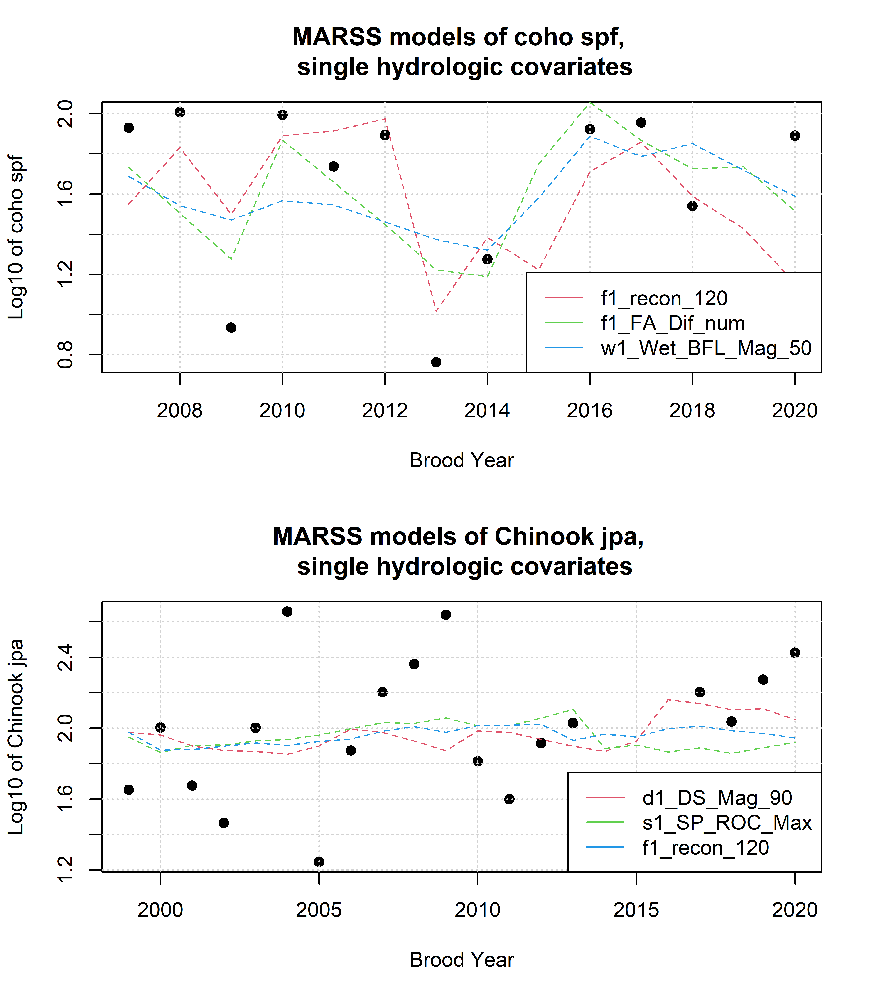
Figure 7: Results of the three best single-hydrologic-covariate MARSS models to predict log-transformed Chinook and coho juvenile-per-spawners ratios with Z-scored hydrologic metrics.

9.2 MARSS models of juveniles abundance, single hydrologic covariate
For purposes of statistical model comparison, we calculated multiple MARSS models (15 for coho and 8 for Chinook) that predicted juvenile abundance for coho and Chinook based on a single Z-scored hydrologic metric.
Table 31: Each row corresponds to a MARSS model predicting the time series of coho smolt abundance observations using itself (up to time t) and one hydrologic metric covariate. Coefficient sign and value indicate the direction and strength of the influence of the hydrologic metric; i.e., a negative coefficient for hydrologic metric f1_recon_120 indicates that an earlier first fall river reconnection (120 cfs) is associated with a greater coho smolt abundance value. Models are listed in order from best (lowest AICc value) to worst. Values marked with -- indicate that gaps in the time series for the hydrologic metric prevented the calculation of a model using that covariate.
Covariate | Coefficient | AICc
f1_FA_Dif_num | 0.206 | 40.37
f2_FA_Dif_num | -0.136 | 41.55
w2_Wet_BFL_Mag_50 | 0.08 | 41.74
d1_DS_Mag_90 | 0.058 | 41.78
s1_SP_ROC_Max | 0.061 | 41.78
s2_SP_ROC_Max | 0.06 | 41.8
w1_Wet_BFL_Mag_50 | 0.059 | 41.83
s2_SP_ROC | 0.045 | 41.83
w2_Wet_Tim | 0.039 | 41.88
s1_SP_ROC | -0.017 | 41.98
f1_recon_120 | -0.035 | 41.98
d1_DS_Mag_50 | -0.015 | 42.01
f2_recon_120 | -0.018 | 42.01
w1_Wet_Tim | 0.007 | 42.01
s2_SP_Tim | -0.002 | 42.02
f1_FA_Dur | -- | --
f2_FA_Dur | -- | --
Table 32: Each row corresponds to a MARSS model predicting the time series of Chinook juv. abundance observations using itself (up to time t) and one hydrologic metric covariate. Coefficient sign and value indicate the direction and strength of the influence of the hydrologic metric; i.e., a negative coefficient for hydrologic metric f1_recon_120 indicates that an earlier first fall river reconnection (120 cfs) is associated with a greater Chinook juv. abundance value. Models are listed in order from best (lowest AICc value) to worst. Values marked with -- indicate that gaps in the time series for the hydrologic metric prevented the calculation of a model using that covariate.
Covariate | Coefficient | AICc
w1_Wet_BFL_Mag_50 | -0.135 | 32.65
s1_SP_ROC_Max | -0.106 | 33.11
d1_DS_Mag_50 | 0.089 | 34.36
w1_Wet_Tim | -0.043 | 34.44
f1_recon_120 | -0.062 | 34.5
f1_FA_Dif_num | -0.053 | 34.85
s1_SP_ROC | 0.007 | 35.06
d1_DS_Mag_90 | -0.006 | 35.08
f1_FA_Dur | -- | --
## png
## 2
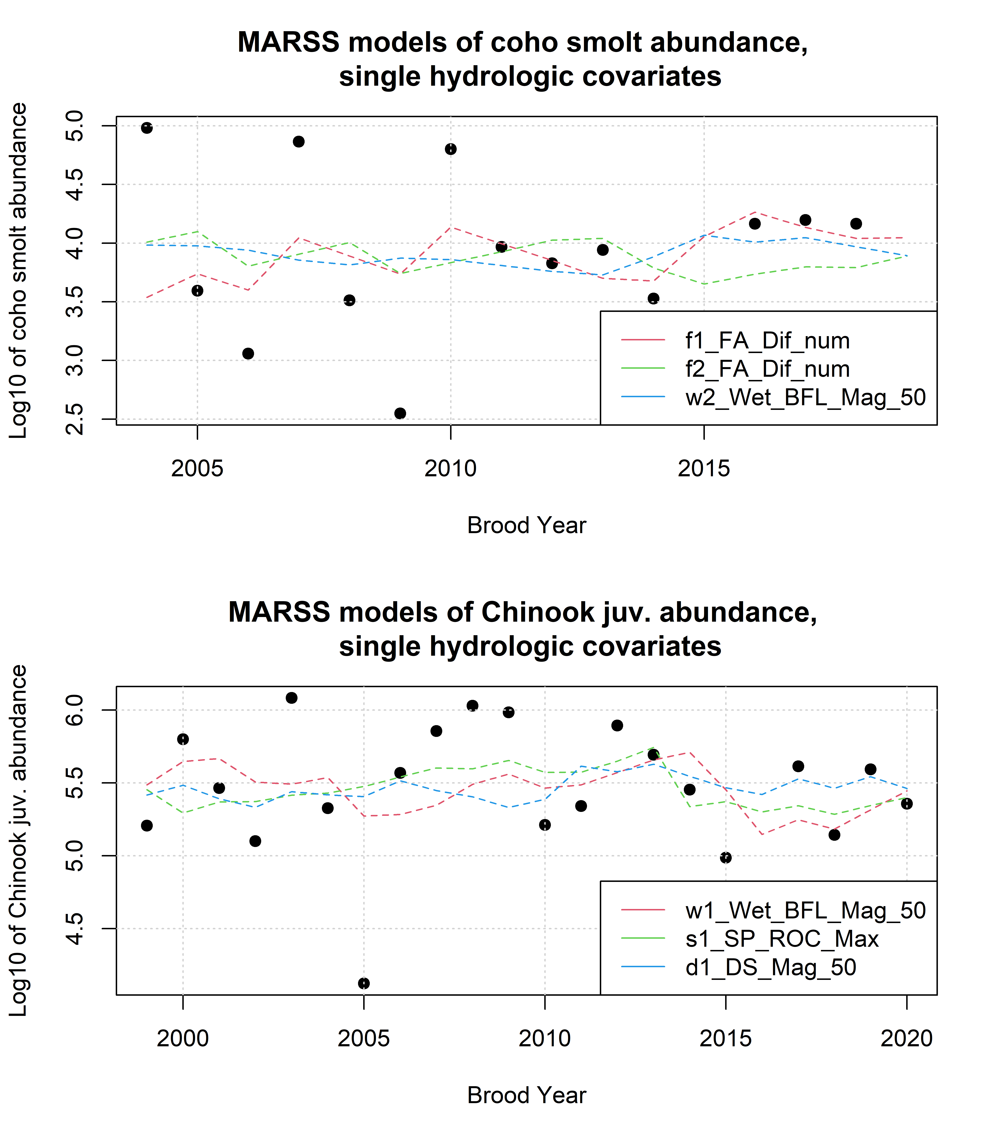
Figure 8: Results of the three best single-hydrologic-covariate MARSS models to predict log-transformed Chinook and coho outcomes with Z-scored hydrologic metrics.

9.3 MARSS models of juvenile abundance, two covariates (spawner abundance and one hydrologic)
For purposes of statistical model comparison, we calculated multiple MARSS models (15 for coho and 8 for Chinook) that predicted juvenile abundance for coho and Chinook based on a single Z-scored hydrologic metric and Z-scored parental spawner abundance; thus, coefficients were calculated for both the hydrology and spawner covariates.
Table 33: Characteristics of MARSS models of coho smolt abundance using one hydrologic metric and Z-scored spawner abundance as the two covariates in each model.
Hydrologic Covariate | AICc | Hydro Coef. | Spawner Coef. | Hyd. / Sp.
f1_FA_Dif_num | 32.11 | 0.550 | 0.374 | 1.5
f1_recon_120 | 37.67 | -0.605 | 0.452 | -1.3
d1_DS_Mag_90 | 38.16 | 0.229 | 0.338 | 0.7
w1_Wet_BFL_Mag_50 | 38.27 | 0.245 | 0.301 | 0.8
f2_recon_120 | 40.62 | -0.237 | 0.161 | -1.5
w2_Wet_BFL_Mag_50 | 41.18 | 0.110 | 0.201 | 0.5
s1_SP_ROC | 41.32 | -0.065 | 0.160 | -0.4
s1_SP_ROC_Max | 41.50 | 0.052 | 0.186 | 0.3
w2_Wet_Tim | 41.50 | 0.049 | 0.176 | 0.3
d1_DS_Mag_50 | 41.61 | 0.045 | 0.164 | 0.3
f2_FA_Dif_num | 41.65 | -0.040 | 0.160 | -0.2
w1_Wet_Tim | 41.66 | -0.021 | 0.171 | -0.1
s2_SP_ROC | 41.66 | 0.017 | 0.169 | 0.1
s2_SP_Tim | 41.67 | -0.010 | 0.159 | -0.1
s2_SP_ROC_Max | 41.68 | -0.004 | 0.167 | 0.0
f1_FA_Dur
f2_FA_Dur
Table 34: Characteristics of MARSS models of Chinook juv. abundance using one hydrologic metric and Z-scored spawner abundance as the two covariates in each model.
Hydrologic Covariate | AICc | Hydro Coef. | Spawner Coef. | HtoS_ratio
s1_SP_ROC_Max | 36.03 | -0.116 | 0.0573 | -2.0
w1_Wet_BFL_Mag_50 | 36.06 | -0.132 | 0.0209 | -6.3
f1_recon_120 | 37.77 | -0.062 | 0.0361 | -1.7
w1_Wet_Tim | 37.80 | -0.040 | 0.0287 | -1.4
d1_DS_Mag_50 | 37.81 | 0.081 | 0.0183 | 4.4
f1_FA_Dif_num | 38.18 | -0.046 | 0.0318 | -1.4
s1_SP_ROC | 38.19 | 0.021 | 0.0528 | 0.4
d1_DS_Mag_90 | 38.35 | 0.004 | 0.0378 | 0.1
f2_recon_120
f1_FA_Dur
f2_FA_Dur
f2_FA_Dif_num
w2_Wet_BFL_Mag_50
w2_Wet_Tim
s2_SP_ROC
s2_SP_ROC_Max
s2_SP_Tim
## png
## 2
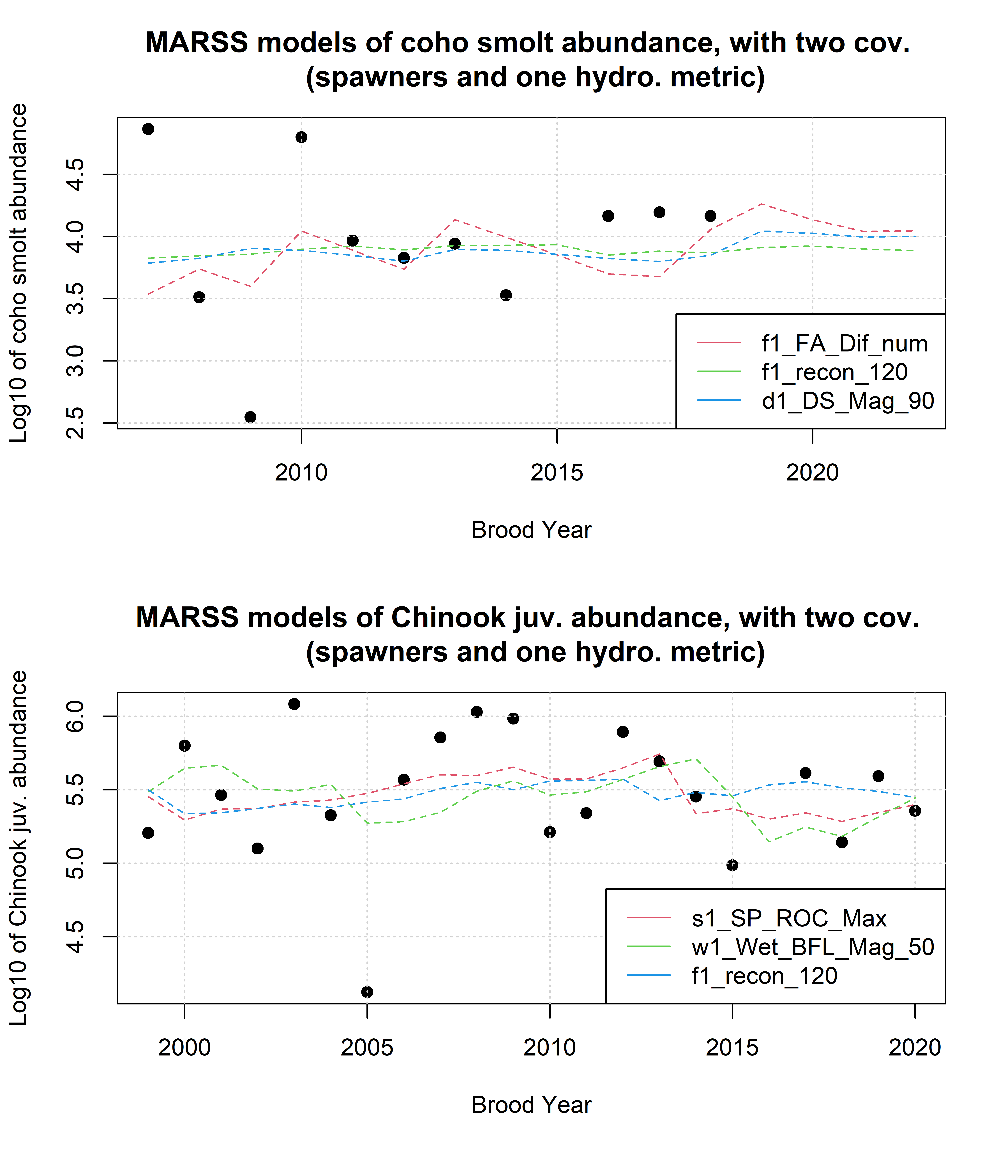
Figure 9: Results of MARSS to predict log-transformed juvenile abundance for coho and Chinook outcomes with Z-scored hydrologic metrics plus spawner data.
Agrawal, A, R S Schick, E P Bjorkstedt, R G Szerlong, M N Goslin, B C Spence, T H Williams, and K M Burnett. 2005. “PREDICTING THE POTENTIAL FOR HISTORICAL COHO, CHINOOK AND STEELHEAD HABITAT IN NORTHERN CALIFORNIA.” National Marine Fisheries Service.
Alomía Herrera, Ilia, and Patricia Carrera Burneo. 2017. “Environmental Flow Assessment in Andean Rivers of Ecuador, Case Study: Chanlud and El Labrado Dams in the Machángara River.” Ecohydrology & Hydrobiology 17 (2): 103–12. https://doi.org/10.1016/j.ecohyd.2017.01.002.
Arriana Brand, L., Juliet C. Stromberg, David C. Goodrich, Mark D. Dixon, Kevin Lansey, Doosun Kang, David S. Brookshire, and David J. Cerasale. 2011. “Projecting Avian Response to Linked Changes in Groundwater and Riparian Floodplain Vegetation Along a Dryland River: A Scenario Analysis.” Ecohydrology 4 (1): 130–42. https://doi.org/10.1002/eco.143.
Ayllón, Daniel, Graciela G. Nicola, Irene Parra, Benigno Elvira, and Ana Almodóvar. 2014. “Spatio-Temporal Habitat Selection Shifts in Brown Trout Populations Under Contrasting Natural Flow Regimes.” Ecohydrology 7 (2): 569–79. https://doi.org/10.1002/eco.1379.
Baruch, Ethan M., Sarah M. Yarnell, Theodore E. Grantham, Jessica R. Ayers, Andrew L. Rypel, and Robert A. Lusardi. 2024. “Mimicking Functional Elements of the Natural Flow Regime Promotes Native Fish Recovery in a Regulated River.” Ecological Applications 34 (6): e3013. https://doi.org/10.1002/eap.3013.
Booth, Derek B., Yantao Cui, Zooey Diggory, Dirk Pedersen, Jordan Kear, and Michael Bowen. 2014. “Determining Appropriate Instream Flows for Anadromous Fish Passage on an Intermittent Mainstem River, Coastal Southern California, USA.” Ecohydrology 7 (2): 745–59. https://doi.org/10.1002/eco.1396.
Bourret, Samuel L., Christopher C. Caudill, and Matthew L. Keefer. 2016. “Diversity of Juvenile Chinook Salmon Life History Pathways.” Reviews in Fish Biology and Fisheries 26 (3): 375–403. https://doi.org/10.1007/s11160-016-9432-3.
Bower, Luke M., Brandon K. Peoples, Michele C. Eddy, and Mark C. Scott. 2022. “Quantifying Flow–Ecology Relationships Across Flow Regime Class and Ecoregions in South Carolina.” Science of The Total Environment 802 (January): 149721. https://doi.org/10.1016/j.scitotenv.2021.149721.
Bradford, Michael J., Garth C. Taylor, and J. Andrew Allan. 1997. “Empirical Review of Coho Salmon Smolt Abundance and the Prediction of Smolt Production at the Regional Level.” Transactions of the American Fisheries Society 126 (1): 49–64. https://doi.org/10.1577/1548-8659(1997)126<0049:EROCSS>2.3.CO;2.
Brown, Larry R., Peter B. Moyle, and Ronald M. Yoshiyama. 1994. “Historical Decline and Current Status of Coho Salmon in California.” North American Journal of Fisheries Management 14 (2): 237–61. https://doi.org/10.1577/1548-8675(1994)014<0237:HDACSO>2.3.CO;2.
Brummer, T. J., A. E. Byrom, J. J. Sullivan, and P. E. Hulme. 2016. “A Quantitative Framework to Derive Robust Characterization of Hydrological Gradients: Framework for Robust Design of Flow-Ecology Studies.” River Research and Applications 32 (7): 1517–29. https://doi.org/10.1002/rra.3001.
Bustard, David R., and David W. Narver. 1975. “Aspects Ofthe Winter Ecology of Juvenile Coho Sahnon (Oncorhynchus Kisutch) and Steelhead Trout (Salmo Gairdneri).” Journal of the Fisheries Resources Board of Canada 32 (5): 667–80. https://doi.org/10.1139/f75-086.
California Department of Fish and Wildlife. 2021. “Scott River Best Available Scientific Information for Instream Flow Criteria.”
California Department of Fish and Wildlife, NOAA-Fisheries, Scott River Water Trust, Siskiyou Resource Conservation District, and U.S. Forest Service - Klamath National Forest. 2015. “Cooperative Scott River Coho Rescue & Relocation Effort: 2014 Drought Emergency.”
Carpenter, Cameron. 2024. “Accurately Identifying Functional Flow Metrics in Flashy and Highly Altered Stream Systems.” Master’s thesis, University of California, Davis.
Cartwright, Jennifer, Casey Caldwell, Steven Nebiker, and Rodney Knight. 2017. “Putting Flow–Ecology Relationships into Practice: A Decision-Support System to Assess Fish Community Response to Water-Management Scenarios.” Water 9 (3): 196. https://doi.org/10.3390/w9030196.
Catford, Jane A., William K. Morris, Peter A. Vesk, Christopher J. Gippel, and Barbara J. Downes. 2014. “Species and Environmental Characteristics Point to Flow Regulation and Drought as Drivers of Riparian Plant Invasion.” Edited by Jeffrey Diez. Diversity and Distributions 20 (9): 1084–96. https://doi.org/10.1111/ddi.12225.
Chowdhury, Shahadat, and Patrick Driver. 2007. “An Ecohydrological Model of Waterbird Nesting Events to Altered Floodplain Hydrology.” In MODSIM 2007 International Congress on Modelling and Simulation, edited by Les Oxley and Don Kulasiri, 2896–2902. Modeling and Simulation Society of Australia and New Zealand.
Coordinated Resource Management Planning Committee, and Scott River Watershed Council. 2000. “FINAL REPORT.”
Daneshvar, Fariborz, Amir Pouyan Nejadhashemi, Matthew R. Herman, and Mohammad Abouali. 2017. “Response of Benthic Macroinvertebrate Communities to Climate Change.” Ecohydrology & Hydrobiology 17 (1): 63–72. https://doi.org/10.1016/j.ecohyd.2016.12.002.
DeWeber, J. Tyrell, and James T. Peterson. 2020. “Comparing Environmental Flow Implementation Options with Structured Decision Making: Case Study from the Willamette River, Oregon.” JAWRA Journal of the American Water Resources Association 56 (4): 599–614. https://doi.org/10.1111/1752-1688.12845.
Gao, Ye, Yong-hong Xie, and Dong-sheng Zou. 2020. “Hydrological Regime Change and Its Ecological Responses in East Dongting Lake, China.” Ecohydrology & Hydrobiology 20 (1): 142–50. https://doi.org/10.1016/j.ecohyd.2019.07.003.
Groot, Cornelis, and Leo Margolis, eds. 1991. “Life History of Chinook Salmon (Onchorhynchus Tshawytscha).” In Pacific Salmon Life Histories. Vancouver: UBC Press.
Guareschi, S., A. Laini, E. Racchetti, T. Bo, S. Fenoglio, and M. Bartoli. 2014. “How Do Hydromorphological Constraints and Regulated Flows Govern Macroinvertebrate Communities Along an Entire Lowland River?” Ecohydrology 7 (2): 366–77. https://doi.org/10.1002/eco.1354.
Guedes, Gustavo Henrique Soares, Tailan Moretti Mattos, Geysa Da Silva Camilo, Wagner Uehara, Débora Lisandra De Paiva Ferreira, and Francisco Gerson Araújo. 2020. “Artificial Flow Regime Promotes Abiotic and Biotic Gradients: Testing the Concept of Longitudinal Zonation in an Off-River Reservoir.” Ecohydrology & Hydrobiology 20 (2): 256–64. https://doi.org/10.1016/j.ecohyd.2020.02.002.
Hain, Ernie F., Jonathan G. Kennen, Peter V. Caldwell, Stacy A. C. Nelson, Ge Sun, and Steven G. McNulty. 2018. “Using Regional Scale Flow–Ecology Modeling to Identify Catchments Where Fish Assemblages Are Most Vulnerable to Changes in Water Availability.” Freshwater Biology 63 (8): 928–45. https://doi.org/10.1111/fwb.13048.
Hale, Robin, Jian D. L. Yen, Charles R. Todd, Ivor G. Stuart, Henry F. Wootton, Jason D. Thiem, John D. Koehn, et al. 2023. “Is My Model Fit for Purpose? Validating a Population Model for Predicting Freshwater Fish Responses to Flow Management.” Ecosphere 14 (9): e4660. https://doi.org/10.1002/ecs2.4660.
Herbst, David B., Scott D. Cooper, Robert Bruce Medhurst, Sheila W. Wiseman, and Carolyn T. Hunsaker. 2019. “Drought Ecohydrology Alters the Structure and Function of Benthic Invertebrate Communities in Mountain Streams.” Freshwater Biology 64 (5): 886–902. https://doi.org/10.1111/fwb.13270.
Hunt, Sharon L, Timothy J Mulligan, and Kenichiro Komori. 1999. “Oceanic Feeding Habits of Chinook Salmon, Oncorhynchus Tshawytscha, Off Northern Californi.” Fishery Bulletin 97 (3): 717–21.
James, Gareth, Daniela Witten, Trevor Hastie, and Robert Tibshirani. 2013. An Introduction to Statistical Learning. Vol. 103. Springer Texts in Statistics. New York, NY: Springer New York. https://doi.org/10.1007/978-1-4614-7138-7.
Kevic, Maja, Johannes Ortlepp, Uta Mürle, and Christopher T. Robinson. 2018. “Effects of Experimental Floods in Two Rivers with Contrasting Valley Morphologies.” Fundamental and Applied Limnology 192 (2): 145–60. https://doi.org/10.1127/fal/2018/1177.
Knechtle, Morgan, and Domenic Giudice. 2020. “2019 SCOTT RIVER SALMON STUDIES FINAL REPORT.” California Department of Fish and Wildlife.
Konrad, Christopher P., Julian D. Olden, David A. Lytle, Theodore S. Melis, John C. Schmidt, Erin N. Bray, Mary C. Freeman, et al. 2011. “Large-Scale Flow Experiments for Managing River Systems.” BioScience 61 (12): 948–59. https://doi.org/10.1525/bio.2011.61.12.5.
Lamouroux, Nicolas, and Jean-Michel Olivier. 2015. “Testing Predictions of Changes in Fish Abundance and Community Structure After Flow Restoration in Four Reaches of a Large River ( F Rench R hône).” Freshwater Biology 60 (6): 1118–30. https://doi.org/10.1111/fwb.12324.
Larsen, Stefano, Bruno Majone, Patrick Zulian, Elisa Stella, Alberto Bellin, Maria Cristina Bruno, and Guido Zolezzi. 2021. “Combining Hydrologic Simulations and Stream-Network Models to Reveal Flow-Ecology Relationships in a Large Alpine Catchment.” Water Resources Research 57 (4): e2020WR028496. https://doi.org/10.1029/2020WR028496.
Magranet, Lindsay. 2015. “Scott River Fall Chinook Spawning Ground Surveys.” Etna, CA: Siskiyou Resource Conservation District.
———. 2017. “Scott River Fall Chinook Spawning Ground Surveys.” Etna, CA: Siskiyou Resource Conservation District.
———. 2018. “2017 Monitoring Report.” Scott River Water Trust.
Mansfield, Carol, George Van Houtven, Amy Hendershott, Patrick Chen, Jeremy Porter, Vesall Nourani, and Vikram Kilambi. 2012. “Klamath River Basin Restoration Nonuse Value Survey.”
Mazor, Raphael D., Jason T. May, Ashmita Sengupta, Kenneth S. McCune, Brian P. Bledsoe, and Eric D. Stein. 2018. “Tools for Managing Hydrologic Alteration on a Regional Scale: Setting Targets to Protect Stream Health.” Freshwater Biology 63 (8): 786–803. https://doi.org/10.1111/fwb.13062.
McMahon, Thomas E. 1983. “Habitat Suitability Index Models: Coho Salmon.” FWS/OBS-82/10.49. U.S. Fish and Wildlife Service.
McManamay, Ryan A., and Emmanuel A. Frimpong. 2015. “Hydrologic Filtering of Fish Life History Strategies Across the United States: Implications for Stream Flow Alteration.” Ecological Applications 25 (1): 243–63. https://doi.org/10.1890/14-0247.1.
McManamay, Ryan A., Donald J. Orth, Charles A. Dolloff, and David C. Mathews. 2013. “Application of the ELOHA Framework to Regulated Rivers in the Upper Tennessee River Basin: A Case Study.” Environmental Management 51 (6): 1210–35. https://doi.org/10.1007/s00267-013-0055-3.
Mellado-Díaz, Andrés, Jorge Rubén Sánchez-González, Simone Guareschi, Fernando Magdaleno, and Manuel Toro Velasco. 2019. “Exploring Longitudinal Trends and Recovery Gradients in Macroinvertebrate Communities and Biomonitoring Tools Along Regulated Rivers.” Science of The Total Environment 695 (December): 133774. https://doi.org/10.1016/j.scitotenv.2019.133774.
Monk, Wendy A., Paul J. Wood, David M. Hannah, and Douglas A. Wilson. 2008. “Macroinvertebrate Community Response to Inter-Annual and Regional River Flow Regime Dynamics.” River Research and Applications 24 (7): 988–1001. https://doi.org/10.1002/rra.1120.
Monk, Wendy A., Paul J. Wood, David M. Hannah, Douglas A. Wilson, Chris A. Extence, and Richard P. Chadd. 2006. “Flow Variability and Macroinvertebrate Community Response Within Riverine Systems.” River Research and Applications 22 (5): 595–615. https://doi.org/10.1002/rra.933.
Moyle, Peter B. 2002. “Coho Salmon, Oncorhynchus Kisutch (Walbaum).” In Inland Fishes of California, 245–51. University of California Press.
National Marine Fisheries Service. 2014. “Final SONCC Coho Recovery Plan.” National Oceanic and Atmospheric Administration.
Nickelson, Thomas E., Jeffrey D. Rodgers, Steven L. Johnson, and Mario F. Solazzi. 1992. “Seasonal Changes in Habitat Use by Juvenile Coho Salmon (Oncorhynchus Kisutch) in Oregon Coastal Streams.” Canadian Journal of Fisheries and Aquatic Sciences 49 (4): 783–89. https://doi.org/10.1139/f92-088.
North Coast Regional Water Quality Control Board. 2006. “ACTION PLAN FOR THE SCOTT RIVER SEDIMENT AND TEMPERATURE TOTAL MAXIMUM DAILY LOADS.” Basin Plan Language. https://www.waterboards.ca.gov/northcoast/water_issues/programs/tmdls/scott_river/060307/bpl/Basin_Plan_Language.pdf.
Patterson, Noelle K., Belize A. Lane, Samuel Sandoval-Solis, Gregory B. Pasternack, Sarah M. Yarnell, and Yexuan Qiu. 2020. “A Hydrologic Feature Detection Algorithm to Quantify Seasonal Components of Flow Regimes.” Journal of Hydrology 585 (June): 124787. https://doi.org/10.1016/j.jhydrol.2020.124787.
Peek, Ryan, Katie Irving, Sarah M. Yarnell, Rob Lusardi, Eric D. Stein, and Raphael Mazor. 2022. “Identifying Functional Flow Linkages Between Stream Alteration and Biological Stream Condition Indices Across California.” Frontiers in Environmental Science 9 (January): 790667. https://doi.org/10.3389/fenvs.2021.790667.
Peterson, James T., and Mary C. Freeman. 2016. “Integrating Modeling, Monitoring, and Management to Reduce Critical Uncertainties in Water Resource Decision Making.” Journal of Environmental Management 183 (December): 361–70. https://doi.org/10.1016/j.jenvman.2016.03.015.
Poff, N. LeRoy, Brian D. Richter, Angela H. Arthington, Stuart E. Bunn, Robert J. Naiman, Eloise Kendy, Mike Acreman, et al. 2010. “The Ecological Limits of Hydrologic Alteration (ELOHA): A New Framework for Developing Regional Environmental Flow Standards.” Freshwater Biology 55 (1): 147–70. https://doi.org/10.1111/j.1365-2427.2009.02204.x.
Qian, Kuimei, Xia Liu, and Yuwei Chen. 2016. “Effects of Water Level Fluctuation on Phytoplankton Succession in Poyang Lake, China – A Five Year Study.” Ecohydrology & Hydrobiology 16 (3): 175–84. https://doi.org/10.1016/j.ecohyd.2016.08.001.
Quiñones, Rebecca M., Marcel Holyoak, Michael L. Johnson, and Peter B. Moyle. 2014. “Potential Factors Affecting Survival Differ by Run-Timing and Location: Linear Mixed-Effects Models of Pacific Salmonids (Oncorhynchus Spp.) in the Klamath River, California.” Edited by Christopher J. Fulton. PLoS ONE 9 (5): e98392. https://doi.org/10.1371/journal.pone.0098392.
Richter, Brian D., Jeffrey V. Baumgartner, Jennifer Powell, and David P. Braun. 1996. “A Method for Assessing Hydrologic Alteration Within Ecosystems.” Conservation Biology 10 (4): 1163–74. https://doi.org/10.1046/j.1523-1739.1996.10041163.x.
Riis, Tenna, Alastair M. Suren, Bente Clausen, and Kaj Sand-Jensen. 2008. “Vegetation and Flow Regime in Lowland Streams.” Freshwater Biology 53 (8): 1531–43. https://doi.org/10.1111/j.1365-2427.2008.01987.x.
Saby, Linnea, Kevin L. McKee, Prakrut Kansara, Jonathan L. Goodall, Lawrence E. Band, and Venkataraman Lakshmi. 2022. “Sensitivity of Remotely Sensed Vegetation to Hydrologic Predictors Across the Colorado River Basin, 2001–2019.” JAWRA Journal of the American Water Resources Association 58 (6): 1017–29. https://doi.org/10.1111/1752-1688.12965.
Scott River Watershed Council. 2005. “Limiting Factors Analysis for Coho Salmon and Other Anadromous Fish.”
———. 2018. “Restoring Priority Coho Habitat in the Scott River Watershed Modeling and Planning Report.”
Scott River Watershed Council, and Siskiyou Resource Conservation District. 2005. “Initial Phase of the Scott River Watershed Council Strategic Action Plan.” Etna, CA.
Scott Valley Area Plan Committee. 1980. “Scott Valley Area Plan.” Siskiyou County.
Sinnathamby, Sumathy, Kyle R. Douglas-Mankin, Muluken E. Muche, Stacy L. Hutchinson, and Aavudai Anandhi. 2018. “Ecohydrological Index, Native Fish, and Climate Trends and Relationships in the Kansas River Basin.” Ecohydrology 11 (1): e1909. https://doi.org/10.1002/eco.1909.
Siskiyou County. 2021. “Scott Valley Groundwater Sustainability Plan.” Scott Valley FINAL GSP. https://www.co.siskiyou.ca.us/naturalresources/page/scott-valley-final-gsp.
Siskiyou Resource Conservation District. 2004. “Final Report Scott River Coho Spawning Assessment: 2003-2004.” Etna, CA: Siskiyou Resource Conservation District.
———. 2025. “Siskiyou Resource Conservation District - Etna, CA.” https://www.siskiyourcd.com.
Stewart-Koster, B., J. D. Olden, M. J. Kennard, B. J. Pusey, E. L. Boone, M. Douglas, and S. Jackson. 2011. “Fish Response to the Temporal Hierarchy of the Natural Flow Regime in the Daly River, Northern Australia.” Journal of Fish Biology 79 (6): 1525–44. https://doi.org/10.1111/j.1095-8649.2011.03072.x.
Tesfaye, Samuale, Emiru Birhane, Toon Leijnse, and S. E. A. T. M. Van Der Zee. 2017. “Climatic Controls of Ecohydrological Responses in the Highlands of Northern Ethiopia.” Science of The Total Environment 609 (December): 77–91. https://doi.org/10.1016/j.scitotenv.2017.07.138.
Tharme, R. E. 2003. “A Global Perspective on Environmental Flow Assessment: Emerging Trends in the Development and Application of Environmental Flow Methodologies for Rivers.” River Research and Applications 19 (5-6): 397–441. https://doi.org/10.1002/rra.736.
Wainwright, Thomas C, Thomas H Williams, Kurt L Fresh, and Brian K Wells. 2013. “CCIEA PHASE II REPORT: ECOSYSTEM COMPONENTS, FISHERIES AND PROTECTED SPECIES - SALMON: Chinook and Coho Salmon.” National Marine Fisheries Service.
Welch, David Warren, Aswea Dawn Porter, and Erin Leanne Rechisky. 2021. “A Synthesis of the Coast-Wide Decline in Survival of West Coast Chinook Salmon (Oncorhynchus Tshawytscha, Salmonidae).” Fish and Fisheries 22 (1): 194–211. https://doi.org/10.1111/faf.12514.
White, James C., Andy House, Neil Punchard, David M. Hannah, Nicholas A. Wilding, and Paul J. Wood. 2018. “Macroinvertebrate Community Responses to Hydrological Controls and Groundwater Abstraction Effects Across Intermittent and Perennial Headwater Streams.” Science of The Total Environment 610–611 (January): 1514–26. https://doi.org/10.1016/j.scitotenv.2017.06.081.
Yao, Weiwei, Ruidong An, Guoan Yu, Jia Li, and Xiaoyi Ma. 2021. “Identifying Fish Ecological Risk Patterns Based on the Effects of Long-Term Dam Operation Schemes.” Ecological Engineering 159 (January): 106102. https://doi.org/10.1016/j.ecoleng.2020.106102.
Yokel, Erich, Shari Witmore, Betsy Stapleton, Charnna Gilmore, and Michael M Pollock. 2018. “Scott River Beaver Dam Analogue Coho Salmon Habitat Restoration Program 2017 Monitoring Report.” Etna, CA: Scott River Watershed Council.

