PROJECT D
DISSIDIA: FINAL FANTASY
ULTIMA PUGMA CLAMORIS
GAME CONCEPT DOCUMENT
CONFIDENTIAL
Developer Codename: Zantetsuken
Document Version: 1.0
Document Date: 20 August 2026
Status: Pre-production concept and licensing proposal

RESTRICTED DISTRIBUTION This document contains confidential pre-production concepts. Distribution is limited to authorized Project D stakeholders, prospective licensors, platform partners, and contracted development personnel.

Document Control
Field | Value
Project | Project D
Final title | Dissidia: Final Fantasy Ultima Pugma Clamoris
Developer codename | Zantetsuken
Classification | CONFIDENTIAL
Version | 1.0
Date | 20 August 2026
Owner | Project D core team
Release target | To be determined after licensing, vertical slice approval, production funding, platform certification, and regional publishing plans
Primary platforms | iOS and Android; PC development client and possible later port
Recommended engine | Unity for mobile-first production; Unreal Engine remains a viable alternative if the existing model/shader pipeline requires it

Confidentiality and Rights Notice
This game concept uses names, characters, worlds, creatures, summons, and visual identities associated with Final Fantasy and Dissidia. These properties are owned or controlled by Square Enix and its licensors. Possession of 3D model files does not itself establish the right to use, modify, distribute, market, or monetize those assets. Public development, testing, promotion, release, and monetization require written authorization and a documented chain of title for every asset. Until authorization is secured, Project D should be treated as a private prototype and licensing pitch only.
DESIGN BOUNDARY All abilities in this document are proposed MOBA interpretations written for Project D. They are not transcriptions of any existing game’s ability text, balance data, animations, or source code.

How to Use This Document
- Creative north star for design, art, engineering, production, QA, publishing, and licensing discussions.
- Baseline for prototype scope and backlog definition.
- Not a final balance sheet. Numerical values must live in data assets and be validated through telemetry and playtests.
- Not legal clearance. Counsel and the rights holder must approve title, roster, models, audio, story, marketing, and distribution.

Contents
- 1. Executive Summary
- 2. Product Vision and Pillars
- 3. Audience, Platform, and Market Position
- 4. Fiction, Premise, and Tone
- 5. Core Match and Rules
- 6. Battlefield, Lanes, and Objectives
- 7. Summons and Divine Manifestations
- 8. Jungle Ecology and Goblin Minions
- 9. Launch Character Roster and Ability Kits
- 10. Controls, Camera, HUD, and Accessibility
- 11. Progression, Economy, and Monetization
- 12. Modes, Social, Competitive, and Live Operations
- 13. Art, Animation, VFX, Audio, and Model Pipeline
- 14. Technology, Networking, Security, and Backend
- 15. Production Plan and Team
- 16. Testing and Quality Strategy
- 17. Release, Certification, and Post-launch
- 18. Legal, Privacy, Safety, and Risk Register
- Appendices: Data, Metrics, Glossary, and Acceptance Gates

1. Executive Summary
Project D is a mobile-first 5v5 multiplayer online battle arena in which champions drawn from multiple Final Fantasy worlds are called into a fractured Dissidia arena. Two teams fight across three lanes, a mirrored jungle, elemental summon sanctums, and a divine rift. Each match is designed for approximately 12 to 18 minutes, with clear touch controls, readable team fights, server-authoritative competition, and strategic variety created by a revealed sequence of three elemental summons followed by Odin.
The product aims to combine the role clarity and match flow expected from modern mobile MOBAs with recognizable Final Fantasy roles, magic, summons, creatures, and dramatic limit-break-style moments. It must not copy League of Legends: Wild Rift code, map geometry, user interface, balance data, terminology, audio, or assets. Inspiration is limited to broadly established genre conventions.

1.1 Product Snapshot
Dimension | Concept
Genre | 5v5 mobile MOBA with optional casual and PvE variants
Perspective | Elevated isometric 3D camera
Match length | Target 12–18 minutes for standard mode
Core victory | Destroy the enemy Crystal Core
Team roles | Vanguard, Fighter, Assassin, Marksman, Mage, Support
Business model | Free-to-play, cosmetic-led; no purchasable combat power
Launch roster | 26 proposed champions spanning Final Fantasy I–XVI and XIV
Differentiator | Revealed randomized summon sequence; Dissidia crossover fantasy; mobile spectacle with competitive readability
Production status | Concept; rights and licensing gate not yet evidenced
Release date | TBD. No responsible date can be fixed until rights, funding, scope, staffing, backend, and certification gates are approved.

1.2 Success Definition
- A first-time player can move, attack, cast, shop, and understand the main objective after one guided match.
- A competitive player experiences deterministic controls, low input latency, fair matchmaking, readable effects, and credible anti-cheat.
- Each champion expresses the identity of the source title while fitting a counterable MOBA role.
- Randomized objectives are disclosed in advance and generated from a seeded, auditable shuffle bag.
- The game maintains 30 or 60 frames per second on declared device tiers and avoids thermal collapse during a full match.
- Monetization never modifies combat statistics or matchmaking rating.

2. Product Vision and Pillars

2.1 Vision Statement
Create the definitive mobile arena for Final Fantasy crossover battles: easy to enter, strategically deep, faithful in spirit, spectacular in motion, and fair enough for long-term competitive play.

2.2 Design Pillars
Pillar | Meaning | Decision Test
Fantasy Fidelity | World, silhouette, role, weapon, spell language, and personality should be recognizable. | Would a fan identify the champion before reading the name?
Mobile Clarity | Short sessions, strong silhouettes, restrained effects, forgiving touch targeting, scalable performance. | Can the action be read on a small screen during a 10-player fight?
Competitive Fairness | Server authority, telegraphed attacks, counterplay, disclosed RNG, no paid power. | Could both teams understand and contest the outcome?
Strategic Variety | Draft, lanes, jungle routes, summon order, item builds, and team compositions create replayability. | Does this choice alter tactics without creating a mandatory answer?
Spectacle with Restraint | Summons and finishing moves feel large but never hide important gameplay. | Can players still see danger zones and health state?
Sustainable Production | Data-driven content, shared rigs where suitable, reusable systems, measurable performance budgets. | Can the team maintain this feature across devices and seasons?

2.3 Non-goals
- A direct port or clone of another MOBA.
- A one-to-one recreation of any Final Fantasy battle system.
- A gacha system that sells combat strength.
- A launch roster covering every Final Fantasy character.
- Unbounded photorealism that compromises mobile performance or visual readability.

3. Audience, Platform, and Market Position

3.1 Target Players
Segment | Need | Project D Response
Final Fantasy fans | Authentic identities, worlds, rivalries, summons, music quality. | Faithful silhouettes and thematic kits, with rights-holder review.
Mobile MOBA players | Fast queue, fair matches, strong controls, ranked integrity. | 12–18 minute target, role queue, reconnect, anti-cheat, telemetry.
New MOBA players | Lower complexity and safe learning. | Guided tutorial, recommended builds, bot matches, role quests.
Competitive teams | Draft depth, spectator tools, stable patches. | Tournament lobby, replay, observer mode, published balance cadence.
Collectors | Expression and long-term goals. | Cosmetics, profile items, mastery, events; never stat power.

3.2 Device Strategy
- Baseline target: modern 64-bit Android and iOS devices, finalized after a market/device study.
- Provide 30 FPS performance mode and 60 FPS quality/performance option where stable.
- Dynamic resolution, scalable shadows, effect density controls, memory budgets, and thermal monitoring are mandatory.
- Controller support and PC development client may be evaluated after mobile controls are validated.

4. Fiction, Premise, and Tone

4.1 Premise
A collision of crystals has broken the boundary between worlds. Materia, Cosmos, Spiritus, and Chaos project shifting manifestations into an arena constructed from memories of many realms. Champions answer competing calls, but no side is permanently aligned with virtue or villainy. Each match is a non-canonical trial in which teams stabilize summon sanctums, claim divine blessings, and shatter the opposing Crystal Core.

4.2 Narrative Principles
- Non-canonical framing allows heroes and antagonists to appear on either team.
- Character voice and relationships may acknowledge source history, subject to licensor approval.
- The arena narrative explains respawning, mirrored structures, rotating objectives, and seasonal changes.
- Avoid converting gender into a gameplay stat category. Divine rewards follow narrative domains, not the manifestation’s gender.
- Story delivery remains optional and does not delay matchmaking: short cinematics, codex entries, event chapters, and pre-match interactions.

4.3 Tone and Rating Goal
Heroic, dramatic, and accessible, with stylized fantasy combat and no graphic injury. Final age ratings depend on regional boards, monetization design, chat features, and final content. The project should target a broad teen audience while implementing parental controls and communication safeguards.

5. Core Match and Rules

5.1 Standard Match Loop
- Queue and role selection.
- Draft or blind pick, with duplicate policy defined per mode.
- Load into base, purchase starting equipment, select first ability.
- Lane and jungle opening; first camps appear.
- Contest elemental summons, towers, river vision, and divine manifestations.
- Destroy lane towers and a lane seal to empower Goblin Warlords.
- Secure Odin or a late divine blessing to create a closing opportunity.
- Destroy the enemy Crystal Core; show rewards, performance, commendations, and report tools.

5.2 Team Roles
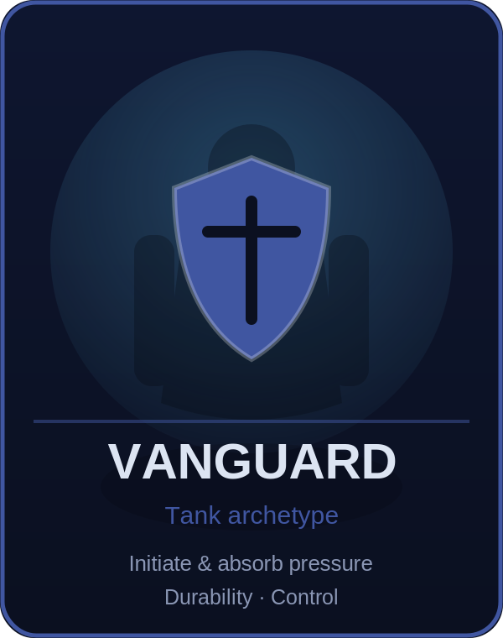 | 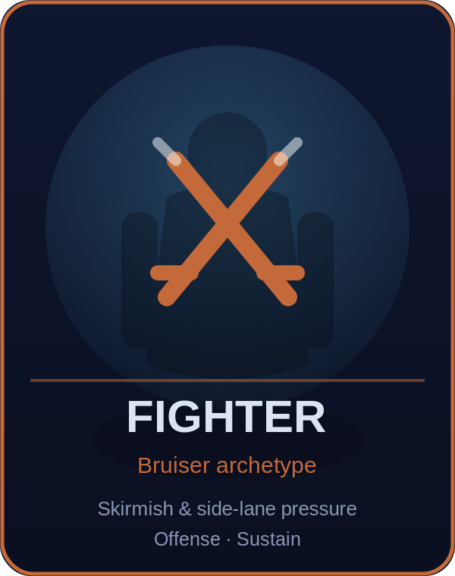 | 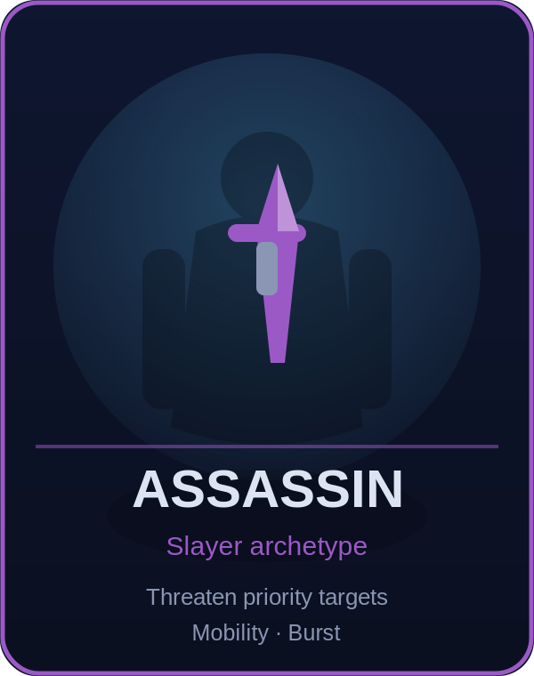
 | 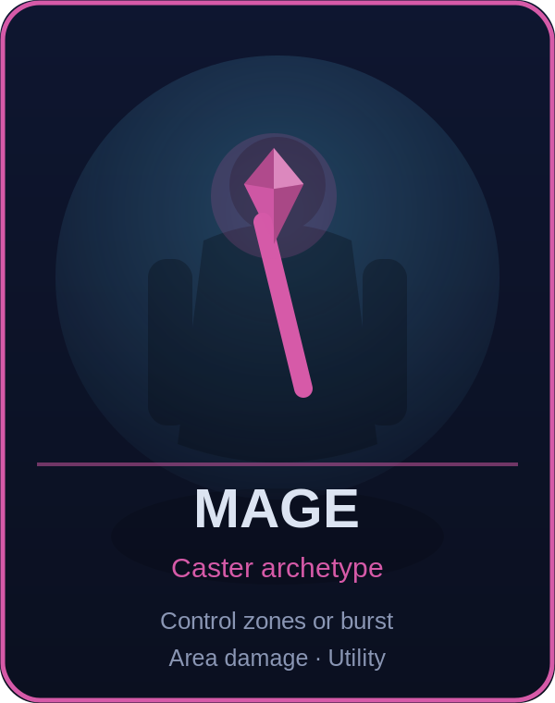 | 
Figure 5.2 — Role archetypes (placeholder). Six team roles; silhouette + weapon-emblem read at mobile distance.
Role | Primary Job | Typical Strength | Typical Weakness
Vanguard | Initiate and absorb pressure | Durability, control | Lower sustained damage
Fighter | Skirmish and side-lane pressure | Mixed offense and sustain | Vulnerable to focus or kiting
Assassin | Threaten priority targets | Mobility and burst | Low durability, cooldown reliance
Marksman | Deliver ranged sustained damage | Scaling and objective damage | Positioning dependent
Mage | Control zones or burst with abilities | Area damage, utility | Resource and cooldown reliance
Support | Protect, enable, and control vision | Healing, shields, setup | Lower solo economy

5.3 Combat Rules
- Basic attacks use assisted targeting with manual target lock and priority toggles.
- Every high-impact crowd-control or execution mechanic requires clear anticipation, effect boundaries, audio cues, and counterplay.
- All damage, healing, shields, cooldowns, movement, objective ownership, and inventory transactions are validated by the authoritative server.
- Respawn duration and home-guard movement scale with match time.
- Surrender rules, remake handling, AFK protection, and reconnect behavior must be specified before external testing.

5.4 Draft and Team Composition
Ranked mode should progress from role declaration to alternating bans and picks once the roster is large enough. Early closed tests may use blind pick to accelerate matches. Duplicate champions are prohibited within one ranked match but can be allowed in training and special events. The matchmaker should consider rating, party size, role preference, latency, recent rematches, and behavior signals without exposing sensitive scoring logic.

6. Battlefield, Lanes, and Objectives

6.1 Map Structure
The primary battlefield is a symmetrical three-lane arena with two bases, paired jungles, a central river, two major-objective pits, brush or mist zones, jump or traversal points limited by champion kits, and strong landmark silhouettes. Final geometry must be original and validated through greybox testing, not traced from an existing MOBA map.
Zone | Purpose | Key Content
Top lane | Solo or durable duel space | Towers, lane seal, side brush, nearby large camp
Mid lane | Fast rotation and mage/assassin pressure | Short lane, river access, vision routes
Bottom lane | Duo lane and early summon pressure | Marksman/support space, sanctum access
Jungle | Economy, ganks, route choices | Small, medium, and large camps
River | Rotation and contested vision | Sahagin, vision nodes, two objective pits
Bases | Spawning, shopping, final defense | Fountain, Crystal Core, defensive towers

6.2 Structures
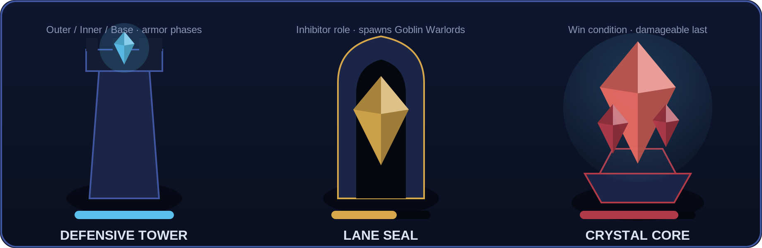
Figure 6.2 — Structures (placeholder). Defensive Tower, Lane Seal (inhibitor), and Crystal Core with health-bar treatments.
- Outer, inner, and base towers protect each lane.
- A lane seal serves the inhibitor function. Destroying it temporarily spawns Goblin Warlords in that lane.
- Backdoor protection reduces damage to isolated structures when no allied lane minion is nearby.
- The Crystal Core becomes damageable only after required base defenses are removed.
- Tower targeting, armor phases, anti-dive rules, and bounty values must be data-driven.

6.3 Objective Schedule
Phase | Event | Design Intent
Opening | Jungle and lane minions spawn shortly after deployment. | Establish lanes and routes.
Early | First revealed elemental summon becomes available. | Create first coordinated contest.
Mid | Second summon and first divine manifestation windows. | Force rotation and trade decisions.
Late | Third summon; stronger manifestations. | Increase map pressure without automatic victory.
Endgame | Odin unlocks after the three elemental trials resolve. | Provide a time-limited closing advantage.

TIMING POLICY Exact seconds are intentionally omitted from the concept baseline. Spawn times, respawns, scaling, and reward duration require simulation and playtesting. Do not hard-code them in champion or map logic.

7. Summons and Divine Manifestations

7.1 Controlled Summon Sequence
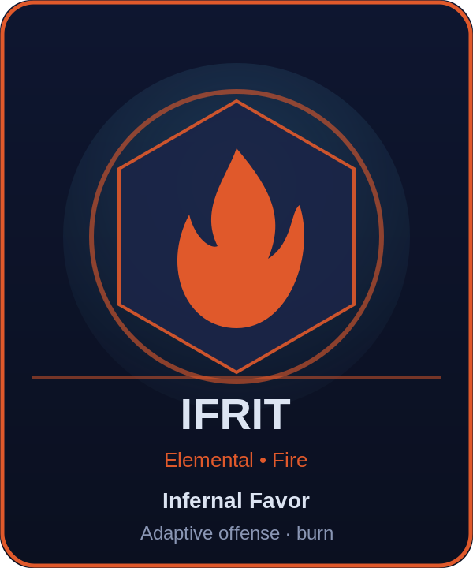 | 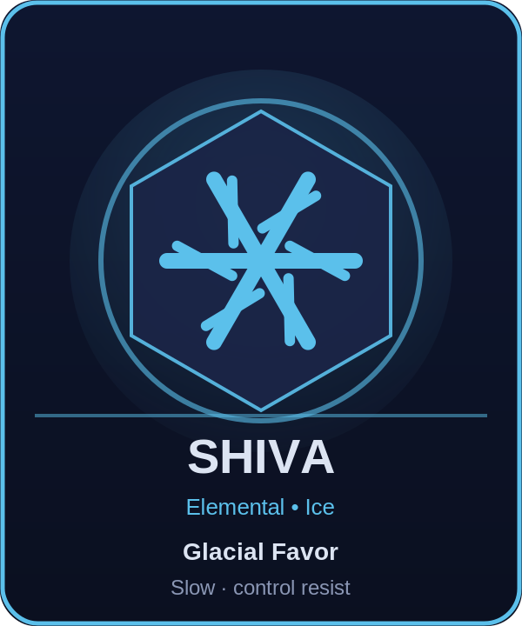 | 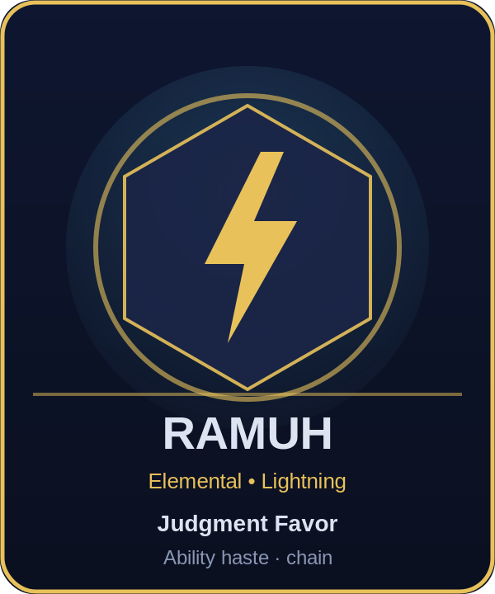 | 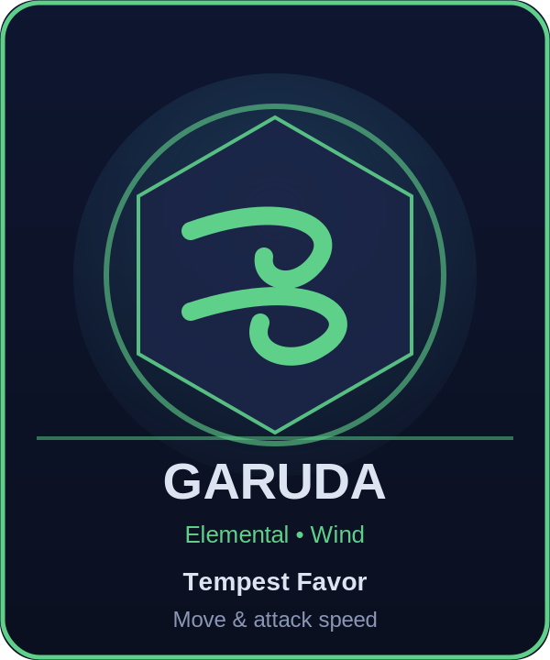
 | 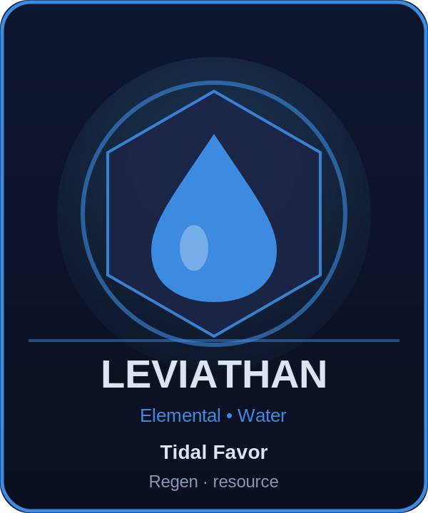 | 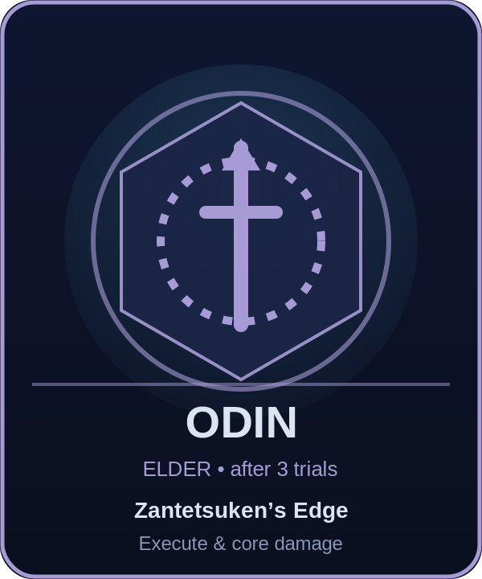
Figure 7.1 — Elemental summons + Odin (placeholder). Element colour, domain and team reward on each medallion.
At match start, the server selects three unique elemental summons from the six-summon pool using a seeded shuffle bag. Their portraits, reward themes, and order are revealed to both teams. No duplicate elemental summon appears in one standard match. After all three trials are resolved, Odin becomes eligible. This creates variety without hidden competitive randomness.
Summon | Domain | Team Reward | Encounter Language | Counterplay
Ifrit | Fire | Infernal Favor: adaptive offense; champion damage applies a short, capped burn. | Cone breath, leap impact, expanding fire rings. | Sustain, disengage, anti-burn defenses.
Shiva | Ice | Glacial Favor: brief slow on ability damage and minor control resistance. | Ice lanes, delayed crystal bursts, radial frost. | Mobility, spacing, cleanse effects.
Ramuh | Lightning | Judgment Favor: ability haste and periodic chain-lightning proc. | Telegraphed bolts, linked targets, storm zones. | Spread formation, timing the proc window.
Garuda | Wind | Tempest Favor: movement and attack speed; out-of-combat acceleration. | Cyclones, displacement gusts, rotating safe sectors. | Anchor control, slows, route denial.
Titan | Earth | Earthen Favor: defenses, a periodic shield, limited displacement resistance. | Ground lines, falling rock markers, frontal slam. | Percent-health damage, flanking, shield break.
Leviathan | Water | Tidal Favor: regeneration and limited resource return; river synergy. | Tidal sweeps, water lanes, knock-up circles. | Burst windows, healing reduction, high ground spacing.
Odin | Elder | Zantetsuken’s Edge: time-limited execute pressure and core damage; removable by death or expiry. | Gungnir line, Sleipnir charge, marked zones, threshold finisher. | Avoid low-health re-entry, stall duration, pick carriers.

7.2 Divine Manifestations: Rift of the Gods
Manifestation | Narrative Domain | Proposed Team Blessing
Materia | Restoration and ability flow | Immediate team recovery, improved healing/shielding, and ability haste.
Cosmos | Protection and harmony | Maximum health, defenses, periodic out-of-combat shield, modest minion empowerment.
Spiritus | Arcane aggression | Magic power, magic penetration, short ability burn, structure pressure.
Chaos | Martial execution | Attack damage, physical penetration, pressure against injured enemies, structure pressure.

- Reveal the next manifestation, buff category, spawn countdown, and exact current values to both teams before activation.
- Use a no-repeat shuffle cycle rather than unrestricted random selection.
- Only one manifestation reward may be active per team unless a future mode explicitly changes the rule.
- Rewards are time-limited and must create an advantage, not a guaranteed win.
- The server logs seed, selection, spawn, damage contribution, last hit, ownership, recipients, and expiry.

8. Jungle Ecology and Goblin Minions

8.1 Neutral Camp Roster
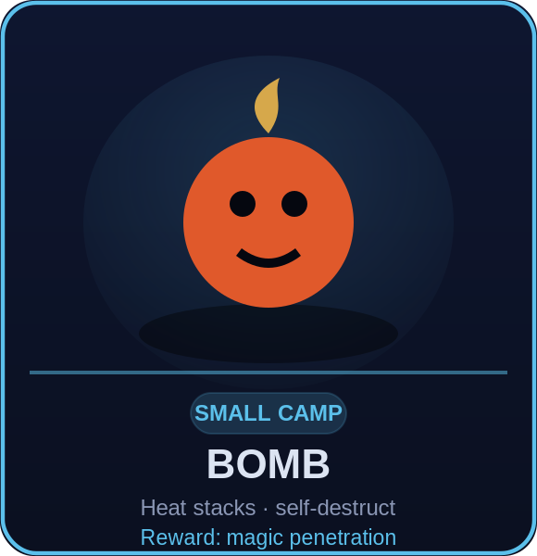 |  | 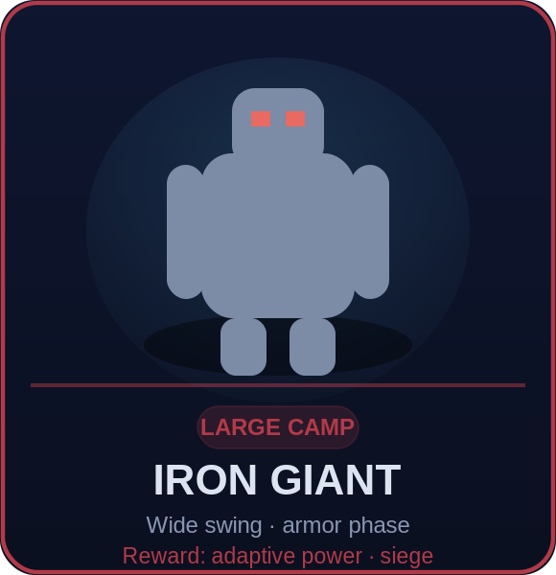
Figure 8.1 — Jungle camp tiers (placeholder). Small / Medium / Large exemplars; tier colours cyan / gold / red.
Monster | Tier | Purpose | Signature Mechanic | Reward Theme
Bomb | Small | Magic-oriented farm | Heat stacks and avoidable self-destruct | Short magic-penetration boost
Flan | Small | Resource camp | High physical resistance; slows | Mana/resource recovery
Mu | Small | Rotation camp | Surround and brief retreat | Out-of-combat movement
Floating Eye | Small | Vision camp | Ranged kiting and reveal pulse | Detection radius
Tonberry | Medium | Risk/reward burst prep | Slow pursuit and telegraphed knife | One-use adaptive damage
Coeurl | Medium | Chase camp | Dash and cone lightning | Attack speed and pursuit
Ahriman | Medium | Utility camp | Vision reduction and channelled zone | Ability haste and ward reveal
Sahagin | Medium | River contest | Spear line and water shots | River movement and regeneration
Iron Giant | Large | Push camp | Wide swing, slam, armor phase | Adaptive power and structure damage
Malboro | Large | Debuff defense | Bad Breath cone and poison zones | Reduced next control duration
Behemoth | Large | Offensive contest | Charge, tail sweep, meteor marker | Damage and pursuit burst
Adamantoise | Large | Defensive contest | Shell phase, knockback, vulnerability | Defense and low-health shield

8.2 Camp Rules
- Mirrored camps and equivalent travel distances preserve side fairness.
- Leash, patience, reset, aggro, and smite-like objective tool rules are server-controlled.
- Rewards should usually go to the killer or nearby allies; team-wide rewards are reserved for major objectives.
- Invade routes need vision counterplay and safe beginner routing.
- Spawn composition and reward values are data assets, not prefab constants.

8.3 Goblin Lane Minions
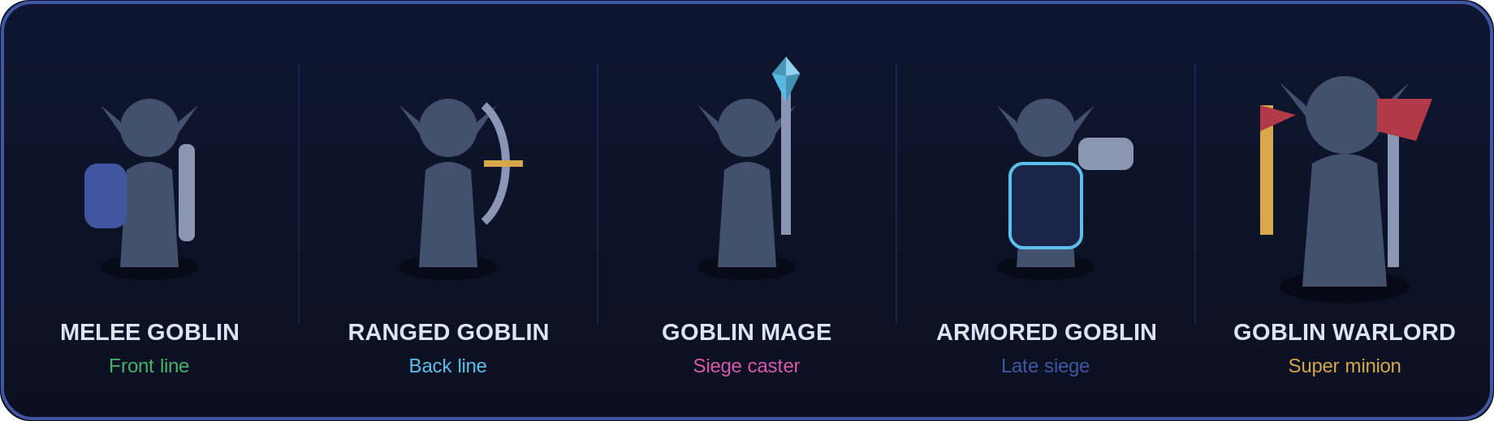
Figure 8.3 — Goblin lane wave (placeholder). Melee, Ranged, Mage, Armored, and the Goblin Warlord super-minion.
Unit | Function | Readability
Melee Goblin | Front line; higher durability, lower damage. | Sword and shield; broad silhouette.
Ranged Goblin | Back line; ranged physical pressure. | Sling or short bow; narrow silhouette.
Goblin Mage | Periodic siege unit with increased structure damage. | Crystal staff and bright projectile.
Armored Goblin | Later-match siege upgrade. | Crystal-powered ram and heavy armor.
Goblin Warlord | Super minion after a lane seal falls. | Large axe, distinct banner, area swing.

9. Launch Character Roster and Ability Kits
The following roster is a proposed licensing and production target, not a rights-cleared commitment. “Source release” identifies the first Japanese release of the associated numbered title, except Final Fantasy XIV, where A Realm Reborn is used for the proposed Y’shtola version. Dates should be revalidated with the rights holder before public materials are published. Ability names and mechanics below are original Project D proposals designed to evoke each character without copying existing game data.

9.1 Roster Overview
Champion | World | Source Release | Role | Core Fantasy
Warrior of Light | FF I | 18 Dec 1987 | Vanguard | Sword/shield protector
Garland | FF I | 18 Dec 1987 | Fighter | Heavy disruptor
Firion | FF II | 17 Dec 1988 | Marksman/Fighter | Weapon-switch skirmisher
The Emperor | FF II | 17 Dec 1988 | Mage | Trap and zone controller
Onion Knight | FF III | 27 Apr 1990 | Assassin/Mage | Adaptive stance diver
Cloud of Darkness | FF III | 27 Apr 1990 | Mage | Void beam controller
Cecil Harvey | FF IV | 19 Jul 1991 | Vanguard/Fighter | Dark-to-paladin stance
Kain Highwind | FF IV | 19 Jul 1991 | Assassin/Fighter | Aerial dragoon engager
Bartz Klauser | FF V | 6 Dec 1992 | Fighter | Job-adaptive generalist
Exdeath | FF V | 6 Dec 1992 | Mage/Vanguard | Void and displacement
Terra Branford | FF VI | 2 Apr 1994 | Mage | Transforming battlemage
Kefka Palazzo | FF VI | 2 Apr 1994 | Mage | Chaotic artillery
Cloud Strife | FF VII | 31 Jan 1997 | Fighter | Limit-building duelist
Sephiroth | FF VII | 31 Jan 1997 | Fighter/Assassin | Long-reach execution
Squall Leonhart | FF VIII | 11 Feb 1999 | Fighter | Timing-based duelist
Ultimecia | FF VIII | 11 Feb 1999 | Mage | Time and space control
Zidane Tribal | FF IX | 7 Jul 2000 | Assassin | Mobile thief
Kuja | FF IX | 7 Jul 2000 | Mage | Combo artillery
Tidus | FF X | 19 Jul 2001 | Fighter/Assassin | Fast tempo skirmisher
Jecht | FF X | 19 Jul 2001 | Fighter | Brawler and finisher
Shantotto | FF XI | 16 May 2002 | Mage | Elemental burst caster
Vaan | FF XII | 16 Mar 2006 | Assassin/Marksman | Opportunistic hybrid
Lightning | FF XIII | 17 Dec 2009 | Fighter/Assassin | Paradigm-style stance
Y'shtola Rhul | FF XIV: A Realm Reborn | 27 Aug 2013 | Support/Mage | Protective spellcaster
Noctis Lucis Caelum | FF XV | 29 Nov 2016 | Assassin/Fighter | Warp-weapon diver
Clive Rosfield | FF XVI | 22 Jun 2023 | Fighter | Eikonic combo bruiser

9.2 Detailed Champion Concepts

1. Warrior of Light
World and source: FF I; original Japanese release used for this concept: 18 Dec 1987. Proposed role: Vanguard. Core fantasy: Lawful guardian who leads from the front.
- Passive – Crystal Resolve: blocking or controlling an enemy builds Resolve, empowering the next shield.
- Q – Radiant Cut: short sword arc; outer edge deals extra damage.
- W – Shield of Light: directional guard that reduces frontal damage, then releases a light wave.
- E – Vanguard Step: dash to an ally or enemy; enemy arrival briefly displaces.
- Ultimate – Shining Bulwark: creates a protective field and marks nearby enemies to encourage focused defense.
Balance and production notes: Final names, animation references, voice, likeness, VFX motifs, damage types, crowd-control duration, targeting rules, and numerical values require licensor approval, accessibility review, performance testing, and competitive playtesting.

2. Garland
World and source: FF I; original Japanese release used for this concept: 18 Dec 1987. Proposed role: Fighter. Core fantasy: Relentless armored knight built for extended disruption.
- Passive – Cycle of Strife: ability hits grant armor and power, capped and lost after leaving combat.
- Q – Greatblade Reap: broad sweep that pulls edge targets slightly inward.
- W – Iron Advance: unstoppable wind-up into a short charge.
- E – Chain of Ruin: throws a chain blade that slows and enables a recast lunge.
- Ultimate – Chaosbringer: empowers size, reach, and repeated shockwaves for a limited time.
Balance and production notes: Final names, animation references, voice, likeness, VFX motifs, damage types, crowd-control duration, targeting rules, and numerical values require licensor approval, accessibility review, performance testing, and competitive playtesting.

3. Firion
World and source: FF II; original Japanese release used for this concept: 17 Dec 1988. Proposed role: Marksman/Fighter. Core fantasy: Versatile rebel who rotates among weapon ranges.
- Passive – Arsenal Rhythm: using a different ability class grants a stacking adaptive bonus.
- Q – Spearline: piercing thrust with a sweet spot at maximum reach.
- W – Bow Volley: targeted area volley that reveals struck enemies.
- E – Blood Blade: close strike that restores health based on champion damage.
- Ultimate – Wild Rose Arsenal: rapid sequence of weapon projections ending in a controllable finishing shot.
Balance and production notes: Final names, animation references, voice, likeness, VFX motifs, damage types, crowd-control duration, targeting rules, and numerical values require licensor approval, accessibility review, performance testing, and competitive playtesting.

4. The Emperor
World and source: FF II; original Japanese release used for this concept: 17 Dec 1988. Proposed role: Mage. Core fantasy: Patient controller who turns terrain into a trap.
- Passive – Dominion: enemies hit by separate traps become Exposed.
- Q – Thunder Sigil: delayed lightning seal.
- W – Hell Snare: hidden zone that roots after arming, visible at close range.
- E – Imperial Repulse: cone blast that pushes enemies toward prepared zones.
- Ultimate – Pandemonium: creates a large domain where traps arm faster and periodic bolts strike Exposed targets.
Balance and production notes: Final names, animation references, voice, likeness, VFX motifs, damage types, crowd-control duration, targeting rules, and numerical values require licensor approval, accessibility review, performance testing, and competitive playtesting.

5. Onion Knight
World and source: FF III; original Japanese release used for this concept: 27 Apr 1990. Proposed role: Assassin/Mage. Core fantasy: Young adaptable hero who changes between nimble and arcane play.
- Passive – Job Mastery: alternating physical and magical casts improves the next opposite type.
- Q – Swift Blade: dash slash with reset potential on a marked target.
- W – Dualcast: launches two compact magic bolts.
- E – Job Shift: toggle between Ninja mobility and Sage range, modifying Q and W.
- Ultimate – Mastered Jobs: briefly activates both stances and grants a finishing recast.
Balance and production notes: Final names, animation references, voice, likeness, VFX motifs, damage types, crowd-control duration, targeting rules, and numerical values require licensor approval, accessibility review, performance testing, and competitive playtesting.

6. Cloud of Darkness
World and source: FF III; original Japanese release used for this concept: 27 Apr 1990. Proposed role: Mage. Core fantasy: Otherworldly entity that controls lanes with void pressure.
- Passive – Particle Beam: sustained attacks apply Void, increasing beam damage.
- Q – Zero Ray: narrow beam with extended range after charge.
- W – Dark Flood: advancing field that slows.
- E – Unbound Form: brief untargetable drift with no ability casting.
- Ultimate – World of Nothing: expanding void zone that reduces vision and detonates accumulated Void.
Balance and production notes: Final names, animation references, voice, likeness, VFX motifs, damage types, crowd-control duration, targeting rules, and numerical values require licensor approval, accessibility review, performance testing, and competitive playtesting.

7. Cecil Harvey
World and source: FF IV; original Japanese release used for this concept: 19 Jul 1991. Proposed role: Vanguard/Fighter. Core fantasy: Atoning knight who chooses sacrifice or protection.
- Passive – Dual Nature: Dark Knight damage fills a Light gauge; Paladin protection consumes it efficiently.
- Q – Darkness / Holy Edge: health-cost cleave or restorative light slash.
- W – Shadow March / Cover: pressure aura or leap to shield an ally.
- E – Nightfall / Radiant Chain: slow field or tether that shares protection.
- Ultimate – Redemption: transforms stance, cleanses Cecil, and empowers that stance for a limited window.
Balance and production notes: Final names, animation references, voice, likeness, VFX motifs, damage types, crowd-control duration, targeting rules, and numerical values require licensor approval, accessibility review, performance testing, and competitive playtesting.

8. Kain Highwind
World and source: FF IV; original Japanese release used for this concept: 19 Jul 1991. Proposed role: Assassin/Fighter. Core fantasy: Aerial initiator with commitment and precise landing zones.
- Passive – Dragoon’s Poise: movement toward isolated enemies grants speed.
- Q – Lancet Thrust: linear stab that heals against champions.
- W – Vault: short hop over terrain with a landing strike.
- E – Dragon Pin: spear toss that marks and slows.
- Ultimate – High Jump: leaves the battlefield, selects a visible landing area, then crashes down and knocks up.
Balance and production notes: Final names, animation references, voice, likeness, VFX motifs, damage types, crowd-control duration, targeting rules, and numerical values require licensor approval, accessibility review, performance testing, and competitive playtesting.

9. Bartz Klauser
World and source: FF V; original Japanese release used for this concept: 6 Dec 1992. Proposed role: Fighter. Core fantasy: Flexible adventurer whose borrowed jobs answer the match.
- Passive – Freelancer: gains small bonuses from different item categories.
- Q – Spellblade Arc: choose a temporary element with distinct secondary effect.
- W – Ranger Step: mobile ranged strike.
- E – Guard Job: brief stance that converts part of incoming damage into speed.
- Ultimate – Job Parade: cycles three empowered job actions chosen from a pre-match loadout.
Balance and production notes: Final names, animation references, voice, likeness, VFX motifs, damage types, crowd-control duration, targeting rules, and numerical values require licensor approval, accessibility review, performance testing, and competitive playtesting.

10. Exdeath
World and source: FF V; original Japanese release used for this concept: 6 Dec 1992. Proposed role: Mage/Vanguard. Core fantasy: Immovable void tyrant who punishes poor positioning.
- Passive – Rooted in the Void: standing ground increases defenses; moving releases stored void energy.
- Q – Black Branch: line of dark roots that erupts after a delay.
- W – Gravity Well: pulls units toward its center.
- E – Void Gate: paired short portals for projectiles and one champion passage.
- Ultimate – Grand Cross: large patterned zone with sequential, avoidable detonations and debuffs.
Balance and production notes: Final names, animation references, voice, likeness, VFX motifs, damage types, crowd-control duration, targeting rules, and numerical values require licensor approval, accessibility review, performance testing, and competitive playtesting.

11. Terra Branford
World and source: FF VI; original Japanese release used for this concept: 2 Apr 1994. Proposed role: Mage. Core fantasy: Ranged battlemage who builds toward a dangerous transformation.
- Passive – Esper Resonance: spell hits generate Trance; excess charge enhances the next basic spell.
- Q – Fire Lance: piercing flame projectile.
- W – Graviga Field: slows and draws enemies slightly toward center.
- E – Protective Magic: shield that bursts if broken.
- Ultimate – Trance: gains flight-like movement, range, and modified spells for a short duration.
Balance and production notes: Final names, animation references, voice, likeness, VFX motifs, damage types, crowd-control duration, targeting rules, and numerical values require licensor approval, accessibility review, performance testing, and competitive playtesting.

12. Kefka Palazzo
World and source: FF VI; original Japanese release used for this concept: 2 Apr 1994. Proposed role: Mage. Core fantasy: Unpredictable artillery mage with deceptive zones.
- Passive – Madcap: every third spell leaves a short-lived hazardous afterimage.
- Q – Jester Bolt: zigzag projectile with a readable path.
- W – False Gift: places a suspicious pickup that explodes for enemies or grants a small ally effect.
- E – Havoc Hop: short evasive leap leaving a damaging patch.
- Ultimate – Light of Ruin: paints multiple warning lines, then fires them in sequence.
Balance and production notes: Final names, animation references, voice, likeness, VFX motifs, damage types, crowd-control duration, targeting rules, and numerical values require licensor approval, accessibility review, performance testing, and competitive playtesting.

13. Cloud Strife
World and source: FF VII; original Japanese release used for this concept: 31 Jan 1997. Proposed role: Fighter. Core fantasy: Heavy-sword duelist who converts pressure into a finishing window.
- Passive – Limit Gauge: taking and dealing champion damage builds Limit; full Limit modifies one basic ability.
- Q – Cross Slash: three-part directional combo.
- W – Braver: committed leap strike with bonus center damage.
- E – Counterstance: braces, reducing damage and enabling a retaliatory sweep.
- Ultimate – Omnisurge: locks a nearby target area and performs a short multi-hit sequence; enemies can peel or exit before the final hit.
Balance and production notes: Final names, animation references, voice, likeness, VFX motifs, damage types, crowd-control duration, targeting rules, and numerical values require licensor approval, accessibility review, performance testing, and competitive playtesting.

14. Sephiroth
World and source: FF VII; original Japanese release used for this concept: 31 Jan 1997. Proposed role: Fighter/Assassin. Core fantasy: Long-reach threat who isolates weakened targets.
- Passive – One-Wing Pressure: hitting at maximum weapon range grants a brief speed and reach rhythm bonus.
- Q – Masamune Line: precise line thrust.
- W – Shadow Flare: orbiting orbs that fire after a delay.
- E – Skyward Cut: launches a nearby enemy and enables an aerial follow-up.
- Ultimate – Fallen Star: marks a large zone; delayed impact damages and applies a short vulnerability, with ample warning.
Balance and production notes: Final names, animation references, voice, likeness, VFX motifs, damage types, crowd-control duration, targeting rules, and numerical values require licensor approval, accessibility review, performance testing, and competitive playtesting.

15. Squall Leonhart
World and source: FF VIII; original Japanese release used for this concept: 11 Feb 1999. Proposed role: Fighter. Core fantasy: Close duelist rewarded for exact input timing.
- Passive – Trigger Window: basic attacks display a short timing cue; successful taps add modest bonus damage, with accessibility auto mode at lower efficiency.
- Q – Renzokuken Step: dash strike that primes Trigger.
- W – Draw Guard: absorbs a spell fragment and grants a temporary resistance based on damage type.
- E – Rough Divide: low-health gap closer with capped scaling.
- Ultimate – Lionheart Sequence: targeted combo with directional final slash and interrupt counterplay.
Balance and production notes: Final names, animation references, voice, likeness, VFX motifs, damage types, crowd-control duration, targeting rules, and numerical values require licensor approval, accessibility review, performance testing, and competitive playtesting.

16. Ultimecia
World and source: FF VIII; original Japanese release used for this concept: 11 Feb 1999. Proposed role: Mage. Core fantasy: Late-scaling control mage who delays and reorders danger.
- Passive – Time Compression: abilities leave temporal echoes that repeat at reduced strength.
- Q – Sorceress Bolt: accelerating projectile.
- W – Delayed Fate: marks a zone that detonates, then briefly rewinds its boundary for a second pulse.
- E – Time Snare: slow that intensifies if the target keeps moving.
- Ultimate – Compressed Hour: creates a domain where enemy cooldown recovery and movement are briefly hindered, within strict balance caps.
Balance and production notes: Final names, animation references, voice, likeness, VFX motifs, damage types, crowd-control duration, targeting rules, and numerical values require licensor approval, accessibility review, performance testing, and competitive playtesting.

17. Zidane Tribal
World and source: FF IX; original Japanese release used for this concept: 7 Jul 2000. Proposed role: Assassin. Core fantasy: Playful roaming assassin who steals tempo rather than inventory.
- Passive – Thief’s Cunning: striking from a new direction grants speed and a small gold-neutral combat bonus.
- Q – Twinblade Dash: passes through a target and marks the exit side.
- W – Mug: quick hit that steals movement speed, never currency or items.
- E – Swing Line: grapples to terrain or a marked unit.
- Ultimate – Trance Rush: gains enhanced mobility and a short finishing combo against marked enemies.
Balance and production notes: Final names, animation references, voice, likeness, VFX motifs, damage types, crowd-control duration, targeting rules, and numerical values require licensor approval, accessibility review, performance testing, and competitive playtesting.

18. Kuja
World and source: FF IX; original Japanese release used for this concept: 7 Jul 2000. Proposed role: Mage. Core fantasy: Elegant combo mage who stages escalating magical performances.
- Passive – Crescendo: distinct spell hits advance a three-step performance; completion empowers the next cast.
- Q – Flare Note: explosive projectile.
- W – Ring of Thorns: circular zone with a safe center that changes on empowered cast.
- E – Regal Drift: glide that allows one basic spell while moving.
- Ultimate – Ultima Performance: channels a series of expanding notes, ending in a high-impact but interruptible blast.
Balance and production notes: Final names, animation references, voice, likeness, VFX motifs, damage types, crowd-control duration, targeting rules, and numerical values require licensor approval, accessibility review, performance testing, and competitive playtesting.

19. Tidus
World and source: FF X; original Japanese release used for this concept: 19 Jul 2001. Proposed role: Fighter/Assassin. Core fantasy: Fast skirmisher who accelerates allies and disrupts slow formations.
- Passive – Blitz Tempo: moving and hitting builds Tempo, improving attack cadence.
- Q – Quick Hit: short targeted dash with low damage and good rhythm.
- W – Cheer: brief team movement and attack-speed aura.
- E – Jecht Shot: charged ball strike that knocks aside nearby secondary enemies.
- Ultimate – Spiral Break: curving dash sequence ending in a knock-up at the selected point.
Balance and production notes: Final names, animation references, voice, likeness, VFX motifs, damage types, crowd-control duration, targeting rules, and numerical values require licensor approval, accessibility review, performance testing, and competitive playtesting.

20. Jecht
World and source: FF X; original Japanese release used for this concept: 19 Jul 2001. Proposed role: Fighter. Core fantasy: Aggressive brawler who thrives under pressure.
- Passive – Brash Momentum: close-range hits build Momentum; crowd control removes part, not all.
- Q – Heavy Hook: short punch and shoulder follow-up.
- W – Guard Break: overhead strike that reduces shields and defenses temporarily.
- E – Rushdown: advancing stance with controlled direction.
- Ultimate – Final Shot: dramatic projectile kick that carries the first champion hit toward a marked impact zone.
Balance and production notes: Final names, animation references, voice, likeness, VFX motifs, damage types, crowd-control duration, targeting rules, and numerical values require licensor approval, accessibility review, performance testing, and competitive playtesting.

21. Shantotto
World and source: FF XI; original Japanese release used for this concept: 16 May 2002. Proposed role: Mage. Core fantasy: Compact elemental mage with sharp burst sequencing.
- Passive – Elemental Chain: alternating elements applies a chain bonus.
- Q – Fire: focused explosion.
- W – Blizzard: slowing shard fan.
- E – Thunder: delayed target-area strike.
- Ultimate – Ancient Magic: select one of three amplified elemental finishes, shown to enemies during wind-up.
Balance and production notes: Final names, animation references, voice, likeness, VFX motifs, damage types, crowd-control duration, targeting rules, and numerical values require licensor approval, accessibility review, performance testing, and competitive playtesting.

22. Vaan
World and source: FF XII; original Japanese release used for this concept: 16 Mar 2006. Proposed role: Assassin/Marksman. Core fantasy: Opportunistic hybrid who changes range to exploit openings.
- Passive – Freebooter: damaging a recently controlled or isolated enemy grants a brief adaptive bonus.
- Q – Dagger Rush: close dash and retreat option.
- W – Crossbow Snap: quick ranged shot that marks.
- E – Mist Step: reposition to the side of a marked enemy.
- Ultimate – Quickening Chain: player chooses up to three rapid actions under a short input window, with predictable variants.
Balance and production notes: Final names, animation references, voice, likeness, VFX motifs, damage types, crowd-control duration, targeting rules, and numerical values require licensor approval, accessibility review, performance testing, and competitive playtesting.

23. Lightning
World and source: FF XIII; original Japanese release used for this concept: 17 Dec 2009. Proposed role: Fighter/Assassin. Core fantasy: Disciplined stance fighter who switches between assault, pressure, and support.
- Passive – Paradigm Flow: changing stance after casting refunds a small portion of the next basic cooldown.
- Q – Commando Strike: direct physical line attack.
- W – Ravager Bolt: ranged magic that amplifies stagger-like pressure.
- E – Medic Guard: small self/ally heal and cleanse with long cooldown.
- Ultimate – Army of One: rapid movement sequence that consumes built pressure for a final area strike.
Balance and production notes: Final names, animation references, voice, likeness, VFX motifs, damage types, crowd-control duration, targeting rules, and numerical values require licensor approval, accessibility review, performance testing, and competitive playtesting.

24. Y'shtola Rhul
World and source: FF XIV: A Realm Reborn; original Japanese release used for this concept: 27 Aug 2013. Proposed role: Support/Mage. Core fantasy: Calm protective caster who controls safe space.
- Passive – Aetheric Insight: abilities reveal affected terrain and build Aether.
- Q – Stone Line: earth projectile that slows.
- W – Aetherial Ward: placed shield zone for allies.
- E – Flow: short reposition to an allied ward or champion, consuming Aether.
- Ultimate – Scion’s Sanctuary: large protective circle that reduces incoming burst and ends with a measured heal.
Balance and production notes: Final names, animation references, voice, likeness, VFX motifs, damage types, crowd-control duration, targeting rules, and numerical values require licensor approval, accessibility review, performance testing, and competitive playtesting.

25. Noctis Lucis Caelum
World and source: FF XV; original Japanese release used for this concept: 29 Nov 2016. Proposed role: Assassin/Fighter. Core fantasy: Royal warp fighter who projects weapons and attacks from unexpected angles.
- Passive – Royal Arms: ability casts rotate a spectral weapon bonus.
- Q – Warp Strike: throws a blade and recasts to warp to it or the struck target.
- W – Phased Guard: brief damage avoidance that consumes resource.
- E – Armiger Arc: spectral weapons sweep a selected sector.
- Ultimate – Armiger Unleashed: orbiting weapons enhance attacks and allow one long-range finishing warp.
Balance and production notes: Final names, animation references, voice, likeness, VFX motifs, damage types, crowd-control duration, targeting rules, and numerical values require licensor approval, accessibility review, performance testing, and competitive playtesting.

26. Clive Rosfield
World and source: FF XVI; original Japanese release used for this concept: 22 Jun 2023. Proposed role: Fighter. Core fantasy: Eikonic bruiser who combines elemental actions into grounded combos.
- Passive – Eikonic Cycle: choose two attuned aspects before the match; alternating their abilities builds Resolve.
- Q – Phoenix Shift: advancing flame strike.
- W – Titanic Block: timed guard that enables a counter.
- E – Garuda Claw: short pull on light targets or self-pull toward heavy targets.
- Ultimate – Ifrit Ascendant: empowered close-combat form with new combo finishers for a limited duration.
Balance and production notes: Final names, animation references, voice, likeness, VFX motifs, damage types, crowd-control duration, targeting rules, and numerical values require licensor approval, accessibility review, performance testing, and competitive playtesting.

9.3 Champion Production Template
- One-page role brief: fantasy, player promise, role, difficulty, strengths, weaknesses, counters.
- Ability specification: input, targeting, range, timing, state machine, interruption, server validation, VFX/audio cues, bot use, accessibility.
- Model package: source, license record, scale, pivot, rig, skeleton version, LODs, materials, textures, collision, sockets.
- Animation set: idle, locomotion, turns, basic chain, abilities, hit reactions, control states, death, recall, emotes.
- QA matrix: terrain behavior, latency, packet loss, cancel windows, untargetability, death interactions, reconnect, low-FPS behavior.
- Telemetry events: cast, hit, miss, interrupt, damage, target type, location, outcome, client performance.

10. Controls, Camera, HUD, and Accessibility

10.1 Mobile Controls
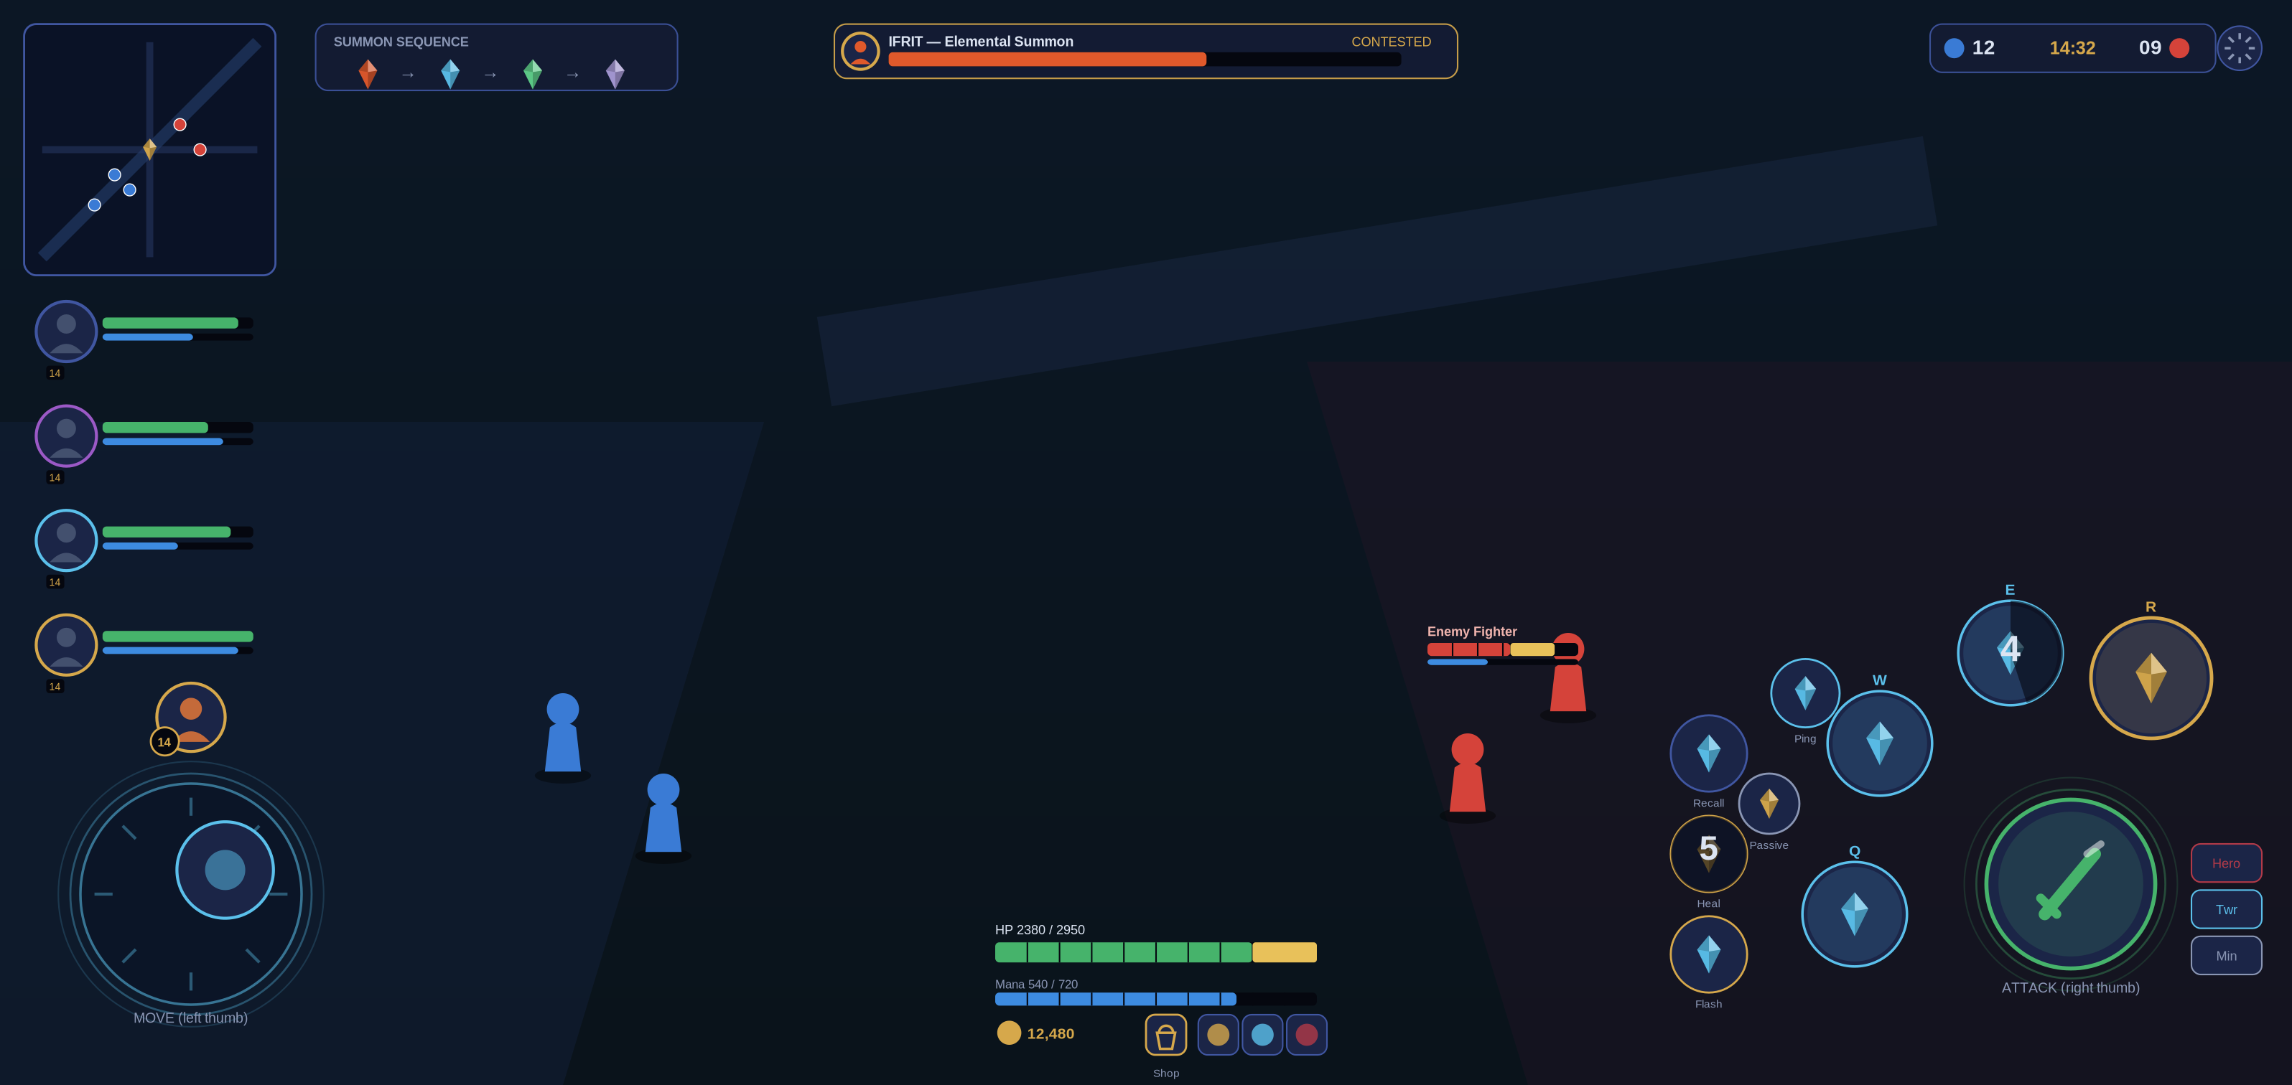
Figure 10.1 — Mobile touch HUD (placeholder). Two-thumb layout: left movement ring; right Attack + Q/W/E/R arc; corners glanceable.
Control | Default Behavior | Options
Movement stick | Left-side floating or fixed virtual stick. | Dead zone, size, position, left-handed layout.
Basic attack | Contextual attack with target priority. | Hero/minion/tower buttons; lock portrait.
Abilities | Right-side buttons with drag aiming and quick cast. | Cancel zones, sensitivity, direction assist.
Camera | Follows hero with edge pan and ability preview. | Pan sensitivity, height presets, shake reduction.
Items/active spell | Compact secondary cluster. | Reorder, resize, hold confirmation.
Communication | Ping wheel, quick chat, objective timers. | Mute categories, text-to-speech where supported.

10.2 HUD Requirements
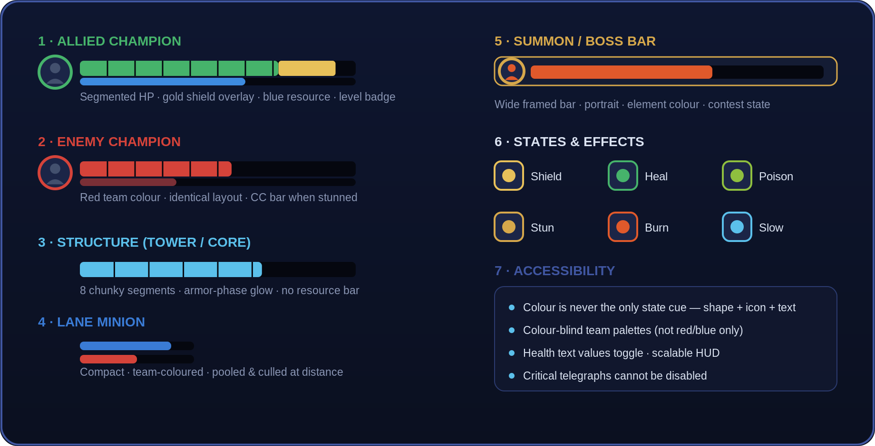
Figure 10.2 — Health-bar & state taxonomy (placeholder). Champion / structure / minion / boss bars; effect chips; accessibility rules.
- Health/resource, level, status effects, ultimate state, inventory, gold, minimap, team state, objective sequence, timers, network quality, and surrender/reconnect states.
- Objective portraits must preview all three elemental summons and indicate Odin unlock conditions.
- Color cannot be the only state indicator. Use icon shape, pattern, position, and text alternatives.
- Damage numbers and non-essential VFX can be reduced. Critical telegraphs cannot be disabled.
- HUD must respect device safe areas, camera cutouts, tablet aspect ratios, and font scaling.

10.3 Accessibility Baseline
- Color-vision presets and team-color customization.
- Subtitle size, speaker labels, background opacity, and captioning for critical sounds.
- Reduced camera shake, flash intensity, motion blur, and screen effects.
- Hold/toggle options, aim assistance, timing accessibility for Squall’s trigger mechanic, and customizable controls.
- Bot modes and tutorial repetition without penalty.
- Plain-language descriptions and practice previews for every ability and item.

11. Progression, Economy, and Monetization

11.1 In-match Economy
Players earn gold and experience through lane participation, last hits or shared rules selected by mode, jungle camps, champion takedowns, structures, and objectives. Comeback systems must reward contested play without deliberately punishing the leading team. Item categories should support attack, magic, defense, movement, utility, and situational counters. All purchasable power resets after each match.

11.2 Account Progression
- Account level unlocks systems and educational rewards, not permanent combat stats.
- Champion mastery records experience and awards cosmetics or profile recognition.
- Ranked seasons provide visible tiers, placement, decay rules where appropriate, and end-of-season cosmetic rewards.
- New players receive a safe starter roster and transparent paths to earn additional champions.

11.3 Monetization Principles
Allowed | Conditional | Prohibited
Champion cosmetics, weapon appearances, recall effects, emotes, profile frames, announcer packs, optional battle pass. | Licensed music, crossover bundles, randomized cosmetic acquisition only if lawful, clearly disclosed, age-appropriate, and approved. | Stat boosts, better matchmaking, paid objective power, paid runes, opaque combat advantages, required spending to remain competitive.

Regional monetization laws, platform rules, probability disclosure, refund handling, parental controls, and consumer-protection requirements must be reviewed before store implementation. A direct-purchase path and duplicate protection are strongly preferred over chance-based acquisition.

12. Modes, Social, Competitive, and Live Operations

12.1 Mode Roadmap
Mode | Players | Purpose | Status
Standard Crystal War | 5v5 | Primary three-lane experience. | Launch target
Ranked Crystal War | 5v5 | Drafted competitive ladder. | Launch or shortly after stability gate
Training Ground | Solo | Ability, item, objective, and control practice. | Launch requirement
Co-op vs AI | 5 humans vs AI | Onboarding and low-pressure play. | Launch requirement
Crystal Clash | 3v3 | Shorter two-lane or compact-map mode. | Post-launch candidate
Summon Rush | Event | Objective-forward rotating rules. | Seasonal candidate
Custom/Tournament | Variable | Scrims, observers, controlled draft. | Competitive roadmap

12.2 Social Systems
- Friends, parties, guild/free-company-style groups subject to terminology approval, recent teammates, block, report, commendations.
- Quick pings are the primary coordination layer. Text and voice chat require moderation, consent, mute, and youth-safety controls.
- Behavior systems must separate reporting from automatic punishment and include review, appeal, evidence retention, privacy limits, and false-report protection.
- Party-size balancing and premade indicators should protect solo players.

12.3 Live Operations
- Use a predictable patch cadence with hotfix capability and server-side tuning.
- Separate balance patches, content updates, events, and emergency fixes in communication.
- Feature flags and staged rollouts reduce blast radius.
- Every season needs a theme, measurable goals, asset plan, localization plan, store plan, and rollback path.
- Do not announce licensed characters, dates, or assets before contractual approval.

13. Art, Animation, VFX, Audio, and Model Pipeline

13.1 Visual Direction
Stylized high-fidelity characters with readable materials, heroic proportions, disciplined effect colors, and an arena that blends crystalline Dissidia motifs with abstracted memories of multiple worlds. The camera distance makes silhouette, pose, timing, and team color more important than small costume detail.

13.2 Existing 3D Model Intake
- Create an asset register recording source, owner, license, permitted territories/platforms, modification rights, expiration, and attribution. Quarantine models without a verified chain of title.
- Normalize units, forward axis, origin, naming, scale, and export settings.
- Audit topology, UVs, texture channels, materials, transparency, bones, blend shapes, animation clips, and hidden geometry.
- Retarget to approved skeletons where possible. Preserve unique anatomy only when it improves the champion and budget allows.
- Generate LOD0–LOD3, mobile collision volumes, VFX sockets, hit boxes, selection radius, ground shadow, and team-color channels.
- Build automated import validation for triangle count, material count, texture size, missing references, rig version, and forbidden shaders.

13.3 Starting Mobile Budgets
Asset | Starting Target | Notes
Hero visible mesh | 25k–60k triangles | Adjust by device tier, silhouette, materials, and on-screen count.
Major summon | 40k–80k triangles | Aggressive LOD and effect scaling; only one major encounter at a time.
Jungle monster | 8k–30k triangles | Share rigs and materials where visually appropriate.
Goblin minion | 3k–10k triangles | Pool aggressively; many units can be visible.
Materials | 1–2 primary per common unit | Use atlases and shared shader variants.
Textures | Importance-based | Do not default every asset to maximum resolution.
VFX | Tiered density | Critical telegraphs remain visible at every quality level.

13.4 Animation and VFX Rules
- Gameplay timing owns animation, not the reverse. Root motion is used only when the server movement model supports it.
- Startup, active, recovery, cancel, and interruption frames are documented per ability.
- Enemy danger uses consistent shapes and timing. Friendly and hostile versions remain distinguishable without relying only on red/blue.
- Large summon cinematics cannot remove player control during a live fight unless all players are safely locked by rule and duration is minimal.
- Use pooled effects, GPU-friendly particles, shader variant control, and overdraw budgets.

13.5 Audio
- Original music and sound design unless separately licensed. Do not use extracted game audio.
- Champion voice requires casting, contracts, union review where applicable, recording specs, localization, and licensor approval.
- Critical ability, objective, low-health, kill, and UI cues need priority mixing and caption alternatives.
- Dynamic music should intensify around summons, Odin, base pressure, and final victory without masking communication.

14. Technology, Networking, Security, and Backend

14.1 Engine Recommendation
Unity is recommended for the first mobile vertical slice because of rapid mobile iteration, mature asset workflows, addressable content, and broad device tooling. Unreal Engine should be selected instead if the existing model, shader, animation, or team expertise materially reduces risk. The decision must be proven through the same benchmark scene on representative low, mid, and high device tiers.
Criterion | Unity Proof | Unreal Proof
Device performance | 10 champions, minion waves, one summon, full VFX. | Same benchmark and thermal run.
Asset pipeline | Model import, LOD, animation retarget, addressables. | Model import, LOD, animation blueprint, asset management.
Networking | Authoritative simulation integration and reconciliation. | Authoritative dedicated server and replication strategy.
Build operations | CI builds, symbols, crash reporting, content delivery. | CI builds, symbols, crash reporting, patch delivery.
Team capability | Available engineers and mobile optimization experience. | Available engineers and Unreal mobile expertise.

14.2 Architecture
- Dedicated authoritative match servers. Clients send inputs and receive validated state.
- Client prediction and reconciliation for movement; lag compensation only where fair and bounded.
- Service separation for identity, entitlement, inventory, matchmaking, rating, parties, chat, telemetry, configuration, and customer support.
- Remote configuration with typed schemas, approval workflow, audit log, versioning, canary rollout, and rollback.
- Content-addressed patching and asset bundles with regional CDN planning.
- Replay system based on authoritative events or snapshots, designed early rather than retrofitted.

14.3 Security and Anti-cheat
- Never trust client-reported damage, cooldown, inventory, movement, or objective ownership.
- Validate input rate, acceleration, ability state, line-of-sight where relevant, target eligibility, economy, and sequence numbers.
- Encrypt transport, protect tokens, rotate secrets, minimize privileges, and isolate production data.
- Use detection layers: impossible-state rules, statistical signals, device integrity signals where lawful, report correlation, and manual review.
- Plan DDoS protection, rate limits, bot detection, secure build pipeline, dependency scanning, and incident response.
- Security controls must respect privacy law and provide appeal paths for enforcement decisions.

14.4 Performance Targets
Metric | Prototype Gate | Release Direction
Frame rate | Stable 30 FPS on declared minimum test device. | 30 FPS minimum mode; stable 60 option on supported tiers.
Thermals | Full-match soak without severe sustained collapse. | Device-tier profile and warning/quality adaptation.
Memory | No out-of-memory in repeated matches. | Headroom for OS variance and social overlays.
Network | Playable under realistic latency, jitter, and packet loss. | Regional targets defined from infrastructure study.
Crash-free sessions | Instrumented and improving each milestone. | Store-quality threshold set by production and platform data.
Load time | Measured from launch, queue, and match entry. | Budgets set per device tier and network condition.

15. Production Plan and Team

15.1 Stage Gates
Stage | Deliverables | Exit Gate
0. Rights and feasibility | Rights outreach, asset chain of title, engine benchmark, budget range, product thesis. | Written permission path; benchmark evidence; approved concept scope.
1. Paper and greybox | Core loop, touch controls, one lane, basic bots, one champion per role. | Fun and readable internal match.
2. Vertical slice | One polished arena sector, 10 champions, goblin wave, camps, one summon, backend skeleton. | Licensor/publisher quality review and mobile performance gate.
3. Pre-alpha | Full map, match flow, 16+ champions, basic progression, telemetry. | Stable team play and content pipeline.
4. Alpha | Target roster, matchmaking, reconnect, social basics, store sandbox, moderation. | Feature complete enough for controlled external tests.
5. Beta/soft launch | Regional operations, scale, retention, balance, device coverage, compliance. | Metrics, stability, and legal gates met.
6. Global release | Certification, localization, support, live-ops calendar, rollback. | Executive, legal, platform, and operational sign-off.

15.2 Disciplines
- Leadership: executive producer, game director, product director, technical director, art director.
- Design: systems, champion, level, economy, UX, narrative, competitive balance.
- Engineering: gameplay, client, server, backend, tools, build/release, security, data.
- Art: concept, character, environment, animation, technical art, VFX, UI, lighting.
- Audio: music, sound design, implementation, voice production.
- Quality: embedded QA, compatibility lab, automation, network testing, localization QA, certification.
- Operations: production, analytics, community, customer support, trust and safety, live operations.
- Business and governance: licensing, legal, privacy, finance, procurement, marketing, regional publishing.

15.3 Backlog Priority for First Playable
- Touch movement, camera, targeting, one basic attack.
- One champion each for Vanguard, Fighter, Assassin, Marksman, Mage, and Support.
- Health, damage, death, respawn, fountain, structures, Crystal Core.
- Goblin minion wave and lane navigation.
- One jungle route with small, medium, and large camps.
- One elemental summon with server-owned reward.
- Dedicated-server match, lobby, reconnect, telemetry, and bot fill.
- Performance overlay, automated build, crash capture, and device test list.

16. Testing and Quality Strategy

16.1 Test Layers
Layer | Coverage
Unit | Damage formulas, cooldowns, buffs, inventory, shuffle bag, objective ownership, serialization.
Integration | Client/server commands, reconnect, matchmaking, entitlements, remote config, store sandbox.
Simulation | Bot-vs-bot balance, economy curves, spawn schedule, pathing, stress, soak.
Functional | Champion interactions, items, map, objective rewards, UI, tutorial, reports.
Compatibility | Devices, OS versions, GPUs, aspect ratios, thermal profiles, memory pressure.
Network | Latency, jitter, loss, reordering, disconnect, server migration policy, regional routing.
Security | Penetration test, abuse cases, cheat attempts, API authorization, dependency and build review.
Accessibility | Control variants, color, text scale, captions, motion settings, assisted timing.
Localization | Expansion, fonts, line breaks, RTL support where planned, voice/text sync, cultural review.
Certification | Apple/Google requirements, privacy labels, purchases, deletion, login, crashes, policy compliance.

16.2 Balance Validation
- Track pick, ban, win, role win, match-up, skill-bracket performance, party effect, objective conversion, item combinations, and side advantage.
- Do not balance from global win rate alone. Segment by role, mastery, rating, region, latency, build, and patch age.
- Use minimum sample thresholds and confidence intervals before routine changes; emergency exploits can bypass normal cadence.
- Keep a balance change log with hypothesis, expected outcome, affected cohorts, telemetry, and rollback criterion.
- Run readability reviews whenever balance changes modify timing, range, or effect density.

16.3 Release-blocking Defects
- Crash, data loss, purchase loss, account compromise, or privacy violation.
- Server desync, objective ownership error, inventory duplication, or competitive exploit.
- Unrecoverable reconnect, stuck match, broken tutorial gate, or certification failure.
- Critical accessibility failure that hides required information.
- Unauthorized asset, missing license, trademark conflict, or prohibited marketing claim.

17. Release, Certification, and Post-launch

17.1 Release Date Policy
The final release date is intentionally listed as TBD. A specific date would be speculative because the project has not established written rights clearance, final engine selection, staffed production capacity, regional server plan, soft-launch evidence, or platform certification. The date may be committed only after the soft-launch exit gate and a joint review by production, engineering, QA, legal/licensing, privacy, security, publishing, customer support, and the rights holder.

17.2 Soft-launch Exit Criteria
- Rights and store metadata approved for the test territories.
- Crash, ANR, server stability, reconnect, purchase, and support metrics meet internally approved thresholds.
- Matchmaking quality and queue health are acceptable by role and party size.
- No severe side advantage or objective-selection defect.
- Retention and session behavior support continued investment without harmful monetization pressure.
- Moderation, privacy requests, refunds, incident response, and customer support operate end to end.
- Content pipeline can sustain the planned cadence without unacceptable overtime or quality decline.

17.3 Store and Certification Checklist
- App identity, signing, bundle IDs, age rating, privacy policy, terms, licenses, account deletion, data safety labels.
- In-app purchase products, restore flow, parental controls, regional pricing, receipts, refund/support paths.
- Third-party SDK inventory, consent, tracking declarations, ad policy if any, child-safety assessment.
- Screenshots and trailers must represent actual gameplay and use only approved assets.
- Offline and degraded-service messaging, maintenance mode, minimum version enforcement, and rollback.
- Symbols, crash reporting, release notes, known issues, customer-support macros, and incident contacts.

17.4 Post-launch Operations
- Daily operational dashboard for stability, matchmaking, economy, security, moderation, and purchases.
- Weekly cross-discipline review; scheduled balance communication; emergency hotfix process.
- Seasonal roadmap with licensor approval lead times and localization capacity.
- Champion releases must include counterplay education and avoid intentional launch over-powering.
- Maintain end-of-life, refund, account export/deletion, and server sunset plans from the start.

18. Legal, Privacy, Safety, and Risk Register

18.1 Mandatory Rights Workstreams
- Trademark and title clearance for “Dissidia: Final Fantasy Ultima Pugma Clamoris” in every intended territory and store.
- Character, creature, summon, world, costume, weapon, logo, likeness, voice, music, sound, animation, and model permissions.
- Written asset chain of title for every provided 3D model and texture.
- License scope: platforms, territories, languages, duration, marketing, esports, merchandise, user-generated content, modifications, sublicensing, and termination.
- Approval workflow and lead times with the rights holder.
- Open-source software notices and obligations; third-party SDK contracts and data processing terms.

18.2 Privacy and Player Safety
- Data minimization, purpose limitation, retention schedules, encryption, access control, deletion/export, breach response, and regional transfer review.
- Age assurance and parental-consent approach appropriate to target regions and features.
- Chat filtering, mute/block/report, human review, appeals, evidence retention, and crisis escalation.
- No dark patterns, coercive countdowns, disguised ads, or monetization that exploits minors or vulnerable users.
- Competitive integrity rules and transparent enforcement categories.

18.3 Key Risks
Risk | Severity | Impact | Mitigation
Rights not secured | Critical | Project cannot lawfully release with proposed IP. | Treat prototype as private; pursue written license; maintain original-IP contingency.
Model provenance unclear | Critical | Takedown, breach, rework, reputational loss. | Asset register, quarantine, legal review, replacement plan.
Scope too large | High | Roster and backend delay quality. | Vertical slice, stage gates, cap launch scope, reuse systems.
Mobile performance | High | Thermals, crashes, poor reviews. | Benchmark early, device tiers, budgets, soak tests.
Combat unreadable | High | Player confusion and accessibility failure. | Effect taxonomy, silhouette review, density settings, playtests.
Objective RNG feels unfair | High | Competitive distrust. | Revealed seeded shuffle bag, no duplicates, audit logs.
Network/cheat risk | High | Unfair matches and churn. | Server authority, validation, monitoring, incident response.
Monetization backlash | High | Trust and regulatory risk. | Cosmetic-led economy, transparent pricing, no paid power.
Content cadence burnout | Medium/High | Quality decline and staff attrition. | Sustainable calendar, tooling, reuse, capacity planning.
Name or cultural issue | Medium/High | Market confusion or rejection. | Trademark, linguistic, cultural, and licensor review.

Appendix A. Core Data Definitions
Entity | Must Be Data-driven
Champion | Identity, role, stats, growth, abilities, costs, cooldowns, targeting, animation/VFX/audio keys, bot tags.
Buff | Source, owner, recipients, duration, stacks, refresh rule, dispel rule, death rule, stat modifiers, UI.
Neutral monster | Tier, stats, scaling, aggro, leash, abilities, rewards, respawn, camp composition.
Objective sequence | Seed, eligible pool, unique count, order reveal, spawn conditions, replacement, audit events.
Item | Recipe, cost, stats, passive uniqueness, active, tags, shop filters, recommended cohorts.
Map object | Team, health, defenses, targeting, invulnerability, bounty, respawn, navigation effect.
Remote configuration | Schema version, environment, approval, rollout cohort, start/end, rollback, audit owner.

Appendix B. Minimum Analytics
- Match: queue, draft, load, start, surrender, remake, disconnect, reconnect, result, duration, side, party, rating cohort.
- Combat: cast, hit, miss, damage, heal, shield, control, death, assist, objective contribution, structure damage.
- Economy: gold source, purchase, sell, build timing, item choice, champion acquisition, cosmetic purchase, refund.
- Experience: tutorial steps, settings, accessibility options, ping use, report, mute, commendation, abandonment reason.
- Performance: device, OS, GPU, memory, FPS distribution, thermal state where available and lawful, crash, ANR, network quality.
- Privacy: consent state and data-governance events must be separated from gameplay analytics and access-controlled.

Appendix C. Vertical Slice Acceptance Gate
☐ Rights posture documented and all slice assets cleared for intended audience.
☐ 10-player dedicated-server match completes with reconnect.
☐ Six role prototypes are playable with bots.
☐ Goblin waves, towers, lane seal, Crystal Core, camps, and one summon function end to end.
☐ Objective ownership and reward are server authoritative and auditable.
☐ Touch controls, target lock, HUD, minimap, item purchase, and tutorial are usable.
☐ Representative mobile benchmark meets agreed frame, memory, thermal, crash, and network budgets.
☐ Art bar demonstrated on one champion, one monster set, one summon, one arena sector, and core UI.
☐ Telemetry, crash capture, build pipeline, feature flags, and rollback are operational.
☐ Licensor/publisher review package includes gameplay capture, asset register, roster plan, budget, schedule assumptions, and risk register.

Appendix D. Glossary
Term | Definition
Adaptive power | A design abstraction that converts to physical or magical scaling based on the recipient’s build; final formula TBD.
Authoritative server | Server decides valid game state rather than trusting the client.
Divine manifestation | Materia, Cosmos, Spiritus, or Chaos major objective at the Rift of the Gods.
Elemental summon | Ifrit, Shiva, Ramuh, Garuda, Titan, or Leviathan objective.
Elder summon | Odin, unlocked after three elemental trials.
Shuffle bag | Randomized selection without replacement, using a match seed and disclosed results.
Lane seal | Project D structure serving the inhibitor-like lane function.
Crystal Core | Primary base objective; destroying it wins the match.
Vertical slice | Small, polished, end-to-end proof of final quality and production pipeline.
Chain of title | Documentation showing lawful ownership and transfer or licensing rights for an asset.

Approval Record
Signatures below indicate review of this concept baseline only. They do not replace a commercial license, legal clearance, platform certification, or production funding approval.
Function | Name | Decision / Date
Project Owner
Game Director
Technical Director
Art Director
Production
Legal / Licensing
Privacy / Security
Rights Holder Representative

END OF CONFIDENTIAL DOCUMENT Project D • Dissidia: Final Fantasy Ultima Pugma Clamoris • Developer codename Zantetsuken • Version 1.0

