PROJECT D
VISUAL CONCEPT ADDENDUM
Dissidia: Final Fantasy Ultima Puga Clamoris • Codename Zantetsuken
CONFIDENTIAL • RESTRICTED DISTRIBUTION • Supplements Game Concept Document v1.0
Addendum v1.1 • 25 August 2026
ORIGINAL PLACEHOLDER ART — RIGHTS NOTICE
Every image here is original vector concept art built for Project D to communicate archetype, readability and HUD layout. It intentionally does not depict any Square Enix character, creature or trademark, so the deck is safe to circulate today and supports the original-IP contingency. Where a licence is in place, the licensed artwork replaces these placeholders through the drop-in slots in Section 8 — once each file carries a recorded chain of title in the asset register, as the LICENSE-NOTICE requires.

How This Addendum Maps to the GCD
This document adds the visual layer requested for the concept baseline: champions, summons, structures, monsters, goblin minions, the mobile touch HUD, and the health-bar system. Each set below is keyed to the section of the Game Concept Document it illustrates, so the images can be dropped straight into the matching chapter.
Visual set | Maps to GCD section | What it shows
Champion role archetypes | §5.2 Roles / §9 Roster | Six team roles with emblem, silhouette, strengths
Elemental summons & elder | §7.1 Summon sequence | Six elements + Odin, domains and team rewards
Structures | §6.2 Structures | Defensive Tower, Lane Seal, Crystal Core
Jungle monsters | §8.1 Neutral camps | Small / Medium / Large camp exemplars
Goblin lane minions | §8.3 Goblin minions | Melee, Ranged, Mage, Armored, Warlord
In-match HUD (mobile/touch) | §10.1 Controls / §10.2 HUD | Two-thumb touch interface with on-screen buttons
Health-bar & state taxonomy | §10.2 / §10.3 | Bar types, effect states, accessibility

1. Champion Role Archetypes
Placeholder silhouettes for the six team roles defined in §5.2. Each card leads with a bold, readable silhouette and a single weapon-emblem so the role is legible at mobile camera distance — the "Mobile Clarity" pillar. Team-colour rim light and role colour carry identity before any costume detail.
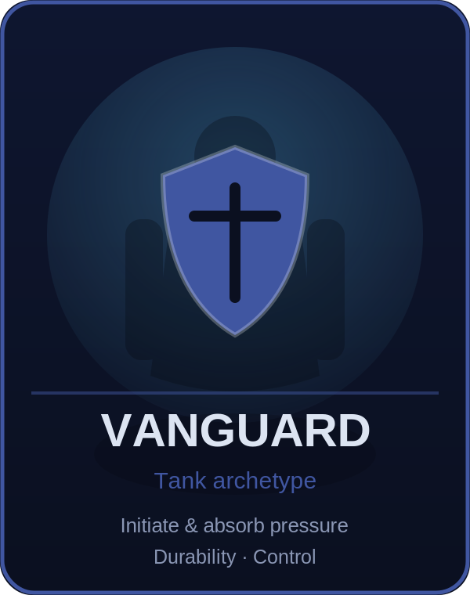 | 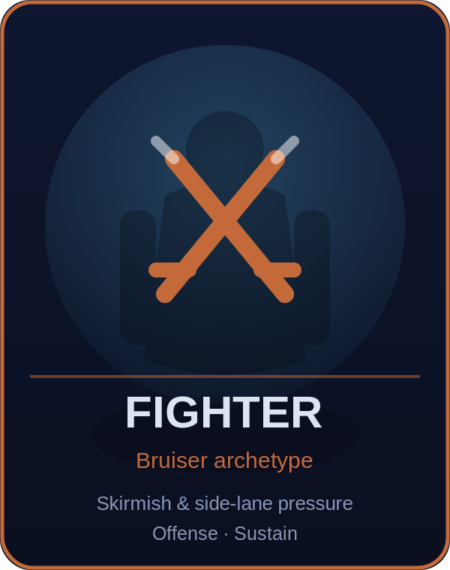 | 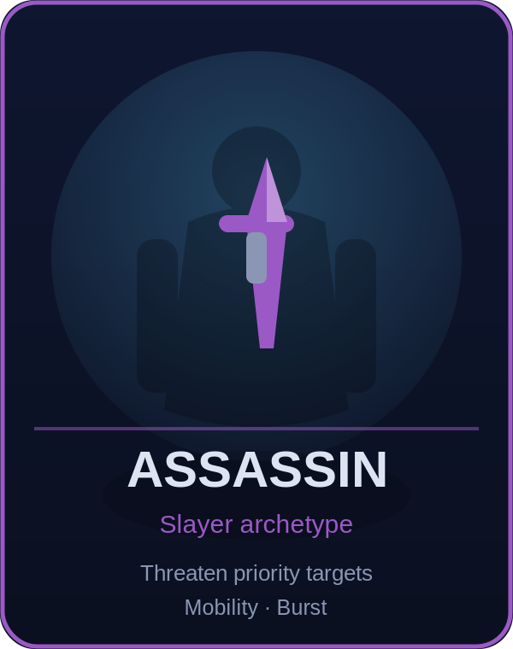
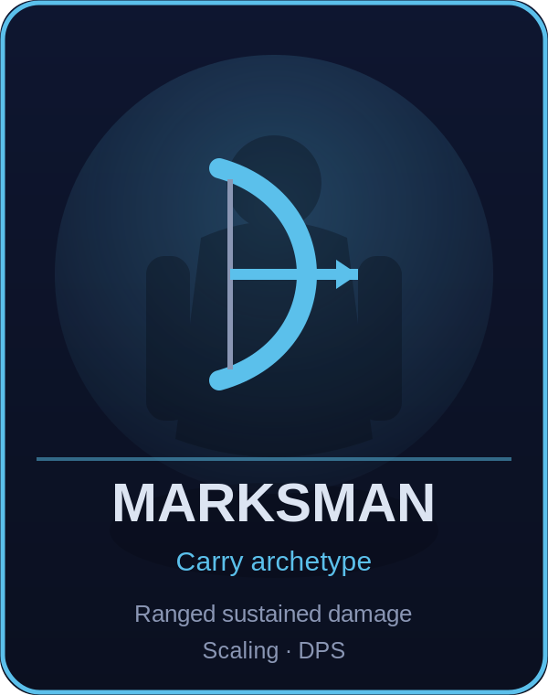 | 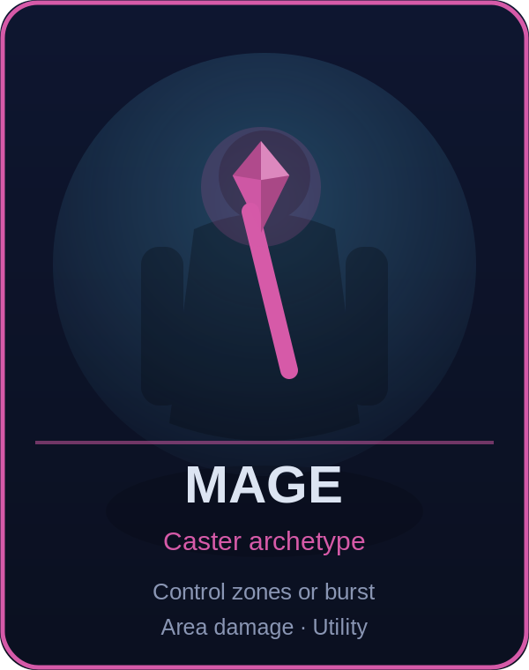 | 
Roster note. These stand in for the 26 proposed champions until licensed models clear review. Silhouette, role colour, and weapon read remain the shipping requirement regardless of final likeness.

2. Elemental Summons & Elder Summon
The six-summon pool (§7.1). At match start the server reveals three of these in a seeded order; after all three trials resolve, the elder summon Odin becomes eligible. Each medallion carries its element colour, domain, and the team reward it grants so both teams can read the objective at a glance.
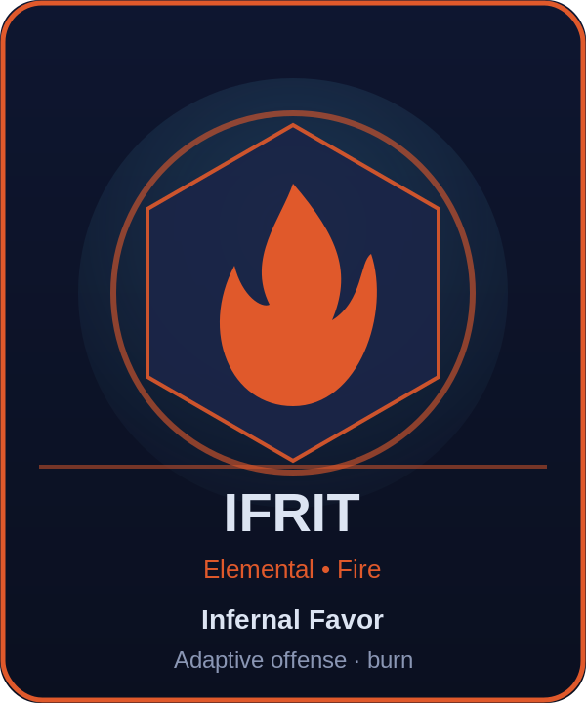 | 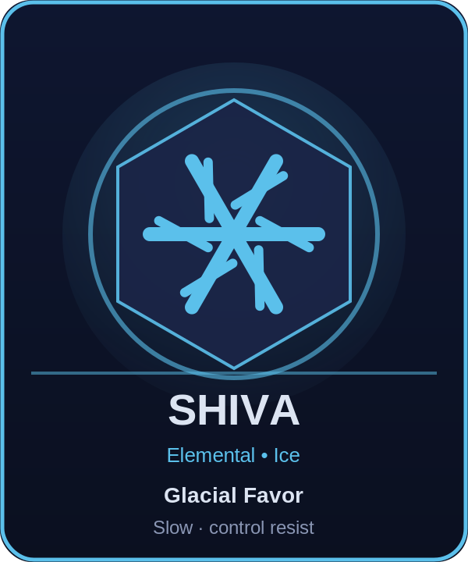 | 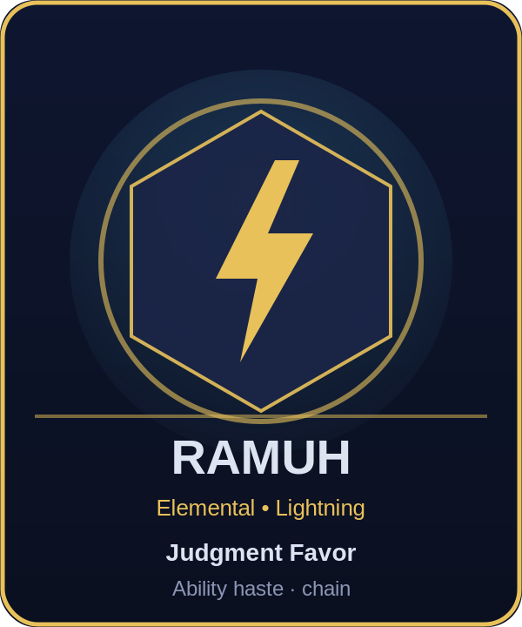 | 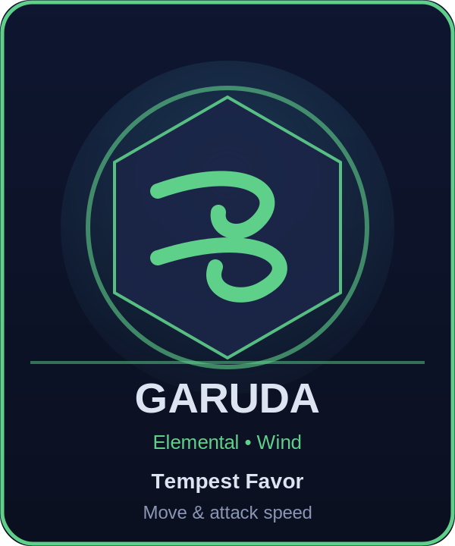
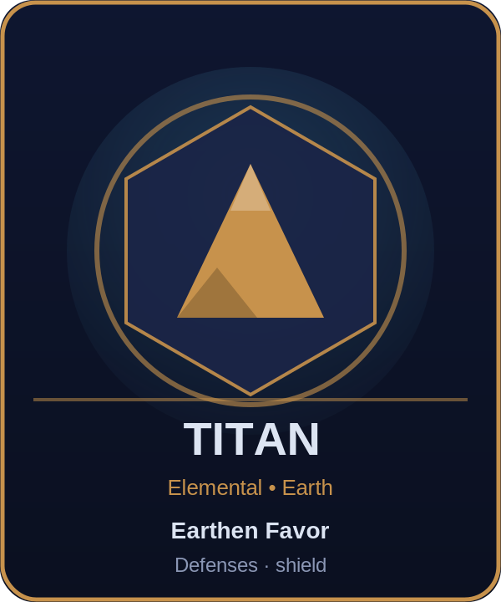 | 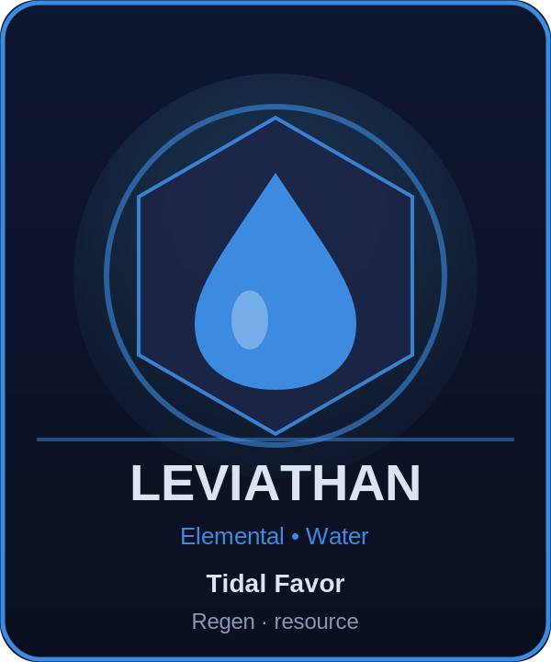 | 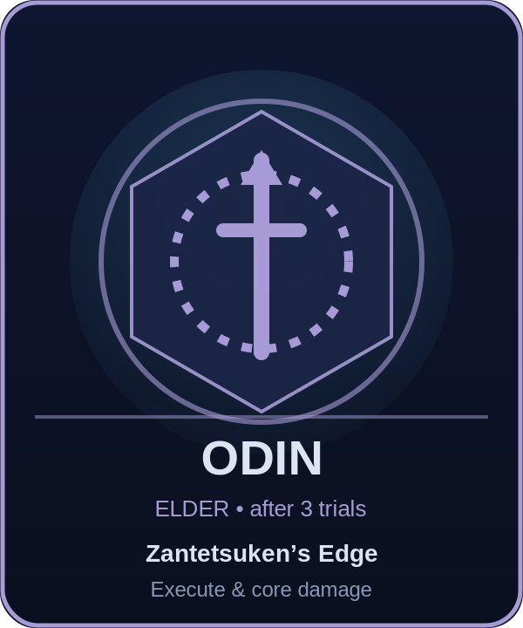
Divine manifestations. The Rift-of-the-Gods blessings (Materia, Cosmos, Spiritus, Chaos) reuse this medallion language with their narrative-domain colours and a countdown, per §7.2.

3. Structures
The lane and base objectives from §6.2, each with its own health-bar treatment. Towers use a cool crystal beacon; the Lane Seal (inhibitor role) is a crystal gate whose fall spawns Goblin Warlords; the Crystal Core is the win condition and only becomes damageable once base defences fall.
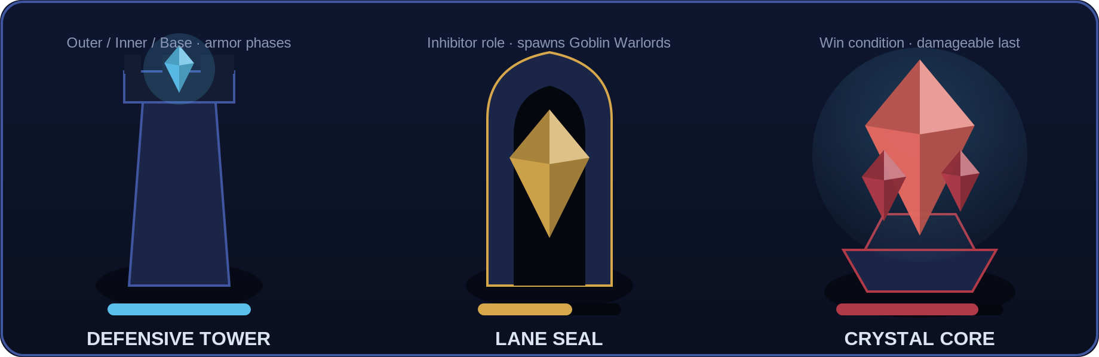
Readability. Structure health uses chunky 8-segment bars (no resource bar) with an armor-phase glow, so siege state is legible from the minimap and at range.
4. Jungle Monsters
Neutral-camp exemplars across the three tiers in §8.1. Small camps feed fast farm, medium camps offer risk/reward buffs, and large camps are team-fight contests. Distinct silhouettes and tier colours (cyan / gold / red) keep camp value obvious.
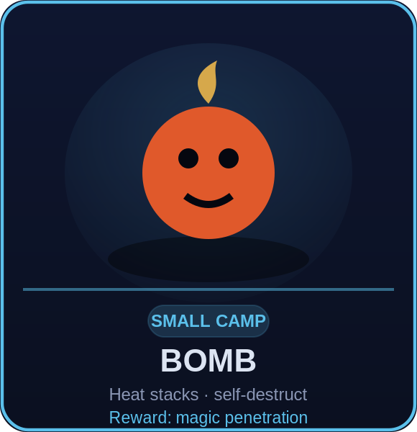 | 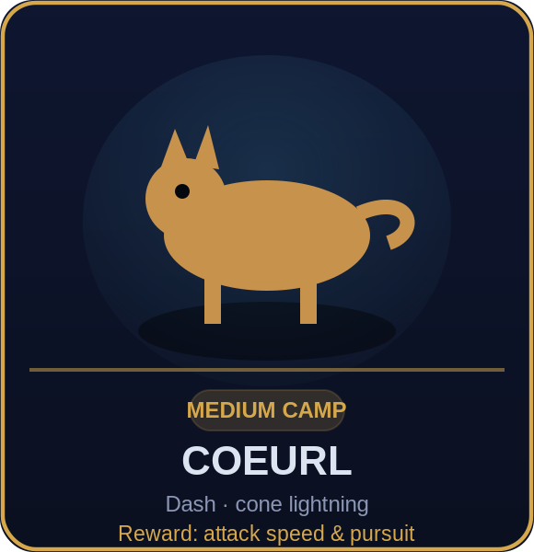 | 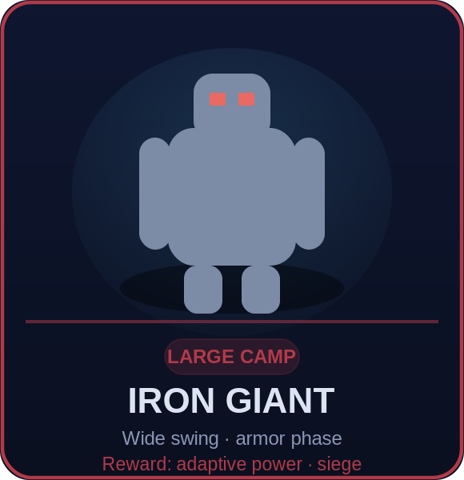
Full roster. Bomb, Flan, Mu, Floating Eye (small); Tonberry, Coeurl, Ahriman, Sahagin (medium); Iron Giant, Malboro, Behemoth, Adamantoise (large) share rigs and materials per the §13.3 budget.

5. Goblin Lane Minions
The lane wave from §8.3. Broad-silhouette melee front line, narrow ranged back line, a bright-projectile siege mage, an armored late-game upgrade, and the banner-carrying Goblin Warlord super-minion that arrives after a Lane Seal falls.
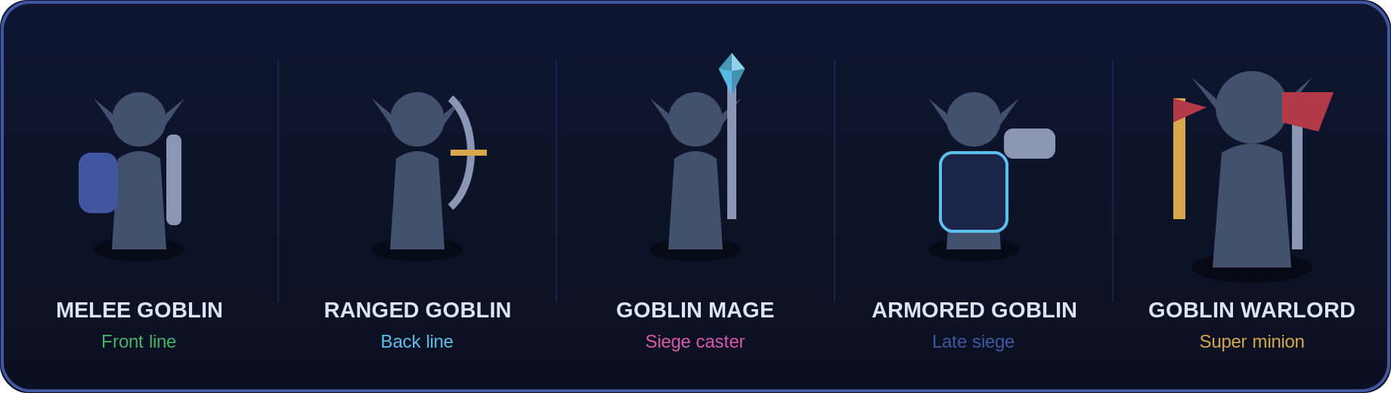
Silhouette rule. Each unit is separable by outline alone (shield, sling, staff, ram, axe-and-banner) so waves stay readable when many are pooled on screen.
6. In-Match HUD (Mobile / Touch)
This is the combat interface as it appears on a phone in landscape. It follows the two-thumb model set out in §10.1: the left thumb drives a floating movement ring, the right thumb drives the attack button and the four ability buttons arranged in a reachable arc. Nothing sits in the centre of the screen, so the battlefield and all danger telegraphs stay visible during a ten-player fight.
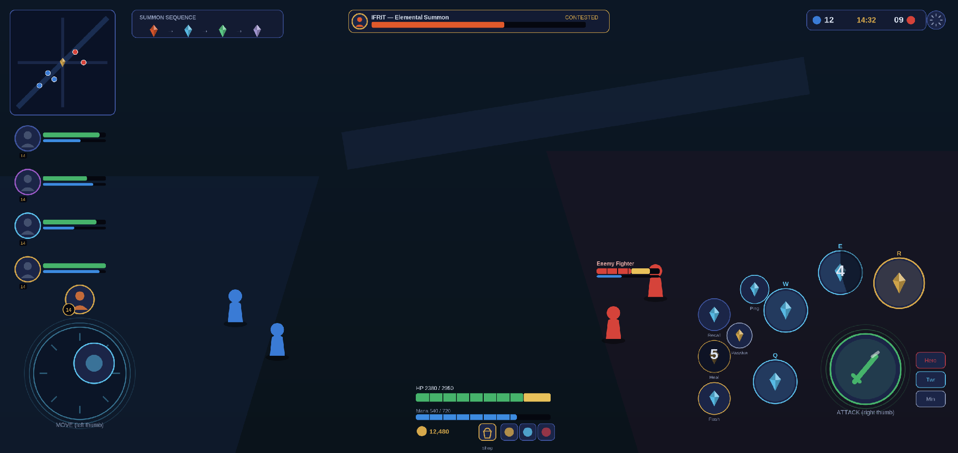
TOUCH CONTROLS — THUMB REACH
Left thumb: floating movement ring (repositions to first touch); dead-zone, size and left-handed mirror are options.
Right thumb: large contextual Attack button, ringed by Passive + Q/W/E/R with drag-to-aim and a radial cooldown sweep; the Ultimate (R) is enlarged and gold.
Reachable cluster: Recall, two summoner spells and the ping button tuck beside the ability arc; a Hero / Turret / Minion target-lock toggle sits under the thumb.
Glanceable edges: minimap top-left, summon sequence and boss bar top-centre, score and timer top-right, self HP / mana / gold / shop along the bottom-centre — corners only, never the play space.

7. Health-Bar & State Taxonomy
The health-bar system underpinning every unit type, with the accessibility rules from §10.2–§10.3. One consistent grammar covers allied and enemy champions, structures, minions, and summon boss bars, plus the status-effect chips shared across the HUD.
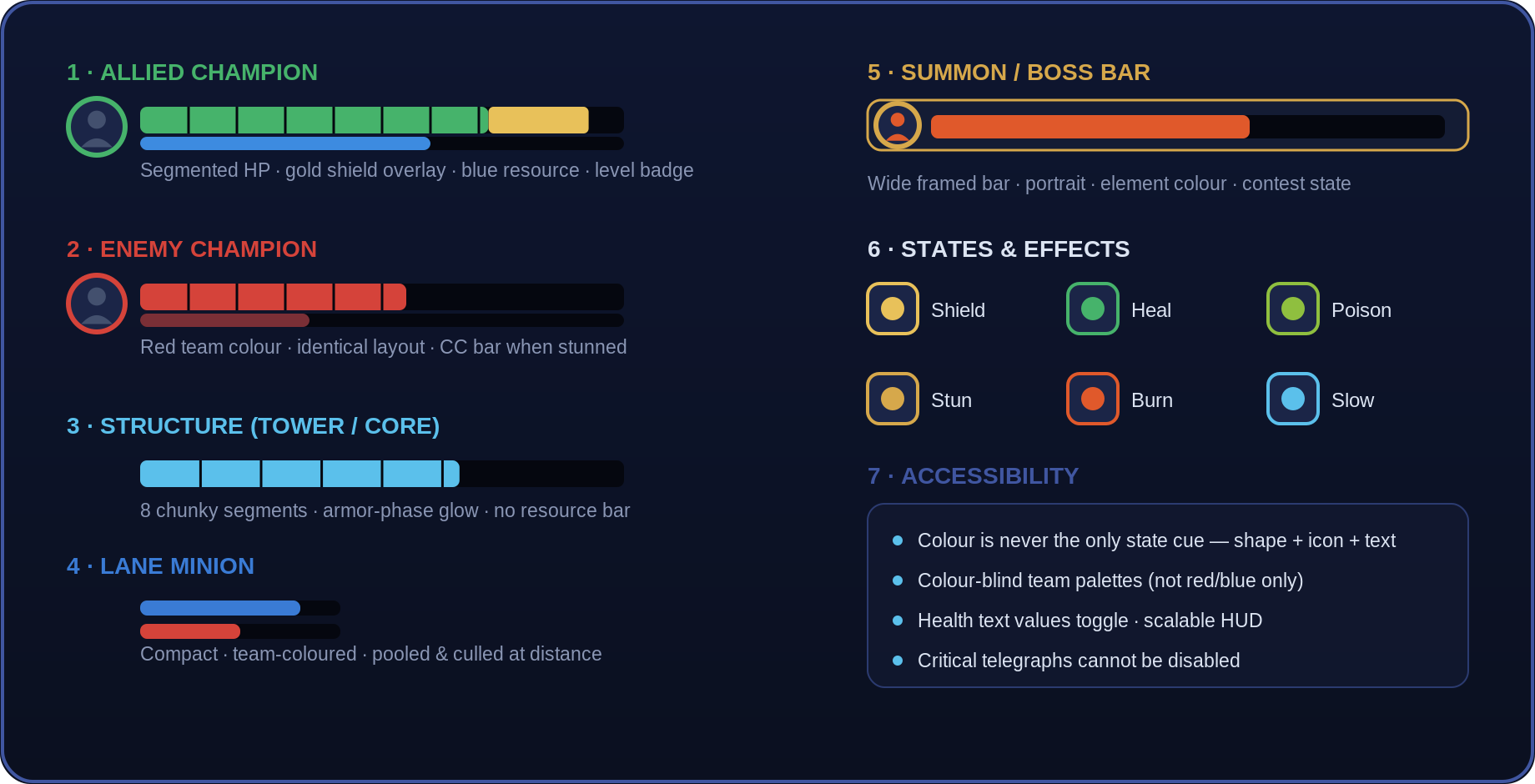
Accessibility baseline. Colour is never the only state cue — shape, icon, and text always accompany it; team palettes are colour-blind-safe; health values and HUD scale are user-toggled; and critical telegraphs can never be disabled.

8. Licensed-Asset Integration Slots
Every image in this addendum is a labelled placeholder. Each one is a drop-in slot: once the licensed Final Fantasy artwork (champion renders, summon portraits, creature art, icons) is supplied as PNG files, it swaps straight into the matching slot below at the same crop and size, and the captions and layout stay intact. Supplying the files is the only step needed — the frames, colours and typography are already built to receive them.
Visual set | Maps to GCD section | What it shows
Champion renders | §9 Roster (26) | One portrait PNG per champion, transparent background preferred
Summon portraits | §7.1 Summons (7) | Ifrit, Shiva, Ramuh, Garuda, Titan, Leviathan, Odin
Creature art | §8.1 Camps (12) | Bomb, Flan, Coeurl, Iron Giant, Behemoth, and the rest
Ability & item icons | §9 kits / §11 shop | Square icon set at a single source resolution
CHAIN-OF-TITLE CHECK BEFORE SWAP
Per the project LICENSE-NOTICE, each licensed file needs a recorded source, owner, permitted platforms/territories and expiry in the asset register before it replaces a placeholder. Keep the original placeholder in version control so the deck can still ship on the original-IP contingency if a specific asset’s rights are ever in question.

9. Summary & Next Steps
This addendum gives the concept baseline the visual layer it was missing: the six roles, the seven summons, the three structures, the jungle tiers, the goblin wave, a touch-first HUD, and one consistent health-bar grammar. Together they satisfy the §13.1 art direction (silhouette, pose and team colour before costume detail) and stand in for the Appendix C art-bar gate — one champion, one monster set, one summon, one arena sector, and the core UI — without depicting any protected likeness.
To take it to the next milestone:
• Drop in the licensed art using the Section 8 slots once files and chain-of-title are ready.
• Merge into the master GCD — fold these visuals into §5–§10 of the main document so the concept and its art live in one file.
• Prototype the touch HUD from the Section 6 layout as the first playable’s control scheme (§15.3 backlog).

