Lab3: Continuous Integration and Delivery using Jenkins
Creacion del jenkinsfile multibranch
// Jenkinsfile (para multibranch CICD)
@Library('epamlab3') _

pipeline {
agent any
environment {
// por defecto, la variable PORT será seteada en 'script' según BRANCH_NAME
IMAGE_NAME = "myapp-${env.BRANCH_NAME}-${env.BUILD_NUMBER}"
}

stages {
stage('Prepare') {
steps {
script {
if (env.BRANCH_NAME == 'master') {
env.APP_PORT = '3000'
} else if (env.BRANCH_NAME == 'dev') {
env.APP_PORT = '3001'
} else {
env.APP_PORT = '3001' // default
}
echo "Branch: ${env.BRANCH_NAME} -> PORT=${env.APP_PORT}"
}
}
}

stage('Checkout') {
steps {
checkout scm
}
}

stage('Build') {
steps {
// Ajusta a tu build: ejemplo Node.js
sh '''
if [ -f package.json ]; then
npm ci
npm run build || true
fi
'''
}
}

stage('Test') {
steps {
sh '''
if [ -f package.json ]; then
npm test --silent || echo "tests may have failed"
fi
'''
}
}

stage('Build Docker Image') {
steps {
script {
sh "docker build -t ${IMAGE_NAME} -f ./Dockerfile ."
}
}
}

stage ('Push and Deploy') {
steps {
dockerPipeline(
image: "${IMAGE_NAME}",
triggerDeploy: true
)
}
}
}

post {
always {
echo "Pipeline finalizado para ${env.BRANCH_NAME}"
}
}
}

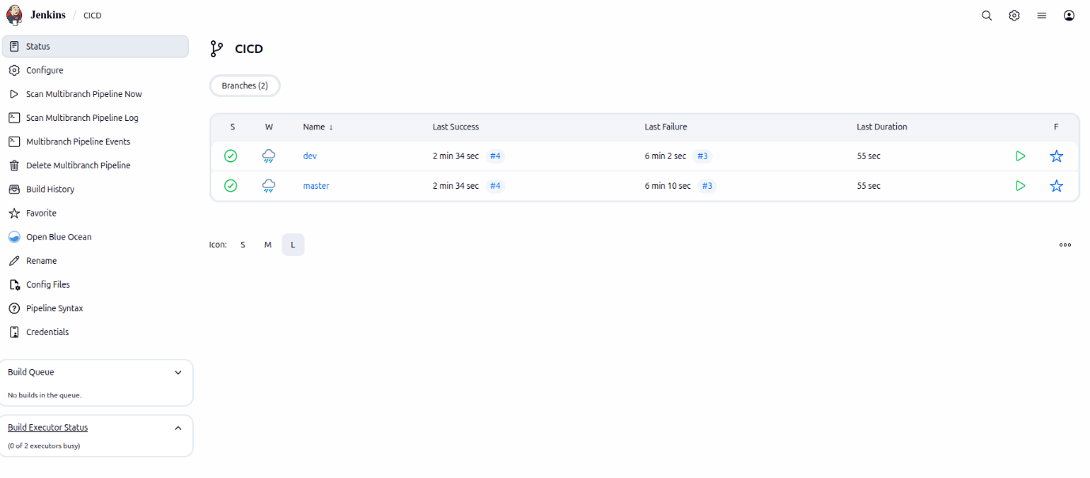
Escenarios de app web con localhost:3000 main branch y localhost:3001 dev branch
Repositorio de GitHub: https://github.com/cmlavaut/epamlab3.git

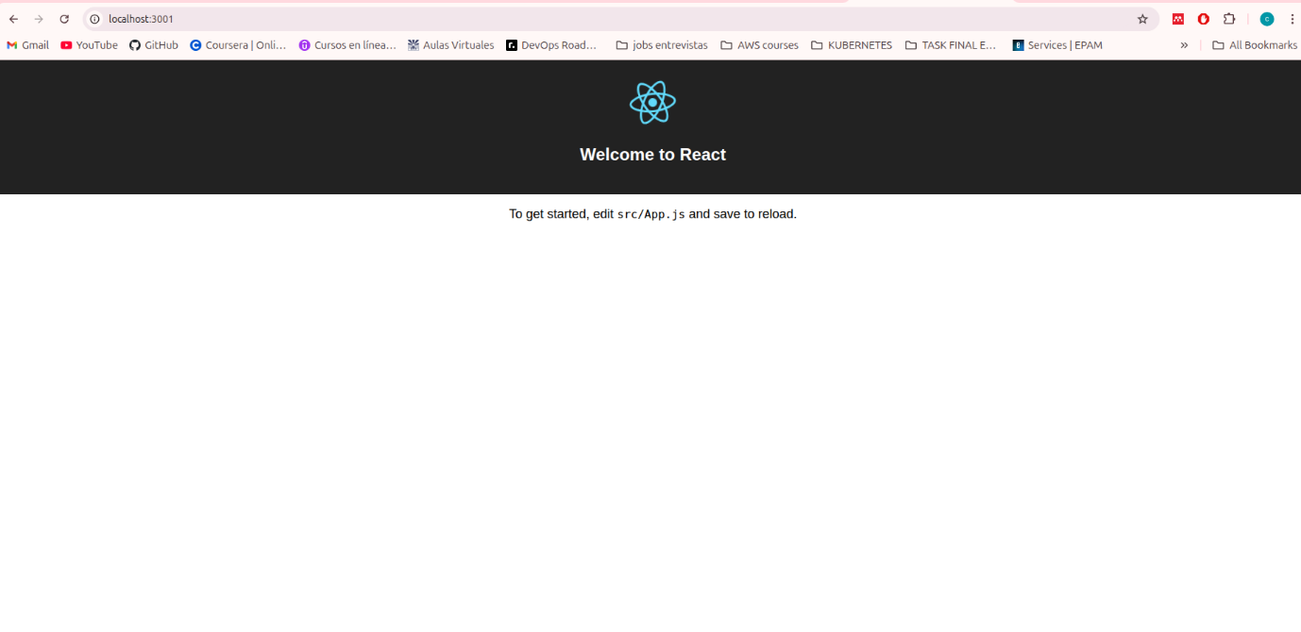
Configuración del dockerPipeline.groovy para utilizarlo en sharedLib Jenkins
def call(Map config) {
pipeline {
agent any

stages {

stage('Login Docker Hub') {
steps {
withCredentials([usernamePassword(credentialsId: 'dockerhub-credentials', usernameVariable: 'USER', passwordVariable: 'PASS')]) {
sh "echo $PASS | docker login -u $USER --password-stdin"
}
}
}

stage('Push Image') {
steps {
sh "docker push ${config.imageName}"
}
}

stage('Trigger Deploy Pipeline') {
when { expression { return config.triggerDeploy } }
steps {
script {
def branch = env.BRANCH_NAME
if (branch == "master") {
build job: "Deploy_to_master", parameters: [string(name: 'IMAGE_NAME', value: config.imageName)]
} else if (branch == "dev") {
build job: "Deploy_to_dev", parameters: [string(name: 'IMAGE_NAME', value: config.imageName)]
}
}
}
}
}
}
}

