Midas – Manual

Midas is a cryptocurrency bot written in Python, that trades all active USDT pairs concurrently from Binance, the largest cryptocurrency exchange.

The implemented trading strategy is obtained from ForexSignals.com. The strategy is a scalping strategy based on the 1-hour and 5-minute charts (Link to [Youtube](https://www.youtube.com/watch?v=zhEukjCzXwM&t=327s) video describing the strategy).

The current implementation only implements uptrend detections and with two fixed Take Profit levels.

Midas can open as many trades as long as there is enough balance in the spot trading account.

# Disclaimer

This software is distributed without any warranty or guarantees of monetary gain. The author is not responsible for any monetary loss from running this software.

# Dependencies

The following dependencies need to be installed for Midas to run correctly.

1. Python3
2. Python libraries:
   1. PySimpleGUI
   2. plotly
   3. pandas
   4. binance
   5. python-binance
   6. requests
   7. wheel
   8. talib
3. Ubuntu Mono font

# Configurations

Configurations can be changed in the config.py file. The following are the descriptions of each configuration:

1. BINANCE_API_KEY / BINANCEE_SECRET_KEY
   1. The Binance Api keys. Enabling spot trading is needed this key.
2. RISK_PERCENT_MIN / RISK_PERCENT_MAX
   1. An open order will only be placed if the risk percentage is within the minimum and maximum defined in this configuration.
3. TRADE_AMOUNT_USD
   1. The order size for each trade in USD.
   2. Note that you will need to place at least 2000 / (100 – RISK_PERCENT_MAX) USD.

# Time Sync

Please ensure that the computer system time is synchronized to internet time before running this software. This can usually be done in the Date and Time settings of the operating system.

# Launching Midas

Open up the Console (Linux / MacOS) / Command Prompt (Windows) and navigate to the project directory.

Run the following command:

python3 app.py

# UI Guide

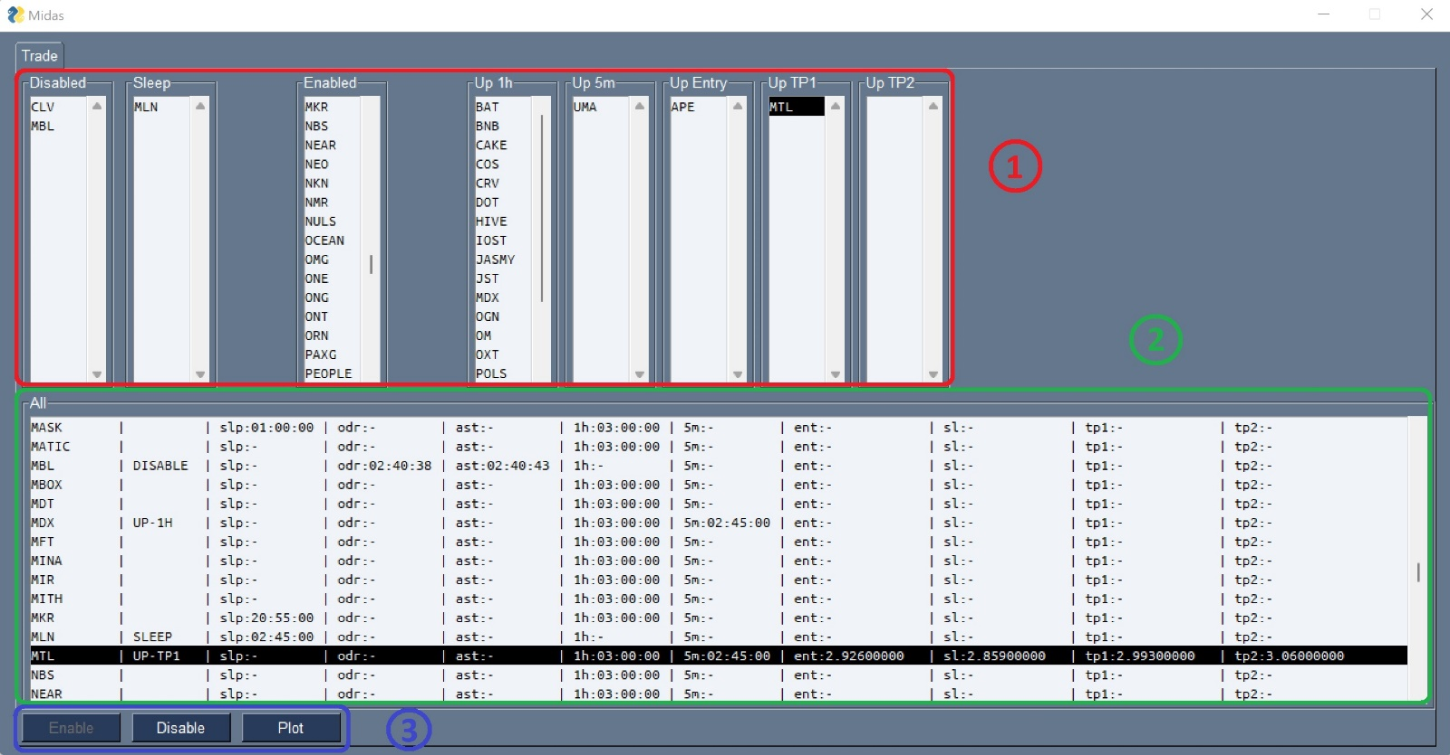

1. State Listbox
   1. Disabled
      1. All currencies in the DISABLE state are listed here.
      2. A currency in the DISABLE state will not be traded.
      3. To Disable a currency, select the pair from any Listbox and press the Disable Button.
   2. Sleep
      1. All currencies in the SLEEP state are listed here.
      2. A currency in the SLEEP state will not be traded temporarily.
      3. A currency will be put in the SLEEP state automatically if an attempt to place a trade for the currency fails (eg. Insufficient balance). This is to prevent the currency from being repeatedly being considered for trade and hence taking up processing power.
   3. Enabled
      1. All currencies in the ENABLE state are listed here
      2. A currency in the ENABLE state will be considered for trade.
      3. All currencies start in the ENABLE state on default. A DISABLED currency can be ENABLED by selecting the Disabled currency form the Disabled Listbox or the All Listbox and press the Enable Button.
   4. Up 1h
      1. All currencies in the UP-1H state are listed here
      2. A currency in the UP-1H state has been identified to have an uptrend in the 1-hour chart as per the trading strategy.
      3. A currency is automatically moved from the Enabled state to the UP-1H state if an uptrend is identified on the 1-hour chart.
   5. Up 5m
      1. All currencies in the UP-5M state are listed here
      2. A currency in the UP-5M state has been identified to have an uptrend in the 5-minute chart as per the trading strategy.
      3. A currency is automatically moved from the UP-1H state to the UP-5M state if an uptrend is identified on the 5-minute chart.
   6. Up Entry
      1. All currencies in the UP-ENTRY state are listed here
      2. A currency in the UP-ENTRY state has an entry trade identified. A currency in this state has a buy order placed and is waiting for the order to be fulfilled.
      3. A currency is automatically moved from the UP-5M state to the UP-ENTRY state if the price has touched 8 EMA on the 5-minute chart.
   7. Up TP1
      1. All currencies in the UP-TP1 state are listed here
      2. A currency in the UP-TP1 state has a sell order placed at the first take profit level as per the trading strategy and is waiting for the order to be fulfilled.
      3. A currency is automatically moved from the UP-ENTRY state to the UP-TP1 state if buy order has been fulfilled.
   8. Up TP2
      1. All currencies in the UP-TP2 state are listed here
      2. A currency in the UP-TP2 state has a sell order placed at the second take profit level as per the trading strategy and is waiting for the order to be fulfilled.
      3. A currency is automatically moved from the UP-TP1 state to the UP-TP2 state if first take profit sell order has been fulfilled.
2. All Listbox
   1. All currency pairs are listed here regardless of their state. It shows further details of each currency in separate columns. The following describes the columns from left to right.
      1. The currency name.
      2. The state of the currency.
      3. The scheduled time at which a currency in the SLEEP state will be put back in the ENABLED state.
      4. The scheduled time at which a currency in the SLEEP or DISABLED state will perform an Order Check. An Order Check is performed to close all open orders for a currency if any.
      5. The scheduled time at which a currency in the SLEEP or DISABLED state will perform an Asset Check. An Asset Check is performed to sell off any currency if there is any.
      6. The scheduled time at which an uptrend check will be performed on the 1-hour chart for a currency. This is scheduled every 1 hour.
      7. The scheduled time at which an uptrend check will be performed on the 5-minute chart for a currency. This is scheduled every 5 minutes.
      8. The entry price.
      9. The stop loss price.
      10. The first take profit price.
      11. The second take profit price.
3. Buttons
   1. Disable
      1. Set a non-DISABLED currency to the DISABLE state.
      2. All open orders and assets will be sold off.
   2. Enable
      1. Set a DISABLED currency to the ENABLE state.
   3. Plot
      1. Plots the 1-hour and 5-minute charts for a currency.

# Chart Plotting

The following shows an example chart generated by Midas.

A chart can be generated manually by pressing the Plot button.

A chart is automatically generated when an Entry order is placed or when an Order is closed / cancelled.

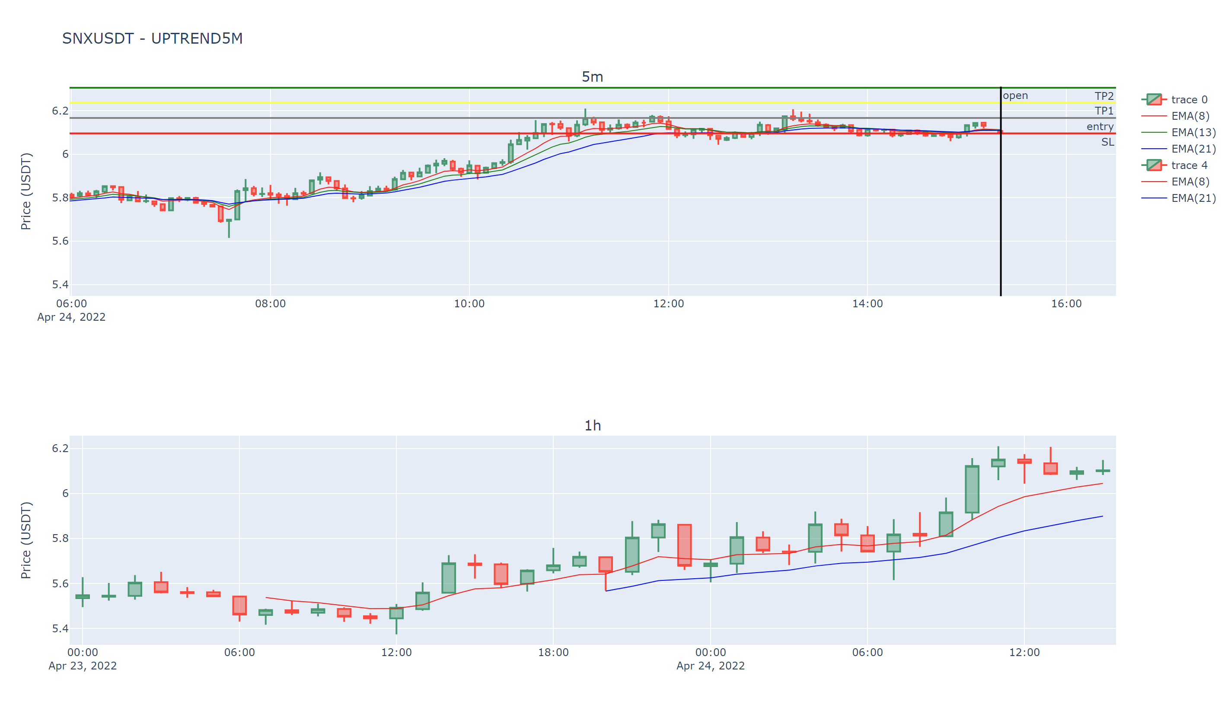

# Logging

Separate log files are generated for each currency in the log folder.

All logs are appended to the file.

All logs are preserved across sessions.

