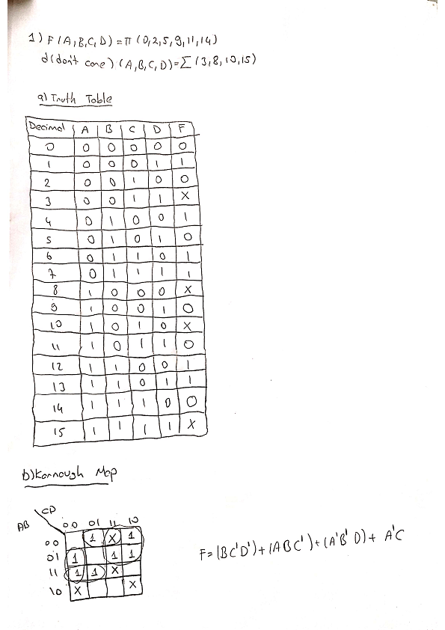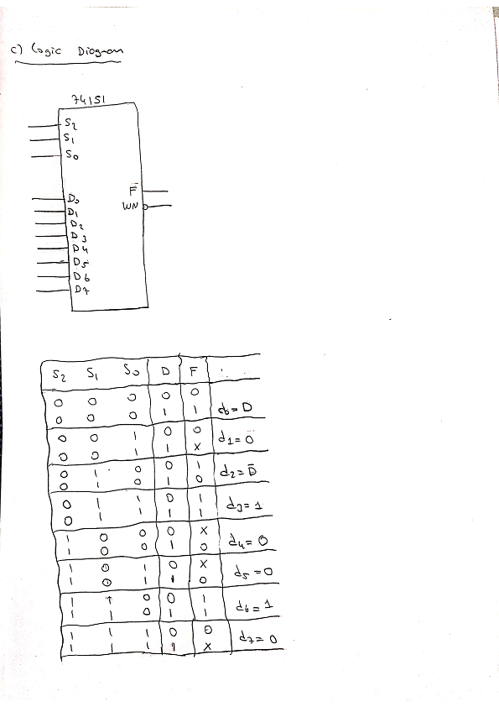

**d)Quartus**

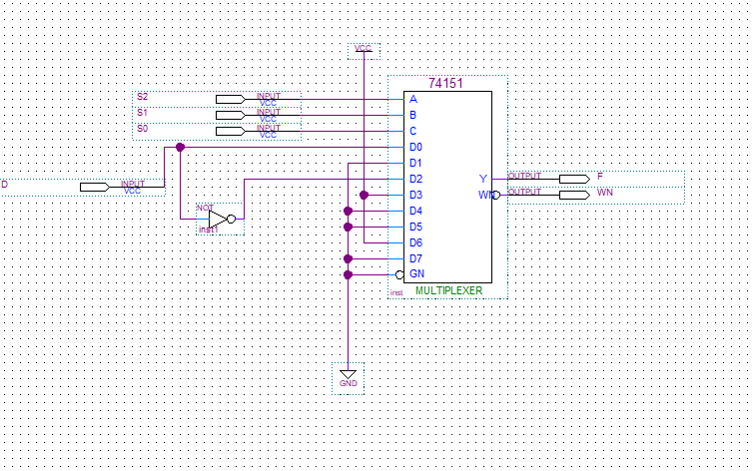

**e)Waveform**

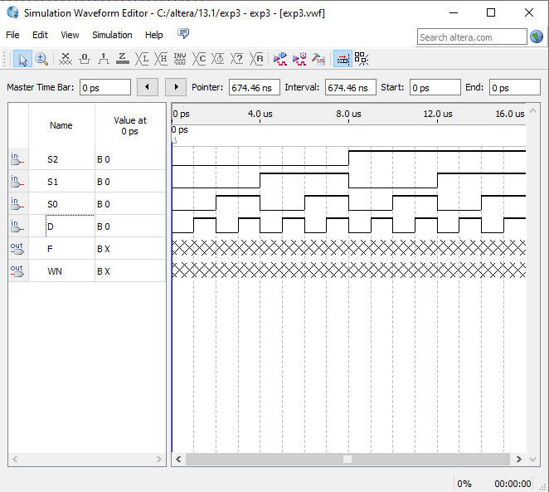

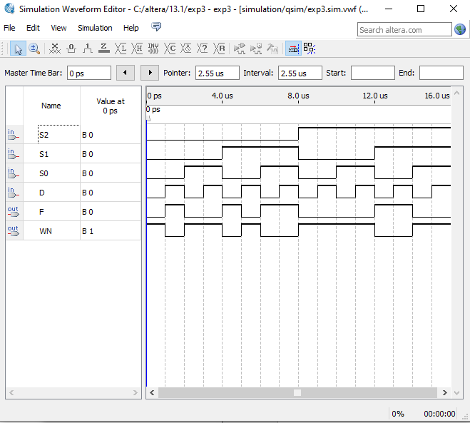

**Waveform result**

**f)Breadboard**

If s2 is equal to 0,s1 is equal to1,s0 is equal to 0 and d is equals to 0 the the result is 1.

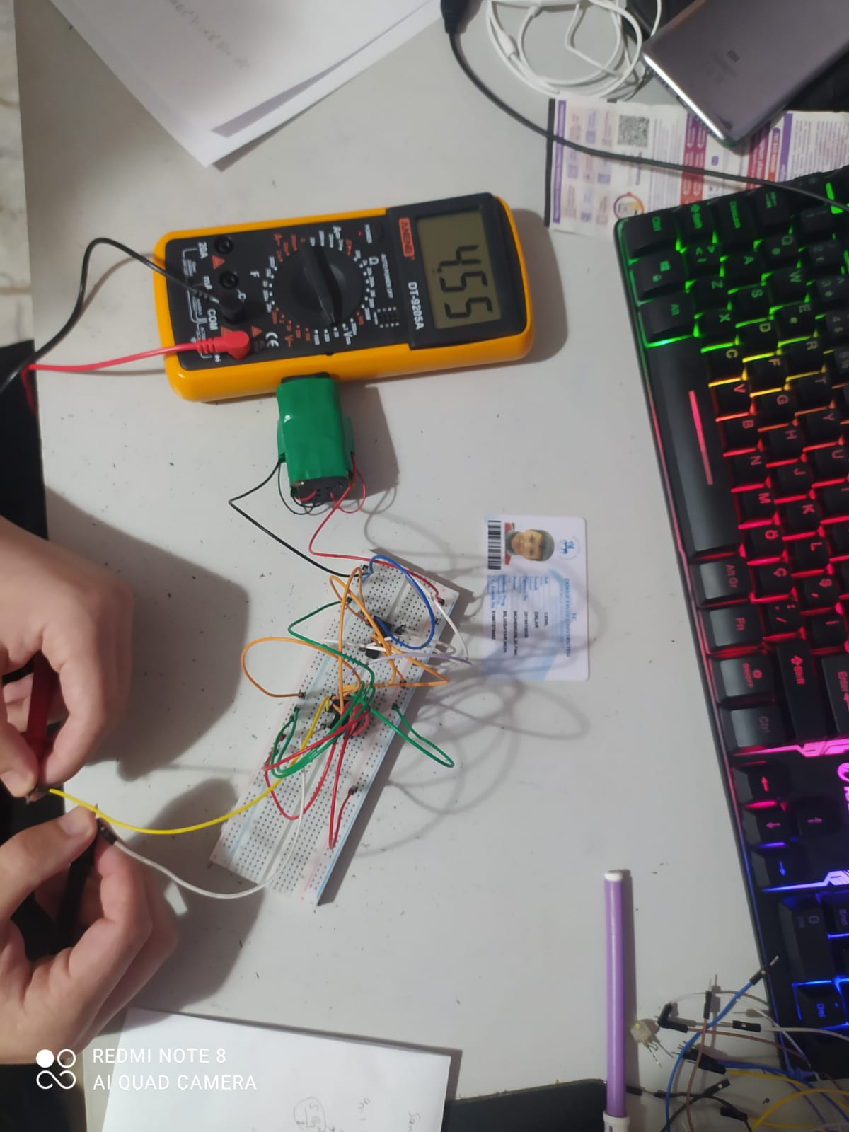

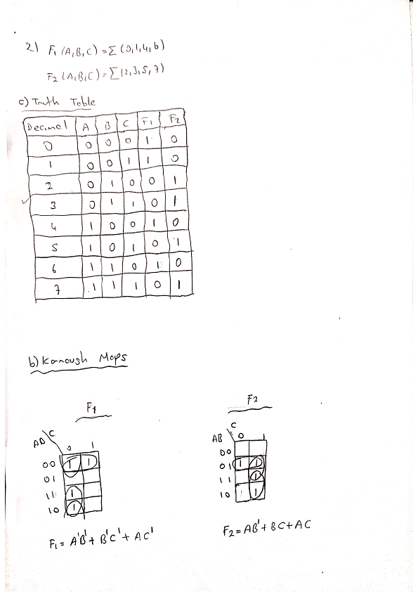

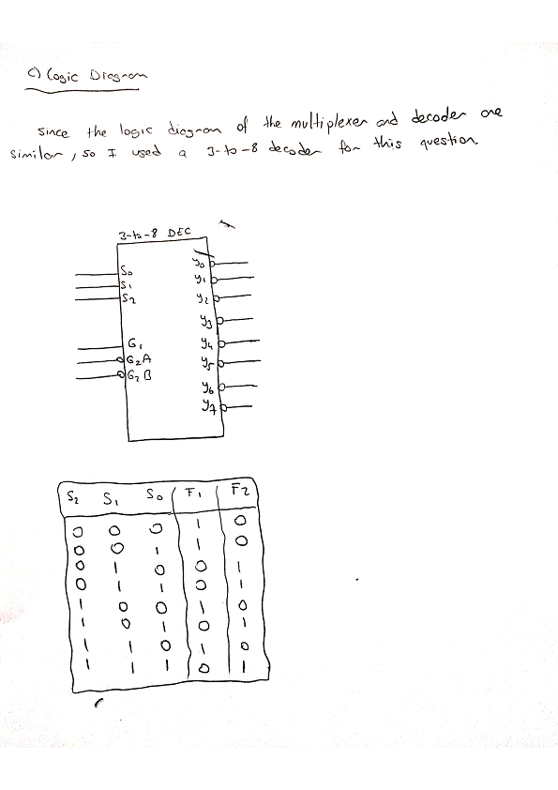

**d)Quartus**

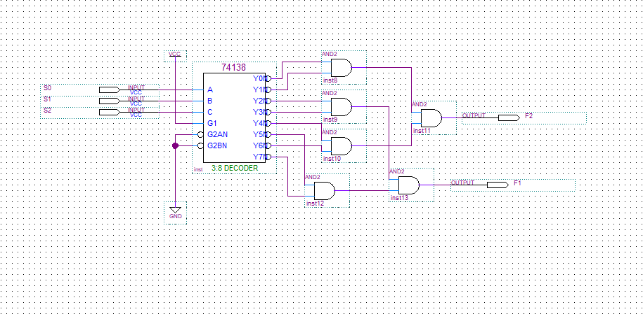

**e)Waveform**

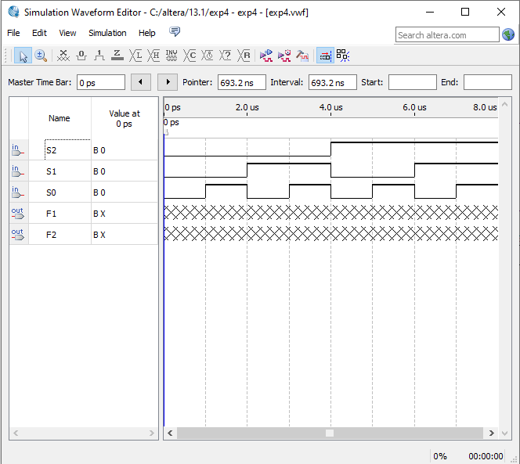

**Waveform results**

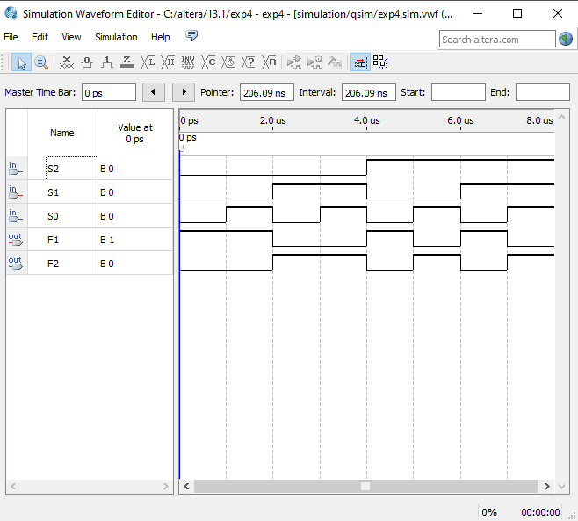

**f)Breadboard**

If s2 is equal to 1,s1 is equal to0,s0 is equal to 0 and d is equals to 0 the the f1’s result is 1.

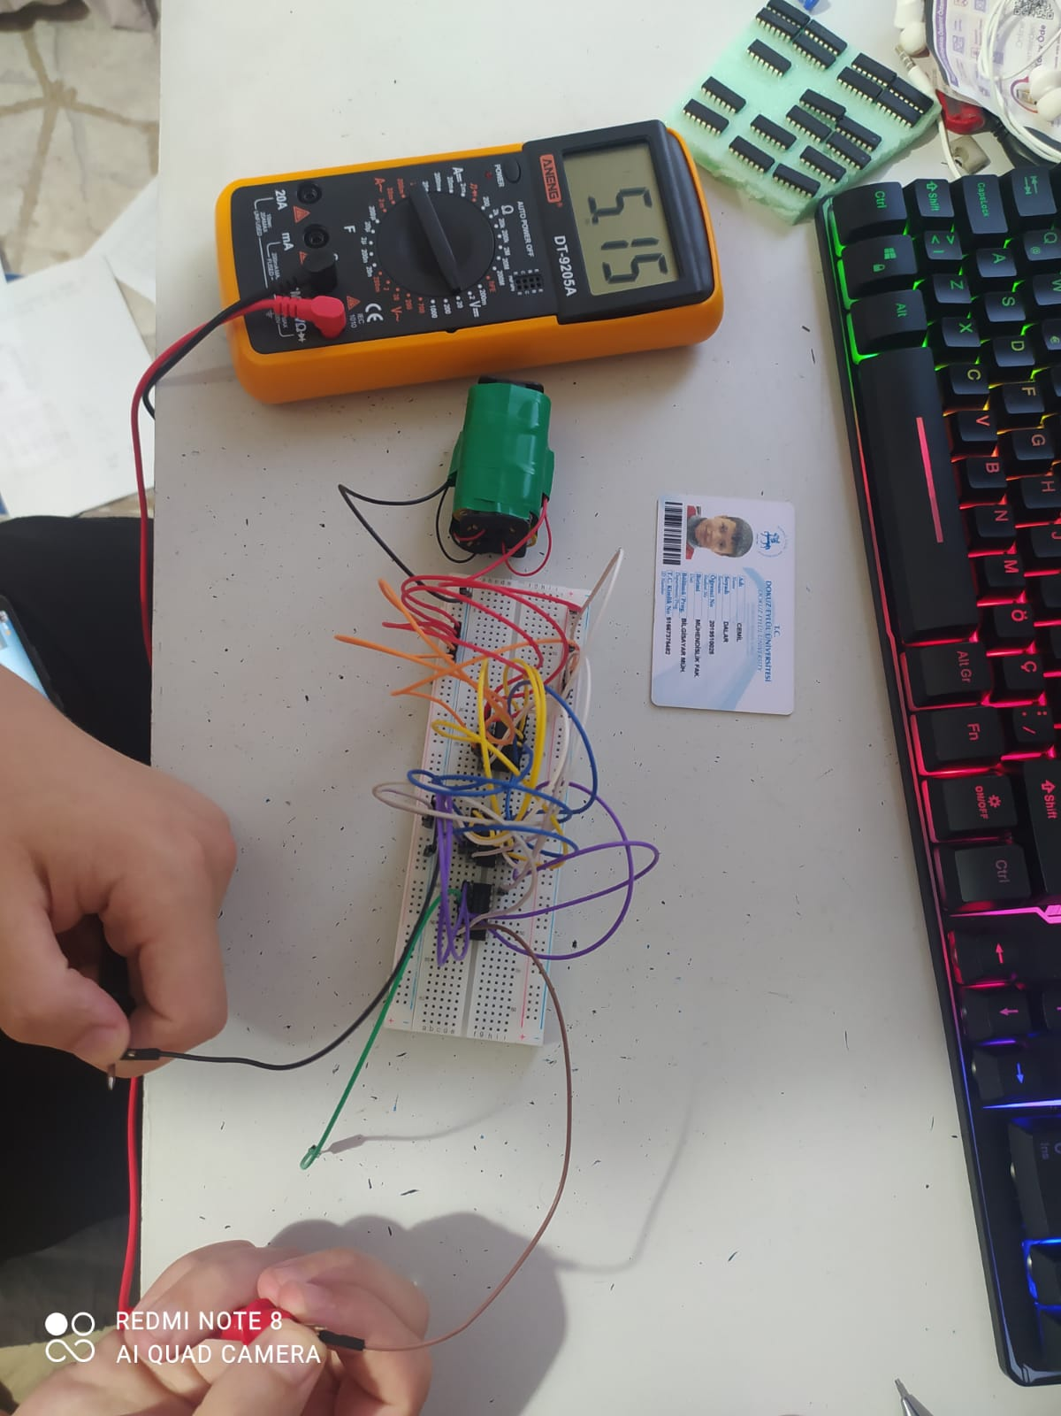

If s2 is equal to 1,s1 is equal to0,s0 is equal to 0 and d is equals to 0 the the f2’s result is 0.

