DOKUZ EYLUL UNIVERSITY
ENGINEERING FACULTY
DEPARTMENT OF COMPUTER ENGINEERING

CME1252 PROJECT BASED LEARNING – I I
FINAL REPORT
PROJECT – I I I

CENG EDITOR

By
Dilara Karacan
Cemil Dalar
Qusai Almoqadam

Lecturers
Prof.Dr. Alp KUT
İlker KALAYCI

IZMIR
24.06.2021

CHAPTER ONE
PROGRESS DESCRIPTION
The purpose of this project is to develop a simplified console editor, this editor provides various word processing capabilities in an active work space of 20*60 characters. The editor contains many operations, and special keys, which the user can use easily by presing F keys in the keyboard. Therefore, the first week of the project was spent learning this structure and creating the necessary variables. In the following weeks, the team had met daily to code the rest of the project. The project started on 24/05/2021 and ended on 24/06/2021.

CHAPTER TWO
TASK SUMMARY

Completed Tasks:
- Cursor movement and screen.
- Load and save.
- Insert/Overwrite modes.
- Special keys.
- Selection.
- Cut/Copy/Paste.
- Find/ Replace.

Task sharing:
Dilara Karacan:
- Selection part.
- Copy/ Cut/ paste.
- Find/ Replace.
- Special keys.

Cemil Dalar:
- Mll class.
- Entering and deleting characters/words.
- Back space and delete keys.

Qusai Almoqadam:
- Creating the necessary variables, structures. Screen.
- Load /save.
- Find part.
- Presentation.
- Poster.

Incomplete Tasks: Reasons and Explanations
Alignment :
The team had shortage in time to finish the Alignment part. Also Qusai’s laptop had been broken for two weeks.

Additional Improvements to the Project
- Paragraphs are automatically capitalized.
- When something is deleted in the remove function, the position of the following lines also changes properly

CHAPTER THREE
EXPLANATION of algorıthms

Screenshots

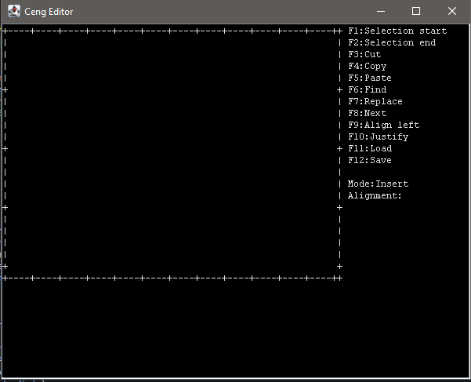
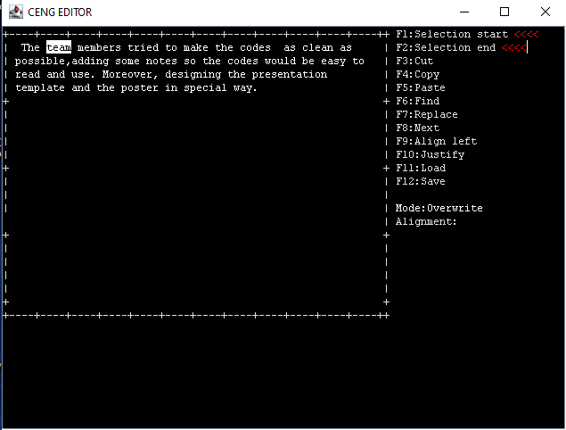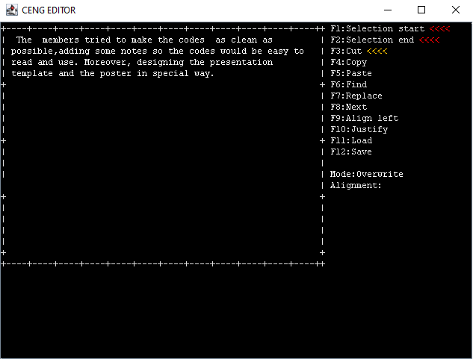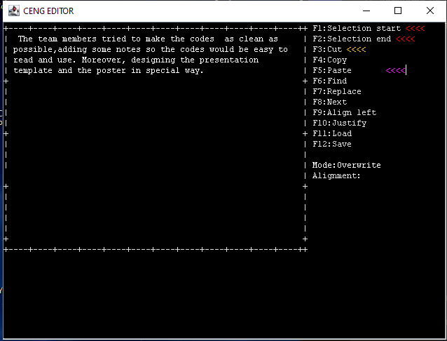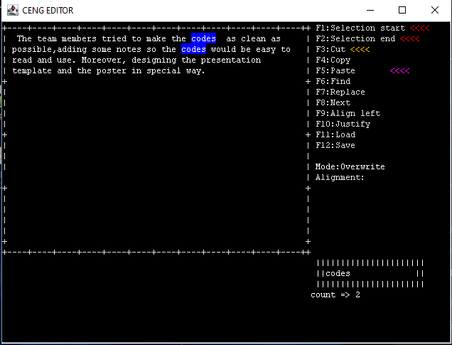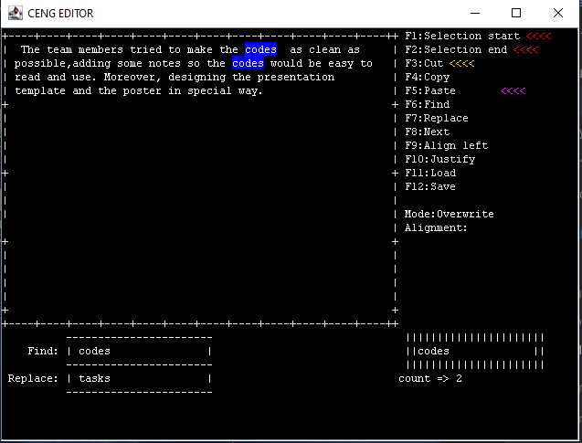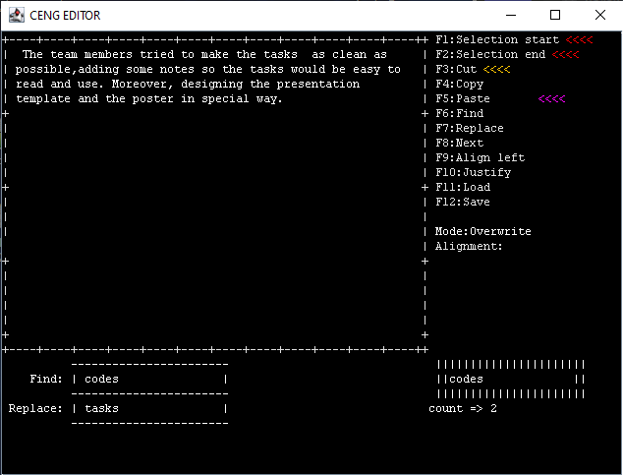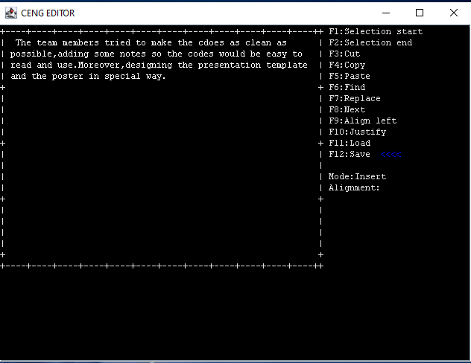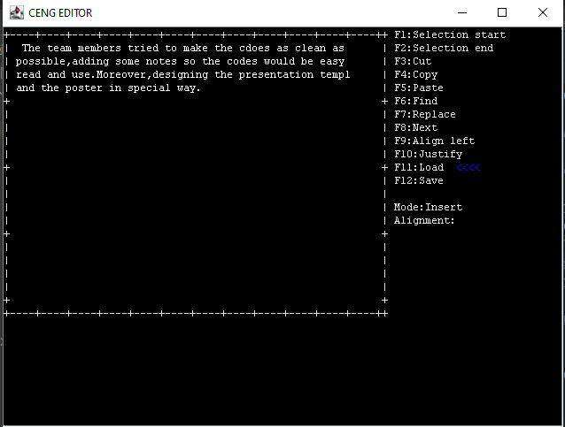

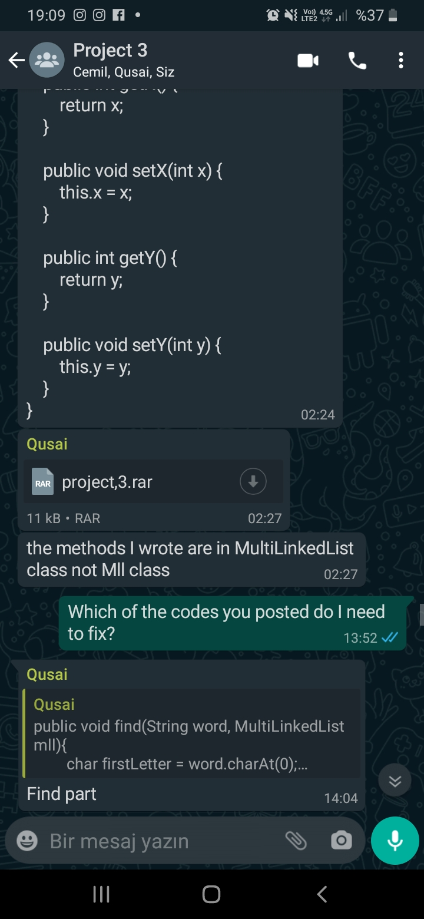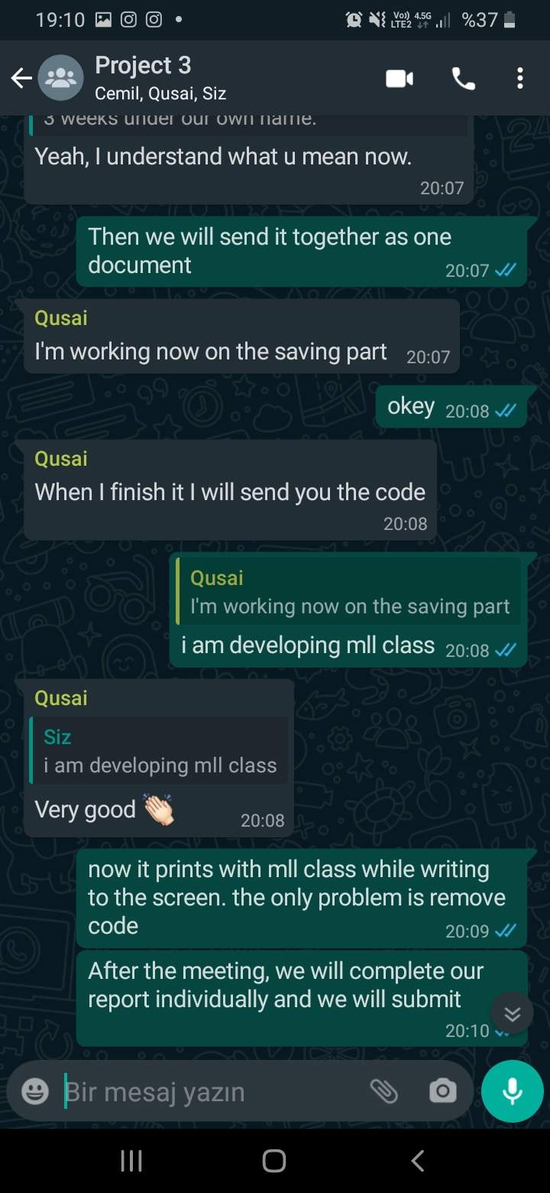

Functions:
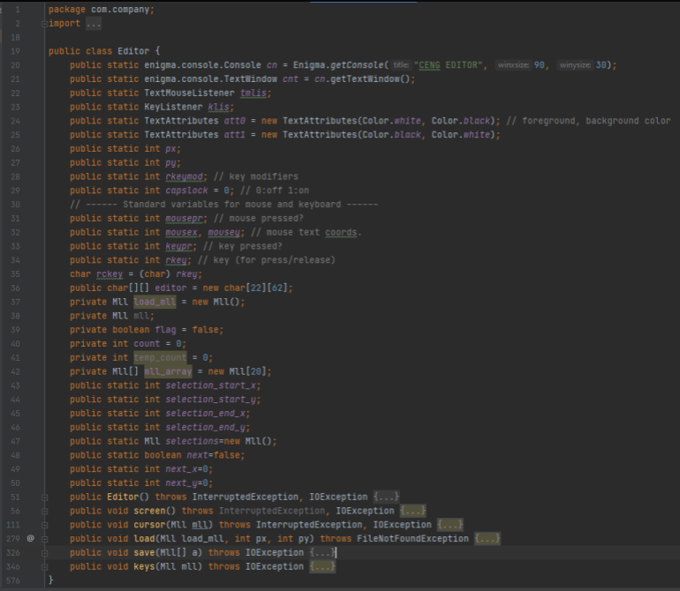

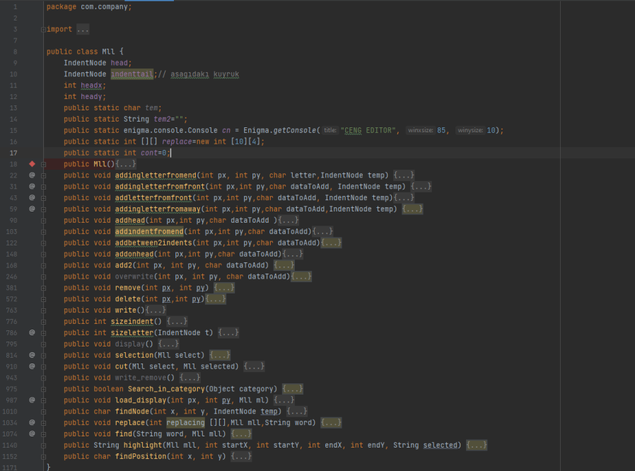

Algorithms and Solution Strategies:
To add method any node to the mll class, we first assign a control variable. This control variable was determining what type of node we wanted to add to the mll object. After we found the node type we want to add, we started adding the nodes according to the cursor location. We kept updating the locations of nodes as we continued adding nodes.
To delete a node from any point, we assign a control variable similar to the add method. After we find the node type we want to delete, we delete the node using the location of the node. We then update the nodes that need to be updated.
In the find code, the mll was searched by taking the string from the user. For loop returns the number of letters of the searched word. If all letters are correct, it is highlighted. Count how many of that word is on the screen and it is written on the screen. The replace code is written using the find code. The replace code was written by changing the data of the words found with the find code

CHAPTER FOUR
PROBLEMS ENCOUNTERED
  - Null pointer exception error.
  - Wrong character deletion error.
  - Adding to wrong location is in add function.
  - pasting in wrong place.
  - Mll methods errors.

CHAPTER FIVE
conclusıon
The team members tried to make the codes as clean as possible, adding some notes so the codes would be easy to read and use. Moreover, designing the presentation template and the poster in special way. Also, The team members have worked together as a professional team and learn many skills like time managing and dividing tasks. In conclusion, the assignment took five weeks to be finished, All member of the team worked so hard in order to provide the best version possible.

REFERENCES

- An Introduction to Object-Oriented Programming with Java, 5th Edition, McGraw-Hill, 2009.

- Michael T. Goodrich, Roberto Tamassia, Data Structures and Algorithms in Java, Wiley.

- https://www.geeksforgeeks.org

- https://stackoverflow.com

AppendIx A
Poster/Web page of the Project

