DOKUZ EYLUL UNIVERSITY
ENGINEERING FACULTY
DEPARTMENT OF COMPUTER ENGINEERING

CME1252 PROJECT BASED LEARNING – II
FINAL REPORT
PROJECT – II

PROJECT: NUMBER MAZE

by
Cemil DALAR - 2019510025
Mustafa Efe DEMİR - 2020510026

Lecturers
Dr. Özlem AKTAŞ
Dr. Ress. Asst. Göksu TÜYSÜZOĞLU

IZMIR
21.05.2021

CHAPTER ONE
PROGRESS DESCRIPTION
Number Maze is a maze game inspired by Pacman. The aim of the project is to develop a maze game in which the numbers are collected and the collected numbers are matched while the player moves in the maze and the highest score is tried to be reached. The start date of the project is April 19, and the completion date is May 21. As we approached the end of the project, we realized that our time would not be enough. Nevertheless, we tried to do our best to complete the project with the least deficiencies and the least bugs.

CHAPTER TWO
TASK SUMMARY

Completed Tasks
We both have work on even the smallest part of the project. However, if we need to separate, our task sharing is as follows.

Cemil DALAR:
- Gameboard
- Timing
- Matching & Scoring
- Input List
- Random Moving Numbers
Mustafa Efe DEMİR:
- Player Movement
- Backpack Implementation
- Collecting Number Rules
- Random Moving Numbers
- Game Over Rules

Incomplete Tasks: Reasons and Explanations
- Path Finding
(Although it didn't work, we tried more than 2 algorithms and wrote more than 1000 lines of code. We tried to do our best as soon as possible.)
Since we noticed the confusion of the path finding algorithm we designed 2-3 days after we started coding, we decided to change our algorithm.
Since our time was not enough, algorithms that were different from each other but did not work remained.

CHAPTER THREE
EXPLANATION of algorıthms

Screenshots
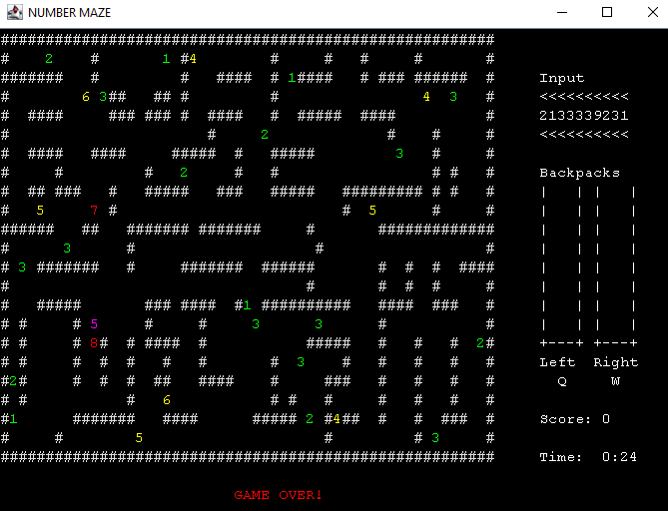
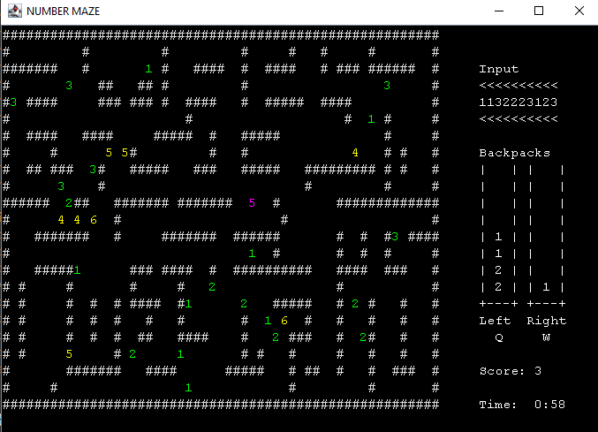

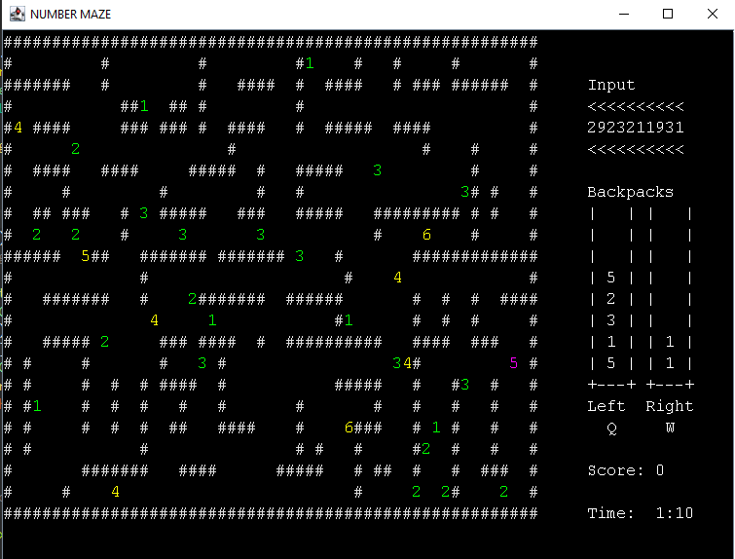

Algorithms and Solution Strategies
Randomly moving numbers were usually able to return to their previous positions. It didn't seem like they were moving randomly either. So we made it so that randomly moving numbers move in the same direction without changing direction until they hit any walls or numbers. In this way, it can be understood that they move randomly in the gameplay.
In the path finding algorithm, a priority variable was created by examining the coordinates of the player and the red numbers and tried to find short ways using this variable.For example, if the Y value of the color of a red number is less than the Y value of the player's coordinate, path finding prefers a downward path as a priority. But if there is an obstacle in the way, this time the algorithm determines another direction by looking at the red number and the player's x coordinates and goes from that side. If there's an obstacle in that direction, it's looking in different directions. But if there is no direction to go, the algorithm works in the direction of going backwards. (While our algorithm was fairly stable in thought, we realized how many possibilities there could be when we started coding.)

CHAPTER FOUR
PROBLEMS ENCOUNTERED
Randomly moving numbers can get stuck with a very small chance. Therefore, the yellow numbers that are unable to move cannot move, but they do not cause any other errors.
Randomly moving numbers could pass through the player number. This bug has been fixed so that when faced with the player, it can change direction and escape. If the yellow number is greater than the player number, the game is over.

CHAPTER FIVE
conclusıon
As a result, in this project, we learned about the task sharing, the responsibilities we should take, how to solve the problems that came up, how to solve the mistakes by discussing with our group friends, to search for the solution of the problems requested from us, to add new things, and how to present the problems to any person or people in any place with the solution

REFERENCES
- CME 1212 Algorithm and Programming Lectures
- https://github.com/Sciumo/Enigma#:~:text=Enigma%20is%20a%20Java%2Dbased,any%20platform%2C%20with%20any%20program
(Enigma Library – Access Time: May 2021)
- https://stackoverflow.com/questions/3664614/how-to-use-colours-in-console-output-in-scala-or-java/15168081
(Colored printing – Access Time: May 2021)

AppendIx A
Poster of the Project
