https://github.com/cmlykke/rime-liuma
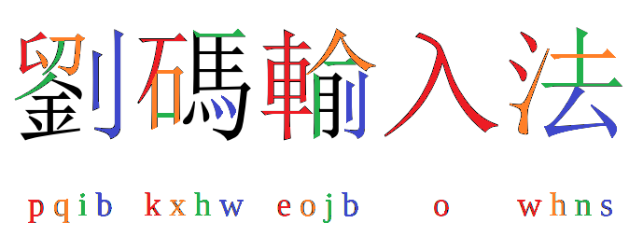

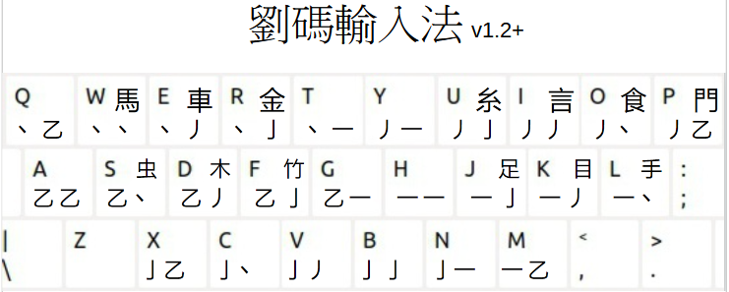

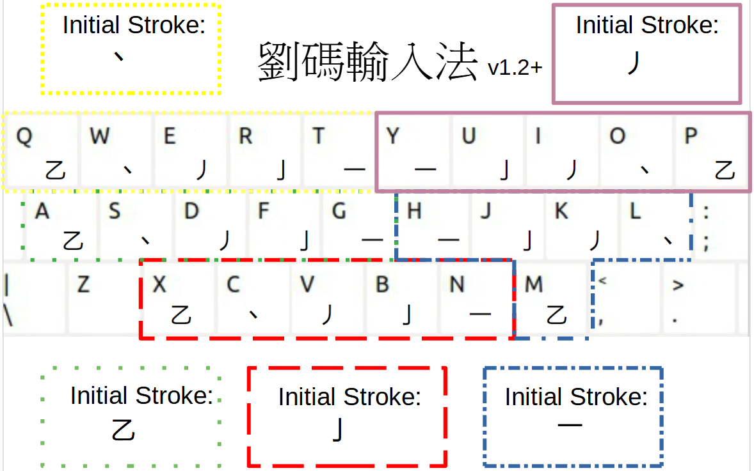

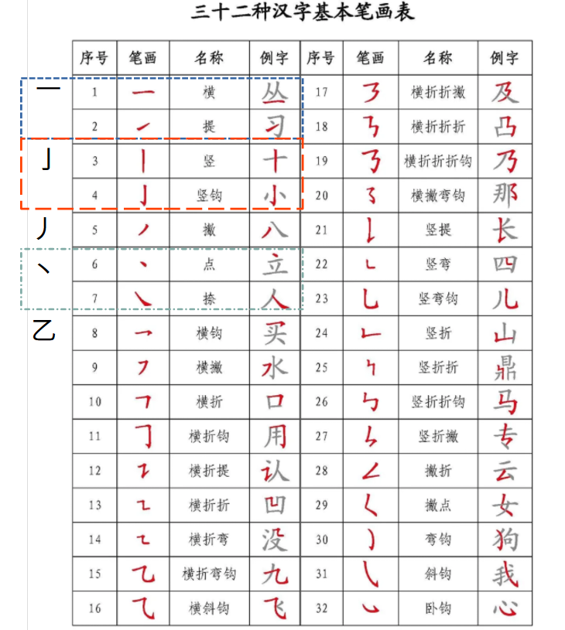

Number of chinese characters: 28.318 Number of words: 179.753
Simplified words: 108004 Traditional words: 108233

Characters beyond the first 9 options:
Simplified (freq.: lingua.mtsu.edu): Traditional (freq.: technology.chtsai.org ):
jjuo 藥3734  njuo 藥3734  ejoo 類4915  jhmo 長4933  nhmo 長4933  jnho 聩5209  綦5599 | xhjo 嗉5351  題5105  kxho 砹5772  硖5856  yhso 锿5941  pxjg 鮈5959  jnxn 難5970 | jjuo 葔3572  njuo 葔3572  yveo 秝5100  hnjo 瑮5135  jnxo 鞅5412  顴5454 茦5879  kxho 饜5477  戛5769  pxjh 魽5613 | njjh 荺5624  jjjh 荺5624  jjjn 蓳5631  njjn 蓳5631  pxjn 鰡5650  jjgo 芵5661  xjgo 嘳5724  xhjo 暪5811  wjgo 漯5821
Single character – 6 letter codes:
謝THXKXC 錯OHCYJH

的UGKS 一 H 不KC 了F

Single character – 4 letter codes:
蚜SMVZ 棧DMEE 筞FWGO

跐JNND 眬KKDT 揂LEJH

謝 IUGC 錯RJNH

的UGKS 一 H 不KC 了F

Two characters
你好 UODMN 我们 YOURG

你好 UOD 我们 YOU

Three characters
为什么 EUJPT 不一样KHDJZ

Four characters:
生日快乐YXWPO

Five characters:
中国共产党 XXJTC

More characters than five:
中华人民共和国 XUOGJ

大卫·艾登堡 KFZJS

Stoke data source and main single character source:  https://github.com/stroke-input/stroke-input-data/  version: v1.33.1 (2024-09-29) retrieved 2024-10-16  Compiled manually by Conway (@yawnoc).  Part of 'Conway Stroke Data',  Licensed under Creative Commons Attribution 4.0 International (CC-BY-4.0)  IDS data source:  https://github.com/cjkvi/cjkvi-ids/blob/master/ids.txt  retrieved 2024-09-08  # Copyright (c) 2014-2017 CJKVI Database  # Based on CHISE IDS Database  https://github.com/cjkvi/cjkvi-ids/blob/master/ids.txt  Multi-character word vocabulary source:  CC-CEDICT - release: 2024-10-16 06:08:17 GMT  Number of entries: 122652  https://www.mdbg.net/chinese/dictionary?page=cedict  Frequency data source - single characters:  simplified:  https://lingua.mtsu.edu/chinese-computing/statistics/char/list.php?Which=MO  Data last updated 最近更新: 2004-03-30  traditional:  http://technology.chtsai.org/charfreq/sorted.html  Updated: 2005-08-03  Frequency data source - multi-character words:  simplified:  The Beijing Language and Culture University corpus of 15 billion characters.  It’s based on news (人民日报 1946-2018，人民日报海外版 2000-2018), literature (books by 472 authors,  including a significant portion of non-Chinese writers), non-fiction books,  blog and weibo entries as well as classical Chinese.  retrieved 2024-10-04  https://www.plecoforums.com/threads/word-frequency-list-based-on-a-15-billion-character-corpus-bcc-blcu-chinese-corpus.5859/  traditional:  List by K. J. Chen and the CKIP Group of the Academia Sinica  Full list contains 10,000 highest frequency Mandarin words that are used in Taiwan."  retrieved 2024-10-04:  https://en.wiktionary.org/wiki/Appendix:Mandarin_Frequency_lists | U+4E79乹 122511125  U+4E7A乺 (1513|3351|4513)33125  U+4E7B乻 (4135|4153)(31|34)445  U+4E7C乼 441411215  U+4E7D乽 12132511(|4)5  U+24C0E 𤰎 ⿰享庸  U+24C0F 𤰏 ⿱⿰甬甬花  U+24C10 𤰐 ⿰⿱业爾甫  U+24C11 𤰑 ⿳𠫓口⿲月⿱龷用凡  U+24C12 𤰒 ⿱人⿻⿻口丨丷  坍方 坍方 [tan1 fang1] /to collapse/landslide/  坎 坎 [kan3] /pit/threshold/one of the Eight Trigrams 八卦[ba1 gua4], symbolizing water/☵/  1 的 7922684 4.094325317834  de/di2/di4 (possessive particle)/of, really and truly, aim/clear  2 一 3050722 5.670893097424  yi1 one/1/single/a(n)  的 6538132 8  是 3200626 9  不 2831612 4  第 2002074595  的 943370349  了 255733044  …  家研发型 25  广州市宝生园有限公司 25  王乐云 25  河北移动通信有限责任公司 25  赤崖堡村 25  |一|一|yī|det.: one {{audio|cmn|Zh-yi1.ogg|yī}}  |在|在|zài|in, at, on, etc. {{audio|cmn|Zh-zài.ogg|zài}}  |有|有|yǒu|have, possess

