https://github.com/cmlykke/rime-liuma
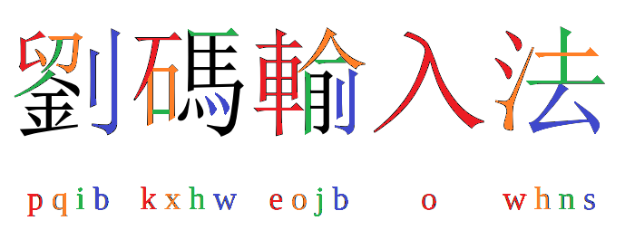

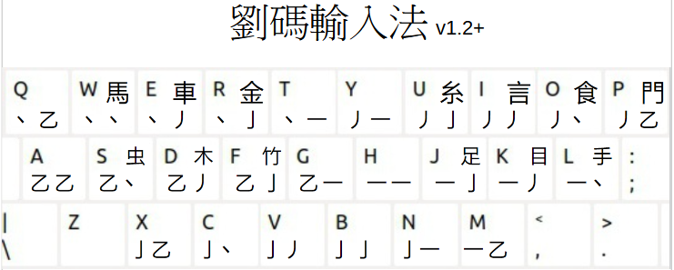

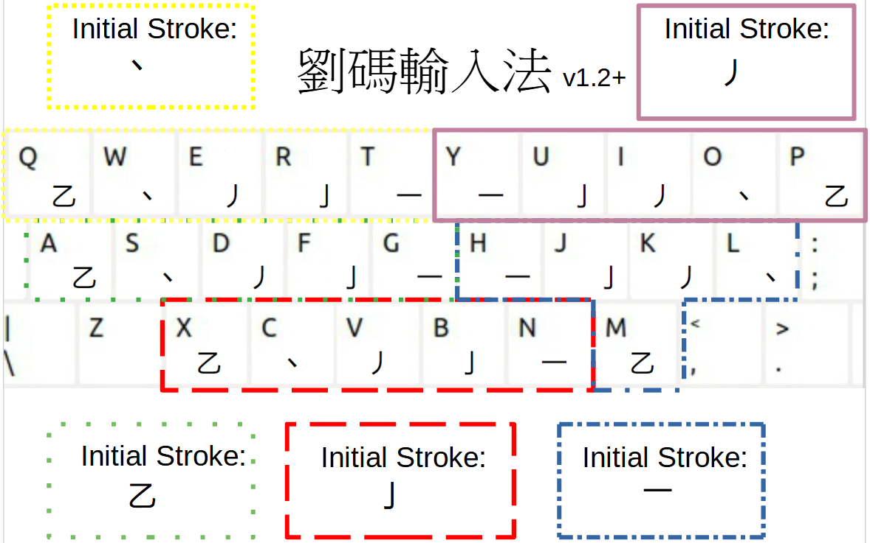

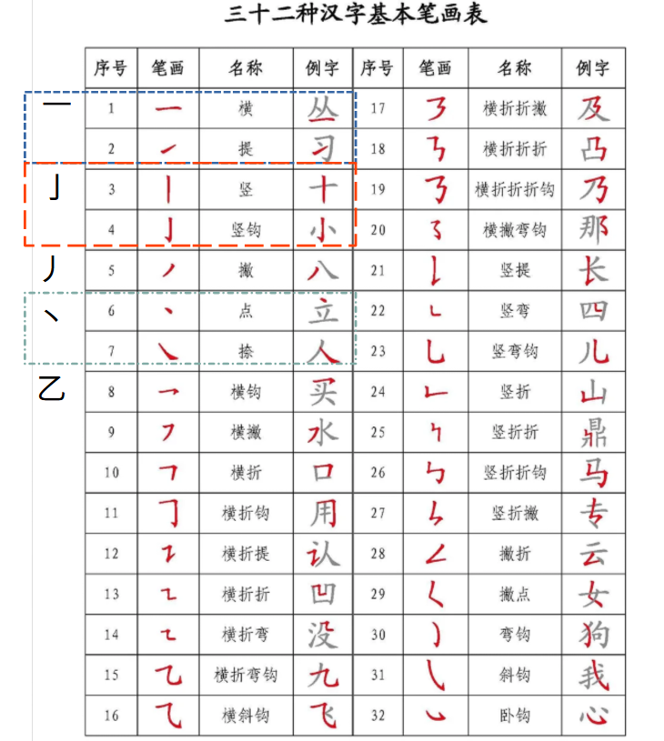

Number of chinese characters: 28.318 Number of words: 179.753
Simplified words: 108004 Traditional words: 108233

Most common characters beyond the first 9 options:
Simplified (freq.: lingua.mtsu.edu): Traditional (freq.: technology.chtsai.org ):
jjuo 藥3734  njuo 藥3734  ejoo 類4915  jhmo 長4933  nhmo 長4933  jnho 聩5209  綦5599 | xhjo 嗉5351  題5105  kxho 砹5772  硖5856  yhso 锿5941  pxjg 鮈5959  jnxn 難5970 | jjuo 葔3572  njuo 葔3572  yveo 秝5100  hnjo 瑮5135  jnxo 鞅5412  顴5454 茦5879  kxho 饜5477  戛5769  pxjh 魽5613 | njjh 荺5624  jjjh 荺5624  jjjn 蓳5631  njjn 蓳5631  pxjn 鰡5650  jjgo 芵5661  xjgo 嘳5724  xhjo 暪5811  wjgo 漯5821
Single character – 6 letter codes: write the first 10 strokes and the last 2 strokes.
If only 1 stroke is left, use the appropriate key that ends with a horizontal stroke.
If the character has too few strokes, add a ”z” character at the end.
謝THXKXC 錯OHCYJH

的UGKS 一 HZ 不KCZ 了FZ

Single character – 4 letter codes: write the first 6 strokes and the last 2.
If a character starts with one of these radicals: 虫木⺮⻊目扌馬車金糸言食門
the corresponding key counts as the first 2 strokes.
蚜SMVZ 棧DMEE 筞FWGO

跐JNND 眬KKDT 揂LEJH

謝 IUGC 錯RJNH

的UGKS 一 HZ 不KCZ 了FZ

Multicharacter combinations:
If a character starts with one of the radicals, the corresponding key counts as the first 2 strokes.
If a multicharacter combination contains a character that is not a chinese character, such as “·” in
“大卫·艾登堡”, then that character is written with the letter “z”.
If a character in a multicharacter combination is normally written with multiple letters, and there are not enough strokes, such as “一” in “不一样”, then you complete the code by writing ”z” at the end.

Two characters: Write the first 2 and last 2 strokes for the first character,
and the first 4 and last 2 strokes of the last character.
The most common two character combinations can be written with the first three letters of the code.

你好 UODMN 我们 YOURG

你好 UOD 我们 YOU

Three characters: write the first 2 strokes from the first character, first 2 and last 2 strokes from the second character, and first 2 and last 2 strokes from the third character.
为什么 EUJPT 不一样KHDJZ

Four characters: write the first 2 strokes from the first three characters, and the first 2 and last 2 strokes from the last character.
生日快乐YXWPO

Five characters: write the first 2 strokes from each of the five characters.
中国共产党 XXJTC

More than five characters: write the first 2 strokes from each of the first five characters.

中华人民共和国 XUOGJ 大卫·艾登堡 KFZJS

Punctuation: punctuation and special characters, such as 。，〇《》「」can be written by pressing “z”,”zx”, “zc”, “zv”, “zb” or “zn”, and then selecting from among the options.

Stoke data source and main single character source:  https://github.com/stroke-input/stroke-input-data/  version: v1.33.1 (2024-09-29) retrieved 2024-10-16  Compiled manually by Conway (@yawnoc).  Part of 'Conway Stroke Data',  Licensed under Creative Commons Attribution 4.0 International (CC-BY-4.0)  IDS data source:  https://github.com/cjkvi/cjkvi-ids/blob/master/ids.txt  retrieved 2024-09-08  # Copyright (c) 2014-2017 CJKVI Database  # Based on CHISE IDS Database  https://github.com/cjkvi/cjkvi-ids/blob/master/ids.txt  Multi-character word vocabulary source:  CC-CEDICT - release: 2024-10-16 06:08:17 GMT  Number of entries: 122652  https://www.mdbg.net/chinese/dictionary?page=cedict  Frequency data source - single characters:  simplified:  https://lingua.mtsu.edu/chinese-computing/statistics/char/list.php?Which=MO  Data last updated 最近更新: 2004-03-30  traditional:  http://technology.chtsai.org/charfreq/sorted.html  Updated: 2005-08-03  Frequency data source - multi-character words:  simplified:  The Beijing Language and Culture University corpus of 15 billion characters.  It’s based on news (人民日报 1946-2018，人民日报海外版 2000-2018), literature (books by 472 authors,  including a significant portion of non-Chinese writers), non-fiction books,  blog and weibo entries as well as classical Chinese.  retrieved 2024-10-04  https://www.plecoforums.com/threads/word-frequency-list-based-on-a-15-billion-character-corpus-bcc-blcu-chinese-corpus.5859/  traditional:  List by K. J. Chen and the CKIP Group of the Academia Sinica  Full list contains 10,000 highest frequency Mandarin words that are used in Taiwan."  retrieved 2024-10-04:  https://en.wiktionary.org/wiki/Appendix:Mandarin_Frequency_lists | U+4E79乹 122511125  U+4E7A乺 (1513|3351|4513)33125  U+4E7B乻 (4135|4153)(31|34)445  U+4E7C乼 441411215  U+4E7D乽 12132511(|4)5  U+24C0E 𤰎 ⿰享庸  U+24C0F 𤰏 ⿱⿰甬甬花  U+24C10 𤰐 ⿰⿱业爾甫  U+24C11 𤰑 ⿳𠫓口⿲月⿱龷用凡  U+24C12 𤰒 ⿱人⿻⿻口丨丷  坍方 坍方 [tan1 fang1] /to collapse/landslide/  坎 坎 [kan3] /pit/threshold/one of the Eight Trigrams 八卦[ba1 gua4], symbolizing water/☵/  1 的 7922684 4.094325317834  de/di2/di4 (possessive particle)/of, really and truly, aim/clear  2 一 3050722 5.670893097424  yi1 one/1/single/a(n)  的 6538132 8  是 3200626 9  不 2831612 4  第 2002074595  的 943370349  了 255733044  …  家研发型 25  广州市宝生园有限公司 25  王乐云 25  河北移动通信有限责任公司 25  赤崖堡村 25  |一|一|yī|det.: one {{audio|cmn|Zh-yi1.ogg|yī}}  |在|在|zài|in, at, on, etc. {{audio|cmn|Zh-zài.ogg|zài}}  |有|有|yǒu|have, possess

