### Cangjie 5 倉頡

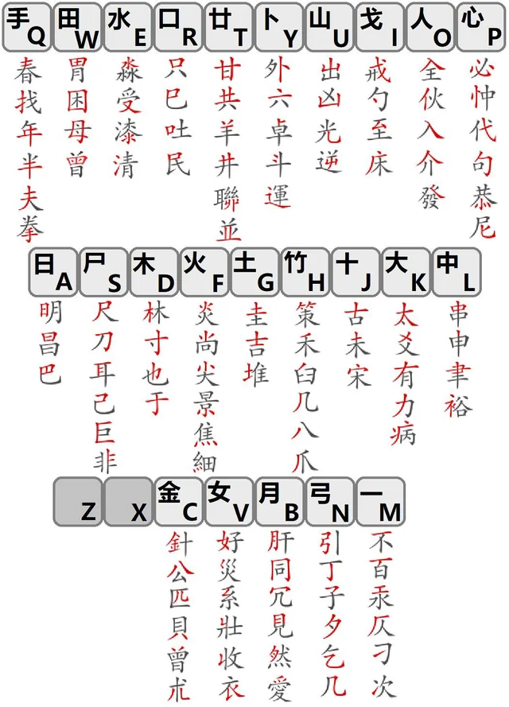
…
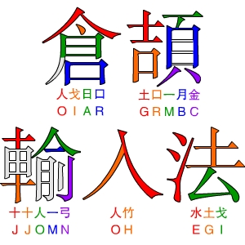

- wikipedia:
- https://en.wikipedia.org/wiki/Cangjie_input_method
- Interactive guide (in english) (incomplete but very usefull):
- https://learningcangjie.com/demo/
- Cangjie typing practice (in english)
- https://cjtt.bzzt.io/
- For RIME IME on github:
- https://github.com/rime/rime-cangjie
- https://github.com/gkovacs/rime-cangjie-tradsimp

### Wubi 86 五笔字型

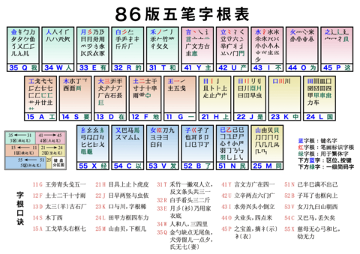
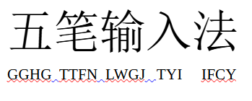

- Classic text guide (in english)
- https://chinesemac.org/wubi/xing.html
- Interactive guide (in english):
- https://ndldd.github.io/wubi-trainer/app/#/info
- Youtube guide:五笔字型 Typing Chinese with WuBi, Video 1, lesson for beginners
- https://www.youtube.com/watch?v=v_w-Q6hDzL8
- For RIME IME on github:
- https://github.com/rime/rime-wubi
- https://github.com/KyleBing/rime-wubi86-jidian
- https://github.com/sheepduke/rime-config

### Hanglie30 (Array30) 行列

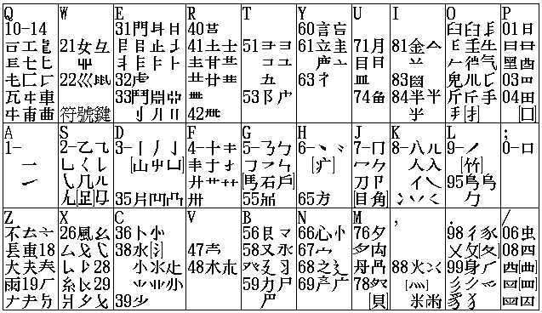
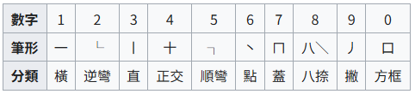

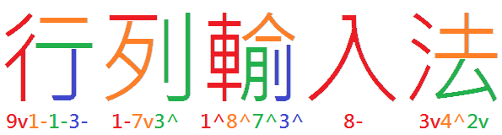
- wikibook:
- https://en.wikibooks.org/wiki/Guide_to_Array_input
- Online practice:
- https://array30.misterfishup.com/en/
- For RIME IME on github:
- https://github.com/rime/rime-array
- https://github.com/archerindigo/rime-array
- https://github.com/Reniastyc/RIME_array30_ex

### Zhengma 郑码
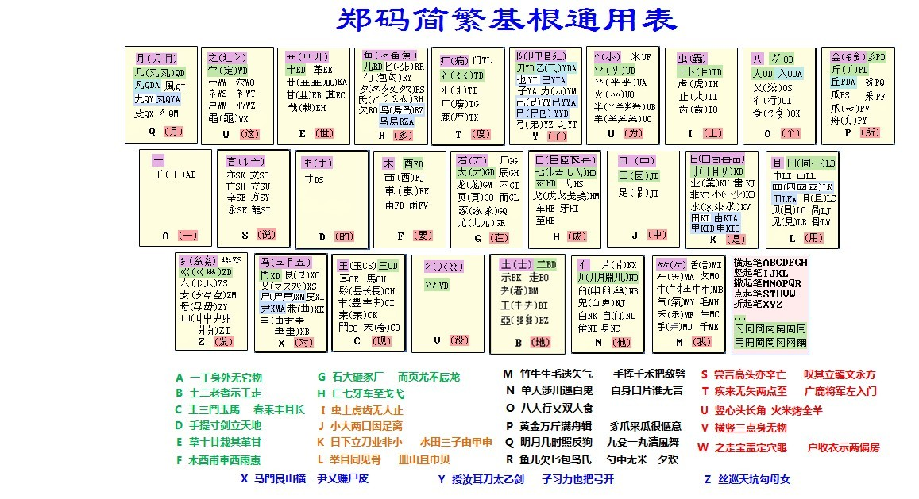

- wikibook:
- https://en.wikibooks.org/wiki/Zhengma_Input
- For RIME IME on github:
- https://github.com/Openvingen/rime-zhengma/
- https://github.com/vfreex/rime-zhengma
- https://github.com/chen32768/zhengma_for_rime
- online lookup:
- https://zhengma.911cha.com/

### Dayi 4 大易

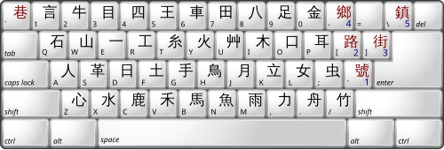
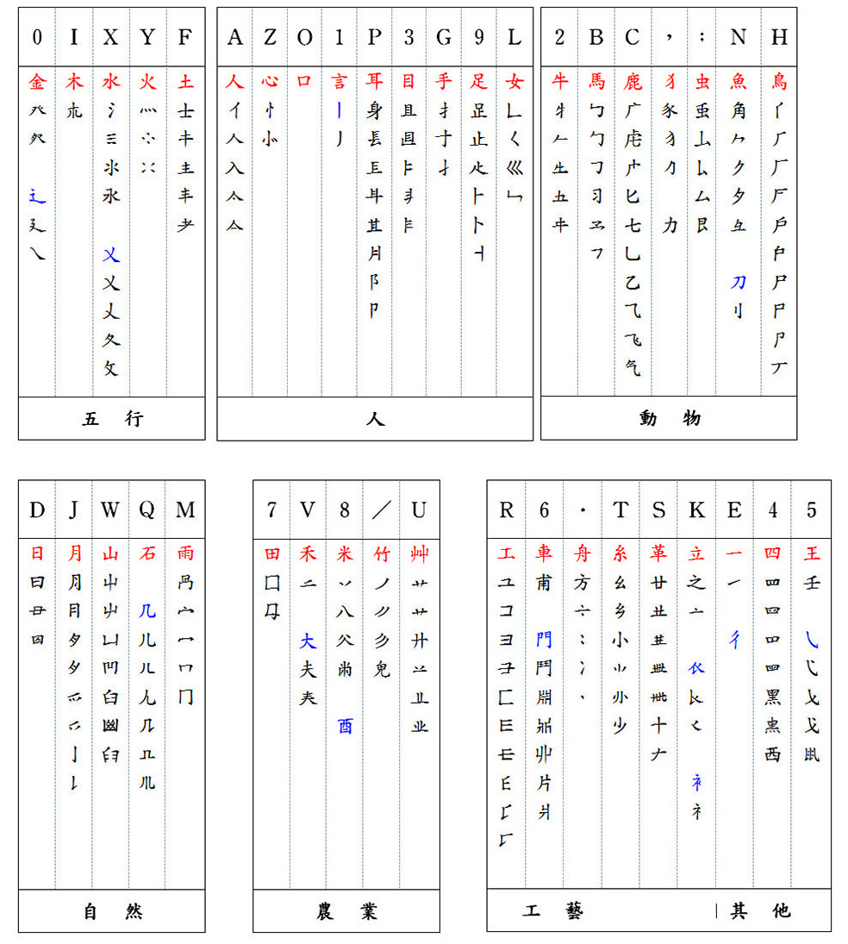

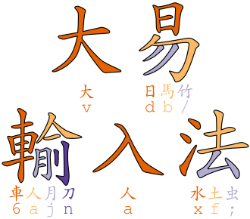

- official website (in chinese):
- http://www.dayi.com/
- wikibook:
- https://en.wikibooks.org/wiki/Guide_to_Dayi_input
- For RIME IME on github:
- https://github.com/chiahsien/RimeDayi

### Huma 虎码

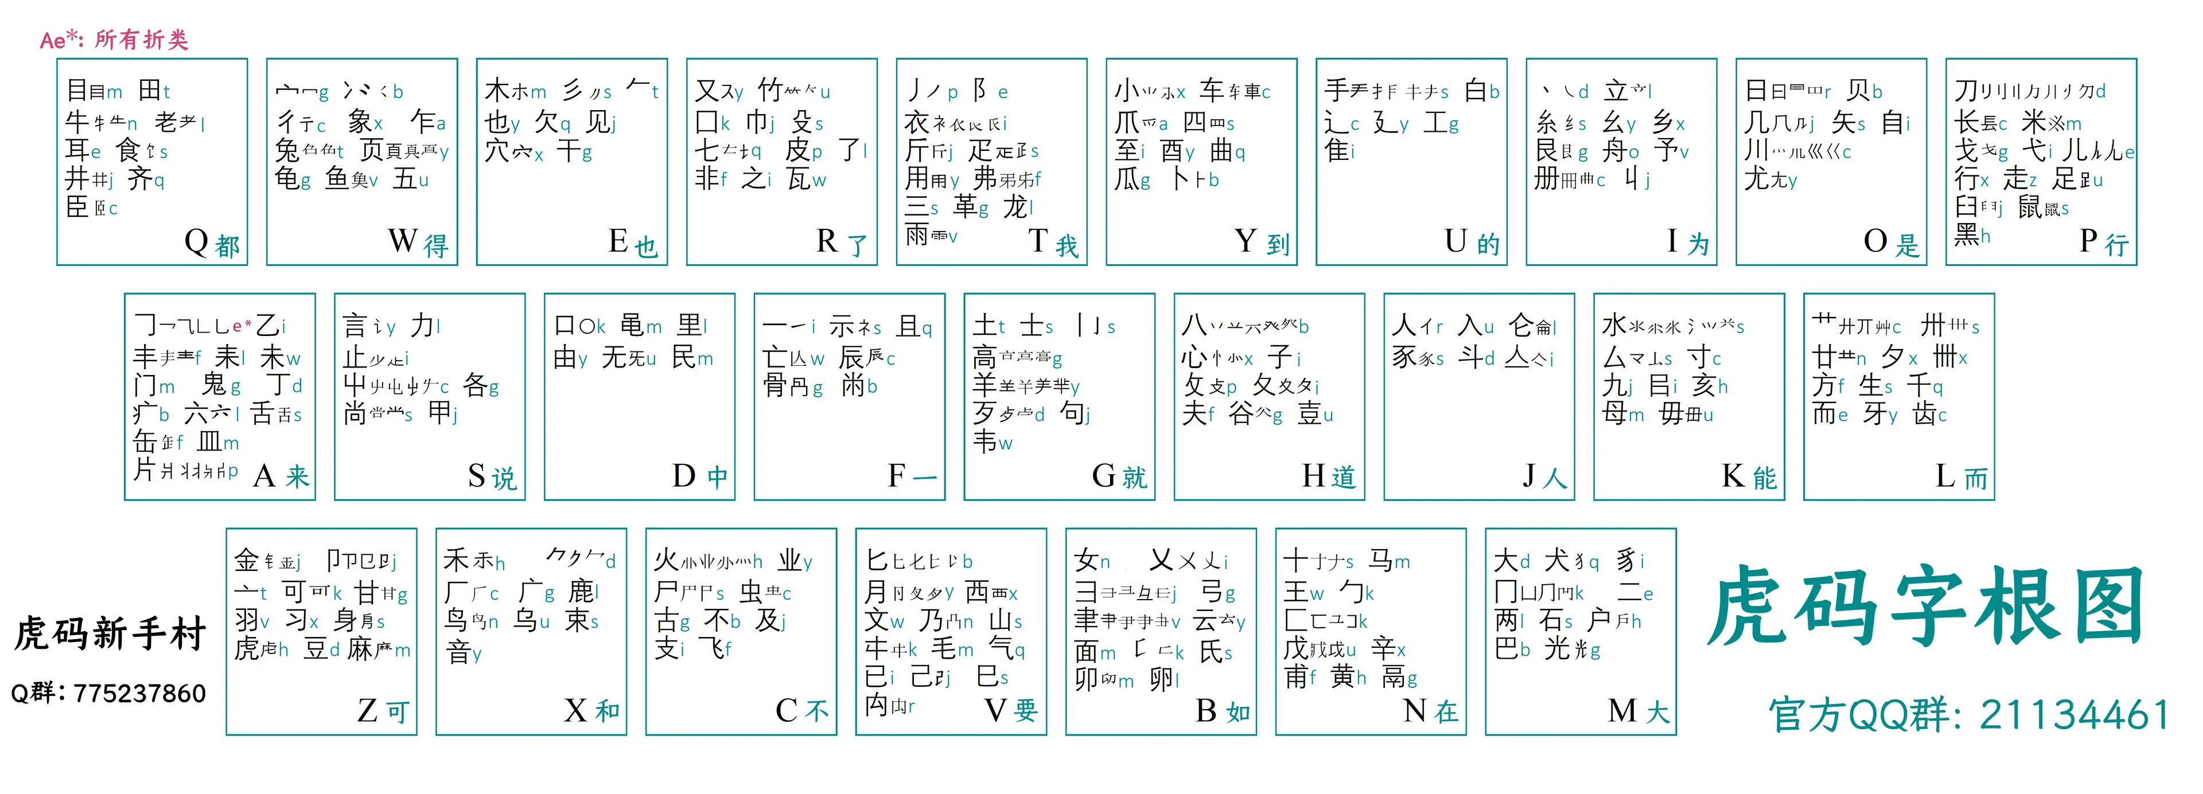

- officiel website (chinese):
- https://www.tiger-code.com/
- For RIME IME on github:
- https://github.com/ywxt/rime-huma
- https://github.com/humaIME/huma
- https://github.com/pimgeek/zen-tiger-code
- https://github.com/impishian/rime-ice-ziranma-zhengma-huma

### Xuma 徐码

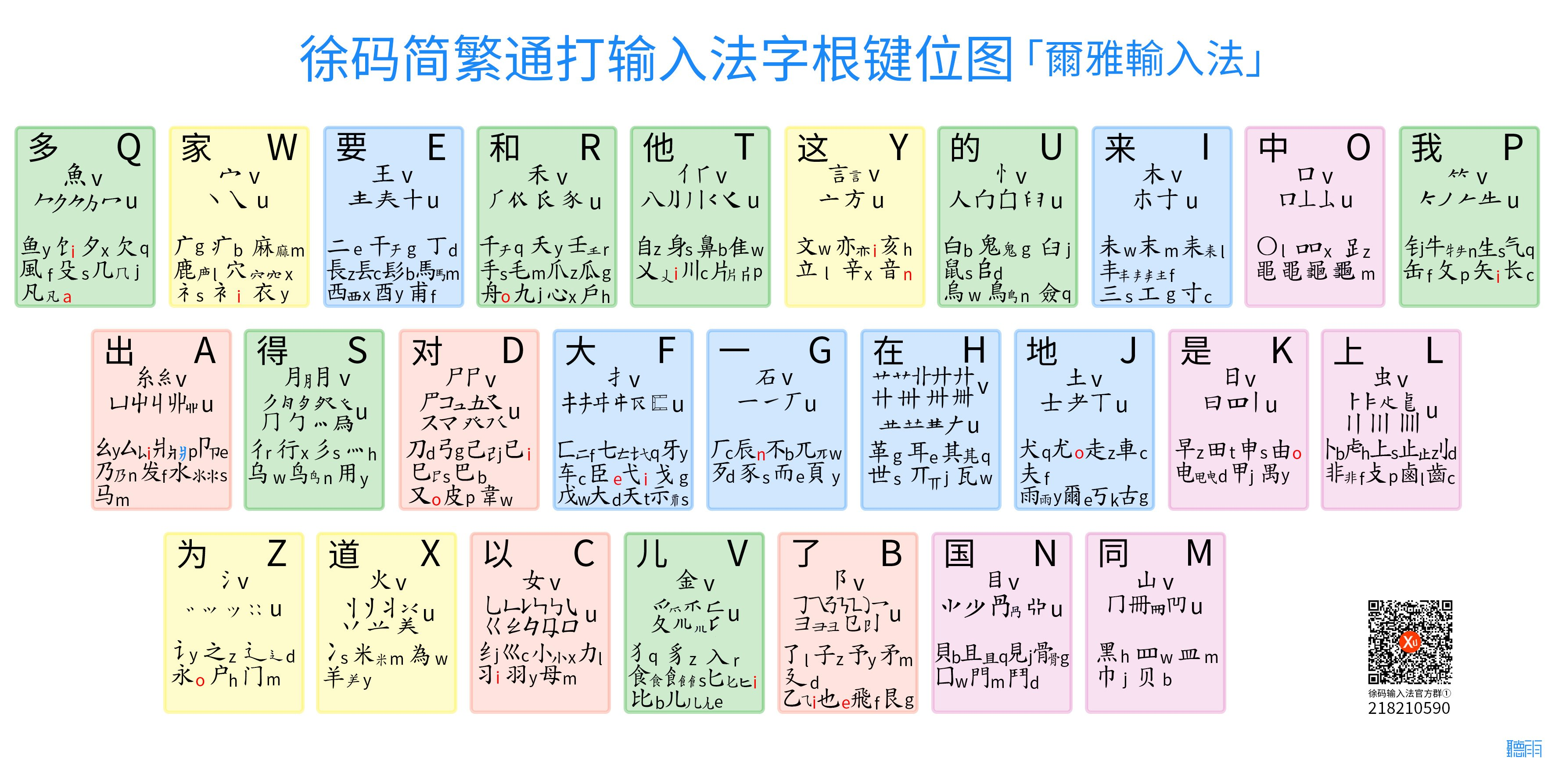
- guide (chinese)
- https://ace-who.github.io/rime-xuma/
- For RIME IME on github:
- https://github.com/Ace-Who/rime-xuma?tab=readme-ov-file

### Yuhao 宇浩

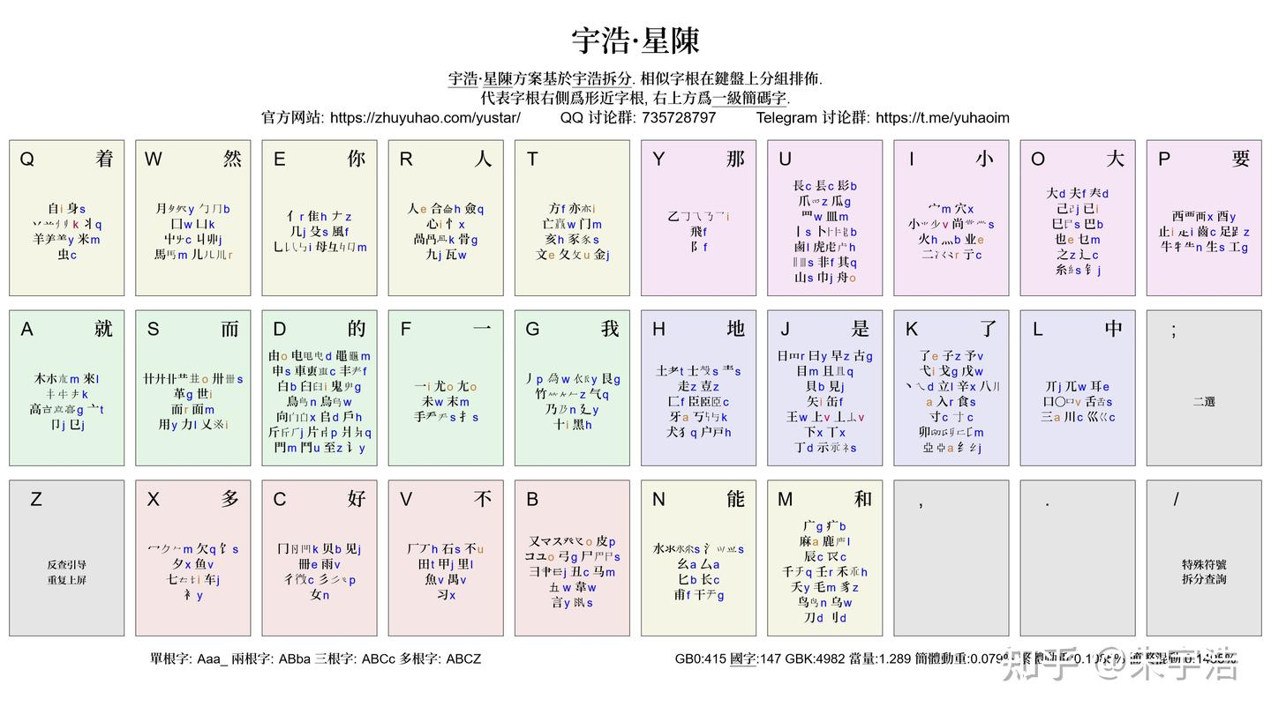

- official website (chinese):
- https://shurufa.app/
- For RIME IME on github:
- https://github.com/forfudan/yuhao-ime-release

### San ma 三碼

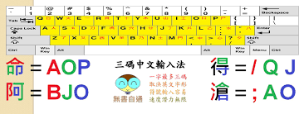

- An input method created by Gemini AI!
- Facebook group:
- https://www.facebook.com/groups/756940847492021

### CKC (zònghéng) 縱橫

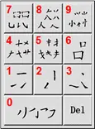

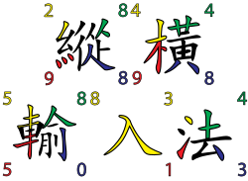

- wikibook:
- https://en.wikipedia.org/wiki/CKC_Chinese_Input_System
- introduction:
- https://ckctic.eduhk.hk/centre/about-ckc
- https://www.ckcsys.com/eng/teach/guide-to-ckc.html
- website:
- https://www.ckcsys.com/eng/
- android version:
- https://github.com/lonixchu-hk/CkcInputMethod-Android13
### G6 六碼筆畫

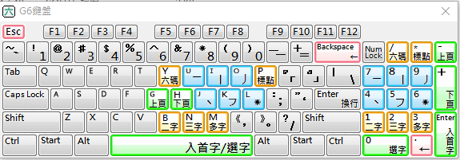

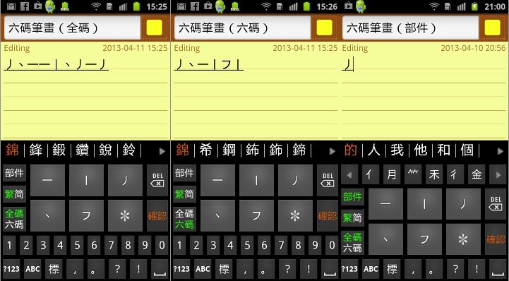

- PDF tutorial:
- https://www.pascal-man.com/navigation/faq-java-browser/2009_SMC_G6.pdf
- Official site (in chinese) with app links:
- http://www.miniapps.hk/g6code/index.html

